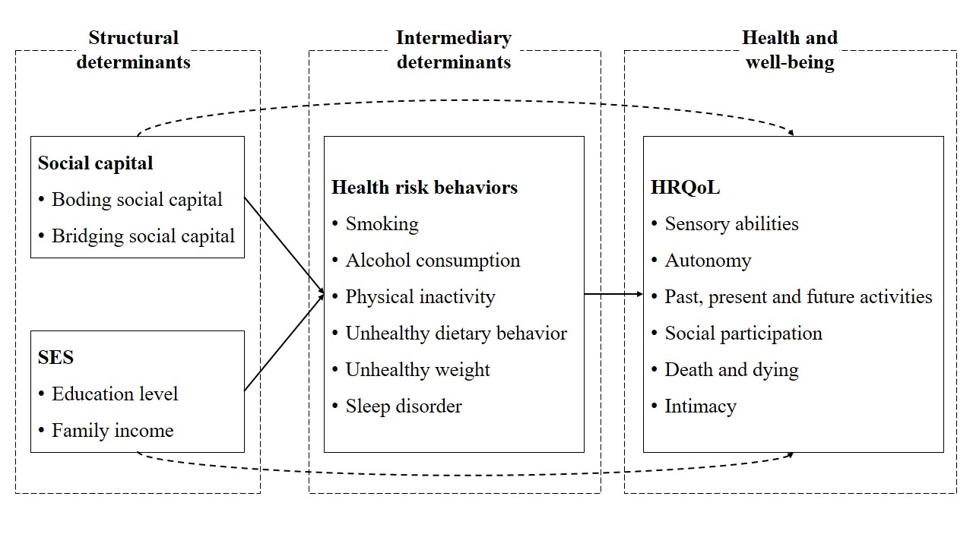

Supplementary figure 1. Conceptual framework
Note: variables in rectangles represent manifest variables, and variables in ovals denote latent variables. Direct effects are indicated by solid lines. Indirect effects are indicated by dashed lines.

Supplementary table 1. Internal consistency and confirmatory factor analysis (CFA) results.
Latent construct | Manifest variable | Cronbach’s alpha | CFA
Latent construct | Manifest variable | Cronbach’s alpha | Standardized  factor loading | p-value
SES | Education level | 0.631 | 0.60 | <0.001
SES | Family income | 0.631 | 0.46 | <0.001
Social capital | Bonding social capital | 0.965 | 0.98 | <0.001
Social capital | Bridging social capital | 0.965 | 0.78 | <0.001
HRQoL | Sensory abilities | 0.864 | 0.18 | <0.001
HRQoL | Autonomy | 0.864 | 0.86 | <0.001
HRQoL | Past, present and future activities | 0.864 | 0.88 | <0.001
HRQoL | Social participation | 0.864 | 0.86 | <0.001
HRQoL | Death and dying | 0.864 | 0.09 | <0.001
HRQoL | Intimacy | 0.864 | 0.63 | <0.001
Model fit statistics for CFA: SRMR = 0.0695, RMSEA = 0.08, GFI= 0.96, CFI= 1.00, NFI= 0.95.

