Table S1 Primer Sequences

Primers | Primer Sequences
Arc-Forwad | CAAGAGAGTGTGGCTATC
Arc-Reverse | TTGAGGTAAGATGGTATGG
c-Fos-Forward | TTCTCATAGCACTAACTAATCT
c-Fos-Reverse | CAGGAACACAGTAGGTATT
EGR-1-Forward | ACTCTGCTGTGACATTAGG
EGR-1-Reverse | AACGGAACAACACTCTGA
PSD-93-Forward | CCTGGTGTGATTGATTCC
PSD-93-Reverse | CTCTGCTCCTTGTTCTTG
PSD-95-Forward | ATCATCGCTCAGTATAAAC
PSD-95-Reverse | CCAGGCTACTATTCATAAG
SYP -Forward | AAGTATTGTGGTTTGGAG
SYP-Reverse | GTAGATTCTGTCTTCTGATT
LDHA-Forward | TGTCTCCAGCAAAGACTACTGT
LDHA-Reverse | GACTGTACTTGACAATGTTGGGA
LDHB-Forward | CATTGCGTCCGTTGCAGATG
LDHB-Reverse | GGAGGAACAAGCTCCCGTG
β-Actin-Forward | GATTACTGCTCTGGCTCCTAGC
β-Actin-Reverse | GACTCATCGTACTCCTGCTTGC

Table S2 PLS-DA Model quality parameters of hippocampus tissues.
Model | Number of Components | Number of Observations | R²X(cum) | R²Y(cum) | Q²(cum) | P
Total | 2 | 38 | 0.525 | 0.650 | 0.579 | <0.001
DM vs. CON | 2 | 22 | 0.504 | 0.863 | 0.691 | <0.001
DM/FGF21 vs. CON | 2 | 25 | 0.570 | 0.870 | 0.771 | <0.001
DM/FGF21 vs. DM | 2 | 29 | 0.458 | 0.716 | 0.437 | 0.00836
P value indicate significance of cross validation analysis of variance for each model.

Table S3 The comparison of relative intensities of the hippocampal metabolites among the control, diabetes and FGF21 groups. | DM vs. FGF21 | |r| | 0.145 | 0.230 | 0.355 | 0.772 | 0.142 | 0.649 | 0.531 | 0.635 | 0.208 | 0.584 | 0.473 | 0.305 | 0.611 | 0.442 | 0.567 | 0.587 | 0.678 | 0.480 | 0.090 | 0.572 | 0.324 | 0.089 | 0.246 | 0.666 | 0.483
 | DM vs. FGF21 | p | 0.876 | 0.349 | 0.054 | 0.003 | 0.297 | 0.028 | 0.012 | 0.031 | 0.093 | 0.012 | 0.491 | 0.086 | 0.006 | 0.000 | 0.002 | 0.040 | 0.001 | 0.008 | 0.782 | 0.035 | 0.547 | 0.317 | 0.861 | 0.016 | 0.144
 | DM vs. FGF21 | fold  change | 0.004 | -0.036 | -0.070 | -0.160 | -0.020 | -0.080 | 0.057 | 0.040 | 0.024 | -0.065 | 0.017 | 0.024 | 0.072 | 0.080 | -0.237 | -0.051 | -0.142 | 0.089 | -0.008 | -0.051 | -0.013 | 0.059 | -0.015 | 0.155 | -0.057
 | CON vs. FGF21 | |r| | 0.364 | 0.136 | 0.358 | 0.791 | 0.165 | 0.868 | 0.703 | 0.828 | 0.705 | 0.565 | 0.751 | 0.616 | 0.712 | 0.408 | 0.261 | 0.323 | 0.351 | 0.279 | 0.465 | 0.560 | 0.551 | 0.152 | 0.592 | 0.705 | 0.455
 | CON vs. FGF21 | p | 0.012 | 0.826 | 0.188 | 0.000 | 0.197 | 0.013 | 0.000 | 0.000 | 0.002 | 0.800 | 0.000 | 0.000 | 0.002 | 0.009 | 0.290 | 0.009 | 0.998 | 0.086 | 0.729 | 0.000 | 0.036 | 0.097 | 0.005 | 0.000 | 0.792
 | CON vs. FGF21 | fold  change | -0.074 | -0.010 | 0.058 | 0.307 | -0.026 | -0.106 | -0.124 | -0.114 | -0.060 | -0.006 | -0.165 | -0.090 | -0.091 | -0.051 | -0.140 | -0.111 | 0.000 | 0.065 | 0.014 | 0.127 | -0.048 | -0.092 | -0.296 | -0.338 | 0.007
 | CON vs. DM | |r| | 0.515 | 0.312 | 0.098 | 0.720 | 0.426 | 0.718 | 0.667 | 0.686 | 0.604 | 0.624 | 0.754 | 0.487 | 0.422 | 0.438 | 0.631 | 0.769 | 0.613 | 0.509 | 0.391 | 0.683 | 0.545 | 0.089 | 0.784 | 0.535 | 0.290
 | CON vs. DM | p | 0.051 | 0.208 | 0.719 | 0.000 | 0.034 | 0.002 | 0.003 | 0.001 | 0.023 | 0.033 | 0.001 | 0.000 | 0.417 | 0.024 | 0.026 | 0.002 | 0.000 | 0.002 | 0.820 | 0.000 | 0.011 | 0.684 | 0.000 | 0.009 | 0.197
 | CON vs. DM | fold  change | -0.070 | -0.045 | -0.012 | 0.147 | -0.046 | -0.186 | -0.067 | -0.074 | -0.036 | -0.071 | -0.148 | -0.066 | -0.019 | 0.029 | -0.378 | -0.162 | -0.142 | 0.154 | 0.006 | 0.076 | -0.061 | -0.033 | -0.310 | -0.183 | -0.050
 | FGF21 |  | 0.42 ± 0.03 | 0.21 ± 0.02 | 0.37 ± 0.04 | 35.56 ± 4.06 | 2.17 ± 0.11 | 0.25 ± 0.02 | 12.51 ± 0.91 | 4.85 ± 0.27 | 11.46 ± 0.51 | 0.89 ± 0.05 | 5.81 ± 0.56 | 2.31 ± 0.09 | 2.28 ± 0.18 | 17.12 ± 0.90 | 0.15 ± 0.04 | 1.00 ± 0.09 | 1.26 ± 0.16 | 12.51 ± 0.88 | 1.61 ± 0.17 | 18.64 ± 1.17 | 3.60 ± 0.22 | 0.05 ± 0.00 | 0.09 ± 0.03 | 0.07 ± 0.02 | 3.00 ± 0.22
 | DM |  | 0.42 ± 0.03 | 0.20 ± 0.02 | 0.35 ± 0.02 | 31.21 ± 3.02 | 2.13 ± 0.11 | 0.22 ± 0.03 | 13.33 ± 0.67 | 5.07 ± 0.25 | 11.75 ± 0.34 | 0.83 ± 0.06 | 5.93 ± 0.27 | 2.37 ± 0.09 | 2.46 ± 0.15 | 18.57 ± 0.39 | 0.11 ± 0.01 | 0.95 ± 0.05 | 1.08 ± 0.08 | 13.56 ± 1.08 | 1.59 ± 0.07 | 17.80 ± 0.61 | 3.55 ± 0.22 | 0.05 ± 0.01 | 0.08 ± 0.02 | 0.09 ± 0.02 | 2.83 ± 0.38
 | CON |  | 0.45 ± 0.04 | 0.21 ± 0.02 | 0.35 ± 0.03 | 27.20 ± 0.68 | 2.23 ± 0.09 | 0.28 ± 0.03 | 14.29 ± 0.64 | 5.47 ± 0.26 | 12.20 ± 0.50 | 0.90 ± 0.05 | 6.96 ± 0.61 | 2.54 ± 0.03 | 2.51 ± 0.11 | 18.04 ± 0.61 | 0.17 ± 0.07 | 1.13 ± 0.13 | 1.26 ± 0.08 | 11.75 ± 1.24 | 1.58 ± 0.11 | 16.55 ± 0.42 | 3.78 ± 0.13 | 0.05 ± 0.01 | 0.12 ± 0.02 | 0.11 ± 0.02 | 2.98 ± 0.10
 | Metabolite |  | Leucine | Isoleucine | Valine | Lactate | Alanine | Acetate | NAA | GABA | Glutamate | Succinate | Glutamine | Glutathione | Aspartate | Creatine | Choline | Phosphocholine | Glycerophosphocholine | Taurine | Glycine | Myo-inositol | ADP/AMP | Fumarate | Tyrosine | Phenylalanine | AMP

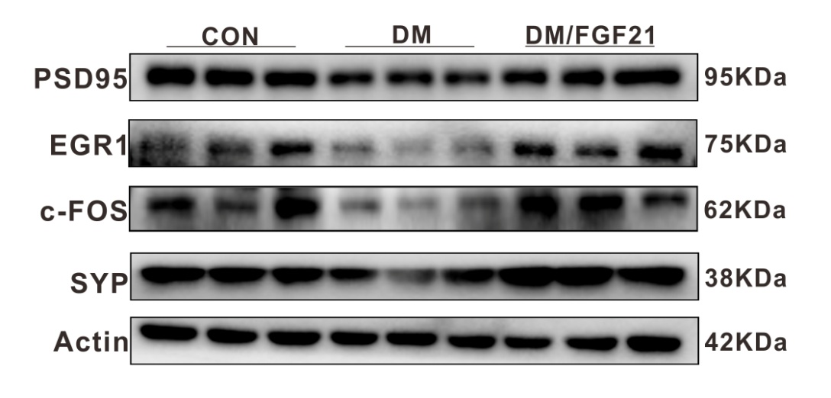

Fig. S1. Western blot determination of protein levels of PSD-95, EGR-1, c-Fos and synaptophysin (SYP) in the hippocampal extracts of the mice.

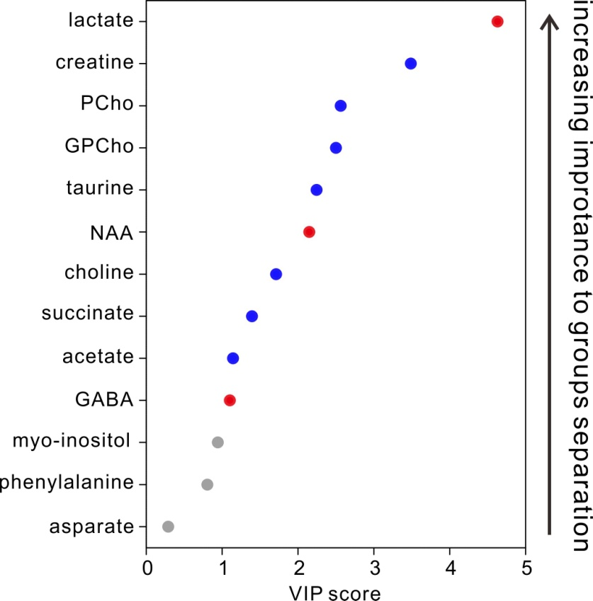
Fig. S2. VIP value rank of characteristic metabolites in the hippocampal extracts from the DM and FGF21 mice. The overall VIP score from PLS-DA shown in the figure was the average across all the selected components. The color of the VIP score plot can be used to identify the changing trend and contribution to the class separation. The grey color indicates that the metabolites with VIP < 1. The blue color indicates that the metabolites were close to the control level after FGF21 treatment, while the red suggests they are away from the control.

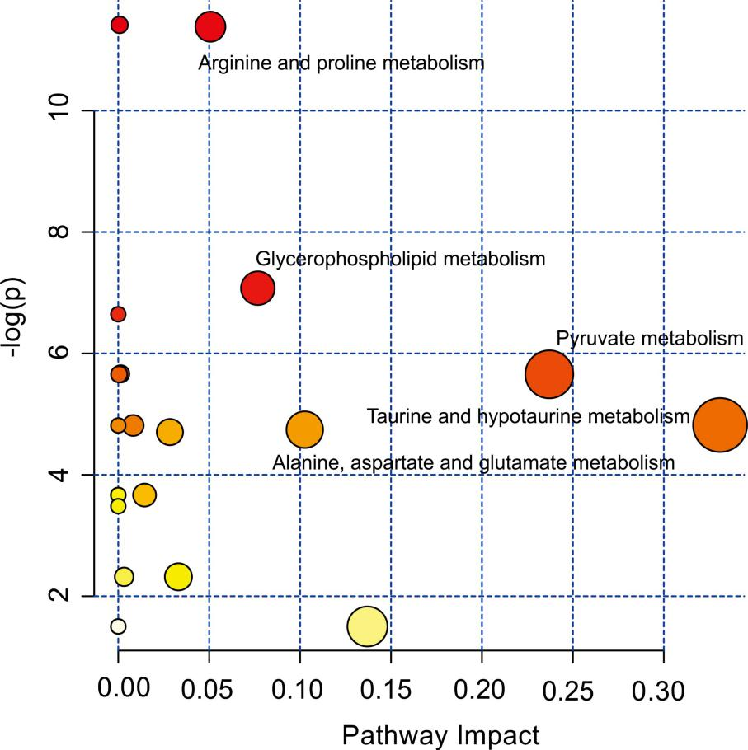

Fig. S3. Pathway impact of metabolisms in the hippocampal extracts from the DM and FGF21 mice. The main metabolic pathways was included pyruvate metabolism; taurine metabolism; alanine, aspartate and glutamate metabolism; glycerophspholipid metabolism; arginine and proline metabolism.

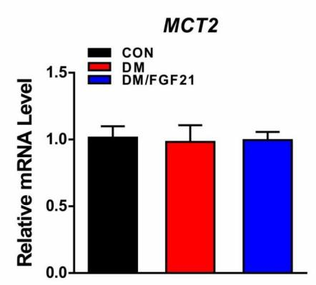
Fig. S4. RT-PCR determination of mRNA levels of MCT2 in the hippocampal extracts of the mice.

