Supporting Information
Fluctuating nanofluid environments induce prebiotic RNA formation in water, which in turn catalyzes polyaromatic semiconductor deposition
Andrea Greiner de Herrera,†‡§ Thomas Markert,∥ Frank Trixler*†§#
† Department of Earth and Environmental Sciences, Ludwig-Maximilians-Universität München, Theresienstraße 41, 80333 Munich, Germany.
‡ Center for Neuropathology and Prion Research (ZNP), Ludwig-Maximilians-Universität München, Feodor-Lynen-Str. 23, 81377 Munich, Germany.
§ School of Education, Technical University of Munich and Deutsches Museum, Museumsinsel 1, 80538 Munich, Germany.
∥ Institute of Theoretical Chemistry, Ulm University, Albert-Einstein-Allee 11, 89081 Ulm, Germany.
# Center for NanoScience (CeNS), Ludwig-Maximilians-Universität München, Schellingtr. 4, 80799 Munich, Germany.
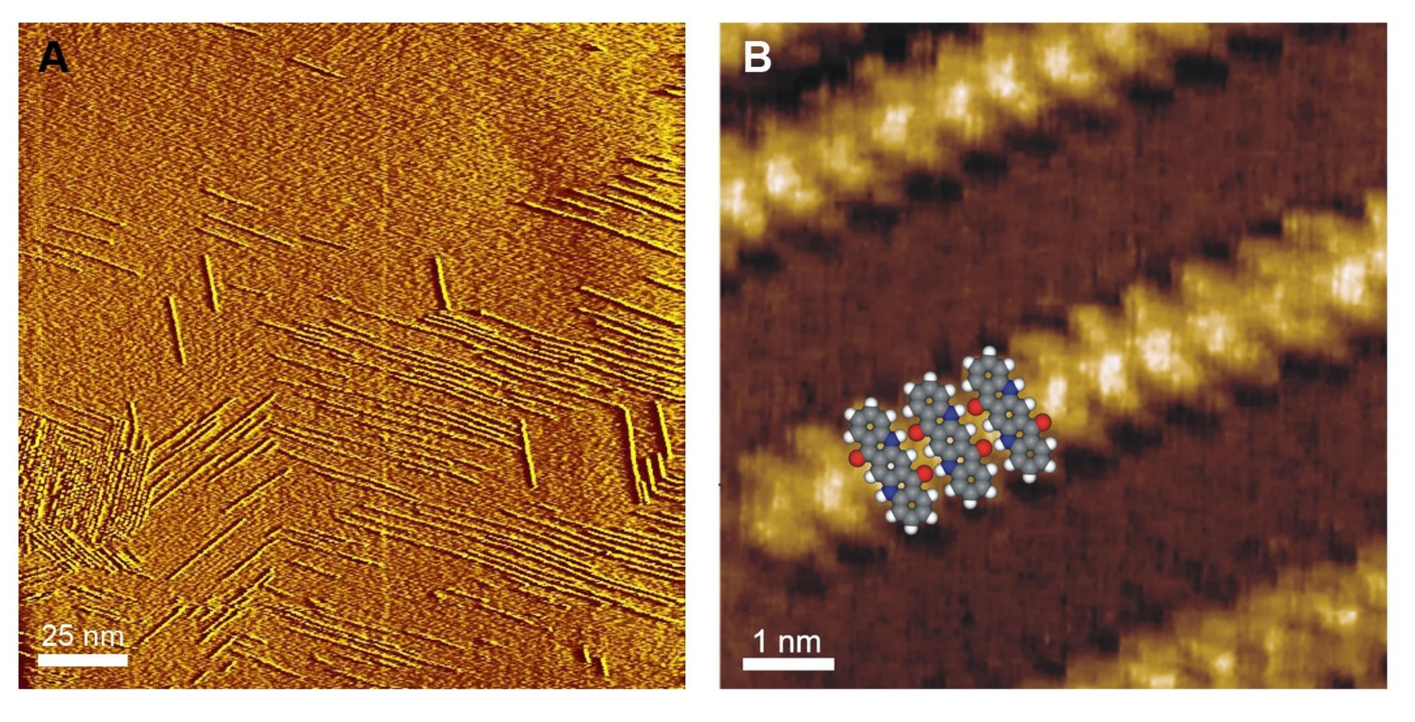
Figure S1. STM images of a graphite surface after OSWD processing. A, Chain-like supramolecular adsorbate structures formed via OSWD after the graphite surface contacts suspensions of QAC particles. B, Close-up view of a single supramolecular QAC adsorbate chain superimposed by a force field calculated assembly of three QAC molecules forming a linear chain via H-bonds.
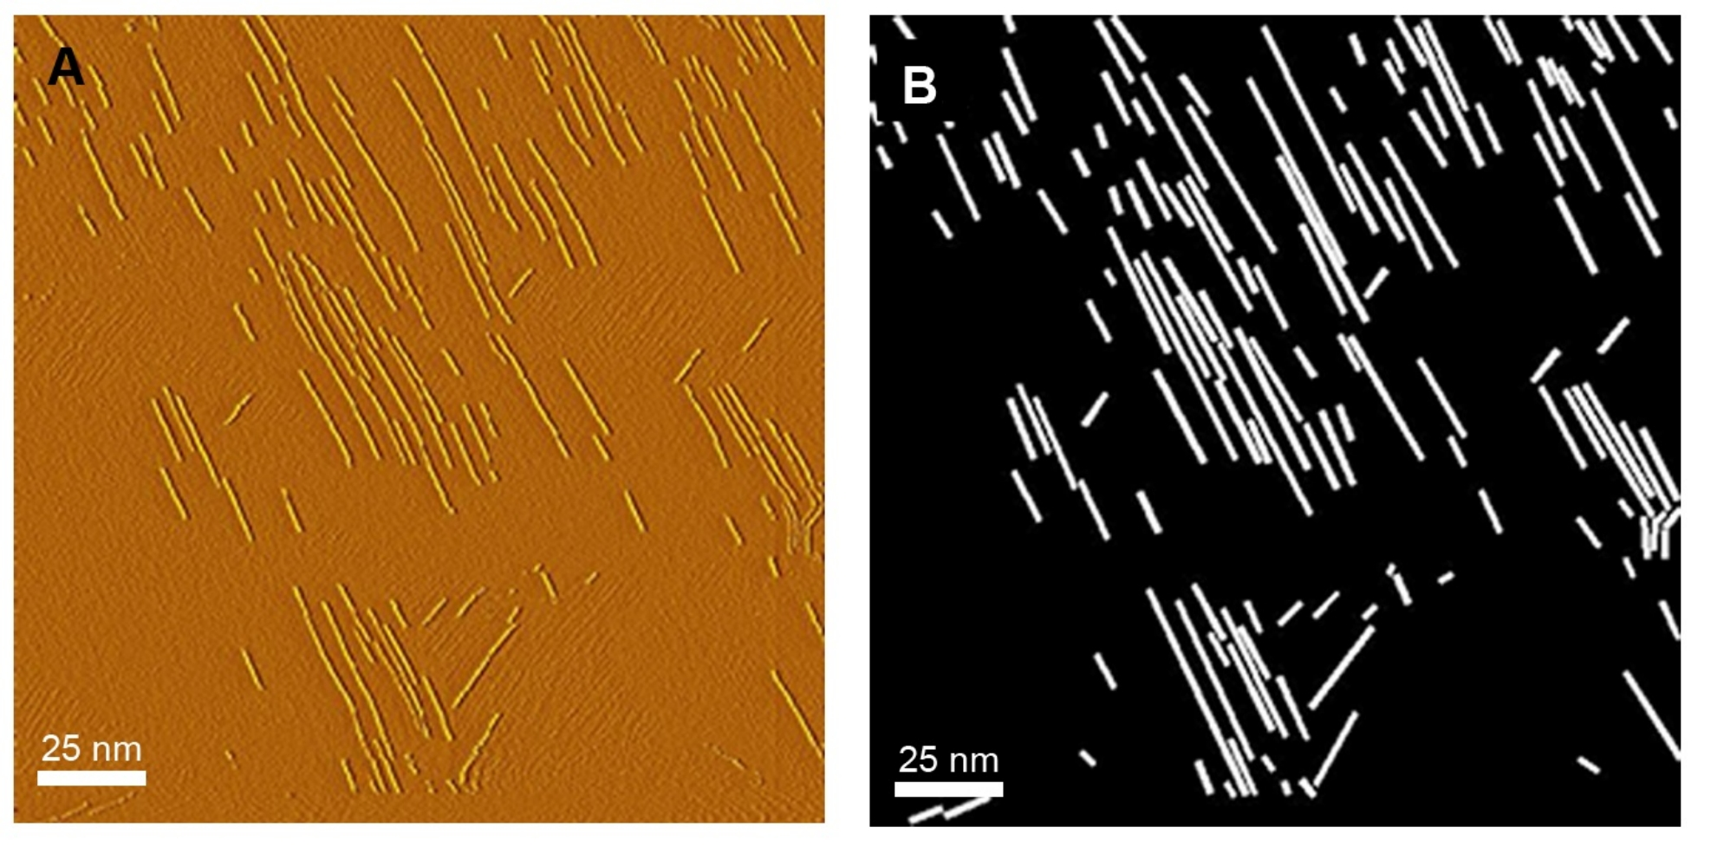
Figure S2. Example of a black/white conversion of STM images for coverage analysis. A, STM image of chain-like QAC assemblies on graphite. B, Black/white conversion of the STM image: QAC chains were masked out (white) and the background was set to black. The percentage of the white proportion (the QAC coverage) was subsequently calculated as described in the methods section.
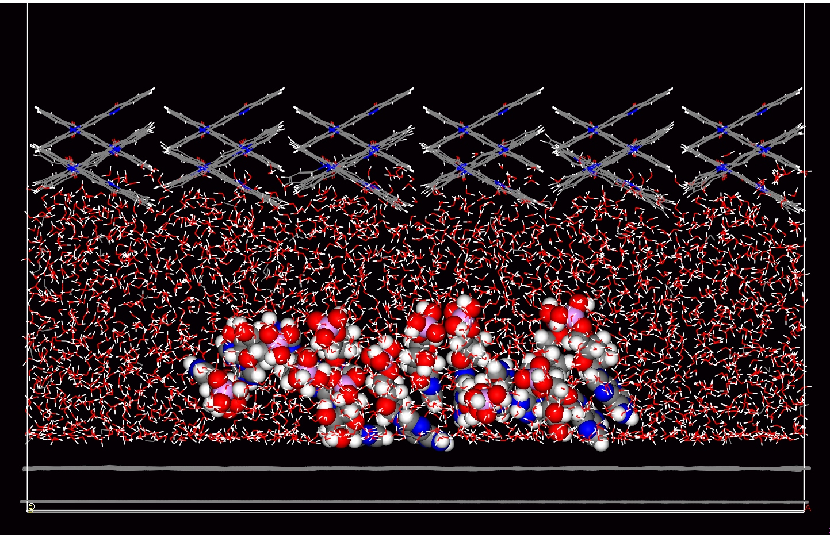
Figure S3. Dynamic force field calculation of an AMP stack within nanoconfined water. The simulation was modelled with a reduced confinement gap size of 2.6 nm between a QAC crystal (top) and a graphene layer (bottom). Displayed is the condition of the stack after a simulated time span of 60 ps, revealing a stack in destabilised, non-ordered condition.
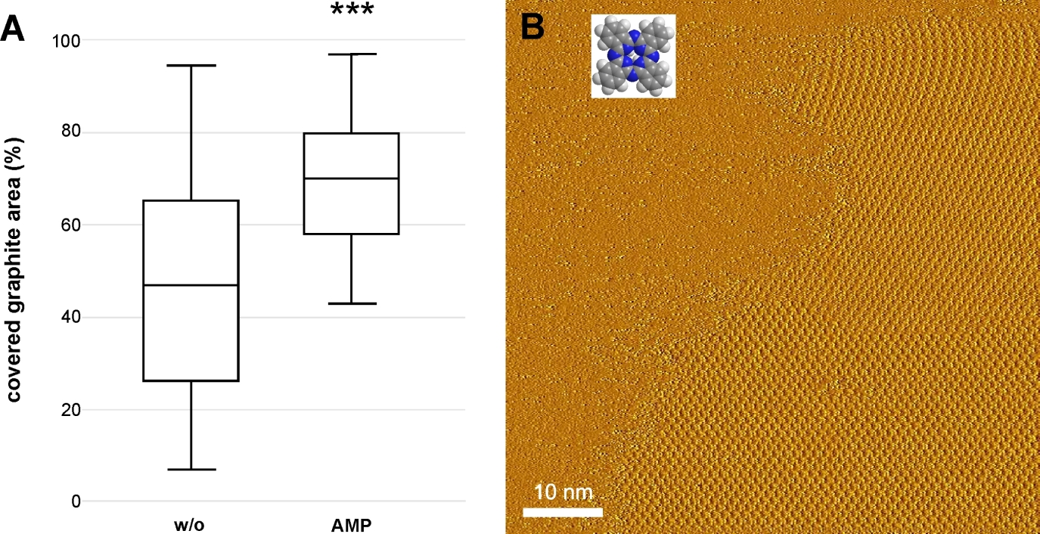

Figure S4. OSWD induced coverage of graphite with phthalocyanine monolayers that form after graphite has been brought into contact with a watery suspension of phthalocyanine particles. A, Box plots based on surface coverage determinations via STM. The suspensions either contain dissolved AMP or no biomolecules (w/o). Testing: t-test with Welch´s correction; n=30; ***: p<0.001. B, Example STM image of a typical monolayer domain showing a densely packed supramolecular pattern that matches well with the structure of phthalocyanine monolayer on graphite.⁴⁷ Inlay: molecular structure of a phthalocyanine molecule.
Supplementary Movie 1. Simulation of an AMP stack within a confinement filled with water. Simulated via dynamic force field calculation is a supramolecular stack of 12 AMPs confined between a QAC crystal (top) and a graphene layer (bottom). A gap of 43 Å separates these confining surfaces and is filled with water. The simulation represents a time span of 50 ps, and the final state of the stack at the end of the simulation is depicted in Fig. 4a.

Supplementary Movie 2. Simulation of an AMP stack within a confinement with a water density reduced to approximately 60%. The dynamic force field calculation simulates a supramolecular stack of 12 AMPs assembled in nanoconfined water. The modelling parameters are identical to those in Supplementary Video 1 with the exception of water density. The simulation represents a time span of 60 ps. The final configuration is shown in Fig. 4b.

