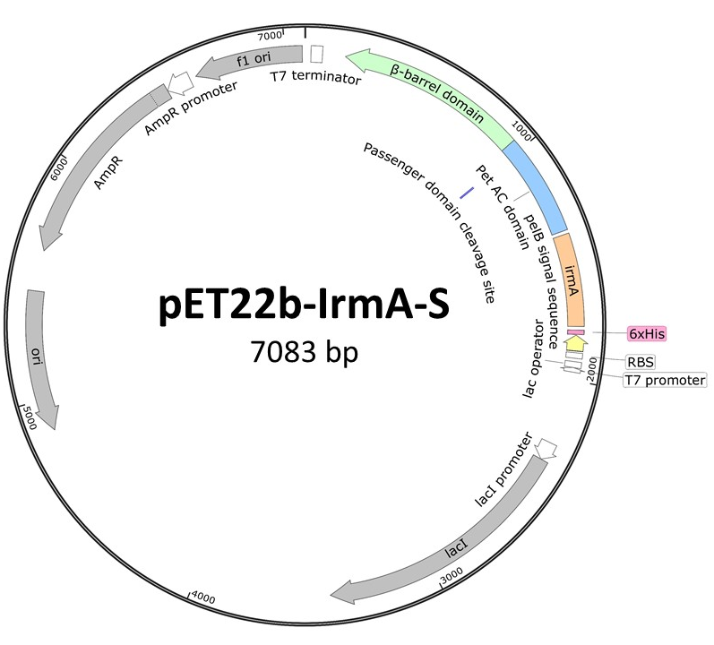
Figure S1: Plasmid map of pET22b-IrmA-S. The irmA gene sequence was amplified from a GSK plasmid and then subcloned into the NcoI and SbfI restriction sites in the pET22b plasmid that encoded the Pet autotransporter. The irmA was fused at the C-terminus to the Pet AC domain and at the N-terminus with a poly histidine tag and PelB signal sequence. The gene is transcribed from a T7 promoter upon IPTG addition. Upon autocatalytic cleavage at the passenger domain cleavage site, IrmA-S is released from the β-barrel domain. The Pet AC domain and α-helix portion fused to IrmA accounts for 15 kDa, IrmA-S molecular mass was therefore predicted to be 29.8 kDa. The plasmid map was created using SnapGene.

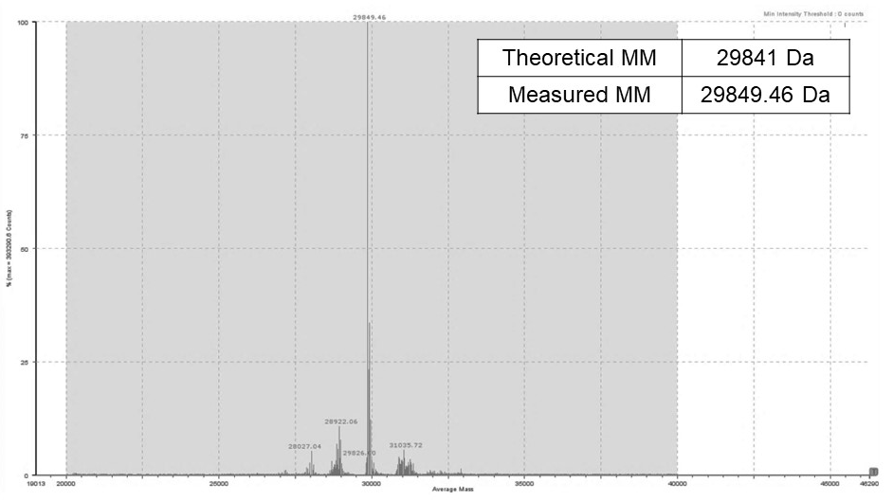
Figure S2: Mass spectrometry analysis of IrmA-S. The purified IrmA-S antigen has been analysed by mass spectrometry to measure the molecular mass of the protein sample. Measured molecular mass was compared with the theoretical value.

Table S1: Peptide score for IrmA-S
Coverage (%) | # Peptides | # AA | Score | Description
8.19 | 23 | 1295 | 661.76 | Serine protease (plasmid-encoded toxin Pet) [Escherichia coli 042]
75.50 | 11 | 151 | 144.08 | Hypothetical protein IrmA [Escherichia coli CFT073]

Table S2: Percentage yield from each processing step for IrmA-S.
Purification step | Yield (%)
TFF | 72
Affinity | 100
Desalting/Size exclusion | 91
Ion Exchange | 33

