Supplementary Information
The Strategy of Precise Targeting and In Situ Oxygenating for Enhanced Triple-Negative Breast Cancer Chemophototherapy Manxiang Wu^{1,2†}, Tianxiang Chen^{2†}, Lianfu Wang¹, Ozioma Udochukwu Akakuru², Xuehua Ma², Jinshan Xu¹, Jiapeng Hu^{2,3}, Jia Chen⁴,Qianlan Fang², Aiguo Wu^{2*}, Qiang Li^{1*}
1. Department of Radiology, The Affiliated People’s Hospital of Ningbo University, Ningbo, 315100, China.
2. Cixi Institute of Biomedical Engineering, International Cooperation Base of Biomedical Materials Technology and Application, Chinese Academy of Science (CAS) Key Laboratory of Magnetic Materials and Devices, Zhejiang Engineering Research Center for Biomedical Materials, Ningbo Institute of Materials Technology and Engineering, CAS, 1219 Zhongguan West Road, Ningbo 315201, P. R. China. Advanced Energy Science and Technology Guangdong Laboratory, Huizhou 516000, P.R. China
3. University of Chinese Academy of Sciences, Beijing, 100049, PR China
4. School of Life Science and Engineering, Southwest Jiaotong University, Chengdu, 610031, China.
* Corresponding Authors
E-mail addresses: rmliqiang@nbu.edu.cn (Qiang Li), aiguo@nimte.ac.cn ( Aiguo Wu)
† These authors contributed equally.

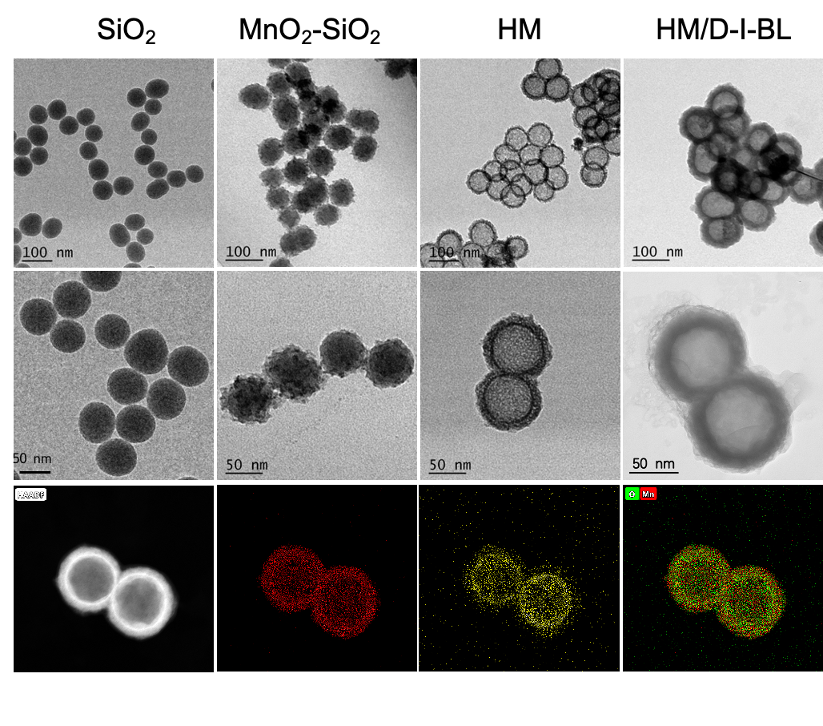
Fig. S1 STM images of SiO₂, MnO₂-SiO₂, HM and HM/D-I-BL; HAADF-STEM image and elemental mapping for HM.

Fig. S2 (A) Mn 2p and (B) O 1s XPS spectrum of HM.

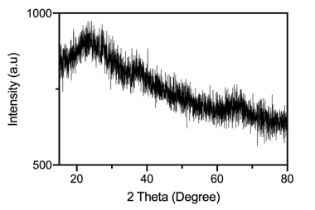
Fig. S3 XRD result of HM.

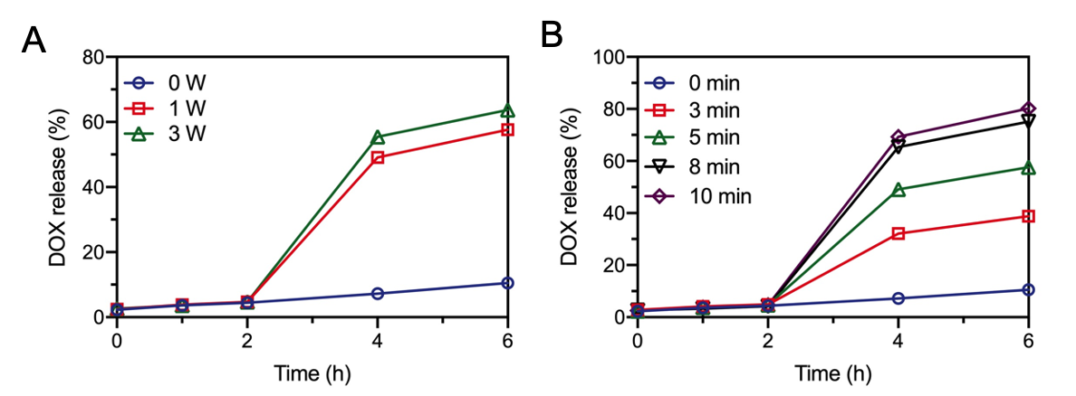
Fig. S4 The influence of different laser irradiation parameters on DOX leakage. (A) The influence of laser irradiation power on DOX leakage; (B) The influence of laser irradiation time on DOX leakage (808nm laser, 1W/cm², 5min).

Figure S5. The O₂ generation image of HM/D-I-BL solutions under different PH values with or without laser irradiation.

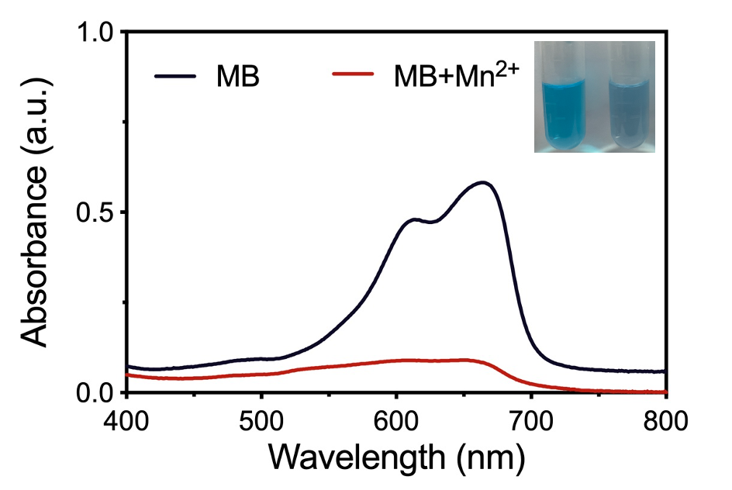
Fig. S6 UV–Vis absorbance spectra and photographs of MB solution in the presence and absence of 0.2mmol/L Mn²⁺ for 30 min. The decreased UV absorbance and faked color indicated the Fenton-like activity.

Fig. S7 The T1 weighted mapping result of HM/D-I-BL solutions under different PH values with or without GSH.

Fig. S8 In vitro infrared thermal images of different solutions after treated with deionized water, ICG and HM/D-I-BL plus laser irradiation (808nm, 1W/cm²). (B) The temperature changes of different solutions after laser irradiation.

Fig. S9 H&E staining of the major organs from 4T1-bearing mice after different treatments. The bar indicates 20 μm.

