A Prospective Cohort Study providing Insights for Markers of Adverse Pregnancy Outcome in Women of Advanced Maternal Age

Samantha C. LEAN, Maternal and Fetal Health Research Centre, Division of Developmental Biology and Medicine, Faculty of Biology, Medicine and Health, University of Manchester, UK. sl961@cam.ac.uk

Rebecca L. JONES, Maternal and Fetal Health Research Centre, Division of Developmental Biology and Medicine, Faculty of Biology, Medicine and Health, University of Manchester, UK. rebecca.lee.jones@manchester.ac.uk

Stephen A. ROBERTS, Centre for Biostatistics, Faculty of Biology, Medicine and Health, University of Manchester, UK. steve.roberts@manchester.ac.uk

Alexander E.P. HEAZELL, Maternal and Fetal Health Research Centre, Division of Developmental Biology and Medicine, Faculty of Biology, Medicine and Health, University of Manchester, UK
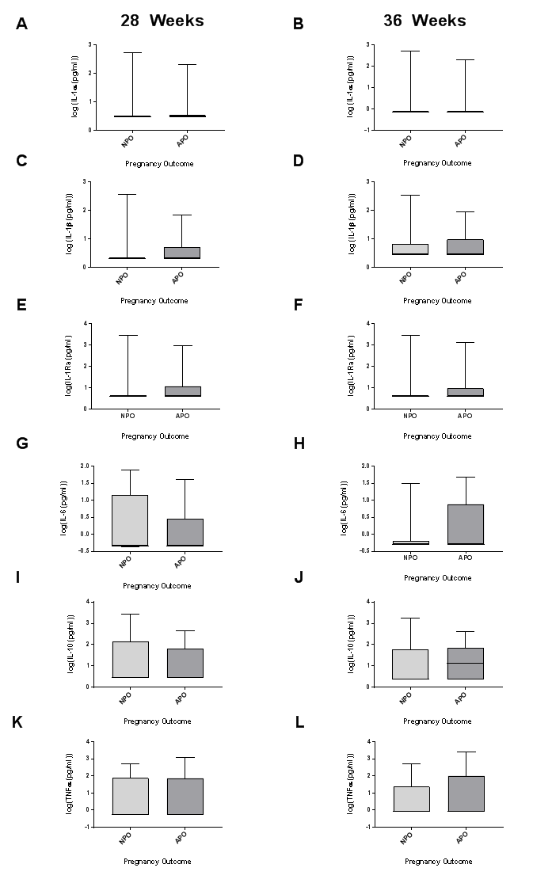
Supplementary Figure 2: Circulating inflammatory markers in women of advanced maternal age with normal and adverse pregnancy outcome, n=43/group. Maternal serum at 28 weeks (A, C, E, G, I, K) and 36 weeks (B, D, F, H, J, L) gestation were quantified for: (A-B) interleukin (IL)-1α (C-D) IL-1β (E-F) IL-1Ra (G-H) IL-6 (I-J) IL-10 and (K-L) TNFα. Data are logarithmic transformed mean ± SEM, unpaired t-test.

