Supplemetal Information

Materials and methods
Mouse strains
Hectd3^{-/-} mice were generated by Taconic Farms, Inc (TF2706, TACONIC KNOCKOUT REPOSITORY), with an 129/SvEv and C57BL/6 Chimeric background as mentioned in our previous study ⁵⁶ . Chimeric offspring were backcrossed to FVB genetic background for eleven generations, then mated to FVB/N-Tg (MMTV-NEU)202ML/J mice (Jackson Laboratories, Bar Harbor, ME, USA) to generate MMTV-Neu;Hectd3^{-/-} mice and MMTV-Neu;Hectd3^{+/+} mice for analysis of tumor incidence and lung metastasis. The Hectd3 deficiency mice with FVB genetic background were also used to generate Hectd3^{-/-} and Hectd3^{+/+} mice for analysis of lung metastasis after tail vein injection of PyMT lentivirus-induced breast tumor cells, and lung and heart metastasis after removal of the orthotopic allograft PyMT lentivirus-induced breast tumor. Chimeric offspring were backcrossed to BALB/c genetic background for nine generations or C57BL/6 genetic background for eight generations to generate Hectd3^{-/-} mice and Hectd3^{+/+} mice for the similar tumor metastasis experiments using 4T1-Luc2 breast cancer cells or B16-F10 melanoma cells. The loxP-Stop-loxP-Hectd3^{KI}-GFP C57BL/6 strain mice were generated by inserting the targeting sequence of CAG Pr-loxP-Stop-loxP-Hectd3 CDS-P2A-eGFP-WPRE-pA at Rosa26 site by using the EGE system based on CRISPR/Cas9 developed by Beijing Biocytogen Co., Ltd. The Stop sequence is flanked by two lox P sites. Followed the second lox P site is a Hectd3 CDS-P2A-eGFP-WPRE-pA expression element. The targeted allele was driven by chicken β-actin promoter and inserted into the Rosa26 allele in C57BL/6 background. The loxP-Stop-loxP-Hectd3^{KI}-GFP mice were crossed with Tie2-Cre or CMV-Cre mice to generate the knockin (KI) mice, which allows specific overexpression of Hectd3 and GFP in the endothelium, or the whole body. These KI mice were confirmed for analysis of lung metastasis after tail vein injection of B16-F10 melanoma cells. All littermate used for tumor analysis above were virgin females. All mice were kept in specific pathogen-free (SPF) conditions at the Animal Resource Center of Kunming Institute of Zoology, Chinese Academy of Sciences. All animal experiments were conducted in accordance with the guidelines and were approved by the Kunming Institute of Zoology, Chinese Academy of Sciences Animal Care and Use Committee.

Intraductal injection of lentivirus overexpressing PyMT to induce breast tumor
Wild type FVB female mice were anesthetized, mammary ducts were exposed by cutting nipple ends, and a 50 μl microsyringe was used to inject 10 μl viral concentrate of lentivirus overexpressing PyMT and GFP (FUCGW-PyMT-GFP lentivirus) into the ductal lumen of glands #4. Two weeks later, the PyMT-induced breast tumors were examined by palpation of mammary glands if the injection was successful. Resected the tumor and digested it to single-cell suspension using collagenase type Ⅲ (Worthington-biochem, NJ, USA) and hyaluronidase (Sigma-Aldrich, MO, USA), which was applied to tail vein injection or orthotopic allograft transplantation.

Spontaneous Metastasis Assay
WT and Hectd3^{-/-} mice with FVB or BALB/c genetic background received mammary fat pad transplantation of 1×10⁵ PyMT-induced breast tumor cells or 4T1-Luc2 cells suspended in 75 μl mixture of PBS and Matrigel (1:1; BD Biosciences, CA, USA). When tumor volume reached 0.5 cm³ (PyMT-induced tumor) or 12 day after transplantation (4T1-Luc2 tumor), surgical resection was operated to remove the tumors. In PyMT-induced tumor cell experiments, the lung and heart metastasis were record when mice being natural mortality or sacrificed 2 months after removal of tumor. In 4T1-luc2 experiment, bioluminescence imaging 4T1-Luc2 tumor burden on day 1 before the tumor resection and tumor metastatic burden was monitored weekly by IVIS imaging after tumor removal.

Immunoblotting analysis and antibodies
Protein samples were separated by 11 % SDS-PAGE and followed by electrophoretic transfer onto PVDF membranes and blocked with 5 % non-fat milk and further incubated overnight in primary antibody (dilute 1:500-5000 in 3 % BSA) at 4 ℃ as described previously [56]. The following primary antibodies were used: anti-E-selectin (sc-137054), anti-ICAM-1 (sc-8439), anti-VCAM-1 (sc-8304), anti-HA (SC-805) and anti-GAPDH (sc-25778) Abs were purchased form are from Santa Cruz Biotechnology, California. The anti-p65 (8242), anti-p-p65(3033), anti-IκBα (9242), anti-p-IκBα (9246), anti-p-IKKα/β (2078), anti-IKKα (2682), anti-IKKβ (2684), anti-NEMO (2685) anti-p-H3(Ser10)(3377), anti-H3 (4499), anti-Lamin B1(13435), anti-K48 Ub (8081), anti-K63 Ub (5621), and HRP-labeled anti-rabbit, anti-mouse or anti-goat secondary antibodies were purchased from Cell Signaling Technology( CST, MA, USA). The anti-GST (G7781) and anti-FLAG (F3165) antibodies were from Sigma-Aldrich. The anti-Ub (04-263) Ab was from Millipore(MA, USA). The anti-K27 Ub Ab (ab181537) was from Abcam (MA, USA). The anti-tubulin Ab (11224-1-AP) was from Proteintech (IL, USA). The anti-GFP Ab (11814460001) was from Roche (Basel, Switzerland). Then anti-HECTD3 Ab was previously described ⁵² .

siRNAs
Small interfering RNA (siRNA) for human genes was synthesized by Guangzhou RiboBio Co., LTD as follows: HECTD3-specific siRNA (1#: sense, GCG GGA ACU AGG GUU GAA Utt; 2#: sense, GGU AUU UCA CCU CUU AAG Att), IKKα-specific siRNA (sense, GCA GGC UCU UUC AGG GA CAtt), p65-specific siRNA (sense, GCC CUA UCC CUU UAC GUC Att), E-selectin-specific siRNA (sense, CAA CAA UAG GCA AAA AGA Utt), ICAM-1-specific siRNA (sense, AGU CAA CAG CUA AAA CCU Utt), VCAM-1-specific siRNA (sense, GGA GUU AAU UUG AUU GGG Att). siRNA oligonucleotides were transfected in HUVEC cells with Lipofectamine 2000 (Invitrogen, CA, USA) according to the manufacturer’s instructions.

Mouse ECs isolation and culture
Lung tissues from WT and Hectd3^{-/-} mice were removed aseptically, rinsed in 1× PBS, minced into≈1×1mm squares, and digested in 10 ml of collagenase A (1 mg/ml, Worthington-biochem) at 37 ℃ for 45 minutes with occasional agitation. The cellular digest was filtered through sterile 31 μm cell strainer (BD Falcon), centrifuged at 500 g for 10 minutes, and wash twice in DMEM with 5 % FBS. The cell pellet was resuspended in 1 ml of 5 % FBS-DMEM. Dynabeads (Dynal AS) coated with sheep anti-rabbit IgG were incubated in 1 ml of anti-mouse CD31 (MEC13.3) (BD bioscience) supernatant at 4 ℃ overnight and then washed three times with 5 % FBS-DMEM; 1 ml of cell suspension was incubated with the washed beads at 4 ℃ for 30 minutes, washed three times with 5 % FBS-DMEM and once FBS-free DMEM, and then digested for 5 minutes at 37℃ in 1 mL of trypsin/EDTA (Gibco/Invitrogen) to release the beads. The bead-free cells were centrifuged and resuspended in 10 ml of EBM-2 medium (Lonza, Basel, Switzerland).

Cells culture and lentivirus infection
HUVEC cells were cultured in EBM-2 medium, HCC1937-GFP cells was cultured in RPMI1640 medium with 5 % FBS, MDA-MB-231-GFP and Jurkat-GFP was cultured in DMEM/F12 medium with 5 % FBS, MDA-MB-468-GFP was cultured in DMEM medium with 5% FBS. Human WT HECTD3 and HECTD3 C823A, WT IKKα and IKKα mutants were cloned into the lentiviral expression vector pCDH-CMV-MCS-EF1-Puro, and sgRNA sequences for IKKα (sgIKKα 3#: 5’-GGC CCT GGG AGA TGC GGG AG-3’) and GFP (sgGFP: 5’-GTC GCC GTC CAG CTC GAC C-3’) were cloned into lentiCRISPR-v2 vector. The viral particles were prepared by transfecting HEK293T cells with the constructed plasmids or control plasmids in combination with packaging vectors. Twelve hours later, media was replaced with fresh complete DMEM. Viral supernatant was harvested and passed through 0.45 µm syringe filter at 48 and 72 hours after transfection. To establish stably infected cells, HUVECs were infected with lentivirus as indicated in the presence of polybrene (8 µg/ml) for 12 hours and selected further in the presence of puromycin (0.2 µg/ml).

Adhesion assay in vitro
To quantify tumor cell adhesion to HUVECs, a standardized cell adhesion assay was performed. Before coculture with tumor cells, HECTD3 or p65 were knocked down with siRNA in HUVECs seeded in 6-well plate, and treated with LPS (300 ng/mL) for 4 hours. Suspended GFP-labeled tumor cells (HCC1937-GFP, MDA-MB-231-GFP, MDA-MB-468-GFP and Jurkat-GFP) (2 × 10⁵ cells per dish) ware added to the confluent monolayer-cultured HUVECs and cocultured for 1 h. The cells were washed three times with PBS gently to remove non-adherent tumor cells, then fixed with 4 % (wt/vol) paraformaldehyde. The number of adhering GFP positive cells in the fixed plate was counted by using images obtained with a fluorescence microscope (Nikon).

Immunofluorescence staining and microscopy
For IKKα and Flag immunostaining, LPS treated and untreated HUVECs were fixed in 4 % paraformaldehyde for 15 min at room temperature. Cells were washed with 1×PBS, blocked in 5 % BSA buffer with 0.1 % saponin for 1 h. The cells were stained with anti-IKKα (CST, 2682) at 1:300 dilution or anti-Flag (Sigma-Aldrich, F7425) at 1:500 dilution, overnight at 4 ℃. The cells were washed, stained with fluorescence conjugated secondary antibody for 1h at room temperature, nuclear was staining by Hoechst (Invitrogen), and mounted using mounting medium (Vector Laboratories, H-1200). The cells were observed on the Olympus FluoView 1000 confocal microscope (Olympus) for image acquisition and data analysis.

Co-immunoprecipitation and GST Pull-down
HECTD3 and IKKα were cloned into pCDH-CMV-MCS-EF1-puro-3×Flag or pLenti6 vector. Truncated mutants of HECTD3 and IKKα were cloned into pEBG-GST vector. Lipofectamine 2000 reagents (Invitrogen) were used for transient transfection of plasmids into HEK293T cells. For immunoprecipitation (IP), whole HEK293T cells collected 48 h post-transfection, HUVECs and HUVECs overexpressed Flag-HECTD3 were lysed in Pierce IP lysis buffer composed of 1.0 % (vol/vol) NP-40, 25 mM Tris-HCl pH 7.4, 1 mM EDTA, 150 mM NaCl, 5 % glycerol (vol/vol) and protease/phosphatase inhibitor cocktails (Sigma-Aldrich). After centrifugation, supernatants were collected and incubated with Flag-M2 beads (Sigma-Aldrich, F3165) or protein A/G Plus-Agarose (Santa Cruz, SC-2003) and 5 μl of the IKKα antibodies (CST, 2682) for 6 h at 4 ℃, followed by washing five times with Pierce IP lysis buffer. For GST pull-down, whole HEK293T cells collected 48 h post-transfection were lysed in Pierce IP lysis buffer. GST fused proteins were pulled down with glutathione sepharose 4B beads(GE Healthcare, Uppsala, Sweden). Immunoprecipitated or pull-down components were eluted by boiling in the 1 % (wt/vol) SDS buffer (60 mM Tris-HCl (pH 6.8), 1 % (wt/vol) SDS, 5 % (vol/vol) glycerol, trace bromophenol blue and 1 % (vol/vol) 2-mercaptoethanol) for 10 minutes. For immunoblotting analysis, immunoprecipitated samples and input lysates were separated by SDS-PAGE, followed by transferring onto PVDF membranes and detected by specific antibodies.

Ubiquitination analysis
For polyubiquitination analysis of IKKα in HEK293T cells, the cells were transfected with plasmids expressing WT HECTD3 or inactivated mutant HECTD3 C823A, HA-ubiquitin (WT, K6 only, K11 only, K27 only, K29 only, K33 only, K48 only, K63 only, or K0), and Flag-IKKα (WT and mutants). Whole cell extracts were immunoprecipitated with the Flag-M2 beads and analyzed by immunoblotting with anti-HA and specific antibodies. For polyubiquitination analysis of endogenous IKKα in HUVECs, HUVECs overexpressed Flag-Ub were transfected with siRNA targeting HECTD3 for 36 h, and whole cell extracts were immunoprecipitated with the Flag-M2 beads and analyzed by immunoblotting with anti-HA and specific antibodies. For In vitro polyubiquitination analysis of IKKα, we assembled the reaction in vitro with all purified components, including Mg-ATP (25 μM), HA-Ub (200 ng), E1 (100 ng), UbcH5b (200 ng), HECTD3 or HECTD3 C823A (500 ng) and Flag-IKKα as substrate in 40 μl ubiquitin conjugation reaction buffer. GST fused HECTD3 and HECTD3 C823A were purified from E. coli BL21 (DE3) with glutathione sepharose beads, and GST was removed by digestion using 3C protease. Flag-IKKα was purified from HEK293T cells transfected plasmid encoding Flag-IKKα using Flag-M2 beads. Other components were purchased from Boston Chem. Reactions were incubated for 1 h at 37℃ and stopped with standard SDS-PAGE loading buffer (β-mercaptoethanol containing). The samples were analyzed by immunoblotting with specific antibodies.

Kinase assays in vitro
Flag-IKKβ, Flag-IKKα and its mutants Flag-IKKα K296R and S176/180A were cloned into pCDH-CMV-MCS-EF1-puro-3×Flag vector. The plasmids were transfected in HEK293T cells with Lipofectamine 2000. After 36 h, cell extracts were immunoprecipitated with anti-Flag M2 beads. Histone H3 and IκBα were cloned into pGEX-6p-1 vector and transduced into DE3 (BL21) E.coli. GST- H3 and GST-IκBα proteins were purified with glutathione sepharose beads. Briefly, the immunoprecipitates were incubated with GST-H3 or GST-IκBα in the kinase reaction buffer which contains 20 mM HEPES at pH 7.5, 10 mM MgCl₂ , 20 mM b-glycerophosphate, 10 mM PNPP, 50 mM Na₃VO₄ , 1 mM DTT, 20 mM ATP, and at 30℃ for 30 min. The products were subjected to SDS-PAGE and immunoblotting with anti-p-H3(Ser10) antibody or anti-p-IκBα(Ser32/36) antibody.

Real-Time quantitative PCR
Total RNA was isolated from tissues or cells using Trizol (Invitrogen) and purified by RNeasy Mini Kit (QIAGEN), cDNA was reverse transcribed by using iScript cDNA Synthesis Kit (Bio-Rad, CA, USA). Primers were designed according to the published sequences and listed as follows: (human) E-selectin: forward 5’-CTG GCT TCG GAA ATG CTT AC-3’, reverse 5’-CCA GAG ACC CGA GGA GAG TT-3’; ICAM-1: forward 5’-GAG CAC TCA AGG GGA GGT C-3’, reverse 5’-CAT TAT GAC TGC GGC TGC TA-3’; VCAM-1: forward 5’-GAA CCC AAA CAA AGG CAG AG-3’, reverse 5’-GGA TTT TCG GAG CAG GAA AG-3’; 18S: forward 5’-CGC CGC TAG AGG TGA AAT TCT-3’, reverse 5’-CGA ACC TCC GAC TTT CGT TCT-3’; GAPDH: forward 5’-GGT GAA GGT CGG AGT CAA CG-3’, reverse 5’-TGG GTG GAA TCA TAT TGG AAC A-3’; HECTD3: forward 5’-ACC GTT CTC GTT TCA TCC AA-3’, reverse 5’-GGT ACC ACC TTC AGC AGA CC-3’; IKKα: forward 5’-CAA ATG AGG AAC AGG GCA AT-3’, reverse 5’-CTT CCA TAG GTT TGG GGA CA-3’; (mouse) E-selectin: forward 5’-TGA CATC GTC CTC ATT GCT C-3’, reverse 5’-CAA ACG ATT GAA GGC TTT GG-3’; Icam-1: forward 5’-TAC GTG TGC CAT GCC TTT AG-3’, reverse 5’-CCT TGA GTT TTA TGG CCT CCT C-3’; Vcam-1: forward 5’-ACG AGG CTG GAA TTA GCA GA-3’, reverse 5’- GAC GGT GTC TCC CTC TTT GA-3’; Hectd3: forward 5’-TGA CCA GTG GTG GAA TGT A-3’, reverse 5’-TGA CAT ATC TGC CAG GCT GT-3’; GFP: forward 5’-ACG ACG GCA ACT ACA AGA CC-3’, reverse 5’-GTC CTC CTT GAA GTC GAT GC-3’. Primers for ChIP as followed: (human) E-selectin: forward 5’- CGG GAA AGT TTT TGG ATG C-3’, reverse 5’- GAG GGA TTG CTT CCT GTG AA -3’; ICAM-1: forward 5’- GGG GCG GGA ATT CAG AAC-3’, reverse 5’- GCC ATC CAG AGA CGC ATA TT -3’; VCAM-1: forward 5’- TTG GCT GGG TGT CTG TTA AA -3’, reverse 5’- TAA AGG GTC TTG TTG CAG AGG -3’. Real-time qPCR was performed on the 7900HT fast real-time PCRsystem (Applied Biosystems) with SYBR Green Select Master mix (Applied Biosystems). Data were normalized based on the 18S or GAPDH expression levels.

Statistical analysis
Data are given as mean±SEM. Statistical analyses were performed using two-tailed t-test, two-way ANOVA, Log-rank test or Chi-square test. P values ≤ 0.05 were considered significant.

Supplemental Figures
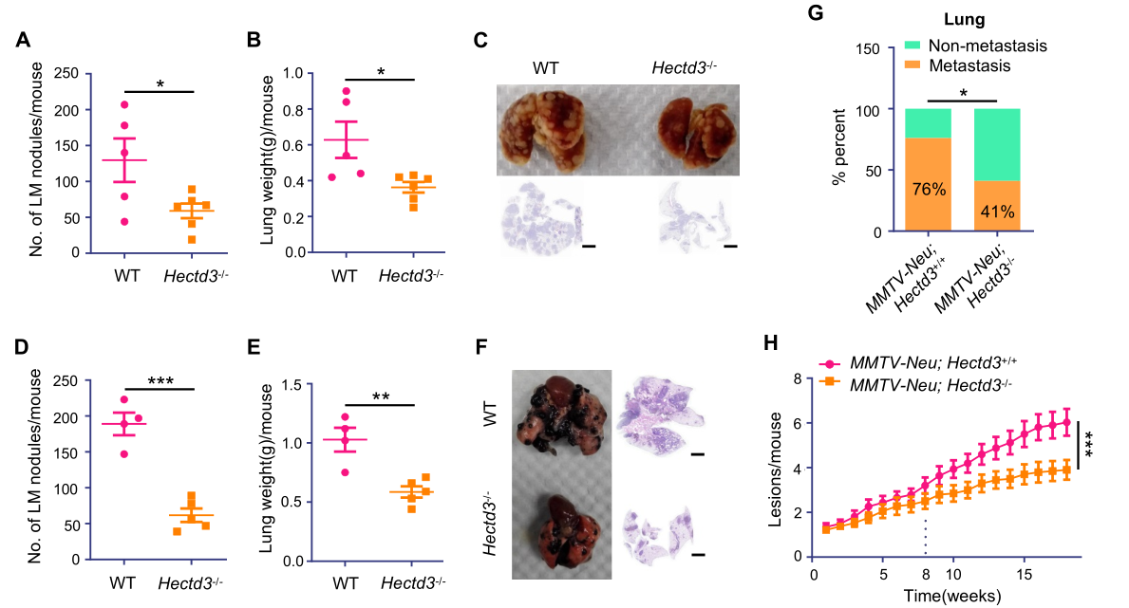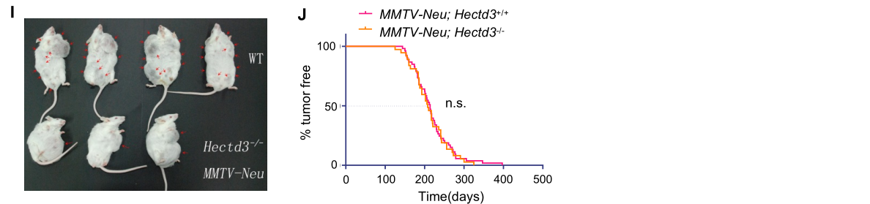
Supplemental Figure 1. Hectd3 knockout inhibits tumor metastasis in different mouse models.
- Hectd3 KO decreased lung metastasis of 4T1-Luc2 breast tumor cells. 4T1-Luc2 cells were injected by tail vein into WT (n=5) and Hectd3^{-/-} (n=6) BALB/c mice (1×10⁵ per mouse) which were pretreated with LPS (1 mg/kg) intravenous injection for 5 h. The mice were sacrificed 20 days after tumor cell injection. Graph shows the number of pulmonary metastasis nodules in each group mice.
- The weight of whole lung with 4T1-Luc2 metastasis nodules in each group mice.
- Representative images of lung metastasis nodules of 4T1-Luc2 and corresponding H&E staining of lungs.
- Hectd3 KO decreased lung metastasis of B16-F10 melanoma tumor cells. B16-F10 cells were injected by tail vein into WT (n=4) and Hectd3^{-/-} (n=5) C57BL/6 mice (1×10⁵ per mouse) which were pretreated with LPS (1 mg/kg) intravenous injection for 5 h. The mice were sacrificed 20 days after the tumor cell injection. Graph shows the number of pulmonary metastasis nodules in each group mice.
- The weight of whole lung with B16-F10 metastasis nodules in each group mice.
- Representative images of lung metastasis nodule of B16-F10 and corresponding H&E staining of lung.
- A comparison of the incidence of lung metastases of MMTV-Neu;Hectd3^{+/+} (n=41) versus MMTV-Neu;Hectd3^{-/-}(n=32).
- Breast tumor lesions of MMTV-Neu;Hectd3^{+/+} (n=32) mice versus MMTV-Neu;Hectd3^{-/-} (n=20) mice over time. Mice were examined weekly for tumor onset and tumor lesions by palpation of all 10 mammary glands.
- Representative images of MMTV-Neu;Hectd3^{+/+} mice versus MMTV-Neu;Hectd3^{-/-} mice carrying tumors in 18th week after tumor onset.
- The tumor incidence of MMTV-Neu;Hectd3^{+/+} (n=53) mice and MMTV-Neu;Hectd3^{-/-} (n=37) mice.
Data are presented as mean±SEM, and statistics were calculated using two-tailed t-test for A, B, D and E, Chi-square test for G, two-way ANOVA for H and Log-rank test for J. *, P<0.05; **, P<0.01; ***, P<0.001; n.s., not significant. Scale bars, 2 mm for C and F.

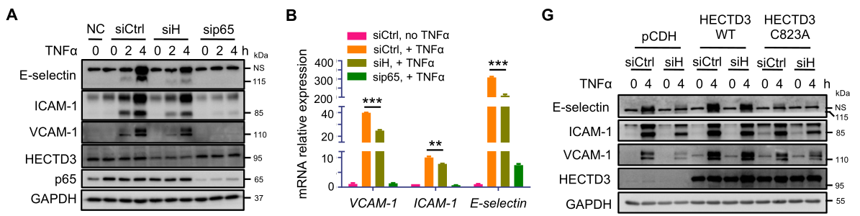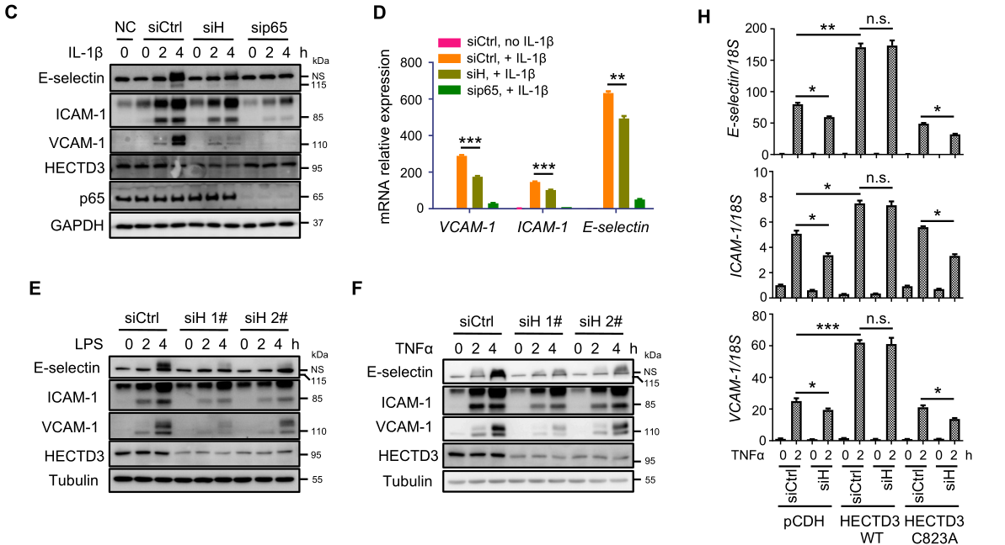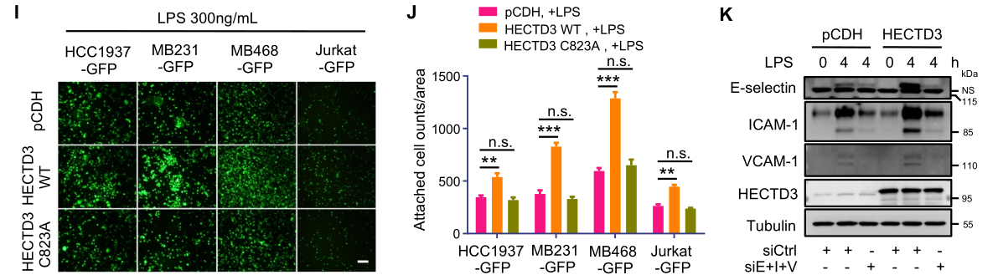

Supplemental Figure 2. HECTD3 promotes the adhesion of tumor cells to HUVECs by upregulating E-selectin, ICAM-1 and VCAM-1 expression in HUVECs.
- HECTD3 knockdown decreased TNFα-induced protein expression of adhesion molecules, including E-selectin, ICAM-1 and VCAM-1 in HUVECs. HECTD3 or p65 were knocked down using corresponding siRNA for 36 h. HUVECs were stimulated with or without TNFα (10 ng/ml) for 0-4 h. siControl (siCtrl) was used as a negative control. sip65 was used as a positive control. siHECTD3 (siH) was a siRNA pool containing siHECTD3 1# and 2#.
- HECTD3 knockdown decreased TNFα-induced mRNA expression of adhesion molecules, including E-selectin, ICAM-1 and VCAM-1 in HUVECs. qRT-PCR was used to analyze the mRNA levels of adhesion molecules. TNFα (10 ng/ml) stimulated the cells for 2 h.
- HECTD3 knockdown decreased IL-1β-induced protein expression of adhesion molecules, including E-selectin, ICAM-1 and VCAM-1 in HUVECs. HECTD3 or p65 were knocked down using corresponding siRNA for 36 h. HUVECs were stimulated with or without IL-1β (20 ng/ml) for 0-4 h.
- HECTD3 knockdown decreased IL-1β-induced mRNA expression of adhesion molecules, including E-selectin, ICAM-1 and VCAM-1 in HUVECs. qRT-PCR was used to analyze the mRNA levels of adhesion molecules. IL-1β (20 ng/mL) stimulated the cells for 2 h.
- HECTD3 knockdown decreased LPS-induced protein expression of adhesion molecules, including E-selectin, ICAM-1 and VCAM-1 in HUVECs. HECTD3 was knocked down using two different siRNAs for 36 h. HUVECs were stimulated with or without LPS (300 ng/ml) for 0-4 h.
- HECTD3 knockdown decreased TNFα-induced protein expression of adhesion molecules, including E-selectin, ICAM-1 and VCAM-1 in HUVECs. HECTD3 was knocked down using two different siRNAs for 36 h. HUVECs were stimulated with or without TNFα (10 ng/ml) for 0-4 h.
- Exogenous HECTD3 increased TNFα-induced protein expression of adhesion molecules, including E-selectin, ICAM-1 and VCAM-1 in HUVECs in an E3 ligase activity dependent manner. HUVECs stably overexpressed siRNA-resistant HECTD3, C823A mutant, and control were established. These HUVECs were transfected with siControl or siHECTD3 respectively and stimulated with TNFα (10 ng/ml) for 4h.
- Exogenous HECTD3 increased TNFα-induced mRNA expression of adhesion molecules, including E-selectin, ICAM-1 and VCAM-1 in HUVECs in an E3 ligase activity dependent manner. qRT-PCR was used to analyze the mRNA levels of adhesion molecules. TNFα (10 ng/ml) stimulated the cells for 2 hours. Endogenous HECTD3 was silenced by siRNA.
- Representative images of the adhesion of tumor cells (HCC1937-GFP, MDA-MB-231-GFP, MDA-MB-468-GFP and Jurkat-GFP) to monolayer-cultured HUVECs transfected with HECTD3 (WT, C823A, and vector control) and stimulated with LPS (300ng/mL, 4h).
- HECTD3 overexpression increased LPS-induced adhesion between tumor cells and HUVECs in an E3 ligase activity dependent manner. Bar graphes show the number of HCC1937-GFP, MDA-MB-231-GFP, MDA-MB-468-GFP and Jurkat-GFP cells attached to monolayer-cultured HUVECs.
- HECTD3 increased LPS-induced tumor cell adhesion to HUVECs through upregulation the expression of adhesion molecules, including E-selectin, ICAM-1 and VCAM-1 in HUVECs. E-selectin, ICAM-1 and VCAM-1 were simultaneously knocked down by siE+I+V, a siRNA mixture of siE-selectin, siICAM-1 and siVCAM-1.
Data are presented as mean±SEM, and statistics were calculated using two-tailed t-test for B, D, H and J. *, P<0.05; **, P<0.01; ***, P<0.001; n.s., not significant. Scale bars, 200 μm for I.

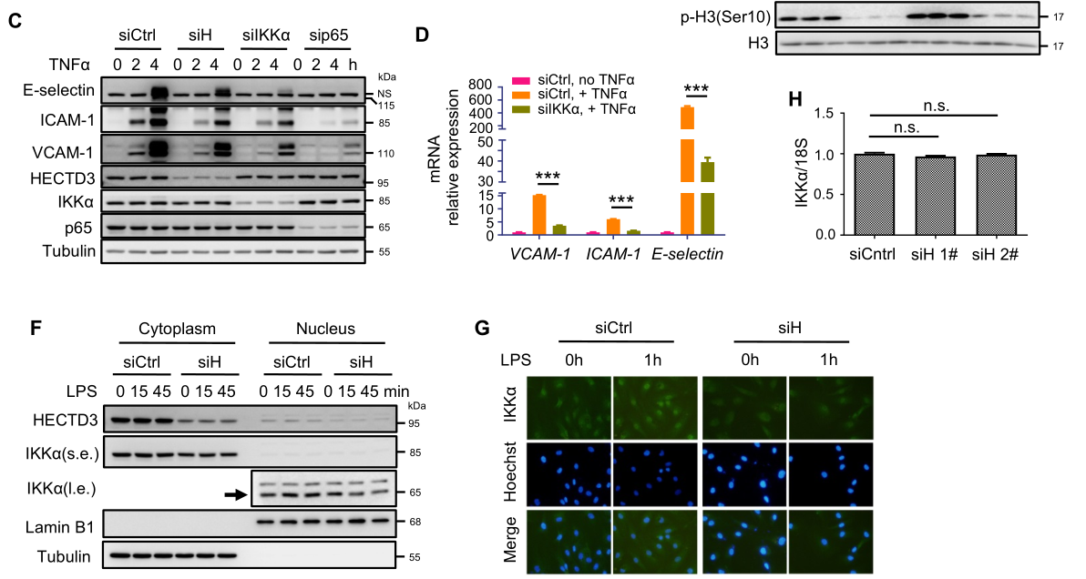
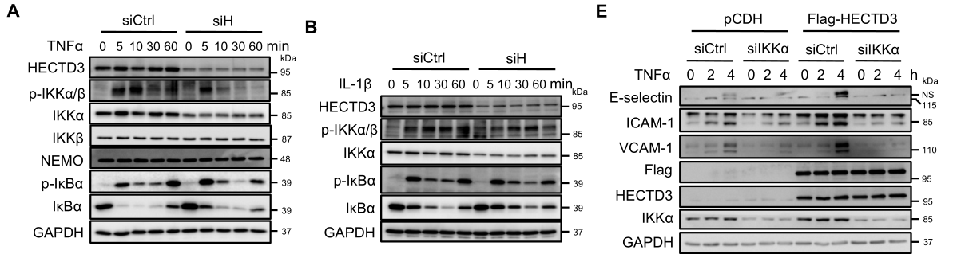

Supplemental Figure 3. HECTD3 increases the expression of adhesion molecules by stabilizing IKKα and recruiting nuclear IKKα to adhesion molecule gene promoters.
- HECTD3 transient knockdown decreased the IKKα protein levels in HUVECs. HECTD3 was knocked down with an siRNA pool in HUVEC cells for 36 h. Following that, the cells were stimulated with TNFα (10 ng/ml) as indicated time (0-60 mins). Protein levels of HECTD3, IKKα, IKKβ，NEMO, pIKKα/β, p-IκBα and IκBα, and GAPDH were detected by immunoblotting.
- HECTD3 transient knockdown decreased the IKKα protein levels in HUVECs. HECTD3 was knocked down with an siRNA pool in HUVEC cells for 36 h. Following that, the cells were stimulated with IL-1β (20 ng/ml) as indicated time (0-60 mins). Protein levels of HECTD3, IKKα, pIKKα/β, p-IκBα and IκBα, and GAPDH were detected by immunoblotting.
- IKKα knockdown decreased TNFα-induced protein expression of adhesion molecules, including E-selectin, ICAM-1 and VCAM-1 in HUVECs. IKKα was knocked down using siRNA for 36 h. HUVECs were stimulated with or without TNFα (10 ng/ml) for 0-4 h. NS, nonspecific band.
- IKKα knockdown decreased TNFα-induced mRNA expression of adhesion molecules, including E-selectin, ICAM-1 and VCAM-1 in HUVECs. IKKα was knocked down using siRNA for 36 h. HUVECs were stimulated with or without TNFα (10 ng/ml) for 2 h.
- HECTD3 functions through IKKα to promote adhesion molecule expression in HUVECs. IKKα was transiently knocked down in HECTD3 overexpressing HUVECs. HUVECs were stimulated with or without TNFα (10 ng/ml) for 0-4 h. NS, nonspecific band.
- HECTD3 transient knockdown decreased the IKKα protein nuclear localization in HUVECs. HUVECs transfected with siRNA were stimulated with LPS (300 ng/ml) for 0-45 min. Nuclear and cytoplasmic fractions were isolated using the NE-PER Nuclear and cytoplasmic Extraction Reagents (Thermo scientific). s.e. and l.e. mean short exposure and long exposure, respectively.
- HECTD3 transient knockdown decreased the IKKα protein nuclear localization in HUVECs. Immunofluorescence analysis of the subcellular localization of IKKα. Nucleus was stained by Hoechst.
- HECTD3 did not affect IKKα mRNA levels in HUVECs. qRT-PCR was used to measure the IKKα mRNA levels in HUVECs knocking down HECTD3 with two different siRNA. 18S was used as internal control.
Data are presented as mean±SEM, and statistics were calculated using two-tailed t-test for D and H. ***, P<0.001; n.s., not significant. Scale bars, 80 μm for F.

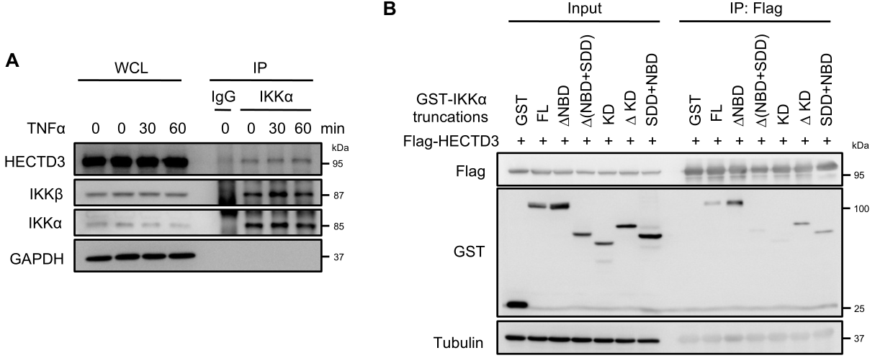

Supplemental Figure 4. HECTD3 interacts with IKKα.
- TNFα did not regulate the interaction between HECTD3 and IKKα in HUVECs. HUVECs were stimulated with TNFα (10 ng/ml) for 0-1 h. Anti-IKKα antibody was used to Immunoprecipitate IKKα. The co-immunoprecipitated endogenous HECTD3 were unchanged.
- The SDD domain of IKKα is responsible for the interaction with HECTD3. Flag- HECTD3 and GST-fused IKKα truncation mutants were co-expressed HEK293T cells. Flag-HECTD3 was immunoprecipitated with Flag-M2 beads, GST-IKKα KD and ΔNBD+SDD failed to interact with Flag-HECTD3, suggesting that SDD domain is important for the protein interaction.

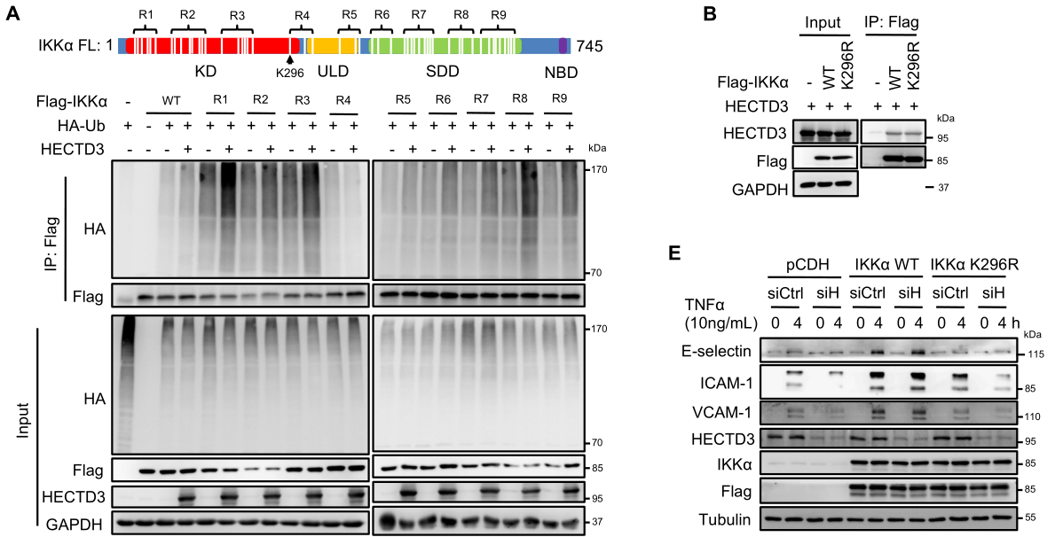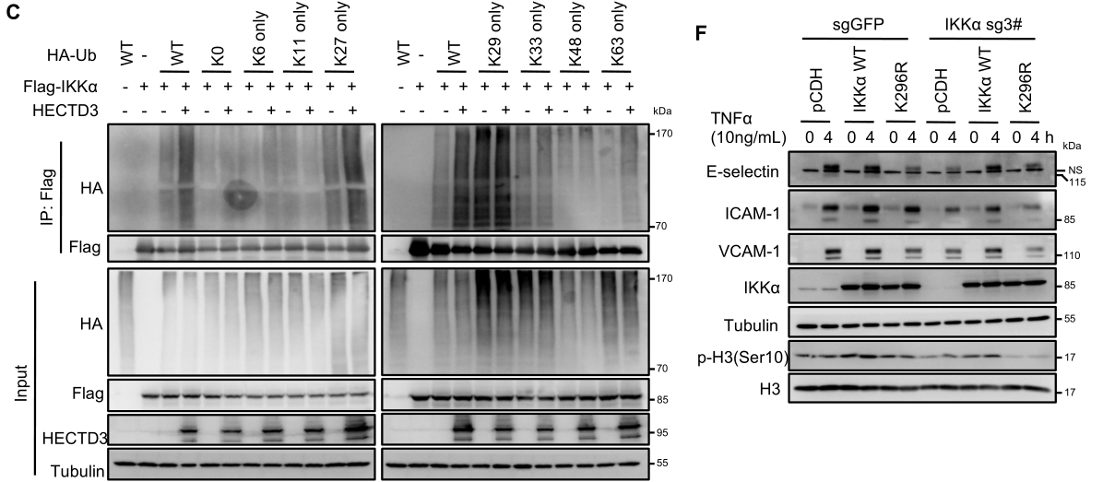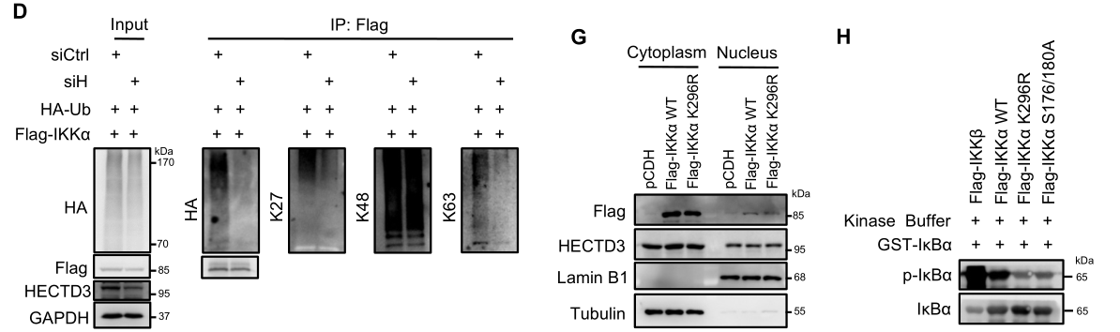
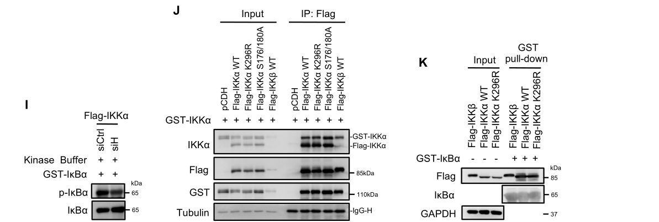

Supplemental Figure 5. HECTD3 ubiquitinates IKKα with the K27, K63-linked polyubiquitin chains at K296 and increases the IKKα protein stability and kinase activity.
- HECTD3 ubiquitinates IKKα at K296 in HEK293T cells. Schematic diagram shows the regions of human IKKα artificially divided dependent on lysine residues distribution (top). HECTD3 failed to ubiquitinate Flag-IKKα R4, which contains K296, K311, K322 (bottom).
- Flag-IKKα K296R still efficiently interacted with HECTD3, like WT Flag-IKKα. HECTD3 and Flag-IKKα WT or K296R were coexpressed into HEK293 cells and Flag-IKKα proteins were immunoprecipitated with Flag-M2 beads.
- HECTD3 ubiquitinates IKKα with the K27- and K63-linked polyubiquitin chains. WT, K27 only, and K63 only HA-Ub supported HECTD3-mediated Flag-IKKα ubiquitination. In contrast, other HA–Ub mutants failed to do so.
- HECTD3 ubiquitinates IKKα with the K27- and K63-linked polyubiquitin chains. Linkage-specific antibodies were used to validate the linkage of Flag-IKKα. HECTD3 knockdown decreased Flag-IKKα polyubiquitin chains were recognized by anti-HA, anti-K27, and anti-K63, but not anti-K48 antibody.
- Flag-IKKα K296R failed to rescue HECTD3 knockdown induced adhesion molecule expression downregulation in response to TNFα. Flag-IKKα WT and Flag-IKKα K296R were stably overexpressed in HUVECs. HECTD3 knockdown dramatically blocked TNFα (10 ng/ml, 4h) induced adhesion molecule expression. Overexpression of Flag-IKKα WT completely rescued the HECTD3 knockdown induced phenotype. However, Flag-IKKα K296R failed to do so, suggesting that HECTD3 mediated IKKα ubiquitination at K296 is important for its functions. NS, nonspecific band.
- Flag-IKKα K296R failed to phosphorylate histone H3 at Ser10 and induce adhesion molecule expression in HUVECs in response to TNFα. We generated an endogenous IKKα KO HUVECs using the CRISPR/Cas9 system. Unlike WT IKKα, IKKα K296R failed to phosphorylate histone H3 at Ser10 and induce adhesion molecule expression in HUVECs in response to TNFα (10 ng/ml, 4h). NS, nonspecific band.
- Flag-IKKα K296R did not change its subcellular localization in HUVECs. Cytoplasmic and nuclear extracts of HUVECs overexpressing Flag-IKKα WT or K296R mutant were subjected to immunoblotting.
- IKKα ubiquitination at K296 is essential for its kinase activity toward IκBα. The in vitro IKKα kinase assay contains purified Flag-IKKα WT, K296R, or S175/180A, GST-IκBα, and ATP. Flag-IKKα proteins were purified from HEK293T cells. Flag-IKKα, but not Flag-IKKα K296R, efficiently phosphorylate IκBα.
- HECTD3 knockdown in HUVECs decreased the IKKα activity toward IκBα. After HECTD3 was knocked down, the purified Flag-IKKα decreased its kinase activity toward IκBα.
- Flag-IKKα K296R did not change its dimerization in HEK293T cells. Flag-IKKα and GST-IKKα were co-expressed in HEK293T cells. Co-immunoprecipitation assays were performed using Flag-M2 beads. Both WT and K296R pulled down similar amount of GST- IKKα.
- Flag-IKKα K296R did not affect the interaction with IκBα compared with Flag-IKKα WT. Cell lysates of HEK293T cells expressing Flag-IKKα WT or Flag-IKKα K296R were collected and incubated with purified GST-IκBα protein for 30 min on ice. The GST pull-down assay was performed using glutathione sepharose beads.

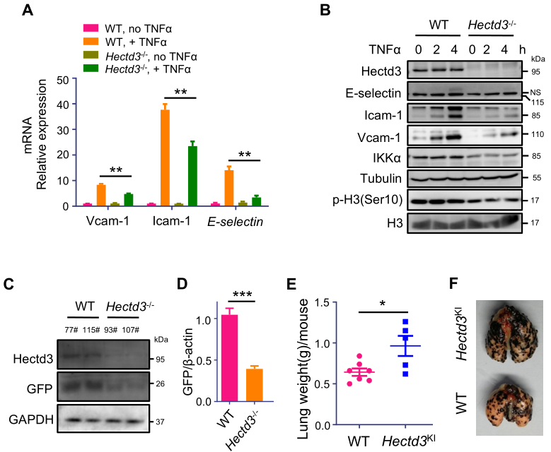

Supplemental figure 6. Hectd3 promotes the adhesion of tumor cells to mouse lung vascular endothelial cells through IKKα under inflammation condition.
- Hectd3 KO significantly decreased TNFα-induced mRNA expression of adhesion molecules, including E-selectin, Icam-1 and Vcam-1 in mECs. qRT-PCR was used to analyze the mRNA levels of adhesion molecules. TNFα (10 ng/ml) stimulated the cells for 2 h. 18S rRNA was used as the internal control.
- Hectd3 KO significantly decreased TNFα-induced protein expression of adhesion molecules, including E-selectin, Icam-1 and Vcam-1 in mECs. IKKα and p-H3(Ser10) levels were also decreased in Hectd3^{-/-} mECs stimulated with TNFα (10 ng/ml) for 0-4 h. NS, nonspecific band.
- Hectd3 KO significantly decreased LPS-induced cancer cell adhesion in the lung in vivo. The expression of GFP protein, standing for PyMT induced mouse breast cancer cells, in the lungs of two WT and Hectd3^{-/-} mice was detected by immunoblotting.
- Hectd3 KO significantly decreased LPS-induced cancer cell adhesion in the lung in vivo. The expression of GFP mRNA, standing for PyMT induced mouse breast cancer cells, in the lungs of two WT and Hectd3^{-/-} mice was detected by qRT-PCR.
- Whole body Hectd3 KI (CMV-Cre driven) promoted lung metastasis of B16-F10 cells. All mice were pretreated with LPS (1 mg/kg) by intravenous injection for 5 h. Cancer cells were injected by tail vein into WT and Hectd3^{KI} mice (1×10⁵ per mouse). The mice were sacrificed 20 days after the injection of cancer cells. The weights of whole lung with metastasis nodules in each group mice are shown.
- Whole body Hectd3 KI promoted lung metastasis of B16-F10 cells. The representative lung metastasis nodule images in each group mice are shown.
Data are presented as mean±SEM, and statistics were calculated using two-tailed t-test for A, D and E. *,P<0.05; **, P<0.01; ***, P<0.001.

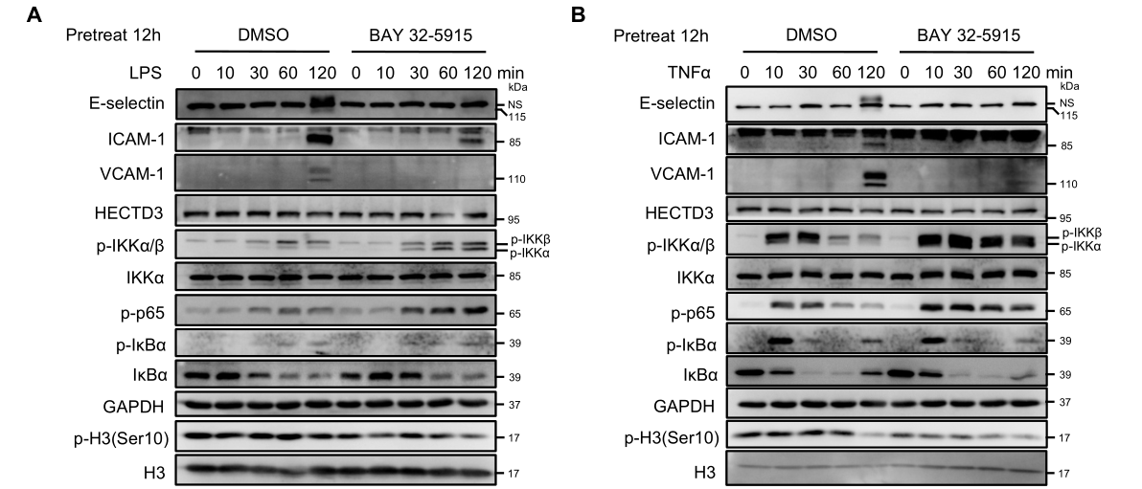
Supplemental Figure 7. BAY 32-5915, an IKKα kinase specific inhibitor, does not inhibit the IKK complex activation but blocks the targeted gene expression of NF-κB pathway.
- BAY 32-5915 did not inhibit the IKK complex activation in response to LPS in HUVECs. HUVECs were pretreated with specific IKKα kinase inhibitor BAY 32-5915 (0.4 mM) or vehicle (DMSO) for 12 h, followed by the treatment of LPS (300 ng/ml) for 1-2 h. BAY 32-5915 did not inhibit the phosphorylation of IKKα/β, IκBα, and p65. The degradation of IκBα was also normal; however, the induction of adhesion molecules was dramatically blocked. The increase of the phosphorylation of IKKα/β and p65 by BAY 32-5915 might be caused by a negative feedback mechanism. NS, nonspecific band.
- BAY 32-5915 did not inhibit the IKK complex activation in response to TNFα in HUVECs. HUVECs were pretreated with specific IKKα kinase inhibitor BAY 32-5915 (0.4 mM) or vehicle (DMSO) for 12 h, followed by the treatment of TNFα (10 ng/ml) for 1-2 h. NS, nonspecific band.

