Aggregation of magnetic nanoparticles functionalized with trans-resveratrol in aqueous solution
Thi-Nga Nguyen^{1,2,3}, Quang-Hung Tran⁴, Clarence Charnay⁵, Xavier Dumail⁵, Corinne Reibel⁵, Guillaume Cazals⁶, Gilles Valette⁶, Christian Jay-Allemand¹, Ferial Terki², Luc P. R. Bidel⁷

¹UMR IATE, University of Montpellier, Institut Agro, INRAE, F-34060 Montpellier, France.
²PhyMedExp UMR CNRS 9214 – Inserm U1046, 34295 Montpellier Cedex 05, France.
³Institute of Natural Products Chemistry, Vietnam Academy of Science and Technology, 18 Hoang Quoc Viet, 100000 Hanoi, Vietnam.
⁴eV-Technologies, 2 Esplanade Anton Philips, Bâtiment 5, 14460 Colombelles, France.
⁵Institut Charles Gerhardt UMR 5253 CNRS-UM, Université de Montpellier, F-34095 Montpellier, France.
⁶IBMM UMR5247, CNRS, ENSCM, Université de Montpellier, Place Eugène Bataillon, 34095 Montpellier Cedex 5, France
⁷UMR AGAP, University of Montpellier, CIRAD, INRAE, Institut Agro, Montpellier, France.

Corresponding: luc.bidel@inrae.fr

Supporting information
S1. Silanization of trans-resveratrol
Figure S1: Transmittance spectra as a function of the wavenumber of the reaction process at 7 hours and 3 days recorded by attenuated total reflection of the infrared spectrometer.
Figure S2: Structure of silanized trans-resveratrol and their numbering of the carbon skeletons: 1, 2, 3 corresponding to the silane derivatives binds covalently to the three, two, and one hydrogen bonding sites of the trans-resveratrol molecule, respectively. Arrows show the key C-H correlations on the HMBC of compounds 2 and 3.

S2. Dynamic light scattering measurement
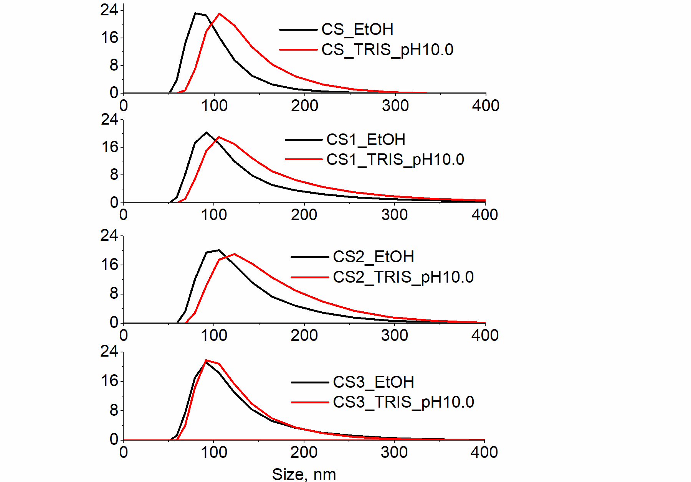
Figure S3: Size distribution of nanoparticles in absolute ethanol and in TRIS buffer at pH 10.0.

S3. Zeta potential measurement
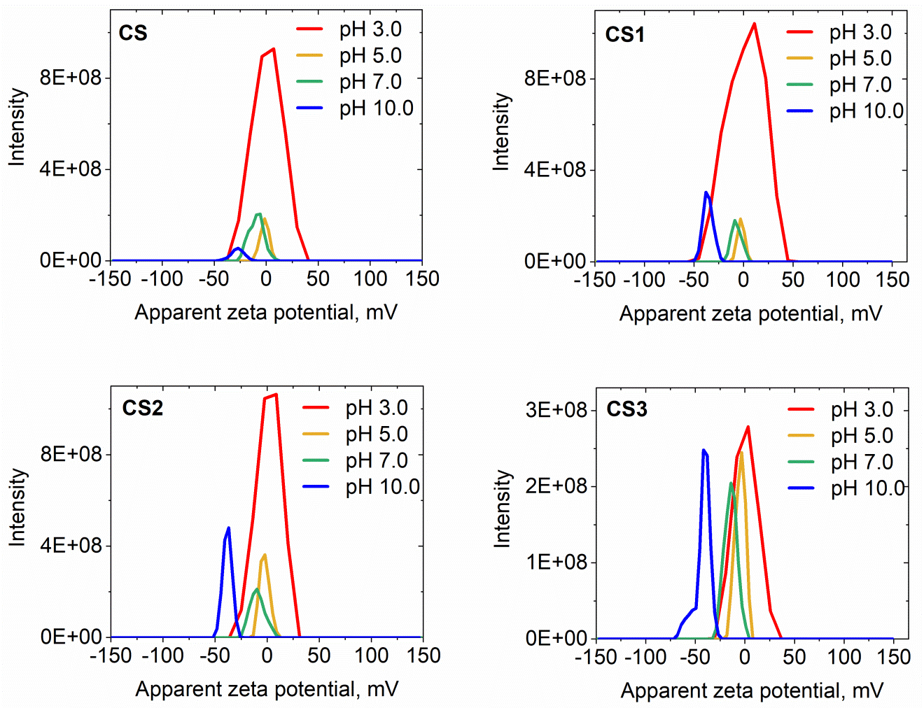
Figure S4: Distribution of zeta potential of nanoparticles at different pH.

S4. Extinction Cross-section
Table S1: The parameters of the Rayleigh-Gans-Debye model $A_{s}(λ)=W.λ^{-n}$deduced from the linear fitting of the logarithm of extinction as a function of the logarithm of the wavelength.

pH | Compound | W | n
3.0 | CS1 | 8.68 | 1.14
3.0 | CS2 | 0.86 | 0.77
3.0 | CS3 | 10.65 | 1.17
5.0 | CS1 | 9.65 | 1.15
5.0 | CS2 | 23.70 | 1.26
5.0 | CS3 | 60.79 | 1.42
7.0 | CS1 | 298.61 | 1.60
7.0 | CS2 | 378.79 | 1.60
7.0 | CS3 | 2618.78 | 1.81
10.0 | CS1 | 59006.52 | 2.39
10.0 | CS2 | 19760.59 | 2.19
10.0 | CS3 | 233292.08 | 2.57

S5. Appendix NMR spectra of compound 1, 2, and 3
Figure S5: NMR spectra of compound 1, 2, and 3
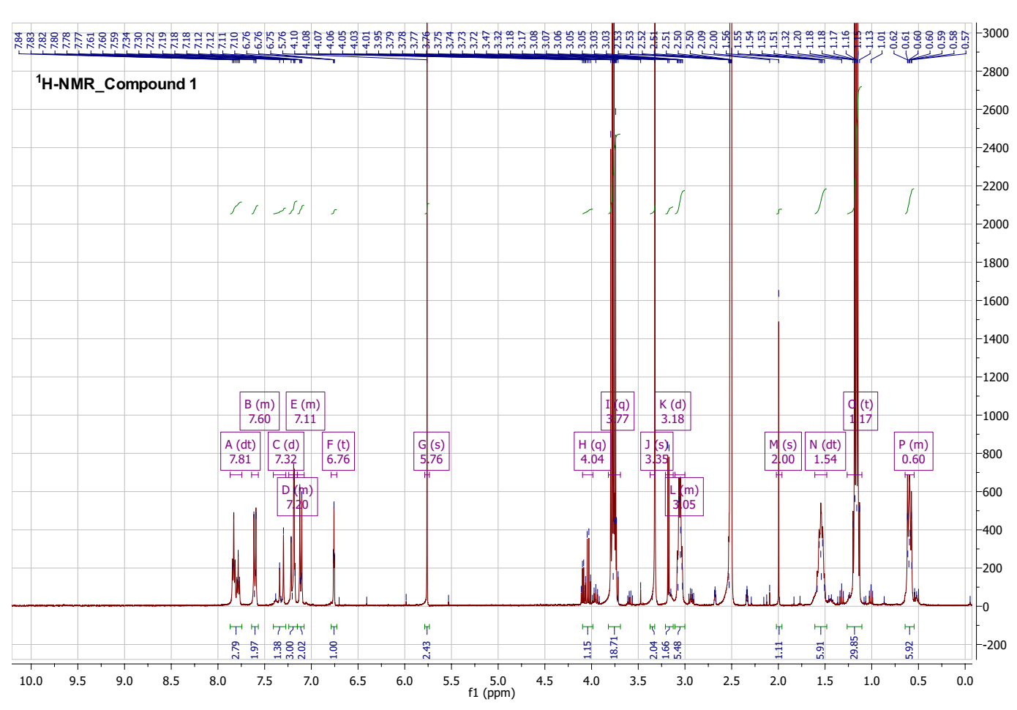
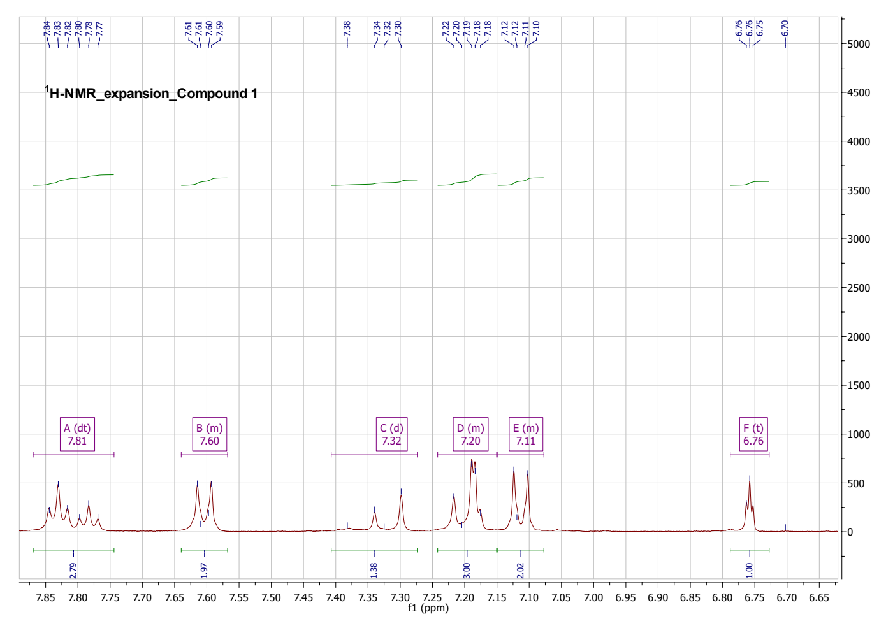
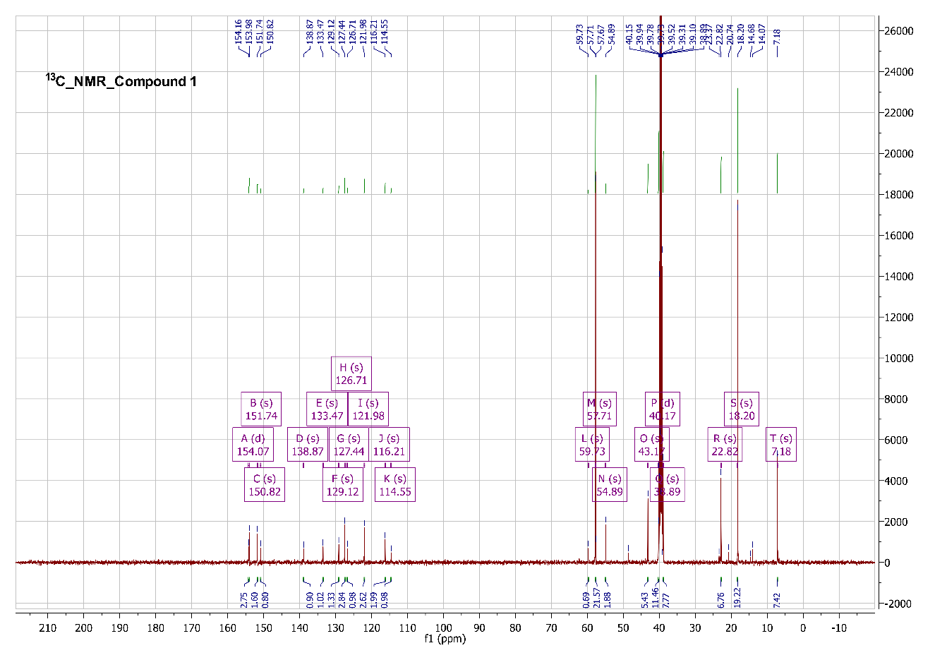

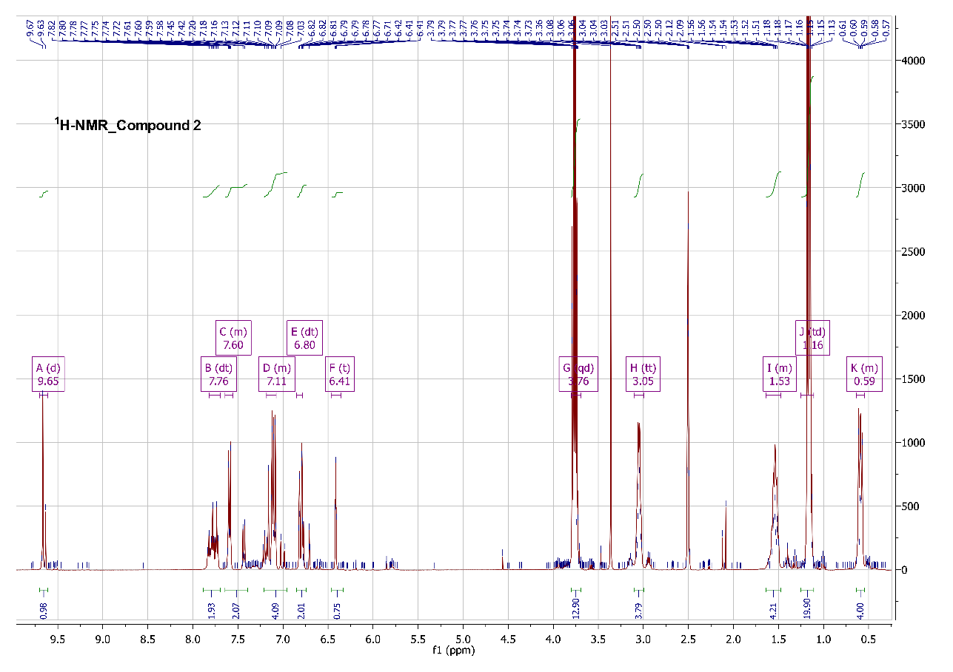
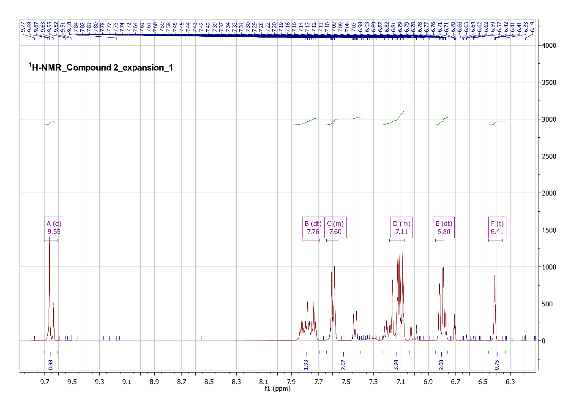
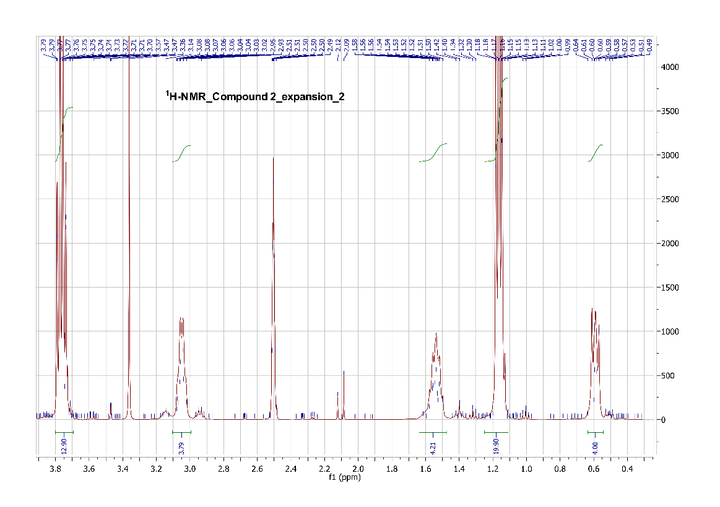
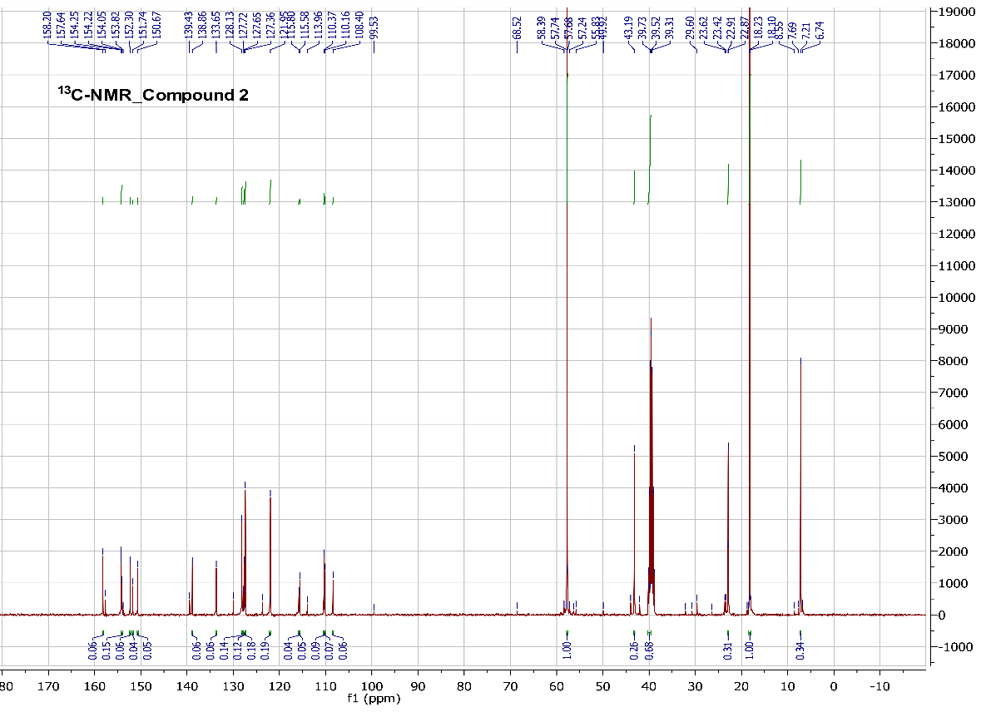
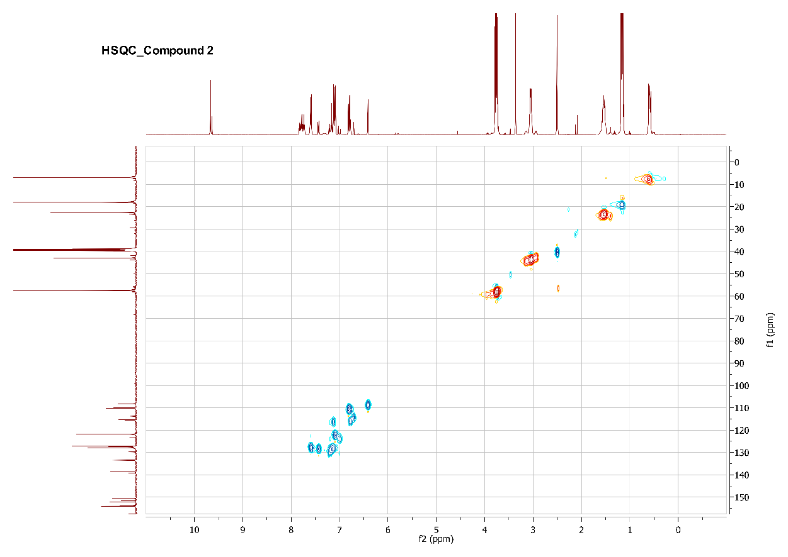
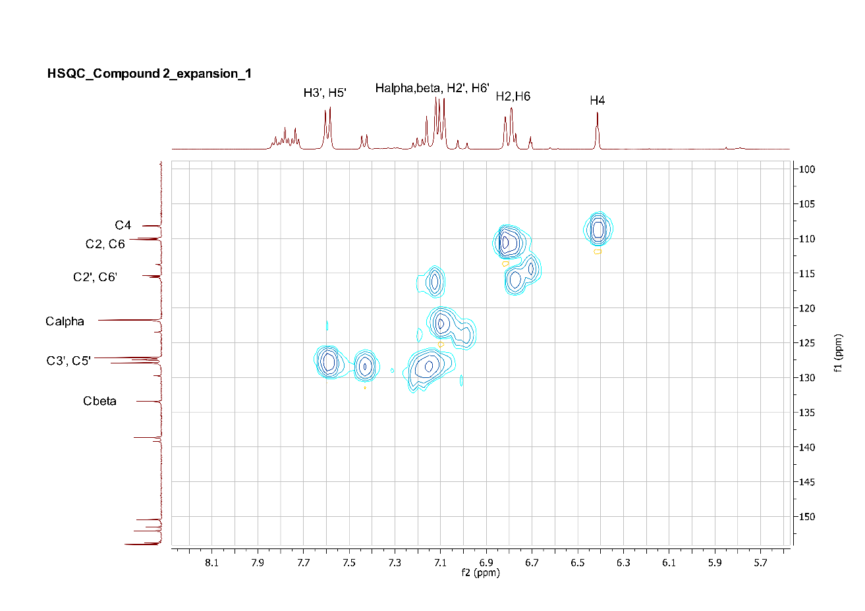
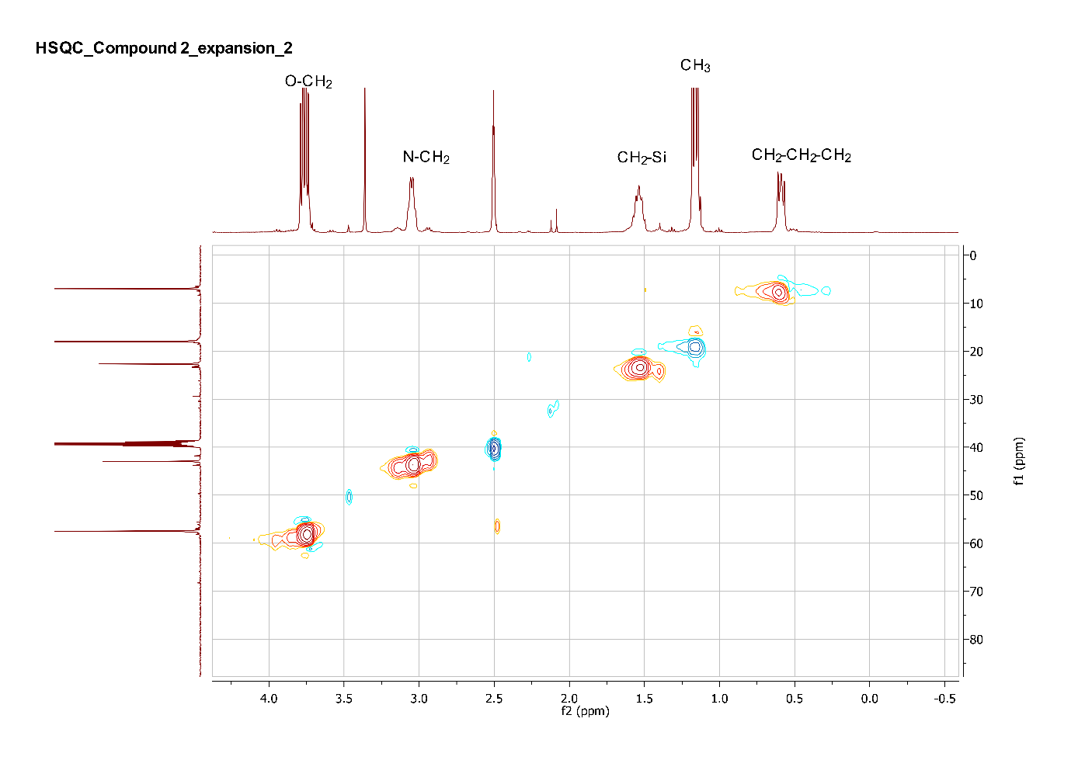
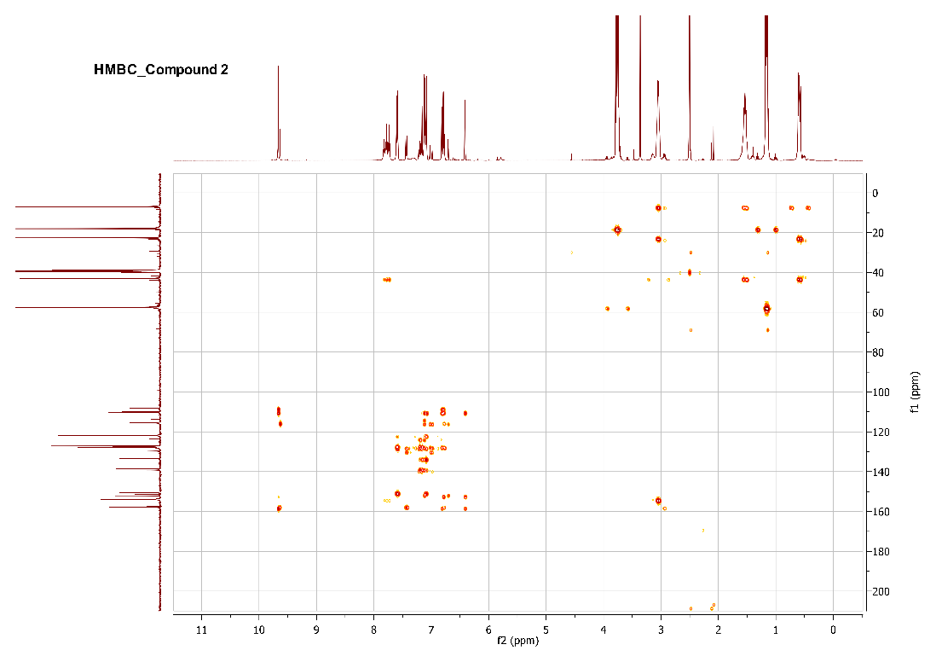
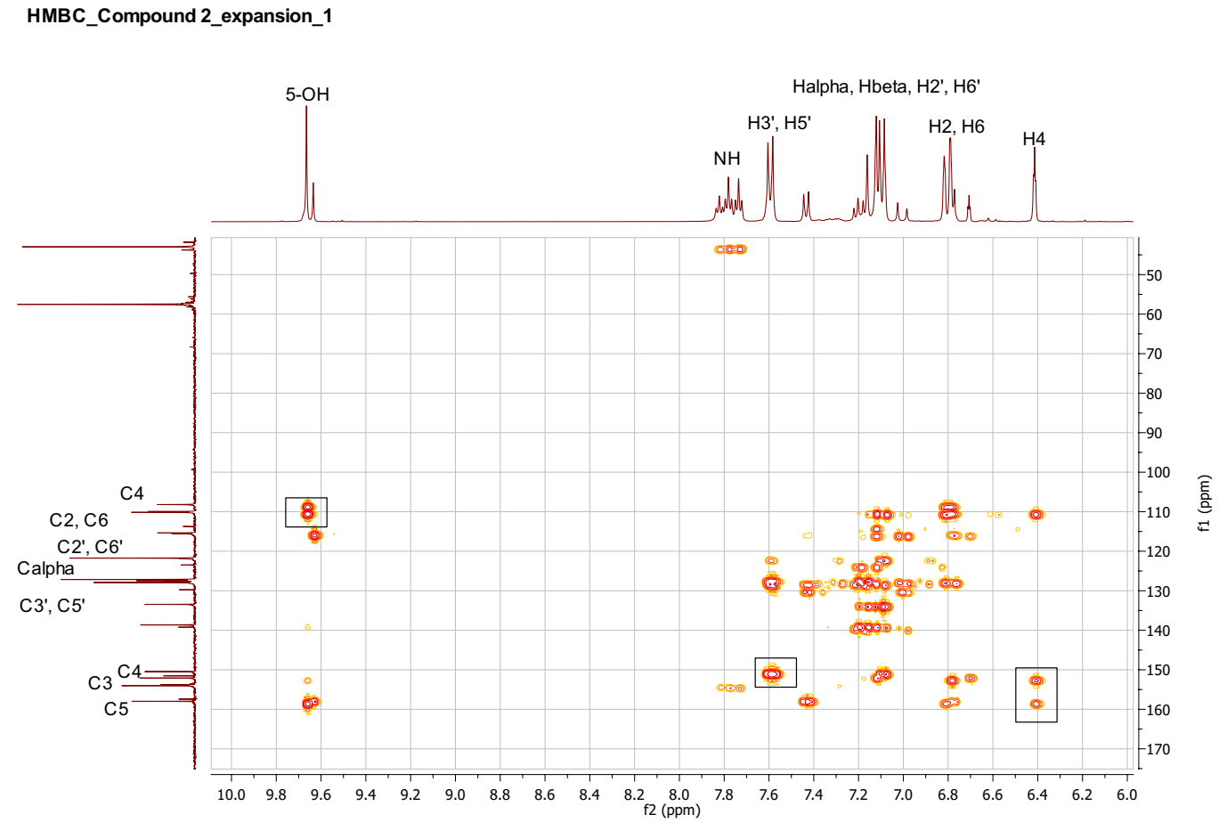

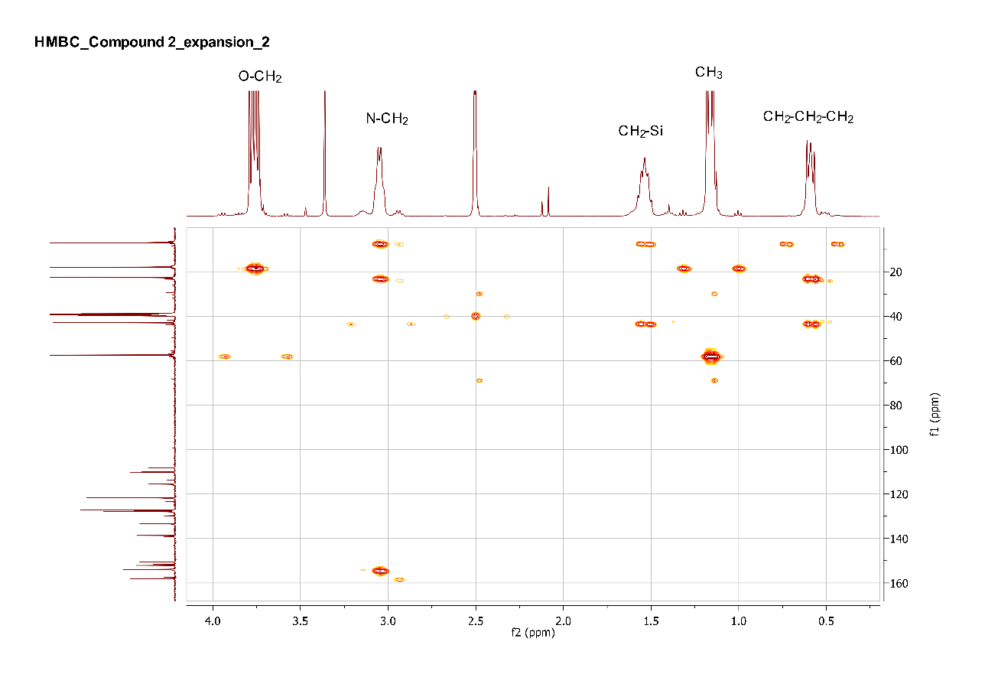
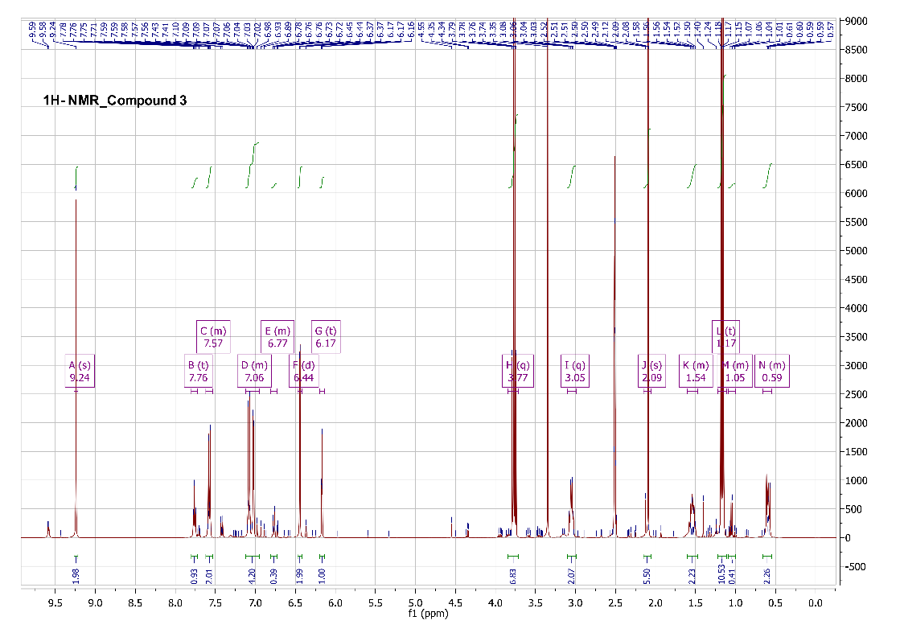

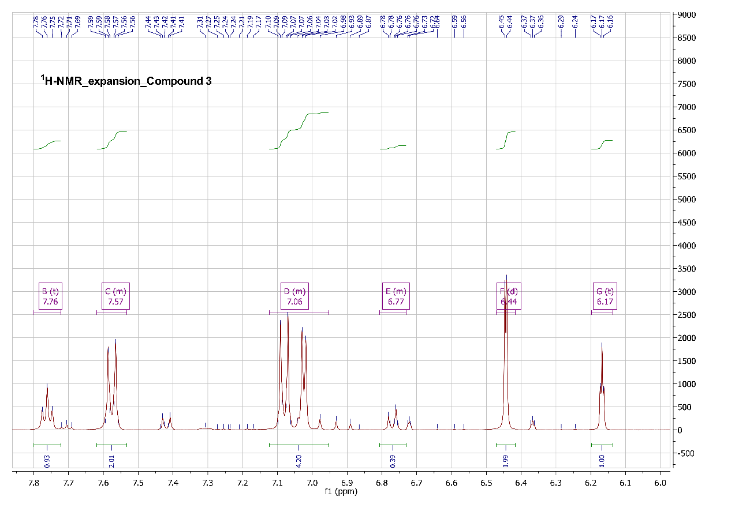
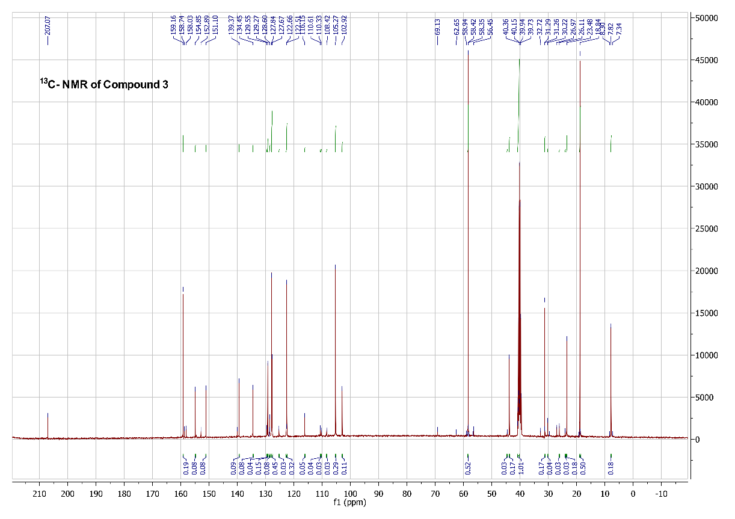

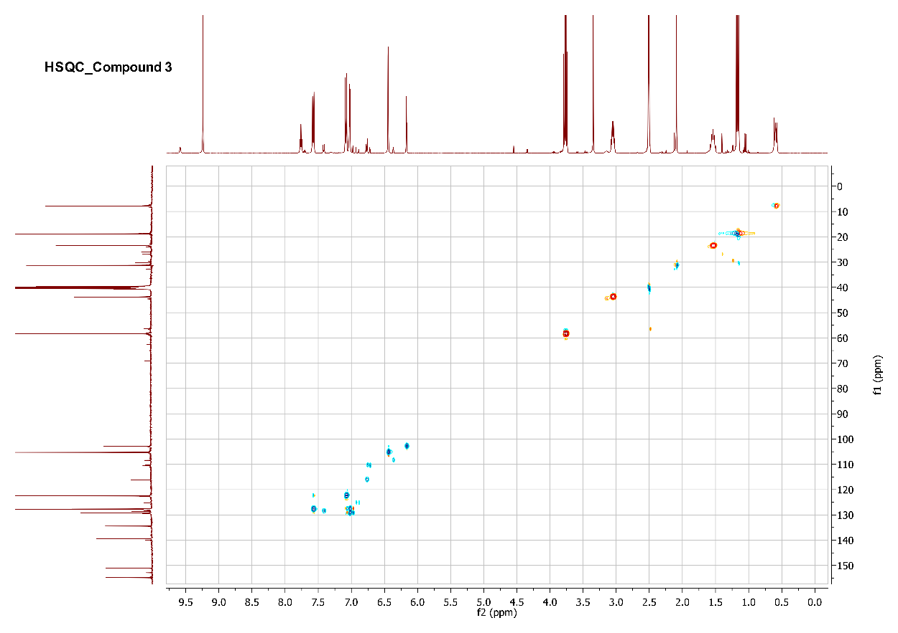
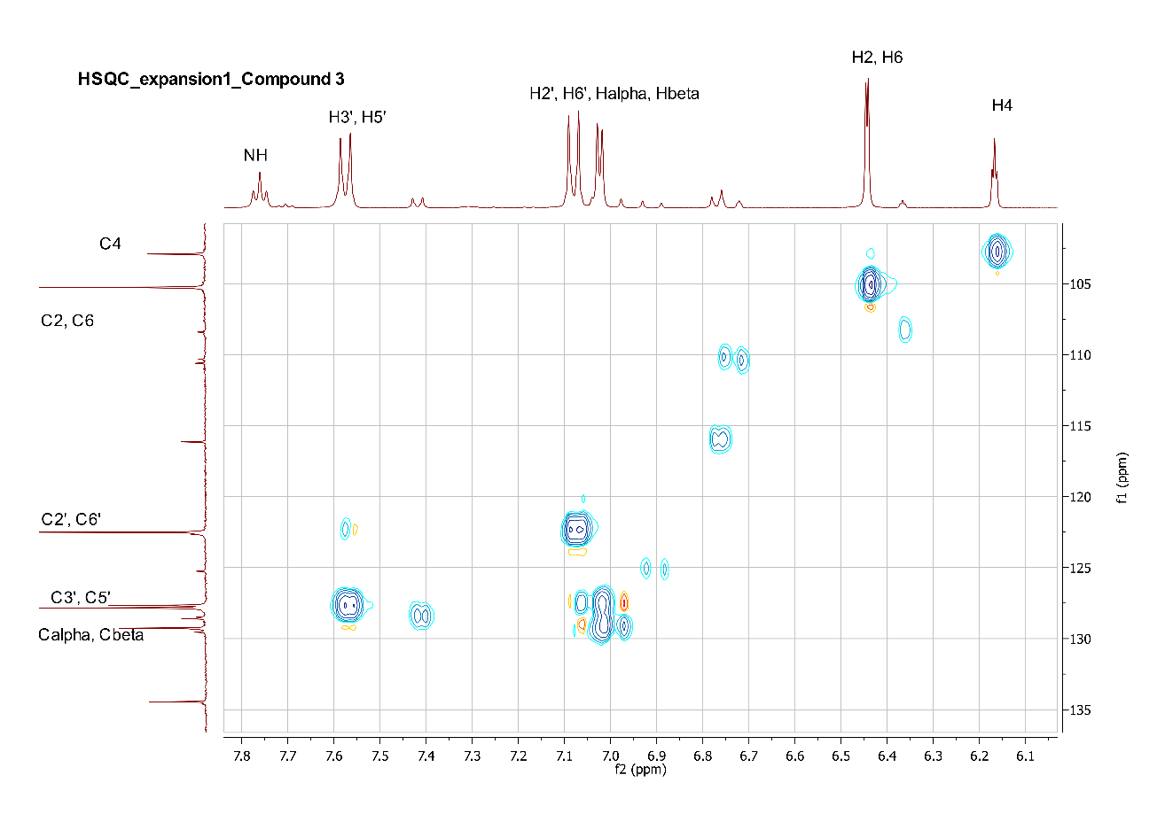
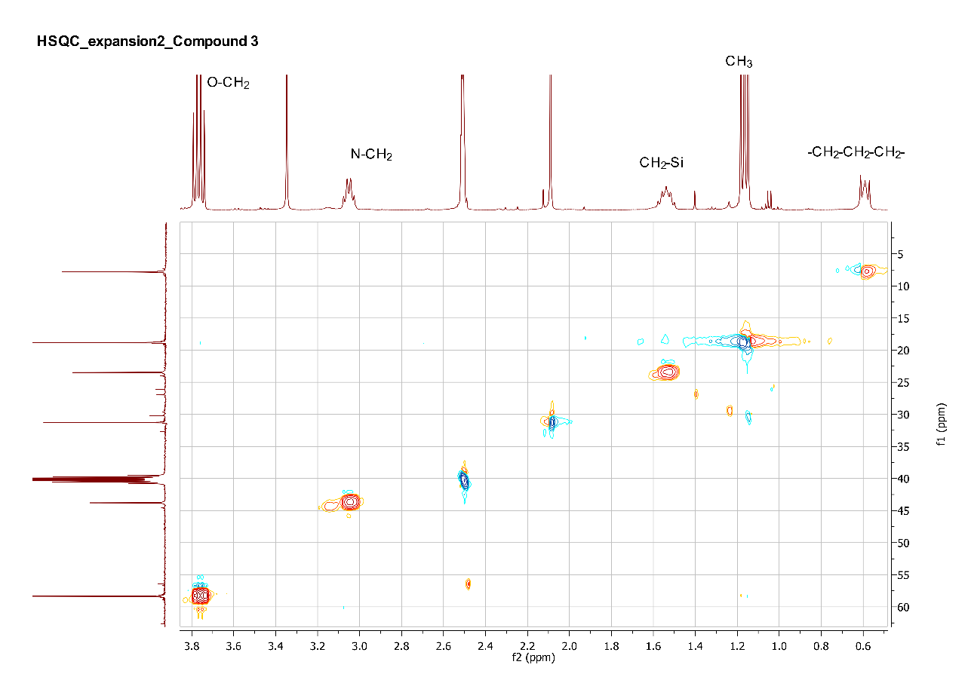
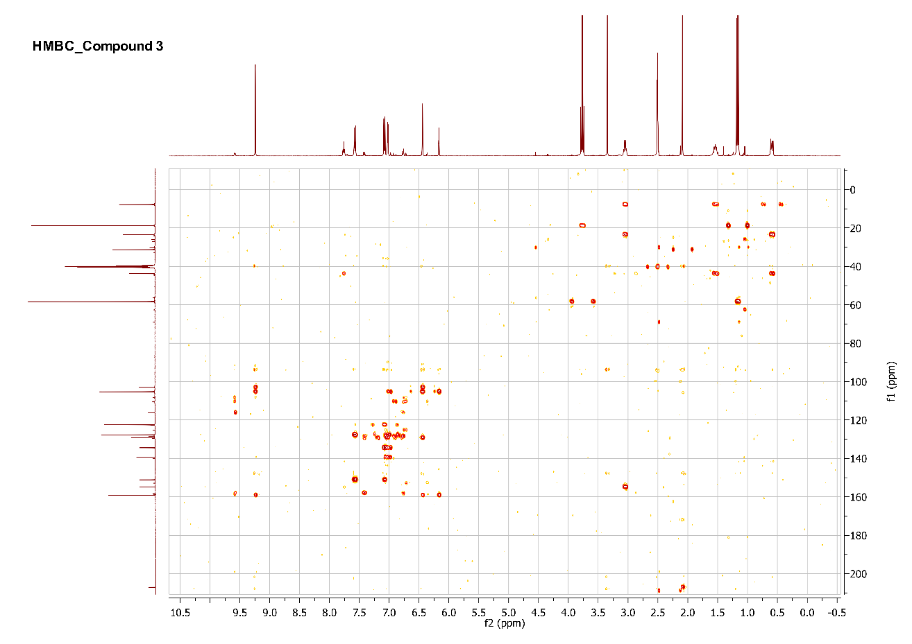
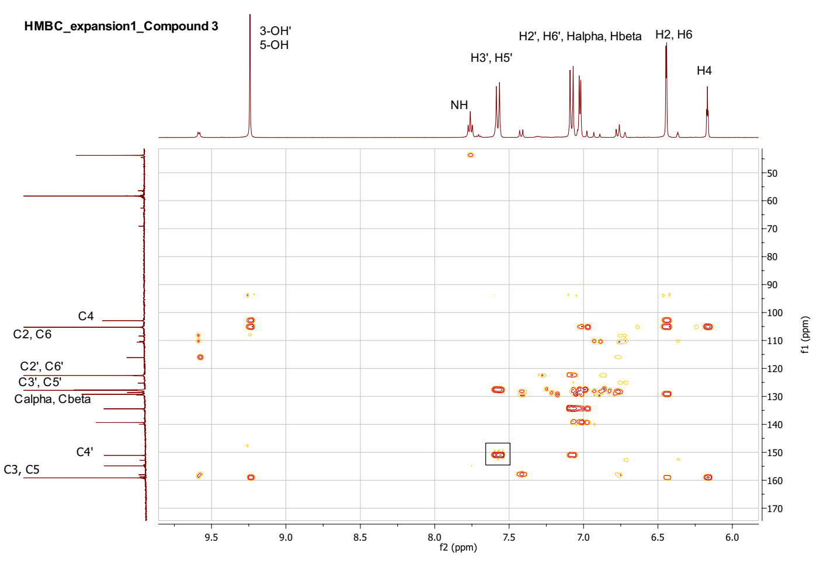
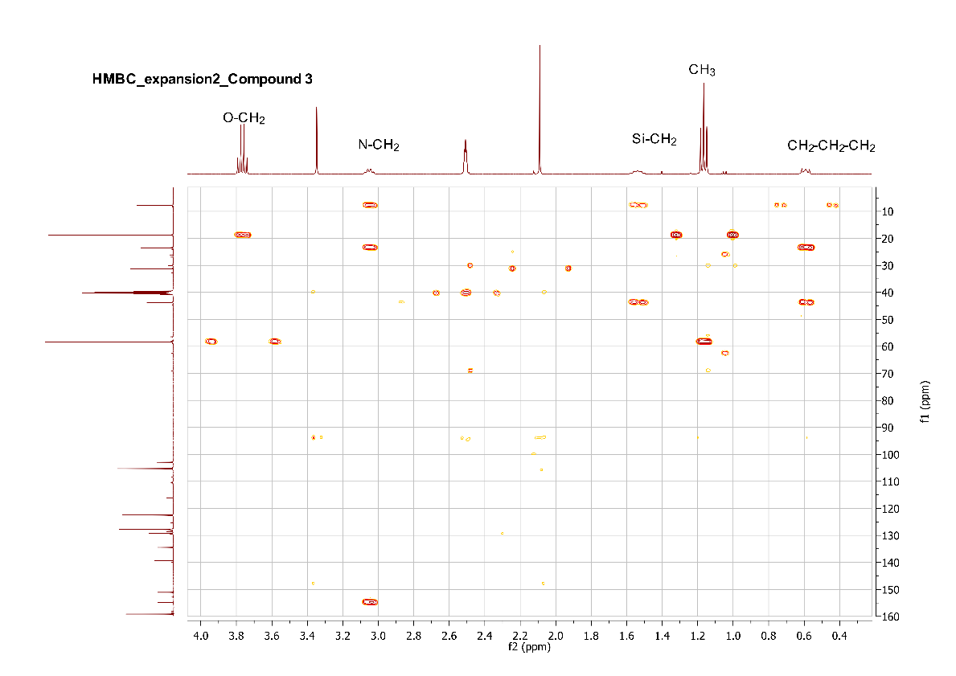

S6. Mass spectroscopy of compound 1, 2, and 3.
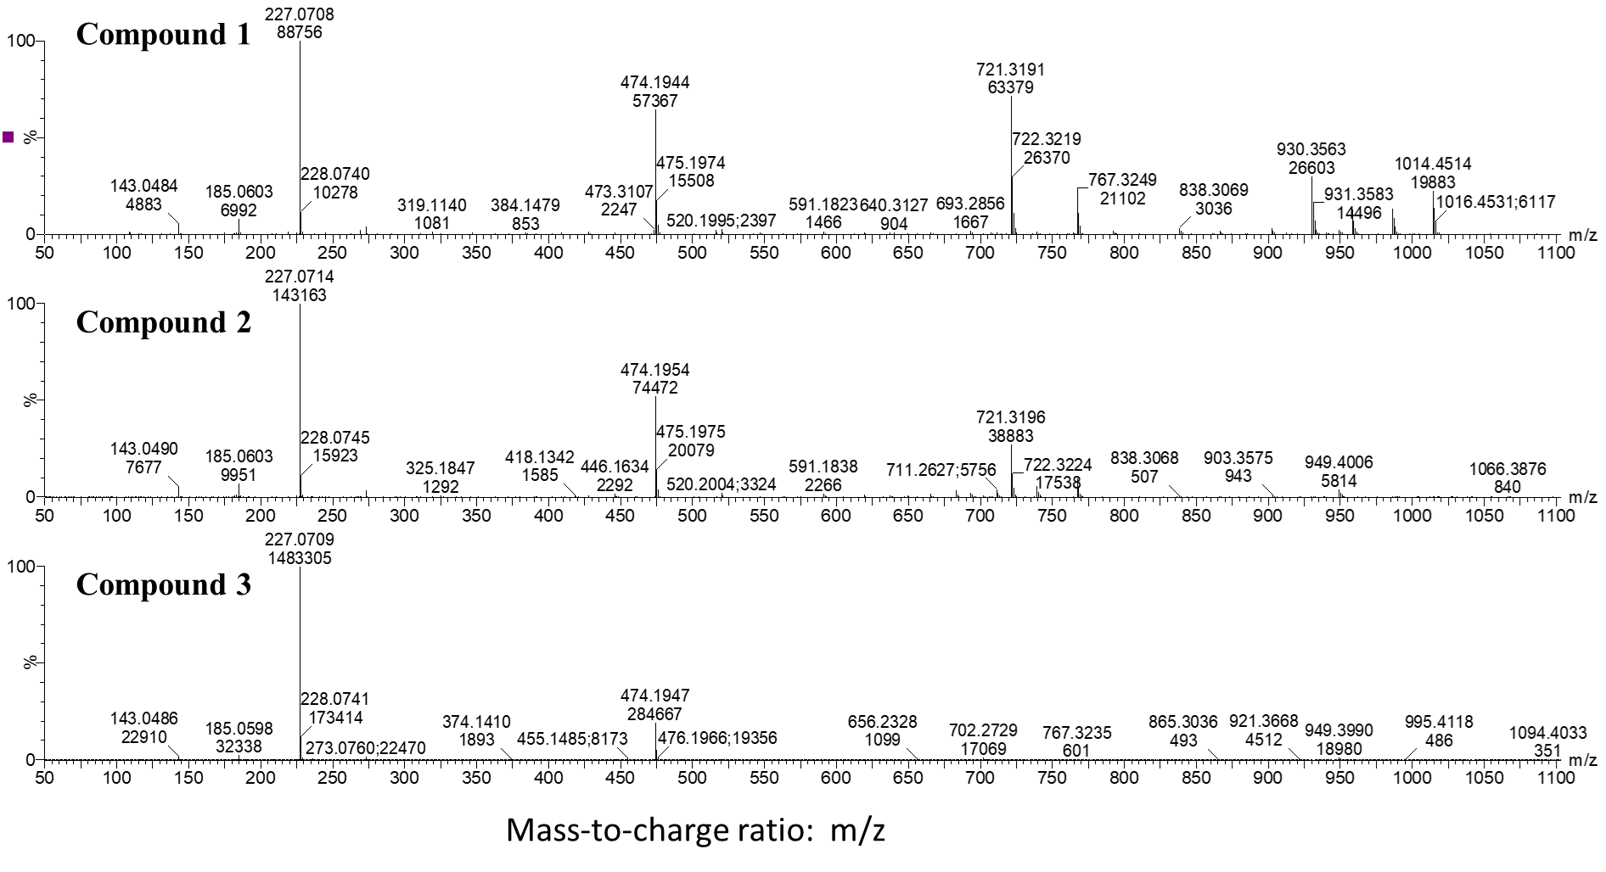
MALDI-TOF Compound 1
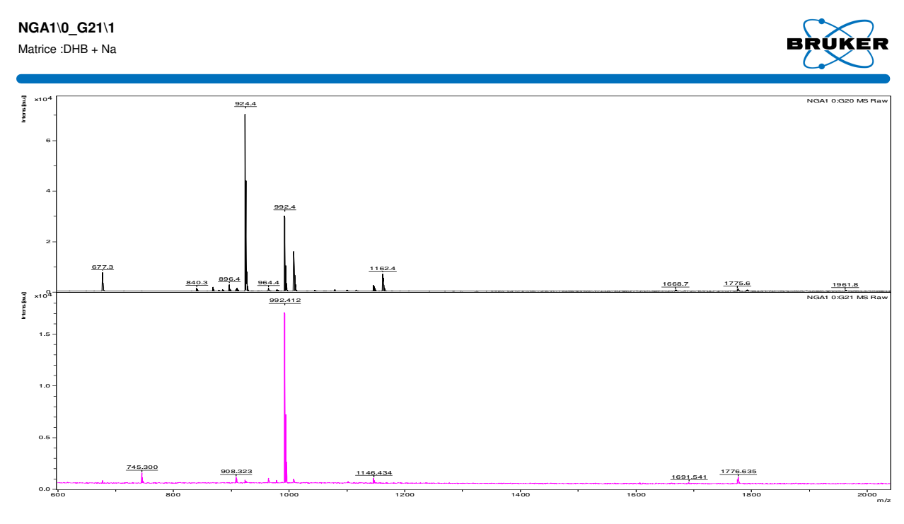

MALDI-TOF Compound 2
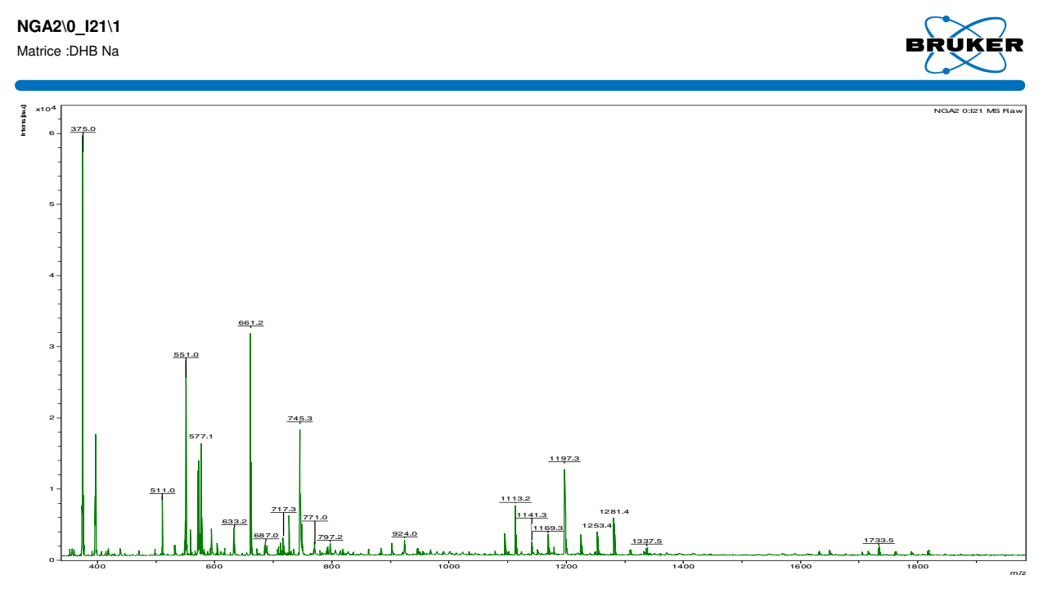
MALDI-TOF Compound 3
