Supplement 1. Data of illness onset and severity of inpatients with laboratory confirmed COVID-19
Number of patients admitted to hospital by severity group from 26 January 2020 to 15 February 2020 in Wuhan Third Hospital.
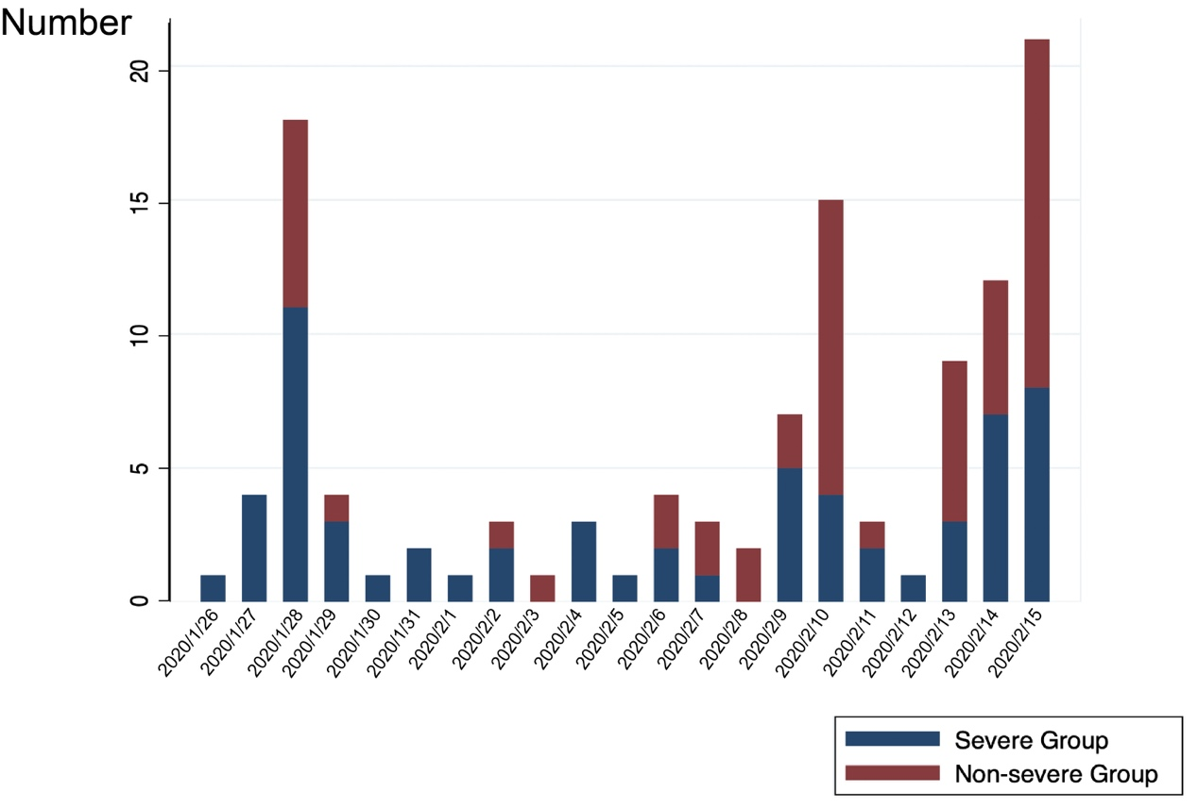

Supplement 2. Binary cox regression for 28-day mortality in severe group
 | HR | 95%CI | P
Age | 1.0182 | 0.9741-1.0644 | 0.4240
Sex | 3.0545 | 0.8615-10.8294 | 0.0840
Smoking history | 1.8476 | 0.8849-3.8580 | 0.1020
BMI | 0.9946 | 0.8328-1.1879 | 0.9520
Comorbidity (Yes/No) | 0.9026 | 0.3084-2.6420 | 0.8520
Comorbidity (Number) | 0.9339 | 0.5372-1.6237 | 0.8090
Hypertension | 0.6150 | 0.2100-1.8011 | 0.3750
Diabetes mellitus | 1.4728 | 0.5024-4.3173 | 0.4800
COPD | - | - | -
Coronary heart disease | 0.8329 | 0.1879-3.6924 | 0.8100
Cerebrovascular disease | 1.1061 | 0.1453-8.4178 | 0.9220
Malignancy | 3.3361 | 0.4367-25.4871 | 0.2460
Chronic liver disease | 2.8722 | 0.3757-21.9560 | 0.3090
Chronic kidney disease | - | - | -
Fever | - | - | -
Respiratory rate | 1.0586 | 0.9461-1.1844 | 0.3210
Onset of symptom to hospital admission | 0.9846 | 0.8785-1.1036 | 0.7900
White blood cell count, ×10⁹/L | 1.1713 | 1.0756-1.2754 | <0.0001
Neutrophil count, ×10⁹/L | 1.1645 | 1.0729-1.2639 | <0.0001
Lymphocyte count, ×10⁹/L | 0.6641 | 0.1603-2.7516 | 0.5720
Median Hemoglobin, g/L | 0.9860 | 0.9665-1/0058 | 0.1640
D-dimer, mg/L | 1.0280 | 0.9135-1.1569 | 0.6460
Fibrinogen, g/L | 1.0766 | 0.7056-1.6427 | 0.7320
Prothrombin time, s | 0.9770 | 0.82491.1570 | 0.7870
Alanine aminotransferase, U/L | 0.9951 | 0.9764-1.0141 | 0.6100
Aspartate aminotransferase, U/L | 0.9975 | 0.9821-1.0130 | 0.7480
Albumin, g/L | 0.9980 | 0.9314-1.0693 | 0.9550
Total bilirubin, µmoll/L | 1.0428 | 0.9641-1.1278 | 0.2950
Creatinine, µmol/L | 0.9998 | 0.9965-1.0031 | 0.9140
Uric acid, µmol/L | 1.0022 | 0.9991-1.0054 | 0.1640
Alkaline phosphatase, U/L | 1.0114 | 0.9990-1.0239 | 0.0720
Creatine kinase, U/L | 0.9998 | 0.9988-1.0008 | 0.7560
Creatine Kinase Isoenzyme-MB, U/L | 1.0095 | 0.9682-1.0526 | 0.6570
Cardiac troponin T | 3.7176 | 1.3206-10.4654 | 0.0130
Lactate dehydrogenase, U/L | 1.0022 | 0.9993-1.0051 | 0.1320
Triglyceride, mmol/L | 1.3744 | 0.6003-3.1465 | 0.4520
Total cholesterol, mmol/L | 0.5548 | 0.2820-1.0914 | 0.0880
Arterial Oxygen Saturation | 0.8392 | 0.7469-0.9430 | 0.0030
Number of lesion lobes | 0.8694 | 0.1142-6.6181 | 0.8930
CT lesion range | 1.0353 | 1.0052-1.0663 | 0.0210

Supplement 3 Binary cox regression for 28-day mortality in all patients
 | HR | 95%CI | P
Age | 1.0143 | 0.9715-1.0590 | 0.5180
Sex | 3.2881 | 0.9278-11.6537 | 0.0650
Smoking history | 1.5586 | 0.8070-3.0101 | 0.1860
BMI | 0.9134 | 0.7554-1.1045 | 0.3500
Comorbidity (Yes/No)
Comorbidity (Number)
Hypertension | 0.5832 | 0.1991-1.7078 | 0.3250
Diabetes mellitus | 1.7282 | 0.5902-5.0609 | 0.3180
COPD | - | - | -
Coronary heart disease | 0.8040 | 0.1814-3.5631 | 0.7740
Cerebrovascular disease | 1.0547 | 0.1387-8.0216 | 0.9590
Malignancy | 7.2202 | 0.9456-55.1332 | 0.0570
Chronic liver disease | 2.3932 | 0.3145-18.2117 | 0.3990
Chronic kidney disease | - | - | -
Fever | - | - | -
Respiratory rate | 1.1846 | 1.0714-1.3099 | 0.0010
Onset of symptom to hospital admission | 0.9623 | 0.8661-1.0691 | 0.4740
White blood cell count, ×10⁹/L | 1.2292 | 1.1292-1.3379 | <0.0001
Neutrophil count, ×10⁹/L | 1.2253 | 1.1324-1.3259 | <0.0001
Lymphocyte count, ×10⁹/L | 0.2338 | 0.0584-0.9349 | 0.0400
Median Hemoglobin, g/L | 0.9827 | 0.9612-1.0047 | 0.1220
D-dimer, mg/L | 1.0681 | 0.9573-1.1918 | 0.2380
Fibrinogen, g/L | 1.2425 | 0.8504-1.8154 | 0.2620
Prothrombin time, s | 1.0228 | 0.8886-1.1771 | 0.7540
Alanine aminotransferase, U/L | 0.9956 | 0.9756-1.0160 | 0.6730
Aspartate aminotransferase, U/L | 1.0055 | 0.9909-1.0204 | 0.4600
Albumin, g/L | 0.9631 | 0.8784-1.0559 | 0.4230
Total bilirubin, µmoll/L | 1.0595 | 0.9757-1.1504 | 0.1690
Creatinine, µmol/L | 1.0006 | 0.9974-1.0037 | 0.7290
Uric acid, µmol/L | 1.0028 | 0.9996-1.0060 | 0.0850
Alkaline phosphatase, U/L | 1.0102 | 0.9972-1.0233 | 0.1250
Creatine kinase, U/L | 1.0003 | 0.9994-1.0012 | 0.5040
Creatine Kinase Isoenzyme-MB, U/L | 1.0263 | 0.9861-1.0681 | 0.2030
Cardiac troponin T | 9.1489 | 3.2473-25.7762 | <0.0001
Lactate dehydrogenase, U/L | 1.0047 | 1.0020-1.0074 | 0.0010
Triglyceride, mmol/L | 1.0666 | 0.5575-2.0407 | 0.8460
Total cholesterol, mmol/L | 0.5102 | 0.2493-1.0444 | 0.0660
Arterial Oxygen Saturation | 0.7849 | 0.7155-0.8610 | <0.0001
Number of lesion lobes | 2.8709 | 0.3777-21.8362 | 0.3080
CT lesion range | 1.0573 | 1.0279-1.0874 | <0.0001

