Supplementary figures: A phylogeographic assessment of the greater kudu (Tragelaphus strepsiceros) across South Africa
R. Jacobs, W.G. Coetzer* and J.P. Grobler
Department of Genetics, University of the Free State, Bloemfontein, South Africa

*Corresponding author:
W.G. Coetzer
Email: coetzerwg@outlook.com
ORCID: https://orcid.org/0000-0003-2189-5539

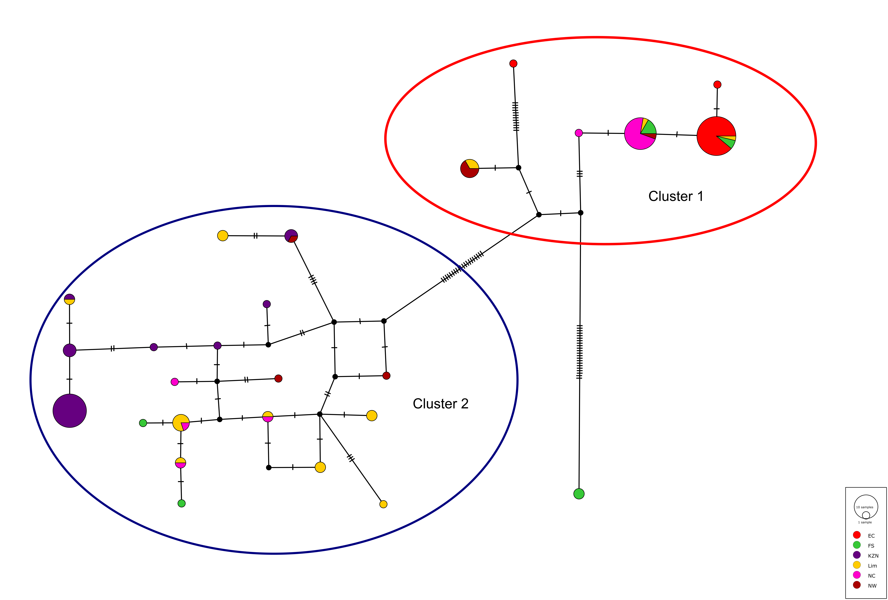

Supplementary Figure S1. The median joining haplotype network representing the mitochondrial control region (CR) sequence data for 108 kudu samples. The hatch marks between the various nodes is an indication of the number of mutational steps between each haplotype observed. The black nodes represent possible haplotypes not sampled during the current study. The size of the circles indicates the number of individuals associated with that specific haplotype.

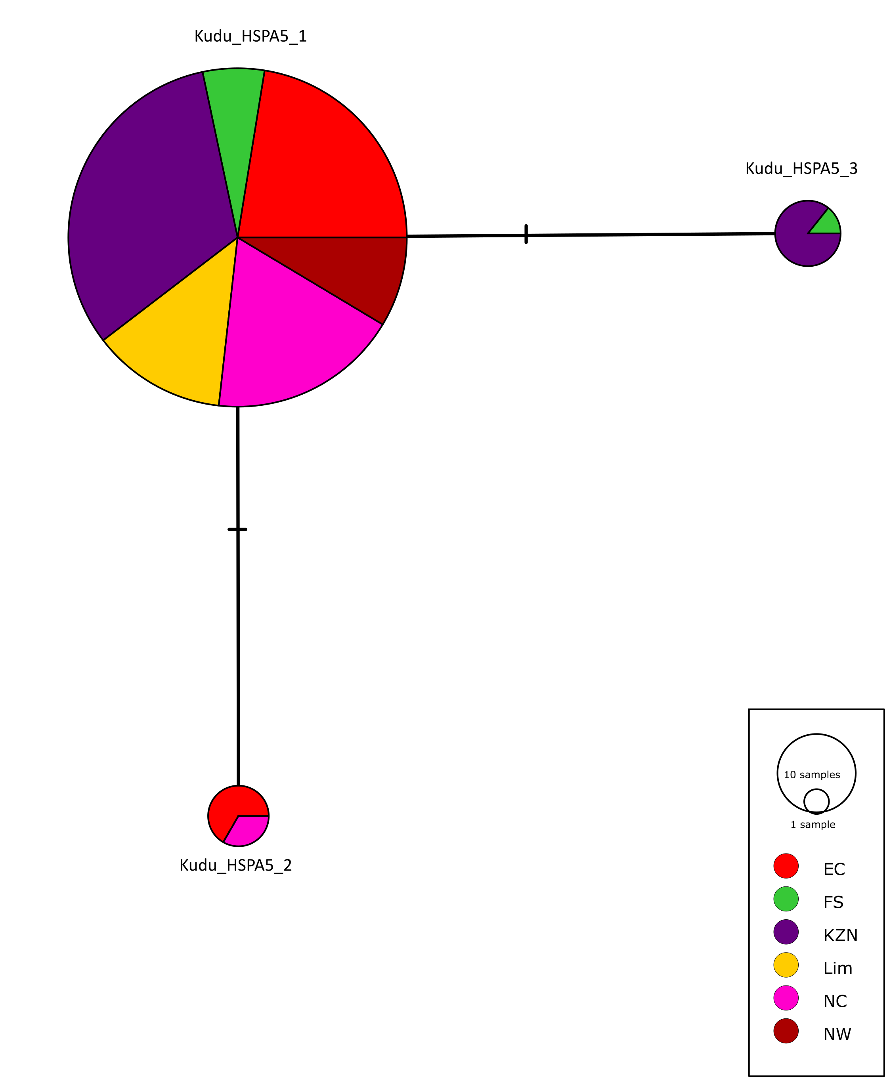
Supplementary Figure S2. The median joining haplotype network for the heat shock protein sub-unit 5 (HSPA5) sequence data obtained from 100 kudu samples. The hatch marks between the various nodes is an indication of the number of mutational steps between each haplotype observed. The size of the circles indicates the number of individuals associated with that specific haplotype.

a)

b)

Supplementary Figure S3. Results of the BMP4 population a) pairwise F_{ST} results and b) Nei’s D presented by a Principal Coordinates Analysis (PCoA) (KZN = KwaZulu-Natal; Lim = Limpopo; EC = Eastern Cape; NC = Northern Cape; FS = Free State; NW = North West)

