SUPPLEMENTARY INFORMATION

Diana Vasconcelos^{1,2}, D. James Harris^{1,3}, Isabel Damas-Moreira⁴, Ana Pereira^{1,2,3}, Raquel Xavier^{1,3*}

1 CIBIO, Centro de Investigação em Biodiversidade e Recursos Genéticos, InBIO Laboratório Associado, Campus de Vairão, Universidade do Porto, Portugal
2 Departamento de Biologia, Faculdade de Ciências, Universidade do Porto, Portugal
3 BIOPOLIS Program in Genomics, Biodiversity and Land Planning, CIBIO, Campus de Vairão, Portugal
4 Behavioural Ecology Department, Bielefeld University, Germany

*corresponding author: raq.xavier@cibio.up.pt

Supplementary material

Supplementary Figure 1: Abundance of Corynebacterium in the gut microbiota of males and females of Podarcis bocagei and Podarcis lusitanicus from Moledo.
Supplementary Figure 2: Boxplots depicting the significant differences in the abundance of the main bacterial genera (> 1% of all sequences) among species collected in Lisbon (Podarcis siculus, Podarcis virescens and Teira dugesii)
Supplementary Figure 3: Boxplots depicting the abundance of the main bacterial genera (> 1% of all sequences) for which species*sex was significant in species collected from Lisbon (Podarcis siculus, Podarcis virescens and Teira dugesii).
Supplementary Figure 4: Linear regression plot between size (SVL) and gut bacterial alpha-diversity (Shannon index) for Podarcis siculus. The coloured area represents the 95% confidence limit.

Supplementary Figure 1

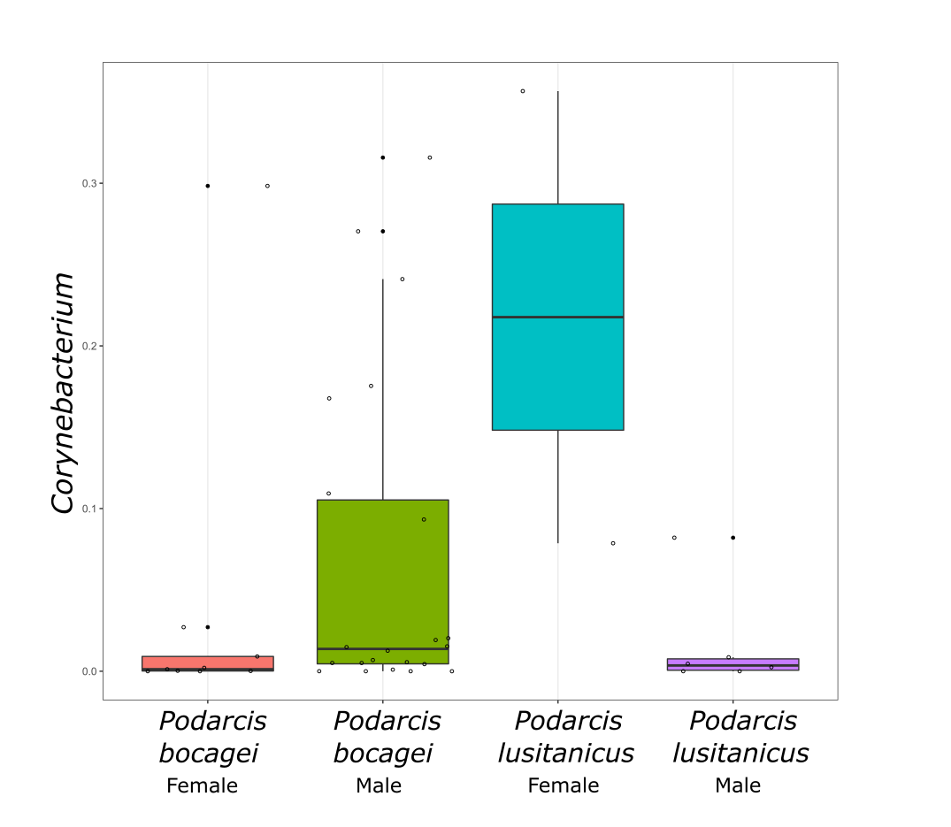

Supplementary Figure 2
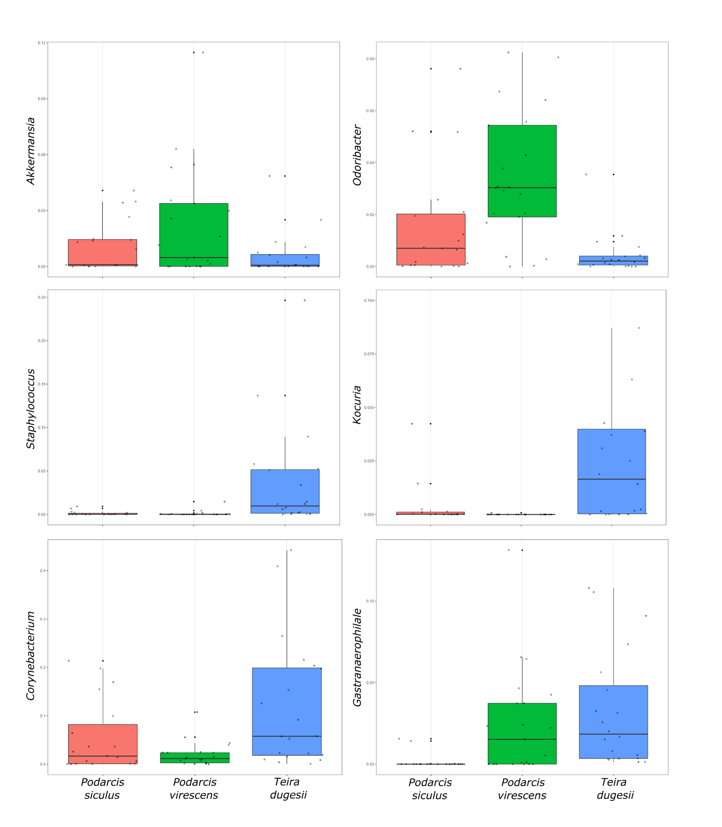

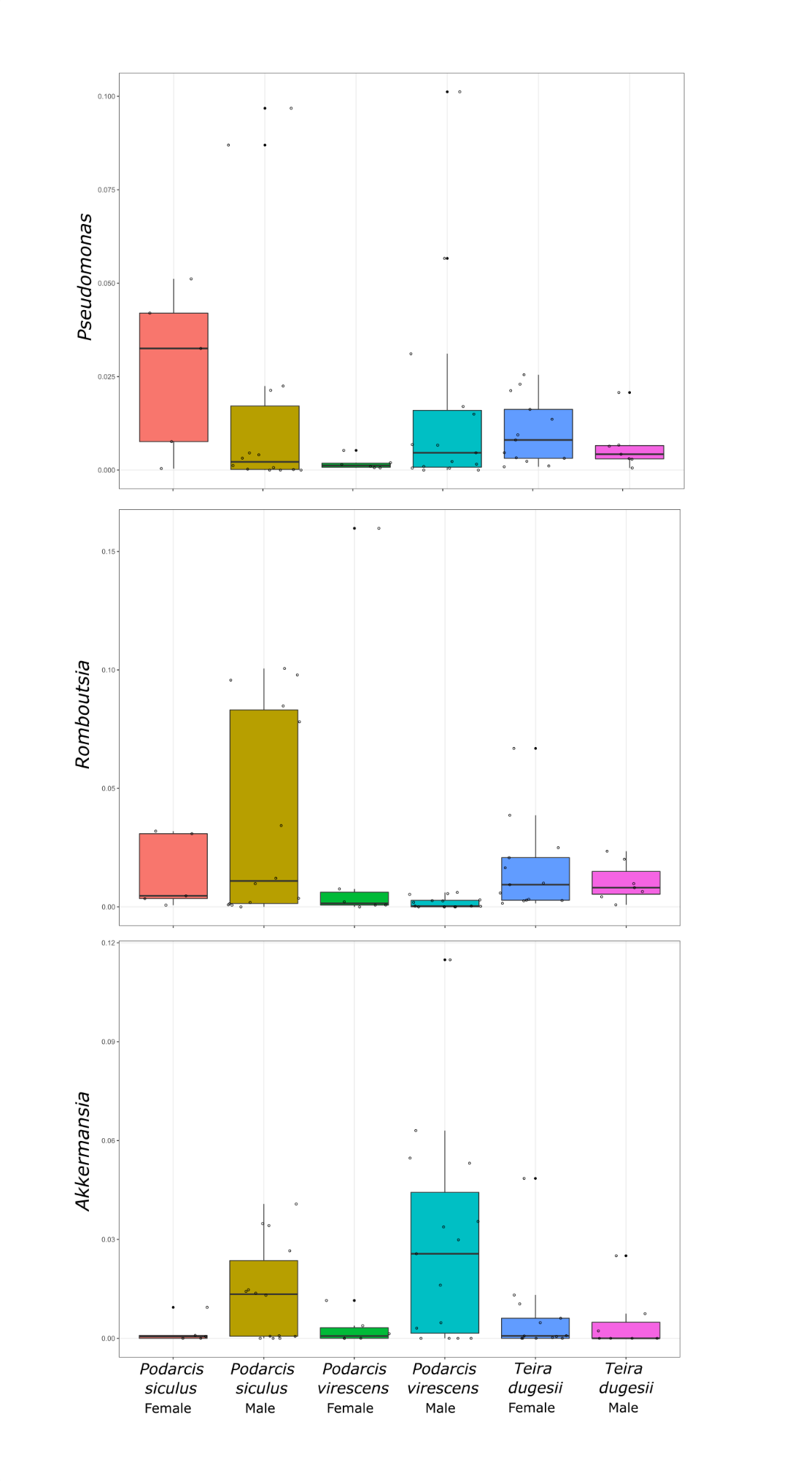
Supplementary Figure 3

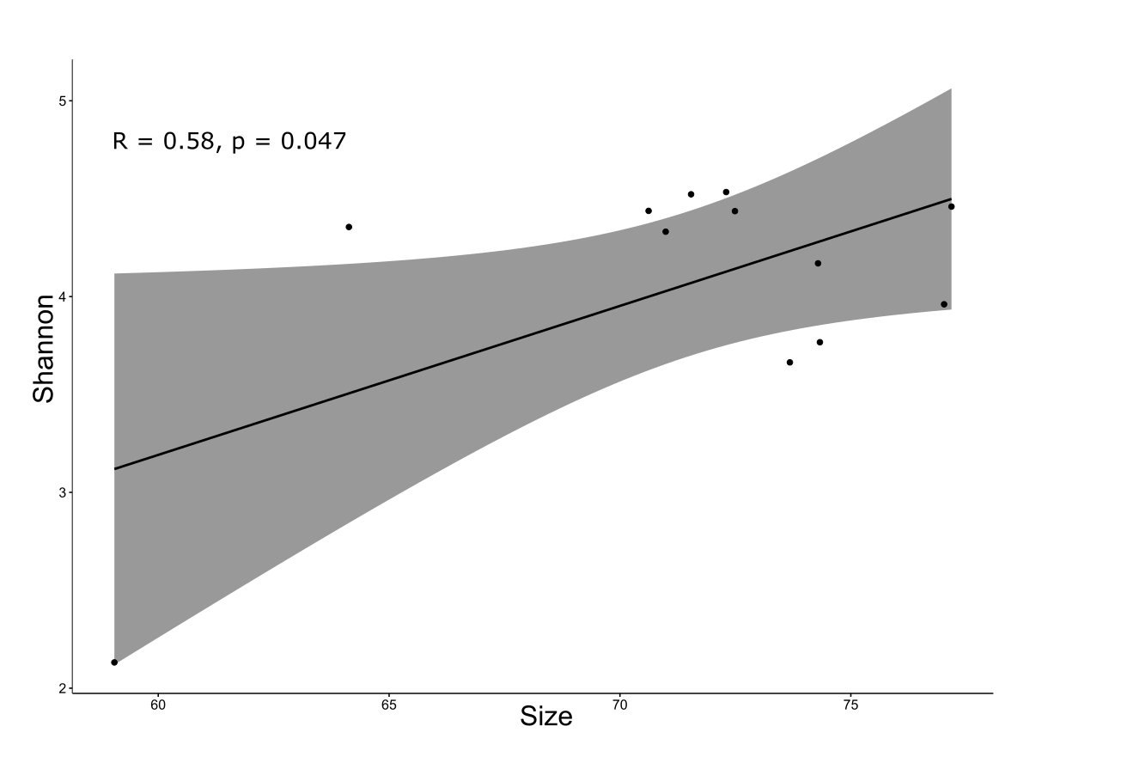
Supplementary Figure 4

