Electronic Supporting Information (ESI)

Impact of Ultraviolet-Absorbing 2-hydroxy-4-quaternaryammoniumalkoxy benzophenone motif on photodegradation of Disulfoton: A case study

Pradeep T Deota,*^{[a]} Hemant S Parmar,^{[b]} Gautam M Patel,^{[c]} and Gaurang J Bhatt^{[a]}

ªApplied Chemistry Department
Faculty of Technology & Engineering
The Maharaja Sayajirao University of Baroda, Vadodara-390 001, Gujarat, India.

^{b}Solaris Chem Tech Industries limited, Vadodara, India.

^{c}Department of Industrial Chemistry, Institute of Science and Technology for Advanced Studies and Research (ISTAR), CVM University, 388120, V.V. Nagar, Gujarat, India

*Corresponding authors’ e-mail: ptdeota-appchem@msubaroda.ac.in or deotapt@yahoo.com (Prof P T Deota).

TABLE OF CONTENTS

Section Contents

- Experimental procedures with spectral data

- Spectral Data

- References associated with SI

SECTION 1 EXPERIMENTAL PROCEDURES WITH SPECTRAL DATA

Experimental Procedures:

General Information
Disulfoton (99 %) was purchased from the Fluka while the rest of the chemicals and HPLC solvents were purchased from Glaxo (Qualigens) India Ltd. All the chemicals and solvents were used without further purification. Melting points were recorded in open capillary tubes and are uncorrected. Ultraviolet spectra were recorded on a Perkin-Elmer Lambda-19 Spectrometer. Infrared spectra were recorded on a Perkin-Elmer PC-16 FTIR Spectrophotometer. PMR (300/400 MHz) spectra and ¹³CMR (75.5 MHz) were recorded either on a Bruker 300-FTNMR or Bruker AC-400-FTNMR using CDCl₃ or (mixture of CDCl₃ and DMSO) as solvent containing tetramethylsilane as an internal standard. Microanalyses were performed on a Perkin-Elmer 2400 series II instrument. Column chromatography was performed using Acme’s silica gel (60–120 mesh size) and the elution was done using mixture of light petroleum and ethyl acetate. The percent yields are reported based on the isolated material after column chromatography. Thin layer chromatography was performed using Acme’s silica gel for TLC and spots were visualized in iodine vapour.

Standard solutions
Standard solution of pure disulfoton (0.5 g/L) was prepared in molar ratio of 1:0 (no UV absorber) in methanol: water (1:1 v/v). Similarly, solutions of four different quaternary ammonium salts (2, 4, 6, 8) were prepared in methanol: water (1:1 v/v) with disulfoton: UV absorbers (1:1 molar). All the quaternary ammonium salts were soluble in water at room temperature and gave clear solutions. The solutions were stored in amber colored bottles between 0° - 4 °C and the disulfoton content in each of the solutions was determined by analytical HPLC.

Irradiation experiments
Solutions of pure disulfoton with and without UV absorbers prepared as above, were placed in a Pyrex immersion–well type of a photochemical reactor and were irradiated separately using a medium- pressure mercury vapor lamp (250 W) (MPMV) for 12 h at a distance 3.8 cm from the light source. The irradiated solutions were withdrawn (5 mL) after 12 h of exposure and diluted with the solvent and were analysed for their remaining disulfoton content by analytical HPLC. Control samples were also irradiated and analysed similarly.

Quantitative analysis of disulfoton
Identification and quantitative analysis of the insecticide and its photoproduct in the sample-solution before and after light exposure was done using a UV-1000, P-200 Spectra-Physics, high performance liquid chromatography (HPLC) equipped with a UV-100 variable wavelength UV-Visible detector. The HPLC column was fitted with a 4.6 mm ID × 250 mm length, Hypersil ODS and 5 micron particle size. The mobile phase consisted of a mixture of acetonitrile and water (60: 40 v/v).

General procedure for the monoalkylation of 2,4-dihydroxybenzophenone (2,4,6,8)^{[1]}
A mixture of 2,4-dihydroxybenzophenone (1) (0.1 mol), anhydrous potassium carbonate (0.15 mol) and an appropriate alkylidene dibromide (0.15 mol each) in dry acetone (200 mL) was refluxed in water bath for 8 to 10 h. In the case of longest chain (n = 12), the refluxing period was extended upto 16 h. After completion of the reaction, solvent was removed under reduced pressure and ice-cold water (100 mL) were added to the contents. The aqueous layer was extracted with ethyl acetate (3 × 50 mL) and combined organic extracts were washed with dilute sodium hydroxide solution (3 %) to remove any unreacted 2,4-dihydroxy benzophenone (1) followed by washing with water (25 mL) and brine solution (15 mL). Drying over anhydrous sodium sulphate followed by removal of solvent under reduced pressure furnished a dark yellow residue, which was chromatographed using mixture of light petroleum and ethyl acetate (96:4) to furnish the monoalkylated 2-hydroxy-4-alkoxybenzophenones (2, 4, 6, 8).

General procedure for the synthesis of QAUVAs (3, 5, 7, 9)
The quaternary ammonium salts (3, 5, 7, 9) were prepared by refluxing the corresponding monoalkylated compounds (2, 4, 6, 8, 0.1 mol each) with trimethylamine (0.18 mol) in dry ethanol (185 mL) for 96 h to 102 h. At the end of this period, solvent was removed under reduced pressure from the reaction mixture and the solid thus obtained was recrystallized several times using 5 % (v/v) methanol in dry acetone to obtain a water-soluble white solid.

(4-(2-bromoethoxy)-2-hydroxyphenyl)(phenyl)methanone (2)
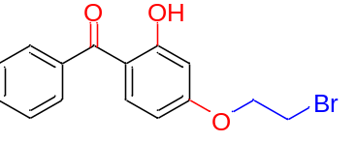
White crystalline solid (63.82 %); mp 93°C; δH (400 MHz, CDCl3): 12.64 (sharp S, 1H of –OH at C2), 7.61 (d, 2H at C2’ and C6’), 7.56 (t, merged, 1H at C4’), 7.50 (d, 1H at C6), 7.45 (t, 2H at C3’ and C5’), 6.49 (d, 1H at C5), 6.42 (dd, J = 1 Hz 1H at C3), 4.33 (t, 2H at –O-CH₂-), 3.64 (t, 2H at -CH₂-Br); ¹³CNMR (75.5 MHz, CDCl3): 28.42 (-CH₂-Br), 67.91 (-O-CH₂-), 101.83 (C3 carbon), 107.53 (C5 carbon), 113.60 (C1 carbon), 128.35 (two carbon at C3’ and C5’), 128.89 (two carbon at C2’ and C6’), 131.61 (C6 carbon), 135.44 (C4’ carbon), 138.15 (C1’ carbon), 164.51 (C2 carbon), 166.20 (C4 carbon), 200.07 (–C=O). ν_{max}: 2961, 1628, 1598, 1275, 1228, 1191, 1077, 1024, 751 and 580 cm⁻¹; UV (λ_{max}): 320 nm; Elemental analysis calcd (%) for C₁₅H₁₃O₃Br: Found C; 56.23 %, H; 3.97 % requires C; 56.07 %, H; 4.07 %.

2-(4-Benzoyl-3-hydroxyphenoxy)ethyl]trimethylammoniumbromide (3)

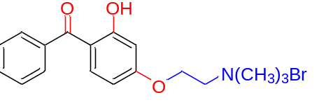
White crystalline solid (53.71 %); mp 111°C; δH (400 MHz, CDCl₃+DMSO): 12.49 (sharp S, 1H of –OH at C3), 7.60 (d, merged with t, 2H at C2’ and C6’), 7.59 (t, merged, 1H at C4’), 7.53 (d, merged with t, 1H at C5), 7.51 (t, 2H at C3’ and C5’), 6.64 (d, 1H at C6), 6.52 (dd, J = 1 Hz 1H at C2), 4.63 (t, 2H at –O-CH₂-), 4.13 (t, 2H at -CH₂-N), 3.45 (sharp S, 9H of –CH3×3); ¹³C NMR (75.5 MHz, CDCl3): 53.66 (3 carbons at -CH3×3), 62.13 (-CH₂-N), 64.10 (-O-CH₂-), 101.84 (C2 carbon), 106.88 (C6 carbon), 113.42 (C4 carbon), 127.91 (two carbons at C3’ and C5’), 128.30 (two carbons at C2’ and C6’), 131.33 (C5 carbon), 134.85 (C4’ carbon), 137.32 (C1’ carbon), 164.09 (C3 carbon), 164.99 (C1 carbon), 199.31 (–C=O); ν_{max}: 3016, 2925, 1624, 1593, 1490, 1475, 1198, 1179, 1049, 1036, and 747 cm⁻¹; UV (λ_{max}): 320 nm; Elemental analysis calcd (%) for C₁₈H₂₂O₃NBr: Found C; 56.23 %, H; 5.97 %, N; 3.24 requires C; 56.84 %, H; 5.78 %, N; 3.68 %.

4-(4-bromobutoxy)-2-hydroxyphenyl)(phenyl)methanone (4)

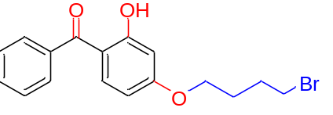

White crystalline solid (61.32 %); mp 84°C; δH(400 MHz, CDCl₃): 12.64 (sharp S, 1H of –OH at C2), 7.60 (d, 2H at C2’ and C6’), 7.54 (t, merged, 1H at C4’), 7.53 (d, 1H at C6), 7.47(t, 2H at C3’ and C5’), 6.48 (d, 1H at C5), 6.38 (dd, J = 1 Hz 1H at C3), 4.05 (t, 2H at –O-CH₂-), 3.47 (t, 2H at -CH₂-Br), 2.04 (q, 4H at –CH₂-×2); ¹³C NMR (75.5 MHz, CDCl₃): 27.69, 29.35 (2×–CH₂-), 33.23 (-CH₂-Br), 67.36 (-O-CH₂-), 101.65 (C3 carbon), 107.64 (C5 carbon), 113.20 (C1 carbon), 128.34 (two carbon at C3’ and C5’), 128.89 (two carbon at C2’ and C6’), 131.51 (C6 carbon), 135.33 (C4’ carbon), 138.30 (C1’ carbon), 165.51 (C2 carbon), 166.35 (C4 carbon), 200.03 (–C=O). ν_{max}: 3077, 2941, 1630, 1259, 1231, 1197, 1075,1042, 745, 602 and 533 cm⁻¹; UV (λ_{max}): 320 nm; Elemental analysis cacld (%) for C₁₇H₁₇O₃Br: Found C; 58.80 %, H; 4.50 % requires C; 58.75 %, H; 4.87 %.

(4-(4-Benzoyl-3-hydroxy phenoxy)butyl)trimethylammoniumbromide (5)
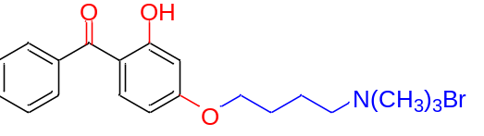
White crystalline solid (54.93 %); mp 168 ºC; δH (400 MHz, CDCl₃+DMSO): 12.54 (sharp S, 1H of –OH at C3), 7.62 (d, merged with t, 2H at C2’ and C6’), 7.57 (t, merged, 1H at C4’), 7.54 (d, merged with t, 1H at C5), 7.49 (t, 2H at C3’ and C5’), 6.52 (d, 1H at C6), 6.46 (dd, J = 1 Hz 1H at C2), 4.15 (t, 2H at –O-CH₂-), 3.66 (t, 2H at -CH2-N), 3.34 (sharp S, 9H at –CH₃×3), 1.93 (q, 4H at central –CH₂-×2); ¹³C NMR (75.5 MHz, CDCl₃): 19.28 and 25.13 (two carbons at –CH₂-×2), 52.53 (three carbons at -CH₃×3), 65.22 (-CH₂-N), 66.87 (-O-CH₂-), 101.36 (C2 carbon), 107.02 (C6 carbon), 112.66 (C4 carbon), 127.88 (two carbon at C3’ and C5’), 128.24 (two carbon at C2’ and C6’), 131.17 (C5 carbon), 134.78 (C4’ carbon), 137.50 (C1’ carbon), 164.77 (C3 carbon), 165.26 (C1 carbon), 199.26 (–C=O); ν_{max}: 3651, 2960, 1636, 1592, 1490, 1264, 1197, 1054, 1016 and 754 cm⁻¹; UV (λ_{max}): 320 nm; Elemental analysis calcd (%) for C₂₀H₂₆O₃NBr: Found C; 58.60 %, H; 6.52 %, N; 3.30 % requires C; 58.82 %, H; 6.37 %, N; 3.43 %.

(4-((6-bromohexyl)oxy)-2-hydroxyphenyl)(phenyl)methanone (6)
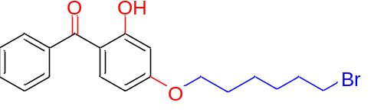
White crystalline solid (65.86 %); mp 64°C; δH (400 MHz, CDCl₃): 12.69 (sharp S, 1H of –OH at C2), 7.60 (d, 2H at C2’ and C6’), 7.53 (t, merged, 1H at C4’), 7.51 (d, 1H at C6), 7.48 (t, 2H at C3’ and C5’), 6.47 (d, 1H at C5), 6.38 (dd, J = 1 Hz 1H at C3), 3.99 (t, 2H at –O-CH₂-), 3.40 (t, 2H at -CH₂-Br), 1.81 (q, 8H at central –CH₂×4); ¹³C NMR (75.5 MHz, CDCl₃): 25.11, 27.76, 28.69, 32.53 ( 4 carbons at –CH₂-×4), 33.67 (-CH₂-Br), 68.09 (-O-CH₂-), 101.48 (C3 carbon), 107.57 (C5 carbon), 112.90 (C1 carbon), 128.19 (2 carbons at C3’ and C5’), 128.75 (2 carbons at C2’ and C6’), 131.35 (C6 carbon), 135.14 (C4’ carbon), 138.18 (C1’ carbon), 165.62 (C2 carbon), 166.24 (C4 carbon), 199.77 (–C=O). ν_{max}: 3050, 2936, 1629, 1597, 1261, 1226, 1197, 1073, 1041, 742, 603 and 568 cm⁻¹; UV (λ_{max}): 320 nm; Elemental analysis calcd (%) for C₁₉H₂₁O₃Br: Found C; 60.38 %, H; 5.35 % requires C; 60.77 %, H; 5.57 %.

(6-(4-Benzoyl-3-hydroxy phenoxy)hexyl)trimethyl ammoniun bromide (7)
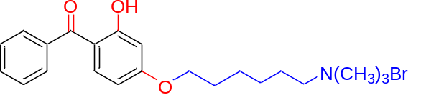
White crystalline solid (57.28 %); mp 162 ºC; δH (400 MHz,CDCl₃+DMSO) 12.54 (sharp S, 1H of – OH at C3), 7.60 (d, merged with t, 2H at C2’ and C6’), 7.56 (t, merged, 1H at C4’), 7.53 (d, merged with t, 1H at C5), 7.48 (t, 2H at C3’ and C5’), 6.47 (d, 1H at C6), 6.44 (dd, J = 1 Hz 1H at C2), 4.04 (t, 2H at –O-CH₂-), 3.56 (t, 2H at -CH₂-N), 3.31 (sharp S, 9H at –CH₃×3), 1.78 (q, 8H at central –CH₂-×4); ¹³C NMR (75.5 MHz, CDCl₃): 22.29, 24.90, 25.23, 28.03 (4 carbons at –CH₂-×4), 52.57 (3 carbons at –CH₃×3), 65.72 (-CH₂-N), 67.53 (-O-CH₂-), 101.14 (C2 carbon), 107.02 (C6 carbon), 112.42 (C4 carbon), 127.83 (2 carbons at C3’ and C5’), 128.20 (2 carbons at C2’ and C6’), 131.07 (C5 carbon), 134.75 (C4’ carbon), 137.53 (C1’ carbon), 165.10 (C3 carbon), 165.39 (C1 carbon), 199.28 (–C=O); ν_{max}: 3000, 2945, 1686, 1638, 1574, 1502, 1471, 1264, 1197, 1165, 1076, 1040 and 744 cm⁻¹; UV (λ_{max}): 320 nm; Elemental analysis calcd (%)for C₂₂H₃₀O₃NBr: Found C; 60.92 %, H; 6.95 %, N; 2.97 % requires C; 60.55 %, H; 6.88 %, N; 3.21 %.

(4-((12-bromododecyl)oxy)-2-hydroxyphenyl)(phenyl)methanone (8)
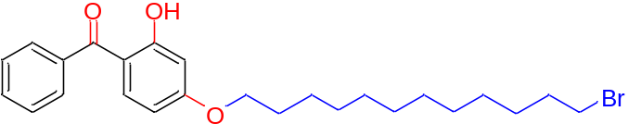
White crystalline solid (48.29 %); mp 62°C; δH (300 MHz, CDCl3): 12.68 (sharp S, 1H of –OH at C2), 7.60 (d, 2H at C2’ and C6’), 7.55 (t, merged, 1H at C4’), 7.53 (d, 1H at C6), 7.49 (t, 2H at C3’ and C5’), 6.48 (d, 1H at C5), 6.38 (dd, J = 1 Hz 1H at C3), 3.99 (t, 2H at –O-CH₂-), 3.38 (t, 2H at -CH₂-Br), 1.43 (q, 20H at central –CH₂-×10); ¹³C NMR (75.5 MHz, CDCl₃): 25.94, 28.17, 28.76, 28.97, 29.31, 29.43, 29.51, 32.84 (10 carbons at –CH₂-×10), 34.01 (-CH₂-Br), 68.48 (-O-CH₂-), 101.53 (C3 carbon), 107.74 (C5 carbon), 112.97 (C1 carbon), 128.27 (2 carbons at C3’ and C5’), 128.85 (2 carbons at C2’ and C6’), 131.39 (C6 carbon), 135.19 (C4’ carbon), 138.34 (C1’ carbon), 165.86 (C2 carbon), 166.37 (C4 carbon), 199.88 (–C=O); ν_{max}: 3049, 2948, 1629, 1595, 1262, 1046, 748 and 542 cm⁻¹; UV (λ_{max}): 320 nm; Elemental analysis calcd (%) for C₂₅H₃₃O₃Br: Found C; 65.53 %, H; 6.89 % requires C; 65.07 %, H; 7.15 %.

(12-(4-Benzoyl-3-hydroxy phenoxy)dodecyl)trimethylammoniumbromide (9)
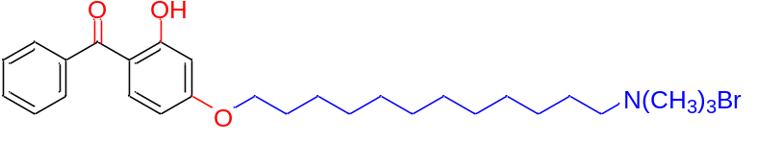
White crystalline solid (43.52 %); mp 144 ºC; δH (400 MHz, CDCl₃+DMSO): 12.59 (sharp S, 1H of –OH at C3), 7.61 (d, merged with t, 2H at C2’ and C6’), 7.57 (t, merged, 1H at C4’), 7.53 (d, merged with t, 1H at C5), 7.50 (t, 2H at C3’ and C5’), 6.47 (d, 1H at C6), 6.43 (dd, J = 1 Hz 1H at C2), 4.03 (t, 2H at –O-CH₂-), 3.47 (t, 2H at -CH₂-N), 3.27 (sharp S, 9H at –CH₃×3), 1.55 (q, 20H at central –CH₂-×10); ¹³C NMR (75.5 MHz, CDCl₃): 22.35, 25.23, 25.56, 28.26, 28.47, 28.58, 28.76 (10 carbons at –CH₂-×10), 52.47 (3 carbons at -CH₃×3), 65.89 (-CH₂-N), 67.87 (-O-CH₂-), 101.10 (C2 carbon), 107.03 (C6 carbon), 112.32 (C4 carbon), 127.80 (2 carbons at C3’ and C5’), 128.16 (2 carbons at C2’ and C6’), 131.01 (C5 carbon), 134.69 (C4’ carbon), 137.55 (C1’ carbon), 165.25 (C3 carbon), 165.40 (C1 carbon), 199.22 (–C=O); ν_{max}: 3013, 2923, 1630, 1507, 1468, 1284, 1265, 1194, 1165, 1035 and 745 cm⁻¹. UV (λ_{max}): 320 nm; Elemental analysis calcd (%) for C₂₈H₄₂O₃NBr: Found C; 64.55 %, H; 8.10 %, N; 2.51 % requires C; 64.61 %, H; 8.07 %, N; 2.69 %.

SECTION 2 ¹H and ¹³C NMR SPECTRA

¹H NMR of (4-(2-bromoethoxy)-2-hydroxyphenyl)(phenyl)methanone (2)

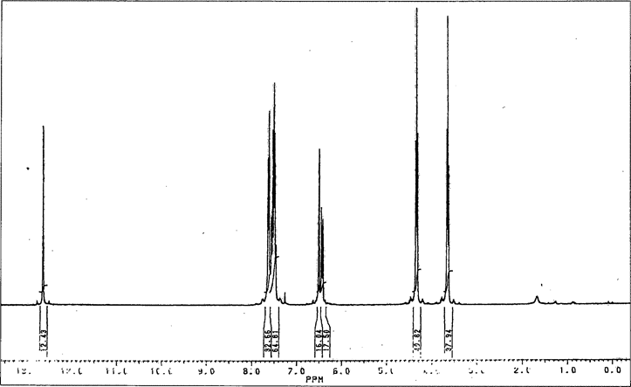

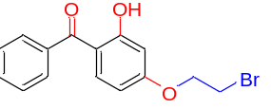

¹³C NMR of (4-(2-bromoethoxy)-2-hydroxyphenyl)(phenyl)methanone (2)

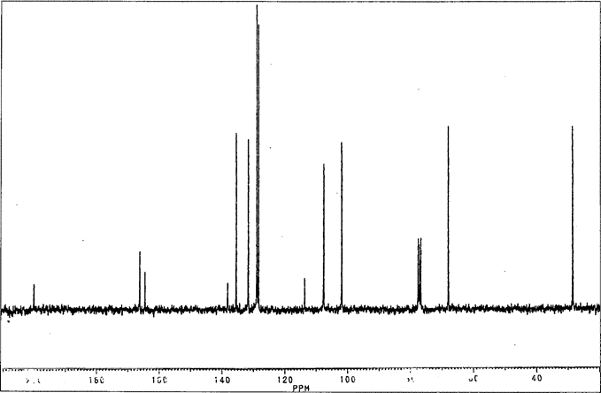

¹H of 2-(4-Benzoyl-3-hydroxyphenoxy)ethyl]trimethylammoniumbromide (3)

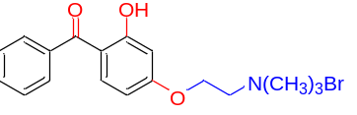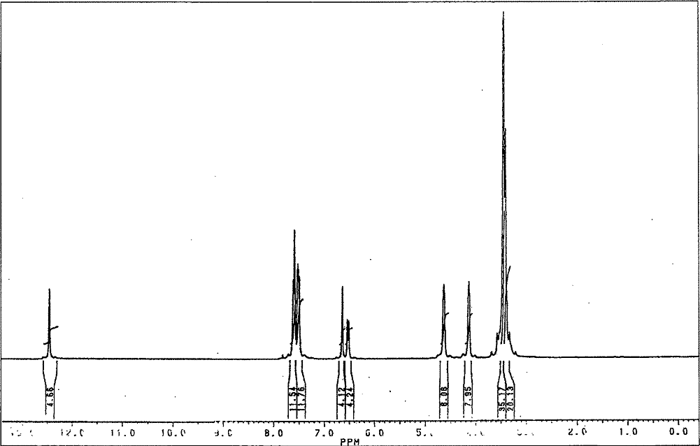

¹³C of 2-(4-Benzoyl-3-hydroxyphenoxy)ethyl]trimethylammoniumbromide (3)

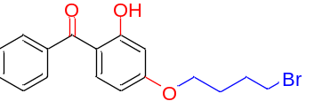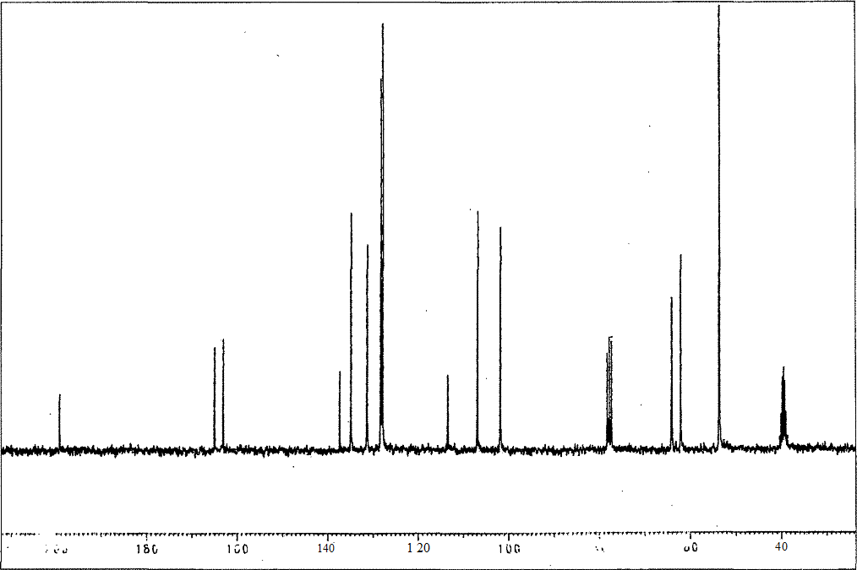

¹H of 4-(4-bromobutoxy)-2-hydroxyphenyl)(phenyl)methanone (4)

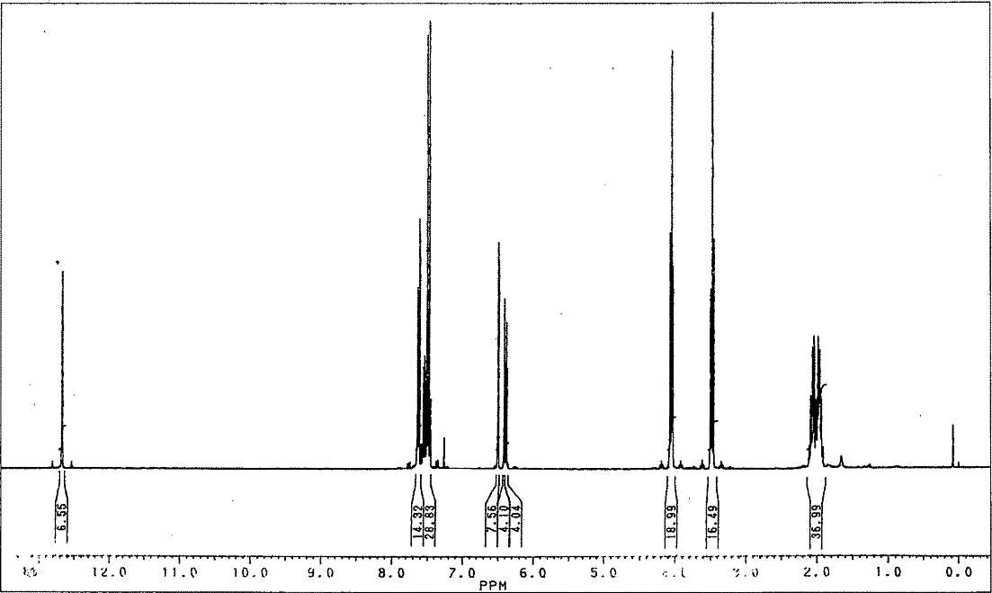

¹³C of 4-(4-bromobutoxy)-2-hydroxyphenyl)(phenyl)methanone (4)

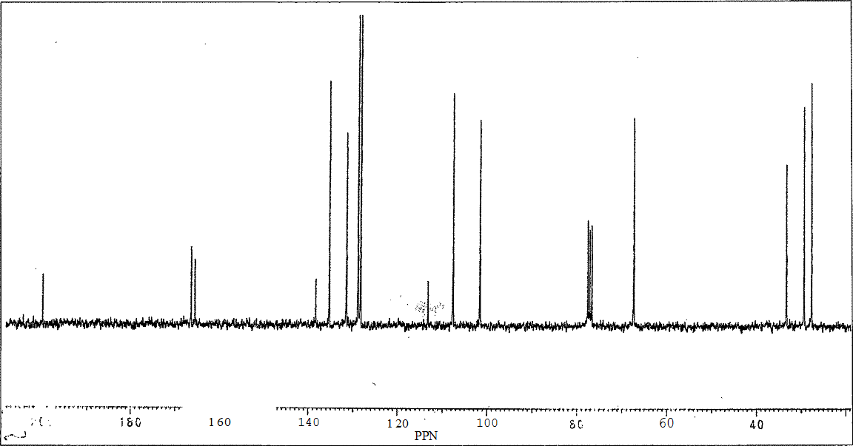

¹H of (4-(4-Benzoyl-3-hydroxy phenoxy)butyl)trimethylammoniumbromide (5)
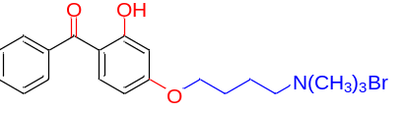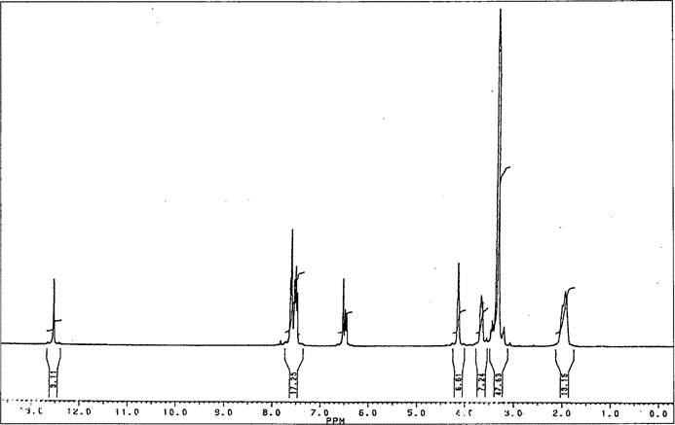

¹³C of (4-(4-Benzoyl-3-hydroxy phenoxy)butyl)trimethylammoniumbromide (5)
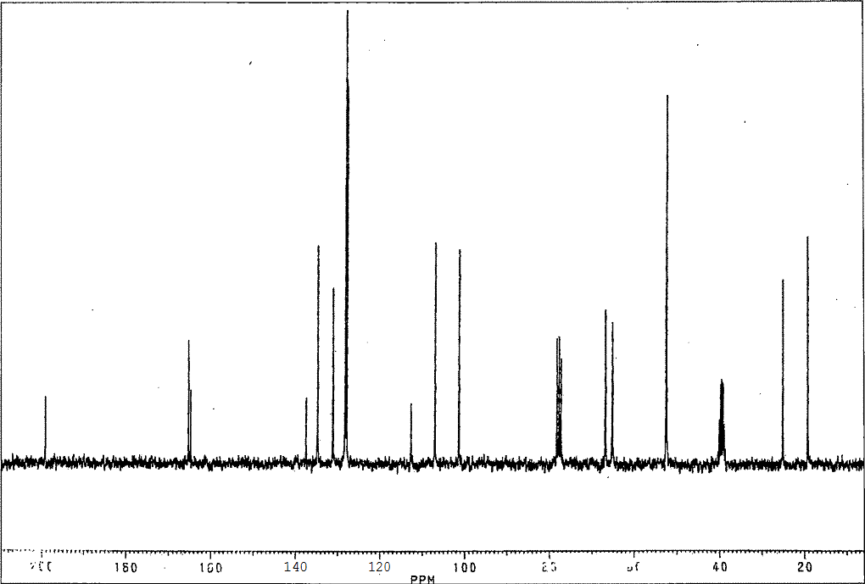

¹H of (4-((6-bromohexyl)oxy)-2-hydroxyphenyl)(phenyl)methanone (6)
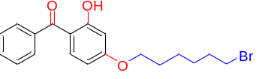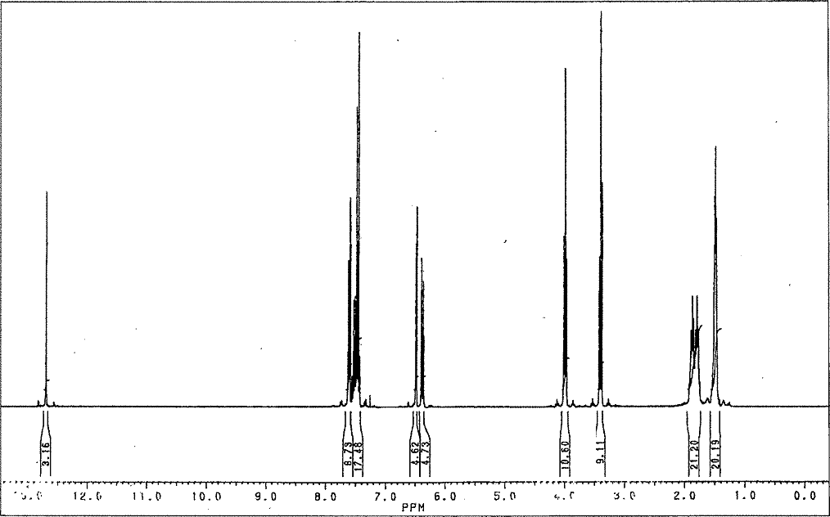
¹³C of (4-((6-bromohexyl)oxy)-2-hydroxyphenyl)(phenyl)methanone (6)
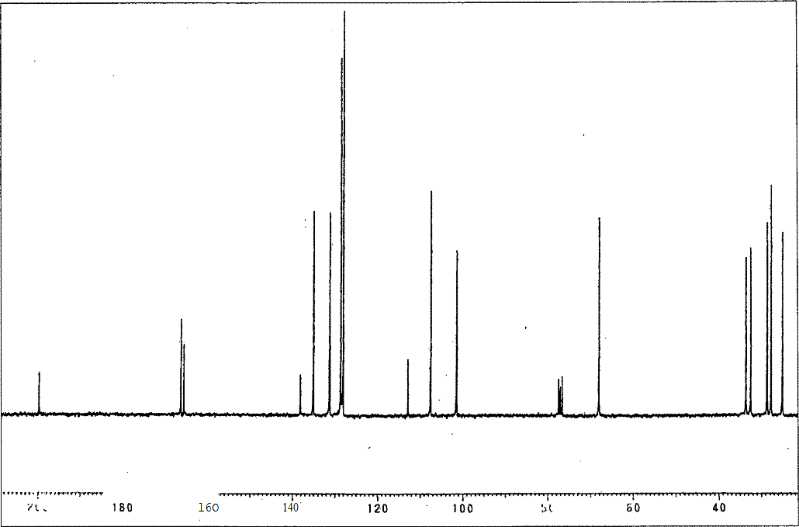

¹H of (6-(4-Benzoyl-3-hydroxy phenoxy)hexyl)trimethyl ammoniun bromide (7)
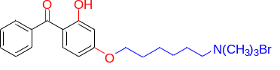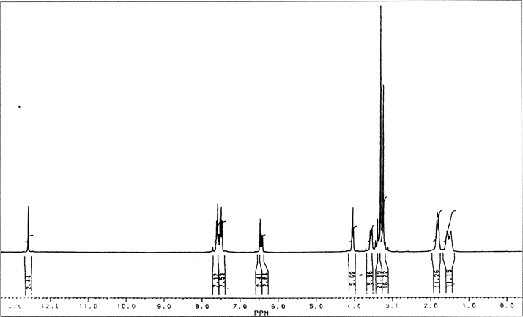
¹³C of (6-(4-Benzoyl-3-hydroxy phenoxy)hexyl)trimethyl ammoniun bromide (7)
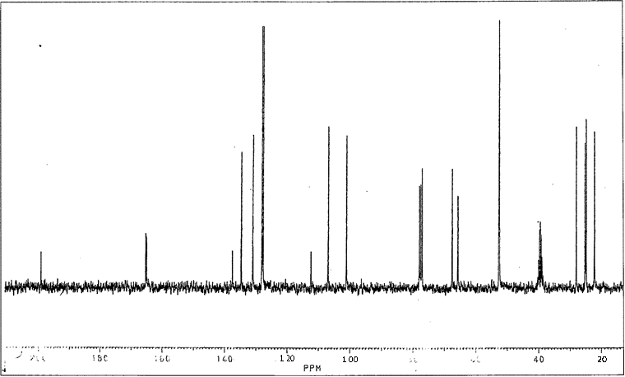

¹H of (4-((12-bromododecyl)oxy)-2-hydroxyphenyl)(phenyl)methanone (8)
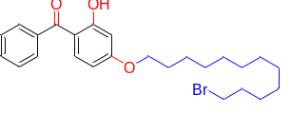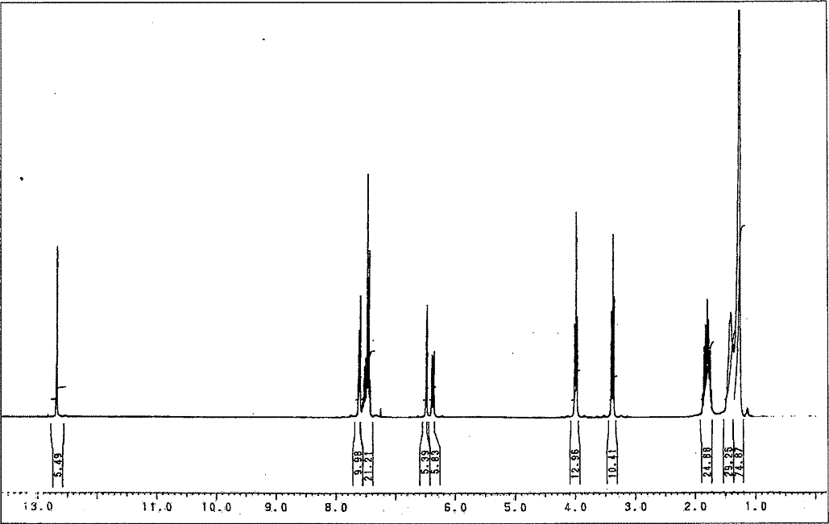
¹³C of (4-((12-bromododecyl)oxy)-2-hydroxyphenyl)(phenyl)methanone (8)
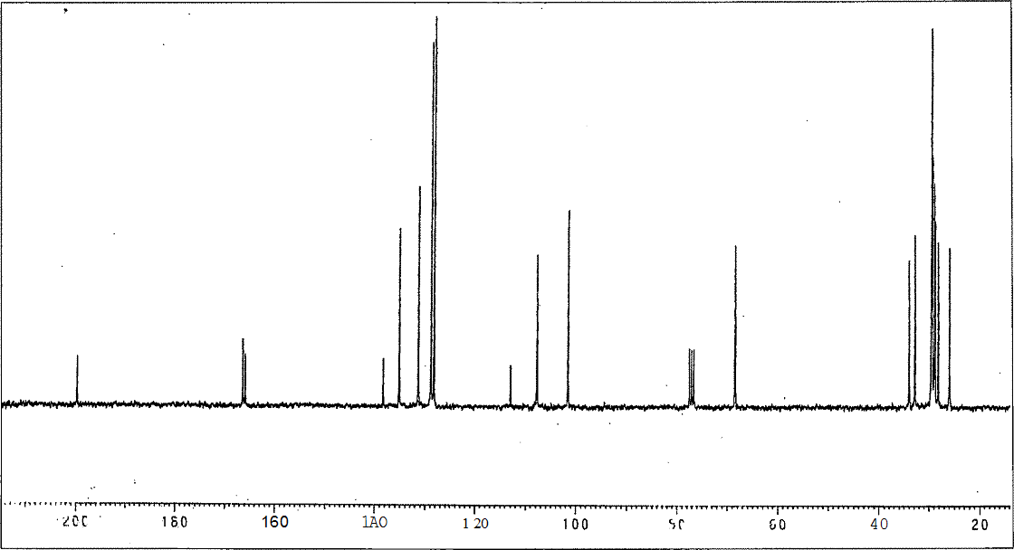
¹H of (12-(4-Benzoyl-3-hydroxy phenoxy)dodecyl)trimethylammoniumbromide (9)
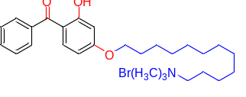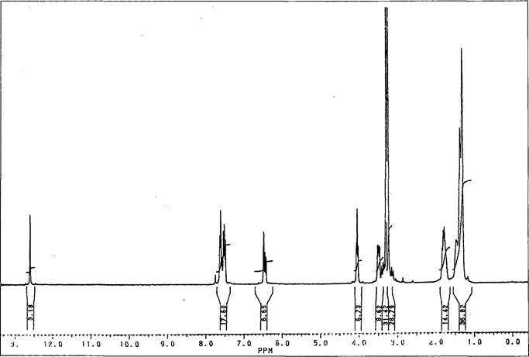

¹³C of (12-(4-Benzoyl-3-hydroxy phenoxy)dodecyl)trimethylammoniumbromide (9)
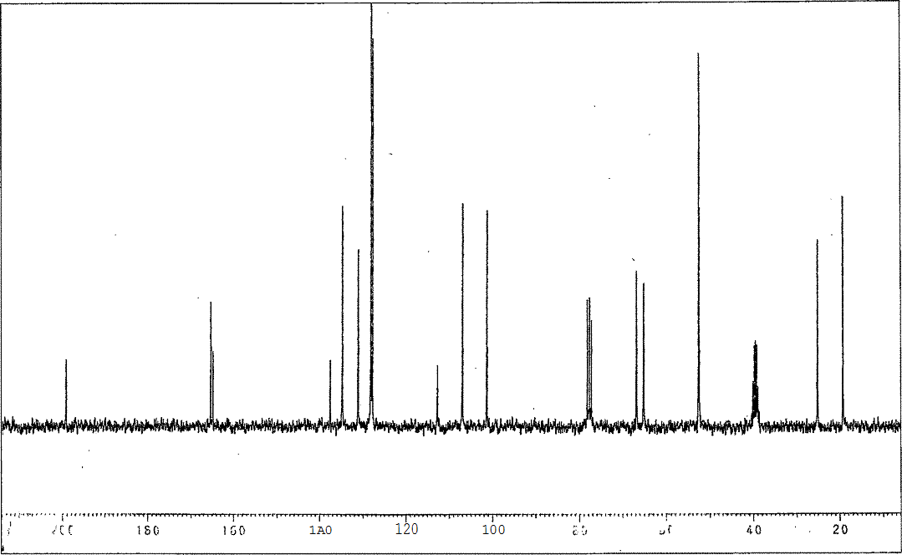

SECTION 3 REFERENCES ASSOCIATED WITH SI

- H. S. Parmar, Ph.D. thesis, The Maharaja Sayajirao University of Baroda (India), 2007.

