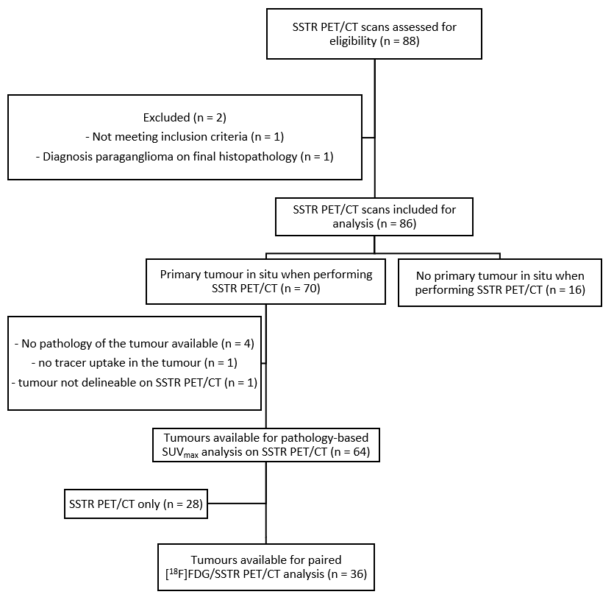
Supplemental figure 1 Consolidated Standards of Reporting Trials (CONSORT) diagram for tumoural SUV_{max} analysis

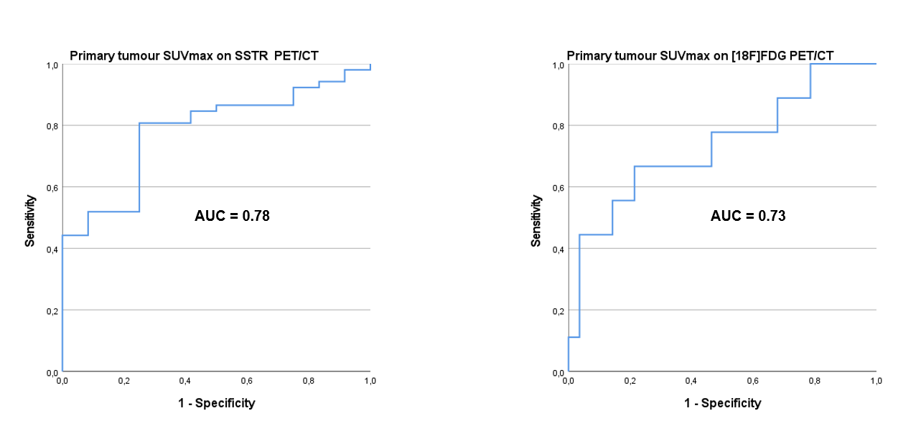
Supplemental figure 2 ROC curve analysis of the sensitivity of non-paired SUV_{max} values in detecting TC on SSTR PET/CT (left curve) and AC on [¹⁸F]FDG PET/CT (right curve), yielding a maximal Youden’s index for detecting TC on SSTR PET/CT at SUV_{max} of 5.1 and for detecting AC on [¹⁸F]FDG PET/CT at SUV_{max} of 4.5 (see dashed reference lines on figure 2)

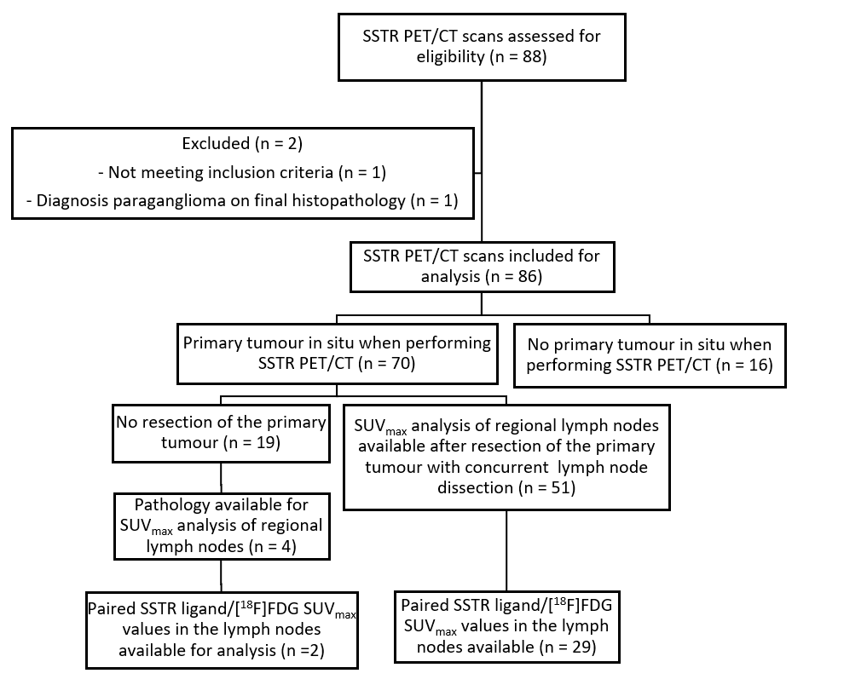
Supplemental figure 3 Consolidated Standards of Reporting Trials (CONSORT) diagram for SUV_{max} analysis of regional lymph nodes
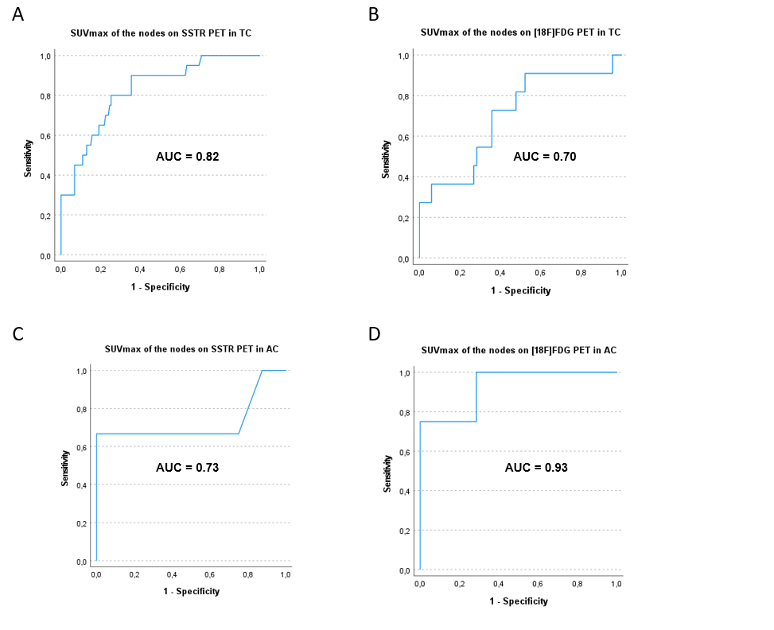
Supplemental figure 4 ROC curve analyses of non-paired SUV_{max} values of mediastinal lymph nodes of typical bronchial carcinoid tumours (TC, upper 2 curves) and atypical bronchial carcinoid tumours (AC, lower 2 curves) with pathological examination as gold standard, reflecting the higher diagnostic accuracy for the detection of mediastinal lymph node metastases of SSTR PET/CT in comparison to [¹⁸F]FDG PET/CT for TC. A: ROC curve analysis of SUV_{max} values on SSTR PET/CT of 167 mediastinal lymph nodes of TC, yielding an area under the curve (AUC) of 0.82. B: ROC curve analysis of SUV_{max} values on [¹⁸F]FDG PET/CT of 78 mediastinal lymph nodes of TC, yielding an AUC of 0.70. C: ROC curve analysis of SUV_{max} values on SSTR PET/CT of 11 mediastinal lymph nodes of AC, yielding an AUC of 0.73. D: ROC curve analysis of SUV_{max} values on [¹⁸F]FDG PET/CT of 11 mediastinal lymph nodes of AC, yielding an AUC of 0.93.

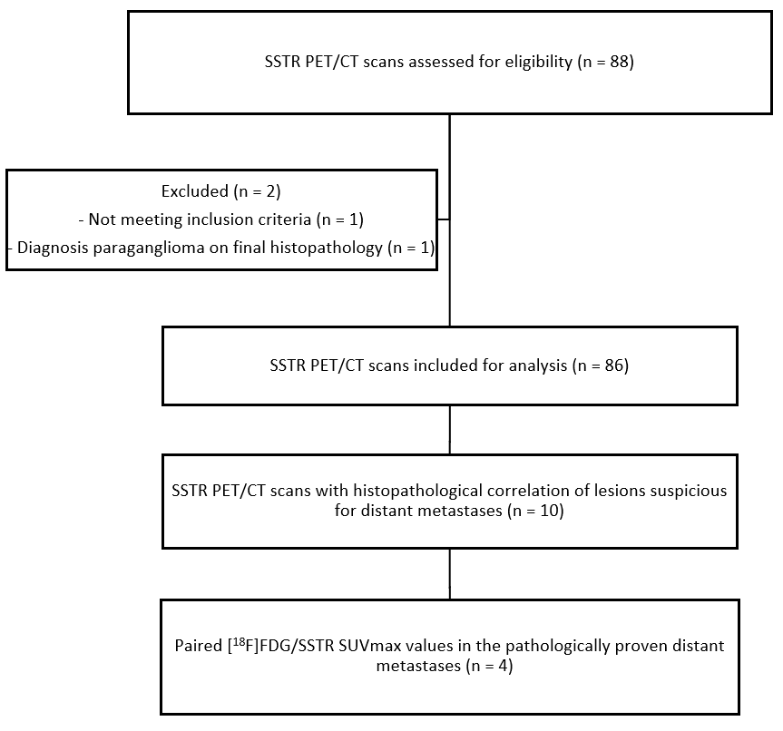
Supplemental figure 5 Consolidated Standards of Reporting Trials (CONSORT) diagram for SUV_{max} analysis of pathologically proven distant metastatic lesions.

