Supporting Information

The Ultra-high Hg⁰ Adsorption Capacity Modified by Selenium

Ye Liuª, Chenglong Maª, Jiacheng Zhouª, Lin Zhuª, Limei Cao^{a,b*}, Ji Yang^{a,b*}

ª State Environmental Protection Key Laboratory of Environmental Risk Assessment and Control on Chemical Processes, School of Resources and Environmental Engineering, East China University of Science and Technology, Shanghai 200237, P. R. China
^{b} Shanghai Institute of Pollution Control and Ecological Security, Shanghai 200092, P. R. China

Table S1. Pore structure parameters and chemical composition of samples
Sample | S_{BET}  (m²/g) | Pore Volume  (cm³/g) | Selenium contents  (wt%)
R-AC | 783.52 | 0.17 | 0
Se_{0.25}/AC | 530.42 | 0.15 | 3.62
Se_{0.5/}AC | 481.73 | 0.12 | 15.29
Se₁/AC | 453.64 | 0.11 | 24.64

Table S2.

Surface | Species | R_{Hg}⁰-M |  | E_{ads} | Reference
Fe/AC | Hg0 | 2.751 | 40.3 |  | [1]
Co/AC | Hg0 | 2.833 | 31.3 |  | [1]
Ni/AC | Hg0 | 2.847 | 30.0 |  | [1]
Cu/AC | Hg0 | 2.734 | 35.9 |  | [1]
Zn/AC | Hg0 | 2.726 | 36.4 |  | [1]
Se@AC | Hg0 | 2.720 | 81.5059 |  | This work

Fig. S1. The SEM of samples: (a) R-AC, (b) Se_{0.25}/AC, (c)(d) used- Se_{0.25}/AC
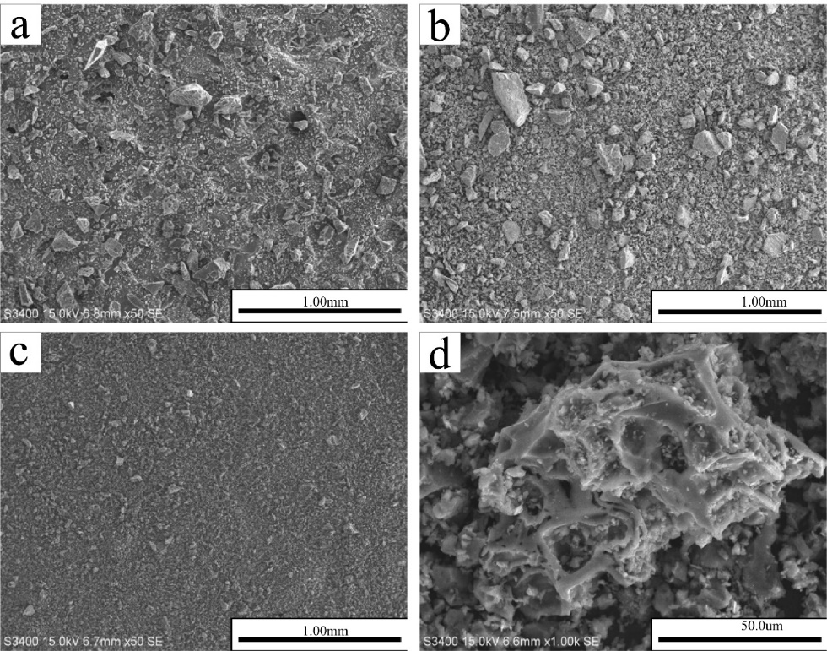

Reference
1. Fan, L.; Ling, L.; Wang, B.; Zhang, R., The adsorption of mercury species and catalytic oxidation of Hg0 on the metal-loaded activated carbon. Applied Catalysis A: General 2016, 520, 13-23.

