Direct observation of spallation bombs during the 2021 La Palma eruption, Canary Islands, Spain

James M.D. Day^{1*}, Harri Geiger², Valentin R. Troll^{3,4}, Francisco J. Perez-Torrado⁴, Meritxell Aulinas⁵, Guillem Gisbert⁵, Juan Carlos Carracedo⁴

¹Scripps Institution of Oceanography, University of California San Diego, La Jolla, CA 92037, USA. Corresponding author: jmdday@ucsd.edu
²Institute of Earth and Environmental Sciences, University of Freiburg, 79104 Freiburg im Breisgau, Germany.
³Uppsala University, Dept. of Earth Sciences, Natural Resources & Sustainable Development, 75236 Uppsala, Sweden
⁴Instituto de Estudios Ambientales y Recursos Naturales (i-UNAT), University of Las Palmas de Gran Canaria (ULPGC), 35017 Las Palmas de Gran Canaria, Spain
⁵Departament de Mineralogia, Petrologia i Geologia Aplicada, University of Barcelona, Marti Franques s/n, 08028, Barcelona, Spain

Supplementary Materials
Supplementary Table S1: Major and trace element abundance data obtained for local tephras and the spallation bomb (LP2106JD) as obtained by ICP-MS.
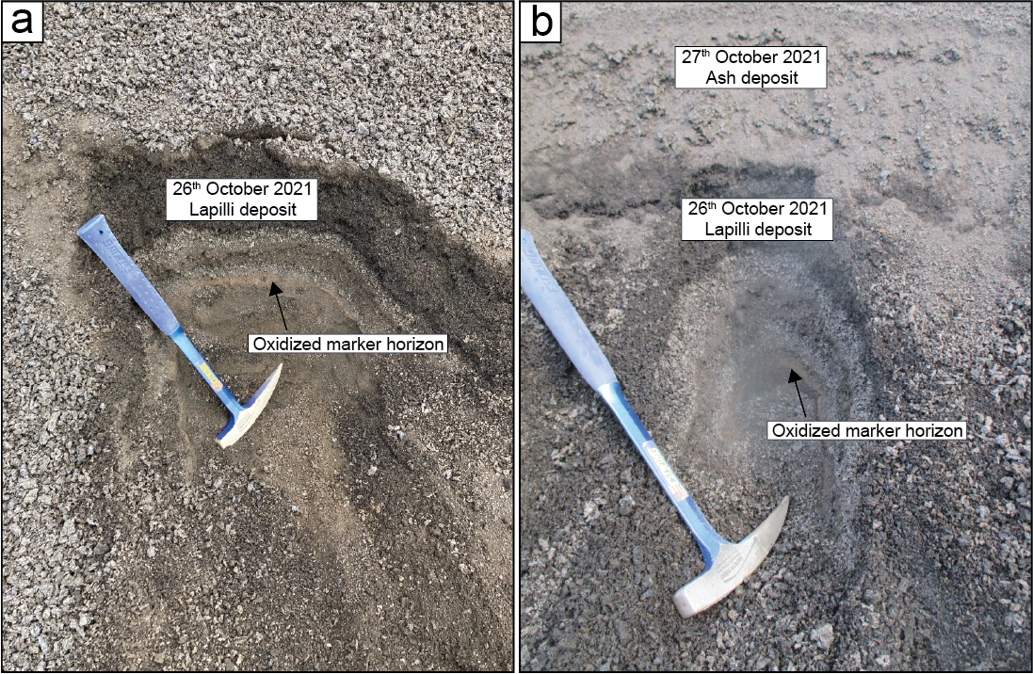
Figure S1 –Pit trenches dug through the local substrate of lapilli and ash on (a) the 26th October 2021 at ~16:00 local time and (b) the 27th October 2021 at ~15:00 local time. Note the presence of around 1cm layer of fine ash at the top of (b). The oxidized marker horizon is known to have fallen at noon on the 16th October 2021, indicating average aggradation rates of 2 cm/day. Hammerhead is 19 cm in length and hammer stem length is 41 cm.
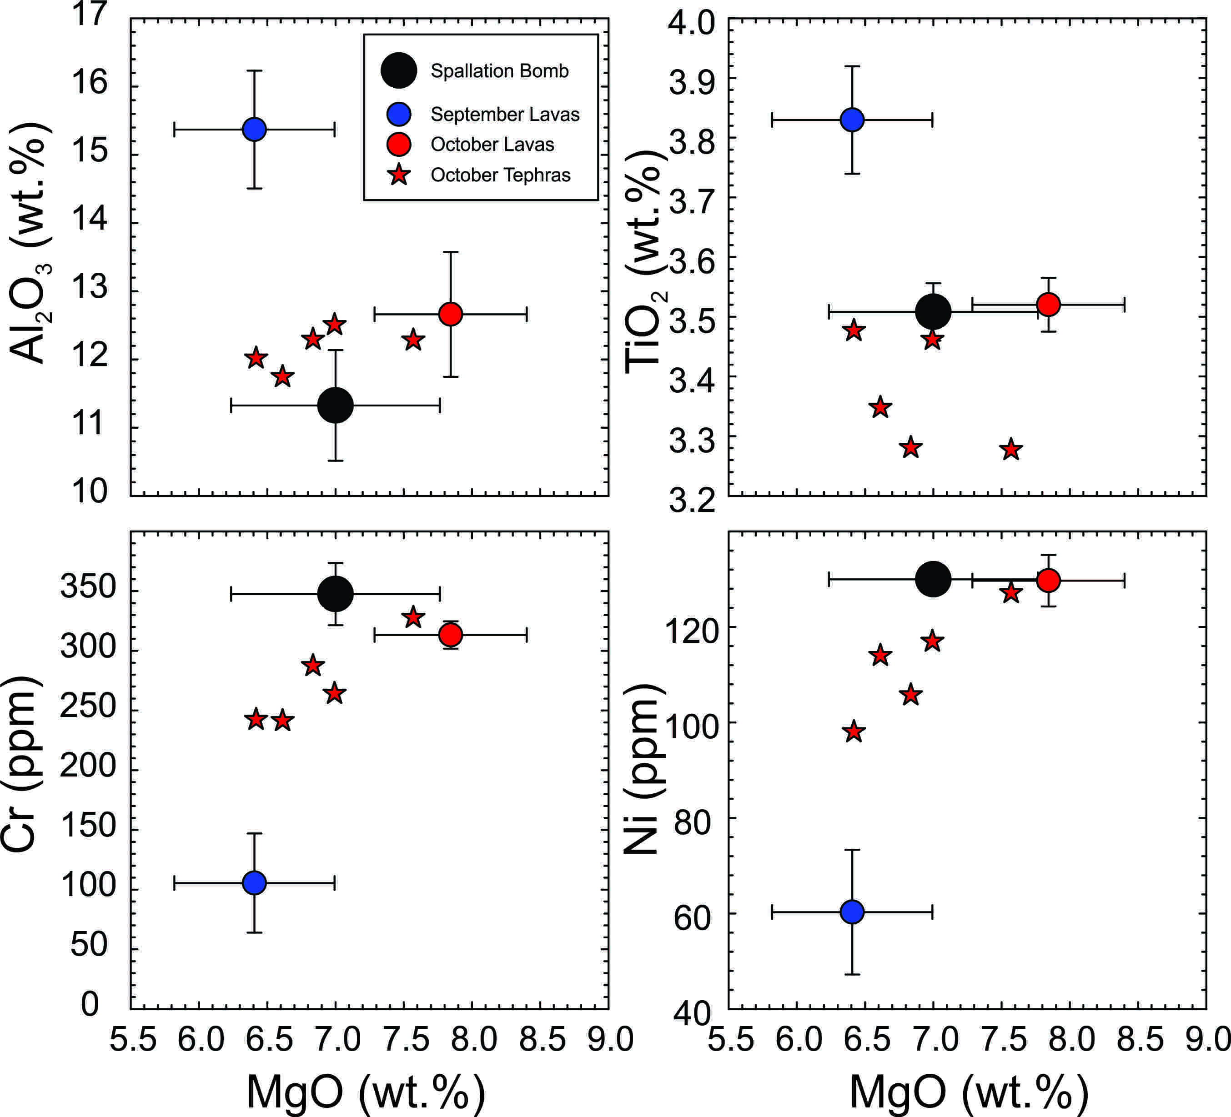
Figure S2: Composition of the spallation bomb (LP2106JD) relative to lavas erupted in September and October, and the tephra layers from Figure 1 as a function of MgO versus Al₂O₃, TiO₂, Cr and Ni content for the samples. Data given in Table S1.

Supplementary Video S1: Image of first (~14:30) spallation bomb track showing >10m distance between bounces.
Supplementary Video S2: Progress of spallation bombs at 14:34 and 14:42 local time, 27th October 2021
Supplementary Video S3: Progress of spallation bomb at 14:54 local time, 27th October 2021
Supplementary Video S4: Progress and close-up view of spallation bomb at 14:56 local time, 27th October 2021
Supplementary Video S5: Footage of the lava bombs from the 1971 Teneguía eruption on La Palma.

