Supplemental information

Synthetic Rashba spin-orbit system
using a silicon metal-oxide semiconductor

Soobeom Lee¹, Hayato Koike², Minori Goto³, Shinji Miwa ^{3, $}, Yoshishige Suzuki³,
Naoto Yamashita¹, Ryo Ohshima¹, Ei Shigematsu¹,
Yuichiro Ando¹ and Masashi Shiraishi^{1, #}
- Department of Electronic Science and Engineering, Kyoto University, Kyoto, Kyoto 615-8510, Japan.
- Advanced Products Development Center, TDK Corporation, Ichikawa, Chiba 272-8558, Japan
- Graduate School of Engineering Science, Osaka University, Toyonaka, Osaka 560-8531, Japan

# Corresponding author: Masashi Shiraishi (shiraishi.masashi.4w@kyoto-u.ac.jp)
$ Present address: Institute for Solid State Physics, The University of Tokyo, Kashiwa, Chiba 277-8581, Japan.

No. 1 Suppression of precessional motion of spins
This section details the data processing method and the discussion about the amplitudes of the magnetic field to dephase the precessional motion of spins. Figure S1(a) shows raw data of spin precession signals as a function of the perpendicular external magnetic field (β = 90°). As seen, a magnetic-field-dependent background is superposed on the signals, whilst clear oscillatory spin precession signals are observed under both the parallel (P, blue closed circles) and antiparallel (AP, red closed circles) magnetization alignments, and crossings of both signals that exhibit averaged spin rotation angles of π and -π are also observed. The oscillation and the crossings are compelling evidence for successful spin propagation in the Si metal-oxide-semiconductor (MOS). To subtract the background and realize a precise estimation of the spin lifetime, the spin signals under the P and AP alignments are subtracted from each other by postulating that the background is independent of the magnetization alignment, which seems physically reasonable. The result after the subtraction is shown in Fig. S1(b), which is the same as that shown in Fig. 2(a) in the main text. The other spin precession signals shown in the main text are obtained in the same manner. As shown in Fig. S1(b), the signals are well fitted by a conventional fitting function¹,
$V_{NL4T}=S_{0} \int_{0}^{∞}{\frac{1}{\sqrt{4πDt}}\exp\left(-\frac{L^{2}}{4Dt}\right)\exp\left(-\frac{t}{τ_{s}}\right)\cos\left(ω_{L}t\right)dt}$, (S1)
where S₀ is the constant that determines the signal amplitude, D is the carrier diffusion constant, τ_{s} is the spin lifetime, L is the distance between the injector and detector contacts, ω_{L} = gμ_{B}B_{ex}/ℏ is the Larmor frequency, g is the Landé g-factor for electrons, μ_{B} is the Bohr magneton, and ℏ is the Dirac constant. As can be seen, the precessional motion of spins dephases at B_{ex} ~ 40 mT.
Since the subtraction process is introduced, spin precession signals under both P and AP alignments are indispensable. When the tilt angle β is low, i.e., the external magnetic field is close to in-plane, magnetization switching of a ferromagnetic electrode with a small coercive force occurs even under the application of a weak magnetic field. Notably, magnetization switching hinders the measurement of spin precession signals at high magnetic fields. This is the reason why the signals were obtained below 20 mT when β was smaller. Thus, we determined the dephasing magnetic field from the fitting. Figure S2 shows examples of spin precession signals at various β under V_{g} of 0 V and 100 V. It is confirmed that constant amplitudes of spin precession signals due to dephasing can be seen in the fitting when the external oblique magnetic field exceeds 40 mT.
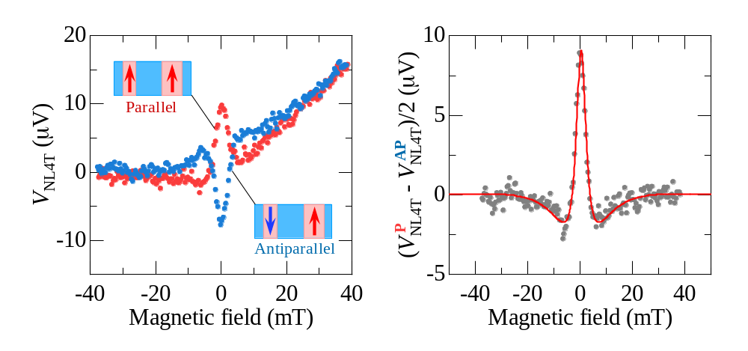
Figure S1. (a) Raw data of spin precession signals for parallel (P, red dots) and antiparallel (AP, blue dots) magnetization configurations. The external magnetic field was set perpendicular to the Si MOS plane (β=90°). (b) Result after subtraction to eliminate unnecessary background signals. Grey closed dots are spin precession signals, and the red line is the result of the fitting using Eq. (S1).
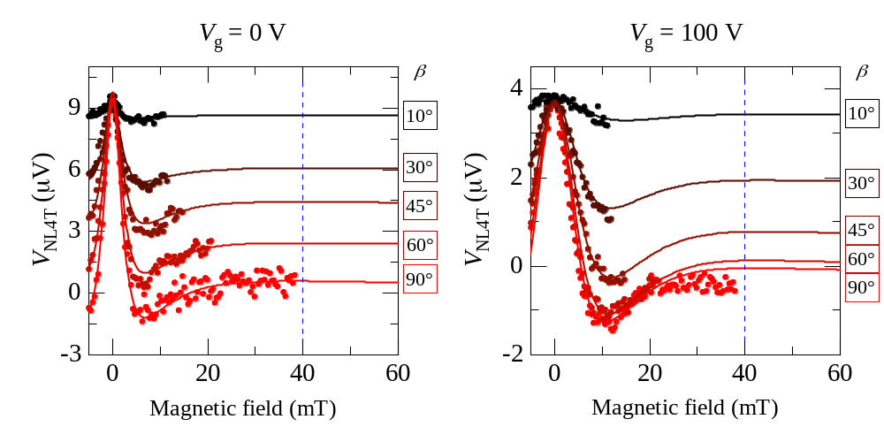
Figure S2. Spin precession signals as a function of the oblique magnetic field with tilt angle β under gate voltages (V_{g}) of 0 V (left) and 100 V (right). Blue dashed lines indicate the oblique magnetic field where spin dephasing occurs due to the oblique magnetic field being sufficient.

No. 2 Gate voltage dependence of the diffusion constant
To investigate the diffusion constant, D, as a function of V_{g}, non-local four-terminal spin voltages (V_{NL4T}) under a perpendicular magnetic field (β = 90°, as shown in Fig. S1) were fitted by the analytical solution of Eq. (S1). The fittings were carried out for all the results under V_{g} from 0 V to 100 V. Figure S3 shows the D extracted from the fitting as a function of V_{g}. D is approximately 6 cm²/s and independent of V_{g}.
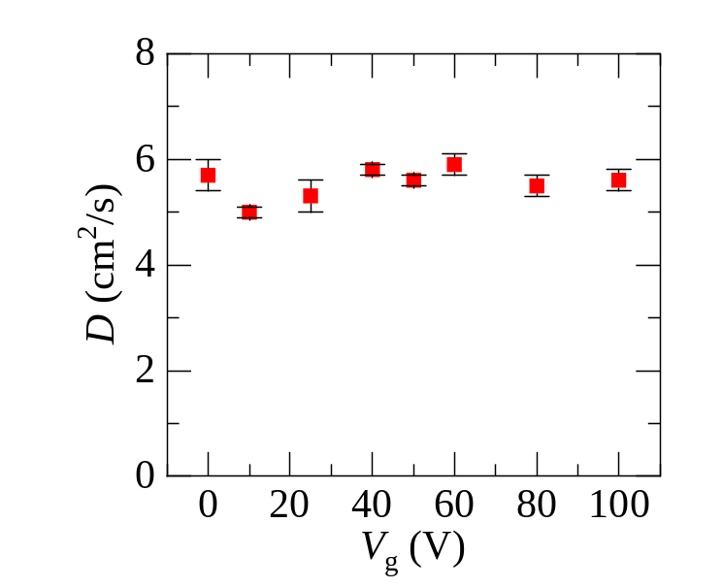
Figure S3. V_{g} dependence of the diffusion constant D.

No. 3 Results of spin lifetime anisotropy from different devices
To compare spin lifetime anisotropy results, we implemented measurements using synthetic Rashba devices with Si MOS of different channel lengths, L, at V_{g} = 0 V. Figure S4 shows the results, and the ζ from the devices with different channel lengths was estimated from the datasets. As can be seen, ζ is not equal to 1 in all the devices and is independent of L, which supports the reproducibility of the results described in the main text.
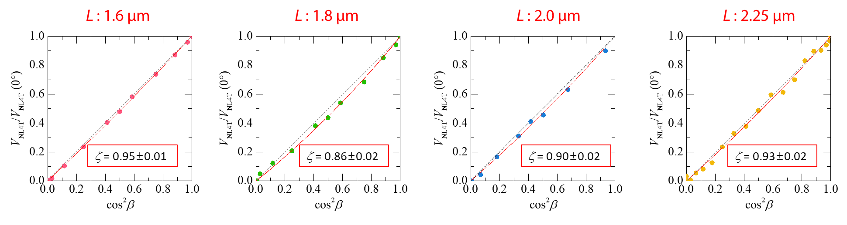
Fig. S4 Spin lifetime anisotropy in Si MOS synthetic Rashba devices. The channel length varies from 1.6 μm to 2.25 μm, where the device of L = 2 μm is discussed in the main text.

Reference
- Sasaki, T., Oikawa, T., Suzuki, T., Shiraishi, M., Suzuki, Y. & Noguchi, K. Temperature dependence of spin diffusion length in silicon by Hanle-type spin precession. Appl. Phys. Lett. 96, 122101 (2010).

