Supporting Information

Mechanochemical synthesis of inverse vulcanized polymers
Peiyao Yan^{⸸1}, Wei Zhao^{⸸1, 2}, Fiona McBride³, Diana Cai¹, Joseph Dale¹, Tom Hasell^{*1}
¹Department of Chemistry, University of Liverpool, Crown Street, Liverpool L69 7ZD (UK); ²Leverhulme Research Centre for Functional Materials Design, Materials Innovation Factory and Department of Chemistry, University of Liverpool, Liverpool (UK); ³ Surface Science Research Centre, University of Liverpool, Liverpool L69 3BX (UK).

Experimental section
Materials
Sulfur (S₈, ≥99.5 %), 1,3-diisopropenylbenzene (DIB), dicyclopentadiene (DCPD), divinylbenzene (DVB), 5-ethylidene-2-norbornene (ENB), limonene, myrcene, dially disulfide (DADS), styrene, isoprene, tetrahydrofuran (THF), chloroform, acetone, toluene, dimethylacetamide (DMAc), dichloromethane (DCM), and chloroform-d (CDCl₃) were purchased from Sigma Aldrich and used as received without further purification.
Characterizations
1. Nuclear magnetic resonance spectroscopy (NMR): Solution NMR of unreacted monomers was recorded using a Bruker Advance DRX (400 MHz) spectrometer. CDCl₃ was used as solvent, and insoluble fractions were filtered by using a 2 µm filter.
2. Fourier transform infrared spectroscopy (FT-IR): FT-IR was carried out using Vertex 70 Fourier Transform Infrared Spectrometer between 400 cm⁻¹ to 4000 cm⁻¹ for 32 scans under resolution of 4 cm⁻¹. FT-IR spectrum of solid polymers were measured by using ATR attachment with diamond, and the liquid cell with 1mm spacer was used for hazardous monomers. Data was analysed using the software OPUS.
3. X-ray photoelectron (XPS): XPS Analysis was performed using a Kratos Axis SUPRA XPS fitted with a monochromated Al kα X-ray source (1486.7 eV), a spherical sector analyser and 3 multichannel resistive plate, 128 channel delay line detectors. All data was recorded at 150 W and a spot size of 700 x 300 µm. Survey scans were recorded at a pass energy of 160 eV, step size 1.0 eV and high-resolution scans recorded at a pass energy of 20 eV, step size 0.1 eV. Electronic charge neutralization was achieved using a magnetic immersion lens. Filament current = 0.27 A, charge balance = 3.3 V, filament bias = 3.8 V. All sample data was recorded at a pressure below 10⁻⁸ Torr and a room temperature of 294 K. Data was analysed using CasaXPS v2.3.24PR1.0 and the spectra were calibrated with C 1s peak at 284.8 eV.
4. Differential scanning calorimetry (DSC): DSC was carried out using Q2000 DSC (TA instruments). The method with heat/cool/heat for three cycles at a heating/cooling rate of 10 °C/min and with ranging from -80 ºC to 150 ºC was performed. The second heating curves were recorded and analysed and glass transition temperatures of polymers were analysed using TA software.
5. Thermogravimetric analysis (TGA): The thermal stability of polymer was conducted using a TA Instruments 550 under nitrogen from room temperature to 1000 ºC at a heating rate of 10 ºC min⁻¹. 10 mg-20 mg of samples were used for testing.
6. Powder x-ray Diffraction (PXRD): PXRD measurements were performed on a PANalytical X’Pert PRO MPD, using in high transmission mode with K_{α} focusing mirror and PIXCEL 1D detector with Cu X-ray source over 2θ range from 1º to 55º over 30 minutes.
7. Scanning electron microscopy (SEM) and energy dispersive spectroscopy (EDS): The micrographs and EDS spectra were acquired when the microscope was operated in SEM mode by using two different equipment (Hitachi S-4800 and Tescan S8000G). When the Hitachi S-4800 was used, all samples were placed on the silica surface and were coated using chromium before the test. When the Tescan S8000G was used, the specimens were prepared on TEM carbon grids.
8. Inductively coupled plasma optical emission spectrometry (ICP-OES): Metal (Hg²⁺, Fe, and Cr) concentrations were analysed by using an Agilent 5110 ICP-OES spectrometer, equipped with an autosampler.
9. Selected ion flow tube mass spectrometer (SIFT-MS): Hydrogen sulphide analysis was conducted on a Selected ion flow tube mass spectrometer (SIFT-MS) operating with O₂⁺, H₂O⁺, and NO₂⁺ reagent ions. 100 mg polymer samples were prepared in vials, with 10 micro litre headspace samples removed at hourly intervals, and analysed assessing the occurrence of H₂S⁺ ions (registering at a mass of 35 Daltons).
Experimental procedures
- Synthesis of polymers MS(S-monomer)
The mechanochemical synthesis of inverse vulcanized polymers were carried out using weight ratio of 1:1 between the elemental sulfur with the crosslinker. Around 400 mg reaction mixture was added into a stainless-steel milling jar (10 ml) with adding 5 stainless-steel ball (diameter, 2 mm) (The photo of the equipment can be found in Figure S1). Milling frequency was 30 Hz, and reaction time was 3 hours. After reaction, the obtained products were filtered by washing with acetone. Mechanochemical synthesized (MS) polymers are named as MS(S-crosslinker), and crosslinkers are shown in Figure 1.
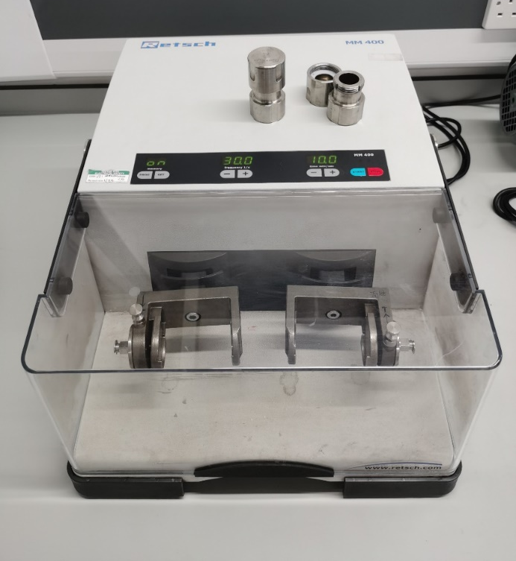
Figure S1. The photograph of the ball mill which was used in the polymer synthesis.
- Synthesis of polymers TS(S-monomer)
In order to compare the properties of MS products with thermal synthesized (TS) polymers, a batch of TS polymers TS(S-crosslinker) were produced using same crosslinkers. The reaction temperature and reaction time followed the reported procedures.^{1, 2, 3, 4, 5}
Table S1 Polymerization conditions of polymers TS(S-monomer)
Sample | Reaction temperature/reaction time | Curing temperature/curing time
TS(S-DIB) | 160 °C/40 mins | 15 hrs/140 °C
TS(S-DCPD) | 160 °C /20 mins | 15 hrs/140 °C
TS(S-DVB) | 160 °C /1 hrs | 15 hrs/140 °C
TS(S-ENB) | 135 °C /35 mins | 15 hrs/140 °C
TS(S-Limonene) | 160 °C /2 hrs | 15 hrs/140 °C
TS(S-Myrcene) | 160 °C /1 hr and 10mins | 15 hrs/140 °C
TS(S-DADS) | 160 °C /30 mins | 15 hrs/140 °C
TS(S-Styrene) | 130 °C /4 hrs | 15 hrs/130 °C

3. Solubility evaluation
The solubility of obtained polymers were evaluated by using three different solvents (THF, chloroform and acetone). The concentrations of polymers were prepared as around 3 mg/ml and the mass of each polymer was recorded. After the solvent was added in, the solution was stirred for 24 hours by using an agitator. The photographs of the solubility of each polymer in each solvent have been recorded.
4. Solution ICP-OES sample preparation
In order to detect the concentration of elemental ion in the generated polymers, solution ICP-OES was performed for each polymer. As all polymers are insoluble, they were digested in nitric acid by using microwave. The procedure of the digestion is: ~50 mg of each polymer was added in 8 ml nitric acid (67–69%, trace metal analysis grade), then was digested by using a standard HDPE procedure in the Perkin Elmer Microwave. The digestion solution was diluted into 52 ml solution by using deionised (DI) water. Then 10 ml of each sample was filtered out using 0.2 µm nylon filter and was submitted for solution ICP-OES analysis.
5. Mercury uptake procedure
A theoretical 100 ppm mercury chloride (HgCl₂) solution (250 ml) was made up from a stock solution of HgCl₂ and DI water. 10 ml of each solution was added in to a series of glass vials along with 20 mg of each polymer. All the polymers were ground by using a pestle and mortar before exposed in to HgCl₂ solutions. The vials were then placed on an agitator for stirring 24 hours at room temperature. The test solutions were filtered into clean polypropylene centrifuge tubes using 0.2 µm nylon filter with a ten-fold dilution and 1 mL nitric acid (10%) for stabilization. A water blank and a theoretical 100 ppm control sample were prepared in same procedure. All test samples were submitted for an analysis using the same calibration method on the ICP-OES. The actual concentration of HgCl₂, the uptake percentage and the capacity of polymers can be analysed according to the ICP-OES results.
6. Making thin film using hot-press and UV-induced self-healing evaluation
MS Polymer powders were able to be processed into thin film by using hot press purchased from Zhengzhou CY Scientific Instrument CO., LTD. Polymers MS(S-DIB) and MS(S-ENB) were hot pressed at 140 °C and under 20 MPa for 15 minutes. After cooling down to room temperature, the polymer film was demoulded. MS(S-ENB) thin film was used into UV-induced self-healing ability investigation. Two pieces of thin films were overlapped for around 1 mm width gap, and were covered by two glass slides and then were irradiated by 285 nm UV light for 40 minutes. Before and after healing, the states of polymer films were recorded by photographs and also video.

Results and discussions
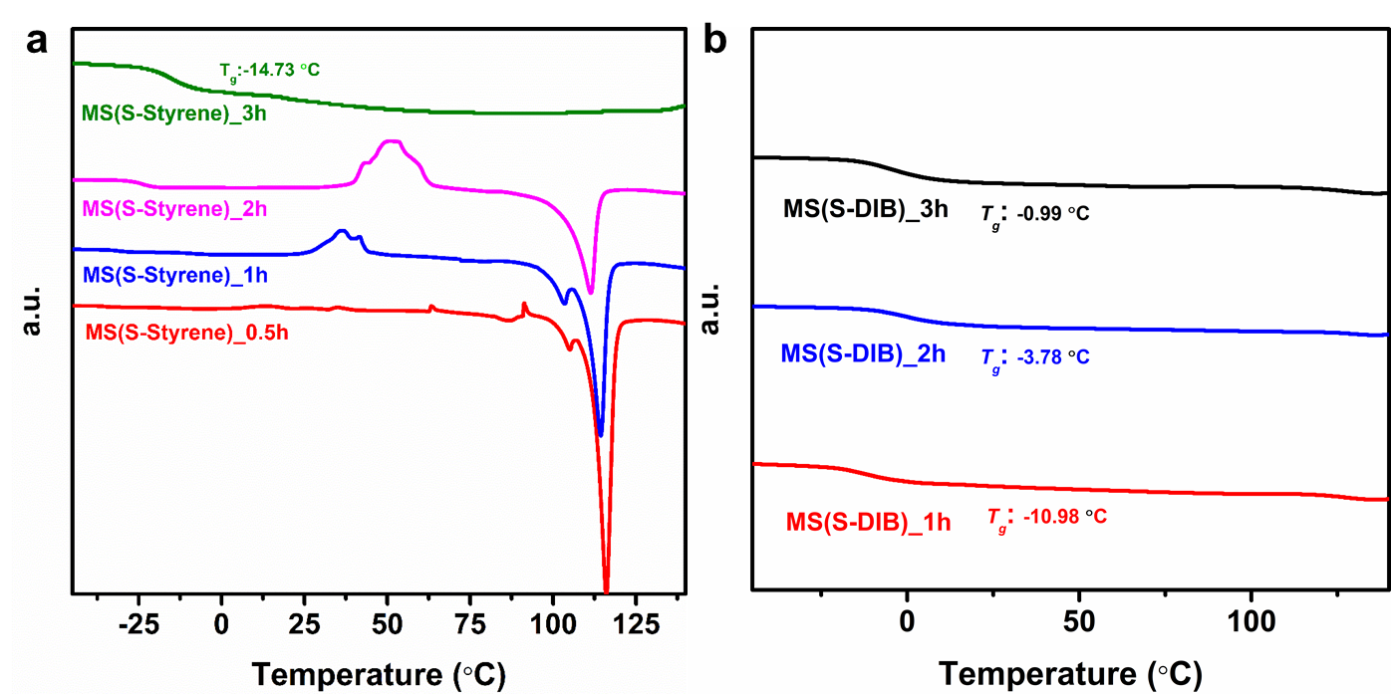
Figure S1. Reaction monitor using DSC of a) MS(S-Styrene) and b) MS(S-DIB).
Figure S2. DSC curves of polymers MS(S-monomer).
Figure S3. DSC curves of polymers TS(S-monomer).
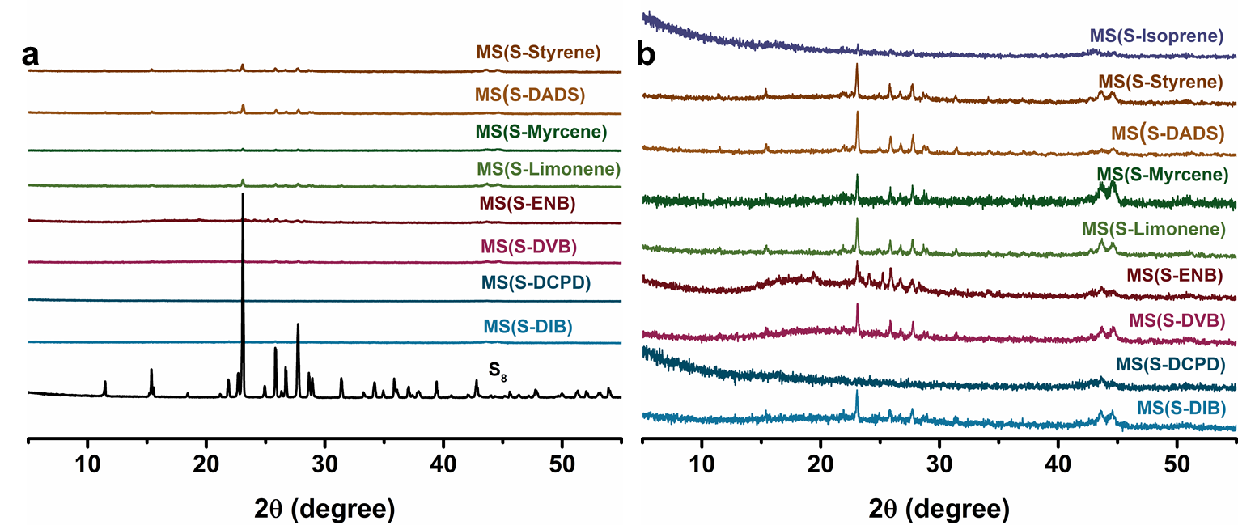
Figure S4. a) PXRD curves of the MS products compared with pure sulfur, and b) zoom of the PXRD curves of the MS products removing the PXRD curve of pure sulfur.
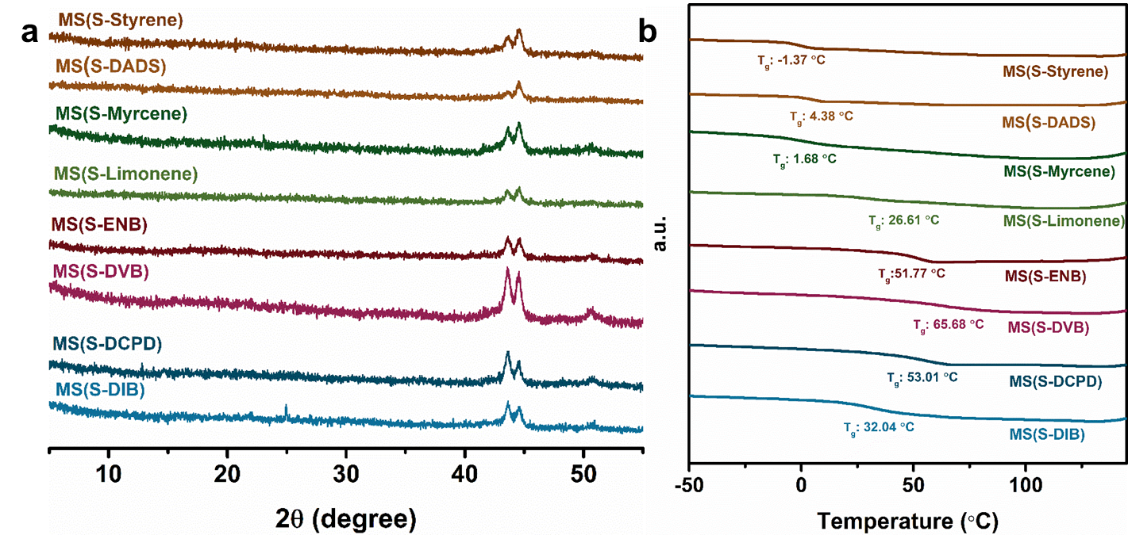
Figure S5. a) PXRD curves and b) DSC curves of the MS products after Soxhlet extraction.
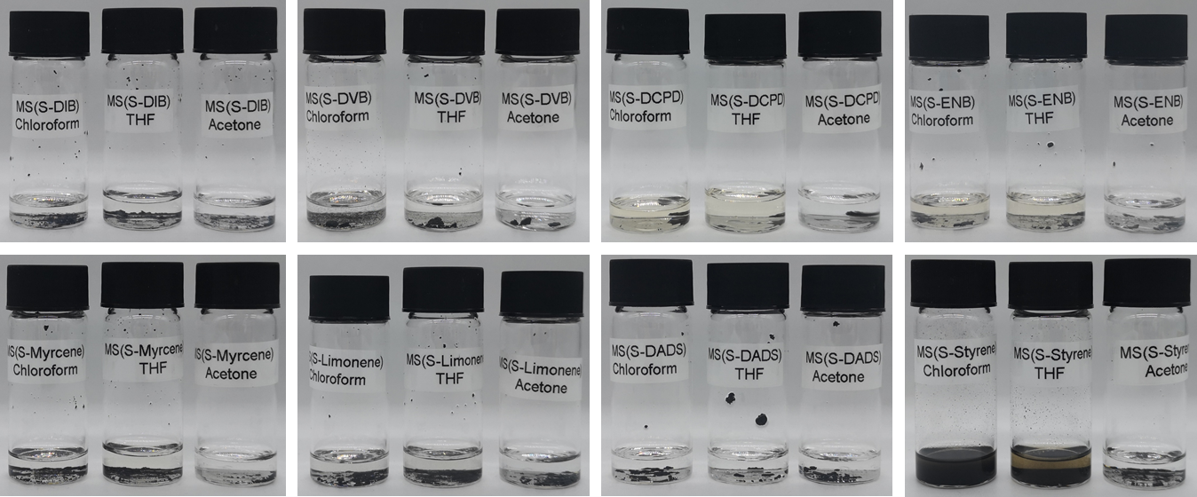
Figure S6. Photographs of solubility evaluation of the MS products using solvents THF, chloroform and acetone.
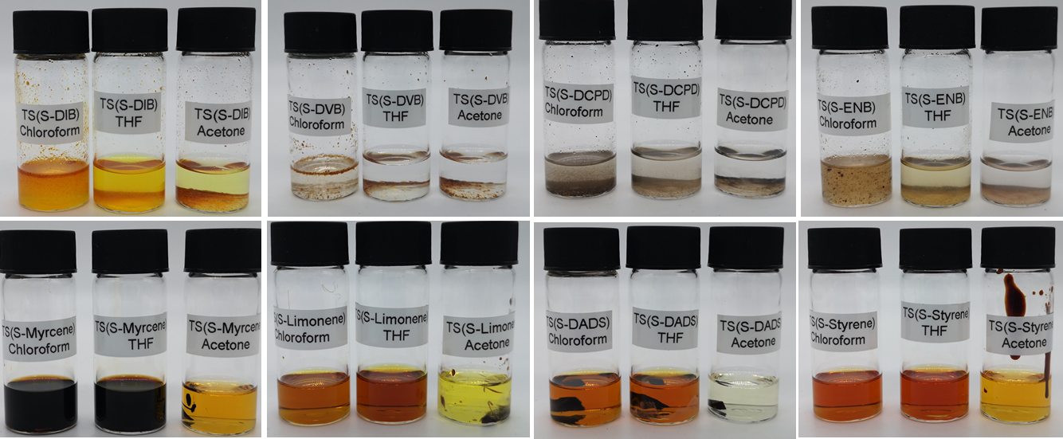
Figure S7. Photographs of solubility evaluation of the TS products using solvents THF, chloroform and acetone.
 |  |  | Calc % |  |  |  |  | Analysis 1 (without any further treatment)
Sample Ref |  |  | %C | %H | %S | C:H | C:S | %C | %H | %S | C:H | C:S
MS(S-DIB) |  |  | 45.50 | 4.50 | 50.00 | 10.11 | 0.91 | 13.40 | 2.10 | 62.30 | 6.38 | 0.22
MS(S-DCPD) |  |  | 45.50 | 4.50 | 50.00 | 10.11 | 0.91 | 22.40 | 3.00 | 42.50 | 7.47 | 0.53
MS(S-DVB) |  |  | 46.20 | 3.80 | 50.00 | 12.16 | 0.92 | 14.93 | 2.05 | 55.00 | 7.28 | 0.27
MS(S-ENB) |  |  | 45.00 | 5.00 | 50.00 | 9.00 | 0.90 | 4.80 | 1.40 | 58.00 | 3.43 | 0.08
MS(S-Limonene) |  |  | 43.50 | 6.50 | 50.00 | 6.69 | 0.87 | 5.40 | 1.40 | 65.00 | 3.86 | 0.08
MS(S-Myrcene) |  |  | 43.50 | 6.50 | 50.00 | 6.69 | 0.87 | 11.00 | 1.80 | 45.50 | 6.11 | 0.24
MS(S-DADS) |  |  | 31.60 | 4.40 | 64.00 | 7.18 | 0.49 | 1.60 | 1.18 | 85.00 | 1.36 | 0.02
MS(S-Styrene) |  |  | 46.00 | 4.00 | 50.00 | 11.50 | 0.92 | 9.90 | 1.30 | 36.70 | 7.62 | 0.27
MS(S-Isoprene) |  |  | 44.10 | 5.90 | 50.00 | 7.47 | 0.88 | 10.09 | 1.60 | 70.80 | 6.31 | 0.14
BM(Sulfur) |  |  | 0 | 0 | 100 | 0 | 0 | 0 | 1.2 | 99.00 | 0 | 0
Table S2. Elemental analysis (EA) results of MS products
Figure S8. FT-IR curves of monomer styrene, polymer MS(S-Styrene) and TS(S-Styrene).
Figure S9. DSC curve of MS(S-Toluene).
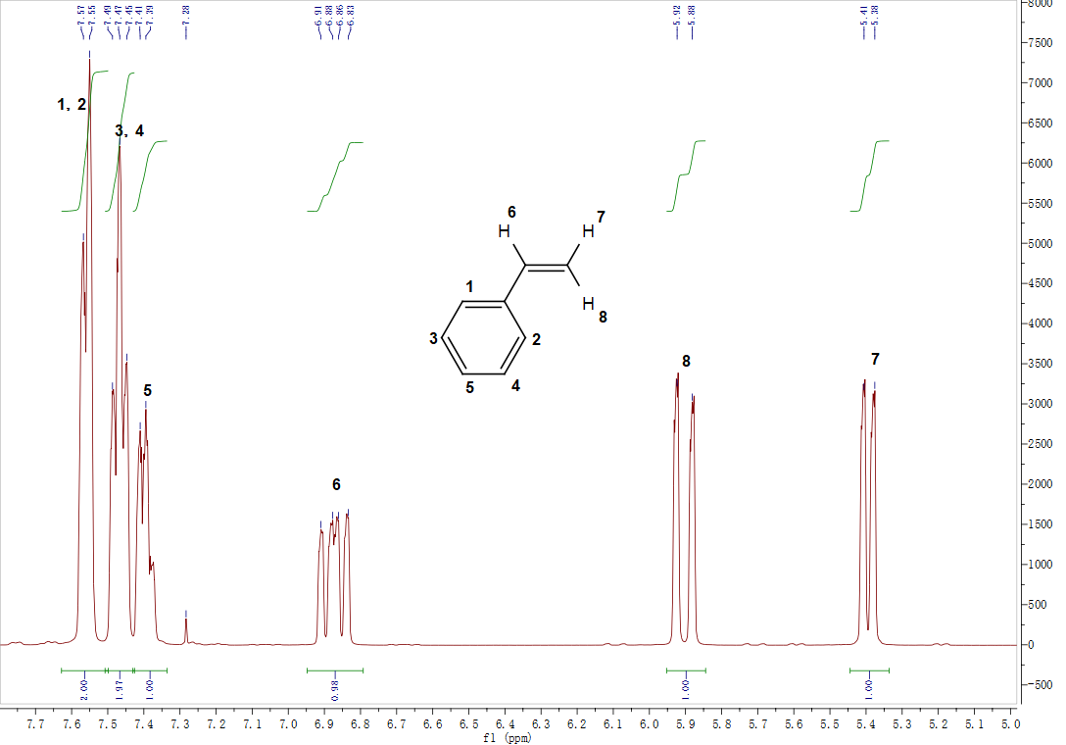
Figure S10. ¹H NMR spectrum of monomer styrene.
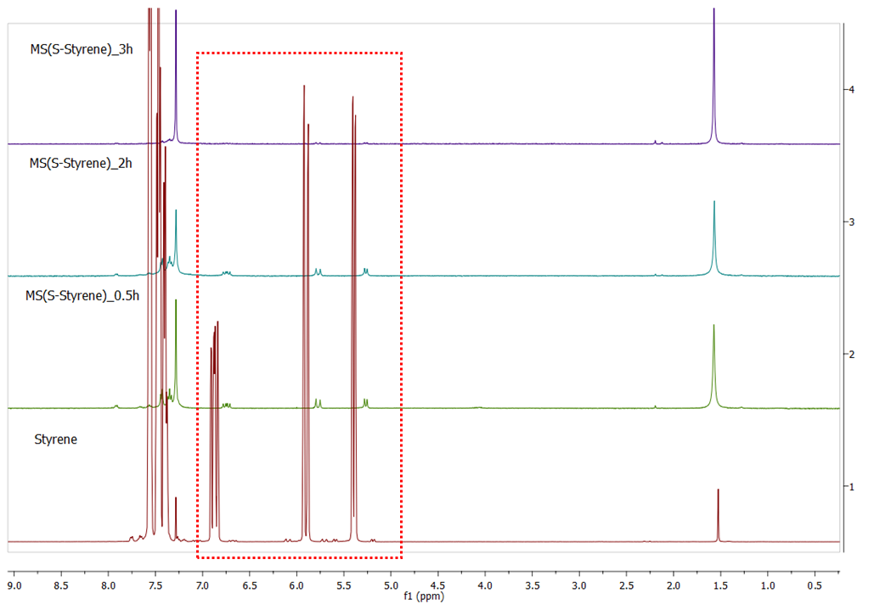
Figure S11. ¹H NMR spectra of MS(S-Styrene) monitored with reaction time at 0.5h, 2h and 3h.
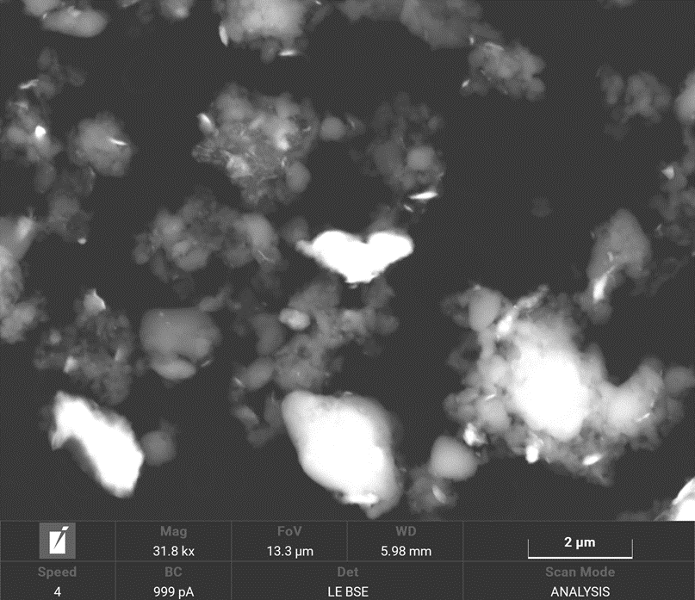
Figure S12. SEM image of MS(S-DIB). Bright part is full of elemental Fe.
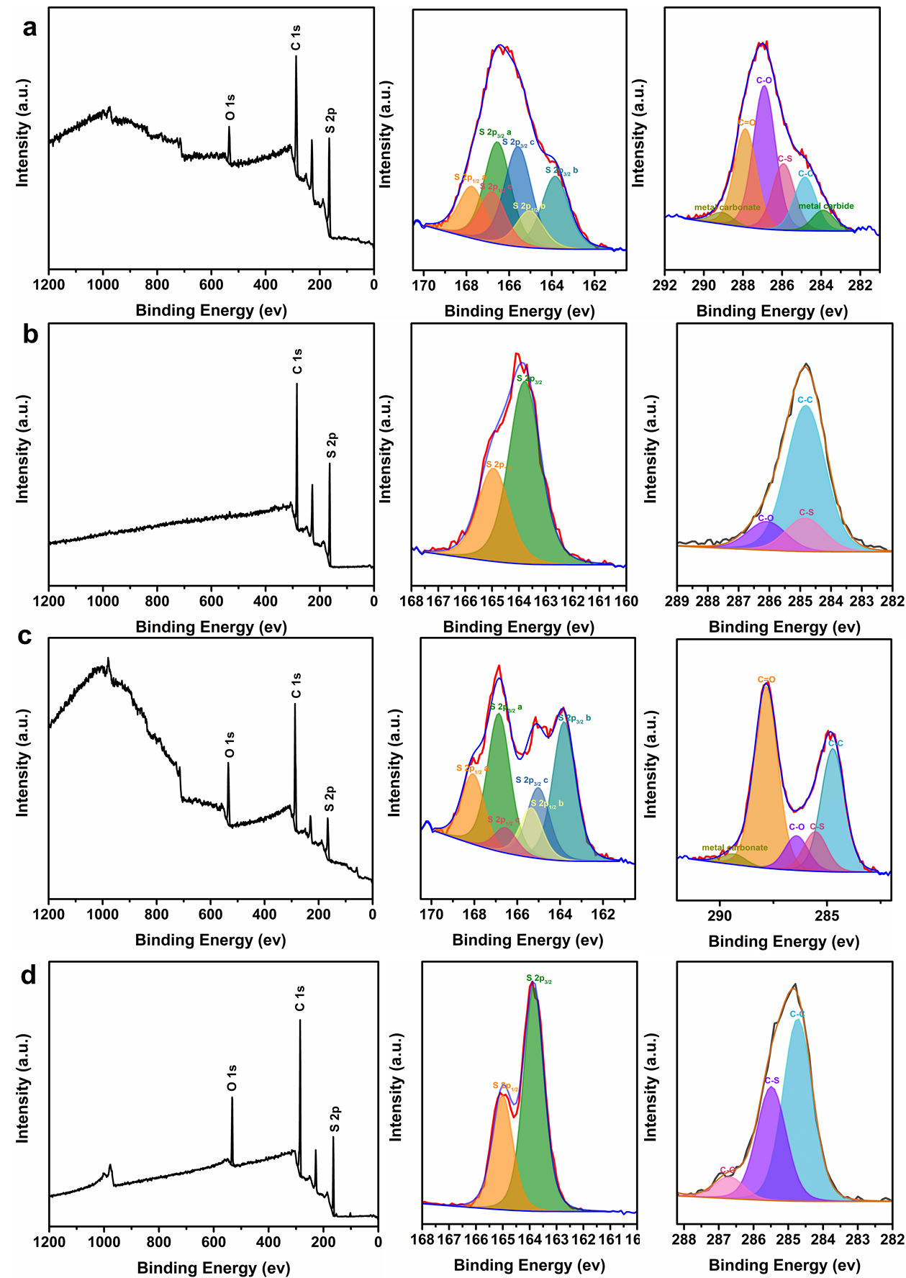
Figure S13. XPS survey scan, S 2p and C 1s spectra (with associated curve fits) of a) MS(S-DIB) b) TS(S-DIB) c) MS(S-Styrene) and d) TS(S-Styrene).

 | Table S3. Fe content of polymers analysed from solution ICP results
Sample Ref |  | Fe (%) | Cr (%)
MS(S-DIB) |  | 13.65±0.19 | 3.60±0.12
MS(S-DCPD) |  | 20.35±0.31 | 5.08±0.02
MS(S-DVB) |  | 17.93±0.23 | 4.53±0.00
MS(S-ENB) |  | 12.84±0.03 | 3.08±0.02
MS(S-Limonene) |  | 11.45±0.15 | 2.86±0.01
MS(S-Myrcene) |  | 12.84±0.13 | 3.21±0.00
MS(S-DADS) |  | 8.82±0.11 | 2.20±0.00
MS(S-Styrene) |  | 8.15±0.09 | 2.02±0.00
BM(Sulfur)¹ |  | 0.77±0.00 | 0.19±0.00
¹BM(Sulfur) refers to ball milled elemental sulfur
Figure S14. TGA curves of MS polymers in the N₂.

Table S4 A summary of values of Fe percent from solution ICP, missing percent from EA and residue percent from TGA in N₂
Sample | Fe percent from solution ICP (%) | Missing percent from EA (%) | Residue percent from TGA in N₂ (%)
MS(S-DIB) | 13.65±0.19 | 22.20 | 18.0
MS(S-DCPD) | 20.35±0.31 | 32.10 | 32.0
MS(S-DVB) | 17.93±0.23 | 28.02 | 55.1
MS(S-ENB) | 12.84±0.03 | 35.80 | 11.7
MS(S-Limonene) | 11.45±0.15 | 28.20 | 22.6
MS(S-Myrcene) | 12.84±0.13 | 41.70 | 39.4
MS(S-DADS) | 8.82±0.11 | 12.22 | 16.7
MS(S-Styrene) | 8.15±0.09 | 52.10 | 27.2
BM(Sulfur) | 0.77±0.00 | 1.00 | 1.4

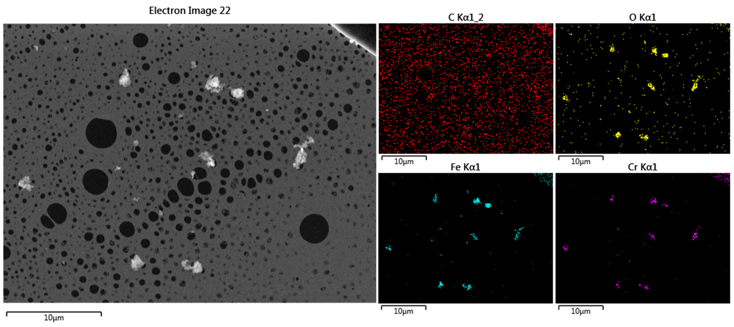
Figure S15. SEM image and EDS images of MS(S-DIB) after burning.
Figure S16. FT-IR curves of monomer DIB, polymer MS(S-DIB) and TS(S-DIB).

Figure S17. FT-IR curves of monomer DCPD, polymer MS(S-DCPD) and TS(S-DCPD).

Figure S18. FT-IR curves of monomer DVB, polymer MS(S-DVB) and TS(S-DVB).

Figure S19. FT-IR curves of monomer ENB, polymer MS(S-ENB) and TS(S-ENB).
Figure S20. FT-IR curves of monomer DADS, polymer MS(S-DADS) and TS(S-DADS).

Figure S21. FT-IR curves of monomer limonene, polymer MS(S-Limonene) and TS(S-Limonene).

Figure S22. FT-IR curves of monomer myrcene, polymer MS(S-Myrcene) and TS(S-Myrcene).

Figure S23. FT-IR curves of monomer isoprene, polymer MS(S-Isoprene) and TS(S-Isoprene).

Figure S24. H₂S gas generation measured of the polymer MS(S-DIB) maintained in the air for 24 h with the temperature ramped from room temperature (kept for 8 h) to 80 °C (kept for 8 h) to 140 °C (kept for 8 h).

Figure S25. H₂S gas generation measured of the polymer TS(S-DIB) maintained in the air for 24 h with the temperature ramped from room temperature (kept for 8 h) to 80 °C (kept for 8 h) to 140 °C (kept for 8 h).

Figure S26. H₂S gas generation measured of the polymer MS(S-DCPD) maintained in the air for 24 h with the temperature ramped from room temperature (kept for 8 h) to 80 °C (kept for 8 h) to 140 °C (kept for 8 h).

Figure S27. H₂S gas generation measured of the polymer TS(S-DCPD) maintained in the air for 24 h with the temperature ramped from room temperature (kept for 8 h) to 80 °C (kept for 8 h) to 140 °C (kept for 8 h).

Figure S28. H₂S gas generation measured of the polymer MS(S-DVB) maintained in the air for 24 h with the temperature ramped from room temperature (kept for 8 h) to 80 °C (kept for 8 h) to 140 °C (kept for 8 h).

Figure S29. H₂S gas generation measured of the polymer TS(S-DVB) maintained in the air for 24 h with the temperature ramped from room temperature (kept for 8 h) to 80 °C (kept for 8 h) to 140 °C (kept for 8 h).

Figure S30. H₂S gas generation measured of the polymer MS(S-ENB) maintained in the air for 24 h with the temperature ramped from room temperature (kept for 8 h) to 80 °C (kept for 8 h) to 140 °C (kept for 8 h).

Figure S31. H₂S gas generation measured of the polymer TS(S-ENB) maintained in the air for 24 h with the temperature ramped from room temperature (kept for 8 h) to 80 °C (kept for 8 h) to 140 °C (kept for 8 h).
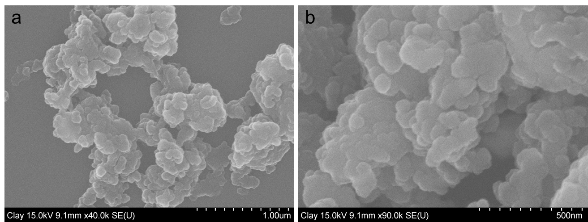
Figure S32. SEM images of polymer MS(S-DIB).
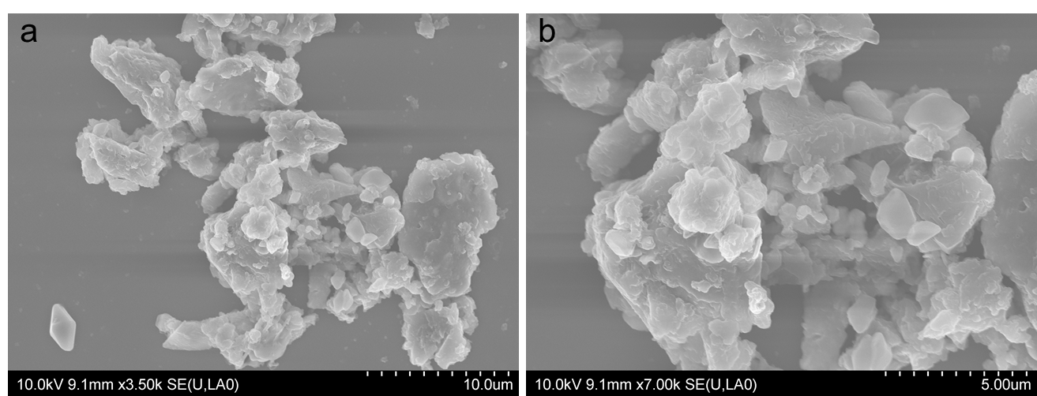
Figure S33. SEM images of polymer MS(S-DCPD).
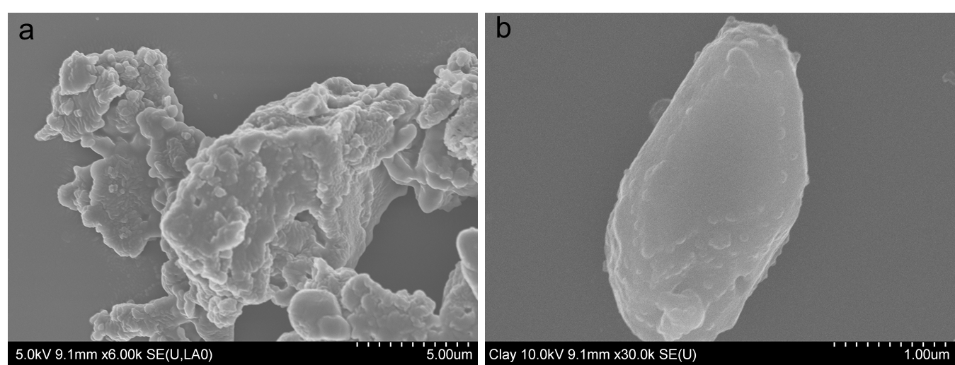
Figure S34. SEM images of polymer MS(S-DVB).
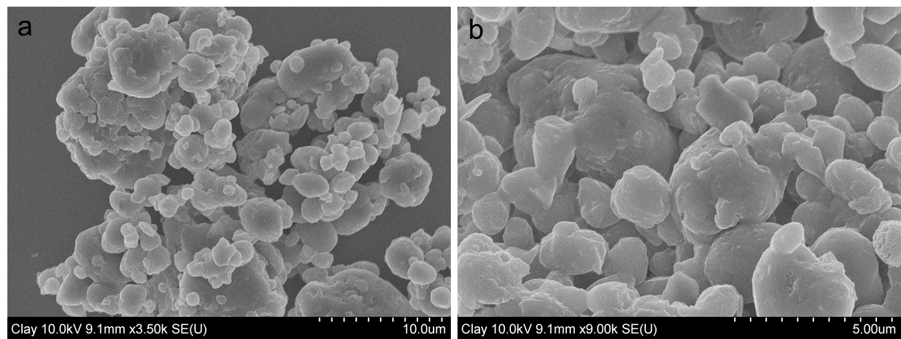
Figure S35. SEM images of polymer MS(S-ENB).
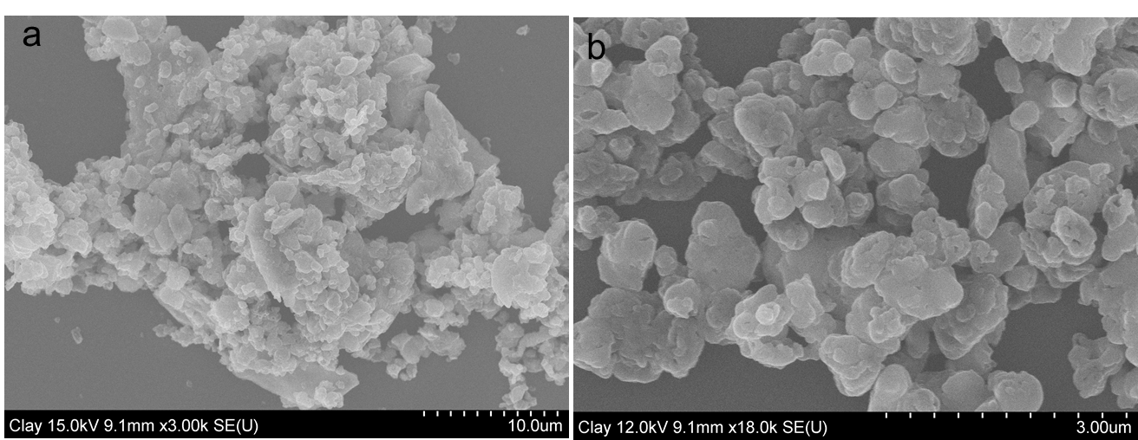
Figure S36. SEM images of polymer MS(S-Limonene).
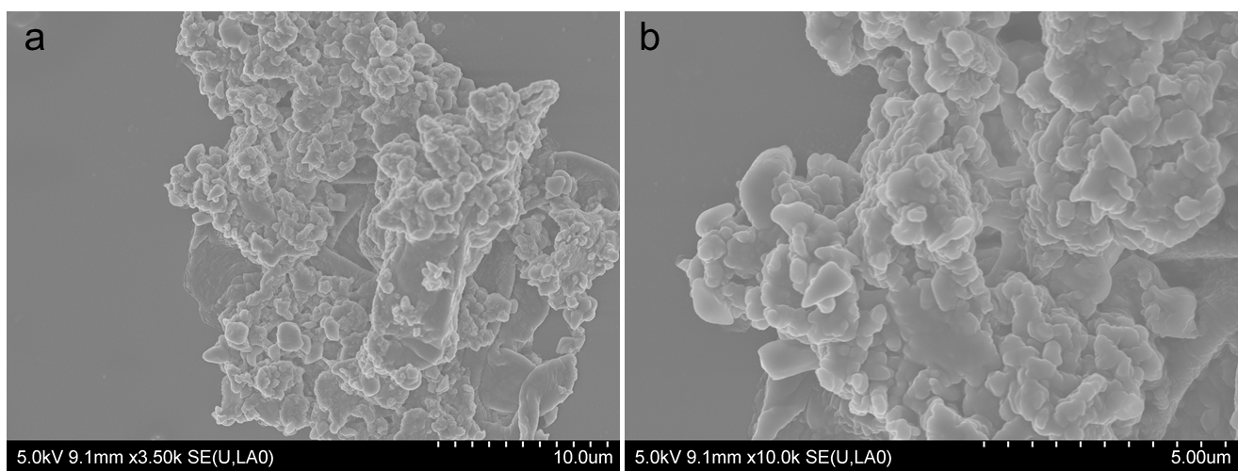
Figure S37. SEM images of polymer MS(S-Myrcene).
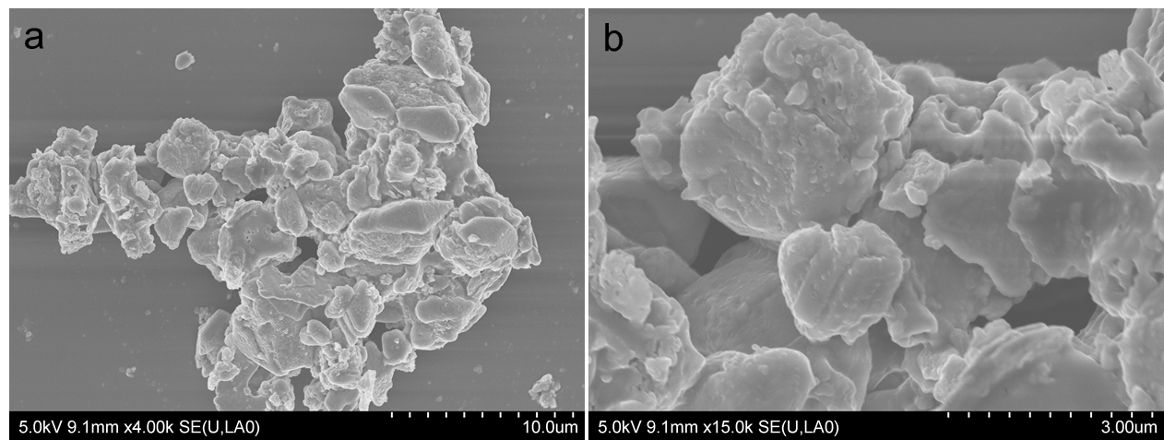
Figure S38. SEM images of polymer MS(S-DADS).
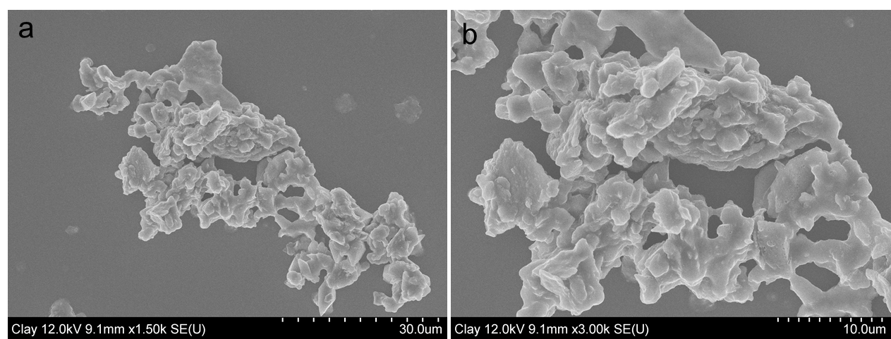
Figure S39. SEM images of polymer MS(S-Styrene).

References:
1. Crockett MP, et al. Sulfur‐Limonene Polysulfide: A Material Synthesized Entirely from Industrial By‐Products and Its Use in Removing Toxic Metals from Water and Soil. Angewandte Chemie International Edition 55, 1714-1718 (2016).
2. Khawaja SZ, Kumar SV, Jena KK, Alhassan SM. Flexible sulfur film from inverse vulcanization technique. Mater Lett 203, 58-61 (2017).
3. Parker D, et al. Low cost and renewable sulfur-polymers by inverse vulcanisation, and their potential for mercury capture. J Mater Chem A 5, 11682-11692 (2017).
4. Smith JA, Wu X, Berry NG, Hasell T. High sulfur content polymers: the effect of crosslinker structure on inverse vulcanization. J Polym Sci A: Polym Chem 56, 1777-1781 (2018).
5. Zhang Y, et al. Inverse vulcanization of elemental sulfur and styrene for polymeric cathodes in Li‐S batteries. J Polym Sci A: Polym Chem 55, 107-116 (2017).

