Supporting Information

Near-Infrared Heterojunction Field Modulated Phototransistors with Distinct Photodetection/Photostorage Switching Feature for Artificial Visuals

Jiayue Han,^{1,†} Xiaoyang Du,^{1,†} Zhenghan Zhang,^{2,3,†} Zeyu He,¹ Runzhang Xie,³ Chongxin Shan,⁴ Silu Tao,^{1,}* Weida Hu,^{3,}* Ming Yang,¹ Jun Gou,^{1,5} Zhiming Wu,^{1,5} Yadong Jiang^{1,5} and Jun Wang^{1,5,}*

1.School of Optoelectronic Science and Engineering, University of Electronic Science and Technology of China, Chengdu 610054, China

2.State Key Laboratory of ASIC and System, School of Microelectronics, Fudan University, Shanghai, China.

3.State Key Laboratory of Infrared Physics, Shanghai Institute of Technical Physics, Chinese Academy of Science, 500 Yutian Road, Shanghai 200083, China

4.Henan Key Laboratory of Diamond Optoelectronic Materials and Devices, School of Physics and Engineering, Zhengzhou University, Zhengzhou 450001, China

Prof. J. Gou, Prof. Z. Wu, Prof. Y. Jiang, Prof. J. Wang
5.State Key Laboratory of Electronic Thin Films and Integrated Devices, University of Electronic Science and Technology of China, Chengdu 610054, China
†These authors contributed equally to this work.
*Silu Tao: E-mail: silutao@uestc.edu.cn
* Weida Hu: E-mail: wdhu@mail.sitp.ac.cn
*Jun Wang: E-mail: wjun@uestc.edu.cn

1. The optical microscope image of graphene/ZnO on SiO₂ substrate.
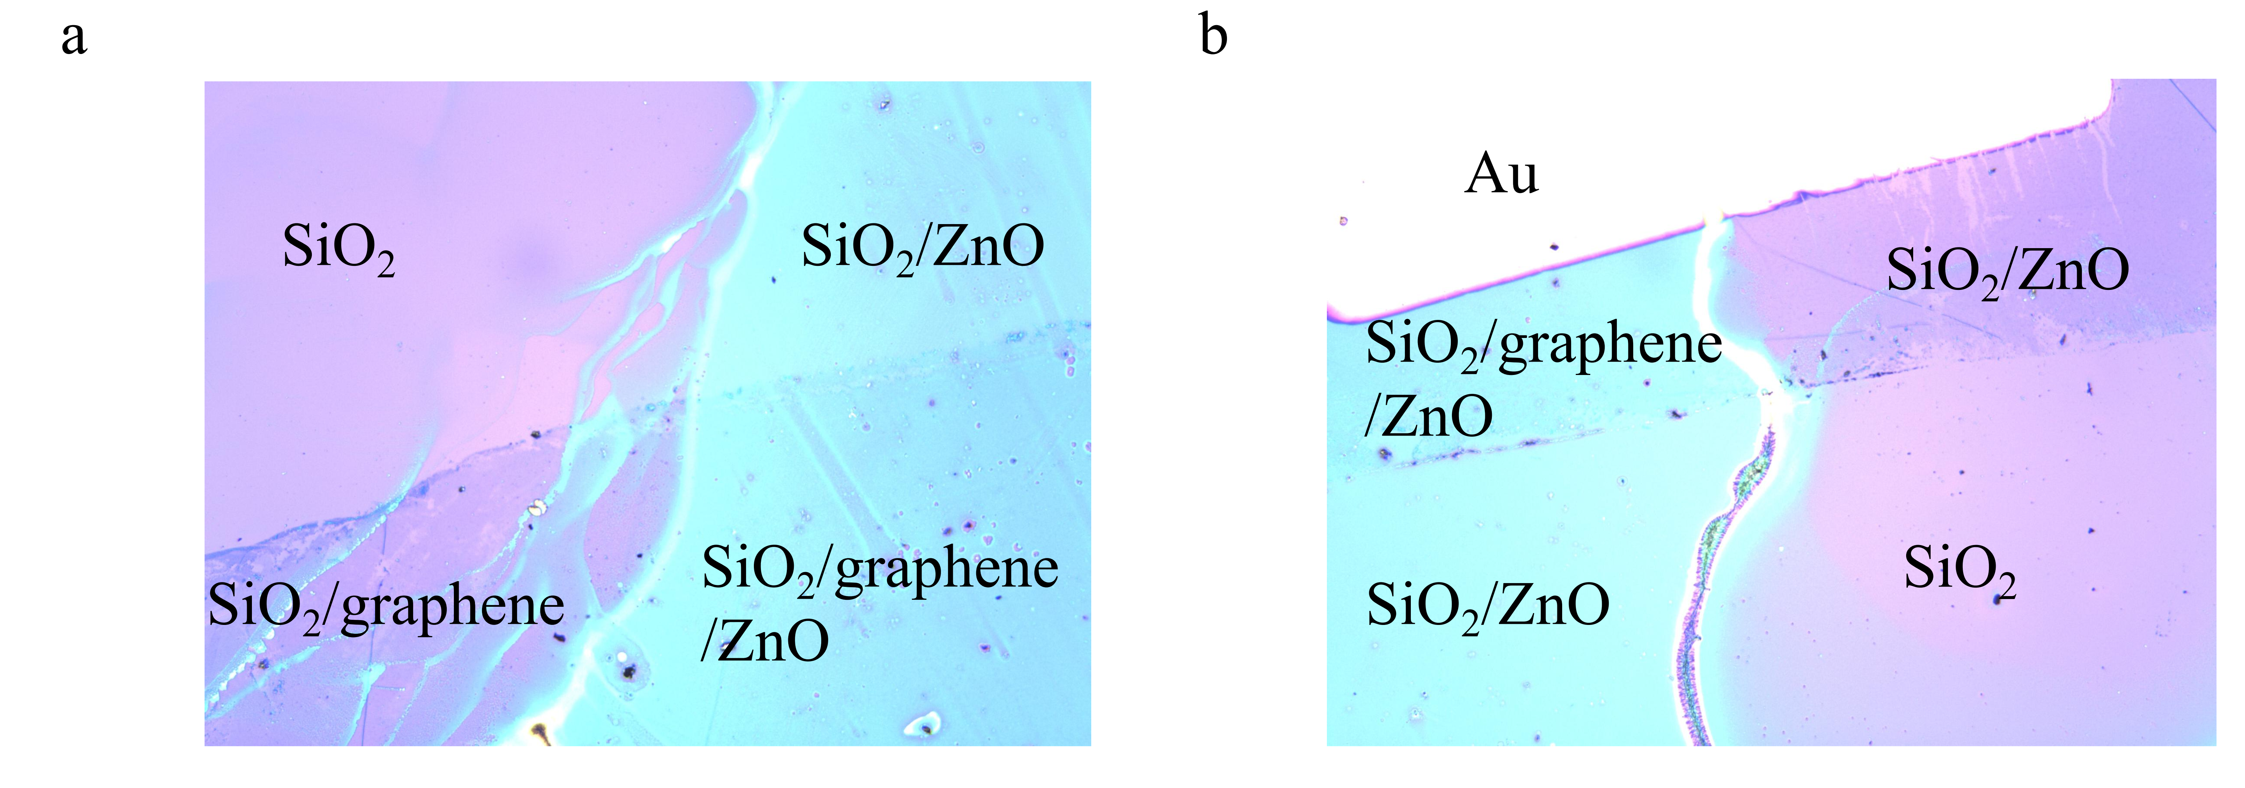
Fig. S1. a, b Optical microscope image of graphene/ZnO on SiO₂ substrate.

2.Morphology and fabrication characterization analysis of graphene/ZnO NPs/PTB7-Th:IEICO-4F phototransistor.
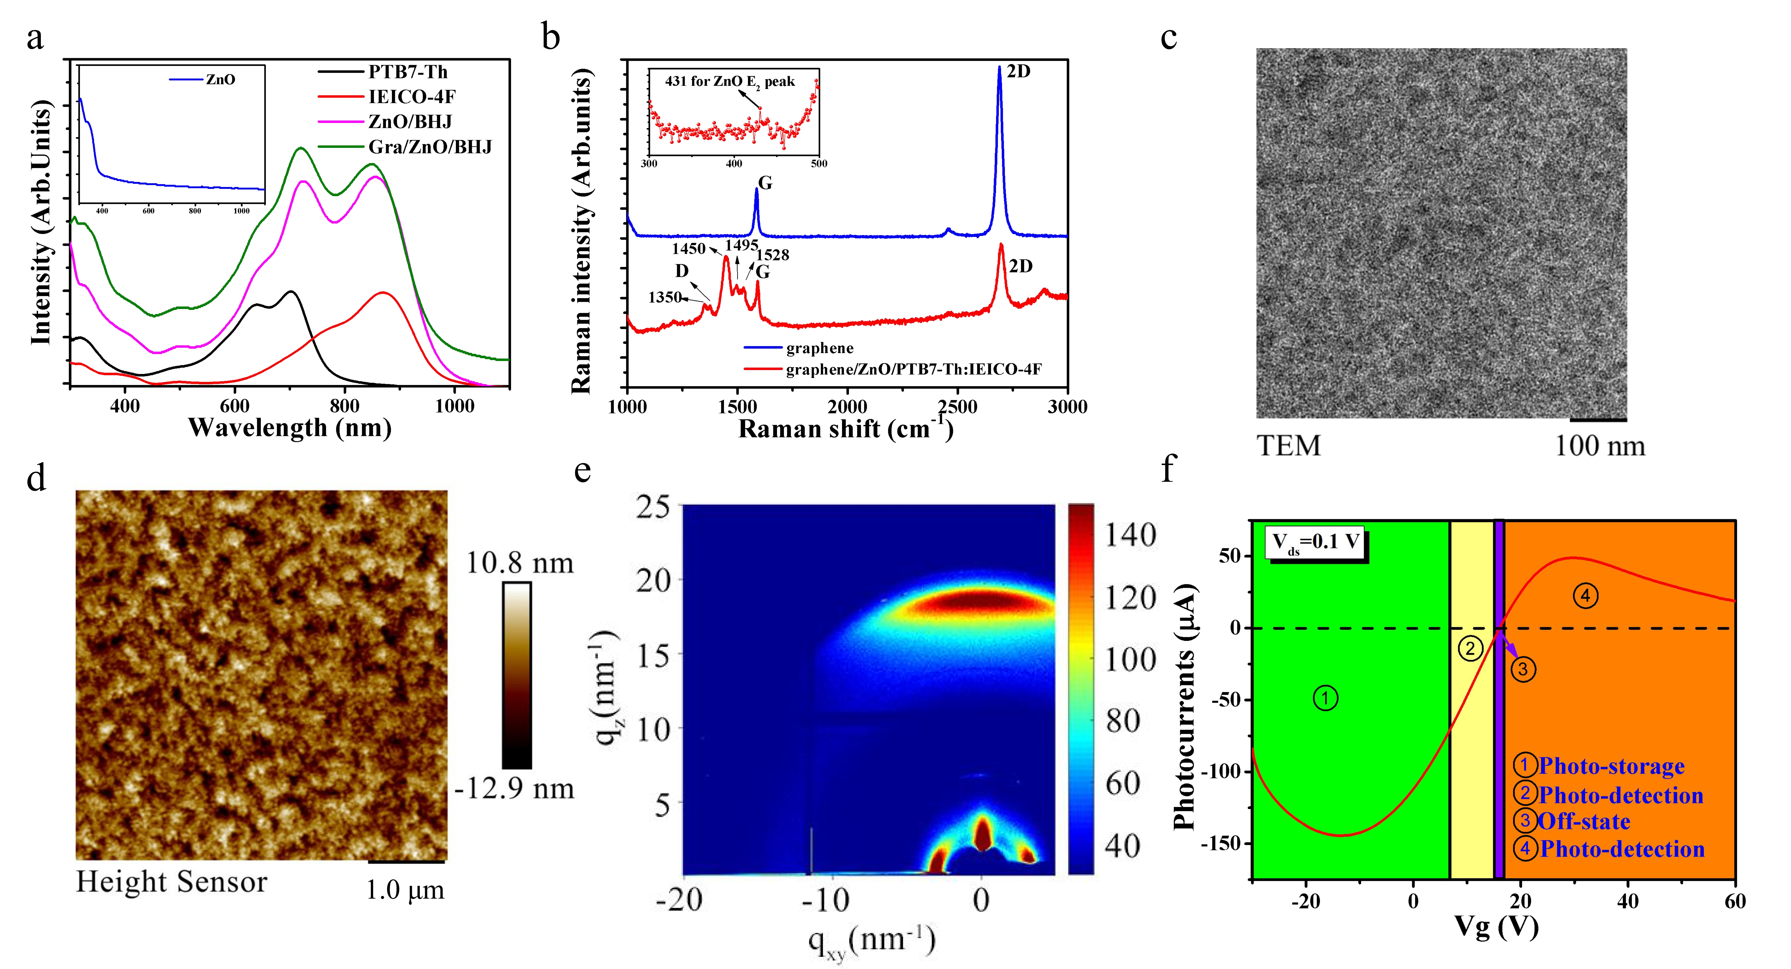
Fig. S2. a, Absorption spectra of PTB7-Th, IEICO-4F, ZnO/BHJ and Gra/ZnO/BHJ. b, Raman spectra for graphene and graphene/ZnO/PTB7-Th:IEICO-4F on SiO₂ substrate. c, TEM image of BHJ layer. d, AFM image of BHJ layer, the scale is 5 μm×5 μm. e, 2D-GIWAXS image of BHJ layer. f, The bi-polar photocurrents and four operation states with the variation of Vg under the 895 nm light at V_{ds}=0.1 V.

3. The Raman spectrum characterization.
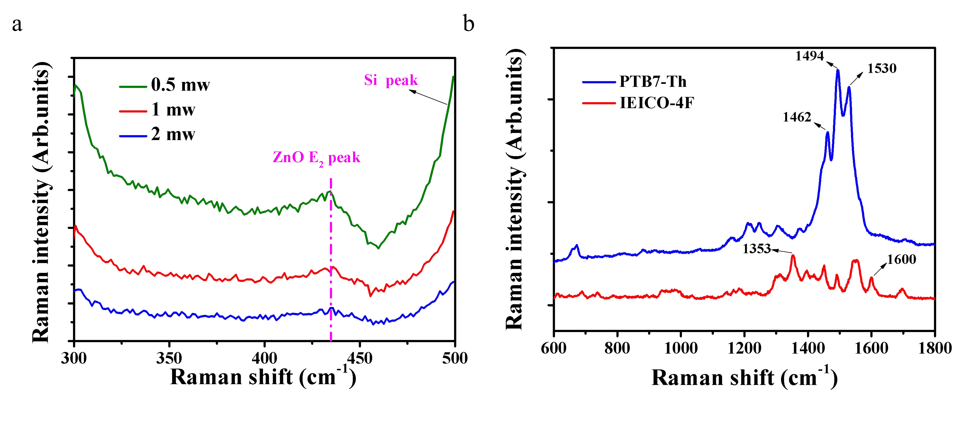
Fig. S3. a, Raman spectra for different light intensity powers of ZnO on SiO₂ substrate, b, Raman spectra for PTB7-Th and IEICO-4F films.
4. The wavelengths photocurrents with 10 V V_{g} applying.
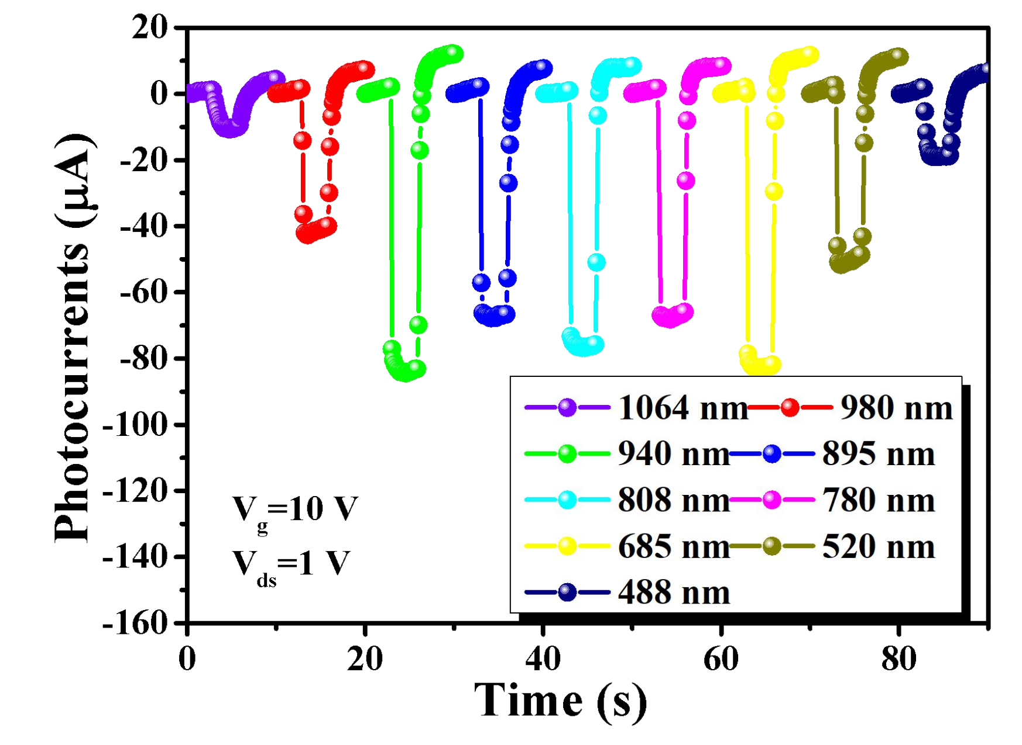
Fig. S4. The time-resolved photocurrents measurement under the wavelengths from 488 to 1064 nm.

5. The photocurrents and responsivity comparison with different control structures. 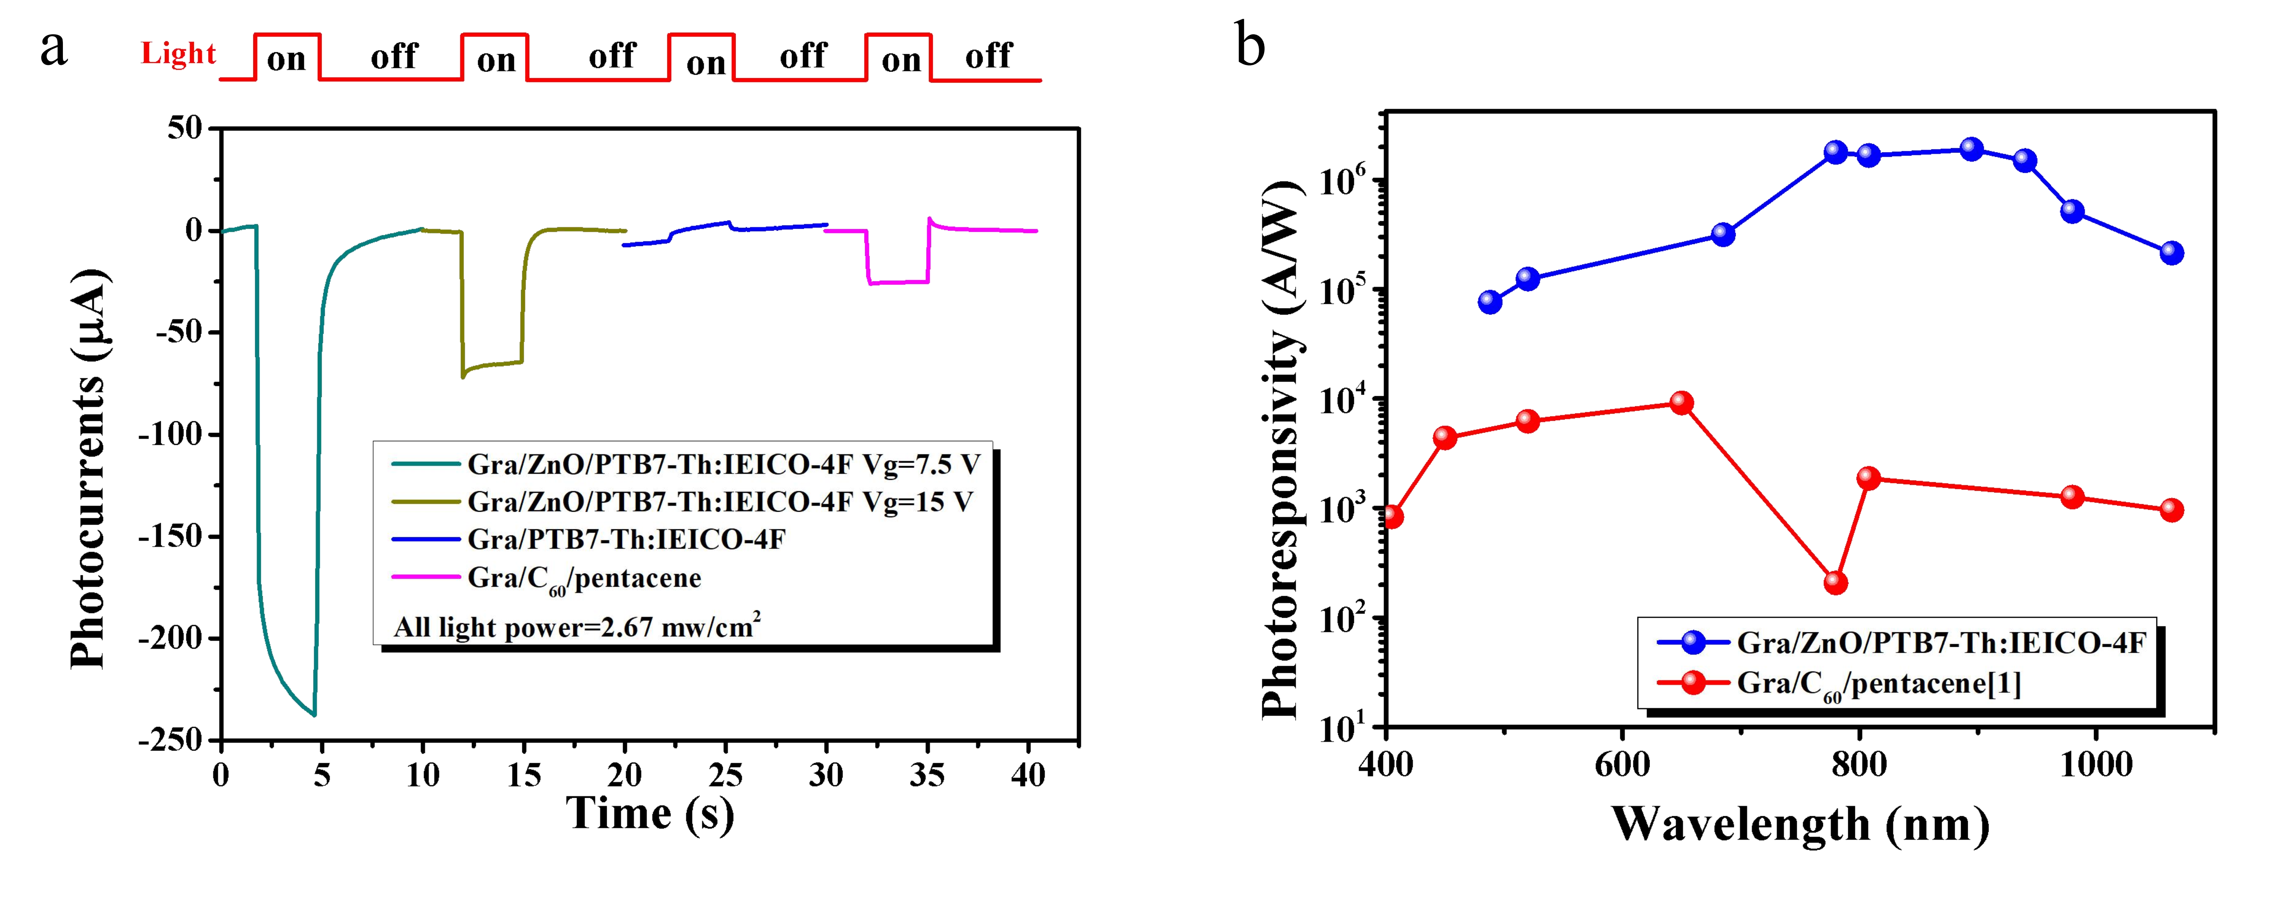
Fig. S5. a, The photocurrent comparison with different device structures and the same input power density. b, The photo-responsivity of graphene/ZnO/PTB7-Th:IEICO-4F and graphene/C₆₀/pentacene.^{[1]}

6. The photocurrents and I-V character with different V_{g} applying.
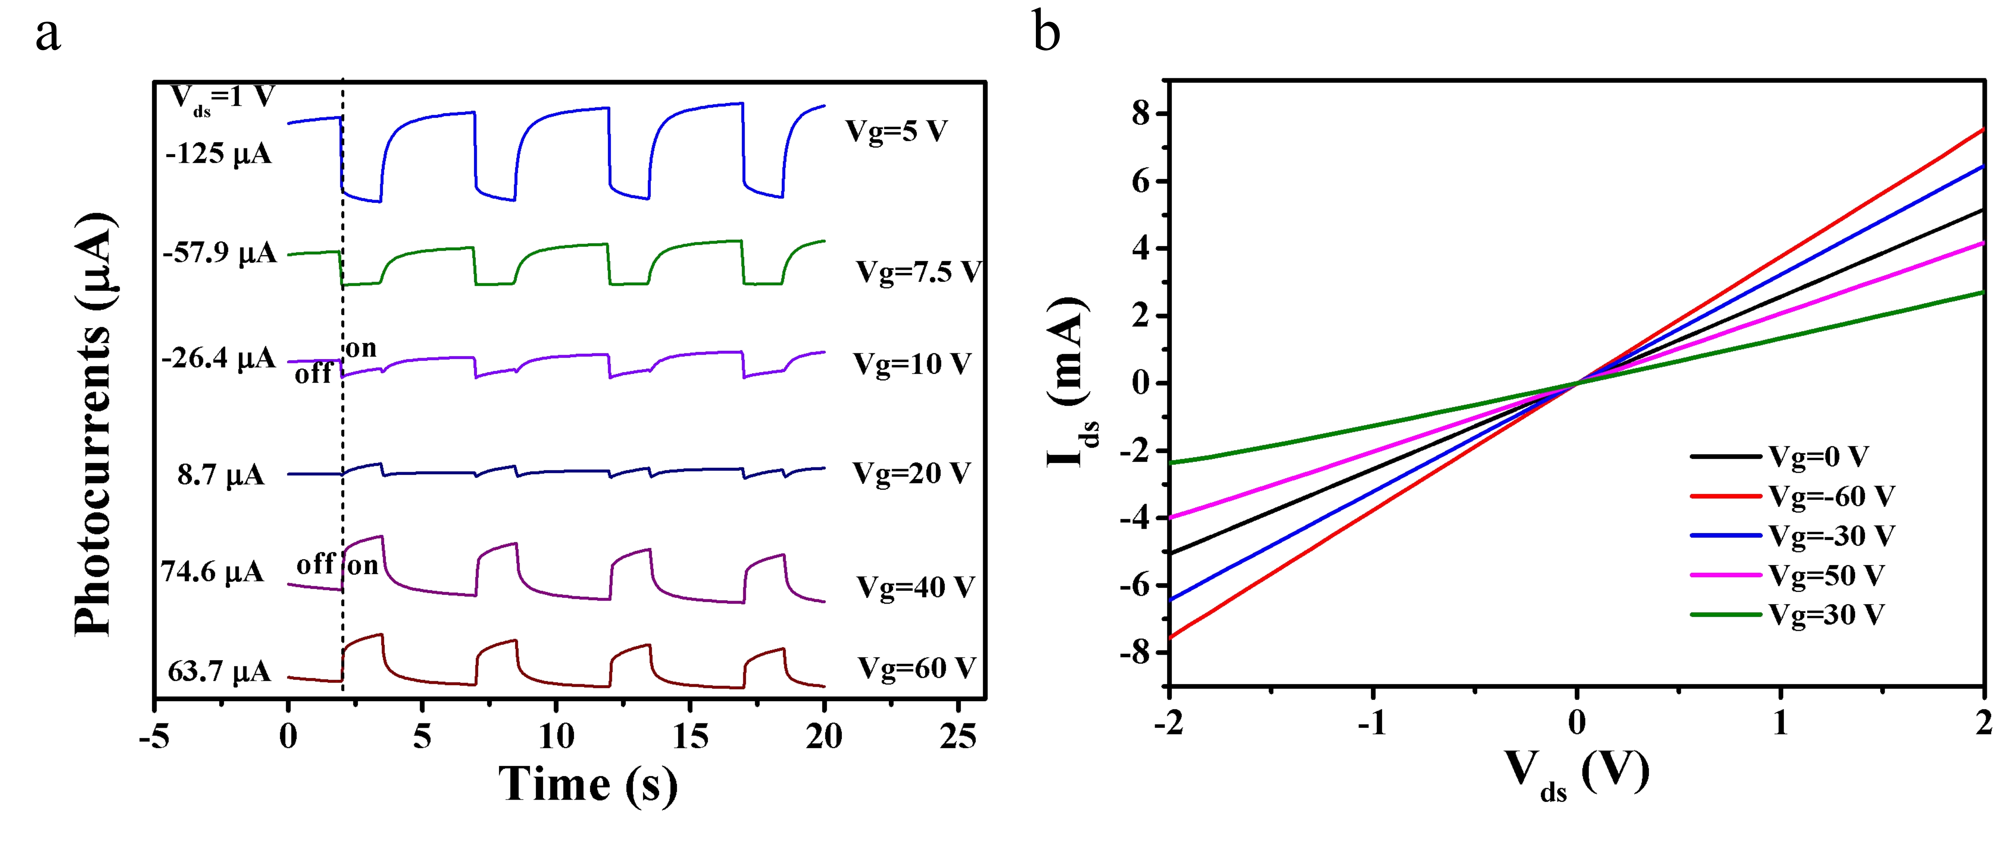
Fig. S6. a, Transient photocurrent measurements with different gate voltages under the illumination of 940 nm light. Power density of 940 nm is 377 μW/cm². b, The I-V curve with different Vg values under the illumination of 808 nm, power density of 808 nm is about 60 mW/cm².

7.Transport Parameters calculation
The carrier mobility $μ$ of graphene/ZnO/PTB7-Th:IEICO-4F heterojunction is estimated by equation :
$$μ=\frac{L}{WC_{ox}V_{ds}}×\frac{∂I_{ds}}{∂V_{g}}$$
Where the $L$ and $W$ are respectively the length and width of channel, the $C_{ox}$ represents the geometric capacitance of bottom gate (285 nm SiO₂) using 12.5 nF/cm², $V_{ds}$ is the bias under the channel and $\frac{∂I_{ds}}{∂V_{g}}$ stands for gradient relation of $I_{ds}$-$V_{g}$ ($\frac{∂I_{ds}}{∂V_{g}}$ obtained from Fig. 2d dark curve). As the result, the $μ$ is computed to be 984 cm²/V⁻¹S⁻¹

8. Photoresponse performance and 1/f noise with the variation of Vg.
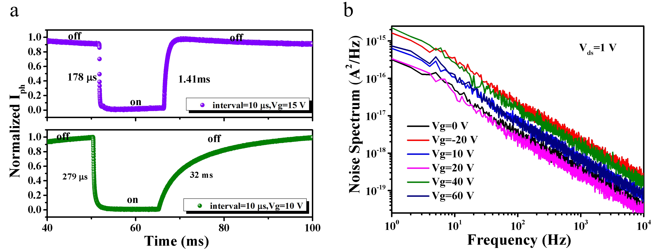
Fig. S8. a, The highly time-resolved photocurrent measurement with interval 10 μs at the gate voltage of 10 V and 15 V. Power density of 895 nm is 263 μW/cm² b, The 1/f noise analysis of the device for different V_{ds} values.

9. Photoresponse performance with the variation of operated frequency.
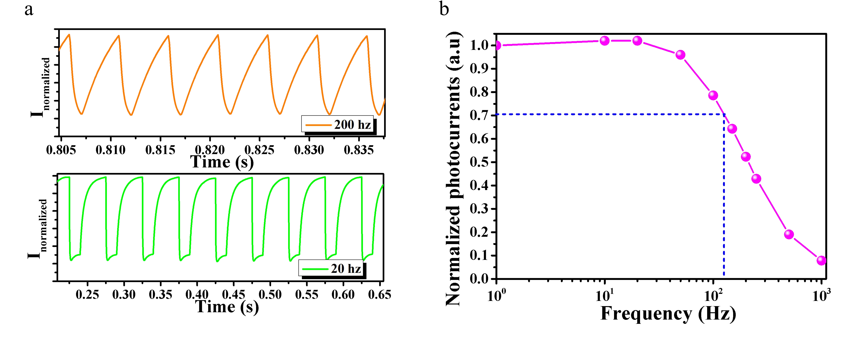
Fig. S9. a, The time-resolved responses of 895 nm under the light on-off frequency of 20 Hz and 200 Hz. b, The normalized photocurrents with the variation of light on-off frequency.

10. The photo-storage character of graphene/ZnO/PTB7-Th:IEICO-4F device.
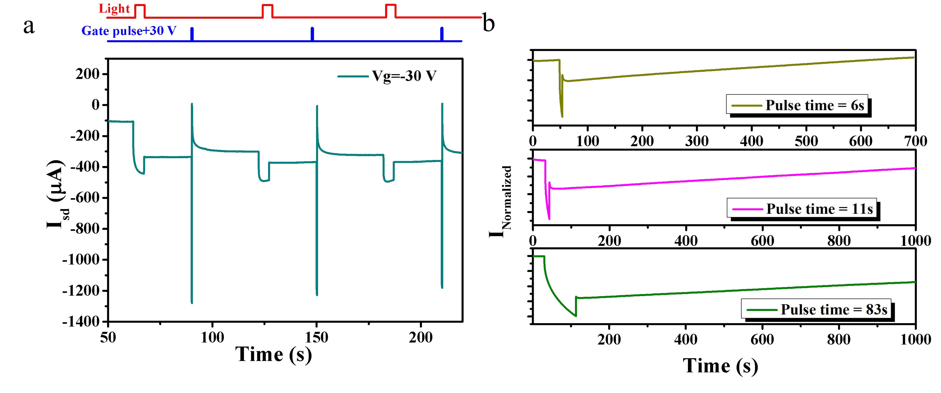
Fig. S10. a, The photocurrents on-off switching operation with +30 V gate pulse (pulse width= 0.25 s) for erasing. The power density of the 895 nm input laser is 20 mW/cm². b, The 940 nm photo-memory persistent states at three different pulse time widths. Vg=-20 V.

Reference
[1] Han, J. et al. Graphene/Organic Semiconductor Heterojunction Phototransistors with Broadband and Bi-directional Photoresponse. Adv Mater 30, 1804020, doi:10.1002/adma.201804020 (2018).

