Appendices

Appendix A. ES supply model documentations

PM₁₀ removal rate
The modelling of PM₁₀ removal by vegetation over the course of 24 hours was performed under the conditions of no precipitation and relatively high ambient PM₁₀ concentration. The original formula used to model the amount of PM₁₀ removed by vegetation can be found below (Nowak, 1994).
$$F = Vd * C$$
Where:
F is the deposition flux (g/m2 sec), Vd is the deposition velocity (m s-1), and C is the concentration of PM10 (g/m³).
Particulate matter concentration data are collected and reported by the National Environment Agency (NEA) of Singapore on an hourly basis over 5 regions. Annual 99th percentile daily (24 hour) mean values are reported online (NEA, 2020). Between 1994 and 2014, the median annual 99th percentile daily mean was 84 μg per m3 (Supplementary Figure 1), thus representing a relatively high exposure to PM₁₀ in the Singapore context. Therefore, we ran the model using this constant value across Singapore. Due to the multiplicative nature of the model equation, the proportion of air pollution removed would scale linearly with the increasing concentration, so the choice of reference concentration will not impact the estimation of the percentage of PM₁₀ removed from the air.
The deposition velocity (Vd) of PM₁₀ depends partly on meteorological conditions of the study area, such as wind velocity, air temperature, and radiant temperature (Sehmel, 1980). Similarly, different species may exhibit different rates for deposition velocity due to differences in their leaf physiology (Chiam et al., 2019). However, several previous PM₁₀ studies have determined that the PM₁₀ removal ability of vegetation is not determined by their photosynthesis activity, and thus used a median value of 0.0064 m/s for Vd (Lovett, 1994) that is based on a leaf area index (LAI) of 6 and 50% resuspension rate (Bottalico et al., 2016; Escobedo and Nowak, 2009; Manes et al., 2014; Nowak et al., 1998). The model above can thus be adjusted based on data on the actual LAI (Escobedo and Nowak, 2009) and re-written as follows (Manes et al., 2016; Nowak et al., 1998).
$$Q = F × L × T × R$$
Where:
Q is total amount of PM₁₀ removed, F is the deposition flux of PM₁₀ L is the leaf area index averaged over a specific vegetation, T is period of time in second, and R is the resuspension rate. We assumed that the deposition flux and resuspension rates were constant across space, with a resuspension rate of 0.5 (Zinke, 1967). We modelled the PM₁₀ removal over a period of one day, so parameterised T as 86,400 seconds.
Leaf area index was parameterised using a national map of leaf area index developed using remote sensing (Richards and Wang, 2020). This LAI map includes only the tree canopy LAI above 2 m, due to constraints on the sampling equipment used (Richards and Wang, 2020). To estimate the additional LAI below the tree canopy in forested areas, we assumed that density of leaves was distributed throughout the tree canopy according to the equation;
$$LDc = CHp × 0.96 +(- 0.01)$$
In which LD_{c} is the cumulative leaf area density and CH_{p} is the proportion of canopy height (Supplementary Figure 2). Canopy height data were extracted from a coarse national map of vegetation height created from spaceborne stereophotogrammetry (Dissegna et al., 2019). We assigned all areas of unmanaged or managed vegetation without a tree canopy to have a minimum leaf area index of 2 following the URA LUSH programme guidelines (URA, 2014a).

Runoff retention rate
Curve numbers were assigned to all ecosystem types following (USDA, 1986). Curve numbers used are given in Supplementary Table 1. It was assumed that all urban area soils were of low quality (Grade D), and all forest soils were of high quality (Grade A) following field data on saturation interception rates (Fung et al., unpublished data). Curve numbers describe the relationship between rainfall runoff coming in, and runoff coming out.
For the purpose of estimating the proportion of rainfall runoff that is prevented by the presence of the ecosystem, we modelled runoff under extreme precipitation conditions. In Singapore, “large storm” events are defined as > 70 mm h-1 falling within an hour (Chow et al., 2016). The frequency of such events, and their magnitude, has increased over time, with the modelled annual maximum hourly rainfall in 2010 around 110 mm mm h-1 (Chow et al., 2016). We therefore used 110 mm mm h-1 as the input rainfall for this model, to simulate an extreme but not impossible rainfall event. It was assumed that this rainfall fell uniformly over the study region.
The runoff per pixel from a 110 mm mm storm event was estimated using the curve number table provided in (USDA, 1986). Input curve number values and rainfall were interpolated to fit the data table provided.

Soil erosion reduction potential
The ecosystem service of soil erosion was modelled using a variation of the Universal Soil Loss Equation (Wischmeier and Smith, 1978), proposed by Guerra et al. (2014). This ecosystem service is defined as the difference between the total actual soil loss and the potential soil loss estimated assuming that no vegetation was present.
The absolute loss of soil in system can be modelled using the USLE as;
$$A = R × LS × K × C × P$$
In which A is the total soil loss, R is the rainfall runoff factor, LS is the topographic factor, K is the soil erodibility factor, C is the vegetation cover factor, and P is the soil conservation management practices factor.
The rainfall runoff factor (R) was taken from a global mapping of erosivity (Panagos et al., 2017). This source dataset is derived from global rainfall records, and has a resolution of approximately 900 m. We resampled this dataset to match the common resolution of the land cover and topographic datasets. Where data were not available (i.e. in some coastal regions not included in the dataset), the mean value across Singapore was taken. Values for R ranged between 8,471 and 10,085 MJ mm ha-1 yr-1.
The topographic factor LS represents the propensity of the landform to soil erosion. This factor was calculated from the digital elevation model using a method developed to facilitate the use of the USLE, according to the following equation (Moore and Burch, 1986);
$${LS= \left(\frac{l}{22.13}\right)}^{m} ×\left(\frac{(0.043×x^{2})+(0.3×x)+0.43}{6.613}\right)$$
Where x is the slope, l is the length slope in metres, m is a factor that is equal to 0.3 for x <= 3%, 0.4 for x > 4% and x <= 5%, and 0.5 for x > 5%. Length slope was calculated as the maximum flow distance from the top of the catchment for each pixel. To prevent extreme values, the maximum slope was capped to 50% (Panagos et al., 2017).
The soil erodibility factor K in SI units was modelled based on field data for soil particle size distribution and clay content, following a method previously proposed by the USLE (Renard et al., 1997) and a conversion factor from U.S. Customary Units to SI units (Foster et al., 1981);
$$K= 0.1317×7.594×\left\{0.0034+0.0405 × exp\left[-\frac{1}{2}×{\left(\frac{loglog \left(Dg\right)+1.659 }{0.7101}\right)}^{2}\right]\right\}$$
Where Dg is the geometric mean of the particle size distribution of the soil sample. The equation was used to estimate K values for five common vegetation types for which field samples were available. Field samples were collected from 24 locations for each vegetation cover type, with samples taken from the top 20 cm of soil. The median values for the five vegetation types were taken and applied to the corresponding vegetation cover categories. For ecosystem cover types with no field soil data available, we assigned the K value from the most similar ecosystem type (Supplementary Table 2).
The vegetation cover factor C was derived using satellite imagery, using a conversion from the normalised difference vegetation index (NDVI). The conversion from NDVI to C was made following the method of the European Commission European Soil Risk Assessment (Van der Knijff et al., 2000), using the equation;
$$C=exp[-α×NDVI/(β-NDVI)]$$
In which α and β are constants set to 2 and 1 respectively (Van der Knijff et al., 2000). We mapped NDVI over the study area using satellite images from the Sentinel 2 satellite (Richards and Wang, 2020). To remove artefacts due to cloud cover and temporal variation in NDVI, the median NDVI from all cloud-free Sentinel 2 images taken between the 1st of January 2016 and 30th of March 2018 was composited in Google Earth Engine (Gorelick et al., 2017; Richards and Wang, 2020).
The soil conservation management practices factor P is intended to simulate the results of management actions such as contouring, terracing, and subsurface drainage (Prasannakumar et al., 2012). Spatially explicit data on such soil conservation management practices are not available at the scale of the whole of Singapore, so this factor was excluded. Exclusion of P is common in large-scale mapping studies of soil erosion (Guerra et al., 2014).
To convert the estimate of soil loss to an ecosystem service value, (Guerra et al., 2014) propose comparing the total actual estimated soil loss (A) against the soil loss estimated if vegetation cover was not considered (SI). The difference between these estimates is therefore the amount of soil loss prevented by vegetation cover – which is defined as the ecosystem service (ES).
$$A = R × LS × K × C$$
$$SI = R × LS × K$$
$$ES = SI - A$$
The calculation of ES was conducted for each terrestrial pixel on Singapore’s main island (thus excluding the outlying Southern Islands, Pulau Ubin, and Pulau Tekong). It was not possible to model these outlying islands due to a lack of topographic data for these regions. The results are presented as the proportion of the possible erosion that was prevented by the presence of vegetation;
$$\frac{ES}{SI}$$

Temperature reduction
The impact of urban ecosystems on the ambient air temperature was modelled using a land cover regression approach. Data on air temperature were collated from two existing weather station networks, covering 45 weather stations in different parts of Singapore (Supplementary Figure 3). The two weather station networks were the National Environment Agency stations (https://data.gov.sg/dataset/realtime-weather-readings) and the WeatherUnderground amateur weather station network (https://www.wunderground.com/). The analysis took data from the period between the 1st of October 2015, and the 2nd October 2018. Data were aggregated into hourly means for each weather station by taking the mean of all measurements within the hour. The dataset is not continuous, as data from the full time period is not available from all weather stations. The statistical model of air temperature is based on a generalised additive model (GAM), with a smoothed function fitted over the variable “hour” to model daily variation in temperature, an autocorrelation structure fitted to remove autocorrelation in the error structure. To account for potential spatial autocorrelation due to the location of the weather stations, we included spatial coordinates as a smoothed term fitted using a Gaussian process spline with the Matern covariance function allowing flexibility in the shape of this relationship (Ziter et al., 2019). Random effects were fitted to account for non-independence between measurements taken at the same weather station, measurements taken on the same day, and any systematic differences between measurements from the two weather station networks. Due to the model specification, the temperature difference caused by the ecosystem variables is quantified as an overall average across the day and night cycle.
Fixed-effects were fitted to model the impacts of surrounding ecosystem characteristics on the air temperature. Due to the low occurrence of some ecosystem types within the proximity of the weather stations, we simplified the ecosystem typology into four broad types; the total area of unmanaged vegetation, the total area of managed tree cover, the total area of managed grass and shrub cover, and the total area of surface water (Gaw et al., 2019). In addition, the leaf area index of the area was quantified using an existing national map layer (Richards & Wang, 2020). Ecosystem variables were calculated within buffers representing four spatial scales; 10 m, 50 m, 100 m, and 200 m. Prior to beginning the overall modelling exercise, we used a pre-selection process to identify the most relevant spatial scales for each explanatory variable. The four scale predictors for each variable were compared against each other in a model, and only those that were significant or marginally significant (p < 0.06) were included in the combined model.
The following variables were included in the initial model:
- Proportional cover of unmanaged vegetation (a combined category including unmanaged scrub, secondary forest, mangrove, and swamp forest) within a 200 m buffer.
- Proportional cover of managed tree canopy vegetation within a 50 m and 100 m buffer.
- Proportional cover of managed turf grass and shrub within a 10 m and 100 m buffer.
- Proportional cover of open water within a 10 m buffer.
- Mean leaf area index within a 100 m buffer.
The model was then simplified by sequential deletion of the least significant fixed effect terms, and the parsimony of the competing models was evaluated using AIC (Akaike, 1974). This process was completed until only significant terms were retained in the model, and a minimal AIC was found.

Noise abatement
Noise attenuation was modelled using a simple 2-dimensional mechanistic model, following the methodology of the System for the Prediction of Acoustic Detectability (SPreAD) model, which is freely available as a package for ArcGIS (Reed et al., 2012). SPreAD-GIS was developed for conservation and ecological planning (Reed et al., 2012). The model as implemented here evaluates four types of noise attenuation over space;
- Spherical spreading loss ssl, which is the decline in sound level due to distance.
- Atmospheric absorption loss aal, which is the decline in sound level due to absorption by the atmosphere.
- Topographic and barrier effects bl, which is the blocking of sound as it passes over buildings and other solid barriers.
- Foliage and ground cover loss hl, which is the decline in sound level due to absorption and scattering of sound waves by vegetation.
A fifth type of sound loss – downwind and upwind loss – is included in SPreAD-GIS but was not modelled here due to the relatively low wind speeds and complexities of modelling wind flow in urban environments. The total potential noise remaining after attenuation (ta) can thus be described by the equation;
$$ta = DB – ssl – aal – bl – hl$$
Where DB is the volume of the noise in decibels at source. ta is moderated by constraint that it cannot be negative, so if ta < 0 then ta = 0.
The ecosystem service of noise attenuation (ES_{N}) is defined as the reduction in total noise due to the vegetation loss component hl, which can be written as;
$$ESN = DB – ssl – aal – bl – ta$$
The general approach and many equations used to model the component forms of noise loss were originally proposed as part of the International Organisation for Standardisation guideline on attenuation of sound during propagation outdoors (ISO 9613-2, 1996). Modelling of atmospheric absorption was modified according to guidelines on absorption of sound by the atmosphere published by the Acoustical Society of America (ANSI S1.26, 1995). Atmospheric conditions were parameterised at 30 °C and 70% humidity; typical daytime conditions in Singapore (Chow and Roth, 2006).
Barrier effects were modelled using an implementation of the SPreAD-GIS (Reed et al., 2012) method developed to run with minimal computation demands in the R environment. This method makes a simplification by modelling the effect of only one barrier for each pixel in the grid – the closest barrier to the closest noise source. Barriers were quantified as topographic or building components that intersect the vertical direct line between the closest noise source and each pixel. In the horizontal dimension, barriers were defined as objects falling within 45° of a direct line between the closest noise source and each pixel.
The attenuation of noise by vegetation was parameterised using a method developed by the US Environmental Protection Agency, in part using an empirical quantification of attenuation by different vegetation types (Harrison et al., 1980). The maximum attenuation of noise due to vegetation was capped at 14 dB (Harrison et al., 1980).
The source noise level was parameterised at 70 dB, an intermediate-high value for traffic noise (Chin et al., 2019; Ma and Yano, 2004). Noise was modelled only for 1000 Hz, as this approximates the dominant frequency of traffic noise (Can et al., 2010). Noise sources were generated as 30,000 points located randomly along Singapore’s road network.

Supplementary figures and tables
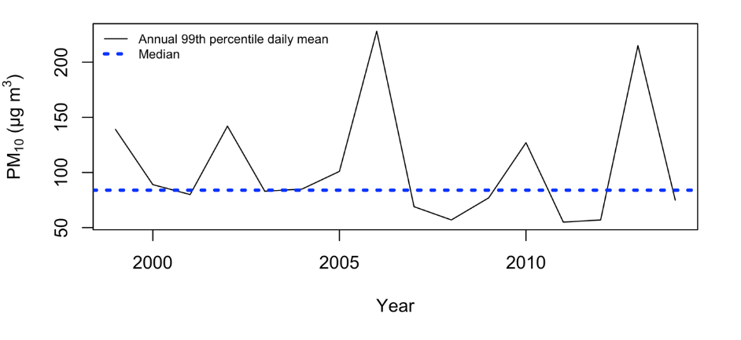
Supplementary Figure 1. Annual 99th percentile daily mean PM10 recorded between 1994 and 2014. Median value equals 84 μg per m3.

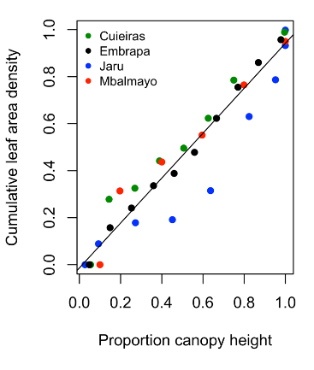
Supplementary Figure 2. Vertical distribution of the leaf area density at four tropical rainforest sites (Meir et al., 2000).

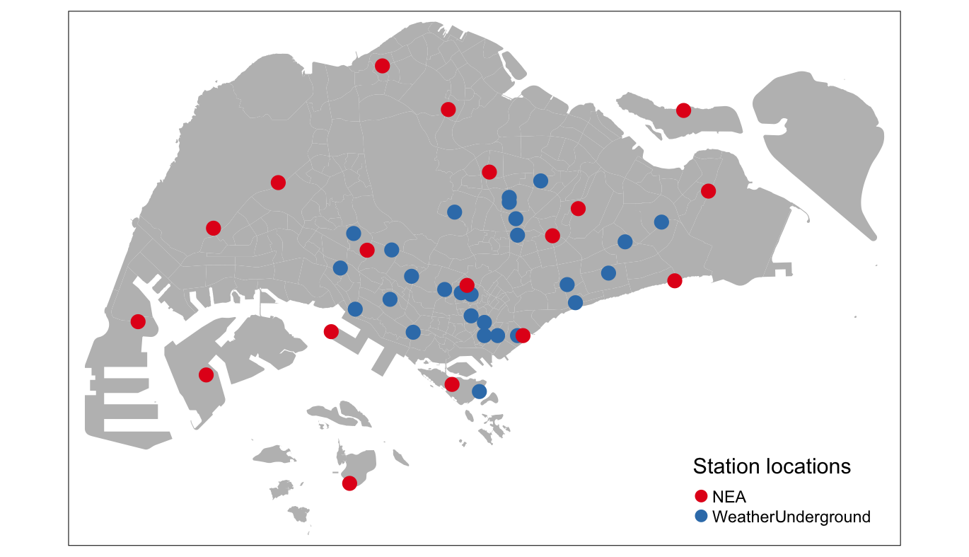

Supplementary Figure 3. Locations of 45 NEA and WeatherUnderground weather stations used in air temperature reduction modelling.

Supplementary Table 1. Curve numbers applied for urban vegetation types.
Class | Assigned curve number | Assumed USDA (1986) soil type
Buildings | 98 | Soil D
Artificial impervious | 98 | Soil D
Non-vegetated pervious | 94 | Soil D
Vegetation with limited management (with tree canopy) | 30 | Soil A
Vegetation with limited management (without tree canopy) | 48 | Soil B
Vegetation dominated by management (with tree canopy) | 80 | Soil D
Vegetation dominated by management (without tree canopy) | 80 | Soil D
Freshwater swamp forest | 30 | Soil A
Freshwater marsh | 30 | Soil A
Mangrove | 30 | Soil A
Water courses | 0
Water bodies | 0
Sea | 0

Supplementary Table 2. K values assigned to different ecosystem cover types.
Ecosystem cover type | K value (SI units)
Non-vegetated pervious surfaces | Same as vegetation with structure dominated by human management (w/o Tree Canopy)
Vegetation with limited human management (w Tree Canopy) | 0.005755266
Vegetation with limited human management (w/o Tree Canopy) | Same as vegetation with limited human management (w Tree Canopy)
Vegetation with structure dominated by human management (w Tree Canopy) | 0.002382996
Vegetation with structure dominated by human management (w/o Tree Canopy) | 0.001960931
Freshwater swamp forest and marsh | Same as vegetation with limited human management (w Tree Canopy)
Mangrove | Same as vegetation with limited human management (w Tree Canopy)

Appendix B. List of questions and information used from the national survey questionnaire.
Q1 Postal code:

Q2 Residential type:
〼HDB (2-Room/ 3-Room/ 4-Room/ 5-Room/ Executive Condominium)
〼Private Condominium
〼Landed property

Q3 Gender:
〼Male
〼Female

Q4 Age:
〼20-24 years 〼25-29 years
〼30-34 years 〼35-39 years
〼40-44 years 〼45-49 years
〼50-54 years 〼55-59 years
〼60-64 years 〼65 years and above

Q5 Occupation status:
〼Self employed 〼Private sector employee
〼Civil servant 〼Homemaker
〼NGOs 〼Academic
〼Student 〼Unemployed
〼Retired 〼Full-time national service

Q6 Ethnicity group:
〼Chinese 〼Indian
〼Malay 〼Other

Q7 Citizenship status in Singapore
〼Singaporean
〼Permanent resident
〼Foreigner

Q8 Total monthly income of your household
〼1,000 and below 〼11,001 - 12,000
〼1,001 - 2,000 〼12,001 - 13,000
〼2,001 - 3,000 〼13,001 - 14,000
〼3,001 - 4,000 〼14,001 - 15,000
〼4,001 - 5,000 〼15,001 - 16,000
〼5,001 - 6,000 〼16,001 - 17,000
〼6,001 - 7,000 〼17,001 - 18,000
〼7,001 - 8,000 〼18,001 - 19,000
〼8,001 - 9,000 〼19,001 - 20,000
〼9,001 -10,000 〼Above 21,000
〼10,001 - 11,000

Q9 How important are these benefits from Singapore’s nature to you?

Benefits from Singapore’s nature | Importance |  |  |  |  | Don’t know
Benefits from Singapore’s nature | (1) Not at all important | (2) Not too important | (3) Somewhat important | (4) Very important | (5) Extremely important | Don’t know
Reducing air pollution from the streets
(e.g. roadside greenspace)
Reducing temperatures
Reducing noise
Reducing soil erosion (e.g. plant roots)
Reducing flood risk by slowing storm water runoff
Providing good nature sceneries

Supplementary references
Akaike, H. (1974). A New Look at the Statistical Model Identification. IEEE Transactions on Automatic Control, 19(6), 716–723. https://doi.org/10.1109/TAC.1974.1100705
ANSI S1.26 (1995). Method for calculation of the absorption of sound by the atmosphere. ANSI S1.26l; 1995. Available online: https://infostore.saiglobal.com/en-us/standards/ansi-s1-26-1995-r2009--133119_SAIG_ASA_ASA_284420/ accessed 18th February 2020.
Bottalico, F., Chirici, G., Giannetti, F., De Marco, A., Nocentini, S., Paoletti, E., Salbitano, F., Sanesi, G., Serenelli, C., & Travaglini, D. (2016). Air Pollution Removal by Green Infrastructures and Urban Forests in the City of Florence. Agriculture and Agricultural Science Procedia, 8, 243–251. https://doi.org/10.1016/j.aaspro.2016.02.099
Can, A., Leclercq, L., Lelong, J., & Botteldooren, D. (2010). Traffic noise spectrum analysis: Dynamic modeling vs. Experimental observations. Applied Acoustics, 71(8), 764–770. https://doi.org/10.1016/j.apacoust.2010.04.002
Chiam, Z., Song, X. P., Lai, H. R., & Tan, H. T. W. (2019). Particulate matter mitigation via plants: Understanding complex relationships with leaf traits. Science of The Total Environment, 688, 398–408. https://doi.org/10.1016/j.scitotenv.2019.06.263
Chin, C., Thang, Z. Y., & Saju, S. (2019). Study on impact of noise annoyance from highway traffic in Singapore City. 178th Meeting of the Acoustical Society of America, 39, 015001. https://doi.org/10.1121/2.0001116
Chow, W. T. L., & Roth, M. (2006). Temporal dynamics of the urban heat island of Singapore. International Journal of Climatology, 26(July), 2243–2260. https://doi.org/10.1002/joc
Chow, W. T. L., Cheong, B. D., & Ho, B. H. (2016). A Multimethod Approach towards Assessing Urban Flood Patterns and Its Associated Vulnerabilities in Singapore. Advances in Meteorology, 7159132.
Dissegna, M. A., Yin, T., Wei, S., Richards, D., & Grêt-Regamey, A. (2019). 3-D Reconstruction of an Urban Landscape to Assess the Influence of Vegetation in the Radiative Budget. Forests, 10(8), 700. https://doi.org/10.3390/f10080700
Escobedo, F.J., & Nowak, D. J. (2009). Spatial heterogeneity and air pollution removal by an urban forest. Landscape and Urban Planning, 90(3-4), 102-110. https://doi.org/10.1016/j.landurbplan.2008.10.021
Foster, G. R., McCool, D. K., Renard, K. G., & Moldenhauer, W. C. (1981). Conversion of the universal soil loss equation to SI metric units. Journal of Soil & Water Conservation, 36(6), 355–359.
Gaw, L. Y. F., Yee, A. T. K., & Richards, D. R. (2019). A high-resolution map of Singapore’s terrestrial ecosystems. Data, 4(3), 1–10. https://doi.org/10.3390/data4030116
Gorelick, N., Hancher, M., Dixon, M., Ilyushchenko, S., Thau, D., & Moore, R. (2017). Google Earth Engine: Planetary-scale geospatial analysis for everyone. Remote Sensing of Environment, 2016. https://doi.org/10.1016/j.rse.2017.06.031
Guerra, C. A., Pinto-Correia, T., & Metzger, M. J. (2014). Mapping Soil Erosion Prevention Using an Ecosystem Service Modeling Framework for Integrated Land Management and Policy. Ecosystems, 17(5), 878–889. https://doi.org/10.1007/s10021-014-9766-4
Harrison, R., Clark, R., & Stankey, G. (1980). Predicting impact of noise on recreationists.
ISO 9613-2. (1996). Acoustics attenuation of sound during propagation outdoors. Part 2: general method of calculation (ISO/DIS Standard No. 9613-2). Available online: https://www.iso.org/standard/20649.html (accessed February 18, 2020).
Lovett, G. M. (1994). Atmospheric Deposition of Nutrients and Pollutants in North America: An Ecological Perspective. Ecological Applications, 4(4), 629–650. https://doi.org/10.2307/1941997
Ma, H., & Yano, T. (2004). An experiment on auditory and non-auditory disturbances caused by railway and road traffic noises in outdoor conditions. Journal of Sound and Vibration, 277(3), 501–509. https://doi.org/10.1016/j.jsv.2004.03.011
Manes, F., Marando, F., Capotorti, G., Blasi, C., Salvatori, E., Fusaro, L., Ciancarella, L., Mircea, M., Marchetti, M., Chirici, G., & Munafò, M. (2016). Regulating Ecosystem Services of forests in ten Italian Metropolitan Cities: Air quality improvement by PM10 and O3 removal. Ecological Indicators, 67, 425–440. https://doi.org/10.1016/j.ecolind.2016.03.009
Manes, F., Silli, V., Salvatori, E., Incerti, G., Galante, G., Fusaro, L., & Perrino, C. (2014). Urban ecosystem services: Tree diversity and stability of PM10 removal in the metropolitan area of Rome. Annali Di Botanica, 4, 19–26. https://doi.org/10.4462/annbotrm-11746
Moore, I. D., & Burch, G. J. (1986). Physical basis of the length-slope factor in the universal soil loss equation. Soil Science Society of America, 50(5), 1294–1298.
NEA. (March 26, 2020). Air Pollutant - Particulate Matter PM10 (24-hr Mean -99th Percentile). Data.gov.sg. Retrieved from https://data.gov.sg/dataset/air-pollutant-particulate-matter-pm10
Nowak, D. J. (1994). Air pollution removal by Chicago’s urban forest. In E. G. McPherson, D. J. Nowak, & R. A. Rowntree (Eds.), Chicago’s Urban Forest Ecosystem: Results of the Chicago Urban Forest Climate Project (pp. 63–81). USDA Forest Service General Technical Report NE-186.
Nowak, D. J., McHale, P. J., Ibarra, M., Crane, D., Stevens, J. C., & Luley, C. J. (1998). Modelling the effects of urban vegetation on air pollution. In S. Grynin & N. Chaumerliac (Eds.), Air Pollution Modelling and Its Application XII (pp. 399–407). Plenum Press.
Panagos, P., Borrelli, P., Meusburger, K., Yu, B., Klik, A., Lim, K. J., Yang, J. E., Ni, J., Miao, C., Chattopadhyay, N., Sadeghi, S. H., Hazbavi, Z., Zabihi, M., Larionov, G. A., Krasnov, S. F., Gorobets, A. V., Levi, Y., Erpul, G., Birkel, C., … Ballabio, C. (2017). Global rainfall erosivity assessment based on high-temporal resolution rainfall records. Scientific Reports, 7(1), 1–12. https://doi.org/10.1038/s41598-017-04282-8
Prasannakumar, V., Vijith, H., Abinod, S., & Geetha, N. (2012). Estimation of soil erosion risk within a small mountainous sub-watershed in Kerala, India, using Revised Universal Soil Loss Equation (RUSLE) and geo-information technology. Geoscience Frontiers, 3(2), 209–215. https://doi.org/10.1016/j.gsf.2011.11.003
Reed, S. E., Boggs, J. L., & Mann, J. P. (2012). A GIS tool for modeling anthropogenic noise propagation in natural ecosystems. Environmental Modelling and Software, 37, 1–5. https://doi.org/10.1016/j.envsoft.2012.04.012
Renard, K., Foster, G., Weesies, G., McCool, D., & Yoder, D. (1997). Predicting soil erosion by water: A guide to conservation planning with the Revised Universal Soil Loss Equation (RUSLE). In Agriculture Handbook Number 703.
Richards, D., & Wang, J. W. (2020). Fusing street level photographs and satellite remote sensing to map leaf area index. Ecological Indicators, 115(April), 106342. https://doi.org/10.1016/j.ecolind.2020.106342
Sehmel, G. A. (1980). Particle and gas dry deposition: a review. Atmospheric Environment, 14, 983–1011.
URA. (2014a). Landscaping for Urban Spaces and High- Rises (LUSH) 2.0 Programme: Landscape Replacement Policy for Strategic Areas.
USDA. (1986). Urban Hydrology for Small Watersheds. In United States Department of Agriculture (Issue Technical Release 55 (TR-55)).
Van der Knijff, J. M., Jones, R. J. A., & Montanarella, L. (2000). Soil Erosion Risk Assessment in Europe. In EUR 19044 EN. Luxembourg: Office for Official Publications of the European Communities: Vol. EUR 19044 (Issue EN). https://doi.org/citeulike-article-id:13481385
Wischmeier, W. H., and Smith, D.D. (1978). Predicting rainfall erosion losses—a guide to conservation planning. U.S. Department of Agriculture, Agriculture Handbook No. 537. Available online: https://naldc.nal.usda.gov/download/CAT79706928/PDF.
Zinke, P. J. (1967). Forest interception studies in the United States. In W. E. Sopper & H. W. Lull (Eds.), Forest Hydrology (pp. 131–161). Oxford, UK: Pergamon Press.
Ziter, C. D., Pedersen, E. J., Kucharik, C. J., & Turner, M. G. (2019). Scale-dependent interactions between tree canopy cover and impervious surfaces reduce daytime urban heat during summer. Proceedings of the National Academy of Sciences, 201817561.

