Giehler et al.

Epstein-Barr virus-driven B cell lymphoma mediated
by a unique LMP1-TRAF6 complex

SUPPLEMENTARY INFORMATION

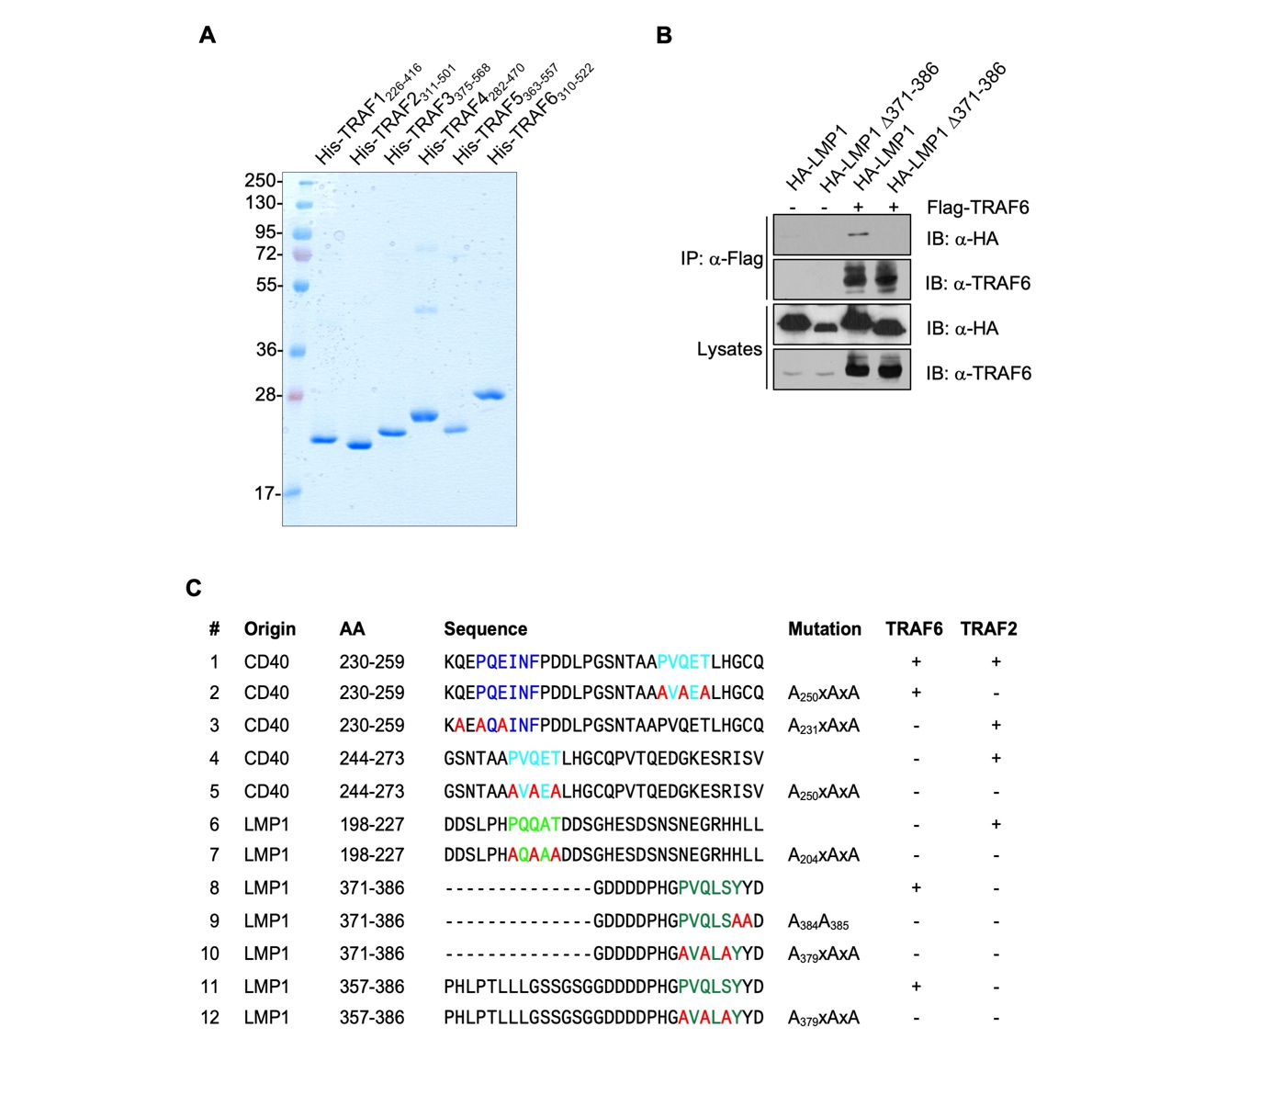

Supplementary Figure 1. TRAF6 directly interacts with the CTAR2.
(A) Recombinant His-TRAF preparations. Coomassie staining of SDS-PAGE gel.
(B) Deletion of the C-terminal sixteen amino acids of CTAR2 abolishes interaction of TRAF6 with LMP1 in vivo. HEK293 cells were transfected with Flag-TRAF6 and HA-LMP1 or the Δ371-386 mutant. 24 h post transfection, Flag-TRAF6 was immunoprecipitated via its Flag-tag and co-precipitating HA-LMP1 was analysed on immunoblots via a α-HA-tag antibody. A representative result of two independent experiments is shown.
(C) Peptide sequences of the arrays shown in Figure 1C. The TRAF6-binding sequence of CD40 is highlighted in dark blue, the CTAR2 core sequence critical for the induction of signaling in dark green, the TRAF-binding PxQxT motifs of CD40 and LMP1 in light blue or light green, respectively. Alanine exchanges are indicated in red. Interaction with TRAF6 or TRAF2 is indicated according to the results shown in Figure 1C.

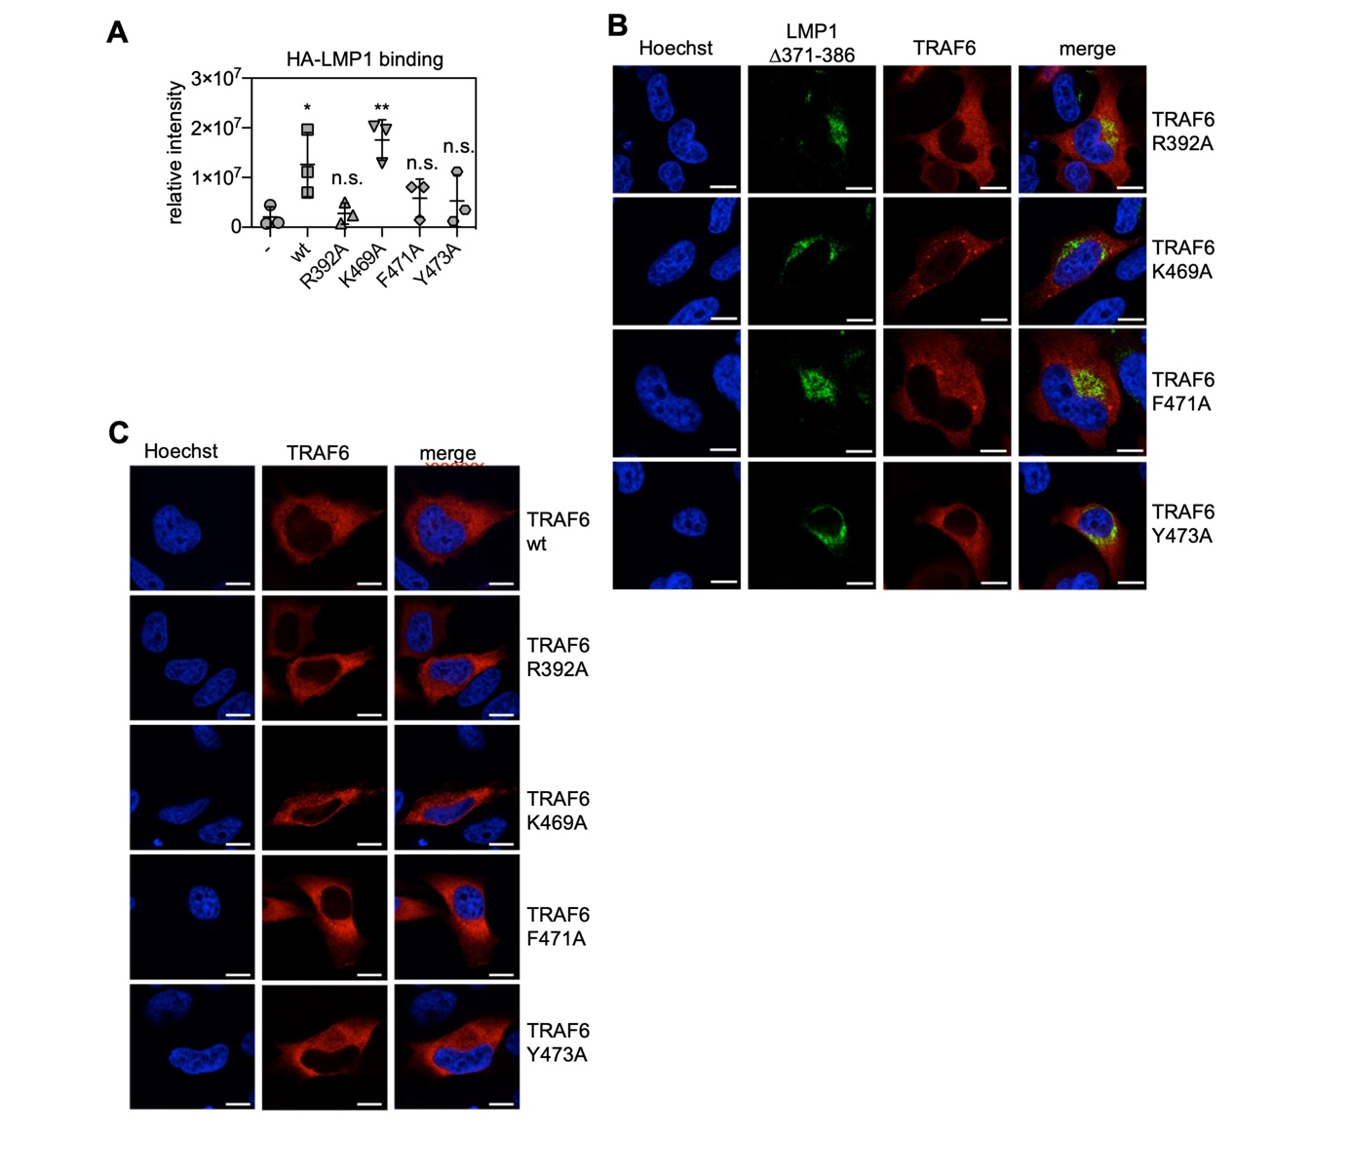

Supplementary Figure 2. TRAF6 interaction with LMP1 in vivo.
(A) Quantification and statistics of the experiment shown in Figure 2B. LMP1 signals were digitalized and quantified. Data are mean values ± SD of three independent experiments. Statistics: one-way ANOVA. p-values: *p ≤ 0.05, **p ≤ 0.01, n.s., not significant.
(B) TRAF6 interacts with the sixteen C-terminal amino acids of CTAR2, demonstrated by confocal microscopy. Neither TRAF6 wildtype nor any of the TRAF6 mutants co-localized with the LMP1 deletion mutant ∆371-386 in HeLa cells. Scale: 10 µm.
(C) Distribution of TRAF6 and the indicated TRAF6 mutants in HeLa cells in the absence of LMP1. Scale: 10 µm.

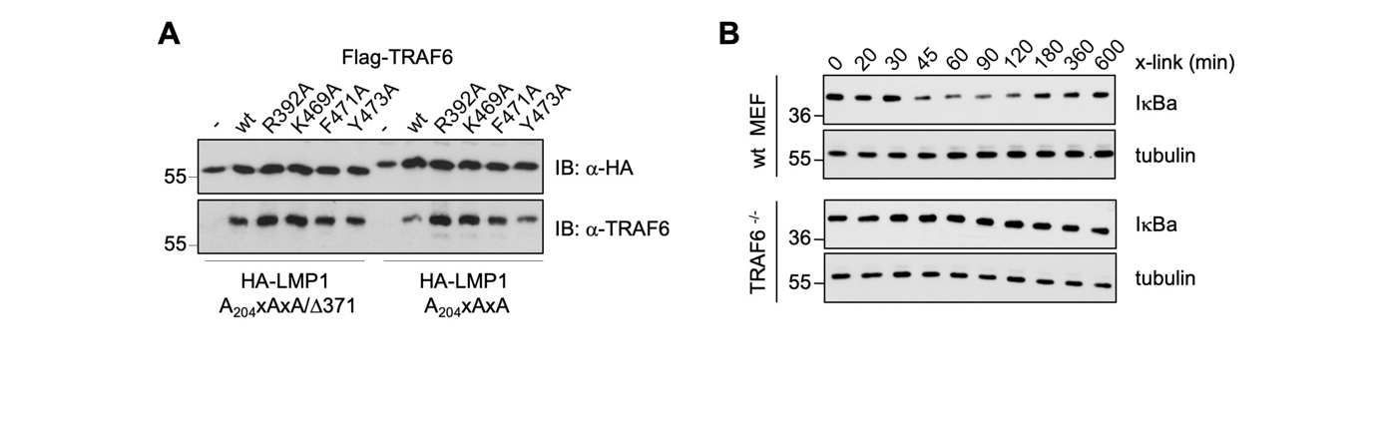

Supplementary Figure 3. Additional controls to the TRAF6 rescue experiments of Figure 3.
(A) Expression levels of recombinant HA-LMP1 and Flag-TRAF6 proteins for the NF-κB rescue experiments shown in Figure 3A. Representative results.
(B) Absent canonical NF-κB activation by NGFR-LMP1 in TRAF6-/- MEFs, which had been transduced with NGFR-LMP1. NGFR-LMP1 activity was induced by antibody cross-linking for different times and IκBα levels were analysed by immunoblotting. Tubulin served as loading control. Representative blots are shown.

