Small Heterocyclic Molecules as Anticancer Agents: Design, Syntheses and Evaluation against MCF-7 Cell Lines
Roshni Varshney, Vimlesh Kumar, Gul Naz Fatima, Shailendra K. Saraf
⌧ Dr. (Prof.) Shailendra K. Saraf
dirpharmniec@gmail.com
Division of Pharmaceutical Chemistry, Faculty of Pharmacy, Babu Banarasi Das Northern India Institute of Technology, Lucknow, Uttar Pradesh, 226028, India.

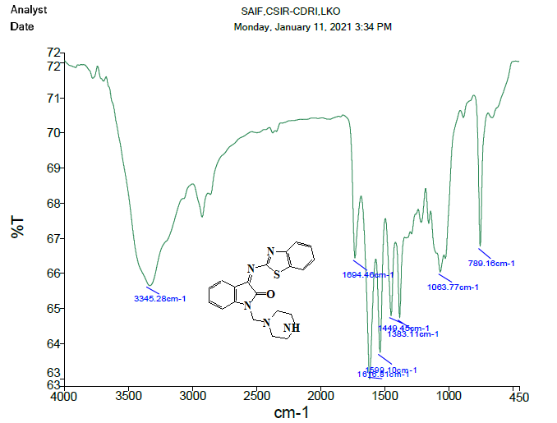
Figure S1. FTIR spectrum of compound IDF 3A

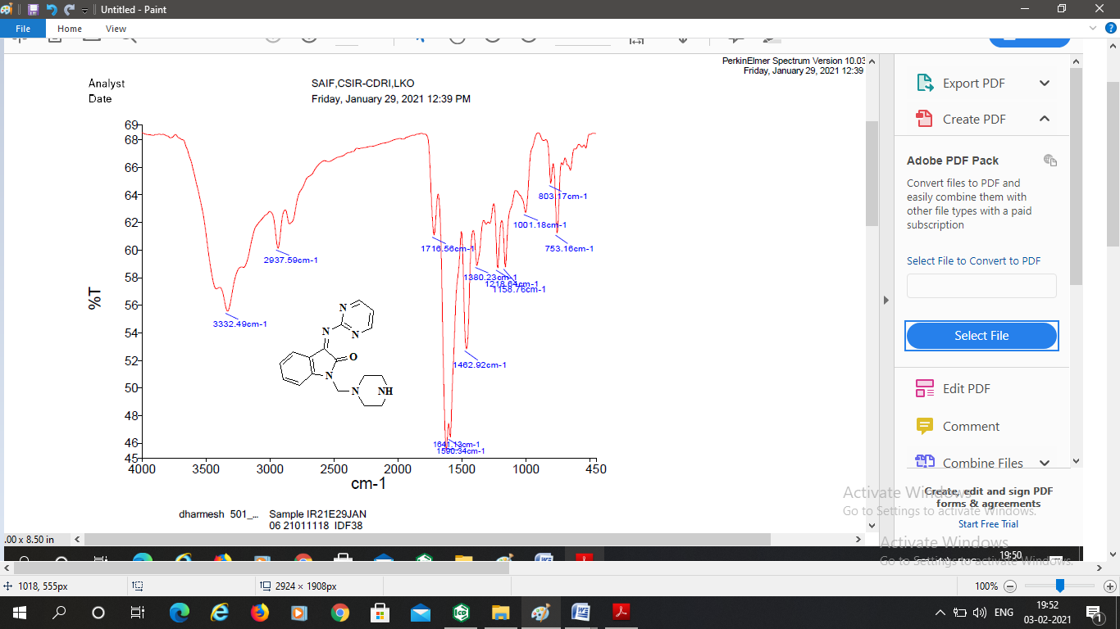
Figure S2. FTIR spectrum of compound IDF 3B

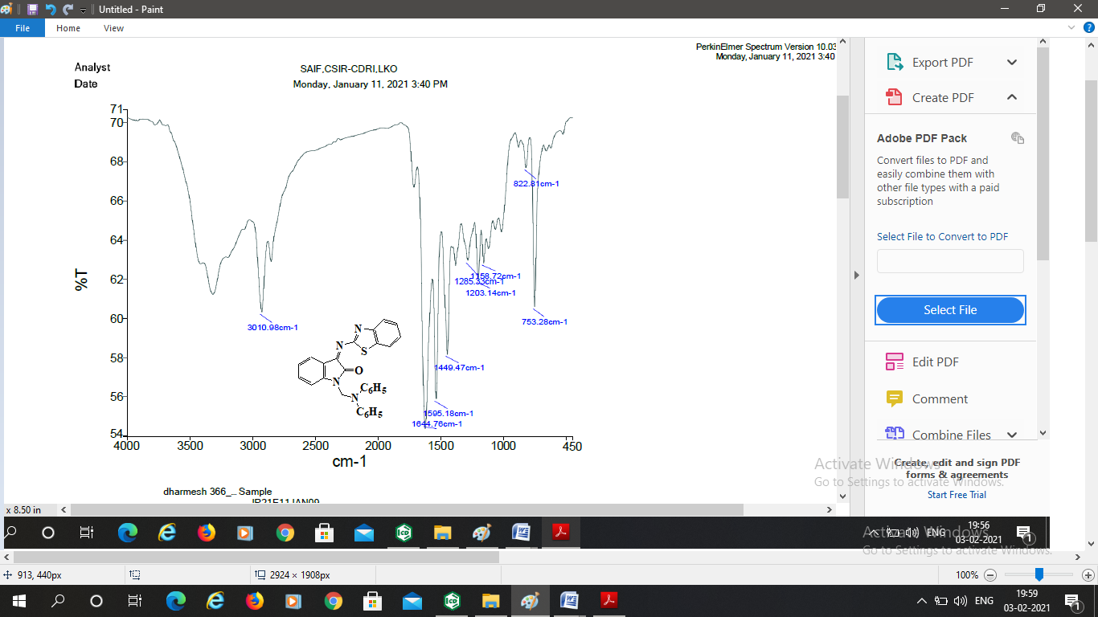
Figure S3. FTIR spectrum of compound IDF 3C

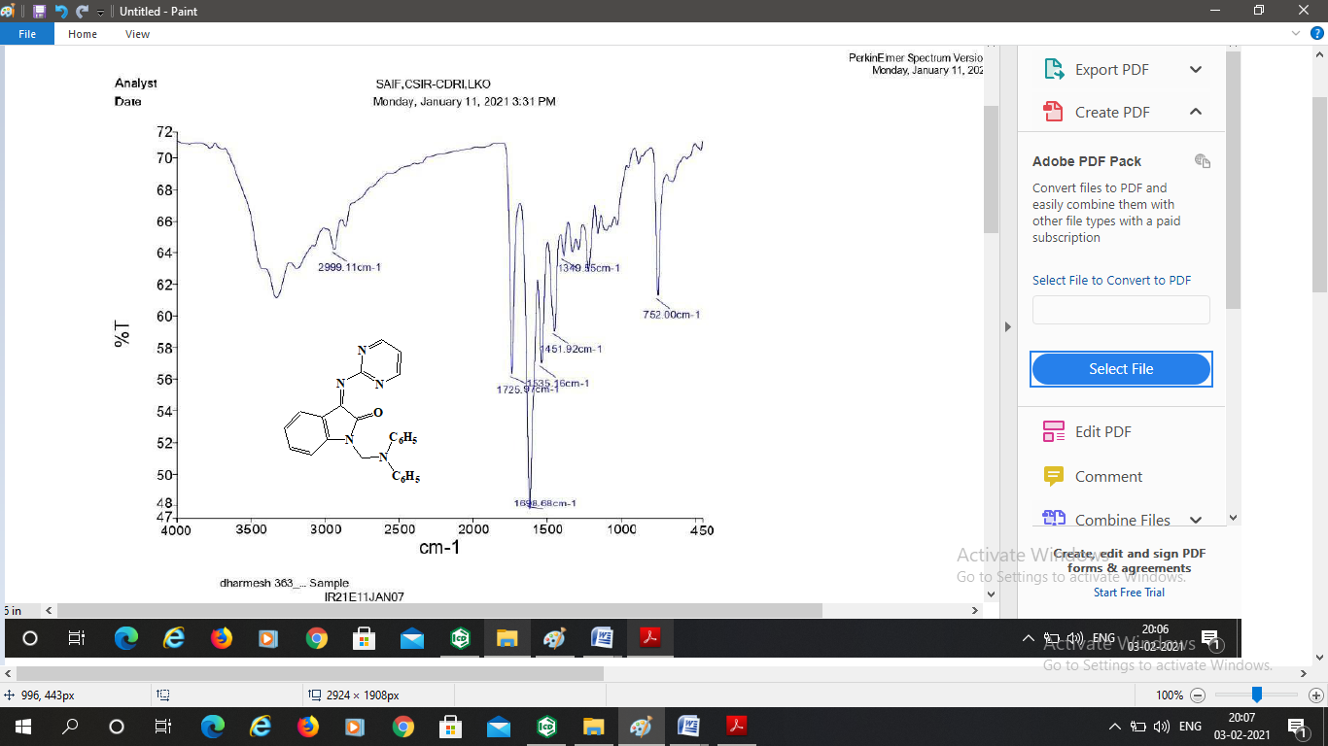
Figure S4. FTIR spectrum of compound IDF 3D

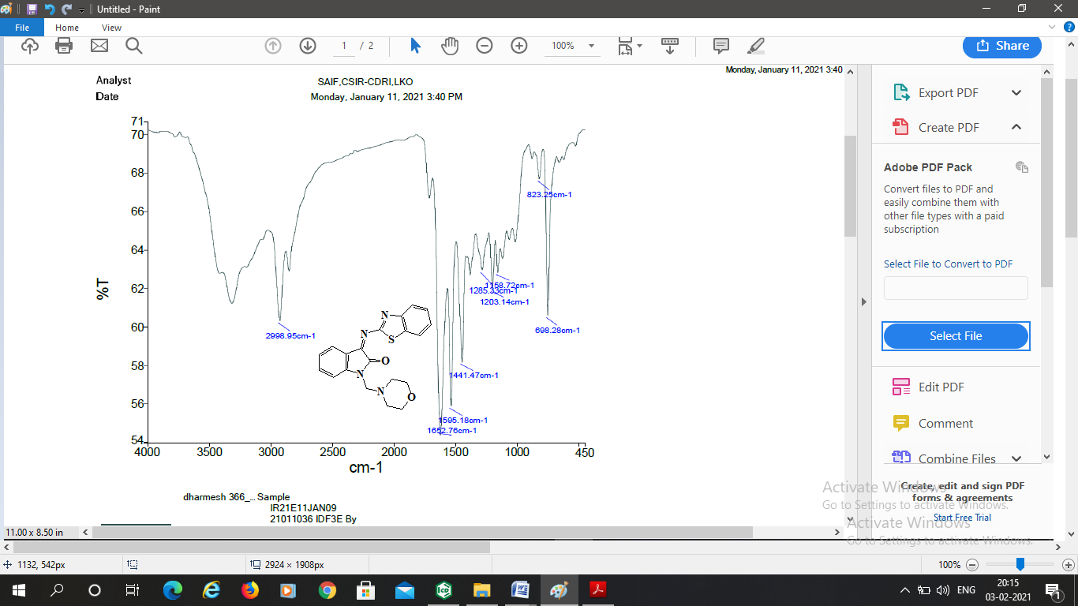
Figure S5. FTIR spectrum of compound IDF 3E

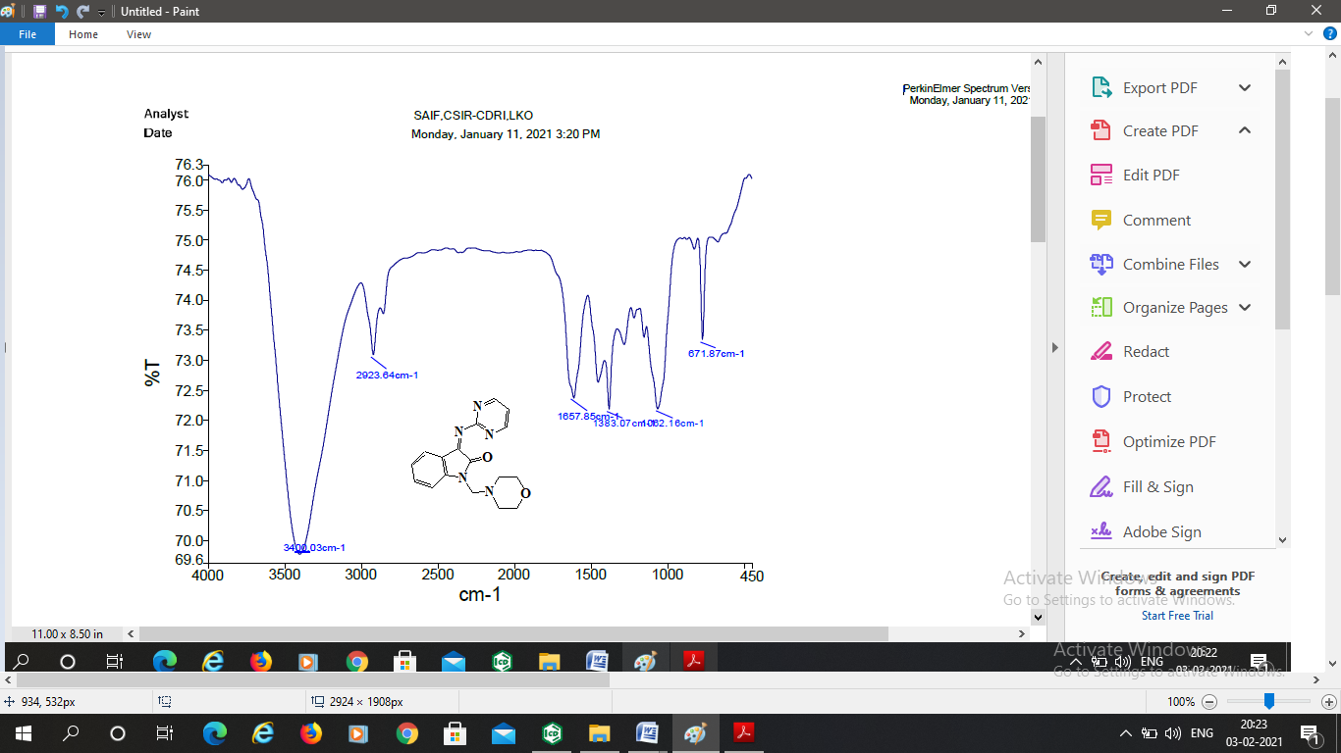
Figure S6. FTIR spectrum of compound IDF 3F

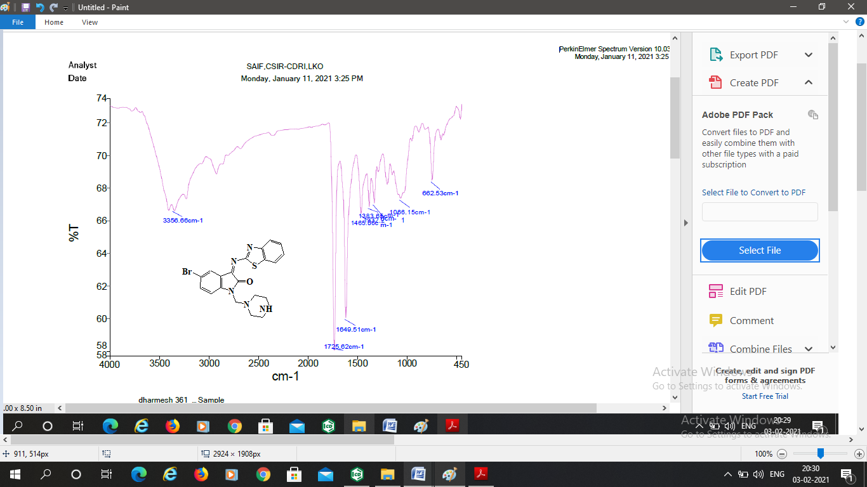
Figure S7. FTIR spectrum of compound IDF 3G

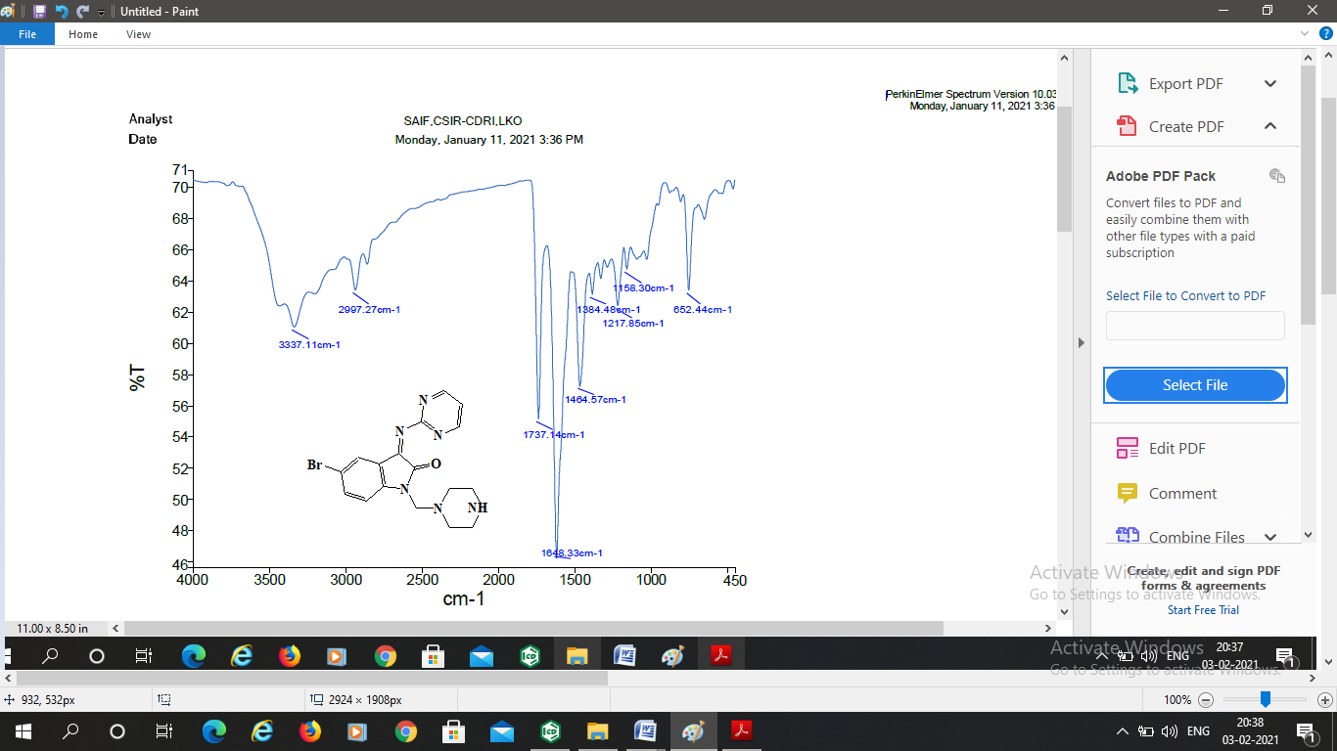
Figure S8. FTIR spectrum of compound IDF 3H

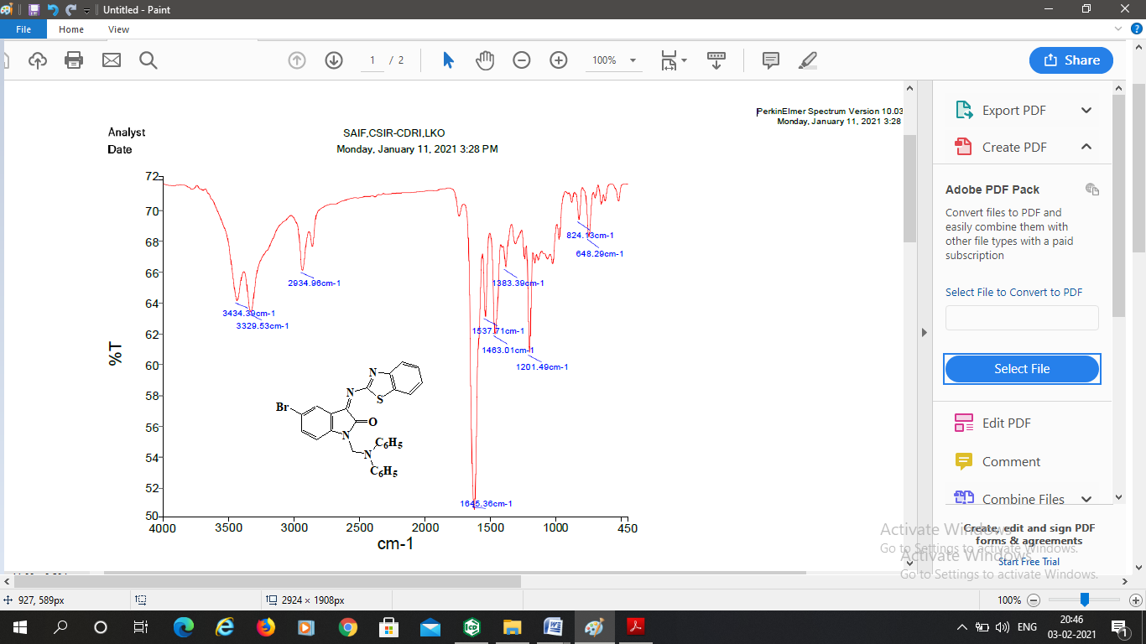
Figure S9. FTIR spectrum of compound IDF 3I

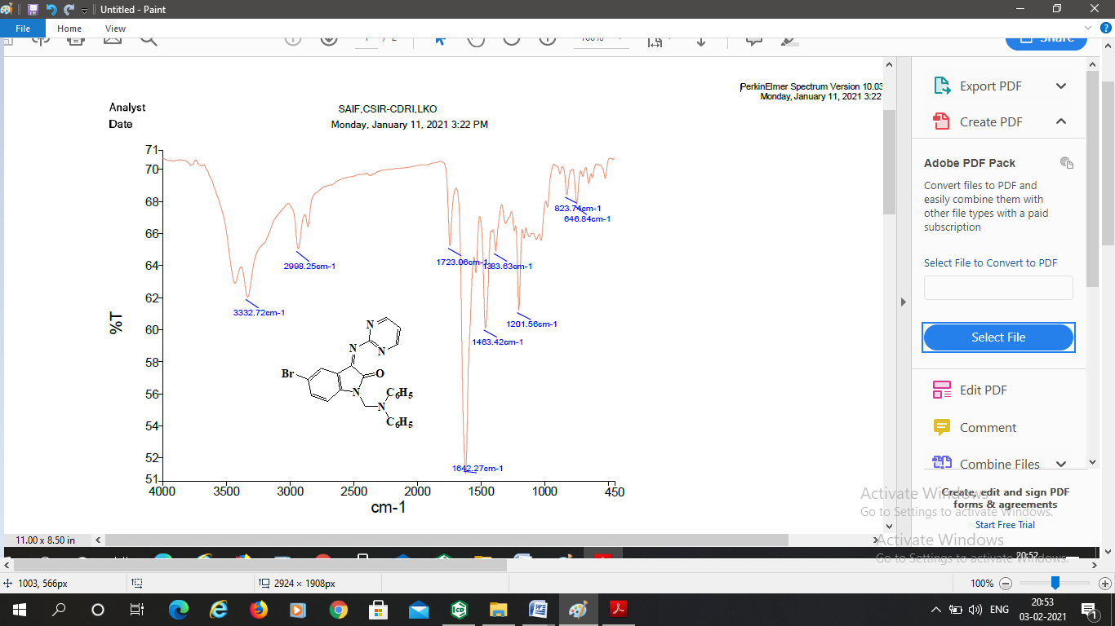
Figure S10. FTIR spectrum of compound IDF 3J

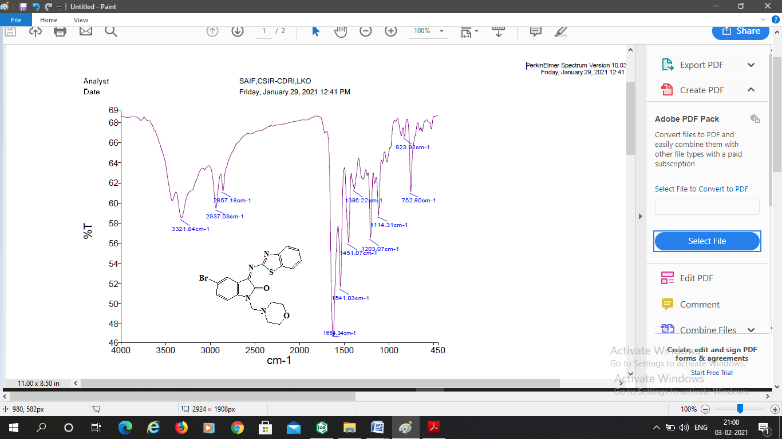
Figure S11. FTIR spectrum of compound IDF 3K

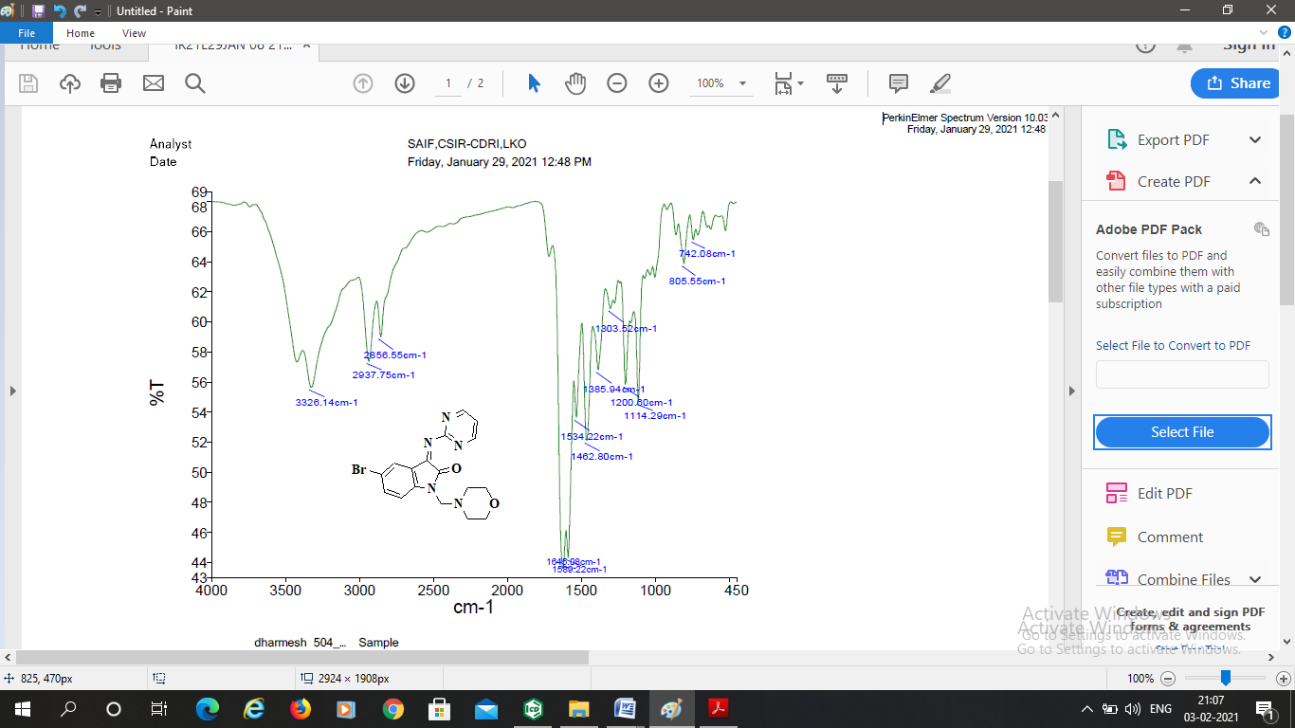
Figure S12. FTIR spectrum of compound IDF 3L

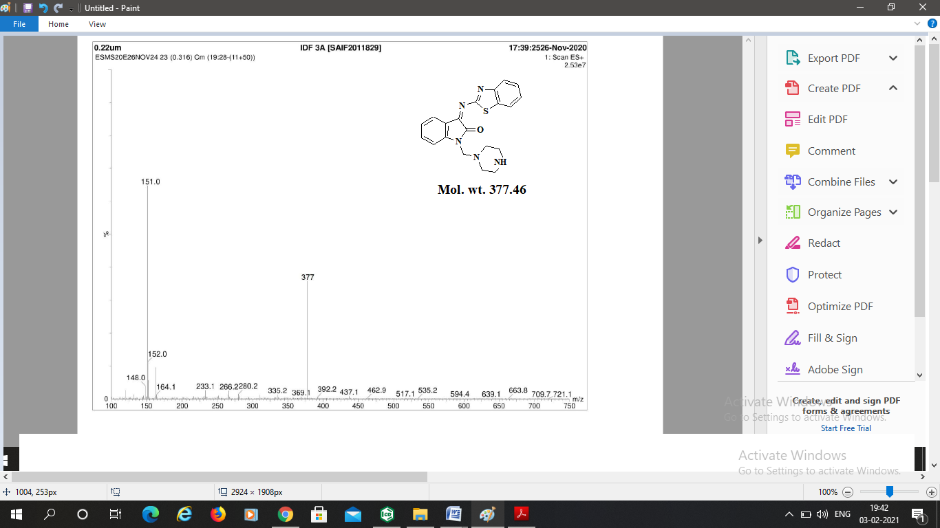
Figure S13. Mass spectrum of compound IDF 3A

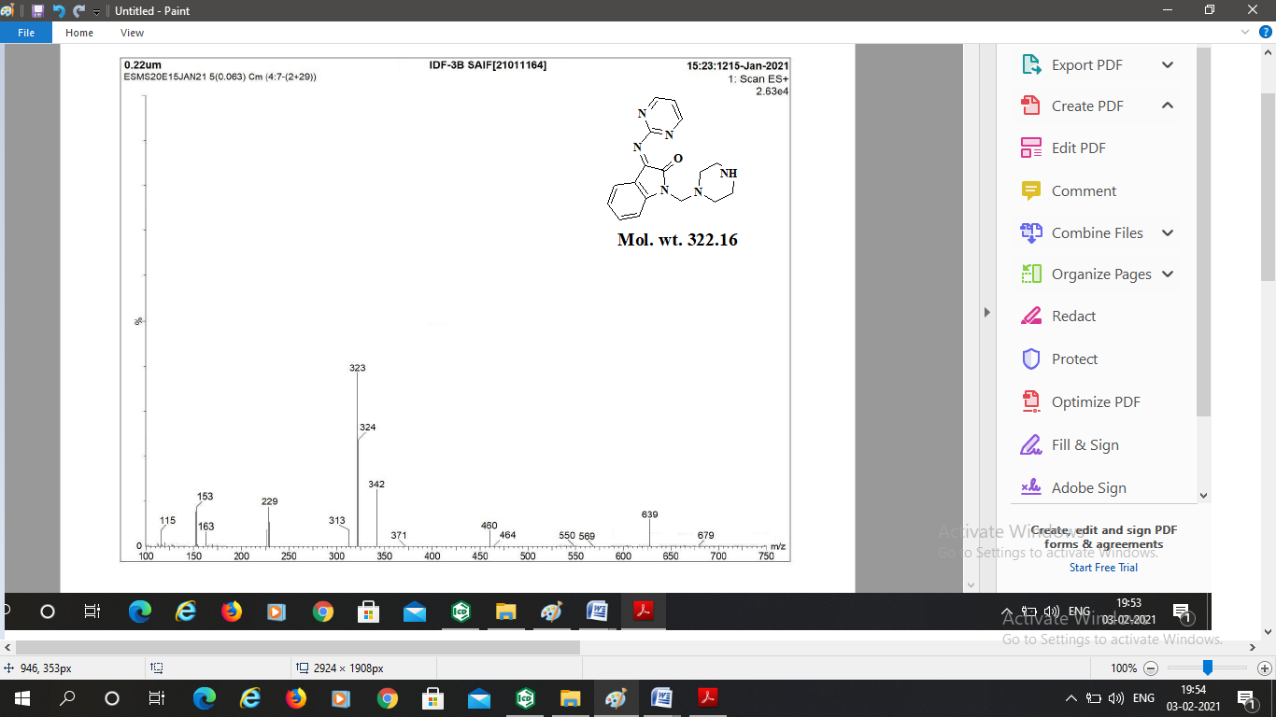
Figure S14. Mass spectrum of compound IDF 3B

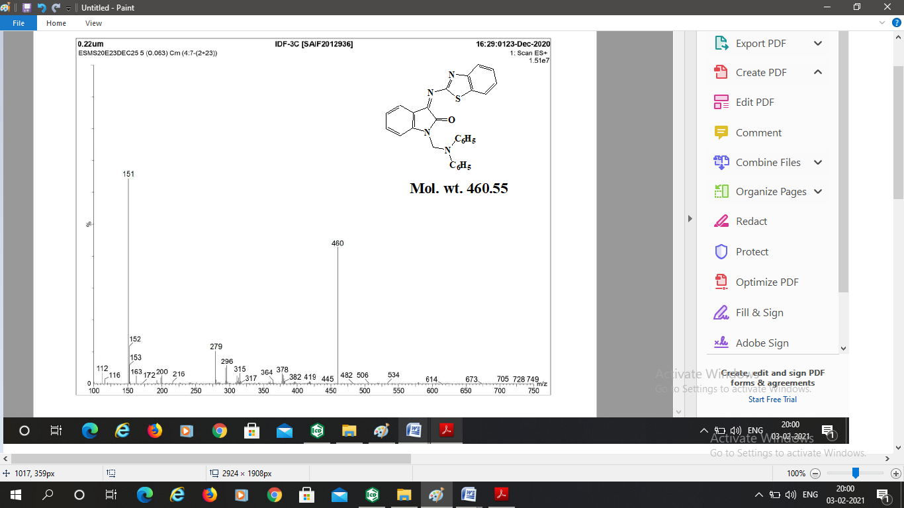
Figure S15. Mass spectrum of compound IDF 3C

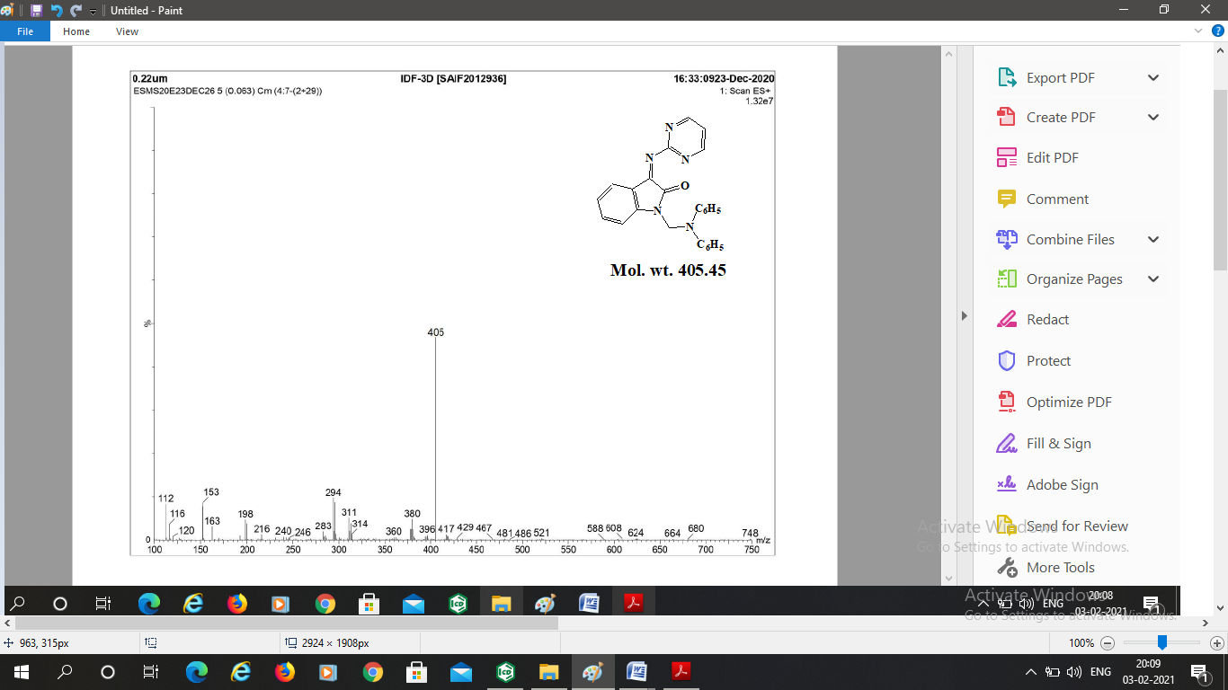
Figure S16. Mass spectrum of compound IDF 3D

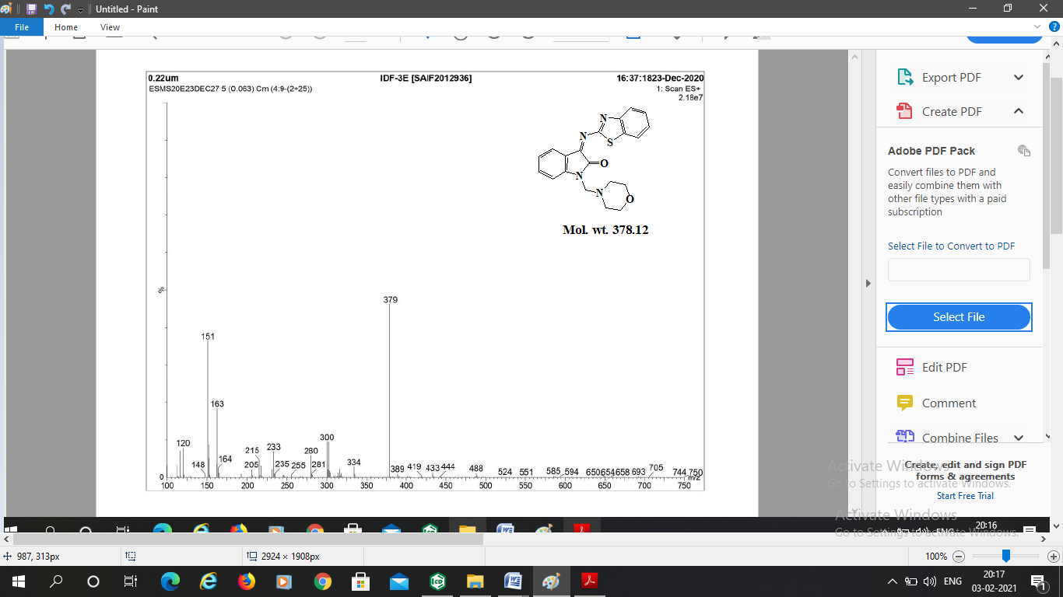
Figure S17. Mass spectrum of compound IDF 3E

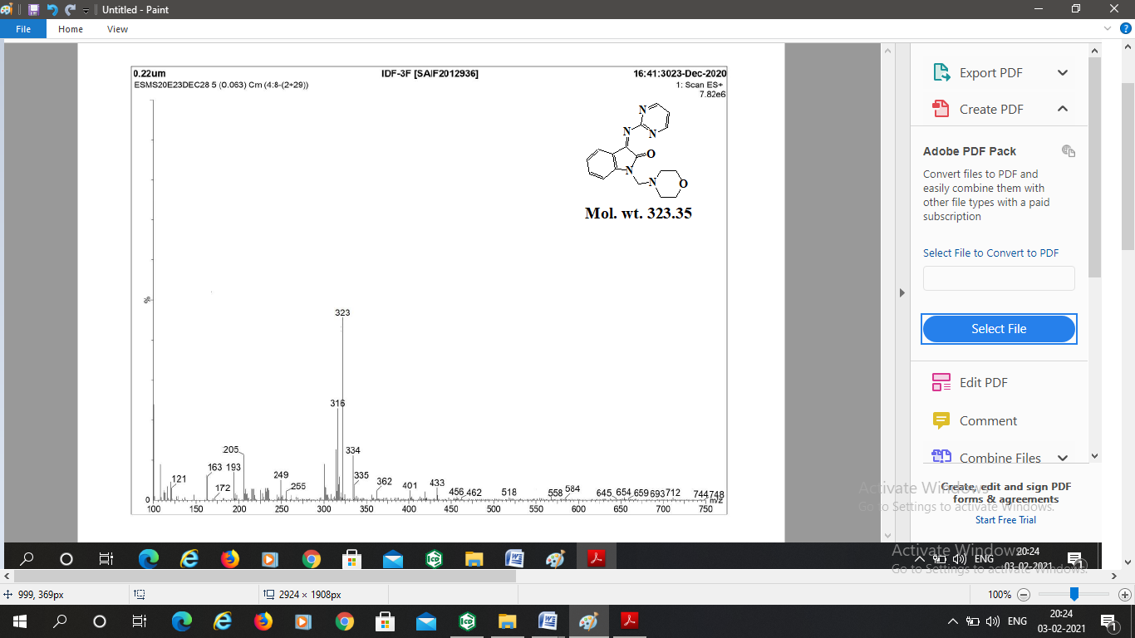
Figure S18. Mass spectrum of compound IDF 3F

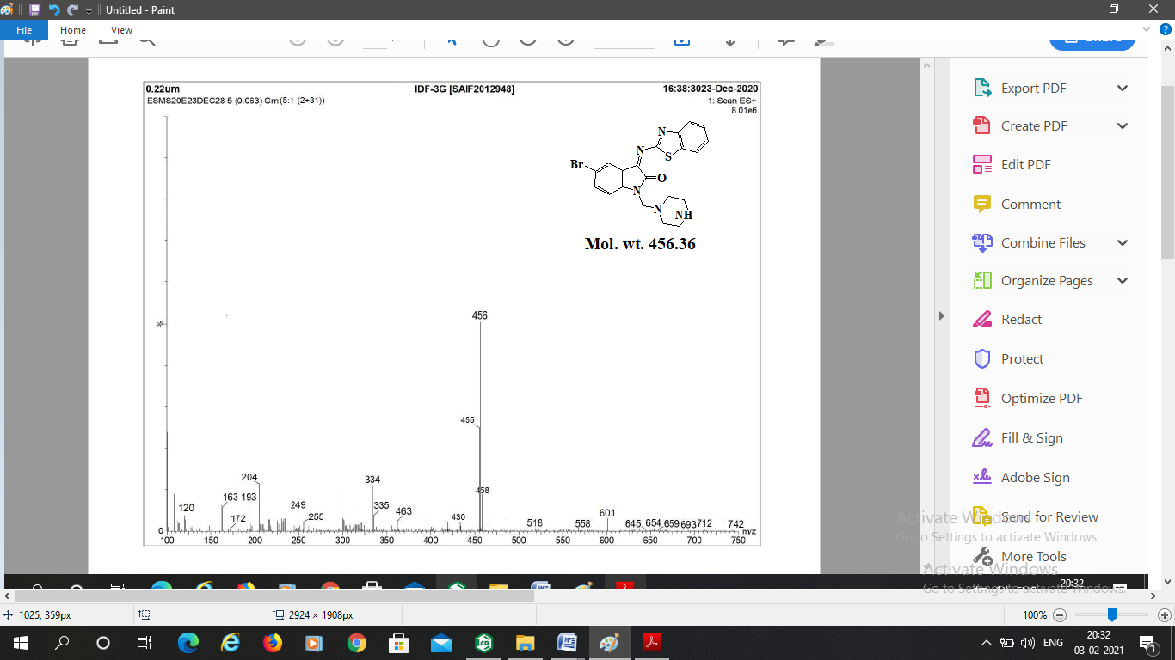
Figure S19. Mass spectrum of compound IDF 3G

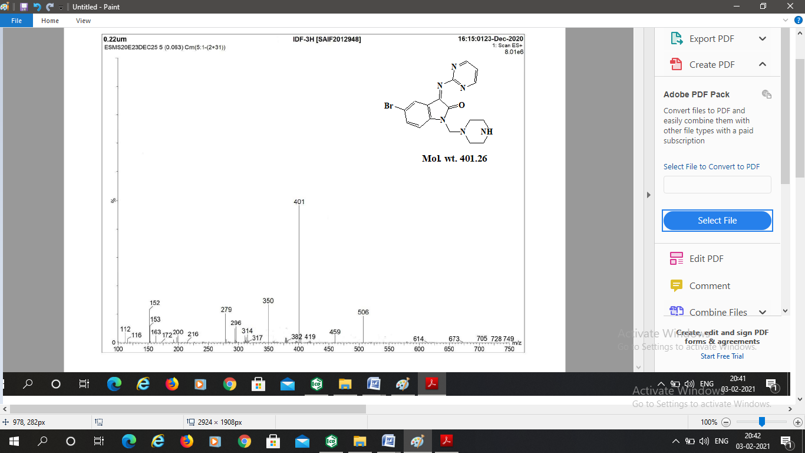

Figure S20. Mass spectrum of compound IDF 3H

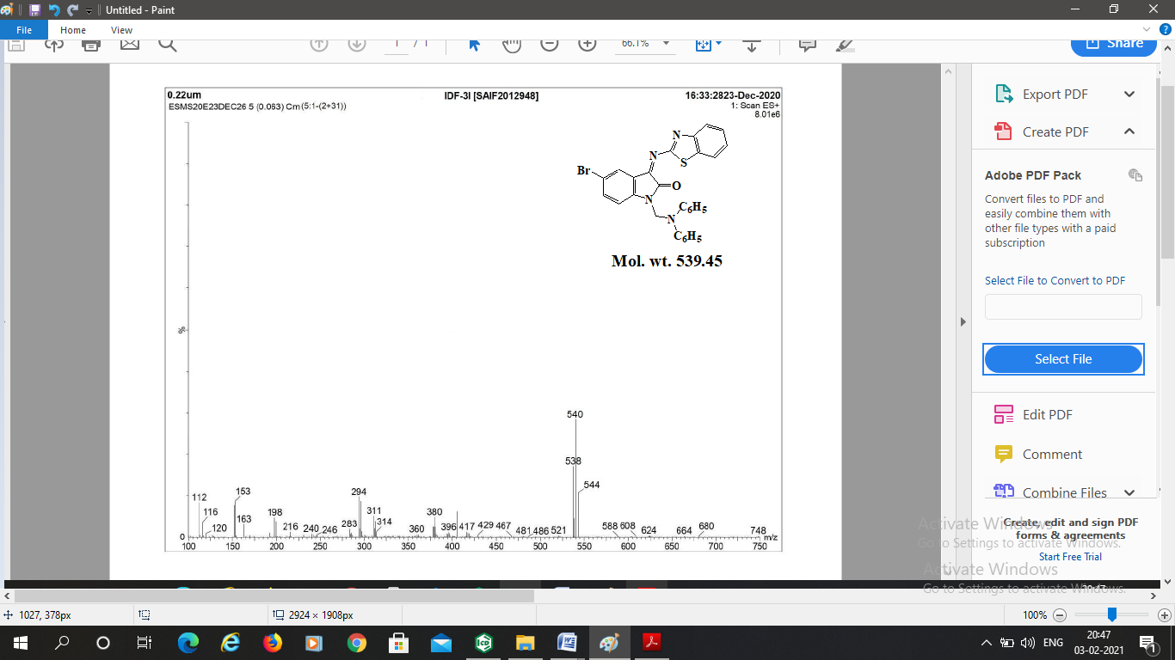
Figure S21. Mass spectrum of compound IDF 3I

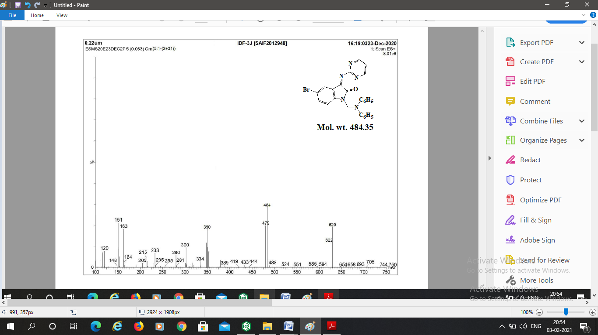
Figure S22. Mass spectrum of compound IDF 3J

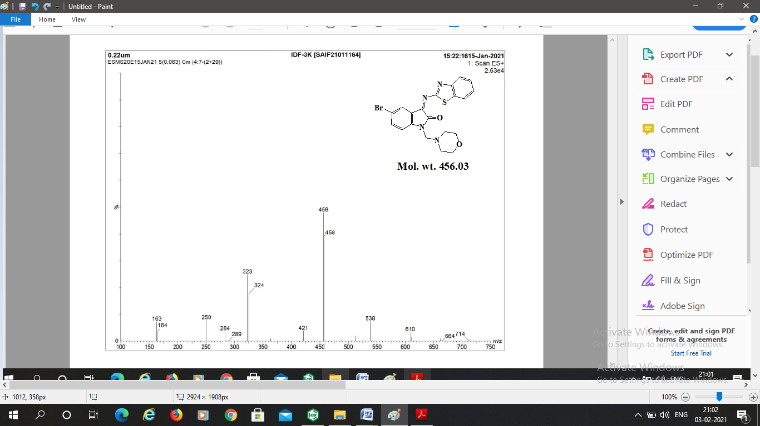
Figure S23. Mass spectrum of compound IDF 3K

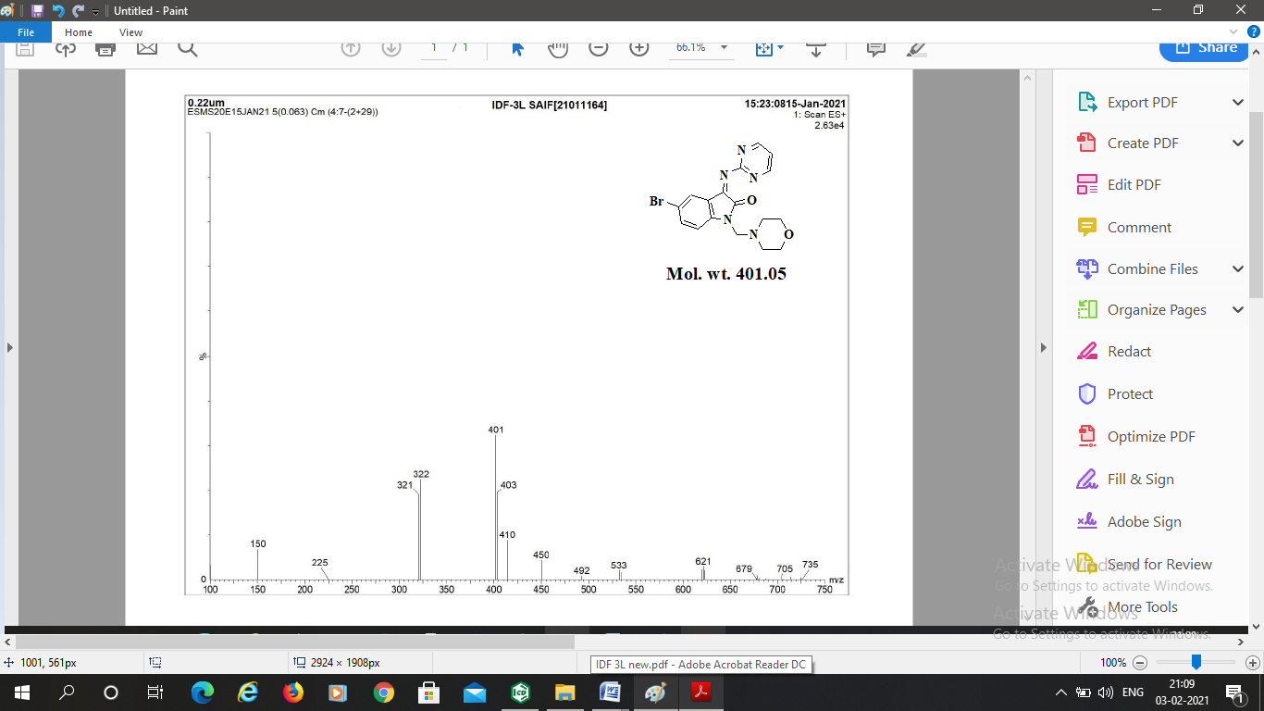
Figure S24. Mass spectrum of compound IDF 3L

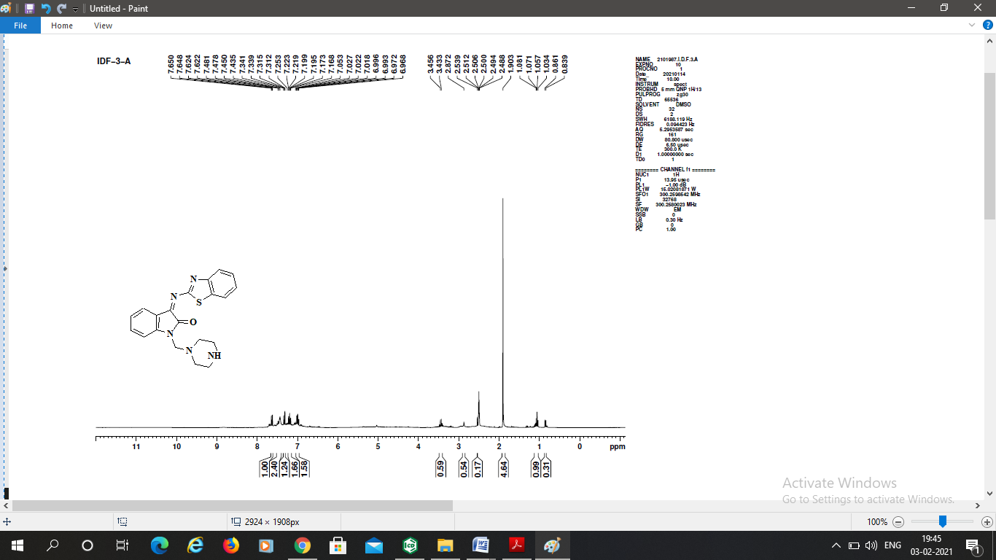
Figure S25. ¹H NMR spectrum of compound IDF 3A

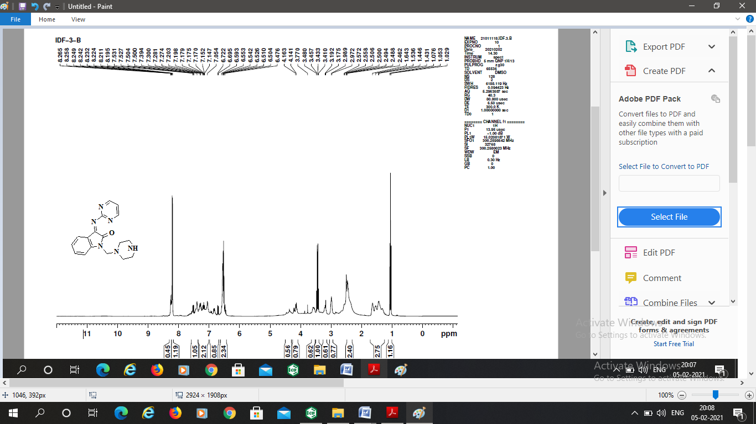
Figure S26. ¹H NMR spectrum of compound IDF 3B

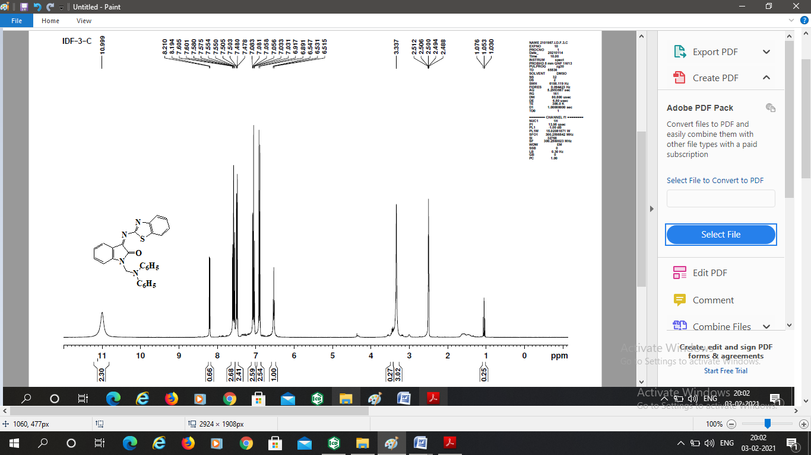
Figure S27. ¹H NMR spectrum of compound IDF 3C

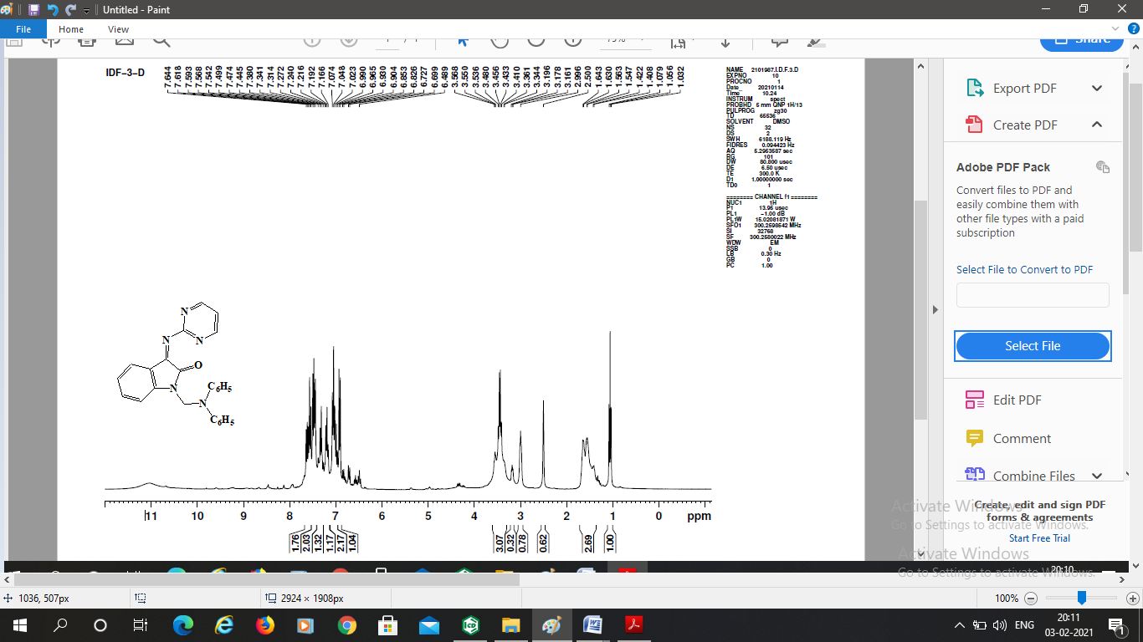
Figure S28. ¹H NMR spectrum of compound IDF 3D

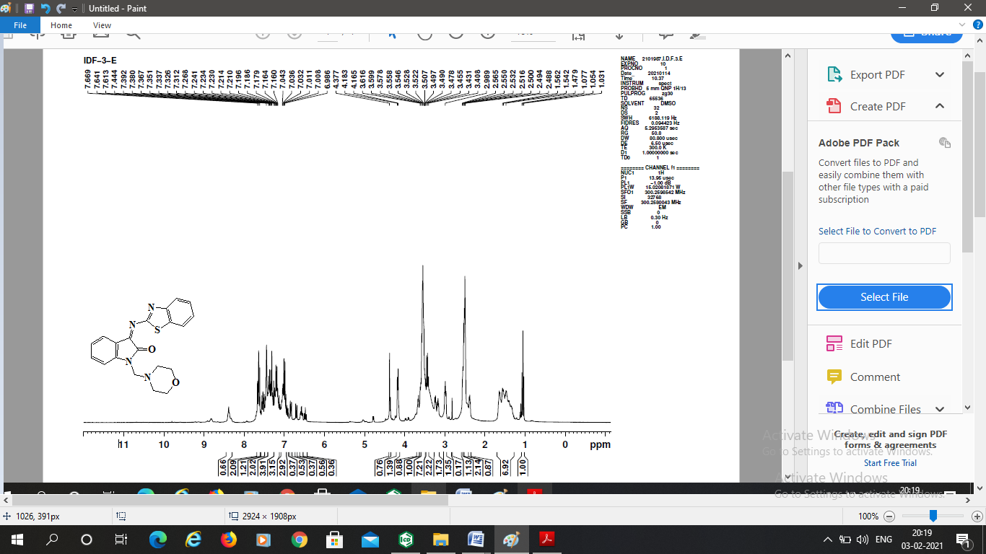
Figure S29. ¹H NMR spectrum of compound IDF 3E

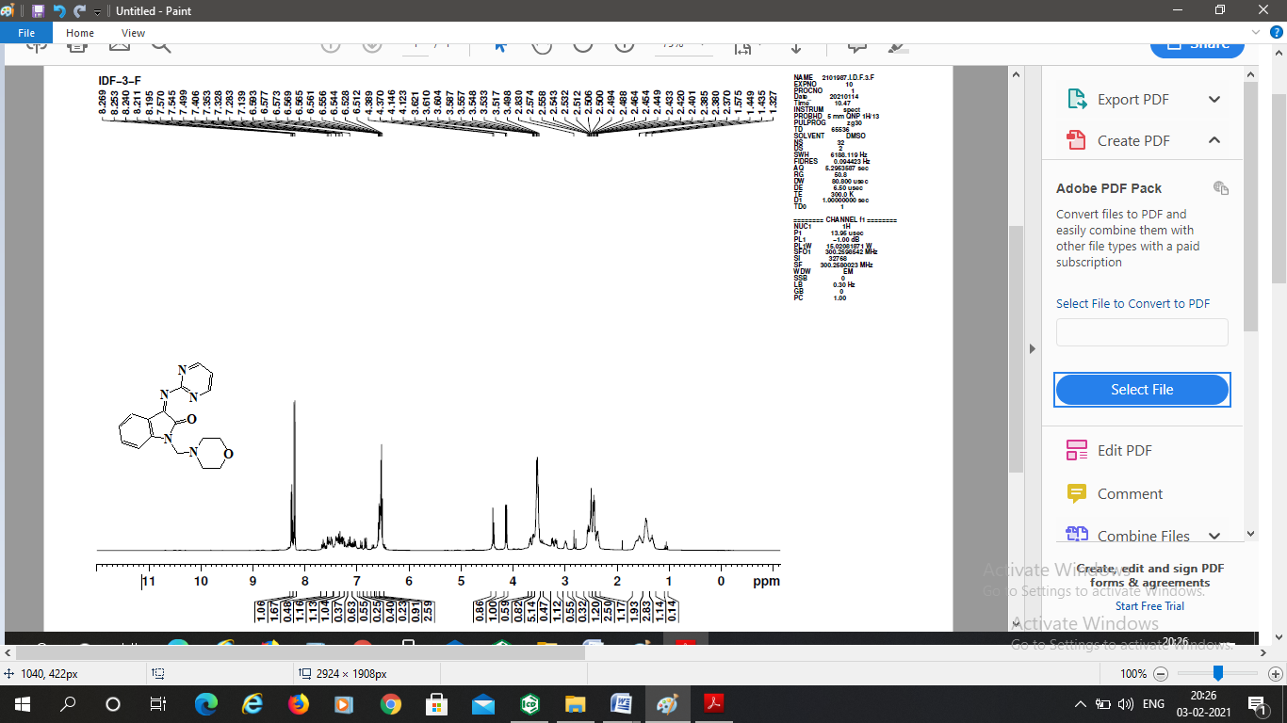
Figure S30. ¹H NMR spectrum of compound IDF 3F

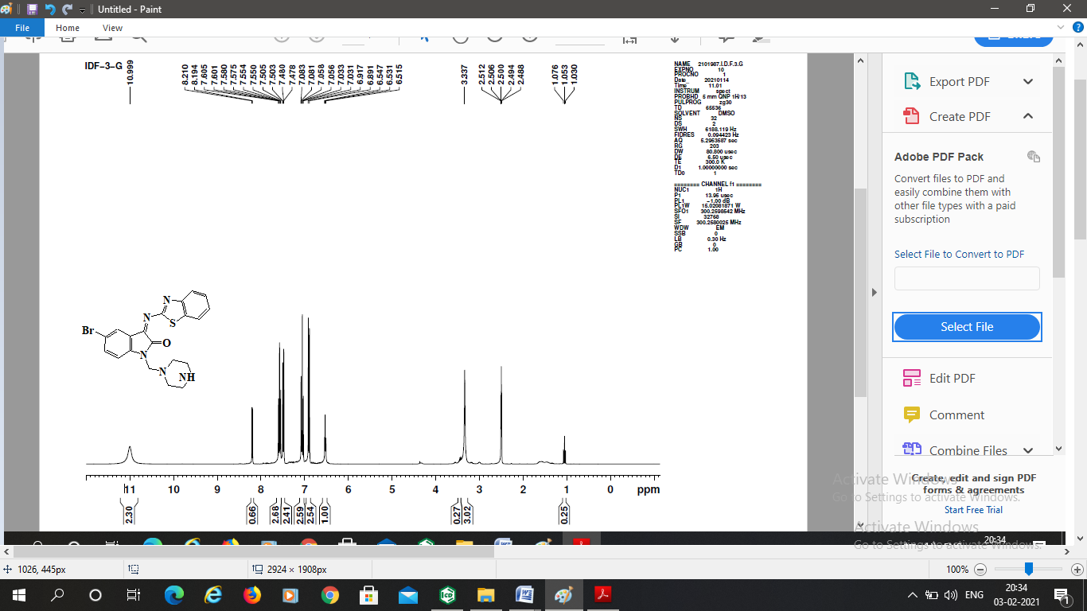
Figure S31. ¹H NMR spectrum of compound IDF 3G

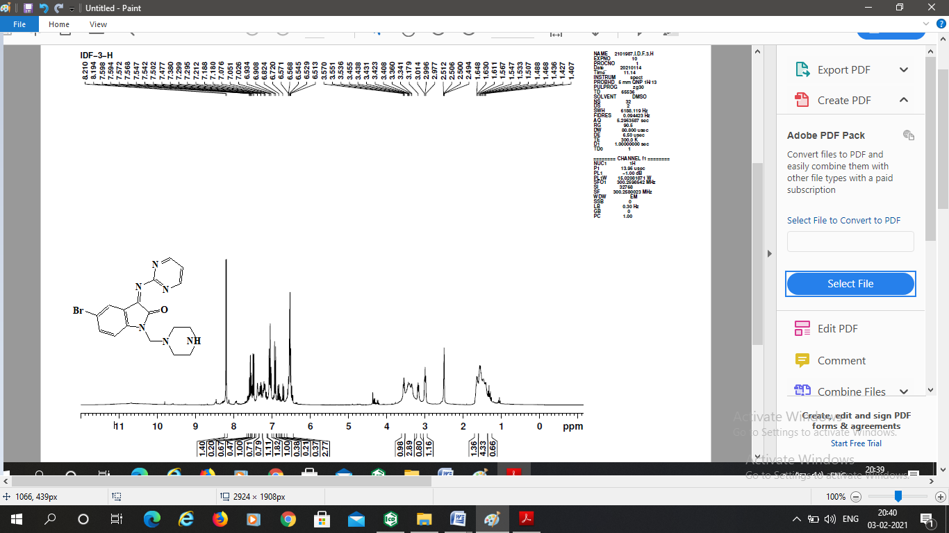
Figure S32. ¹H NMR spectrum of compound IDF 3H

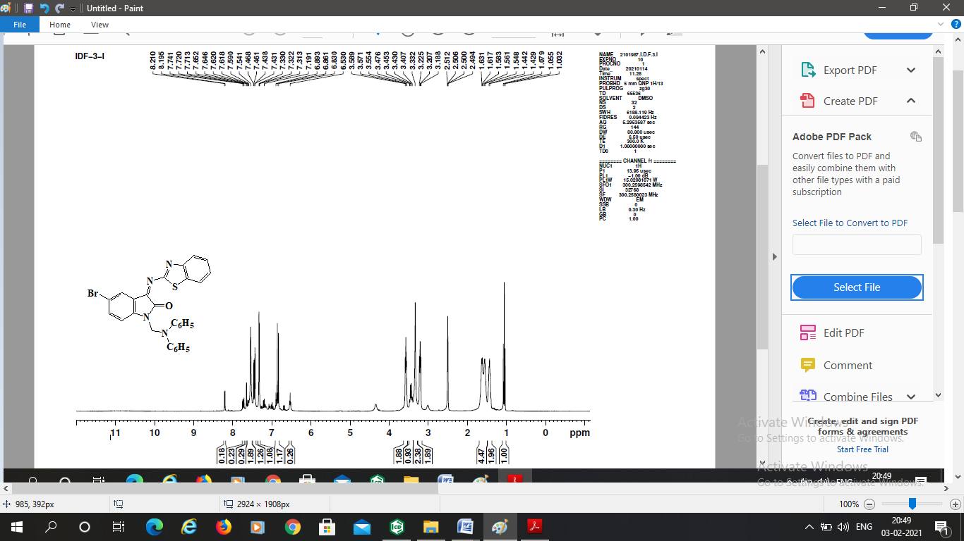
Figure S33. ¹H NMR spectrum of compound IDF 3I

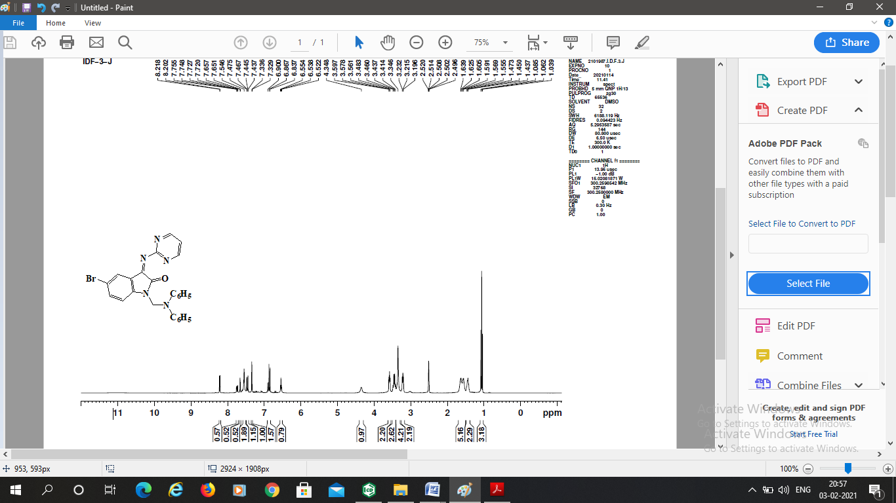
Figure S34. ¹H NMR spectrum of compound IDF 3J

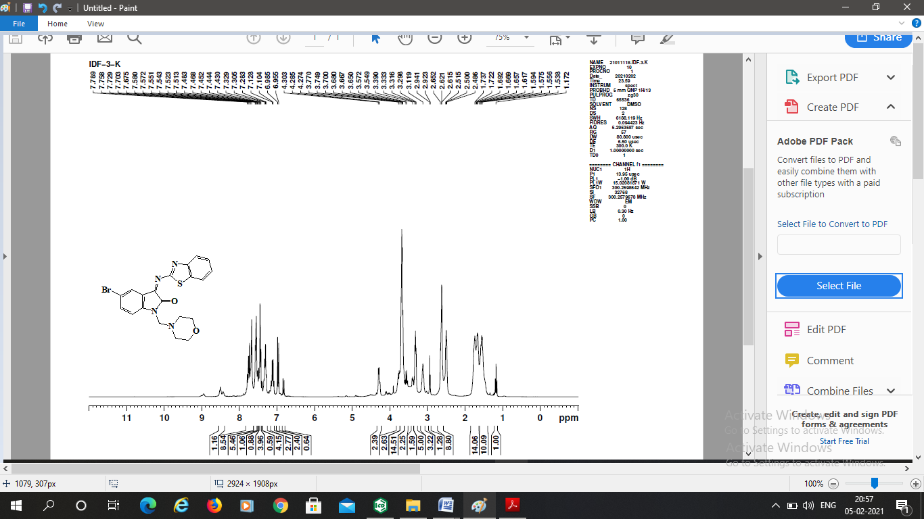
Figure S35. ¹H NMR spectrum of compound IDF 3K

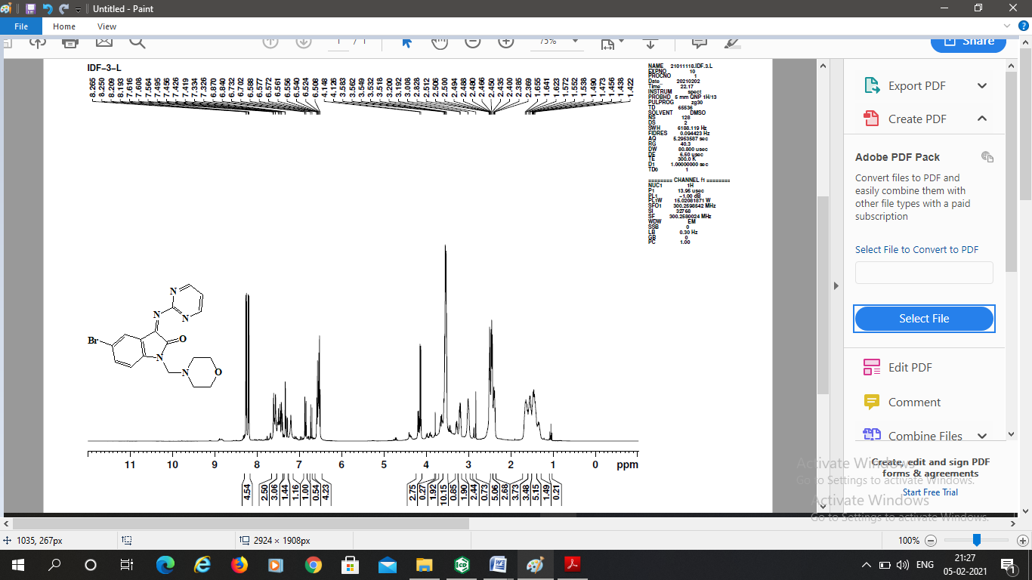
Figure S36. ¹H NMR spectrum of compound IDF 3L

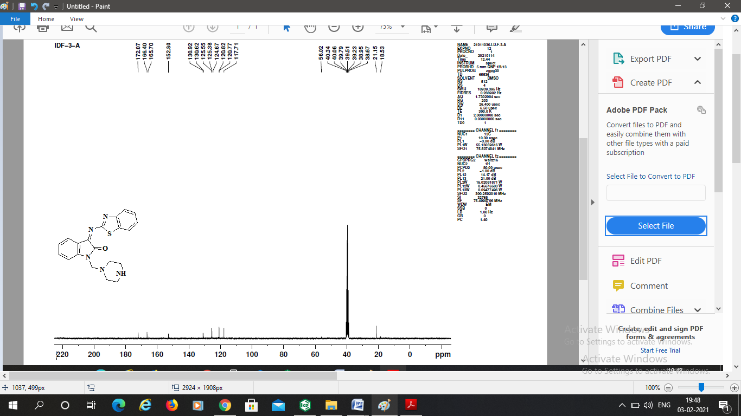
Figure S37. ¹³C NMR spectrum of compound IDF 3A

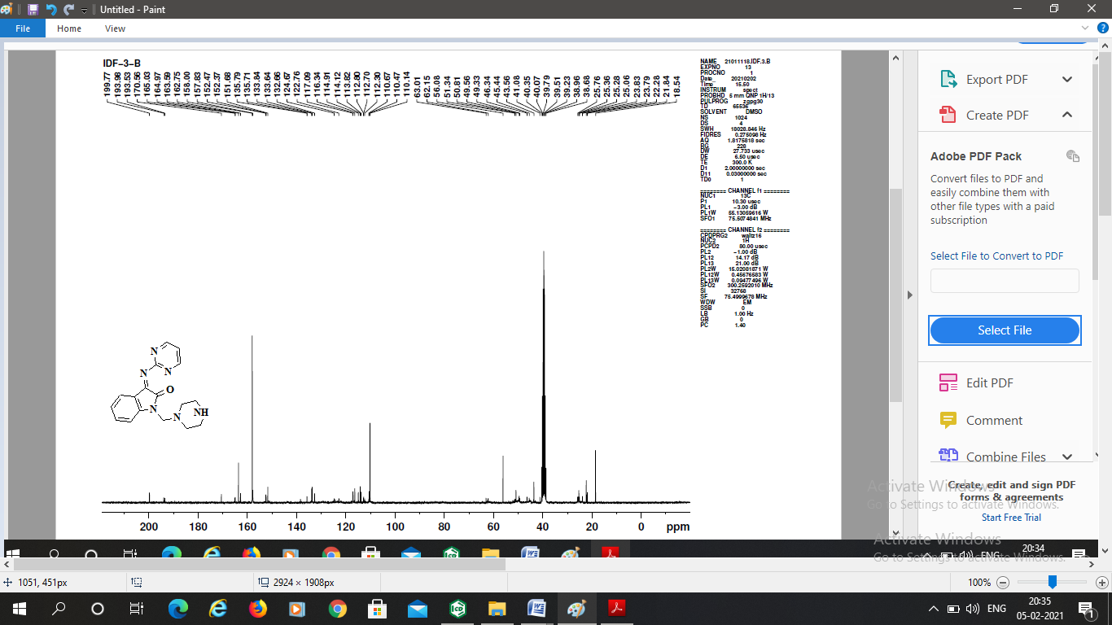
Figure S38. ¹³C NMR spectrum of compound IDF 3B

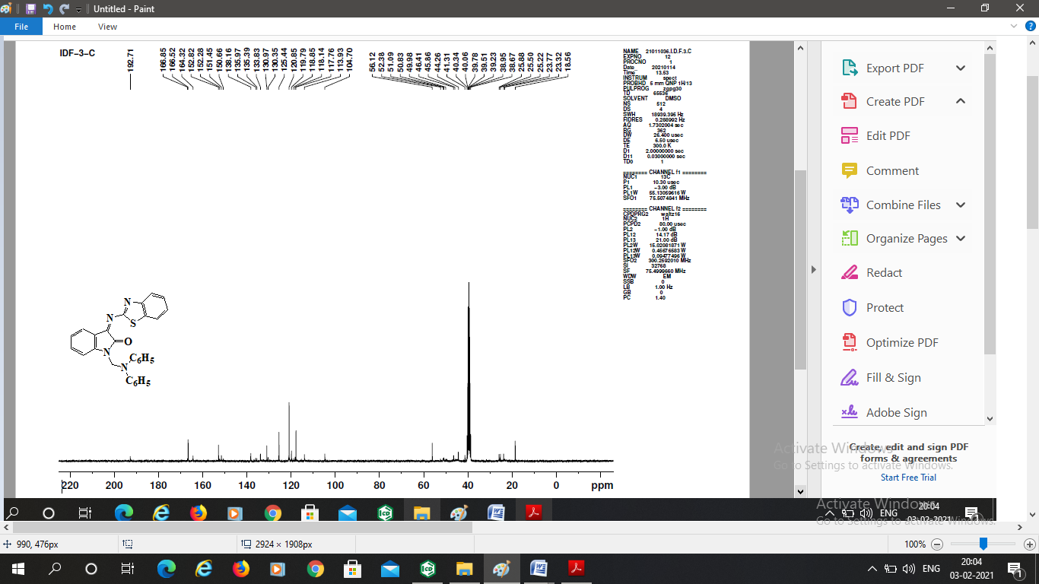
Figure S39. ¹³C NMR spectrum of compound IDF 3C

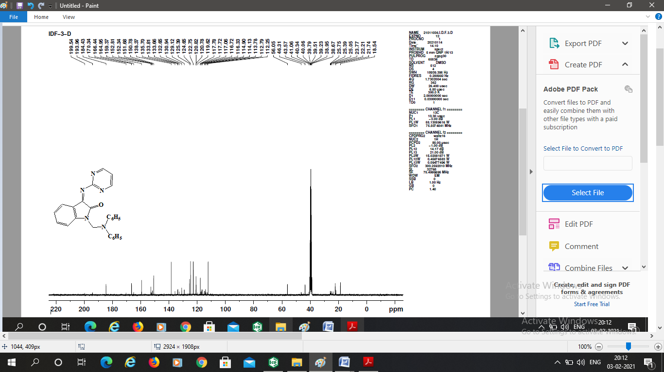
Figure S40. ¹³C NMR spectrum of compound IDF 3D

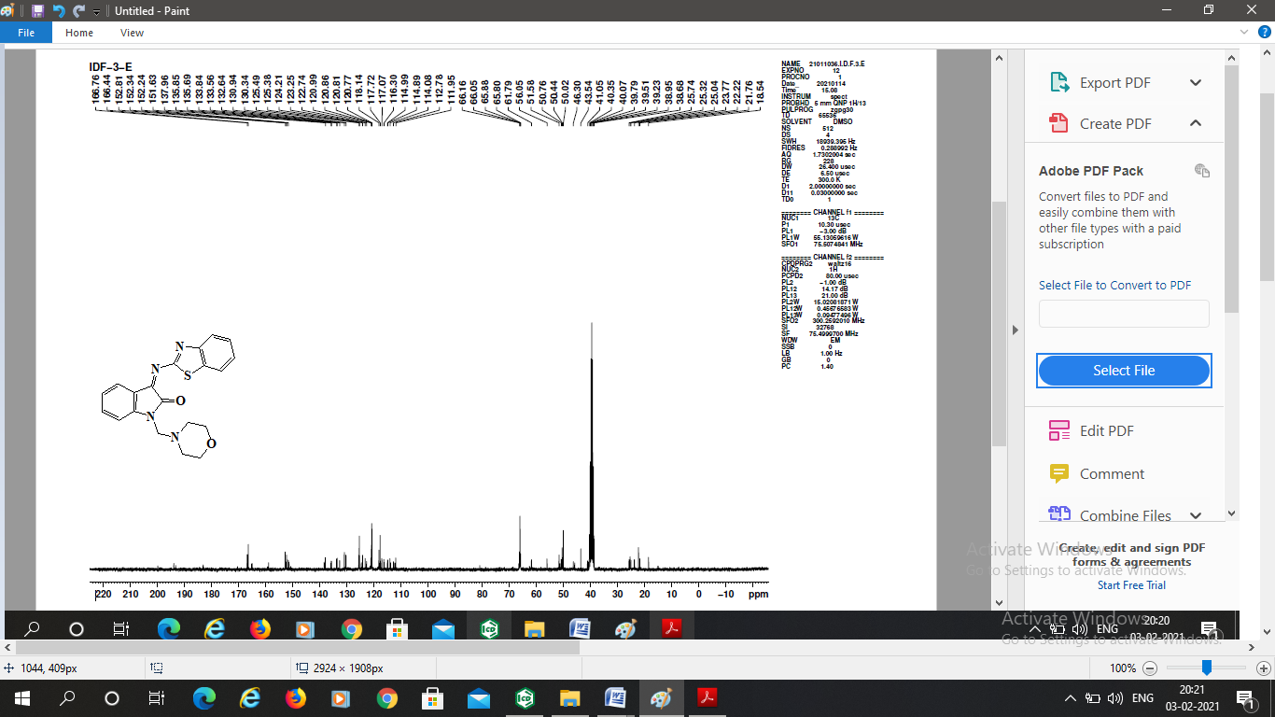
Figure S41. ¹³C NMR spectrum of compound IDF 3E

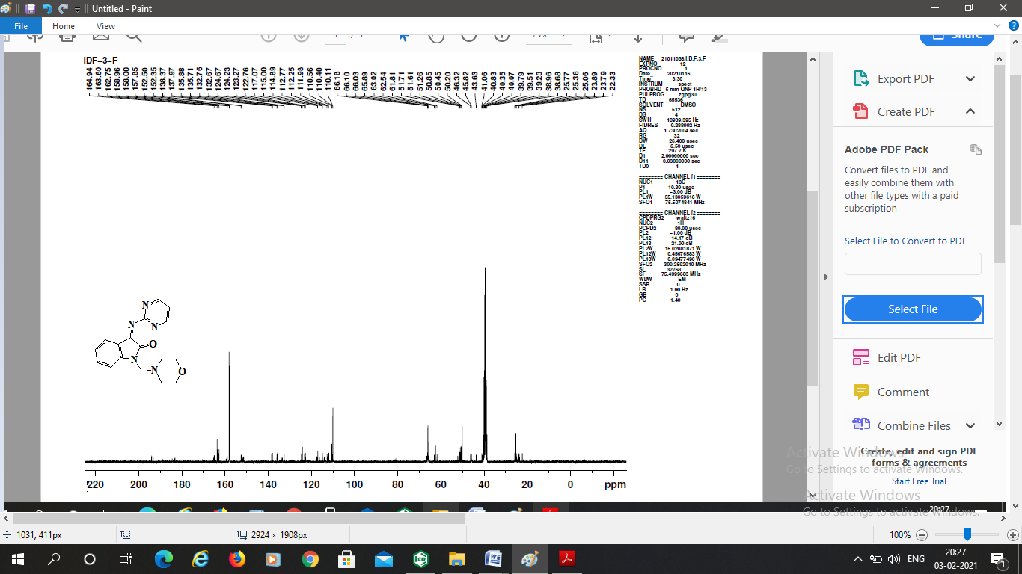
Figure S42. ¹³C NMR spectrum of compound IDF 3F

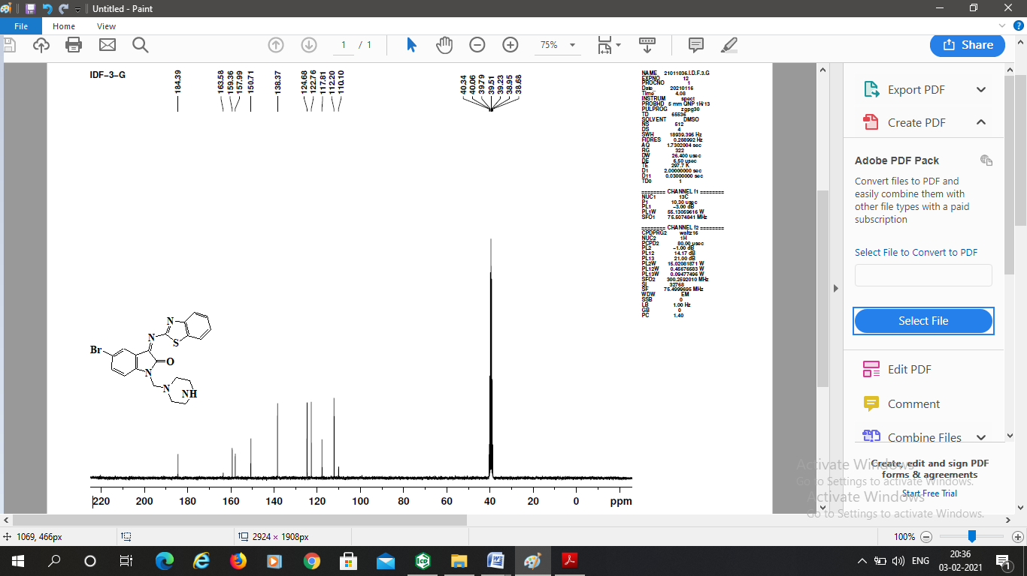
Figure S43. ¹³C NMR spectrum of compound IDF 3G

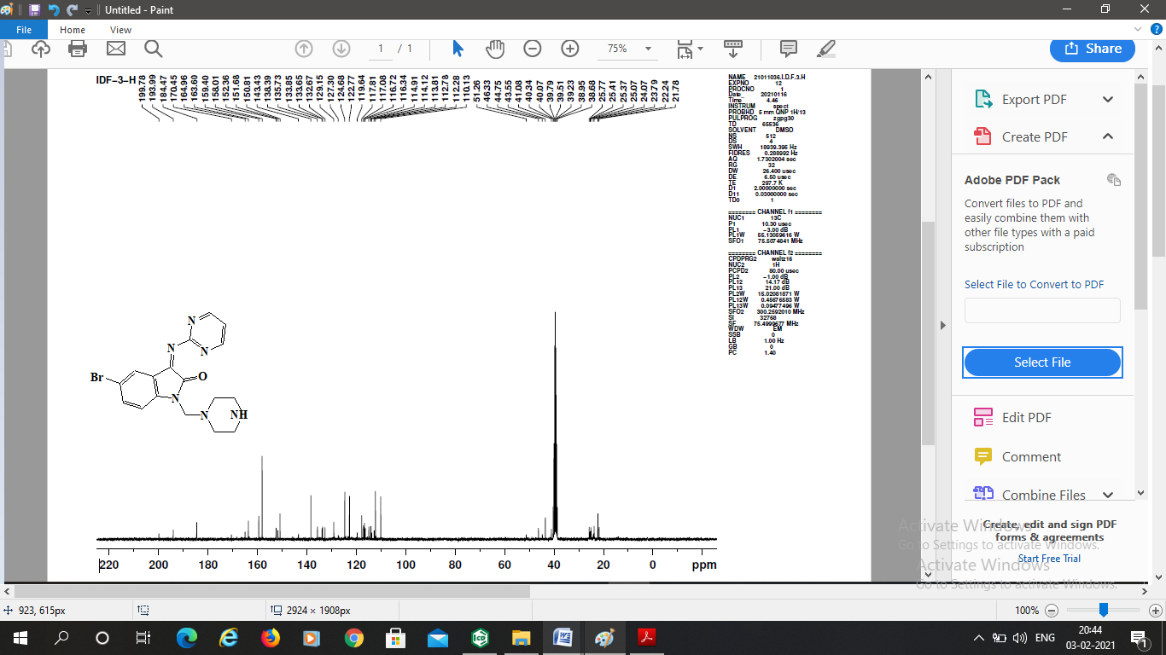
Figure S44. ¹³C NMR spectrum of compound IDF 3H

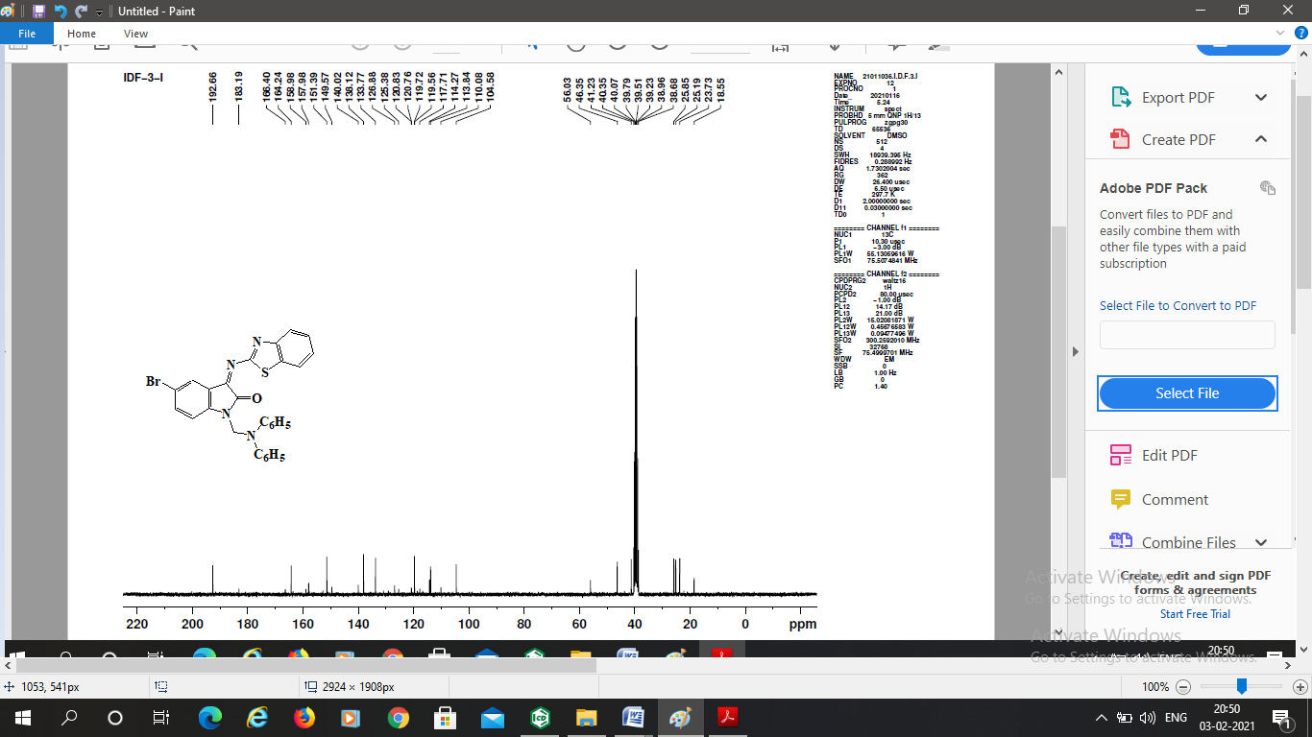
Figure S45. ¹³C NMR spectrum of compound IDF 3I

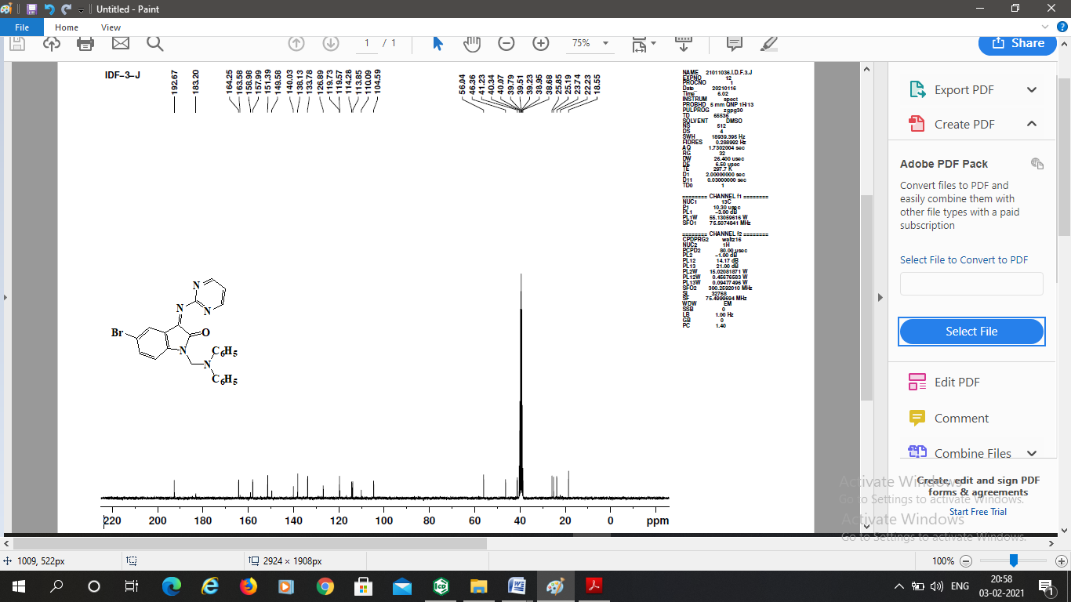
Figure S46. ¹³C NMR spectrum of compound IDF 3J

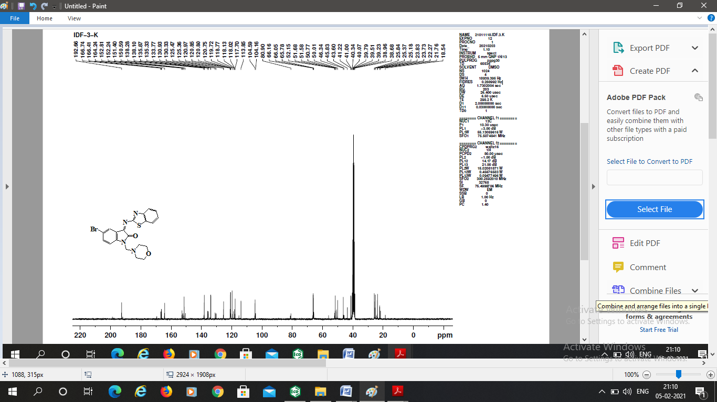
Figure S47. ¹³C NMR spectrum of compound IDF 3K

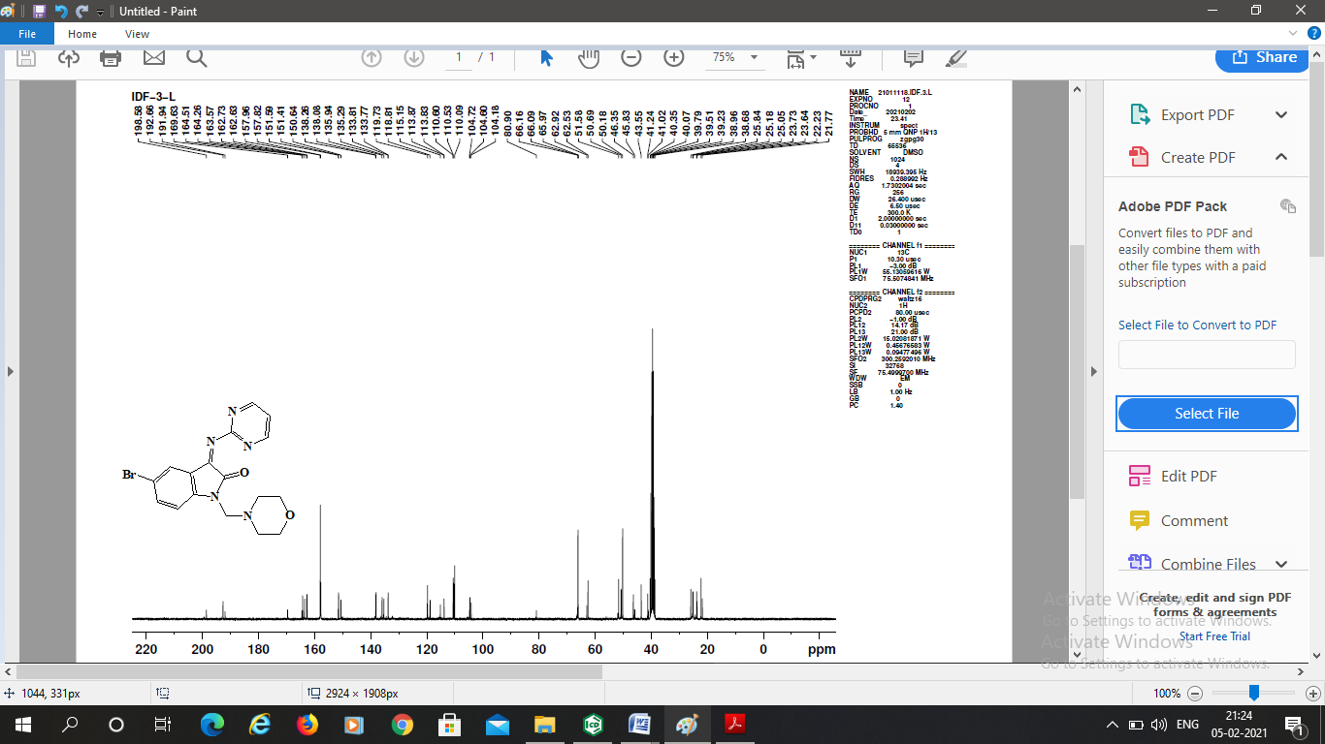
Figure S48. ¹³C NMR spectrum of compound IDF 3L

