Supplementary Material
In Silico Screening and Pharmacological Evaluation of Fluoroquinolones: Lead-Optimization Studies

Srimai Vuppala¹, Jaeyoung Kim¹, Ji Myung Choi², Bo Sun Joo^{3*}, and Joonkyung Jang¹*
¹Department of Nanoenergy Engineering, Pusan National University, Busan 46241, Republic of Korea.
²Lab-to-Medi CRO, 12 Dosandae-ro-8-gil, Seoul 06038 Republic of Korea
³Infertility Institute, Pohang Women’s Hospital, Pohang 37754, Republic of Korea

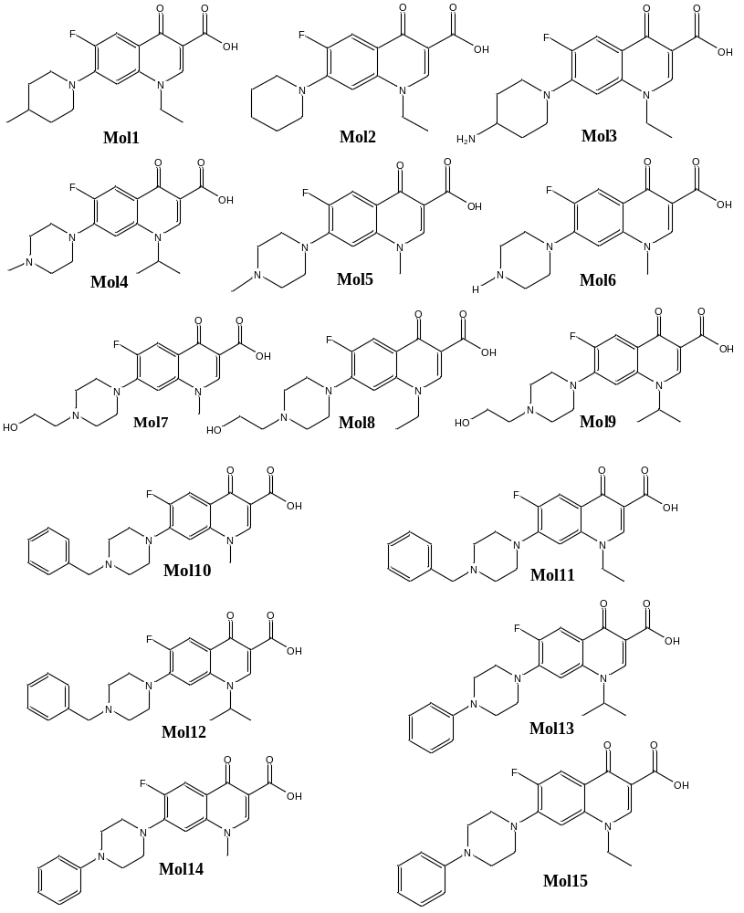
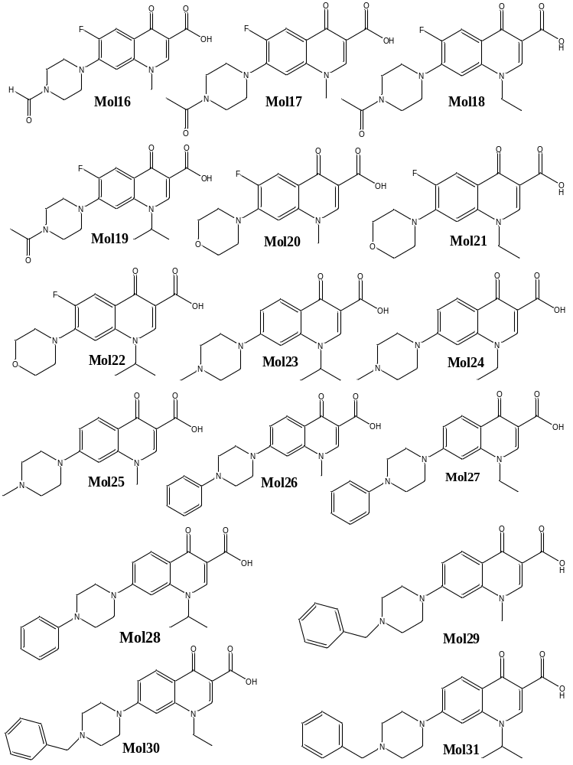
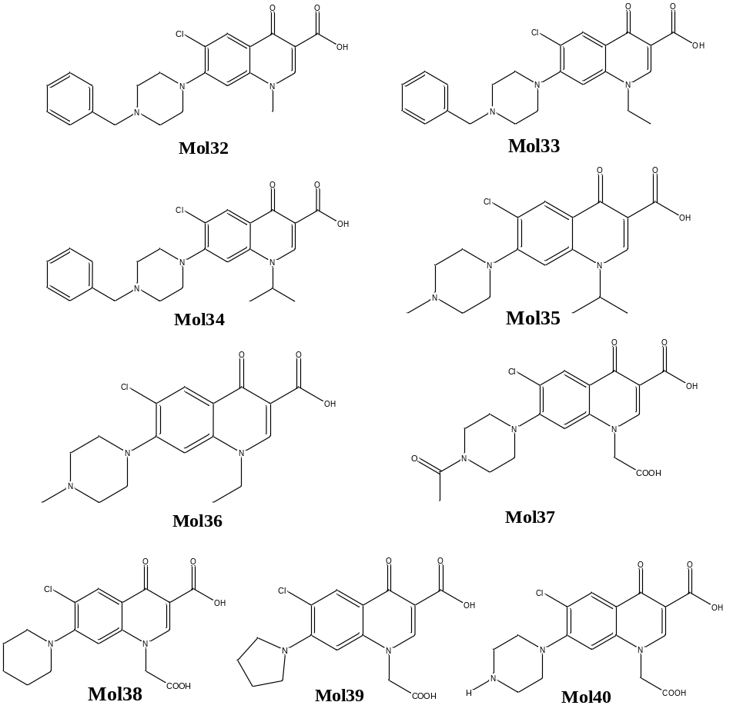

Figure S1. Molecular structures of designed quinolone derivatives.

Table S1. Molecular structures and corresponding activities of the selected dataset.
Structures | Activity(µgr/mL)
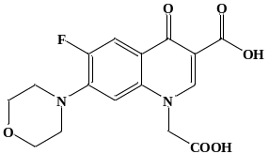  7a | 37.5
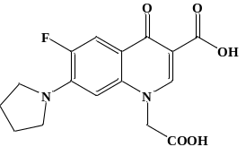  7b | 37.5
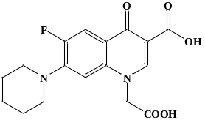  7c | 150
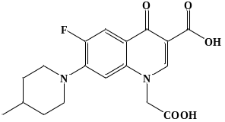  7d | 150
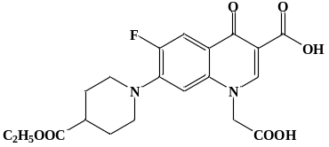  7e | 75
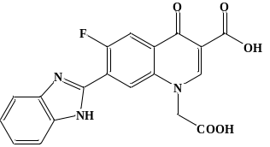  7f | 150
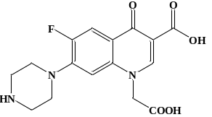  7g | 37.5
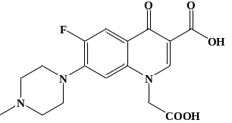  7h | 150
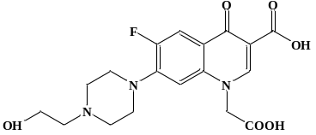  7i | 150
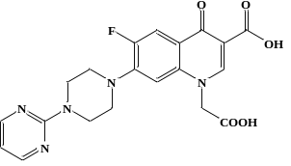  7j | 150
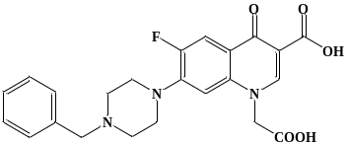  7k | 150
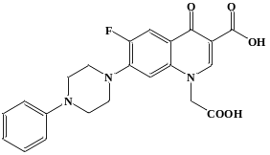  7l | 150
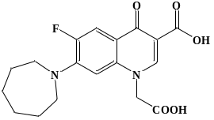  7n | 150
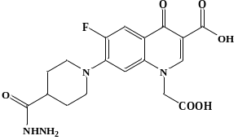  7o | 150
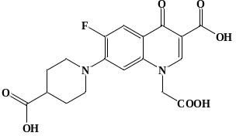  7p | 75

Table S5. SAR properties of designed pharmacophore analogs.
Molecules | TPSAª | natoms | M.Wt^{b} | nON^{c} | nOHNH^{d} | n  violations | n  rotb^{e} | volume | Enzyme inhibitor
Mol1 | 62.54 | 24 | 332.38 | 5 | 1 | 0 | 3 | 300.22 | 0.13
Mol2 | 62.54 | 23 | 318.34 | 5 | 1 | 0 | 3 | 283.63 | 0.17
Mol3 | 88.56 | 24 | 333.36 | 6 | 3 | 0 | 3 | 294.95 | 0.27
Mol4 | 65.78 | 25 | 347.39 | 6 | 1 | 0 | 3 | 312.76 | 0.21
Mol5 | 65.78 | 23 | 319.34 | 6 | 1 | 0 | 2 | 279.37 | 0.16
Mol6 | 74.57 | 22 | 305.31 | 6 | 2 | 0 | 2 | 262.43 | 0.19
Mol7 | 86.01 | 25 | 349.36 | 7 | 2 | 0 | 4 | 304.43 | 0.14
Mol8 | 86.01 | 26 | 363.39 | 7 | 2 | 0 | 5 | 321.24 | 0.13
Mol9 | 86.01 | 27 | 377.42 | 7 | 2 | 0 | 5 | 337.82 | 0.18
Mol10 | 65.78 | 29 | 395.43 | 6 | 1 | 0 | 4 | 351.02 | 0.12
Mol11 | 65.78 | 30 | 409.46 | 6 | 1 | 0 | 5 | 367.82 | 0.11
Mol12 | 65.78 | 31 | 423.49 | 6 | 1 | 0 | 5 | 384.41 | 0.15
Mol13 | 65.78 | 30 | 409.46 | 6 | 1 | 0 | 4 | 367.61 | 0.14
Mol14 | 65.78 | 28 | 381.41 | 6 | 1 | 0 | 3 | 334.22 | 0.10
Mol15 | 65.78 | 29 | 395.43 | 6 | 1 | 0 | 4 | 351.02 | 0.09
Mol16 | 82.85 | 24 | 333.32 | 7 | 1 | 0 | 2 | 281.80 | 0.21
Mol17 | 82.85 | 25 | 347.35 | 7 | 1 | 0 | 2 | 298.36 | 0.09
Mol18 | 82.85 | 26 | 361.37 | 7 | 1 | 0 | 3 | 315.16 | 0.08
Mol19 | 82.85 | 27 | 375.40 | 7 | 1 | 0 | 3 | 331.75 | 0.14
Mol20 | 71.78 | 22 | 306.29 | 6 | 1 | 0 | 2 | 259.01 | 0.16
Mol21 | 71.78 | 23 | 320.32 | 6 | 1 | 0 | 3 | 275.81 | 0.14
Mol22 | 71.78 | 24 | 334.35 | 6 | 1 | 0 | 3 | 292.40 | 0.20
Mol23 | 65.78 | 24 | 329.40 | 6 | 1 | 0 | 3 | 307.83 | 0.21
Mol24 | 65.78 | 23 | 315.37 | 6 | 1 | 0 | 3 | 291.24 | 0.15
Mol25 | 65.78 | 22 | 301.35 | 6 | 1 | 0 | 2 | 274.44 | 0.17
Mol26 | 65.78 | 27 | 363.42 | 6 | 1 | 0 | 3 | 329.29 | 0.12
Mol27 | 65.78 | 28 | 377.44 | 6 | 1 | 0 | 4 | 346.09 | 0.11
Mol28 | 65.78 | 29 | 391.47 | 6 | 1 | 0 | 4 | 362.68 | 0.16
Mol29 | 65.78 | 28 | 377.44 | 6 | 1 | 0 | 4 | 346.09 | 0.12
Mol30 | 65.78 | 29 | 391.47 | 6 | 1 | 0 | 5 | 362.89 | 0.11
Mol31 | 65.78 | 30 | 405.50 | 6 | 1 | 0 | 5 | 379.48 | 0.16
Mol32 | 65.78 | 29 | 411.89 | 6 | 1 | 0 | 4 | 359.63 | 0.06
Mol33 | 65.78 | 30 | 425.92 | 6 | 1 | 0 | 5 | 376.43 | 0.05
Mol34 | 65.78 | 31 | 439.94 | 6 | 1 | 0 | 5 | 393.02 | 0.10
Mol35 | 65.78 | 25 | 363.85 | 6 | 1 | 0 | 3 | 321.37 | 0.14
Mol36 | 65.78 | 24 | 349.82 | 6 | 1 | 0 | 3 | 304.78 | 0.08
Mol37 | 120.15 | 27 | 393.78 | 9 | 2 | 0 | 4 | 317.64 | 0.20
Mol38 | 99.84 | 25 | 364.79 | 7 | 2 | 0 | 4 | 302.68 | 0.18
Mol39 | 99.84 | 24 | 350.76 | 7 | 2 | 0 | 4 | 285.88 | 0.18
Mol40 | 111.87 | 25 | 365.77 | 8 | 3 | 0 | 4 | 298.28 | 0.18
ª Tpsa (topological polar surface area), ^{b} Molecular weight, ^{c} number of H-bond donors, ^{d} number of H-bond acceptors, ^{e} Number of rotatable bonds

Molecules | clogP | solubility | Drug-like  score | Overall drug  score
Mol1 | 1.99 | -4.04 | 2.98 | 0.77
Mol2 | 1.72 | -3.88 | 0.24 | 0.60
Mol3 | -1.26 | -3.56 | 2.69 | 0.82
Mol4 | 0.10 | -2.87 | 5.33 | 0.88
Mol5 | -0.67 | -2.19 | 5.16 | 0.92
Mol6 | -2.06 | -2.56 | 2.27 | 0.87
Mol7 | -1.19 | -1.99 | 5.13 | 0.90
Mol8 | -0.78 | -2.99 | 5.09 | 0.89
Mol9 | -0.42 | -2.66 | 4.77 | 0.86
Mol10 | 0.75 | -3.52 | 4.83 | 0.80
Mol11 | 1.16 | -3.82 | 4.78 | 0.76
Mol12 | 1.52 | -4.19 | 4.46 | 0.71
Mol13 | 2.52 | -4.72 | 4.87 | 0.66
Mol14 | 1.76 | -4.04 | 5.25 | 0.76
Mol15 | 2.16 | -4.34 | 5.20 | 0.72
Mol16 | -0.05 | -2.64 | 2.84 | 0.87
Mol17 | 0.32 | -2.48 | 5.01 | 0.89
Mol18 | 0.72 | -2.78 | 5.01 | 0.87
Mol19 | 1.08 | -3.15 | 4.39 | 0.83
Mol20 | 0.50 | -2.69 | 0.80 | 0.77
Mol21 | 0.56 | -2.99 | 0.77 | 0.75
Mol22 | 0.92 | -3.37 | 0.47 | 0.69
Mol23 | -0.00 | -2.56 | 6.00 | 0.90
Mol24 | -0.36 | -2.18 | 6.34 | 0.92
Mol25 | -0.77 | -1.88 | 5.83 | 0.93
Mol26 | 1.65 | -3.73 | 5.92 | 0.80
Mol27 | 2.06 | -4.03 | 5.87 | 0.76
Mol28 | 2.42 | -4.40 | 5.54 | 0.71
Mol29 | 0.65 | -3.20 | 5.50 | 0.46
Mol30 | 1.06 | -3.50 | 5.46 | 0.80
Mol31 | 1.42 | -3.88 | 5.14 | 0.76
Mol32 | 1.26 | -3.94 | 6.37 | 0.75
Mol33 | 1.66 | -4.24 | 6.33 | 0.71
Mol34 | 2.02 | -4.62 | 6.02 | 0.65
Mol35 | 0.60 | -3.29 | 6.86 | 0.84
Mol36 | 0.25 | -2.92 | 7.20 | 0.87
Mol37 | -0.42 | -2.84 | -1.89 | 0.48
Mol38 | 0.95 | -3.78 | -4.83 | 0.41
Mol39 | 0.61 | -3.51 | -3.32 | 0.43
Mol40 | -2.42 | -2.75 | -2.46 | 0.47
Table S6. Physicochemical parameters and drug-likeness properties of designed molecules.

Table S7. Molecular docking results of designed pharmacophore analogs.
Molecules | Binding Energy  (kcal/mol) | Fitness score | S(hb_ext) | S(vdw_ext) | S(vdw_int)
Mol1 | -8.5 | 59.31 | 6.99 | 48.60 | -14.51
Mol2 | -8.3 | 58.54 | 6.58 | 47.28 | -13.05
Mol3 | -8.0 | 60.55 | 6.20 | 48.58 | -12.45
Mol4 | -8.4 | 62.00 | 6.23 | 50.02 | -13.00
Mol5 | -8.1 | 53.87 | 1.07 | 46.97 | -11.78
Mol6 | -8.3 | 51.95 | 0.56 | 45.56 | -11.25
Mol7 | -8.3 | 52.96 | 0.88 | 49.70 | -16.26
Mol8 | -8.3 | 57.65 | 1.11 | 52.33 | -15.41
Mol9 | -8.5 | 60.84 | 7.52 | 53.22 | -19.87
Mol10 | -10.1 | 62.36 | 0.07 | 56.16 | -14.92
Mol11 | -10.1 | 68.02 | 0.58 | 58.93 | -13.59
Mol12 | -9.9 | 68.38 | 0.26 | 59.77 | -14.07
Mol13 | -9.4 | 52.61 | 0.21 | 49.92 | -16.24
Mol14 | -9.4 | 55.21 | 3.01 | 49.62 | -16.04
Mol15 | -9.3 | 60.75 | 1.45 | 53.43 | -14.17
Mol16 | -8.1 | 51.11 | 1.09 | 44.80 | -11.58
Mol17 | -8.7 | 51.07 | 8.00 | 46.07 | -20.28
Mol18 | -8.7 | 58.27 | 1.76 | 49.28 | -11.24
Mol19 | -8.7 | 56.41 | 0.39 | 49.64 | -12.24
Mol20 | -8.1 | 50.73 | 2.58 | 43.38 | -11.49
Mol21 | -8.1 | 54.85 | 0.55 | 48.26 | -12.06
Mol22 | -7.0 | 56.53 | 0.83 | 48.02 | -10.32
Mol23 | -8.5 | 57.55 | 0.67 | 50.31 | -12.30
Mol24 | -8.3 | 58.51 | 6.46 | 49.11 | -15.48
Mol25 | -8.3 | 51.82 | 1.52 | 45.78 | -12.64
Mol26 | -9.5 | 55.17 | 1.26 | 49.59 | -14.28
Mol27 | -9.4 | 53.98 | 0.85 | 49.30 | -14.67
Mol28 | -9.5 | 58.46 | 1.44 | 52.37 | -15.00
Mol29 | -9.8 | 60.04 | 0.04 | 53.84 | -14.03
Mol30 | -9.9 | 64.32 | 0.06 | 56.02 | -12.77
Mol31 | -10.1 | 67.54 | 1.32 | 57.95 | -13.46
Mol32 | -9.7 | 63.17 | 1.07 | 54.48 | -12.82
Mol33 | -9.5 | 60.41 | 0.53 | 52.46 | -12.26
Mol34 | -10.6 | 62.95 | 7.98 | 55.18 | -21.91
Mol35 | -8.3 | 54.59 | 6.57 | 47.05 | -16.67
Mol36 | -7.9 | 58.57 | 5.92 | 48.17 | -13.50
Mol37 | -9.0 | 54.26 | 0.49 | 49.00 | -13.60
Mol38 | -8.9 | 59.09 | 2.65 | 48.02 | -9.59
Mol39 | -9.0 | 53.39 | 1.13 | 49.68 | -16.04
Mol40 | -8.6 | 55.69 | 5.09 | 46.38 | -13.16
ªProtein-Ligand H-bond Scores, ^{b}Protein-Ligand van der Waals scores, ^{C}Intramolecular van der Waals strain within the ligand

