Supplementary Information

Ultrafast Femtosecond Laser Maskless Patterning for Multitype Microsupercapacitors
Yongjiu Yuan^{1,2,3}, Lan Jiang^{1,2,3}, Xin Li^{1,2,3✉}, Misheng Liang⁴, Chenyang Xu^{1,2,3}, Le Ma^{1,2,3}, Junrui Wu^{1,2,3}, Junqi Huang⁵, Yang Zhao⁶ and Liangti Qu⁷
¹Laser Micro/Nano-Fabrication Laboratory, School of Mechanical Engineering, Beijing Institute of Technology, 10081 Beijing, P. R. China.
²Yangtze Delta Region Academy of Beijing Institute of Technology, 314000 Jiaxing, P. R. China.
³Beijing Institute of Technology Chongqing Innovation Center, 401120 Chongqing, P. R. China.
⁴School of Instrument Science and Opto-Electronics Engineering, Beijing Information Science and Technology University, 100096 Beijing, P. R. China.
⁵School of Design and Arts, Beijing Institute of Technology, 10081 Beijing, P. R. China.
⁶Key Laboratory of Cluster Science Ministry of Education of China, School of Chemistry and Chemical Engineering, Beijing Institute of Technology, 102488 Beijing, P. R. China.
⁷MOE Key Laboratory of Bioorganic Phosphorus Chemistry & Chemical Biology, Department of Chemistry, Tsinghua University, 100084 Beijing, P. R. China.
✉e-mail: lixin02@bit.edu.cn

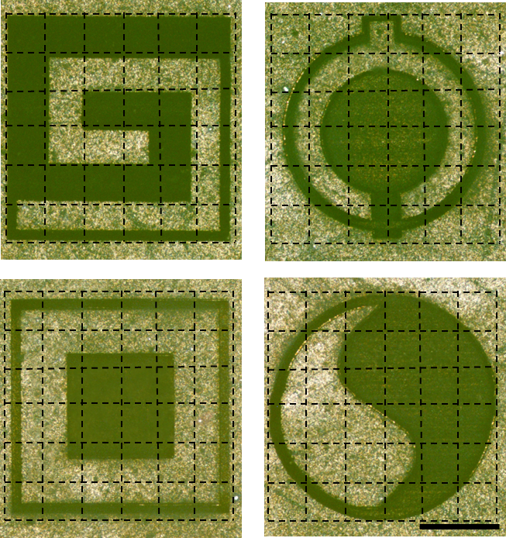

Supplementary Figure 1: The optical micrographs of asymmetric MSCs with a variety of personalized patterns. We can use this technology to achieve large-scale processing, and use the reshaped laser light field to complete the stitching in a short time (Each small square represents a sub-pulse shaped light field, which can be spliced into a large-scale pattern by using different pulse light fields). This proves that our technology can achieve pattern processing from small size to large size (scale bar, 500 μm).

Supplementary Figure 2: The MSCs arrays fabricated by temporally and spatially shaped femtosecond laser can adjust the linewidth of MSCs arrays, while maintaining high consistency of the patterned arrays (scale bar, 5 μm).

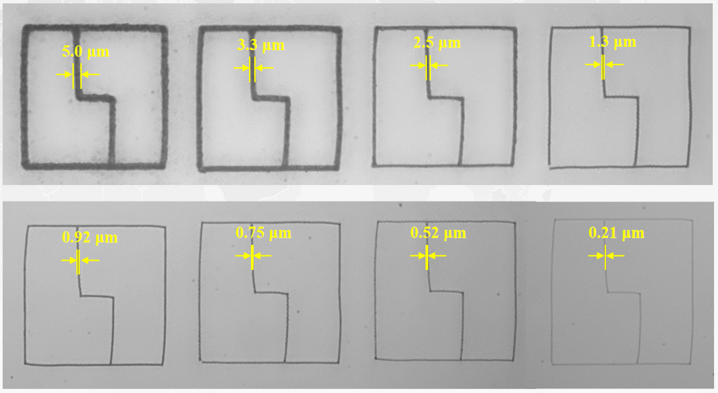

Supplementary Figure 3: MSCs patterns with different line widths.We can design patterned MSCs with different linewidths by adjusting the patterns and parameters of the light field using the shaped laser.These line widths can be adjusted from micron to nanometer scale.

c
b
a
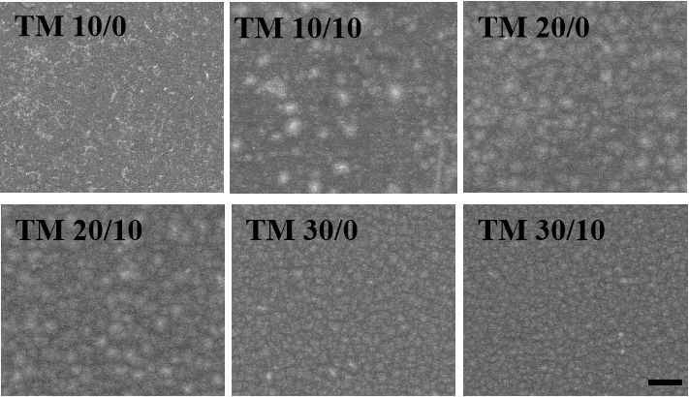
f
e
d
Supplementary Figure 4: The SEM images of 1T-MoS₂/MXene composite films processed by different shaped laser parameters (scale bar, 1 μm). With the increase of laser energy, it can be found that the particle size of composite surface decreases gradually, which is related to the cumulative ablation of laser.

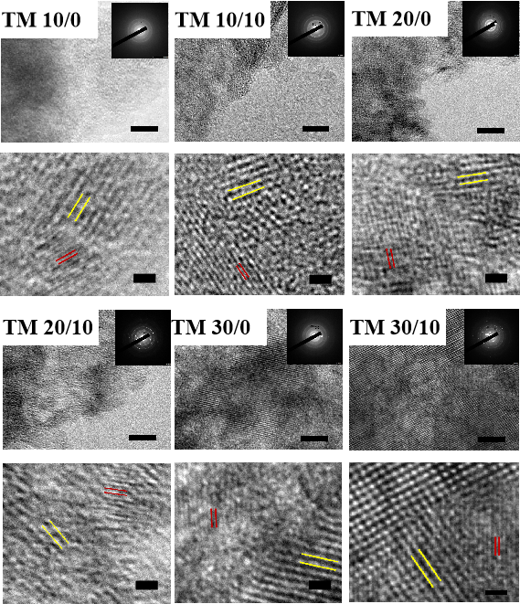
c
f
e
d
b
a

Supplementary Figure 5: TEM and high-resolution TEM of laser-induced materials with different laser parameters showed that MoO₃ and TiO₂ existed in the laser-induced composites with different parameters, which also proved that the oxidation of metal oxides was realized in our processing process.

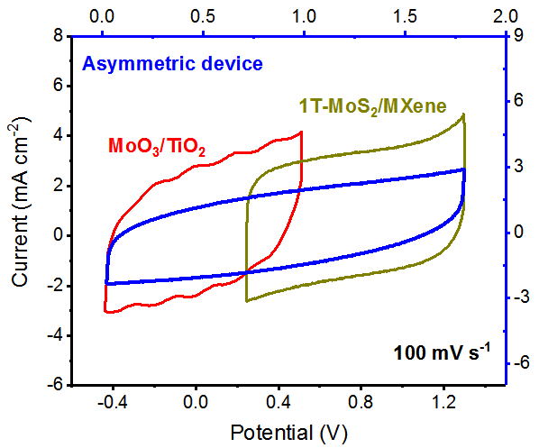

Supplementary Figure 6: CV curves of the 1T-MoS₂/MXene and MXene-derived TiO₂/1T-MoS₂-derived MoO₃ at a scan rate of 100 mV s⁻¹ measured in a three-electrode cell.

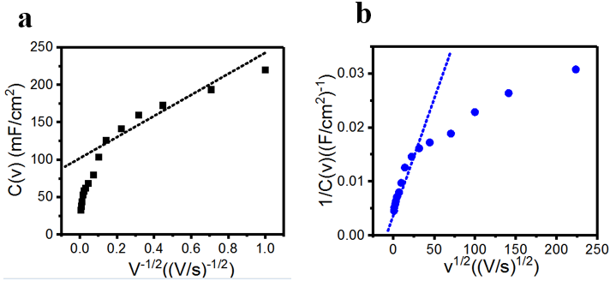
Supplementary Figure 7: CV curves of asymmetric MSCs prepared by our strategy at extremely high and very low scan rates.The regular rectangles indicate that asymmetric MSCs can retain good capacitance characteristics even at ultra-high scan rate.Supplementary Figure 10: (a) Plot of C(v) versus v^{−1/2} and (b) a plot of 1/C(v) versus v^{1/2} for the hybrid electrode cycled at sweep rates in the range 1–500 mV/s. The total voltammetric charge (q_{T}) is obtained from the contribution of the outer surface of the electrode (q_{o}) and the inner bulk of electrode (q_{i}): q_{T} = q_{o} + qi. As v→∞, q(v) = q_{o} + C₁v^{−1/2}, where q (v) is the measured voltammetric charge and C₁ is a numerical constant; as v goes to 0,1/q(v) = 1/q_{T} + C₂v^{1/2}, where C₂ is a numerical constant. So we did the research on our MXene/graphene as described above. The capacitance is directly proportional to the charge: C=q/V, where V is the potential window used. The diffusion-limited capacitance C_{D} then can be calculated by subtracting the value of the electrical double layer capacitance from the value of total capacitance C_{T} from the figure. So we can get C_{D} Thus, we can obtain the proportions of C_{DL} and C_{D} in the total C_{T}, indicating that MXene and Graphene alone provide their respective capacitance contributions.

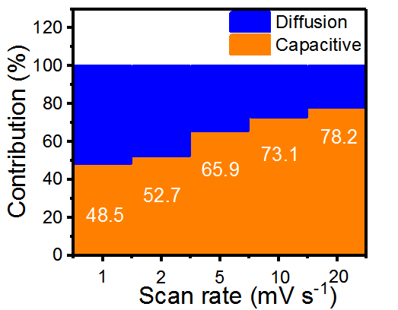

Supplementary Figure 8: The ratio of the diffusion-limited and capacitive capacitance at different scan rates. It can be obtained that the proportion of capacitance contributed by the capacitive capacitance in the hybrid electrode with different scan rates (1, 2, 5, 10 and 20 mV s⁻¹) is 48.5%, 52.7%, 65.9%, 73.1%, and 78.2%, respectively.

b
a

Supplementary Figure 9: CV curves of asymmetric MSCs prepared by our strategy at extremely high and very low scan rates.The regular rectangles indicate that asymmetric MSCs can retain good capacitance characteristics even at ultra-high scan rate.

Supplementary Figure 10: Capacitance retention of the asymmetric MSCs obtained in different bending states compared with that in the flat state. Inset: CV curves measured in different bending states. Contrary to expectations, the CV curves are almost coincident. This outstanding flexibility will expand the use of our MSCs across numerous fields, including integrated circuits, wearable microelectronics, and medical devices.

- Supplementary Table
Table 1. Comparison of asymmetric planar micro-supercapacitors prepared by different processes.
AMSCs | Machining technology | Size (mm) | Resolution  (μm) | Refs
CuSe@FeOOH// CuSe@MnOOH | Alternate  Electrodeposition | 2×2 | 100 | 6
Mesoporous Fe₂O₃/MnO₂ | Inkjet printing /Deposition | 20×20 | 20 | 4
Co(OH)₂//erGO | Photolithography  /Electrodeposition | 4×4 | 10 | 1
Ni(OH)₂/Ag-NW  //rGO/Ag-NW | Laser-Printing/  Coating | 40×30 | 1000 | 2
PNG//PNG-MoO₂ | Laser cutting /Reassembly | 5×10 | 1000 | 3
LIG-FeOOH  //LIG-MnO₂ | Laser reduction  /Electrodeposition | 20×40 | 1000 | 987
Graphene quantum dots//PANI | Two-step electrodeposition | 10×10 | 400 | Nanoscale  2013, 5, 6053.
1T-MoS₂/MXene//laser-induced MXenes-derived TiO₂ and 1T-MoS₂-derived MoO₃ | Shaped femtosecond laser pulse patterning | 0.01×0.01 | 0.2 | Our work

Supplementary Table 1. The comparison of our technology with other methods in terms of the size and highest resolution of the fabricated asymmetric supercapacitors. It can be found that our proposed shaped femtosecond laser patterning for asymmetric supercapacitors are micron in size, which has dozens or even hundreds of times in reducing the size of asymmetric supercapacitors. At the same time, our processing technology has greatly improved the processing resolution of miniature asymmetric supercapacitors.

Table 2. Summary of the Energy Dispersive Spectrometer for the different laser-induced TM.
Material | C | O | Mo | S | Ti
MT-10/0 | 52.15% | 32.01% | 4.34% | 2.22% | 9.28%
MT-10/10 | 49.19% | 34.20% | 4.12% | 2.04% | 10.45%
MT-20/0 | 24.83% | 36.79% | 9.94% | 4.97% | 23.47%
MT-20/10 | 18.86% | 37.45% | 11.43% | 6.28% | 25.98%
MT-30/0 | 17.18% | 36.42% | 14.76% | 5.18% | 27.55%
MT-30/10 | 11.94% | 36.33% | 13.45% | 6.89% | 31.39%

Supplementary Table 2. This result is listed in detail in Supplementary Table 2, which represents the presence of molybdenum oxide and titanium oxide in the different TM.

5. Supplementary References

- Qian, D. S. et al. Microstructures induced by excimer laser surface melting of the SiC p/Al metal matrix composite. Appl. Surf. Sci. 412, 436–446 (2017).
- Xue, Z. W. et al. Actively compensation of low order aberrations by refractive shaping system for high power slab lasers. Opt. Laser. Technol. 75, 71–75 (2015).
- He, F. et al. Fabrication of microfluidic channels with a circular cross section using spatiotemporally focused femtosecond laser pulses. Opt. letters 35, 1106-1108 (2010).
- Anaïs Ferris. et al. Atypical properties of FIB-patterned RuOx nanosupercapacitors. ACS Energy Lett. 2, 1734−1739 (2017).
- El-Kady, M. F. & Kaner, R. B. Scalable fabrication of high-power graphene micro- supercapacitors for flexible and on-chip energy storage. Nat. Commun. 4, 1475(2013).
- Zhang, C. F. et al. Stamping of flexible, coplanar MSCs using MXene inks. Adv. Funct. Mater. 28, 1705506 (2018).
- Liu, Y. Q. et al. Facile fabrication of fexible MSC with high energy density. Adv. Mater. Technol. 1, 1600166 (2016).
- Liu, Z. Y. et al. Ultraflexible in-plane MSCs by direct printing of solution-processable electrochemically exfoliated graphene. Adv. Mater. 28, 2217−2222 (2016).
- Wang, W. et al. A novel exfoliation strategy to significantly boost the energy storage capability of commercial carbon cloth. Adv. Mater. 27, 3572–3578 (2015).
- Jeon, H. et al. Facile and fast microwave-assisted fabrication of activated and porous carbon cloth composites with graphene and MnO₂ for flexible asymmetric supercapacitors. Electrochim Acta. 280, 9-16 (2018).

