Supplementary information
Supplemental methods
HML model
HML simultaneously estimates the parameters for a decision tree and the prediction models using the expectation-maximization (EM) algorithm based on factorized information criterion (FIC), which is an estimator specific to HML.
We had observation data $x^{N}=x^{(1)},…,x^{(N)}$, where $x∈R^{D}$, N is the number of individuals, and D is the number of dimensions in $x$, that is 12 variables that were used in this study. As we described in an article, a decision tree was created in which the gating nodes were non-leaf nodes and the expert nodes were leaf nodes (Figure S1). The i-th gating node $g_{i}$ assigns an individual as input data $x$ to an appropriate expert node for prediction based on the rule ${x\left[γ_{i}\right]<t}_{i}$, where $γ_{i}$ and $t_{i}$are the index of a variable and a threshold in a gating node $g_{i}$, respectively. The prediction model in the j-th expert node is presented as a binary logistic regression model in the following equation:
$$\begin{aligned}p\left(y^{N} | x^{N},ϕ_{j}\right)=\frac{1}{1+exp\left(-ϕ_{j}^{T}x^{N}\right)}.\#\left(1\right)\end{aligned}$$
Let us denote the regression target as $y^{N}=y^{(1)},…,y^{(N)}$, where $y^{(n)}$corresponds to $x^{(n)}$ and $ϕ_{j}$ indicates a weight vector of parameters in the j-th expert node.
The HML model is expressed as follows:
$$\begin{aligned}p\left(y^{N} | x^{N},g, γ, t, ϕ\right)=\sum_{j=1}^{E}{\prod_{i=E_{j}}{ψ_{g}\left(x^{N},i,j\right)p\left(y^{N}|x^{N},ϕ_{j}\right)}},\#\left(2\right)\end{aligned}$$
where $g=\left(g_{1},…,g_{G}\right)$, $γ=\left(γ_{1},…,γ_{G}\right)$, $t=\left(t_{1},…,t_{G}\right)$ are the parameter vectors for the gating nodes shown above. $ϕ=\left(ϕ_{1},…,ϕ_{E}\right)$ is the parameter vector for the expert nodes. G and E are the number of the gating nodes and the expert nodes, respectively. $E_{j}$ is an index set of the gating nodes that exist from the root gating node to the j-th expert node (for example, $E_{2}=\left\{1,2\right\}$ in Figure S1). $ψ_{g}\left(x^{N},i,j\right)$ is a probability of the i-th gating node. $\prod_{i=E_{j}}{ψ_{g}\left(x^{N},i,j\right)}$ represents a probability that the j-th expert node is selected. A latent variable when the j-th expert node is selected is represented as $ζ_{j}$ and is expressed as a one-hot vector (for example, $ζ_{2}=\left(0,1,0\right)$).

Factorized information criterion
Likelihood functions for the expert and gating nodes are expressed as follows:
$$\begin{aligned}p\left(y^{N}|ζ^{N},x^{N},ϕ\right)=\prod_{n=1}^{N}{\prod_{j=1}^{E}{p{\left(y^{\left(n\right)}|x^{\left(n\right)},ϕ_{j}\right)}^{ζ_{j}^{\left(n\right)}}}},\#\left(3\right)\end{aligned}$$
$$\begin{aligned}p\left(ζ^{N}|x^{N},g, γ, t\right)=\prod_{n=1}^{N}{\prod_{j=1}^{E}{\prod_{i∈E_{j}}{ψ_{g}{\left(x^{\left(n\right)},i,j\right)}^{ζ_{j}^{\left(n\right)}}}}}.\#\left(4\right)\end{aligned}$$
A marginal log-likelihood is obtained as follows:
$$\log{p\left(y^{N}|x^{N}\right)}=\log{\sum_{j=1}^{E}{p\left(y^{N},ζ^{N}|x^{N},ϕ\right)}} \\ =\log{\sum_{j=1}^{E}{q\left(ζ^{N}|x^{N}\right)\frac{p\left(y^{N},ζ^{N}|x^{N},ϕ\right)}{q\left(ζ^{N}|x^{N}\right)}}} \\ =\log{E_{q\left(ζ^{N}|x^{N}\right)}\left[\log{\frac{p\left(y^{N},ζ^{N}|x^{N},ϕ\right)}{q\left(ζ^{N}|x^{N}\right)}}\right]} \\ \begin{aligned}≥E_{q\left(ζ^{N}|x^{N}\right)}\left[\log{\frac{p\left(y^{N},ζ^{N}|x^{N},ϕ\right)}{q\left(ζ^{N}|x^{N}\right)}}\right].\#\left(5\right)\end{aligned}$$

The marginal likelihood $p\left(y^{N}|x^{N}\right)$ is a joint probability distribution $p\left(y^{N},ζ^{N}|x^{N}\right)$ that is marginalized over $ζ^{N}$. We introduced $q\left(ζ^{N}|x^{N}\right)$, which is an arbitrary distribution on $ζ$, at line 2 in the above equation (5). This equation equals to the expectation of a function $\log{\frac{p\left(y^{N},ζ^{N}|x^{N},ϕ\right)}{q\left(ζ^{N}|x^{N}\right)}}$ with respect to $q\left(ζ^{N}|x^{N}\right)$. We obtained a variational lower bound $E_{q\left(ζ^{N}|x^{N}\right)}\left[\log{\frac{p\left(y^{N},ζ^{N}|x^{N},ϕ\right)}{q\left(ζ^{N}|x^{N}\right)}}\right]$ at line 4 using Jensen's inequality.
Maximizing the variational lower bound gives an approximate solution of the marginal log-likelihood.
$$\begin{aligned}\log{p\left(y^{N}|x^{N}\right)}=\max_{q\left(ζ^{N}|x^{N}\right)}{E_{q\left(ζ^{N}|x^{N}\right)}\left[\log{\frac{p\left(y^{N},ζ^{N}|x^{N},ϕ\right)}{q\left(ζ^{N}|x^{N}\right)}}\right]}.\#\left(6\right)\end{aligned}$$
Then, we obtain a FIC by applying the Laplace method to a joint probability distribution $p\left(y^{N},ζ^{N}|x^{N}\right)$ under a proper regularity condition. For more information, please refer to the references [2, 3].
$$(7)$$

$$\log{p\left(y^{N}|x^{N}\right)}≈FIC\left(y^{N},x^{N}\right)=\max_{q\left(ζ^{N}|x^{N}\right)}\left\{E_{q\left(ζ^{N}|x^{N}\right)}\left[\log{p\left(y^{N},ζ^{N}|x^{N},θ\right)}-\sum_{i=1}^{G}{\left(\frac{D_{β_{i}}}{2}\log{\sum_{n=1}^{N}{\sum_{j∈G_{i}}{ζ_{j}^{\left(n\right)}}}}\right)}-\sum_{j=1}^{E}{\left(\frac{D_{ϕ_{j}}}{2}\log{\sum_{n=1}^{N}{ζ_{j}^{\left(n\right)}}}\right)}\right]+H_{q\left(ζ^{N}|x^{N}\right)}\right\},$$
where $θ=\left(g_{1},…,g_{G},t_{1},…,t_{G},ϕ_{1},…,ϕ_{E}\right)$ is a model parameter, $H_{q\left(ζ^{N}|x^{N}\right)}$ is the entropy of $q\left(ζ^{N}|x^{N}\right)$, $D_{β_{i}}$ is the number of dimensions of the i-th gating nodes, and $D_{ϕ_{j}}$ is the total number of parameters with non-zero weight in j-th expert node, that is cardinality.
In (7), we can see that the variational lower bound is split into the q function and the entropy. An advantage of applying the Laplace method is to enables a Bayesian treatment of logistic regression, which is difficult to solve analytically.

Estimation of parameters by EM-like iterative optimization
To obtain a decision tree model via HML, we needed the parameters for the gating nodes (i.e., $g$, $γ$, and $t$) and the expert nodes (i.e., $ϕ$). These parameters were estimated by EM-like iterative optimization. HML automatically selects an optimal decision tree and optimal model parameters to maximize FIC [2, 3]. We first set the tree depth d. The maximum number of expert nodes is 2^{d} since a decision tree is composed of binary trees. The estimation of parameters by EM-like iterative optimization is shown in Algorithm 1, where $g^{*}, γ^{*}, t^{*}, ϕ^{*}$ are the estimated values, the superscript (k) denotes the k-th step, and $q^{(k)}\left(ζ^{(N)}\right)$ is a variational distribution shown below (see [2, 3] for a detailed description of these steps). The q function has a regularization effect as we will see below, preventing overfitting by some biases in the dataset. In the process of EM-like iterative optimization, the expert nodes with low predictive power are pruned from the decision tree, resulting in a more appropriate tree structure (line 4 in Algorithm 1).
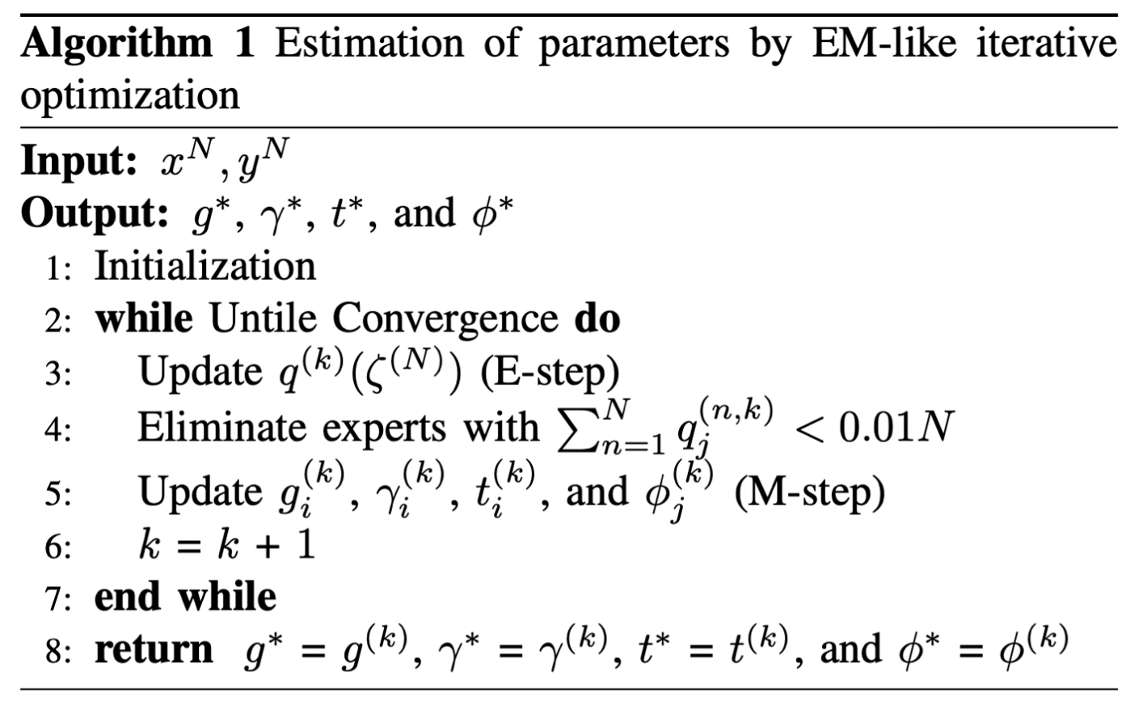

E-step
The E-step optimizes the variational distribution. The variational distribution in n-th individual in j-th expert is given below:
$$q^{(t)}\left(ζ_{j}^{\left(n\right)}\right)∝\prod_{i∈E_{j}}{ψ_{g}^{\left(t-1\right)}\left(x^{\left(n\right)},i,j\right)}p\left(y^{\left(n\right)}|x^{\left(n\right)},ϕ_{j}^{(t-1)}\right)\exp\left\{\sum_{i∈E_{j}}{\frac{{-D}_{β_{i}}}{2N_{β_{i}}^{(t-1)}}}+\frac{{-D}_{ϕ_{j}}}{2N_{ϕ_{j}}^{(t-1)}}\right\},$$
$$N_{β_{i}}^{(t)}=\sum_{n=1}^{N}{\sum_{j∈G_{i}}{q^{(t)}\left(ζ_{j}^{\left(n\right)}\right)},}$$
$$\begin{aligned}N_{ϕ_{j}}^{\left(t\right)}=\sum_{n=1}^{N}{q^{\left(t\right)}\left(ζ_{j}^{\left(n\right)}\right)},\#\left(8\right)\end{aligned}$$
where $β_{i}=\left\{g_{i},t_{i}\right\}$. The high $\sum_{i∈E_{j}}{D_{β_{i}}}$ means more complex tree-structure. The high $D_{ϕ_{j}}$ needs many variables in a logistic regression model in an expert node. The exponentiated form $\exp\left\{\sum_{i∈E_{j}}{\frac{{-D}_{β_{i}}}{2N_{β_{i}}^{(t-1)}}}+\frac{{-D}_{ϕ_{j}}}{2N_{ϕ_{j}}^{(t-1)}}\right\}$ has a regularization effect and penalizes the expert nodes that contribute to the formation of complex tree structure and that have more variables with small effects. In this E-step, expert nodes with $\sum_{n=1}^{N}{q^{(t)}\left(ζ_{j}^{\left(n\right)}\right)}=N_{ϕ_{j}}^{\left(t\right)}<0.01N$ are eliminated from the model, pruning a tree-structure.

M-step
The M-step optimizes the gating and expert nodes as follows:
$$\begin{aligned}β_{i}^{\left(t\right)}=\underset{β_{i}}{\arg{max}}\left\{\sum_{n=1}^{N}{\sum_{j∈G_{i}}{q^{\left(t\right)}\left(ζ_{j}^{\left(n\right)}\right)\log{ψ_{g}\left(x^{\left(n\right)},i,j\right)}}}-\frac{D_{β_{i}}}{2}\log\left(N_{β_{i}}^{\left(t\right)}\right)\right\},\#\left(9\right)\end{aligned}$$
$$\begin{aligned}ϕ_{j}^{\left(t\right)}=\underset{ϕ_{j}}{\arg{max}}\left\{\sum_{n=1}^{N}{q^{\left(t\right)}\left(ζ_{j}^{\left(n\right)}\right)\log{p\left(y^{\left(n\right)}|x^{\left(n\right)},ϕ_{j}\right)}}-\frac{D_{ϕ_{j}}}{2}\log\left(N_{ϕ_{j}}^{\left(t\right)}\right)\right\}.\#\left(10\right)\end{aligned}$$
For detailed optimization of each parameter, please refer to the references [2, 3]. After the above EM-like algorithm converged, we can simultaneously obtain the estimated parameters for a decision tree and the prediction models.

Supplemental reference
1. Jordan MI, Jacobs RA. Hierarchical Mixtures of Experts and the Em Algorithm. Neural Comput. 1994;6(2):181-214.
2. Fujimaki R, Morinaga S. Factorized Asymptotic Bayesian Inference for Mixture Modeling. In: Neil DL, Mark G, editors. Proceedings of the Fifteenth International Conference on Artificial Intelligence and Statistics; Proceedings of Machine Learning Research: PMLR; 2012. p. 400--8.
3. Eto R, Fujimaki R, Morinaga S, Tamano H. Fully-Automatic Bayesian Piecewise Sparse Linear Models. Jmlr Worksh Conf Pro. 2014;33:238-46.

Supplemental figures
