Supplementary information for
“First report on the bacterial community composition, diversity, and functions in Ramsar site of Central Himalayas, Nepal”
Namita Paudel Adhikari^{1,4}, Subash Adhikari⁵, Keshao Liu¹, Yuying Chen^{1,4}, Birendra Prasad Sharma¹, Ganesh Paudel⁶, Yongqin Liu^{1,2,3*}
¹ State Key Laboratory of Tibetan Plateau Earth System, Resources and Environment (TPESRE), Institute of Tibetan Plateau Research, Chinese Academy of Sciences, Beijing 100101, China
² CAS Center for Excellence in Tibetan Plateau Earth Sciences, Chinese Academy of
Sciences, Beijing 100101, China
³Center for the Pan-third Pole Environment, Lanzhou University, Lanzhou 730000,
China
⁴ University of Chinese Academy of Sciences, Beijing 100049, China
⁵Policy and Planning Commission, Gandaki Province, Pokhara 33700, Nepal
⁶ Tribhuvan University, Institute of Forestry, Pokhara 33700, Nepal
*To whom correspondence should be addressed
Yongqin Liu, State Key Laboratory of Tibetan Plateau Earth System, Resources and Environment (TPESRE), Institute of Tibetan Plateau Research, Chinese Academy of Sciences, Beijing 100101, China
E-mail: yqliu@itpcas.ac.cn

Table S1 Location and water physiochemical characteristics and bacterial abundance of different sampling sites in wetlands at foothills of the Himalayas. Temp: Temperature, EC: electrical conductivity, TDS: total dissolved solids, DOC: dissolved organic carbon, TN: total nitrogen, Chla: Chlorophyll a, BA: bacterial abundance
sample ID | Temp (°C) | pH | EC (µS cm⁻¹) | TDS (mg L⁻¹) | DOC (mg L⁻¹⁾ | TN  (mg L⁻¹) | Chla  (µg L⁻¹) |  | BA  (cells mL⁻¹)
W1-A | 20.4 | 7.9 | 86 | 45 | 0.9 | 0.6 | 1.5 | 73833
W2-A | 20.6 | 7.4 | 85 | 48 | 0.9 | 0.7 | 2.9 | 1026666
W3-A | 20.6 | 7.2 | 86 | 50 | 0.8 | 0.7 | 2.1 | 481166
W4-A | 21 | 7 | 48 | 28 | 1.4 | 0.9 | 0.5 | 1453666
W5-A | 20.4 | 8.6 | 115 | 58 | 1.2 | 0.9 | 0.7 | 996666
W6-A | 20.3 | 7.2 | 39 | 20 | 1.2 | 0.7 | 4 | 954666
W7-A | 21 | 7.6 | 39 | 20 | 1.1 | 0.6 | 5.6 | 627833
W8-A | 20.9 | 6.9 | 40 | 21 | 1.4 | 0.7 | 2.7 | 190181
W9-A | 22 | 8 | 45 | 23 | 2.1 | 0.2 | 26.9 | 1340666
W1-S | 29 | 6.4 | 63 | 32 | 1.7 | 0.5 | 5.7 | 1266333
W2-S | 28.6 | 6.2 | 78 | 39 | 1.5 | 0.3 | 13 | 760167
W3-S | 29 | 6.5 | 79 | 40 | 1.4 | 0.3 | 16.7 | 880533
W4-S | 29.5 | 6.8 | 75 | 38 | 0.7 | 0.4 | 2.7 | 137200
W5-S | 28.6 | 6.9 | 112 | 56 | 2.2 | 0.4 | 4.9 | 1110333
W6-S | 28.4 | 7.2 | 53 | 27 | 2.3 | 0.4 | 30.2 | 2996000
W7-S | 30.5 | 7.2 | 54 | 27 | 1.8 | 0.4 | 48 | 639333
W8-S | 29.6 | 7.2 | 44 | 22 | 2 | 0.4 | 10.8 | 581333
W9-S | 31 | 7.2 | 38 | 19 | 8.9 | 3.9 | 83.4 | 2808333

TABLE S2 Bray–Curtis distance-based dissimilarity tests showing differences between spring and autumn bacterial communities.
Communities | MRPPª |  | ANOSIM^{b} |  | Adonis^{c}
 | δ | P | r | P | F | P
spring vs. autumn | 0.65 | 0.001 | 0.71 | 0.001 | 7.16 | 0.001

ªMRPP, multiresponse permutation procedure. MRPP is a nonparametric procedure that depends on the internal variability of the data.
^{b}ANOSIM, analysis of similarities.
^{c}Nonparametric multivariate analysis of variance with the Adonis function
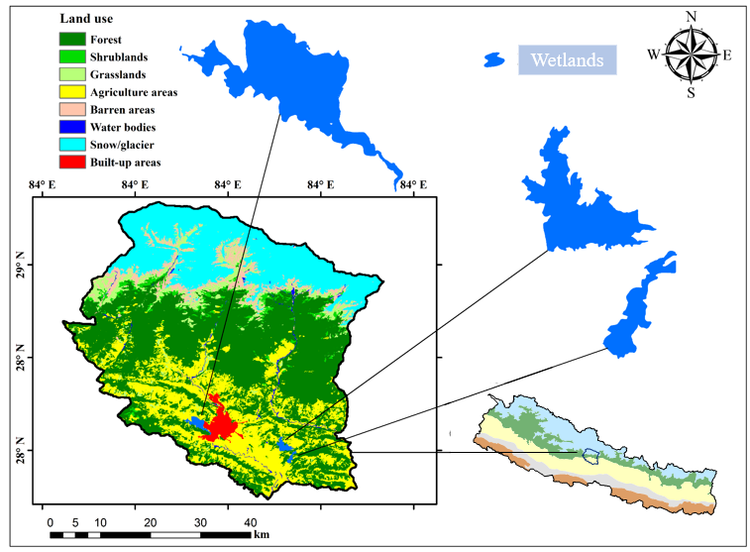
Fig. S1 Location map of three urban lakes at the foothills of Himalayas, Nepal showing different land use types
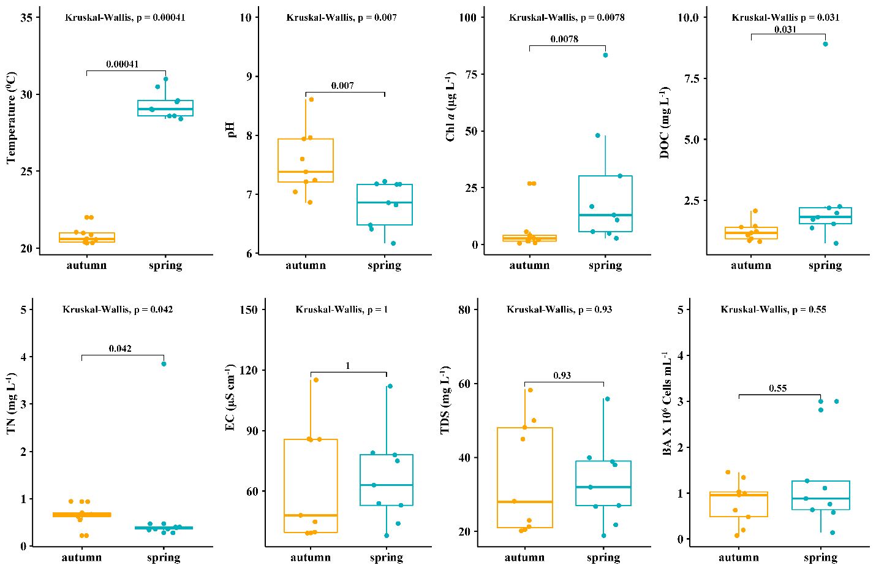
Fig. S2 Boxplots comparing water physicochemical and biological parameters in autumn and spring. Dots represent individual data points. Illustrated p- value is based on non-parametric Kruskal-Wallis test. Chl a: Chlorophyll a, DOC: dissolved organic carbon, TN: total nitrogen, EC: electrical conductivity, TDS: total dissolved solids, BA: bacterial abundance

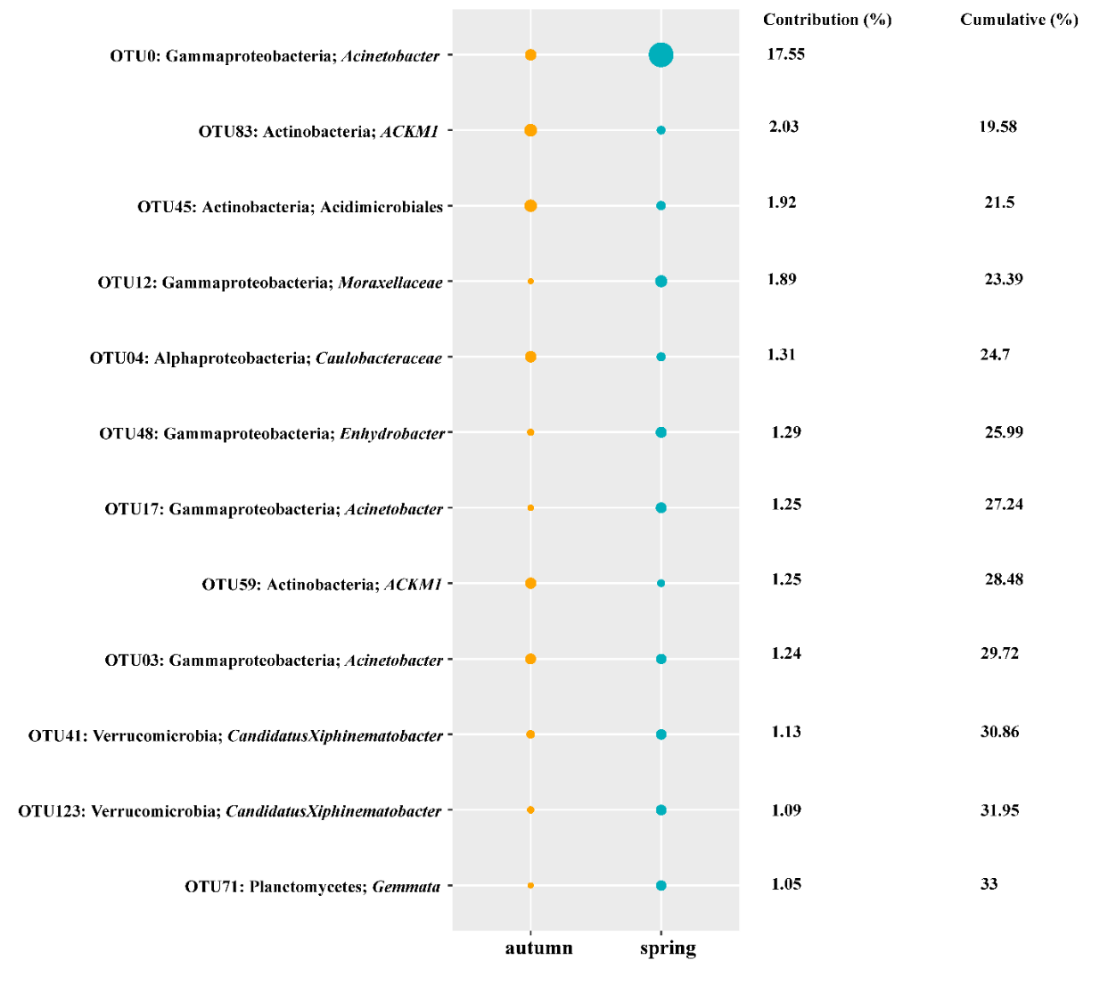
Fig. S3 Taxonomic identities of the 12 OTUs serving as indicator taxa among different season with their relative contributions to community dissimilarities. Diameters of the circles are proportional to the abundances of the OTUs

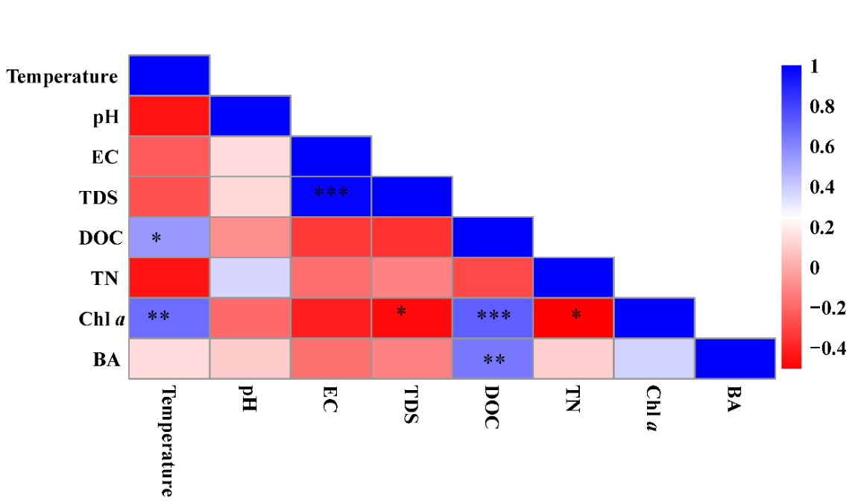
Fig. S4 Heatmap matrix showing Spearman’s correlation between lake water properties. Colors represent the r - values, symbols inside the cells indicate significance of the correlation i.e. (*P < 0.05, **P < 0.01, and ***P < 0.001). EC: electrical conductivity, TDS: total dissolved solids, DOC: dissolved organic carbon, TN: total nitrogen, Chl a: chlorophyll a, BA: bacterial abundance

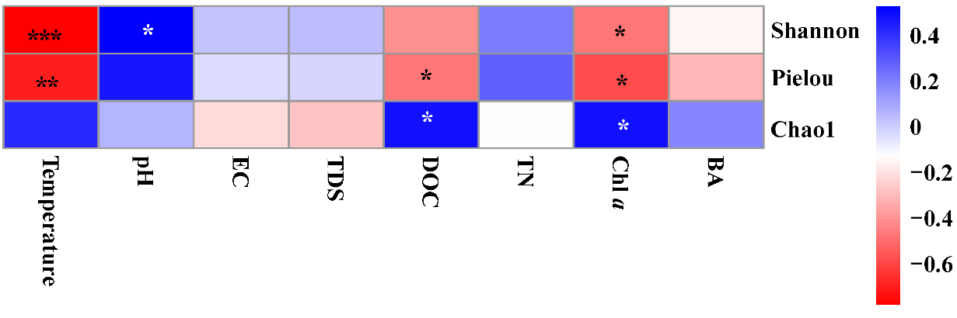
Fig. S5 Heatmap of Spearman’s correlation between lake water properties and bacterial alpha diversity indices. Colors represent the r - values, symbols inside the cells indicate significance of the correlation i.e. (*P < 0.05, **P < 0.01, and ***P < 0.001). EC: electrical conductivity, TDS: total dissolved solids, DOC: dissolved organic carbon, TN: total nitrogen, Chl a: chlorophyll a, BA: bacterial abundance
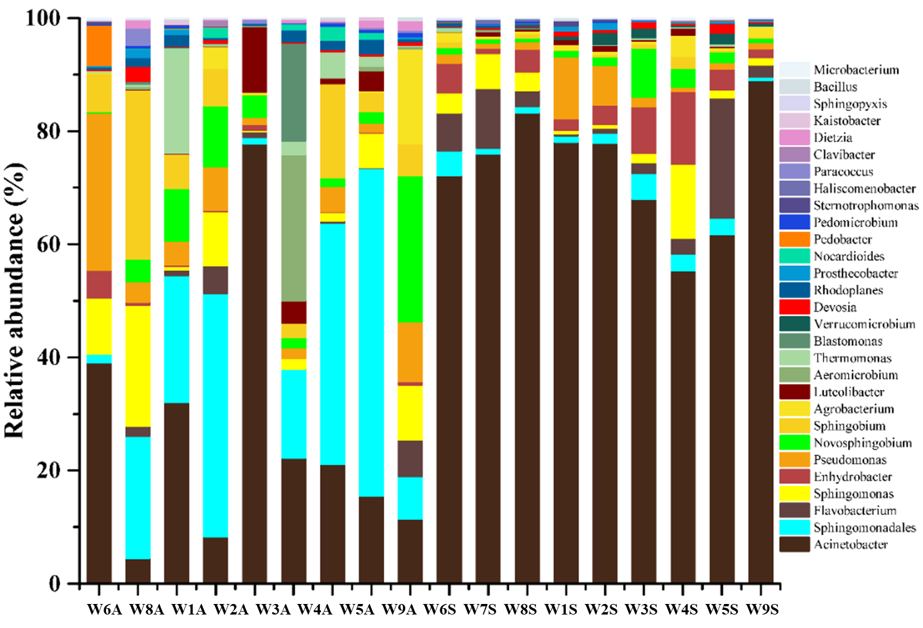
Fig. S6 Relative abundance of major genera assigned to aerobic chemoheterotrophy
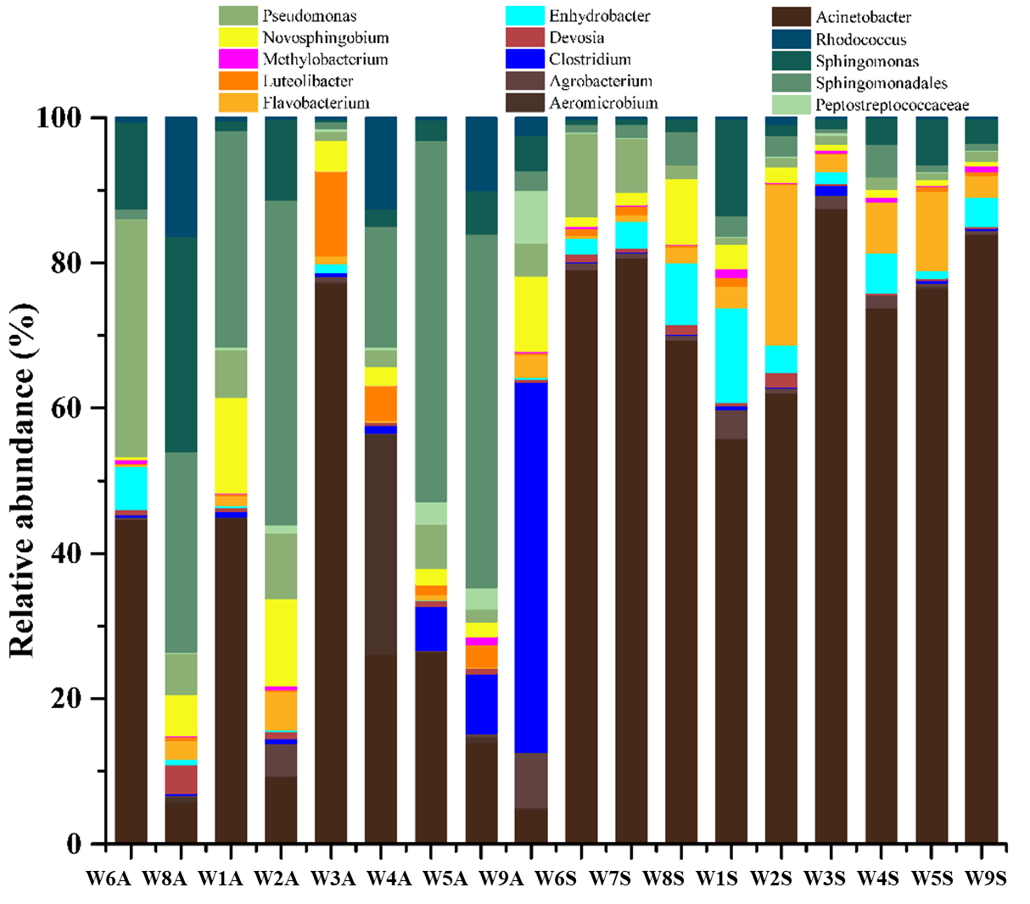
Fig. S7 Relative abundance of major genera assigned to chemoheterotrophy
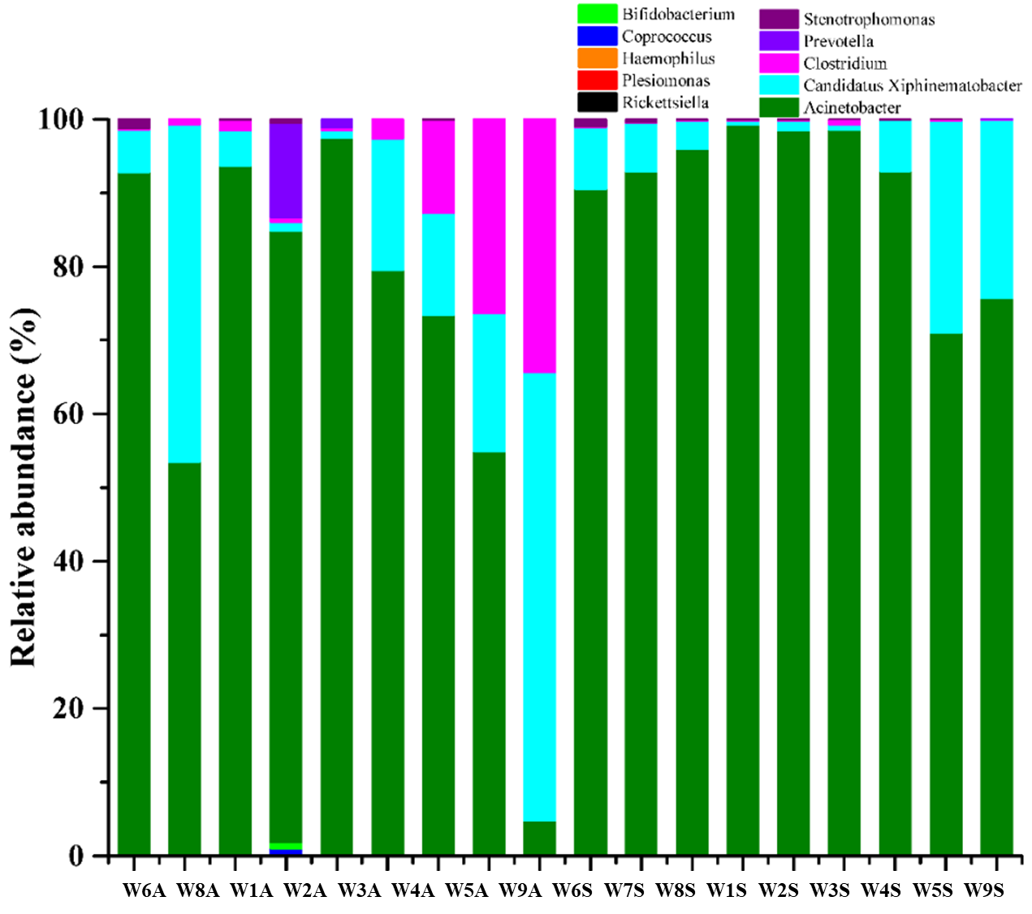
Fig. S8 Relative abundance of major genera assigned to animal parasites or symbionts
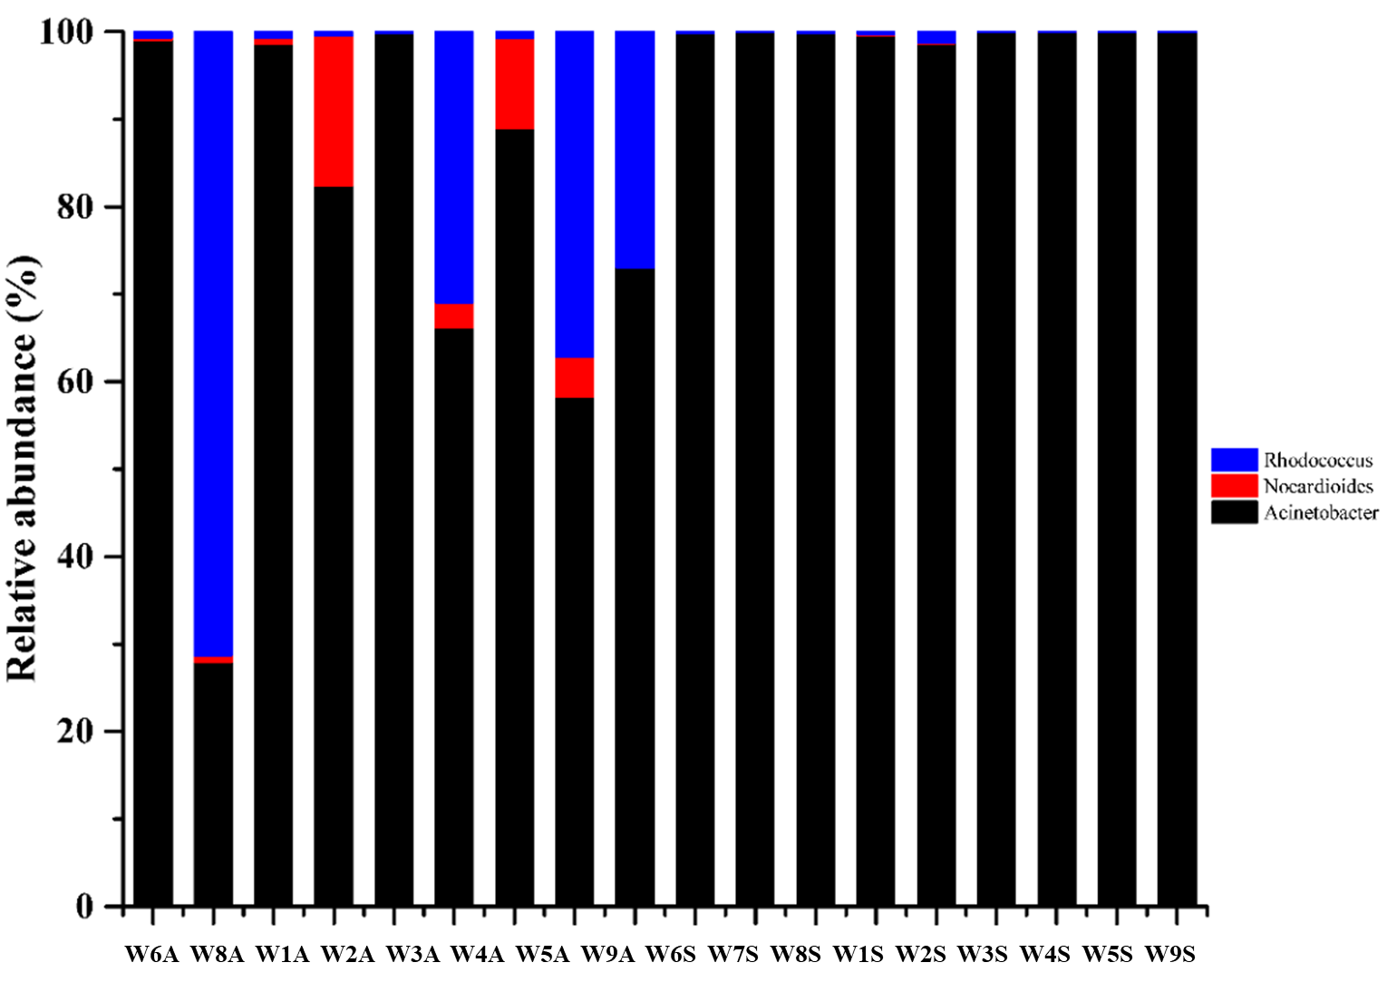
Fig. S9 Relative abundance of major genera assigned to aromatic compound degradation

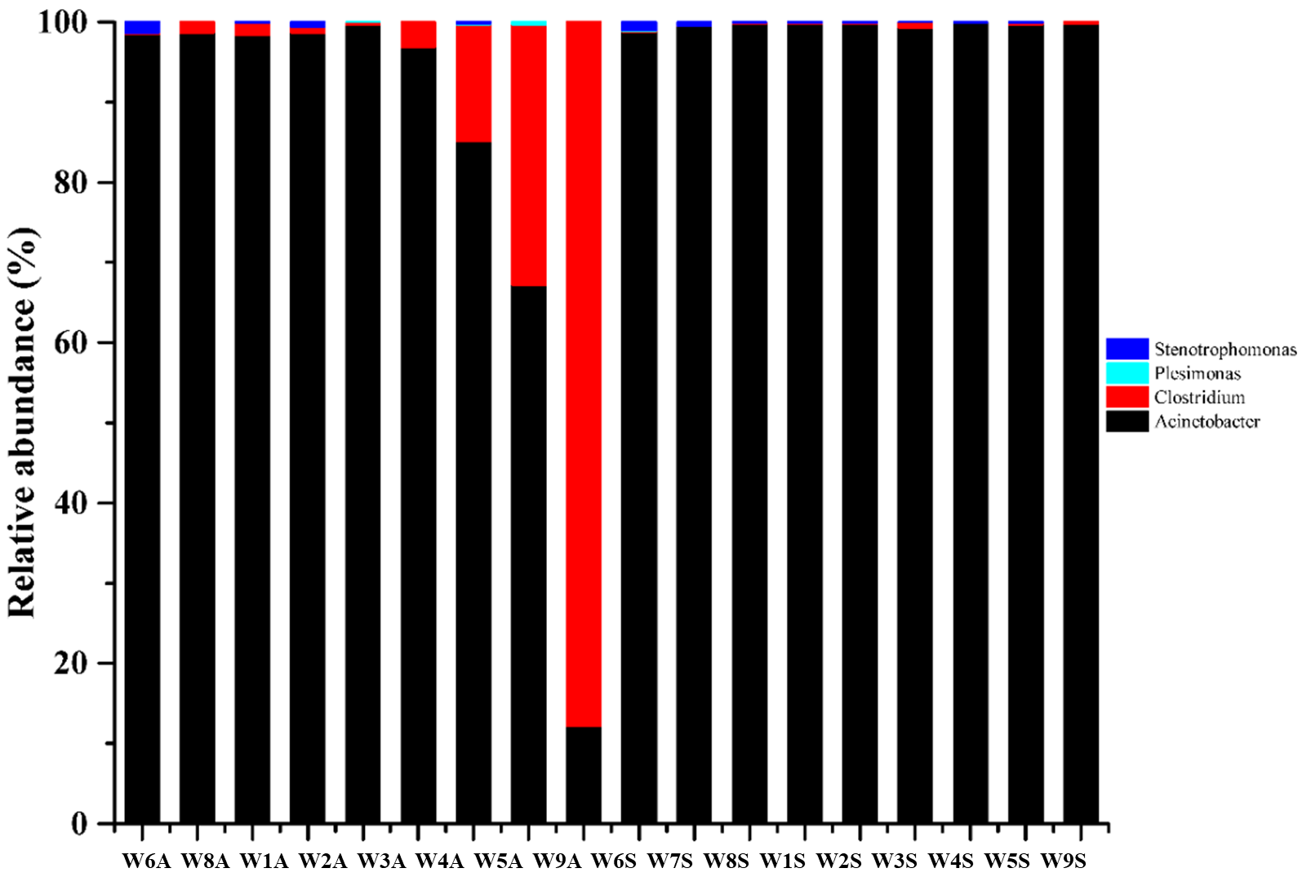
Fig. S10 Relative abundance of major genera assigned to human pathogens
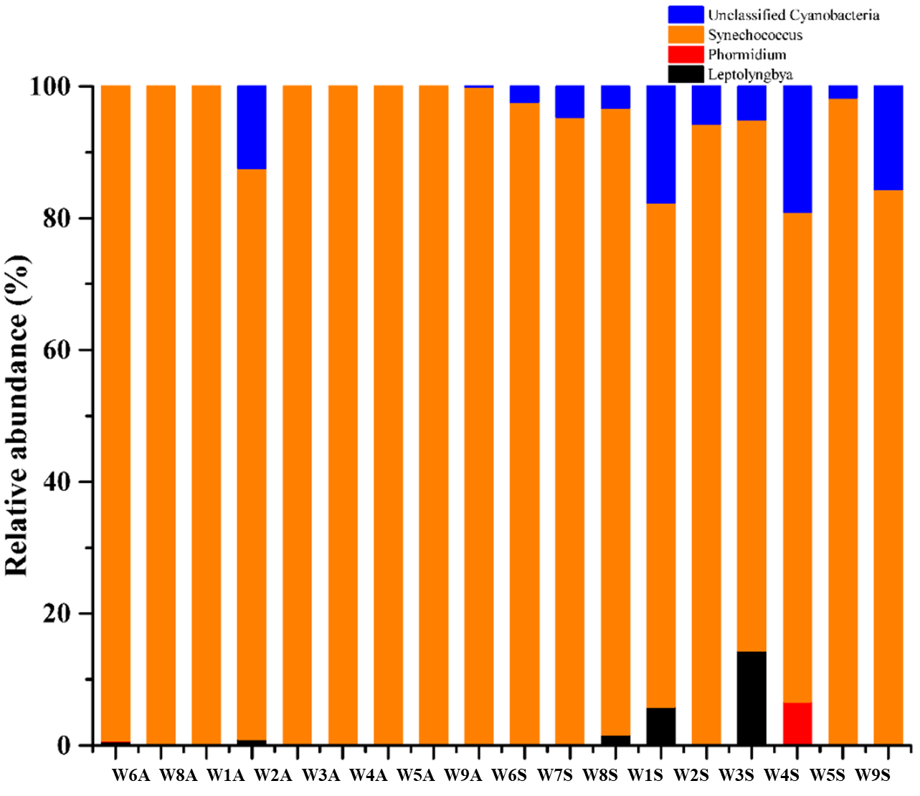
Fig. S11 Relative abundance of major genera assigned to oxygenic phototrophy
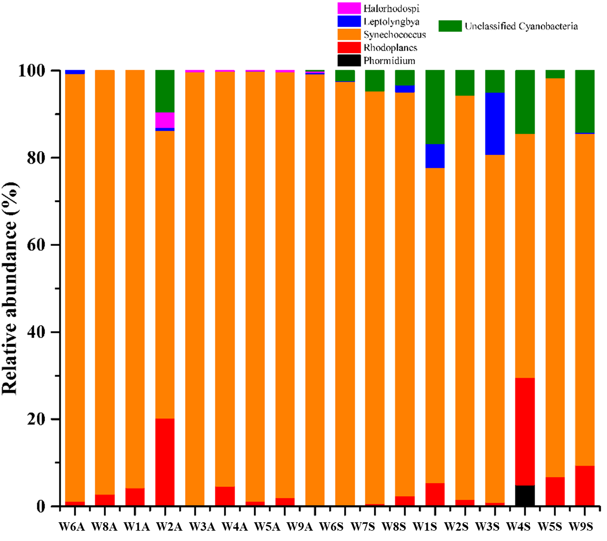
Fig. S12 Relative abundance of major genera assigned to photoautotrophy
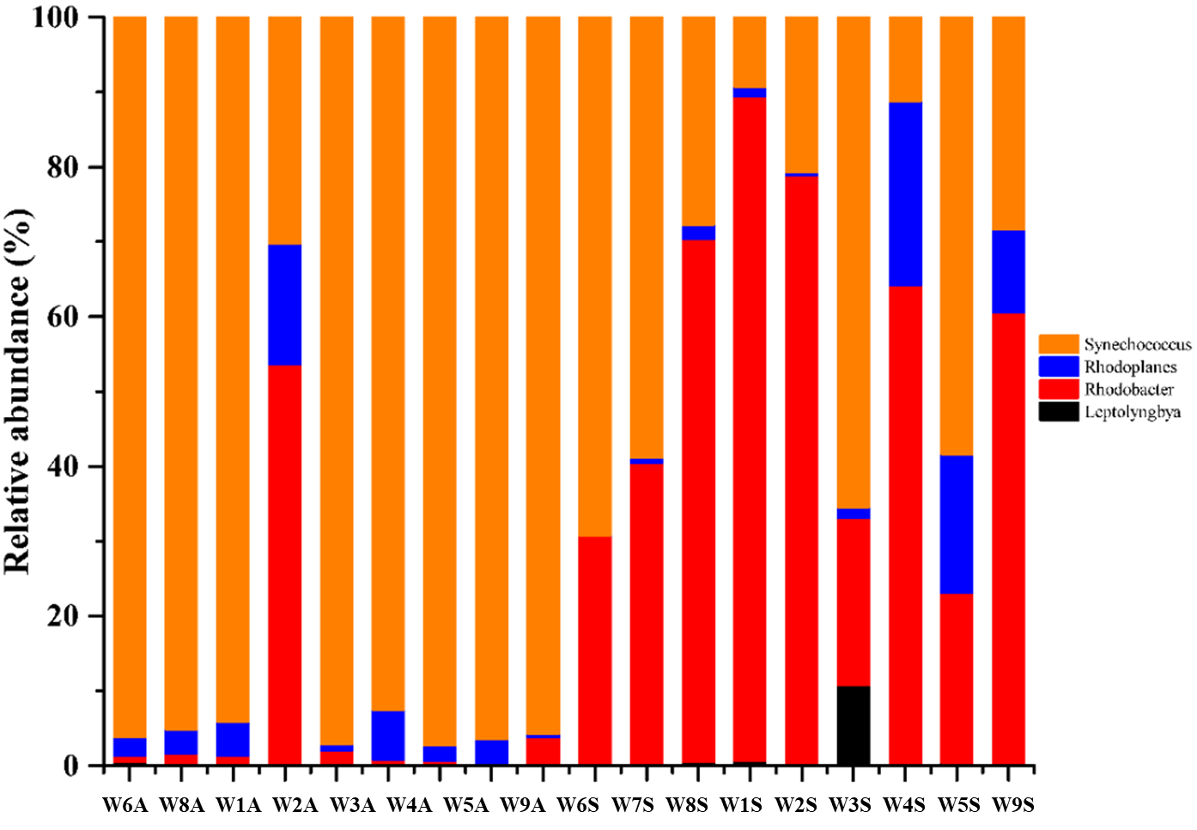
Fig. S13 Relative abundance of major genera assigned to phototrophy

