Supporting information Figure S1-9

Figure S1. Morphological comparison between the wild type (WT) and fgw1 mutant.
A, Morphology of WT and fgw1 mutant at the seedling stage, scale bar = 5 cm. B, Morphology of WT and fgw1 mutant at the tillering stage, scale bar = 10 cm. C, Gross morphologies of WT and fgw1 mutant at filling stage, scale bar = 15 cm. D–F, Internodes (D), panicle (C), and grain (E) of the WT and fgw1 mutant, scale bars = 5 cm. 1 and 2 represent scanning electron micrographs of the outer epidermis in WT and fgw1 mutant (F), scale bars = 50 µm. 3 and 4 represent cell length (3) and cell width (4) of the outer epidermis. Means ± SD are given in 3 and 4 (n = 40). **P < 0.01 (Student’s t-test).

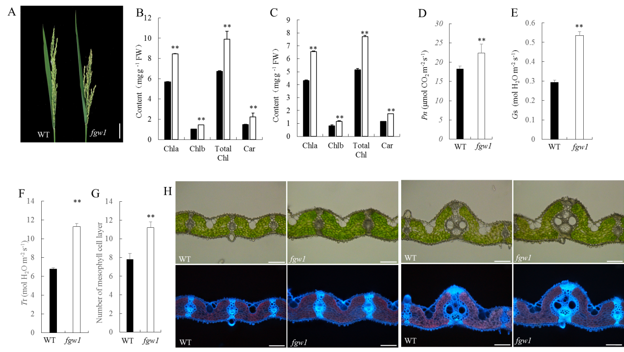
Figure S2. Comparison of morphological and photosynthetic characteristics between the wild type (WT) and fgw1 mutant.
A, Panicle and flag leaf of WT and fgw1 mutant at the grain-filling stage, scale bar = 5 cm. B, C, Photosynthetic pigment content of flag leaf (B) and second leaf (C) between WT (black column) and fgw1 (white column). D–F, Photosynthetic characteristics of WT and fgw1 mutant, Pn presents photosynthetic rate (D), Gs presents stomatal conductance (E) and Tr presents transpiration rate (F). (G) Number of mesophyll cell layers between WT and fgw1 mutant. H, Transverse section of large vein and small vein at the midpoint of the flag leaf at the heading stage. Scale bar = 50 μm. Means ± SD are given in B, C (n = 3), D-F (n = 9), G (n = 10). **P < 0.01 (Student’s t-test).

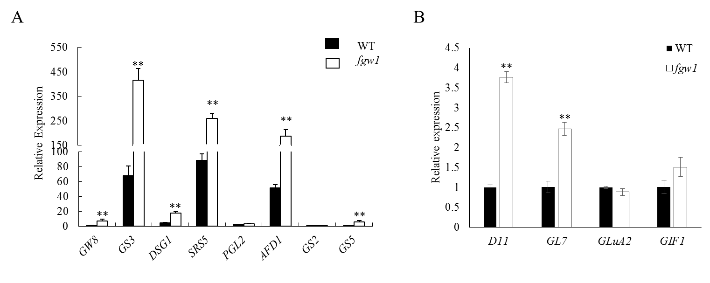
Figure S3. Relative expression level of cell division- and cell expansion-related genes in the wild type (WT) and fgw1 mutant. Means ± SD are given.

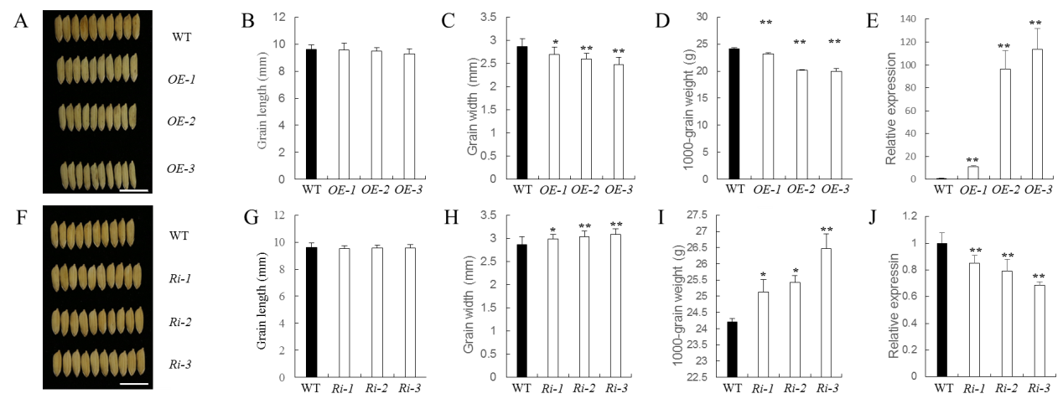
Figure S4. Complementation analysis of fgw1.
A, Gross morphology of the wild type (WT) and complemented transgenic plants (C-fgw1), scale bars = 25 cm. B, Panicle morphology of WT and C-fgw1, scale bars = 5 cm. C–E, Statistical analysis of grain length (C), grain width (D), and 1000-grain weight (E) in WT and C-fgw1. F–H, Statistical analysis of plant height (F), number of tillers per plant (G), and panicle length (H) in WT and C-fgw1. I, Sequence verification of FGW1 in complemented transgenic plants. Red arrow represents the peak of mutation and rescue. The mutation site shows a double peak owing to the presence of the mutant gene and the complementary gene; the latter gene also produces a double peak owing to the frame shift mutation. Means ± SD are given in C–E (n = 20) and F–H (n = 10).

Figure S5. Multiple sequence alignment and phylogenetic analysis of FGW1.
A, Multiple sequence alignment of sequences for the DUF630/DUF632 protein. The alignment was generated using ClustalX. Dark blue background indicates 100% homology of the aligned sequence; pink background indicates positions conserved in >75% of the aligned sequences; light blue background indicates positions conserved in >50% of the aligned sequences. B, Phylogenetic analysis of FGW1. The tree for DUF630/DUF632 domain homologous amino acid sequences was reconstructed using MEGA 5.05.

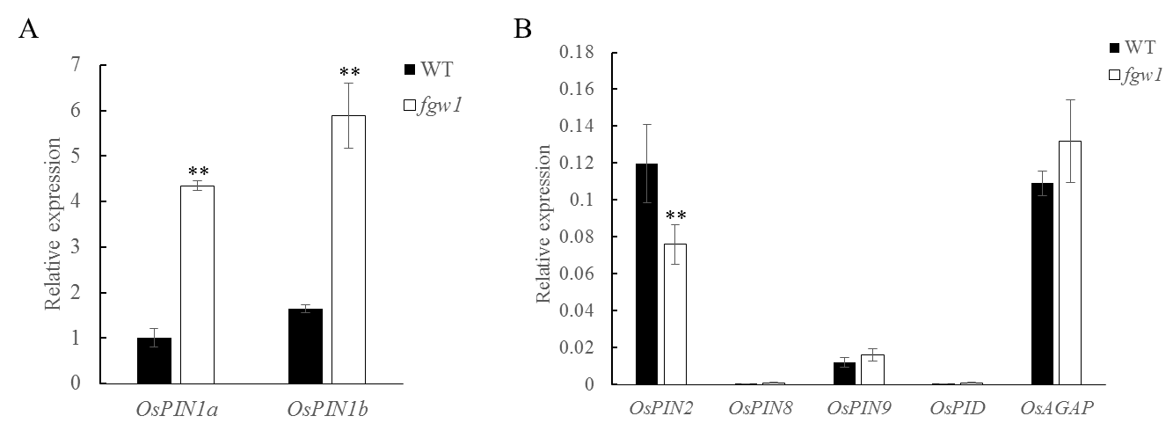
Figure S6. Relative expression level of auxin efflux carrier-like genes in the wild type (WT) and fgw1 mutant. Means ± SD are given.

Figure S7. Scanning electron micrographs of grains from FGW1-overexpression (OE) and FGW1-RNAi (Ri) plants.
A–C, Images of wild-type (WT), OE, and Ri grains, scale bar: a, 1 mm; b, 100 μm; c, 50 μm. D–G, Number of outer epidermal cells in the transverse and longitudinal planes in WT, OE, and Ri grains. H–K, Cell length and cell width of the outer epidermis in WT, OE, and Ri grains. L–O, Cell length and cell width of the inner epidermis in WT, OE, and Ri grains. Means ± SD are given in D–G (n = 10) and H–O (n = 40). *P < 0.05, **P < 0.01 (Student’s t-test).

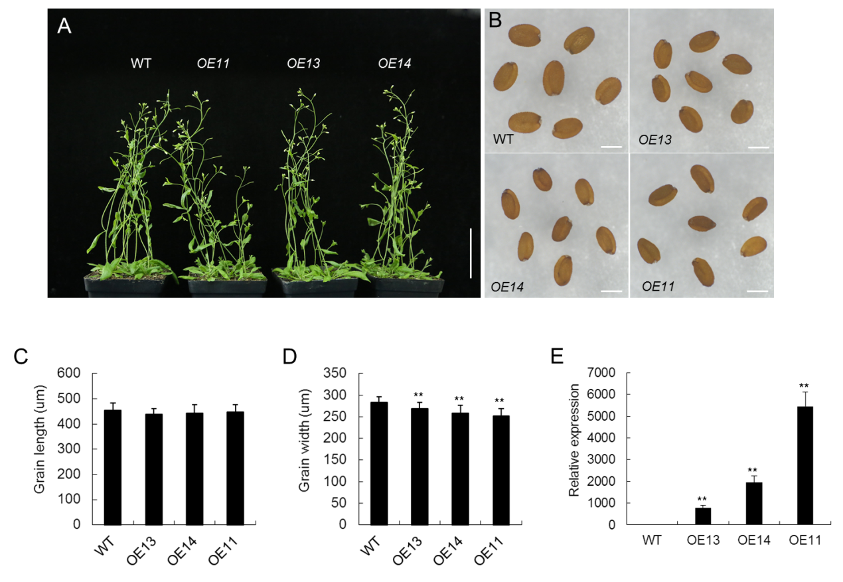
Figure S8. Analysis of FGW1 in Arabidopsis.
A, Gross morphology of wild-type (WT) and FGW1-overexpressing plants (OEs). Scale bar = 5 cm. B, Seed morphology of WT and FGW1-overexpressing plants. Scale bar = 1 mm. C–D, Grain length and grain width in WT and OEs. E, Expression level of FGW1 in WT and OEs. Means ± SD are given in C–D (n = 20). **P < 0.001 (Student’s t-test).

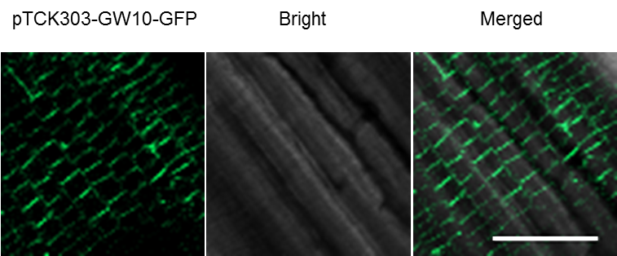
Figure S9. Subcellular localization of FGW1 in transgenic root cells. Fluorescent signals of FGW1-GFP fusion protein localized at the plasma membrane. Scale bars = 50 µm.

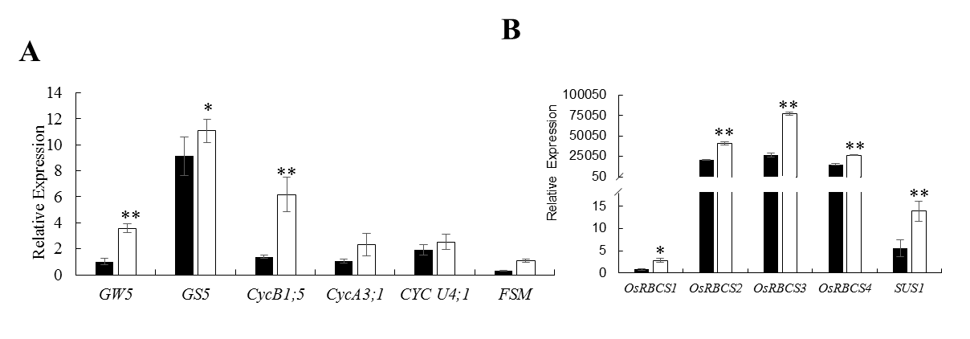
Figure S10. qPCR analysis of differentially expressed genes.
A, Relative expression levels of cell division- and expansion-related genes in the wild type (WT) and fgw1 mutant. B, Relative expression levels of carbohydrate transport- and metabolism-related genes in WT and fgw1 mutant. Data are given as mean ±SD of three biological replicates. * and ** represent a significant difference of P < 0.01 and P < 0.01(Student’s t-test).

