Molecular xenomonitoring as a complement to human antigen seroprevalence for lymphatic filariasis surveillance in Samoa

Brady McPherson, Helen J. Mayfield, Angus McLure, Katherine Gass, Take Naseri, Robert Thomsen, Steven Williams, Nils Pilotte, Therese Kearns, Patricia M. Graves, Colleen L. Lau

Supplementary material

Supplementary Table S1: Number of female mosquitoes caught by species category and PSU – 2018
PSU No. | Village(s) | Ae. polynesiensis | Ae. (Finlaya) spp. | Aedes spp. (other) | Culex spp. (all) | All species
1 | Vaivase Tai | 63 | 3 | 55 | 108 | 229
2 | Vaiala Tai + Vaiala Uta | 178 | 91 | 0 | 121 | 390
3 | Avele + Letava | 151 | 60 | 8 | 128 | 347
4 | Vaimea + Fugalei | 10 | 87 | 0 | 174 | 271
5 | Vaimoso | 12 | 0 | 35 | 160 | 207
6 | Vaitoloa | 53 | 1 | 81 | 157 | 292
7 | Letego | 248 | 11 | 38 | 134 | 431
8 | Vaiusu | 36 | 1 | 73 | 87 | 197
9 | Puipaa | 25 | 3 | 37 | 156 | 221
10 | Ululoloa | 31 | 3 | 91 | 208 | 333
11 | Vaitele Fou | 9 | 0 | 35 | 135 | 179
12 | Lotosoa | 245 | 6 | 63 | 282 | 596
13 | Nuu | 75 | 13 | 55 | 638 | 781
14 | Tuanai | 177 | 10 | 161 | 201 | 549
15 | Fasitoo Uta | 142 | 5 | 221 | 52 | 420
17 | Leauvaa | 152 | 8 | 29 | 61 | 250
21 | Fusi | 11 | 11 | 76 | 114 | 212
22 | Faleseela | 39 | 9 | 33 | 348 | 429
23 | Manono Uta | 39 | 3 | 109 | 96 | 247
25 | Mutiatele + Saleaaumua | 107 | 113 | 4 | 87 | 311
26 | Falefa | 51 | 6 | 73 | 97 | 227
27 | Musumusu + Faleapuna | 66 | 36 | 1 | 105 | 208
29 | Lalomalava + Safua | 111 | 61 | 11 | 257 | 440
30 | Lano | 71 | 40 | 26 | 147 | 284
31 | Safotu | 159 | 17 | 42 | 86 | 304
32 | Sataua | 73 | 5 | 27 | 42 | 147
33 | Sagone | 57 | 29 | 56 | 127 | 269
34 | Papa + Tafua | 107 | 66 | 3 | 25 | 201
Total |  | 2498 | 698 | 1443 | 4333 | 8972
Mean |  | 89 | 25 | 52 | 155 | 320

Supplementary Table S2: Number of female mosquitoes caught by species category and PSU - 2019.
PSU No. | Village | Ae. polynesiensis | Ae. aegypti | Ae. albopictus | Ae. upolensis | Ae. (Finlaya) spp. | Aedes spp. (other) | Cx. quinquefasciatus | Culex spp. (other) | Other | All species
1 | Vaivase Tai | 362 | 161 | 0 | 0 | 1 | 12 | 327 | 0 | 1 | 864
2 | Vaiala Tai + Vaiala Uta | 567 | 61 | 0 | 0 | 0 | 6 | 343 | 0 | 0 | 977
3 | Avele + Letava | 96 | 74 | 0 | 0 | 12 | 10 | 596 | 0 | 0 | 788
4 | Vaimea + Fugalei | 61 | 114 | 0 | 0 | 0 | 14 | 573 | 0 | 0 | 762
5 | Vaimoso | 83 | 95 | 0 | 0 | 0 | 7 | 814 | 0 | 0 | 999
6 | Vaitoloa | 63 | 118 | 0 | 0 | 2 | 5 | 312 | 0 | 1 | 501
7 | Letego | 469 | 74 | 0 | 0 | 31 | 38 | 1035 | 0 | 1 | 1648
8 | Vaiusu | 22 | 34 | 0 | 0 | 4 | 0 | 230 | 0 | 0 | 290
9 | Puipaa | 50 | 34 | 0 | 0 | 1 | 0 | 217 | 0 | 0 | 302
10 | Ululoloa | 85 | 71 | 0 | 0 | 0 | 12 | 898 | 0 | 2 | 1068
11 | Vaitele Fou | 85 | 158 | 0 | 0 | 1 | 8 | 336 | 0 | 1 | 589
12 | Lotosoa | 959 | 131 | 0 | 0 | 11 | 50 | 231 | 0 | 0 | 1382
13 | Nuu | 81 | 247 | 0 | 0 | 1 | 19 | 994 | 0 | 0 | 1342
14 | Tuanai | 164 | 149 | 0 | 0 | 1 | 28 | 314 | 0 | 1 | 657
15 | Fasitoo Uta | 109 | 75 | 0 | 0 | 6 | 21 | 205 | 0 | 0 | 416
16 | Vailuutai | 173 | 87 | 0 | 0 | 2 | 12 | 221 | 0 | 0 | 495
17 | Leauvaa | 132 | 94 | 0 | 0 | 4 | 8 | 250 | 0 | 0 | 488
18 | Fasitoo Tai* | 413 | 140 | 0 | 0 | 7 | 49 | 246 | 0 | 0 | 855
19 | Faleasiu* | 446 | 77 | 0 | 0 | 4 | 21 | 332 | 0 | 3 | 883
20 | Laulii* | 255 | 61 | 0 | 0 | 34 | 17 | 314 | 0 | 1 | 682
21 | Fusi | 116 | 154 | 0 | 0 | 31 | 2 | 775 | 0 | 0 | 1078
22 | Faleseela | 69 | 49 | 0 | 0 | 17 | 18 | 1644 | 0 | 0 | 1797
23 | Manono Uta | 62 | 76 | 0 | 0 | 5 | 13 | 786 | 0 | 0 | 942
24 | Salani + Utulaelae | 1046 | 133 | 0 | 0 | 102 | 180 | 2257 | 0 | 1 | 3719
25 | Mutiatele + Saleaaumua | 683 | 131 | 0 | 0 | 32 | 268 | 928 | 0 | 1 | 2043
26 | Falefa | 150 | 71 | 0 | 0 | 10 | 4 | 457 | 0 | 0 | 692
27 | Musumusu + Faleapuna | 156 | 76 | 0 | 0 | 4 | 2 | 247 | 1 | 1 | 487
28 | Salua* | 360 | 132 | 0 | 0 | 5 | 21 | 85 | 0 | 0 | 603
29 | Lalomalava + Safua | 558 | 196 | 0 | 0 | 207 | 77 | 221 | 0 | 0 | 1259
30 | Lano | 330 | 9 | 0 | 0 | 252 | 23 | 204 | 3 | 3 | 824
31 | Safotu | 385 | 72 | 0 | 0 | 14 | 12 | 251 | 1 | 1 | 736
32 | Sataua | 387 | 49 | 0 | 0 | 68 | 4 | 289 | 0 | 1 | 798
33 | Sagone | 479 | 61 | 0 | 0 | 229 | 12 | 161 | 0 | 0 | 942
34 | Papa + Tafua | 855 | 7 | 0 | 0 | 184 | 137 | 332 | 18 | 0 | 1533
35 | Salelologa* | 229 | 125 | 0 | 0 | 95 | 26 | 382 | 1 | 0 | 858
Total |  | 10540 | 3396 | 0 | 0 | 1377 | 1136 | 17807 | 24 | 19 | 34299
Mean |  | 301 | 97 | 0 | 0 | 39 | 32 | 509 | 0.7 | 0.5 | 980

Supplementary Table S3: Estimated prevalence of female mosquitoes infected with W. bancrofti by PSU and species category in 2018 in Samoa
PSU | All Species |  |  | Ae. polynesiensis |  |  | All Aedes |  |  | All Culex
PSU | Prev | Lower CI | Upper CI | Prev | Lower CI | Upper CI | Prev | Lower CI | Upper CI | Prev | Lower CI | Upper CI
1 | 1.33% | 0.40% | 4.23% | 2.88% | 0.65% | 13.10% | 2.41% | 0.73% | 7.84% | 0.00% | 0.00% | 2.26%
2 | 0.41% | 0.09% | 1.72% | 0.29% | 0.03% | 2.80% | 0.60% | 0.13% | 2.57% | 0.00% | 0.00% | 1.57%
3 | 0.00% | 0.00% | 0.55% | 0.00% | 0.00% | 1.26% | 0.00% | 0.00% | 0.87% | 0.00% | 0.00% | 1.49%
4 | 0.59% | 0.13% | 2.50% | 0.00% | 0.00% | 17.48% | 0.55% | 0.05% | 5.38% | 0.30% | 0.03% | 2.81%
5 | 0.24% | 0.02% | 2.24% | 4.29% | 0.42% | 36.71% | 1.03% | 0.10% | 9.81% | 0.00% | 0.00% | 1.19%
6 | 0.00% | 0.00% | 0.70% | 0.00% | 0.00% | 3.49% | 0.00% | 0.00% | 1.43% | 0.00% | 0.00% | 1.35%
7 | 0.11% | 0.01% | 1.07% | 0.00% | 0.00% | 0.77% | 0.00% | 0.00% | 0.64% | 0.35% | 0.03% | 3.39%
8 | 1.43% | 0.43% | 4.57% | 0.00% | 0.00% | 5.20% | 0.47% | 0.04% | 4.48% | 2.08% | 0.46% | 9.39%
9 | 1.54% | 0.46% | 4.98% | 2.77% | 0.28% | 39.07% | 3.39% | 0.75% | 16.90% | 0.42% | 0.04% | 4.00%
10 | 1.20% | 0.43% | 3.26% | 1.97% | 0.20% | 21.74% | 1.39% | 0.30% | 6.07% | 0.80% | 0.17% | 3.43%
11 | 0.33% | 0.03% | 3.17% | 0.00% | 0.00% | 19.22% | 1.31% | 0.13% | 13.08% | 0.00% | 0.00% | 1.73%
12 | 2.53% | 1.42% | 4.51% | 1.70% | 0.61% | 4.65% | 2.18% | 0.96% | 4.95% | 2.65% | 1.17% | 6.13%
13 | 0.54% | 0.16% | 1.71% | 1.20% | 0.12% | 13.67% | 3.27% | 1.00% | 11.77% | 0.00% | 0.00% | 0.50%
14 | 0.89% | 0.32% | 2.40% | 1.06% | 0.23% | 4.56% | 1.61% | 0.58% | 4.38% | 0.00% | 0.00% | 1.10%
15 | 1.84% | 0.86% | 3.89% | 3.29% | 1.20% | 9.47% | 2.16% | 1.01% | 4.60% | 0.00% | 0.00% | 3.63%
17 | 4.18% | 2.07% | 8.67% | 6.73% | 3.01% | 18.90% | 6.66% | 3.31% | 14.82% | 0.00% | 0.00% | 3.10%
21 | 0.78% | 0.17% | 3.36% | 0.00% | 0.00% | 16.02% | 1.97% | 0.44% | 9.05% | 0.00% | 0.00% | 1.67%
22 | 0.12% | 0.01% | 1.12% | 0.00% | 0.00% | 4.58% | 0.00% | 0.00% | 2.40% | 0.15% | 0.01% | 1.39%
23 | 0.19% | 0.02% | 1.80% | 0.00% | 0.00% | 4.81% | 0.30% | 0.03% | 2.88% | 0.00% | 0.00% | 1.98%
25 | 0.00% | 0.00% | 0.62% | 0.00% | 0.00% | 1.78% | 0.00% | 0.00% | 0.86% | 0.00% | 0.00% | 2.18%
26 | 6.43% | 3.33% | 13.67% | 1.14% | 0.11% | 12.53% | 5.71% | 2.35% | 16.00% | 5.75% | 2.16% | 19.45%
27 | 6.10% | 3.04% | 13.46% | 7.80% | 2.48% | 60.98% | 10.32% | 4.22% | 53.36% | 3.12% | 0.96% | 10.75%
29 | 0.12% | 0.01% | 1.09% | 0.00% | 0.00% | 1.85% | 0.29% | 0.03% | 2.72% | 0.00% | 0.00% | 0.74%
30 | 0.00% | 0.00% | 0.67% | 0.00% | 0.00% | 2.60% | 0.00% | 0.00% | 1.39% | 0.00% | 0.00% | 1.29%
31 | 0.53% | 0.11% | 2.26% | 1.10% | 0.24% | 4.76% | 0.77% | 0.17% | 3.27% | 0.00% | 0.00% | 2.23%
32 | 0.00% | 0.00% | 1.28% | 0.00% | 0.00% | 2.60% | 0.00% | 0.00% | 1.81% | 0.00% | 0.00% | 4.27%
33 | 0.99% | 0.29% | 3.14% | 0.00% | 0.00% | 2.87% | 2.00% | 0.60% | 6.50% | 0.00% | 0.00% | 1.50%
34 | 2.74% | 1.10% | 6.70% | 4.75% | 1.73% | 13.88% | 3.26% | 1.32% | 8.06% | 0.00% | 0.00% | 7.12%

Supplementary Table S4: Estimated prevalence of female mosquitoes infected with W. bancrofti by PSU and species category in 2019 in Samoa
PSU | All Species |  |  | Ae. polynesiensis |  |  | All Aedes |  |  | All Culex
PSU | Prev | Lower CI | Upper CI | Prev | Lower CI | Upper CI | Prev | Lower CI | Upper CI | Prev | Lower CI | Upper CI
1 | 0.18% | 0.04% | 0.74% | 0.14% | 0.01% | 1.31% | 0.29% | 0.06% | 1.21% | 0.00% | 0.00% | 0.59%
2 | 0.26% | 0.08% | 0.83% | 0.46% | 0.14% | 1.46% | 0.41% | 0.12% | 1.29% | 0.00% | 0.00% | 0.56%
3 | 0.00% | 0.00% | 0.24% | 0.00% | 0.00% | 1.98% | 0.00% | 0.00% | 1.00% | 0.00% | 0.00% | 0.32%
4 | 0.07% | 0.01% | 0.62% | 0.00% | 0.00% | 3.10% | 0.00% | 0.00% | 1.01% | 0.09% | 0.01% | 0.83%
5 | 0.58% | 0.25% | 1.29% | 0.68% | 0.06% | 6.62% | 1.50% | 0.45% | 4.75% | 0.32% | 0.09% | 1.01%
6 | 0.30% | 0.06% | 1.27% | 0.86% | 0.08% | 7.93% | 0.84% | 0.18% | 3.49% | 0.00% | 0.00% | 0.61%
7 | 0.15% | 0.04% | 0.48% | 0.00% | 0.00% | 0.41% | 0.08% | 0.01% | 0.76% | 0.15% | 0.03% | 0.61%
8 | 0.17% | 0.02% | 1.60% | 0.00% | 0.00% | 8.36% | 0.83% | 0.08% | 7.52% | 0.00% | 0.00% | 0.83%
9 | 0.54% | 0.11% | 2.26% | 0.00% | 0.00% | 3.77% | 0.00% | 0.00% | 2.23% | 0.77% | 0.16% | 3.27%
10 | 0.25% | 0.07% | 0.77% | 0.00% | 0.00% | 2.29% | 0.00% | 0.00% | 1.15% | 0.29% | 0.09% | 0.93%
11 | 0.61% | 0.22% | 1.64% | 0.60% | 0.06% | 5.57% | 1.03% | 0.31% | 3.25% | 0.15% | 0.01% | 1.41%
12 | 2.94% | 2.07% | 4.20% | 3.50% | 2.34% | 5.29% | 3.27% | 2.25% | 4.77% | 1.26% | 0.38% | 4.04%
13 | 0.49% | 0.23% | 1.03% | 0.61% | 0.06% | 5.71% | 1.78% | 0.77% | 3.96% | 0.05% | 0.00% | 0.46%
14 | 0.38% | 0.11% | 1.21% | 1.59% | 0.48% | 5.03% | 0.75% | 0.22% | 2.35% | 0.00% | 0.00% | 0.61%
15 | 1.17% | 0.47% | 2.82% | 1.62% | 0.35% | 7.05% | 1.31% | 0.39% | 4.14% | 0.76% | 0.16% | 3.24%
16 | 1.26% | 0.55% | 2.80% | 1.87% | 0.56% | 6.12% | 2.43% | 1.07% | 5.46% | 0.00% | 0.00% | 0.91%
17 | 0.95% | 0.38% | 2.29% | 1.26% | 0.27% | 5.33% | 2.04% | 0.82% | 4.90% | 0.00% | 0.00% | 0.77%
18 | 3.19% | 2.07% | 4.93% | 6.63% | 4.03% | 11.51% | 4.46% | 2.83% | 7.11% | 0.67% | 0.14% | 2.84%
19 | 3.12% | 2.05% | 4.76% | 6.04% | 3.66% | 10.40% | 6.50% | 4.25% | 10.16% | 0.00% | 0.00% | 0.58%
20 | 2.38% | 1.40% | 4.01% | 6.94% | 3.81% | 13.30% | 4.87% | 2.80% | 8.51% | 0.16% | 0.02% | 1.54%
21 | 0.00% | 0.00% | 0.18% | 0.00% | 0.00% | 1.64% | 0.00% | 0.00% | 0.67% | 0.00% | 0.00% | 0.25%
22 | 0.00% | 0.00% | 0.11% | 0.00% | 0.00% | 2.75% | 0.00% | 0.00% | 1.22% | 0.00% | 0.00% | 0.12%
23 | 0.00% | 0.00% | 0.20% | 0.00% | 0.00% | 3.05% | 0.00% | 0.00% | 1.22% | 0.00% | 0.00% | 0.24%
24 | 0.00% | 0.00% | 0.05% | 0.00% | 0.00% | 0.18% | 0.00% | 0.00% | 0.13% | 0.00% | 0.00% | 0.09%
25 | 0.02% | 0.00% | 0.23% | 0.00% | 0.00% | 0.28% | 0.00% | 0.00% | 0.17% | 0.05% | 0.01% | 0.51%
26 | 0.53% | 0.19% | 1.42% | 1.09% | 0.24% | 4.62% | 0.68% | 0.14% | 2.84% | 0.34% | 0.07% | 1.44%
27 | 1.16% | 0.50% | 2.58% | 0.34% | 0.03% | 3.22% | 0.62% | 0.13% | 2.61% | 1.50% | 0.53% | 4.03%
28 | 0.26% | 0.05% | 1.08% | 0.44% | 0.09% | 1.87% | 0.30% | 0.06% | 1.27% | 0.00% | 0.00% | 2.23%
29 | 0.04% | 0.00% | 0.37% | 0.09% | 0.01% | 0.85% | 0.05% | 0.00% | 0.45% | 0.00% | 0.00% | 0.87%
30 | 0.00% | 0.00% | 0.23% | 0.00% | 0.00% | 0.58% | 0.00% | 0.00% | 0.31% | 0.00% | 0.00% | 0.92%
31 | 0.65% | 0.26% | 1.56% | 1.01% | 0.36% | 2.72% | 1.02% | 0.41% | 2.46% | 0.00% | 0.00% | 0.76%
32 | 0.00% | 0.00% | 0.24% | 0.00% | 0.00% | 0.50% | 0.00% | 0.00% | 0.38% | 0.00% | 0.00% | 0.66%
33 | 0.27% | 0.08% | 0.85% | 0.11% | 0.01% | 0.99% | 0.33% | 0.10% | 1.03% | 0.00% | 0.00% | 1.19%
34 | 0.51% | 0.25% | 1.01% | 0.56% | 0.22% | 1.35% | 0.66% | 0.32% | 1.33% | 0.00% | 0.00% | 0.55%
35 | 0.06% | 0.01% | 0.54% | 0.22% | 0.02% | 2.07% | 0.11% | 0.01% | 0.99% | 0.00% | 0.00% | 0.50%

Supplementary Table S5: Values and confidence intervals for estimated prevalence of female mosquitoes infected with W. bancrofti by PSU and species category in 2018 and 2019 in Samoa.
 |  | 2018 | 2019
All species | National | 0.86 (0.63,1.4) | 0.29 (0.23,0.53)
All species | NWU | 1.11 (0.65,1.04) | 0.51 (0.32,0.53)
All species | ROU | 1.03 (0.68,1.32) | 0.17 (0.13,0.23)
All species | SAV | 0.66 (0.48,0.73) | 0.22 (0.15,0.26)
All species | AUA | 0.59 (0.44,0.64) | 0.25 (0.17,0.3)
All Aedes | National | 1.32 (0.97,1.99) | 0.52 (0.46,1.35)
All Aedes | NWU | 1.7 (0.99,1.68) | 0.98 (0.59,1)
All Aedes | ROU | 1.43 (0.95,1.91) | 0.22 (0.16,0.33)
All Aedes | SAV | 0.98 (0.69,1.03) | 0.29 (0.21,0.39)
All Aedes | AUA | 1.03 (0.73,1.15) | 0.48 (0.34,0.7)
All Culex | National | 0.41 (0.31,0.59) | 0.16 (0.14,0.41)
All Culex | NWU | 0.52 (0.32,0.59) | 0.3 (0.19,0.32)
All Culex | ROU | 0.44 (0.29,0.62) | 0.07 (0.05,0.11)
All Culex | SAV | 0.3 (0.21,0.34) | 0.09 (0.06,0.13)
All Culex | AUA | 0.31 (0.22,0.36) | 0.15 (0.1,0.21)
Ae. polynesiensis | National | 1.22 (0.94,1.92) | 0.52 (0.47,1.46)
Ae. polynesiensis | NWU | 1.6 (0.95,1.73) | 0.9 (0.56,1.01)
Ae. polynesiensis | ROU | 1.38 (0.94,1.87) | 0.21 (0.16,0.31)
Ae. polynesiensis | SAV | 0.95 (0.69,1.09) | 0.31 (0.22,0.37)
Ae. polynesiensis | AUA | 0.94 (0.67,1) | 0.44 (0.31,0.56)

Supplementary Table S6: PSU-level odds ratios for the change in prevalence between 2018 and 2019 of filarial DNA in mosquitoes, adjusted for species

PSU | PSU Name | Region | OR* 2019 vs 2018 | 95% CrI
1 | Vaivase Tai | AUA | 0.30 | 0.09-0.78
2 | Vaiala Tai + Vaiala Uta | AUA | 0.42 | 0.17-1.16
3 | Avele + Letava | AUA | 0.39 | 0.09-1.81
4 | Vaimea + Fugalei | AUA | 0.34 | 0.10-0.99
5 | Vaimoso | AUA | 0.54 | 0.23-1.76
6 | Vaitoloa | AUA | 0.53 | 0.19-2.05
7 | Letego | NWU | 0.46 | 0.17-1.40
8 | Vaiusu | NWU | 0.36 | 0.12-1.01
9 | Puipaa | NWU | 0.37 | 0.13-1.00
10 | Ululoloa | NWU | 0.35 | 0.13-0.85
11 | Vaitele Fou | NWU | 0.46 | 0.18-1.50
12 | Lotosoa | NWU | 0.65 | 0.35-1.31
13 | Nuu | NWU | 0.46 | 0.21-1.19
14 | Tuanai | NWU | 0.40 | 0.16-0.96
15 | Fasitoo Uta | NWU | 0.52 | 0.24-1.35
17 | Leauvaa | NWU | 0.32 | 0.13-0.67
21 | Fusi | ROU | 0.27 | 0.06-0.79
22 | Faleseela | ROU | 0.31 | 0.08-1.08
23 | Manono Uta | ROU | 0.33 | 0.08-1.13
25 | Mutiatele + Saleaaumua | ROU | 0.39 | 0.10-1.57
26 | Falefa | ROU | 0.22 | 0.07-0.52
27 | Musumusu + Faleapuna | ROU | 0.26 | 0.09-0.59
29 | Lalomalava + Safua | SAV | 0.36 | 0.10-1.15
30 | Lano | SAV | 0.37 | 0.09-1.50
31 | Safotu | SAV | 0.50 | 0.22-1.36
32 | Sataua | SAV | 0.36 | 0.08-1.51
33 | Sagone | SAV | 0.33 | 0.12-0.81
34 | Papa + Tafua | SAV | 0.31 | 0.13-0.65
* odds ratios closely approximate prevalence ratios since prevalence of LF DNA was low in all vector species, all PSUs, and both years.

Supplementary Table S7: Number of participants in each year in each of the four regions of Samoa in the 28 PSUs included in both years and both surveys.
Region | 2018 |  | 2019
Region | 5-9 year-olds | 10+ year-olds | 5-9 year-olds | 10+ year-olds
AUA | 299 | 349 | 339 | 323
NWU | 572 | 567 | 596 | 699
ROU | 340 | 342 | 393 | 394
SAV | 331 | 293 | 368 | 371

Supplementary Table S8: Number of participants in each year in each of the four regions of Samoa in the 30 randomly selected PSUs included in the human survey both years.
Region | 2018 |  | 2019
Region | 5-9 year-olds | 10+ year-olds | 5-9 year-olds | 10+ year-olds
AUA | 299 | 349 | 339 | 323
NWU | 640 | 621 | 648 | 665
ROU | 398 | 402 | 456 | 456
SAV | 331 | 293 | 368 | 371

Supplementary Table S9: The presence of PCR-positive mosquito pools as a predictor of Ag-positive PSUs. Concordance is the percentage of PSUs where the MX and human survey (Ag) were both positive or both negative. Sensitivity and specificity with Ag-positive PSU as the reference state
Mosquito Category | Year | Sensitivity  (95% CI) | Specificity (95% CI) | PPV  (95% CI) | NPV  (95% CI) | Concordance (%)
Ae. polynesiensis | 2018 | 50  (28.2-71.8) | 50  (11.8-88.8) | 78.6  (49.2-95.3) | 21.4  (4.7-50.8) | 50
Ae. polynesiensis | 2019 | 64.3  (44.1-81.4) | 42.9  (9.9-81.6) | 81.8  (59.7-94.8) | 23.1  (5-53.8) | 60
All Aedes | 2018 | 72.7  (49.8-89.3) | 16.7  (0.4-64.1) | 76.2  (52.8-91.8) | 14.3  (0.4-57.9) | 57
All Aedes | 2019 | 67.9  (47.6-84.1) | 28.6  (3.7-71) | 79.2  (57.8-92.9) | 18.2  (2.3-51.8) | 60
All Species | 2018 | 81.8  (59.7-94.8) | 16.7  (0.4-64.1) | 78.3  (56.3-92.5) | 20  (0.5-71.6) | 68
All Species | 2019 | 78.6  (59-91.7) | 14.3  (0.4-57.9) | 78.6  (59-91.7) | 14.3  (0.4-57.9) | 67

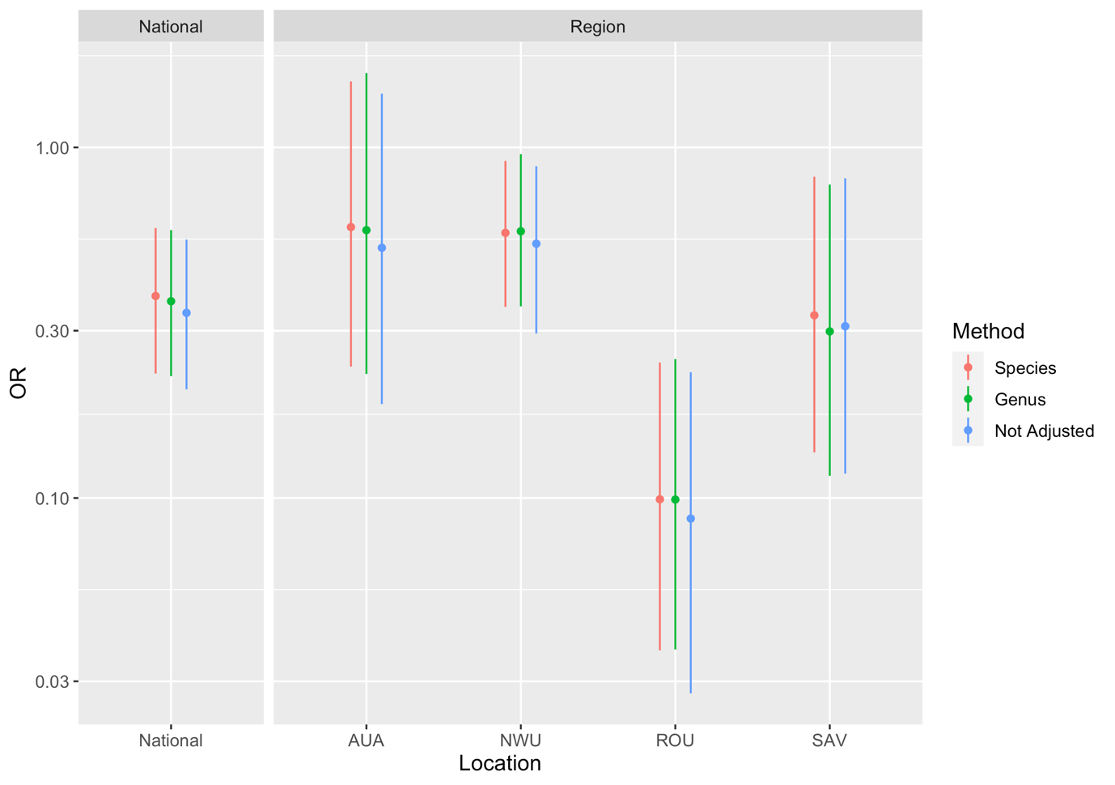
Supplementary Figure S1: Change in prevalence between 2018 and 2019, expressed as an odds ratio (OR), for mosquito infection prevalence with different methods of adjusting for mosquito categories: Species (2018 categorisation), Genus (i.e. Aedes vs Culex) or no adjustment. Given the low prevalence across measures, the ORs are approximately equal to prevalence ratios. Compare Figure 8 in main text. ORs <1 indicate decrease in infection prevalence in 2019 compared to 2018, ORs >1 indicate an increase, and OR of 1 indicate no change.

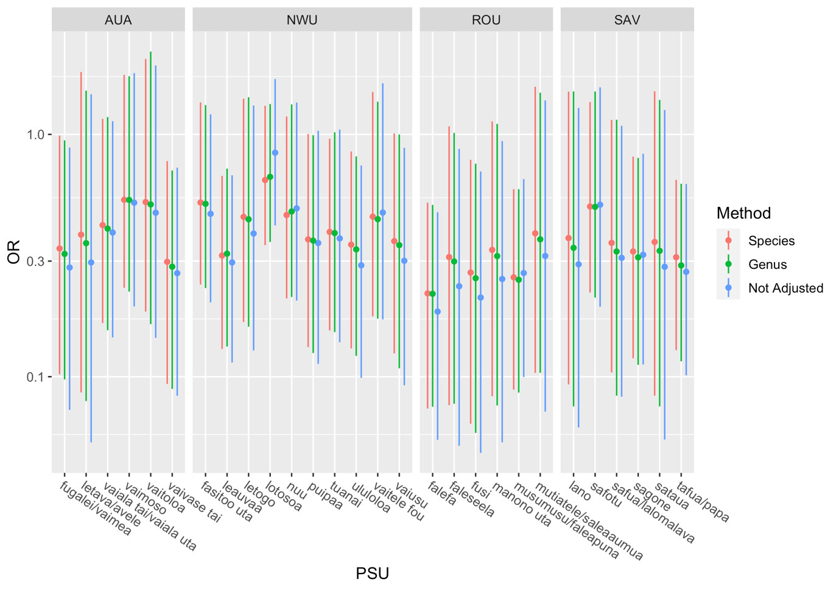

Supplementary Figure S2: Change in prevalence between 2018 and 2019, expressed as an odds ratio (OR), for mosquito infection prevalence with different methods of adjusting for mosquito categories: Species (2018 categorisation), Genus (Aedes vs Culex) or no adjustment. Given the low prevalence across measures, the ORs are approximately equal to prevalence ratios. ORs <1 indicate decrease in infection prevalence in 2019 compared to 2018, ORs >1 indicate an increase, and OR of 1 indicate no change.

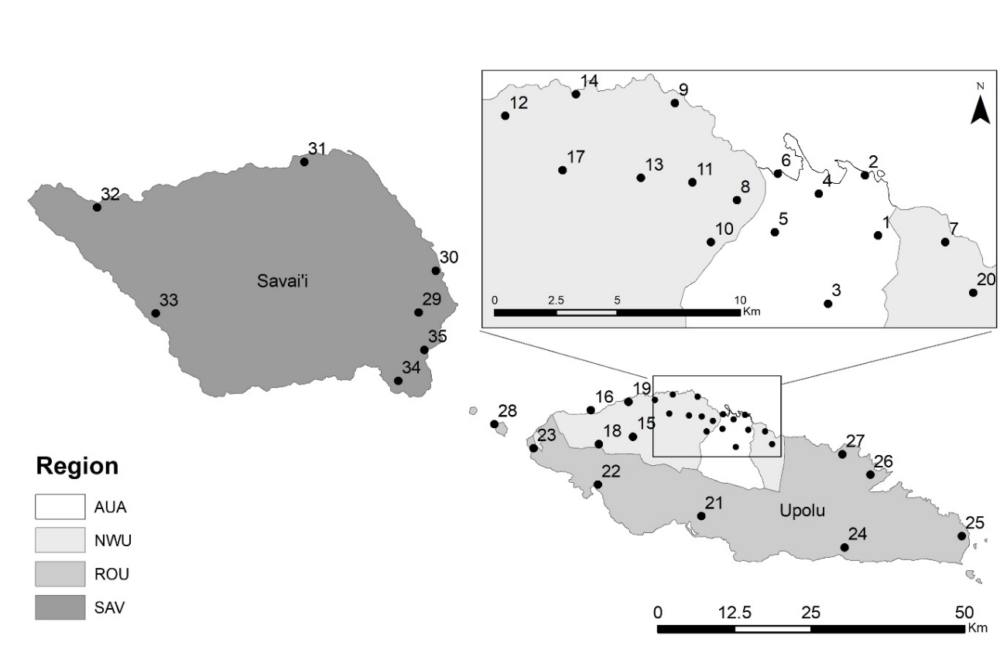
Region | PSU | Village(s) | Region | PSU | Village(s)
AUA | 1 | Vaivase Tai | ROU | 21 | Fusi
AUA | 2 | Vaiala Tai + Vaiala Uta | ROU | 22 | Faleseela
AUA | 3 | Avele + Letava | ROU | 23 | Manono Uta
AUA | 4 | Vaimea + Fugalei | ROU | 24 | Salani + Utulaelae
AUA | 5 | Vaimoso | ROU | 25 | Mutiatele + Saleaaumua
AUA | 6 | Vaitoloa | ROU | 26 | Falefa
NWU | 7 | Letogo | ROU | 27 | Musumusu + Faleapuna
NWU | 8 | Vaiusu | ROU | 28 | Salua ⴕ
NWU | 9 | Puipaa | SAV | 29 | Lalomalava + Safua
NWU | 10 | Ululoloa | SAV | 30 | Lano
NWU | 11 | Vaitele Fou | SAV | 31 | Safotu
NWU | 12 | Lotosoa | SAV | 32 | Sataua
NWU | 13 | Nuu | SAV | 33 | Sagone
NWU | 14 | Tuanai | SAV | 34 | Papa + Tafua
NWU | 15 | Fasitoo Uta | SAV | 35 | Salelologa ⴕ
NWU | 16 | Vailuutai
NWU | 17 | Leauvaa
NWU | 18 | Fasitoo Tai ⴕ
NWU | 19 | Faleasiu ⴕ
NWU | 20 | Laulii ⴕ
ⴕ denotes purposively selected PSU
Supplementary Figure S3: Regions and approximate locations of the selected PSUs, Samoa

Jun | Jul | Aug | Sep | Oct | Nov | Dec | Jan | Feb | Mar | Apr | May | Jun
2018 |  |  |  |  |  |  | 2019

Supplementary Figure S4: Schedule of 2018 and 2019 surveys (human and mosquitoes) relative to the roll-out of the mass drug administration in Samoa

