Supplement
COVID-19 associated mortality and cardiovascular disease outcomes among U.S. women veterans

Shirling Tsai, M.D.^{1,2} ; Hang Nguyen, M.S.^{1,3}; Ramin Ebrahimi, M.D.^{4,5}; Monica R. Barbosa, M.D.^{1,6}; Bala Ramanan, M.B.B.S. ^{1,2}; Daniel F. Heitjan, Ph.D.^{3,7}; Jeffrey L. Hastings, M.D. ^{1,6}; J. Gregory Modrall, M.D. ^{1,2}; Haekyung Jeon-Slaughter, Ph.D.^{1,6}*

1. Veterans Affairs North Texas Health Care System, Dallas, Texas
2. Department of Surgery, University of Texas Southwestern Medical Center, Dallas Texas
3. Southern Methodist University, Dallas Texas
4. Veterans Affairs Greater Los Angeles Health Care System, Los Angeles, California
5. Department of Medicine, University of California at Los Angeles, Los Angeles, California
6. Department of Internal Medicine, University of Texas Southwestern Medical Center, Dallas, Texas
7. Department of Population and Data Sciences, University of Texas Southwestern Medical Center, Dallas, Texas

*Corresponding author:
Haekyung Jeon-Slaughter, Ph.D.
Statistician, VA North Texas Health Care System
Assistant Professor
Division of Cardiology, Department of Internal Medicine
University of Texas Southwestern Medical Center
4500 South Lancaster Road,
Dallas, Texas 75216
Email: Haekyung.jeon-slaughter@utsouthwestern.edu
Phone (214) 857-3509

eTable 1. ICD-9 and ICD-10 codes and definitions for variables
Variables | Code number | Key definitions
Hypertension | 401-405, 437, 642; O10, O16 | Hypertensive heart disease, hypertensive chronic kidney disease, hypertensive encephalopathy, hypertension of pregnancy/eclampsia
Stroke | 430, 431; I60, I61 | Hemorrhage
Stroke | 433; I66 | Occlusion and stenosis of cerebral arteries
Stroke | 434; I63 | Cerebral thrombosis; Cerebral infarction
COPD | 115 | Histoplasmosis
COPD | 490, 491, 492, 494; J40, J41, J43, J44, J47 | Chronic bronchitis; emphysema
COPD | V81.3 | Screening for chronic bronchitis and emphysema
CKD | 361, 364, 458, 792; R88, V45, V56, Z49 | Hemodialysis; renal dialysis status
CKD | 585, 753; N18, V18 | Kidney disease
Diabetes mellitus (DM) | 249, 250; E08 – E13, O24, O99 | Diabetes mellitus, Type ½ diabetes mellitus, abnormal glucose complication
Cerebrovascular disease | 346 | Migraine aura with cerebral infarction
Cerebrovascular disease | 430-432; I60 – I62 | Hemorrhage
Cerebrovascular disease | 433; I66, I68 | Occlusion and stenosis of cerebral arteries
Cerebrovascular disease | 434 | Cerebral thrombosis; Cerebral infarction
Cerebrovascular disease | 435; I67 | Cerebral ischemia
Cerebrovascular disease | 436 – 438 | Cerebrovascular disease
Cardiomyopathy | 425 | Hypertrophic, alcoholic, nutritional and metabolic cardiomyopathy; other primary/secondary cardiomyopathy
Cardiomyopathy | A36, A38, A39, B26, B33, B58, I40, I42 | Myocarditis; Meningococcal myocarditis, carditis; Viral myocarditis, carditis, cardiomyopathy
CAHD | 391 | Acute rheumatic endocarditis, myocarditis
CAHD | 411, 414; I24, V17.3, V81 | Acute/chronic ischemic heart diseases; coronary atherosclerosis
CAHD | 413, I20 | Angina pectoris
CAHD | 425 | Hypertrophic, alcoholic, nutritional and metabolic cardiomyopathy; other primary/secondary cardiomyopathy
CAHD | 440; I25 | Atherosclerosis of arteries
CAHD | Z95, Z98 | Aortocoronary bypass graft, coronary angioplasty
CVD | 410; I20-I24 | Myocardial infarction
CVD | 411, 414 | Acute/chronic ischemic heart diseases
CVD | 428; I50 | Heart failure, acute chronic systolic/diastolic heart failure or combined
CVD | 433, 435; I65 | Occlusion and stenosis of basilar/carotid/vertebral arteries; Transient cerebral ischemia
CVD | 434; I63 | Cerebral embolism/infarction/artery occlusion
CVD | 440; I25, I70 | Atherosclerosis of arteries
CVD | 441 | Dissecting aneurysm; abdominal/aortic/thoracic aneurysm
Abbreviations. BMI = Body Mass Index; CAHD = coronary artery heart disease; CVD = cardiovascular disease; DM = Diabetes; CKD = Chronic Kidney Disease; COPD = Chronic Obstructive Pulmonary Disease.

eFigure 1. Proportions of SARS-CoV-2 positive cases out of all women veterans tested by state.
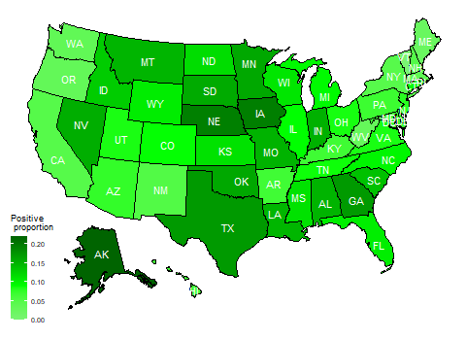

eFigure 2. Numbers of women veterans tested for SARS-CoV-2 and testing positive by month.
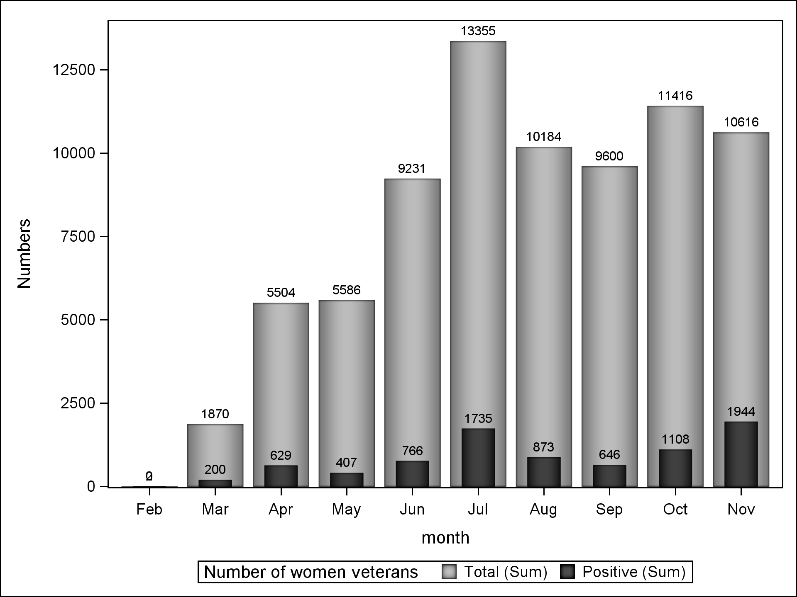

eFigure 3. Number of COVID-19-associated deaths in women veterans by state.
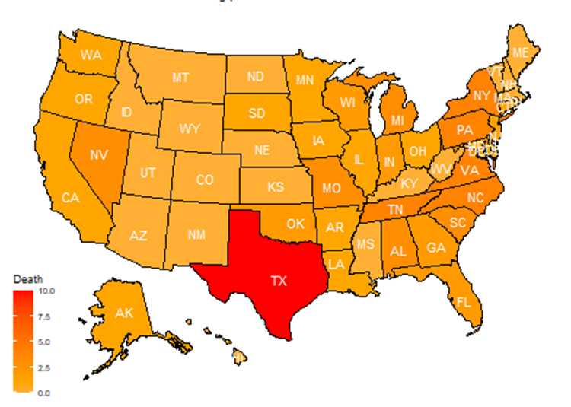

eFigure 4. Body mass Index non-linear spline component results of Generalized Additive Model (GAM) for 60-day mortality risk.
