Characterization of new multifunctional GH20 β-N-acetylglucosaminidase from Chitinibacter sp. GC72 and its application in converting chitin into N-acetyl glucosamine
Yan Chen^{a,#}, Ning Zhou^{a,#}, Xueman Chenª, Guoguang Weiª, Alei Zhang^{a,b,}*, Kequan Chenª , Pingkai Ouyangª

ªState Key Laboratory of Materials-Oriented Chemical Engineering, College of Biotechnology and Pharmaceutical Engineering, Nanjing Tech University, Nanjing 211816, China.
^{b}Jiangsu Key Laboratory of Marine Bioresources and Environment, Jiangsu Ocean University, Lianyungang, 222005, China.
*Corresponding author.
- mail address: zhangalei@njtech.edu.cn .
# These authors contributed equally to this work.

Table S1. Purification of recombinant NGAseA.
Purification method | Total activity  (U) | Total protein  (mg) | Specific activity (U/mg) | Purification (fold) | Recovery yield (%)
Crude enzyme | 16048.18 | 59.4 | 270.17 | 0 | 100
Ni–NTA resin | 12613.87 | 33.7 | 373.29 | 1.39 | 78.6

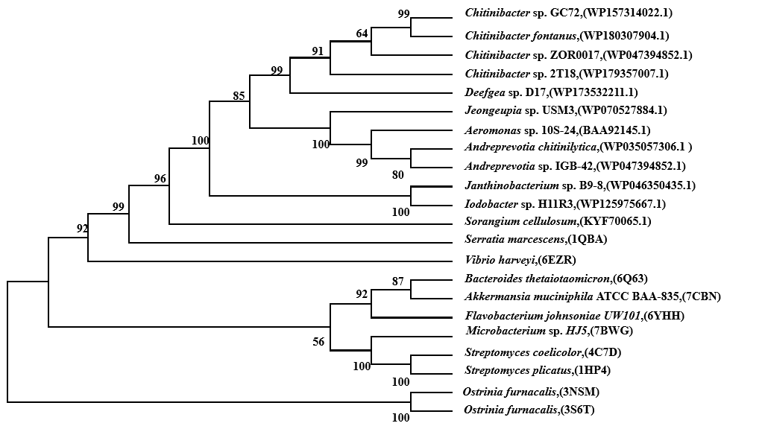
Figure S1. Phylogenetic relationships between NAGaseA and other bacterial GH20 NAGases. The phylogenetic tree was constructed by the neighbor-joining algorithm based on the amino acid sequence alignment in MEGA 7.0.

Figure S2. Partial amino acid sequences and structures alignments of NAGaseA with other GH20 NAGases. Similar sequences are marked by pentagrams and identical sequences are highlighted in red and yellow. Sequences are shown as follows: BAA92145: NAGase from Aeromonas sp. 10S-24 (accession no. BAA92145); CmNAGase: the GlcNAcase from Streptomyces coelicolor A3(2); NHZ74170: the NAGase from Microbacterium sp. HJ5; OIN60453: the NAGase from Vibrio harveyi; MBK22148: the NAGase from Serratia marcescens.

