⁶⁸Ga-FAPI improves tumor staging in patients with colorectal cancer: comparing to ¹⁸F-FDG PET/CT
Xinfeng Lin¹, Yingjie Li², Shuailiang Wang¹, Yan Zhang¹, Xuetao Chen¹, Maomao Wei¹, Hua Zhu¹, Aiwen Wu², Zhi Yang¹, Xuejuan Wang¹
Affiliations
1 Key Laboratory of Carcinogenesis and Translational Research (Ministry of Education/Beijing), NMPA Key Laboratory for Research and Evaluation of Radiopharmaceuticals (National Medical Products Administration), Department of Nuclear Medicine, Peking University Cancer Hospital & Institute, Beijing 100142, China
2 Department of Gastrointestinal Cancer Center, Unit III, Key Laboratory of Carcinogenesis and Translational Research (Ministry of Education/Beijing), Peking University Cancer Hospital & Institute, Beijing 100142, China

For correspondence or reprints contact:
Xuejuan Wang
Department of Nuclear Medicine, Peking University Cancer Hospital & Institute
52 Fucheng Road, Haidian, Beijing, China, 100142
Email: xuejuan_wang@hotmail.com
Telephone: +86 10 88196363; Fax: +86 10 88196196
ORCID-ID: 0000-0003-3648-5874

Zhi Yang
Department of Nuclear Medicine, Peking University Cancer Hospital & Institute
52 Fucheng Road, Haidian, Beijing, China, 100142
Email: pekyz@163.com
Telephone: +86 10 88196196; Fax: +86 10 88196196

Aiwen Wu
Department of Gastrointestinal Cancer Center, Unit III, Peking University Cancer Hospital & Institute
52 Fucheng Road, Haidian, Beijing, China, 100142
Email: wuaw@sina.com
Telephone: +86 10 88196086; Fax: +86 10 88196086

First author:
Xinfeng Lin
An attending Doctor at the Department of Nuclear Medicine, Peking University Cancer Hospital & Institute, Beijing, China
52 Fucheng Road, Haidian, Beijing, China, 100142
Email: lxfpku@163.com
Telephone: +86 10 88196732; Fax: +86 10 88196732
ORCID-ID: 0000-0002-1891-2505

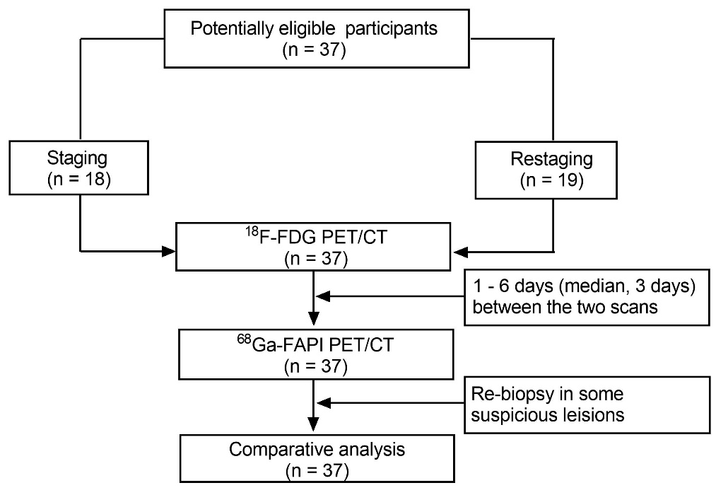

Supplemental Fig. 1 Flow diagram of patient selection
⁶⁸Ga-FAPI, gallium 68-fibroblast-activation protein inhibitor; ¹⁸F-FDG, fluorine-18 fluorodeoxyglucose; CT, computed tomography; PET, positron emission tomography

