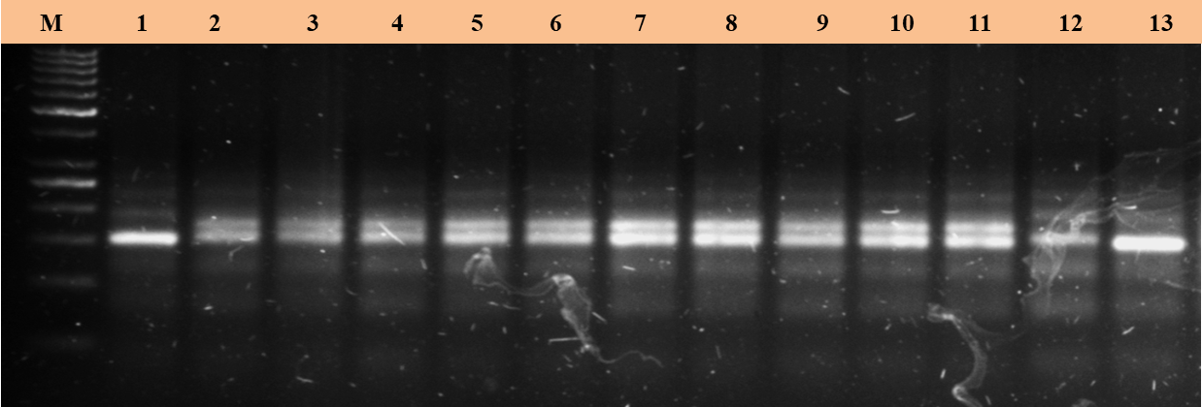
Supplementary Fig. 1: F₁ hybridity test for lpa2 allele using SSR marker, umc2230
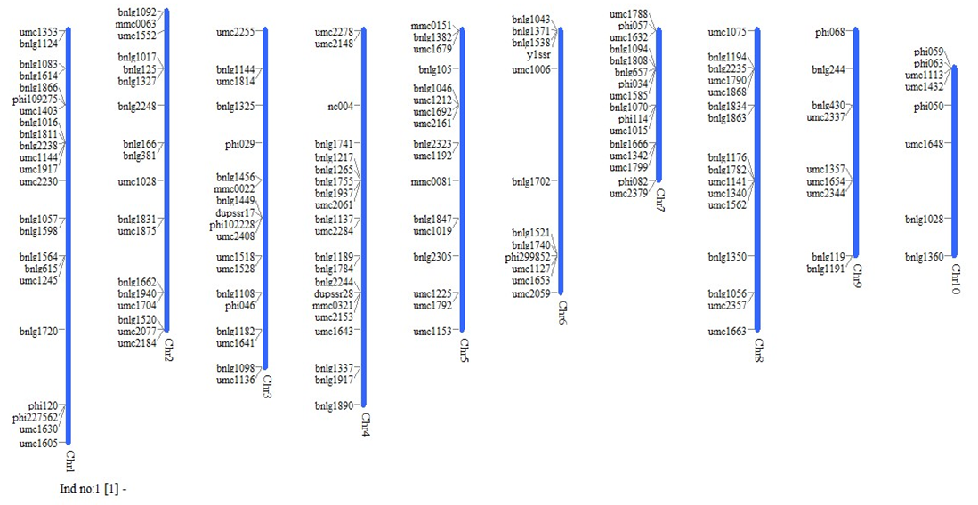
Lane 1- BML6, 2 to 7 - BML6×LPA2, 8 to 11 – BML45×LPA2, 12-LPA2, 13 - BML45.

Supplementary Fig. 2: Graphical representation of selected polymorphic markers used for background selection forlpa2 allele in each backcross generation

