Association of Fluid Management with Outcome in Invasively Ventilated COVID–19 ARDS Patients – insights from the PRoVENT–COVID study: a national, multicenter, observational cohort analysis
Additional File 1
Sanchit Ahuja^{1,2}, Harm-Jan de Grooth³, Frederique Paulus^{4,5}, Fleur L. van der Ven⁴, Ary Serpa Neto^{6,7,8}, Marcus J. Schultz^{4,9,10}, Pieter R. Tuinman³, for the PRoVENT-COVID Study Collaborative Group* ‘PRactice of VENTilation in COVID–19’
¹Department of Anesthesiology, Pain Management & Perioperative Medicine, Henry Ford Hospital, Detroit, Michigan, USA
²Outcomes Research Consortium, Cleveland Clinic, Cleveland, Ohio, USA
³Department of Intensive Care, Amsterdam UMC, location VU Medical Center, Amsterdam, The Netherlands
⁴Department of Intensive Care, Amsterdam UMC, location AMC, Amsterdam, The Netherlands
⁵ACHIEVE, Centre of Applied Research, Amsterdam University of Applied Sciences, Faculty of Health, Amsterdam, The Netherlands
⁶Department of Critical Care Medicine, Melbourne Medical School, University of Melbourne, Austin Hospital, Melbourne, Australia.
⁷Australian and New Zealand Intensive Care Research Centre (ANZIC-RC), School of Public Health and Preventive Medicine, Monash University, Melbourne, Australia.
⁸Department of Critical Care Medicine, Hospital Israelita Albert Einstein, São Paulo, Brazil.
⁹Mahidol Oxford Tropical Medicine Research Unit (MORU), Mahidol University, Bangkok, Thailand
¹⁰Nuffield Department of Medicine, University of Oxford, Oxford, UK
Correspondence:
Prof. Marcus J. Schultz, MD PhD
Department of Intensive Care, C3–415, Academic Medical Center, Meibergdreef 9
1105 AZ Amsterdam, The Netherlands
Email: m.j.schultz@amsterdamumc.nl
Table of Contents:
Supplementary Figure 1 a Histogram of model residuals showing zero-inflated count
distributions. b Predicted values vs. model residuals.
Supplementary Figure 2 Models with different spline complexities
Supplementary Figure 3 Box and violin plots of cumulative fluid balance over days 0-3
Supplementary Table 1 Potential predefined confounding variables
Supplementary Table 2 Senstivity analysis to missing data and imputation method
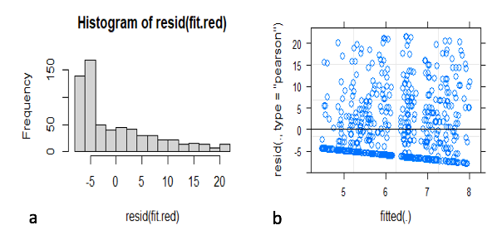
Supplementary Figure 1: After fitting the prespecified linear model regressing ventilator-free days on cumulative fluid balance at day 3, the residuals were found to be poorly distributed because of the relative overabundance of cases with 0 ventilator-free days (i.e., the distribution was severely zero-inflated). Based on these findings, this model was abandoned and all reported results were based on other methods. a Histogram of model residuals showing severe skewness as a consequence of zero-inflated count distributions. b Predicted values vs. model residuals.
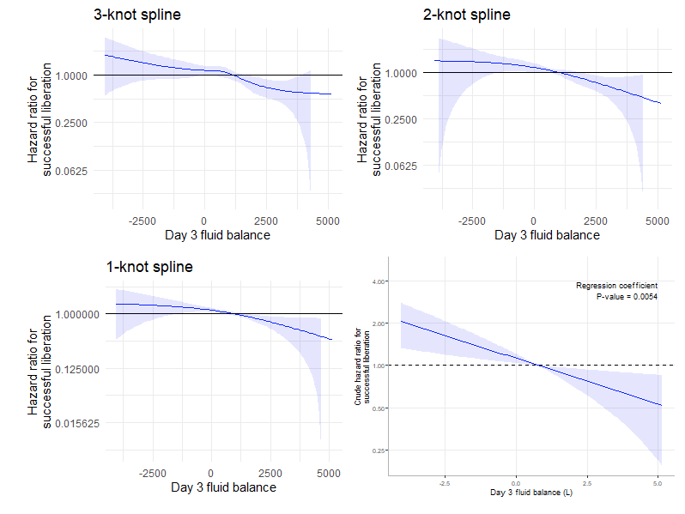
Supplementary Figure 2: Models regressing the hazard of successful liberation on day 3 fluid balance with different spline complexities. The Akaike Information Criterion (AIC) for the four models was 4381, 4379, 4377 and 4376, in descending order of model complexity. Therefore, the no-spline model (AIC 4376) was found to be most parsimonious and was used for the main analyses.

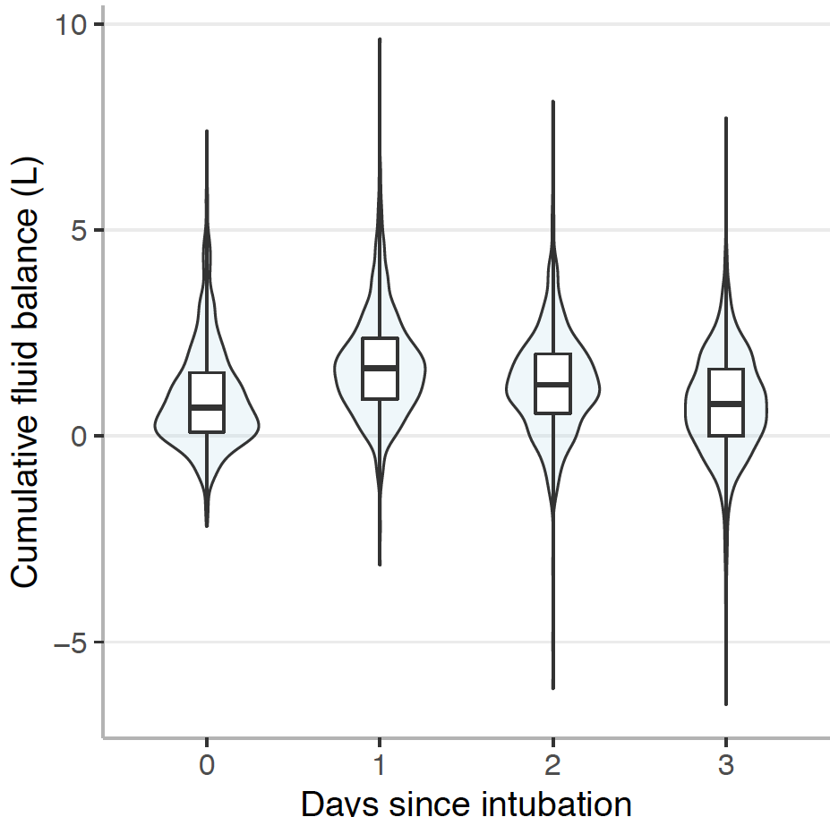
Supplementary Figure 3: Box and violin plots of cumulative fluid balance over days 0-3

Supplementary Table 1: Potential confounding variables
Confounding Variables | Hazards ratio, (95% CI) | P value
cFB at day 3, ml | 0.99, (0.99-1.00) | 0.005
Sex | 0.78, (0.60-1.04) | 0.096
Age | 0.95, (0.94-0.96) | 0.001
Body mass index (kg/m²) | 0.99, (0.97-1.01) | 0.643
Creatinine at day 0 | 0.99, (0.98-0.99) | 0.012
Norepinephrine dose, calculated log dose at day 0 | 1.02, (0.97-1.07) | 0.289
Tidal volume at day 0 (expired) | 1.00, (0.99-1.00) | 0.645
pH at day 0 | 7.01, (2.38-20.64) | 0.0004
Heart rate at day 0 | 0.99, (0.99-1.00) | 0.131
PEEP at day 0 | 0.97, (0.92-1.01) | 0.220
PaO₂/FiO₂ at day 0 | 0.99, (0.99-1.00) | 0.091
Dynamic compliance (Cdyn) at day 0 | 1.00, (0.99-1.00) | 0.776
Lactate at day 0 | 0.98, (0.8840-1.09) | 0.794
The hazards ratios were estimated using Cox proportional hazard model, adjusted for predefined confounding variables. Abbreviations. cFB cumulative fluid balance, PEEP positive endexpiratory pressure, PaO2/FiO2 PaO2 arterial partial pressure of oxygen/Fraction of inspired oxygen. Note that the hazard ratio for day 3 cFB is expressed here per milliliter.

Supplementary Table 2: Senstivity analysis to missing data and imputation method
 | Hazards ratio, (95% CI) | P value
cFB at day 3, ml | 0.99, (0.99, 1.00) | 0.02
Sex | 0.819, (0.60, 1.11) | 0.2
Age | 0.956, (0.94, 0.96) | <0.001
Creatinine at day 0 | 0.994, (0.989, 0.987) | 1
pH at day 0 | 18.1444, (3.58, 91.74) | 0.0004
PaO₂/FiO₂ | 0.9987, (0.99, 1.00) | 0.15

The hazards ratios were estimated using Cox proportional hazard model, adjusted for missing data and imputation method. Abbreviations. cFB cumulative fluid balance, PaO2/FiO2 PaO2 arterial partial pressure of oxygen/Fraction of inspired oxygen. Note that the hazard ratio for day 3 cFB is expressed here per milliliter.

Acknowledgements: *PRoVENT-COVID Collaborative Group. Investigators: (in alphabetic order): S. Ahuja¹; J.P. van Akkeren²; A.G. Algera³; C.K. Algoe³; R.B. van Amstel³; A. Artigas⁴; O.L. Baur³; P. van de Berg⁵; A.E. van den Berg⁶; D.C.J.J. Bergmans⁷; D.I. van den Bersselaar³; F.A. Bertens³; A.J.G.H. Bindels⁵; M.M. de Boer³; S. den Boer⁸; L.S. Boers³; M. Bogerd³; L.D.J. Bos³; M. Botta³; J.S. Breel⁹; H. de Bruin³; S. de Bruin³; C.L. Bruna³; L.A. Buiteman–Kruizinga¹⁰; O. L. Cremer¹¹; R.M. Determann¹²; W. Dieperink¹³; D.A. Dongelmans³; H.S. Franke¹³; M.S. Galek-Aldridge³; M.J. de Graaff¹⁴; L.A. Hagens³; J.J. Haringman¹⁶; S.T. van der Heide³; P.L.J. van der Heiden¹⁰; N.F.L. Heijnen¹⁵; S.J.P. Hiel²; L.L. Hoeijmakers³; L. Hol^{3,9}; M.W. Hollmann⁹; M.E. Hoogendoorn¹⁶; J. Horn³; R. van der Horst¹⁷; E.L.K. Ie³; D. Ivanov³; N.P. Juffermans¹²; E. Kho³; E.S. de Klerk⁹; A.W.M.M. Koopman-van Gemert¹⁸; M. Koopmans¹²; S. Kucukcelebi³; M.A. Kuiper¹⁹; D.W. de Lange¹¹; N. van Mourik³; S.G. Nijbroek^{3,9}; M. Onrust¹³; E.A.N. Oostdijk²⁰; F. Paulus^{3,21}; C.J. Pennartz³; J. Pillay^{3,13}; L. Pisani³; I.M. Purmer⁶; T.C.D. Rettig²²; J.P. Roozeman³; M.T.U. Schuijt³; M.J. Schultz^{3,23,24}; A. Serpa Neto²⁵; M.E. Sleeswijk²⁶; M.R. Smit³; P.E. Spronk²⁷; W. Stilma³; A.C. Strang²⁸; A.M. Tsonas³; P.R. Tuinman²⁹; C.M.A. Valk³; F.L. Veen-Schra¹⁶; L.I. Veldhuis³; P. van Velzen³⁰; W.H. van der Ven⁹; A.P.J. Vlaar³; P. van Vliet³¹; P.H.J. van der Voort¹³; L. van Welie³²; H.J.F.T. Wesselink¹⁶; H.H. van der Wier-Lubbers¹⁶; B. van Wijk³; T. Winters³; W.Y. Wong³; A.R.H. van Zanten³².
Institutional and Departmental Affiliations: ¹Department of Anesthesiology, Pain Management & Perioperative Medicine, Henry Ford Health System, Detroit, Michigan, United States; ²Department of Intensive Care, Maxima Medical Center, Eindhoven, The Netherlands; ³Department of Intensive Care, Amsterdam University Medical Centers, location ‘Academic Medical Center’, Amsterdam, The Netherlands; ⁴Critical Care Center, Sabadell Hospital, Sabadell, Spain; ⁵Department of Intensive Care, Catharina Hospital, Eindhoven, The Netherlands; ⁶Department of Intensive Care, Haga Hospital, the Hague, The Netherlands; ⁷Department of Intensive Care, Maastricht University Medical Center, Maastricht, The Netherlands; ⁸Department of Intensive Care, Spaarne Hospital, Haarlem, The Netherlands; ⁹Department of Anaesthesiology, Amsterdam University Medical Centers, location ‘Academic Medical Center’, Amsterdam, The Netherlands; ¹⁰Department of Intensive Care, Reinier de Graaf Hospital, Delft, The Netherlands; ¹¹Department of Intensive Care, University Medical Center Utrecht, Utrecht, The Netherlands; ¹²Department of Intensive Care, OLVG Hospital, location East, Amsterdam, The Netherlands; ¹³Department of Intensive Care, University Medical Center Groningen, Groningen, The Netherlands; ¹⁴Department of Intensive Care, Sint Antonius Hospital, Nieuwegein, The Netherlands; ¹⁵Department of Intensive Care, Maastricht University Medical Center, Maastricht, The Netherlands; ¹⁶ Department of Intensive Care, Isala Hospital, Zwolle, The Netherlands; ¹⁷Department of Intensive Care; Zuyderland Hospital, Heerlen and Sittard, The Netherlands; ¹⁸Department of Intensive Care ZGT Hospital, Almelo, The Netherlands; ¹⁹Department of Intensive Care Medical Center Leeuwarden, Leeuwarden, The Netherlands; ²⁰Department of Intensive Care; Maasstad Hospital, Rotterdam, The Netherlands; ²¹ACHIEVE, Center of Applied Research Amsterdam University of Applied Sciences, Faculty of Health, Amsterdam, The Netherlands; ²²Department of Intensive Care Amphia Hospital, Breda, The Netherlands; ²³Mahidol–Oxford Tropical Medicine Research Unit (MORU), Mahidol University, Bangkok, Thailand; ²⁴Nuffield Department of Medicine, University of Oxford, Oxford, United Kingdom; ²⁵Department of Critical Care Medicine, Australian and New Zealand Intensive Care Research Center (ANZIC-RC), Monash University, Melbourne, Australia; ²⁶Department of Intensive Care, FlevoHospital, Almere, The Netherlands; ²⁷Department of Intensive Care, Gelre Hospital, Apeldoorn and Zutphen, The Netherlands:; ²⁸Department of Intensive Care, Rijnstate Hospital, Arnhem, The Netherlands; ²⁹Department of Intensive Care, Amsterdam University Medical Centers, location ‘VU Medical Center’, Amsterdam, The Netherlands; ³⁰Department of Intensive Care, Dijklander Hospital, location Hoorn, Hoorn, The Netherlands; ³¹Department of Intensive Care Haaglanden Medical Center, location Westeinde, the Hague, The Netherlands; ³²Department of Intensive Care Gelderse Vallei Hospital, Ede, The Netherlands.

