O-link proteins analysed
Adenosine Deaminase (ADA) | Allergin-1 (MILR1)
Artemin (ARTN) | Amphiregulin (AREG)
Axin-1 (AXIN1) | Aryl hydrocarbon receptor nuclear translocator (ARNT)
Beta-nerve growth factor (Beta-NGF) | Baculoviral IAP repeat-containing protein 2 (BIRC2)
C-C motif chemokine 19 (CCL19) | Beta-galactosidase (GLB1)
C-C motif chemokine 20 (CCL20) | Butyrophilin subfamily 3 member A2 (BTN3A2)
C-C motif chemokine 23 (CCL23) | C-type lectin domain family 4 member A (CLEC4A)
C-C motif chemokine 25 (CCL25) | C-type lectin domain family 4 member C (CLEC4C)
C-C motif chemokine 28 (CCL28) | C-type lectin domain family 4 member D (CLEC4D)
C-C motif chemokine 3 (CCL3) | C-type lectin domain family 4 member G (CLEC4G)
C-C motif chemokine 4 (CCL4 ) | C-type lectin domain family 6 member A (CLEC6A)
C-X-C motif chemokine 1 (CXCL1) | C-type lectin domain family 7 member A (CLEC7A)
C-X-C motif chemokine 10 (CXCL10 ) | CD83 antigen (CD83)
C-X-C motif chemokine 11 (CXCL11) | Contactin-associated protein-like 2 (CNTNAP2)
C-X-C motif chemokine 5 (CXCL5 ) | Corneodesmosin (CDSN)
C-X-C motif chemokine 6 (CXCL6) | Corticosteroid 11-beta-dehydrogenase isozyme 1 (HSD11B1)
C-X-C motif chemokine 9 (CXCL9 ) | Coxsackievirus and adenovirus receptor (CXADR)
Caspase-8 (CASP-8 ) | Cytoskeleton-associated protein 4 (CKAP4)
CD40L receptor (CD40) | Diacylglycerol kinase zeta (DGKZ)
CUB domain-containing protein 1 (CDCP1) | Discoidin, CUB and LCCL domain-containing protein 2 (DCBLD2)
Cystatin D (CST5) | DNA fragmentation factor subunit alpha (DFFA)
Delta and Notch-like epidermal growth factor-related receptor (DNER) | Dual adapter for phosphotyrosine and 3-phosphotyrosine and 3-phosphoinositide (DAPP1)
Eotaxin (CCL11) | Dynactin subunit 1 (DCTN1)
Eukaryotic translation initiation factor 4E-binding protein 1 (4E-BP1) | E3 ubiquitin-protein ligase TRIM21 (TRIM21)
Fibroblast growth factor 19 (FGF-19) | Egl nine homolog 1 (EGLN1)
Fibroblast growth factor 21 (FGF21) | Eotaxin (CCL11)
Fibroblast growth factor 23 (FGF-23) | Eukaryotic translation initiation factor 4 gamma 1 (EIF4G1)
Fibroblast growth factor 5 (FGF-5) | Eukaryotic translation initiation factor 5A-1 (EIF5A)
Fms-related tyrosine kinase 3 ligand (Flt3L) | Fc receptor-like protein 3 (FCRL3)
Fractalkine (CX3CL1 ) | Fc receptor-like protein 6 (FCRL6)
Glial cell line-derived neurotrophic factor (GDNF) | Fibroblast growth factor 2 (FGF2)
Hepatocyte growth factor (HGF) | FXYD domain-containing ion transport regulator 5 (FXYD5)
Interferon gamma (IFN-gamma) | Hematopoietic lineage cell-specific protein (HCLS1)
Interleukin-1 alpha (IL-1 alpha) | Histamine N-methyltransferase (HNMT)
Interleukin-10 (IL10) | Importin subunit alpha-5 (KPNA1)
Interleukin-10 receptor subunit alpha (IL-10RA) | Inactive dipeptidyl peptidase 10 (DPP10)
Interleukin-10 receptor subunit beta (IL-10RB) | Integral membrane protein 2A (ITM2A)
Interleukin-12 subunit beta (IL-12B) | Integrin alpha-11 (ITGA11)
Interleukin-13 (IL-13) | Integrin alpha-6 (ITGA6)
Interleukin-15 receptor subunit alpha (IL-15RA) | Integrin beta-6 (ITGB6)
Interleukin-17A (IL-17A) | Interferon lambda receptor 1 (IFNLR1)
Interleukin-17C (IL-17C) | Interferon regulatory factor 9 (IRF9)
Interleukin-18 (IL-18) | Interleukin-1 receptor-associated kinase 1 (IRAK1)
Interleukin-18 receptor 1 (IL-18R1) | Interleukin-1 receptor-associated kinase 4 (IRAK4)
Interleukin-2 (IL-2) | Interleukin-10 (IL10)
Interleukin-2 receptor subunit beta (IL-2RB) | Interleukin-12 receptor subunit beta-1 (IL12RB1)
Interleukin-20 (IL-20) | Interleukin-5 (IL5)
Interleukin-20 receptor subunit alpha (IL-20RA) | Interleukin-6 (IL6)
Interleukin-22 receptor subunit alpha-1 (IL-22 RA1) | Islet cell autoantigen 1 (ICA1)
Interleukin-24 (IL-24) | Keratin, type I cytoskeletal 19 (KRT19)
Interleukin-33 (IL-33) | Leukocyte immunoglobulin-like receptor subfamily B member 4 (LILRB4)
Interleukin-4 (IL-4) | Lymphocyte activation gene 3 protein (LAG3)
Interleukin-5 (IL5) | Lymphocyte antigen 75 (LY75)
Interleukin-6 (IL6) | Lysosome-associated membrane glycoprotein 3 (LAMP3)
Interleukin-7 (IL-7) | Mannan-binding lectin serine protease 1 (MASP1)
Interleukin-8 (IL-8) | Merlin (NF2)
Latency-associated peptide transforming growth factor beta-1 (LAP TGF-beta-1) | Methylated-DNA--protein-cysteine methyltransferase (MGMT)
Leukemia inhibitory factor (LIF) | Natural cytotoxicity triggering receptor 1 (NCR1)
Leukemia inhibitory factor receptor (LIF-R) | Natural killer cells antigen CD94 (KLRD1)
Macrophage colony-stimulating factor 1 (CSF-1) | Neurabin-2 (PPP1R9B)
Matrix metalloproteinase-1 (MMP-1) | Neurotrophin-4 (NTF4)
Matrix metalloproteinase-10 (MMP-10) | Nuclear factor of activated T-cells, cytoplasmic 3 (NFATC3)
Monocyte chemotactic protein 1 (MCP-1) | Parathyroid hormone/parathyroid hormone-related peptide receptor (PTH1R)
Monocyte chemotactic protein 2 (MCP-2) | PC4 and SFRS1-interacting protein (PSIP1)
Monocyte chemotactic protein 3 (MCP-3) | Peroxiredoxin-1 (PRDX1)
Monocyte chemotactic protein 4 (MCP-4) | Peroxiredoxin-5, mitochondrial (PRDX5)
Natural killer cell receptor 2B4 (CD244) | Phosphoinositide 3-kinase adapter protein 1 (PIK3AP1)
Neurotrophin-3 (NT-3) | Plexin-A4 (PLXNA4)
Neurturin (NRTN) | Polypeptide N-acetylgalactosaminyltransferase 3 (GALNT3)
Oncostatin-M (OSM) | Probable ATP-dependent RNA helicase DDX58 (DDX58)
Osteoprotegerin (OPG) | Protein FAM3B (FAM3B)
Programmed cell death 1 ligand 1 (PD-L1) | Protein HEXIM1 (HEXIM1)
Protein S100-A12 (EN-RAGE ) | Protein kinase C theta type (PRKCQ)
Signaling lymphocytic activation molecule (SLAMF1) | Protein sprouty homolog 2 (SPRY2)
SIR2-like protein 2 (SIRT2) | Protein-arginine deiminase type-2 (PADI2)
STAM-binding protein (STAMBP) | SH2 domain-containing protein 1A (SH2D1A)
Stem cell factor (SCF) | SH2B adapter protein 3 (SH2B3)
Sulfotransferase 1A1 (ST1A1) | Signaling threshold-regulating transmembrane adapter 1 (SIT1)
T cell surface glycoprotein CD6 isoform (CD6) | SRSF protein kinase 2 (SRPK2)
T-cell surface glycoprotein CD5 (CD5) | Stanniocalcin-1 (STC1)
T-cell surface glycoprotein CD8 alpha chain (CD8A) | Stromal cell-derived factor 1 (CXCL12)
Thymic stromal lymphopoietin (TSLP) | T-cell-specific surface glycoprotein CD28 (CD28)
TNF-beta (TNFB) | Thioredoxin-dependent peroxide reductase, mitochondrial (PRDX3)
TNF-related activation-induced cytokine (TRANCE) | TNF receptor-associated factor 2 (TRAF2)
TNF-related apoptosis-inducing ligand (TRAIL) | TRAF family member-associated NF-kappa-B activator (TANK)
Transforming growth factor alpha (TGF-alpha) | Transcription factor AP-1 (JUN)
Tumor necrosis factor (Ligand) superfamily, member 12 (TWEAK) | Transcription regulator protein BACH1 (BACH1)
Tumor necrosis factor (TNF) | Triggering receptor expressed on myeloid cells 1 (TREM1)
Tumor necrosis factor ligand superfamily member 14 (TNFSF14 ) | Tripartite motif-containing protein 5 (TRIM5)
Tumor necrosis factor receptor superfamily member 9 (TNFRSF9) | Tryptase alpha/beta-1 (TPSAB1)
Urokinase-type plasminogen activator (uPA) | Tumor necrosis factor receptor superfamily member EDAR (EDAR)
Vascular endothelial growth factor A (VEGF-A) | Zinc finger and BTB domain-containing protein 16 (ZBTB16)
Supplementary Table 1: Proteins analysed as part of Olink proteomic immune response and inflammation panels.

 | Severe COVID19 disease |  |  | Univariate P value
 | All  (n=46) | Interstitial change on CT (n=26) | Resolution on CT (n=20) | Univariate P value
Age (mean ±SD) | 56 ±12 | 60 ±10 | 52 ±13 | 0.01
Female (n (%)) | 14 (30.4) | 8 (30.8) | 6 (30.0) | 0.96
Ethnicity (n (%)) |  |  |  | 0.50
- Asian | 18 (39.1) | 11 (42.3) | 7 (35.0)
- Caucasian | 25 (54.3) | 13 (50.0) | 12 (60.0)
- Black | 1 (2.2) | 0 (0.0) | 1 (5.0)
- Other | 2 (4.3) | 2 (7.7) | 0 (0.0)
BMI (mean ±SD) | 30.1 ±6.7 | 28.5 ±4.9 | 32.0 ±8.2 | 0.08
Co-morbidities (n %)
- Diabetes | 16 (34.8) | 12 (46.2) | 4 (20.0) | 0.06
- Hypertension | 16 (34.8) | 13 (50.0) | 3 (15.0) | 0.01
- Dyslipidaemia | 6 (13.0) | 5 (19.2) | 1 (5.0) | 0.16
- Obesity | 18 (39.1) | 10 (38.5) | 8 (40.0) | 0.53
- Ischaemic heart disease | 4 (8.7) | 3 (11.5) | 1 (5.0) | 0.44
- Ex-smoker | 8 (17.4) | 5 (19.2) | 3 (15.0) | 0.71
- Asthma | 7 (15.2) | 6 (23.1) | 1 (5.0) | 0.09
- Haematological malignancy | 1 (2.2) | 1 (3.8) | 0 (0.0) | n/a
Length of hospital stay (days)(median (IQR)) | 32.0 (37.5) | 44.5 (36.5) | 12 (10.5) | <0.0001
ICU admission (n (%)) | 34 (73.9) | 24 (92.3) | 10 (50.0) | 0.001
Invasive ventilation requirement (n (%)) | 27 (58.7) | 20 (76.9) | 7 (35.0) | 0.004
- Invasive ventilation duration (days)^{κ} (median (IQR)) | 30.0 (16.0) | 30 (15.8) | 13 (19.5) | 0.0004
V-V Extra-corporeal membrane oxygenation requirement (n (%)) | 6 (13.0) | 4 (15.4) | 2 (10.0) | 0.59
Non-invasive ventilation requirement (n (%)) | 23 (50.0) | 13 (50.0) | 10 (50.0) | 0.31
Pulmonary embolism (n (%)) | 14 (30.4) | 12 (46.2) | 2 (10.0) | 0.008
Myocarditis (n (%)) | 3 (6.5) | 1 (3.8) | 2 (10.0) | 0.40
Medications administered
- Dexamethasone | 11 (23.9) | 2 (7.7) | 9 (45.0)
- Methylprednisolone | 9 (19.6) | 9 (34.6) | 0 (0.0)
- Remdesivir | 9 (19.6) | 1 (3.8) | 8 (40.0)
- Toculizumab | 1 (2.2) | 0 (0.0) | 1 (5.0)
- Therapeutic anticoagulation | 25 (54.3) | 20 (76.9) | 5 (25.0)
- Pulmonary vasodilator therapy | 5 (10.9) | 4 (15.4) | 1 (5.0)
- Hydroxychloroquine | 1 (2.2) | 0 (0.0) | 1 (5.0)
Duration of sampling from discharge date (days) (median (IQR)) | 125 (90) | 144 (78) | 90 (87) | 0.20
Duration of sampling from COVID19 infection (days) (median (IQR)) | 180.5 (100.8) | 202.0 (41.0) | 108 (81) | 0.0004
Lung function at time of sampling
- Forced vital capacity (FVC) (% predicted) (mean ±sd) | 88.2 ±16.6 | 80.4 ±14.2 | 98.4 ±13.8 | <0.0001
- Forced expiratory time in 1 second (FEV1) (L) (mean ±sd) | 90.0 ±14.5 | 84.1 ±13.5 | 97.4 ±12.3 | 0.001
- FEV1 / FVC ratio (%)(mean ±sd) | 83.8 ±6.5 | 85.3 ±7.6 | 81.8±4.2 | 0.08
- TLCO (mean ±sd) (n=33) | 59.7 ±15.9 | 54.4 ±15.0 | 71.4±11.5 | 0.003
- kCO (mean ±sd) (n=33) | 87.2 ±17.0 | 84.3 ±17.7 | 93.3 ±14.3 | 0.17
CT features at sampling
- Extent of abnormality % |  | 57.9 ±21.1 | 0.8 ±1.8 | <0.0001
- Of which GGO (%) |  | 66.7 ±22.7
- Of which bands (%) |  | 26.2 ±24.2
- Of which reticulation (%) |  | 5.9 ±8.3
- Of which consolidation (%) |  | 2.1 ±4.8
- Traction score |  | 2.5 ±2.4
St George Respiratory Questionnaire (n=43)
- Total Score (median (IQR)) | 22.3 (33.1) | 35.3 (41.7) | 13.8 (21.7) | 0.001
- Symptoms (median (IQR)) | 23.4 (34.9) | 33.4 (48.4) | 19.3 (20.4) | 0.03
- Activity (median (IQR)) | 41.5 (47.9) | 60.1 (47.6) | 23.3 (31.4) | 0.001
- Impacts (median (IQR)) | 11.5 (31.7) | 14.8 (34.8) | 3.0 (15.3) | 0.004
Supplementary Table 2: Demographic and clinical variables in subgroups with interstitial changes and resolution

Nanostring nCounter Gene panel list
ACE2 | CXCR2 | ITGA5 | OASL
AGER | CXCR4 | ITGA9 | OXER1
ALOX12 | CYSLTR1 | ITGB1 | PDGFA
ALOX15 | CYSLTR2 | ITGB2 | PIK3C2G
ALOX5 | DAXX | ITGB3 | PLA2G4A
AREG | DCBLD2 | JUN | PLCB1
AREG | DDIT3 | KEAP1 | PPP1R12B
ARG1 | DEFA1 | KNG1 | PRDX1
ATF2 | ELK1 | KRT19 | PRDX5
BCL2L1 | ET-1 (EDN1) | LIMK1 | PRKCA
BCL6 | FAP | LTA | PRKCB
BIRC2 | FASLG | LTB | PTGDR2
C1QA | FGF19 | LTB4R | PTGER1
C1QB | FGF2 | LTB4R2 | PTGER2
C1R | FGF21 | LY96 | PTGER3
C1S | FLT1 | MAFF | PTGER4
C2 | FOS | MAFG | PTGFR
C3 | FXYD2 | MAFK | PTGIR
C3AR1 | GNAQ | MAP2K1 | PTGS1
C4A | GNAS | MAP2K4 | PTGS2
C5 | GNB1 | MAP2K6 | PTK2
C6 | GNGT1 | MAP3K1 | RAC1
C7 | GRB2 | MAP3K5 | RAF1
C8A | HDAC4 | MAP3K7 | RAPGEF2
C8B | HEXIM1 | MAP3K9 | RELA
C9 | HIF1A | MAPK1 | RELB
CCL11 | HLA-DRA | MAPK14 | RHOA
CCL13 | HLA-DRB1 | MAPK3 | RIPK1
CCL16 | HMGB1 | MAPK8 | RIPK2
CCL17 | HMGB2 | MAPKAPK2 | ROCK2
CCL19 | HMGN1 | MAPKAPK5 | RPS6KA5
CCL2 | HRAS | MASP1 | SERPINE1
CCL20 | HSH2D | MASP1 | SERPINF1
CCL21 | HSPB1 | MASP2 | SERPING1
CCL22 | HSPB2 | MAX | SERPINH1
CCL23 | IFI44 | MBL2 | SHC1
CCL24 | IFIT1 | MEF2A | SMAD2
CCL3 | IFIT2 | MEF2BNB-MEF2B | SMAD7
CCL4 | IFIT3 | MEF2C | STAT1
CCL5 | IFNA1 | MEF2D | STAT2
CCL7 | IFNB1 | MGMT | STAT3
CCL8 | IFNG | MKNK1 | TBXA2R
CCR1 | IL10 | MMP1 | TCF4
CCR2 | IL10RB | MMP10 | TGFB1
CCR3 | IL11 | MMP11 | TGFB2
CCR4 | IL12A | MMP12 | TGFB3
CCR7 | IL12B | MMP13 | TGFBR1
CD163 | IL13 | MMP14 | TGFBR1
CD4 | IL15 | MMP16 | TLR1
CD40 | IL17A | MMP2 | TLR2
CD40LG | IL18 | MMP3 | TLR3
CD55 | IL18RAP | MMP3 | TLR4
CD86 | IL1A | MMP7 | TLR5
CDC42 | IL1B | MMP8 | TLR6
CEBPB | IL1R1 | MMP9 | TLR7
CFB | IL1RAP | MMP9 | TLR8
CFD | IL1RN | MRC1 | TLR9
CFL1 | IL2 | MUC5A | TNF
COL1A1 | IL21 | MUC5B | TNFAIP3
COL1A2 | IL22 | MX1 | TNFSF14
COL3A1 | IL22RA2 | MX2 | TOLLIP
COL4A1 | IL23A | MYC | TRADD
COL4A2 | IL23R | MYD88 | TRAF2
COL5A1 | IL3 | MYL2 | TRAIL
COX-1 | IL4 | NFATC3 | TREM-1
CREB1 | IL5 | NFE2L2 | TREM2
CRP | IL6 | NFKB1 | TSLP
CSF1 | IL6R | NLRP3 | TWIST2
CSF2 | IL7 | NOD1 | TYROBP
CSF3 | IL8 | NOD2 | VEGFB
CXCL1 | IL9 | NOS1 | Internal reference genes
CXCL10 | ILK | NOS2 | CLTC
CXCL2 | IRF1 | NOTCH2 | GAPDH
CXCL3 | IRF3 | NOTCH3 | GUSB
CXCL5 | IRF5 | NOTCH4 | HPRT1
CXCL6 | IRF7 | NOX1 | PGK1
CXCL9 | ITGA1 | NR3C1 | TUBB
CXCR1 | ITGA4 | OAS2
Supplementary Table 3: Nanostring nCounter gene panel list

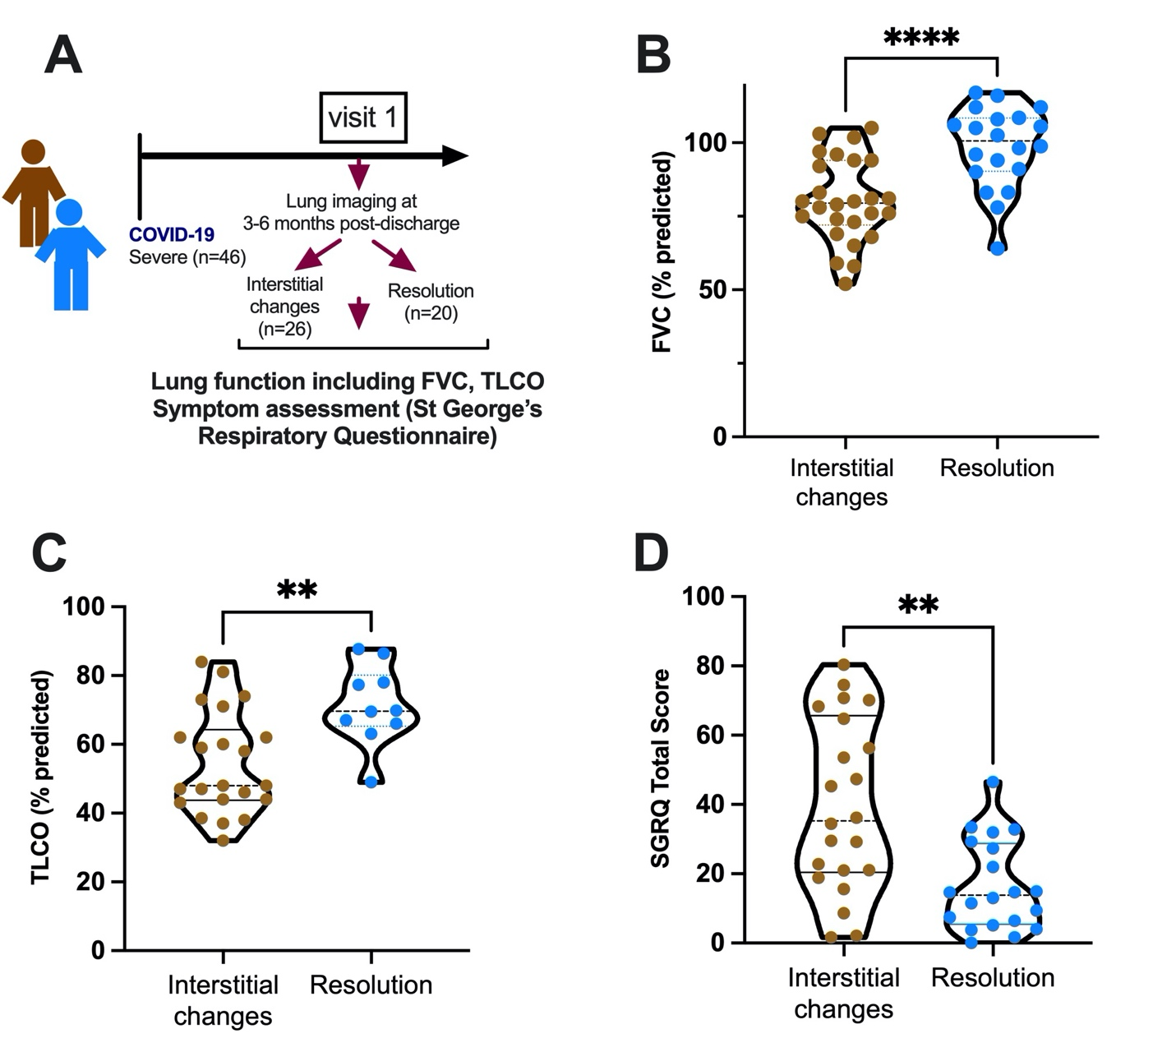
Extended Data Figure 1: Impaired lung function and increased symptom scores in individuals with Post-COVID19 interstitial lung changes. (A) Schematic of Study Design. Graphs indicate comparison of (B) FVC (Forced vital capacity), (C) TLCO (transfer factor for carbon monoxide) and (D) symptom scores as measured by St Georges Respiratory Questionnaire (SGRQ) in subjects with interstitial lung changes (n=26) versus full resolution of lung changes (n=20).Boxplots indicate median and inter-quartile range. Data Analysed by Mann-Whitney U test. **P<0.01, ****P<0.0001. In (C), data only shown for subjects where TLCO was measured.

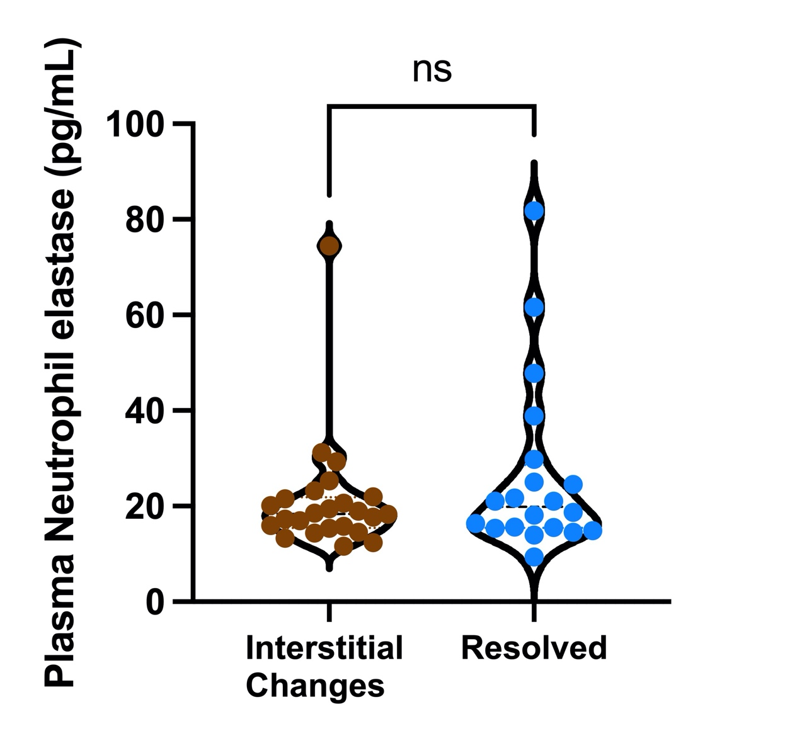
Extended Data Figure 2: No difference in plasma neutrophil concentrations between individuals with or without post-COVID19 interstitial changes. Boxplots indicate median and inter-quartile range and data analysed by Mann Whitney U test. ns=non-significant.

Extended Data Figure 3: No difference in plasma cell free DNA concentrations between individuals with or without post-COVID19 interstitial changes. Boxplots indicate median and inter-quartile range and data analysed by Mann Whitney U test. ns=non-significant

