Supplementary Materials

For
Accuracy and Social Incentives Shape Belief in (Mis)Information

Steve Rathje¹
Jay Van Bavel²
Sander van der Linden¹

¹Department of Psychology, University of Cambridge, Cambridge CB2 3RQ, United Kingdom
² Department of Psychology & Center for Neural Science, New York University, New York, NY 10003

S1: Extended Results

Study 1
Analysis of Type of Headlines Impacted. To explore what kind of headlines the incentives impacted specifically, we conducted a 2 (incentives vs. control condition) X 2 (true headlines vs. false headlines) X 2 (politically-congruent versus politically-incongruent) mixed-design ANOVA with the percentage of articles rated as accurate as the dependent variable. There was a main effect of condition, F(1, 460) = 12.71, p < 0.001, η²_{G} = 0.01, political congruence, F(1, 460) = 263.50, p < 0.001, η²_{G} = 0.11, and veracity of the headlines, F(1, 460) = 5.58, p < 0.001, η²_{G} = 0.27. There was also an interaction effect between the incentives and political congruence of the headlines, F(1, 460) = 8.00, p = 0.01, η²_{G} = 0.004, and between the incentives and the veracity of the headlines F(1, 460) = 7.77, p = 0.003, η²_{G} = 0.004.

Following up on these interaction effects with Tukey HSD post-hoc tests, we found that the incentives primarily increased belief in politically-incongruent true news (M = 51.53, 95% CI = [47.36, 55.70]) when compared to the control condition (M = 38.25, 95% CI = [34.41, 42.08]), p < 0.001, d = 0.43. However, incentives did not increase belief in politically-incongruent false news (p = 0.444), politically-congruent false news (p = 0.999), or politically-congruent true news (p = 0.472).
Study 2

Analysis of Type of Headlines Impacted. To test what types of headlines were affected by the incentives, we ran a 2 (accuracy incentive vs. no incentive) X 2 (social incentive vs. no incentive) X 2 (politically congruent vs. politically incongruent) X 2 (true headlines vs. false headlines) mixed-design ANOVA with the percent of articles rated as accurate as the dependent variable. There was a significant main effect of the accuracy incentives, F(1, 994) = 23.44, p < 0.001, η²_{G} = 0.01, veracity, F(1, 994) = 550.43, p < 0.001, η²_{G} = 0.20, and political congruence, F(1, 994) = 8.99, p = 0.003, η²_{G} = 0.002. Furthermore, there was a significant interaction between accuracy incentives and political congruence, F(1,994) = 8.99, p = 0.003, η²_{G} = 0.00, between accuracy incentives and veracity, F(1, 994) = 29.06, p < 0.001, η²_{G} = 0.01, and between social incentives and veracity, F(1, 994) = 7.613, p = 0.006, η²_{G} = 0.00. All other ps > 0.085.

Tukey HSD post-hoc tests found that there was a significant difference in the amount of incongruent true articles rated as accurate between the accuracy incentives condition (M = 55.61%, 95% CI = [51.68, 59.54]) and the control condition (M = 37.65%, 95% CI = [33.83, 41.46]), p < 0.001, d = 0.58. However, the mixed incentives condition (M = 46.07%, 95% CI = [42.04, 51.10]) did not differ from the control condition (M = ), p = 0.092, once again supporting the idea that social incentives distract from accuracy incentives. The incentives once again did not impact congruent true news, incongruent false news, or congruent false news (ps > 0.148).
Analysis of Sharing Behavior. To test how incentives influenced sharing intentions, we ran another 2X2X2X2 mixed ANOVA on sharing intentions. Here, there was no effect of accuracy incentives, F(1, 994) = 0.05, p = 0.830, η² = 0.00, but there was a significant main effect of social incentives, F(1, 994) = 10.07, p = 0.002, η² = 0.00, political congruence, F(1, 994) = 368.96, p < 0.001, η² = 0.05, and veracity, F(1, 994) = 173.71, p < 0.001, η² = 0.01. Furthermore, there was a significant interaction between social incentives and political congruence, F(1, 994) = 20.41, p < 0.001, η² = 0.00.
Following up on the interaction between the social incentives and political congruence, we found that those in the social incentives condition shared more politically congruent news (either true or false) (M = 1.98, 95% CI = [1.90, 2.05]) as compared to the control condition (M = 1.80, 95% CI = [1.74, 1.87]), p = 0.015, d = 0.21. Additionally, those in the mixed condition (M = 2.02, 95% CI = [1.94, 2.10]) shared more politically congruent news (true or false) as compared to the control condition, p < 0.001, d = 0.26. Thus, thinking about whether an article will be liked by one’s party, whether or not one is incentivized to be accurate, appears to indiscriminately increase sharing of both true and false news that appeal to one’s political party.

Study 3
Analysis of Type of Headlines Impacted. We ran a 2 (accuracy incentive vs. no incentive) X 2 (social incentive vs. no incentive) X 2 (politically congruent vs. politically incongruent) X 2 (true headlines vs. false headlines) mixed-design ANOVA. Here, we saw a significant main effect of political congruence on perceived accuracy, F(1, 917) = 457.79, p < 0.001, η² = 0.09. There was also a significant main effect of veracity on perceived accuracy, F(1, 917) = 945.35, p < 0.01, η² = 0.20. As in Study 2, there was a significant interaction between the accuracy incentives condition and political congruence, F(1, 917) = 18.22, p < 0.001, η² = 0.00, a significant interaction between veracity and political congruence, F(1, 917) = 5.65, p = 0.018, η² = 0.00, a significant interaction between the accuracy incentives and source cues, F(1, 917) = 4.71, p = 0.030, η² = 0.00, and a significant interaction between the accuracy incentives and the veracity of the headline, F(1, 917) = 4.71, p = 0.036, η² = 0.00.

We then followed up on these interactions with Tukey post-hoc tests. Replicating the results of studies 1 and 2, there was a large difference in the percentage of incongruent true headlines rated as accurate in the accuracy incentive (with sources) condition (M = 51.20, 95% CI = [47.28, 55.12]) versus the control (with sources) condition (M = 39.47, 95% CI = [35.69, 43.34]), p < 0.001, d = 0.39. However, without sources present beside the headlines, there was no difference in the percentage of incongruent true headlines rated as accurate when comparing the accuracy incentive and control condition (p = 0.605). No other post-hoc tests were significant (ps > 0.864). These results replicate the finding that the effects are driven by an increase in belief in politically-incongruent headlines, but also show these effects depend upon source cues being present beside the headlines.

Integrative Data Analysis

Reaction Time Data. To further examine whether the accuracy incentives increased the amount of effort people put into discerning the accuracy of headlines, we also examined reaction time data (in seconds) in the pooled dataset. We ran a 2X2X2 ANOVA (Condition X Political Congruence X Veracity) and found a main effect of condition such that people spent more time on each item in the accuracy (M = 18.27, 95% CI = [17.58, 18.95]) as opposed to control condition (M = 15.88, 95% CI = [15.45, 16.30]), F(1, 1458) = 20.50, p < 0.001, η² = 0.01. There was also a main effect of veracity such that people spent more time on true news (M = 18.77, 95% CI = [18.15, 19.40]) than false news (M = 16.56, 95% CI = [15.82, 17.30]), F(1, 1458) = 17.28, p = 0.002, η² = 0.00.

Addressing Multiple Interpretations. One alternate interpretation of our results is that participants were simply guessing what fact-checkers would say is true in the accuracy incentives condition rather than expressing their genuine beliefs about accuracy. However, in studies 2 and 3, we asked participants in the accuracy incentive condition whether they answered in a way that did not reflect their true beliefs just to receive the payment, and told participants that their answer to this question would not affect their final payment (See S7 for question wording). Only 3% of participants said “yes” to this question, indicating that people reported responding in a way that reflected their true beliefs.
Another interpretation is that accuracy incentives inhibit motivated responding (also known as “expressive responding” or “partisan cheerleading”)^{48,49}, or partisans’ tendency to purposely give incorrect answers just to express support for their own party. To address this interpretation, in study 2, we asked participants who were not in the accuracy incentives condition whether they ever said an article was true (or false) not because they actually believed it was true (or false), but because they liked (or disliked it). Only 5% of participants admitted to engaging in this kind of motivated responding, indicating that most participants reported answering in line with their genuine beliefs.
While our designs cannot fully tease apart these explanations, the self-report questions (if we assume people are being truthful in their answers) indicate these alternate interpretations are unlikely. Instead, it appears that the accuracy incentives motivate people to put more effort into providing correct responses rather than giving a quick response based on the partisan-lean of the source and content. Further supporting this interpretation, supplementary analysis indicated that participants responded more slowly in the accuracy incentives condition, presumably because they were putting more effort into their responses.
We also directly asked participants whether they believed their responses were influenced by the treatment conditions at the end of the experiment. In total, 20% of participants said they believed their judgements were influenced by the accuracy incentives, and 24% of participants said they believed their judgements were influenced by the task of identifying politically-congruent articles. Thus, while some participants were aware that the experimental conditions impacted how they responded, the majority were not aware of this. In most cases, it seems as if participants were responding in a way that they thought reflected their true beliefs and were blind to the impact of incentives. Furthermore, only 7% of participants said they would knowingly share fake news on social media.

S2: Item-by-Item Analysis
Type | Headline | Source | Mean (Accuracy) | Mean (Control) | Mean Difference | CI Low | CI High | t | df | p | Cohen's D
Democrat True | Trump allies are handing out cash to black voters | Politico | 0.40 | 0.30 | -0.10 | 0.05 | 0.15 | 3.97 | 1412.44 | 0.000 | 0.21
Democrat True | Trump targets Reagan foundation after it asks campain, RNC to stop using former president's likeness | CBS News | 0.69 | 0.55 | -0.14 | 0.09 | 0.19 | 5.48 | 1424.16 | 0.000 | 0.29
Democrat True | Facebook removes Trump ads with symbols once used by Nazis | AP News | 0.67 | 0.58 | -0.09 | 0.04 | 0.14 | 3.51 | 1425.70 | 0.000 | 0.19
Democrat True | Melania Trump was praised for acknowledging racism. But she has also spread false 'birther' claims about Trump. | Washington Post | 0.70 | 0.60 | -0.10 | 0.05 | 0.15 | 3.87 | 1424.70 | 0.000 | 0.21
Democrat False | White House Chef Quits because Trump Has Only Eaten Fast Food For 6 Months | HalfWay Post | 0.21 | 0.18 | -0.03 | -0.01 | 0.07 | 1.25 | 1415.68 | 0.212 | 0.07
Democrat False | Trump's Top Scientist Pick: "Scientists Are Just Dumb Regular People That Think Dinosaurs Existed and the Earth is Getting Warmer" | USPoln | 0.27 | 0.23 | -0.04 | -0.01 | 0.08 | 1.65 | 1416.00 | 0.099 | 0.09
Democrat False | Hispanic Women Claims, "Donald Trump Paid Me For Sex in Cancun, This Is Our Love Child" | Now8News | 0.18 | 0.11 | -0.06 | 0.03 | 0.10 | 3.36 | 1363.43 | 0.001 | 0.18
Democrat False | Donald Trump Signs Executive Order Allowing the Hunting of Bald Eagles |  | 0.18 | 0.18 | 0.01 | -0.05 | 0.03 | -0.33 | 1425.48 | 0.745 | -0.02
Republican True | Plant a Million Trees: Republicans Offer Fossil-Friendly Climate Fix | Reuters | 0.56 | 0.45 | -0.11 | 0.05 | 0.16 | 3.99 | 1424.56 | 0.000 | 0.21
Republican True | UPSP Flashback: Obama administration removed thousands of mailboxes | Fox News | 0.49 | 0.34 | -0.15 | 0.09 | 0.20 | 5.64 | 1415.93 | 0.000 | 0.30
Republican True | Trump gets support of NYC police union, warns 'no one will be safe in Biden's America' | NBC News | 0.84 | 0.78 | -0.06 | 0.02 | 0.10 | 2.73 | 1416.80 | 0.006 | 0.15
Republican True | Chinese dissedent brought to US by Obama administration praises Trump at RNC | CNN | 0.52 | 0.44 | -0.07 | 0.02 | 0.13 | 2.79 | 1423.73 | 0.005 | 0.15
Republican False | UPDATE: Malia Obama Among 10 Arrested In Racist Antifa Attach -- US NEWS | PoliceUS.Info | 0.09 | 0.10 | 0.01 | -0.04 | 0.02 | -0.35 | 1425.91 | 0.730 | -0.02
Republican False | Hillary Clinton Accepted $30,000 Donation From NXIVM Child Sex Cult | YourNewsWire | 0.30 | 0.27 | -0.03 | -0.02 | 0.08 | 1.22 | 1420.17 | 0.222 | 0.06
Republican False | The 'Obama Foundation' Just Broke Its First Federal Law | WeaponStricks | 0.28 | 0.29 | 0.01 | -0.05 | 0.04 | -0.30 | 1425.01 | 0.767 | -0.02
Republican False | Donald Trump Sent His Own Plane To Transport 200 Stranded Marines | Uconservative | 0.42 | 0.44 | 0.02 | -0.07 | 0.03 | -0.78 | 1424.86 | 0.437 | -0.04
Note: Data is from the integrative data analysis.
S3: Full Regression Models for Integrative Data Analysis

 | Truth Discernment | Partisan Bias | Incongruent True News
(Intercept) | 2.298 *** | 1.615 *** | 1.663 ***
 | [2.092, 2.503] | [1.437, 1.793] | [1.553, 1.773]
conditionRecode | 0.700 *** | -0.538 *** | 0.581 ***
 | [0.468, 0.931] | [-0.738, -0.337] | [0.457, 0.705]
PoliticalOrientation | -0.633 *** | 0.631 *** | -0.230 ***
 | [-0.753, -0.513] | [0.527, 0.736] | [-0.294, -0.166]
CRSum | 0.371 *** | -0.157 ** | 0.116 ***
 | [0.249, 0.493] | [-0.263, -0.052] | [0.051, 0.181]
PKSum | 0.444 *** | -0.034 | 0.074 *
 | [0.319, 0.568] | [-0.142, 0.074] | [0.007, 0.141]
outgrouphate | 0.159 * | 0.521 *** | -0.119 ***
 | [0.035, 0.282] | [0.414, 0.628] | [-0.185, -0.053]
Education | -0.025 | -0.087 | 0.081 *
 | [-0.148, 0.099] | [-0.194, 0.021] | [0.015, 0.147]
Age | -0.161 ** | 0.202 *** | -0.106 **
 | [-0.280, -0.041] | [0.099, 0.306] | [-0.170, -0.043]
Income | 0.045 | -0.016 | 0.028
 | [-0.078, 0.168] | [-0.123, 0.091] | [-0.038, 0.094]
GenderRecode | -0.170 | 0.324 ** | -0.249 ***
 | [-0.409, 0.068] | [0.118, 0.531] | [-0.376, -0.122]
N | 1385 | 1385 | 1385
AIC | 6117.177 | 5722.786 | 4380.750
BIC | 6174.745 | 5780.354 | 4438.318
Pseudo R2 | 0.192 | 0.187 | 0.145
*** p < 0.001; ** p < 0.01; * p < 0.05.

S4: Full Relative Importance Analysis for Integrative Data Analysis
Truth Discernment
term | lmg | conf.low | conf.high
conditionRecode | 0.020532317 | 0.008935026 | 0.036625856
PoliticalOrientation | 0.071745706 | 0.049429337 | 0.100798511
CRSum | 0.035210002 | 0.02058485 | 0.054147144
PKSum | 0.040337337 | 0.024215731 | 0.061294932
outgrouphate | 0.013212485 | 0.005012211 | 0.025773805
Education | 0.000615348 | 0.000255952 | 0.004317704
Age | 0.005573851 | 0.001001938 | 0.014396754
Income | 0.000445728 | 0.000133143 | 0.004277437
GenderRecode | 0.002093208 | 0.000285042 | 0.008885336
Partisan Bias
term | lmg | conf.low | conf.high
conditionRecode | 0.015910588 | 0.00633209 | 0.030680641
PoliticalOrientation | 0.079438354 | 0.053838595 | 0.106793351
CRSum | 0.007990016 | 0.00192017 | 0.018036401
PKSum | 0.000988131 | 0.000618156 | 0.005037605
outgrouphate | 0.048763912 | 0.031689179 | 0.071379885
Education | 0.004500754 | 0.000611908 | 0.014214294
Age | 0.0174529 | 0.007333396 | 0.032545215
Income | 0.000862162 | 0.000238516 | 0.005147937
GenderRecode | 0.008326444 | 0.002133619 | 0.019153783
Incongruent True News
term | lmg | conf.low | conf.high
conditionRecode | 0.053477661 | 0.033399849 | 0.078825372
PoliticalOrientation | 0.031479192 | 0.015709584 | 0.051636357
CRSum | 0.012995727 | 0.004533847 | 0.02632355
PKSum | 0.003228492 | 0.000391516 | 0.010660455
outgrouphate | 0.006170344 | 0.000933994 | 0.015800282
Education | 0.007324363 | 0.001636777 | 0.018196119
Age | 0.010170418 | 0.002677802 | 0.021930849
Income | 0.002166289 | 0.000335553 | 0.008761043
GenderRecode | 0.012443196 | 0.004029015 | 0.026493235

S5: Example Stimuli

Example Republican-Leaning Real News:

Example Democrat-Leaning Real News:
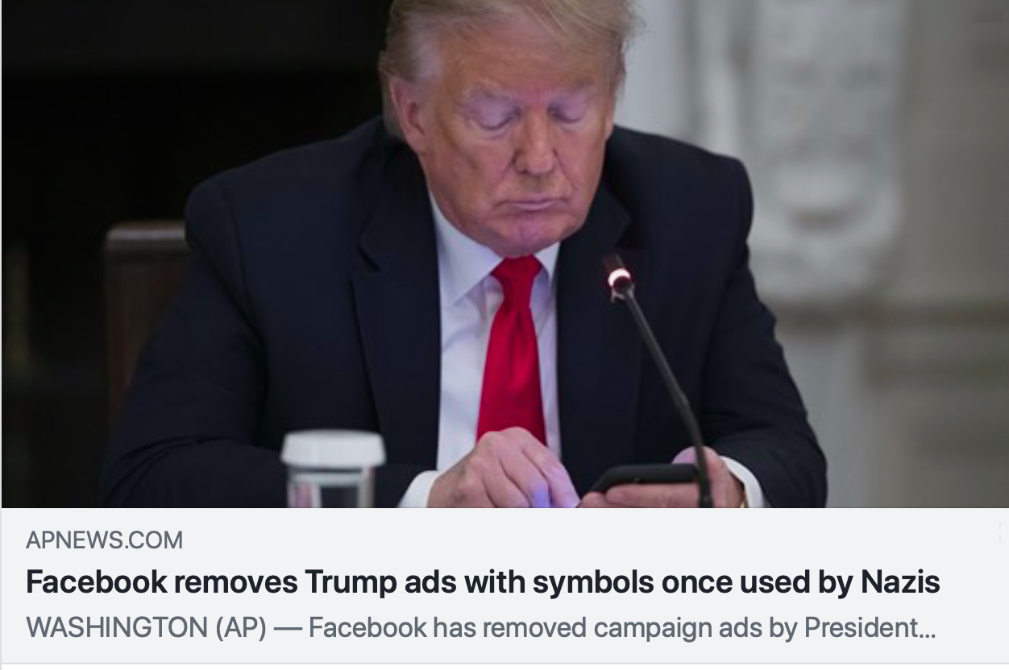
Example Democrat-Leaning Fake News
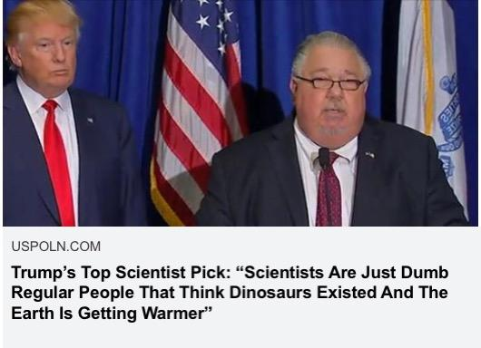
Example Republican-Leaning Fake News:
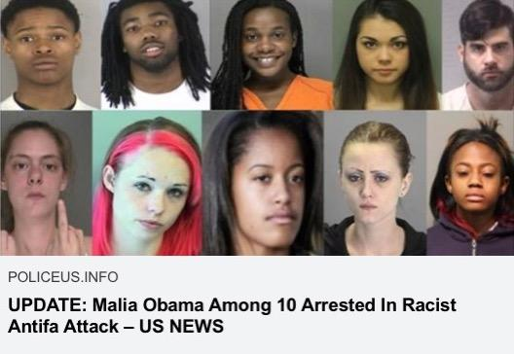

Example headline without source:
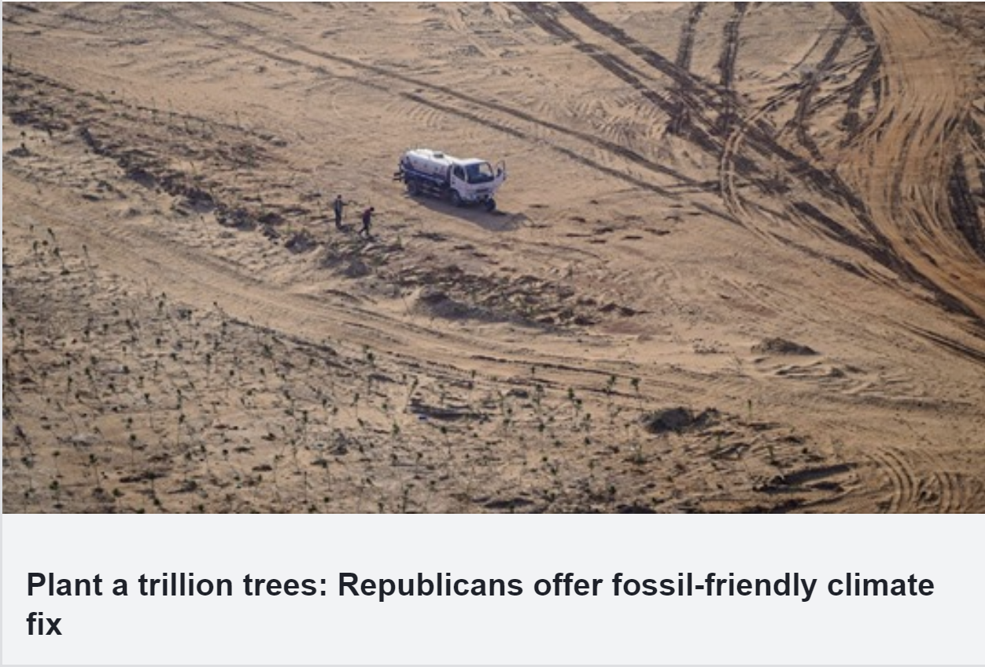
The full set of stimuli are available in our OSF: https://osf.io/75sqf/?view_only=623d654c17b94d958a0857c06b181073

S6: Manipulation Text

Accuracy Incentives Manipulation Text

You will be presented with a series of real and fake news headlines. There are 16 headlines in total.

We are interested in your opinion about the following:

1) How accurate is the headline?
2) How likely would you be to share the headline on social media?
You will be given 60 seconds to answer these two questions about each headline.

Note: You will receive a BONUS PAYMENT of up to $1.00 (£0.75) based on how many CORRECT answers you provide regarding the accuracy of the articles. Correct answers are based on the expert evaluations of non-partisan fact-checkers.
More specifically, if you answer 15 or more of the out 16 questions correctly, you will receive the full bonus payment of $1.00. If you answer 13 or more of the 16 questions correctly, you will receive a partial bonus payment of $0.50. Your bonus payment will be delivered to your Prolific ID. It may take a few weeks to calculate your scores and for you to receive your bonus payment.
We ask you about accuracy on a 6-point scale ranging from "extremely inaccurate" to "extremely accurate." For the purpose of this study, if the headline describes a true event, either "slightly accurate," "moderately accurate," or "extremely accurate" constitute correct responses. Similarly, if the headline describes a false event, either "extremely inaccurate," "moderately inaccurate," or "slightly inaccurate" constitute "correct" responses.
Your answers to all other questions will not contribute to your bonus payment.

After seeing each headline, questions in this condition appeared as follows:

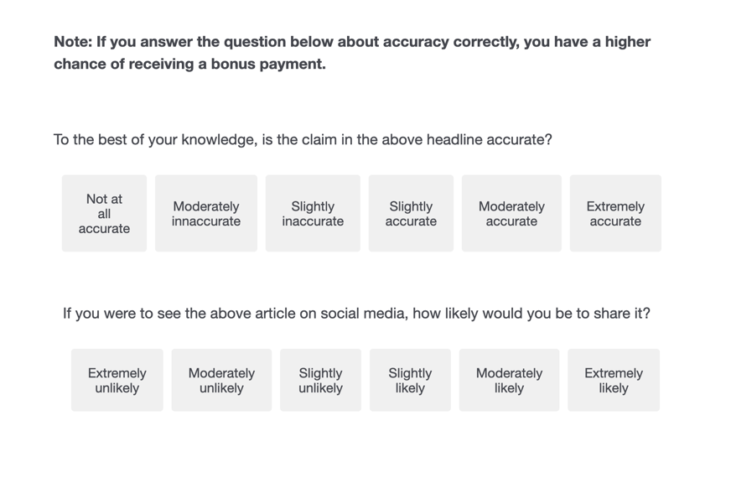

Control Text

You will be presented with a series of real and fake news headlines. There are 16 headlines in total.

We are interested in your opinion about the following:

1) How accurate is the headline?
2) How likely would you be to share the headline on social media?

You will be given 60 seconds to answer these two questions about each headline.

After seeing each headline, questions in this condition appeared as follows:

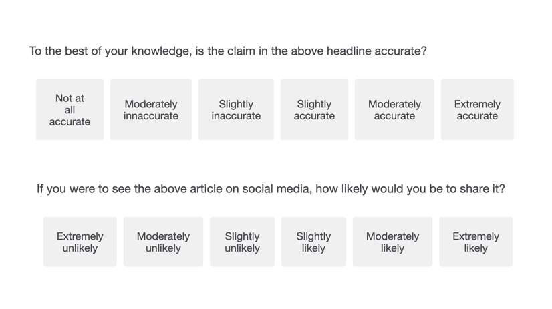

Social Incentive Manipulation Text:

You will be presented with a series of real and fake news headlines. There are 16 headlines in total.

We are primarily interested in your opinion about the following:

1) How likely is this article to appeal to [Democrats/Republicans]?

We want to see how well you can identify articles that appeal to [Democrats/Republicans]?
You will receive a BONUS PAYMENT of up to $1.00 (£0.75) based on how well you identify articles that are likely to appeal to [Democrats/Republicans]?
More specifically, we have pre-tested these articles to see how much they are liked by [Democrats/Republicans]. We want to see how close your answers are to the answers we identified in the pre-test. If you correctly identify 15 or more out of 16 articles that are liked by [Democrats/Republicans], you will receive the full bonus payment of $1.00. If you correctly identify 13 or more of the 16 articles that are liked by [Democrats/Republicans], you will receive a partial bonus payment of $0.50.

We will also ask you:

2) How accurate is the headline?
3) How likely would you be to share the headline on social media?

But, we will not give you a bonus payment based on your response to these questions. Your answers to all other questions in the survey will not contribute to your bonus payment.

The images may take a second to load. Please wait for the images to load before answering the questions.

After seeing each headline, questions in this condition appeared as follows:

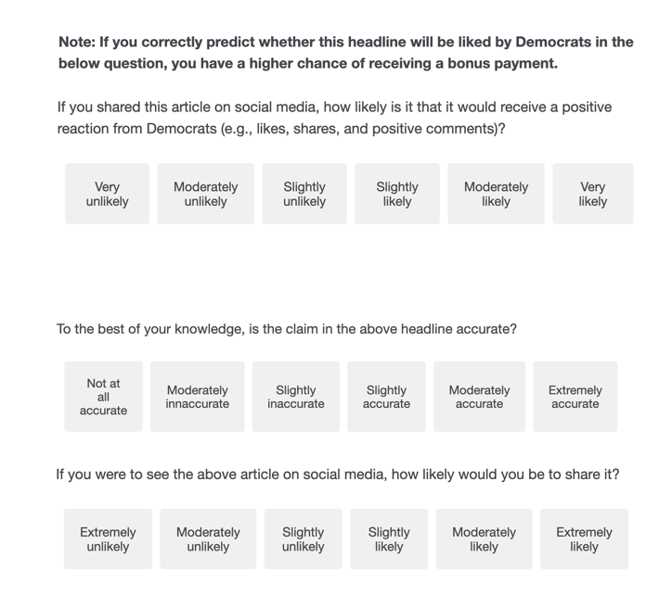

Mixed Incentives Manipulation Text

You will be presented with a series of real and fake news headlines. There are 16 headlines in total.
We are primarily interested in your opinion about the following:

1) How likely is this article to appeal to [Democrats/Republicans]?
2) How accurate is the headline?

We want to see how well you can identify articles that appeal to [Democrats/Republicans]? You will receive a BONUS PAYMENT of up to $1.00 (£0.75) based on how well you identify articles that are likely to appeal to [Democrats/Republicans]?

You will receive an ADDITIONAL BONUS PAYMENT of up to $1.00 (£0.75) based on how many CORRECT answers you provide regarding the accuracy of the articles. Correct answers are based on the expert evaluations of non-partisan fact-checkers.
More specifically, we have pre-tested these articles to see how much they are liked by [Democrats/Republicans]. We want to see how close your answers are to the answers we identified in the pre-test. If you correctly identify 15 or more out of 16 articles that are liked by [Democrats/Republicans], you will receive the full bonus payment of $1.00. If you correctly identify 13 or more of the 16 articles that are liked by [Democrats/Republicans], you will receive a partial bonus payment of $0.50.
Additionally, if you answer 15 or more out of the 16 questions about accuracy correctly, you will receive the full bonus payment of $1.00. If you answer 13 or more of the 16 questions correctly, you will receive a partial bonus payment of $0.50. Your bonus payment will be delivered to your Prolific ID. It may take a few weeks to calculate your scores and for you to receive your bonus payment.
We ask you about accuracy on a 6-point scale ranging from "extremely inaccurate" to "extremely accurate." For the purpose of this study, if the headline describes a true event, either "slightly accurate," "moderately accurate," or "extremely accurate" constitute correct responses. Similarly, if the headline describes a false event, either "extremely inaccurate," "moderately inaccurate," or "slightly inaccurate" constitute "correct" responses.

We will also ask you:

3) How likely would you be to share the headline on social media?

But, we will not give you a bonus payment based on your response to this question. Your answers to all other questions in the survey will not contribute to your bonus payment.

After seeing each headline, questions in this condition appeared as follows:

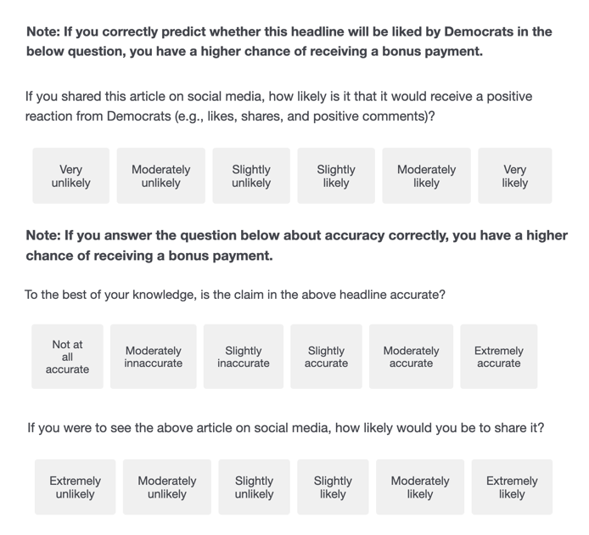

S7: Question Wording

Cognitive Reflection Test.
The ages of Mark and Adam add up to 28 years total. Mark is 20 years older than Adam. How many years old is Adam?
If it takes 10 seconds for 10 printers to print out 10 pages of paper, how many seconds will it take 50 printers to print out 50 pages of paper?
On a loaf of bread, there is a patch of mold. Every day, the patch doubles in size. If it takes 40 days for the patch to cover the entire loaf of bread, how many days would it take for the patch to cover half of the loaf of bread?

Affective Polarization.
How favorable do you feel towards Democrats?
How favorable do you feel towards Republicans?
Note: Affective polarization was measured as positive feelings toward the in-party minus negative feelings toward the out-party.

Political Knowledge.
Whose responsibility is it to determine if a law is constitutional or not – is it the President, the Congress, or the Supreme Court?
President
Congress
Supreme Court
How much of a majority is required for the U.S. Senate and House to override a presidential veto?
1/2 majority
1/3 majority
3/4 majority
What party currently has the most members in the House of Representatives in Washington?
Democrats
Republicans
Neither
Would you say that one of the major parties is more conservative than the other at the national level? If so, which party is more conservative?
Democrats
Republicans
Neither
How many justices are on the U.S. Supreme Court?
9
12
18

Political Conservatism.
Which of the following best describes your political preference?
Strongly Democratic
Democratic
Lean Democratic
Lean Republican
Republican
Strongly Republican

Education.
What is the highest level of school you have completed or the highest degree you have received?
Less than high school degree
High school graduate (high school diploma or equivalent including GED)
Some college but no degree
Associate degree in college (2-year)
Bachelor's degree in college (4-year)
Master's degree
Doctoral degree
Professional degree (JD, MD)

Income.
Information about income is very important to understand. Would you please give your best guess?
Please indicate the answer that includes your entire household income in (previous year) before taxes.
Less than $10,000
$10,000 to $19,999
$20,000 to $29,999
$30,000 to $39,999
$40,000 to $49,999
$50,000 to $59,999
$60,000 to $69,999
$70,000 to $79,999
$80,000 to $89,999
$90,000 to $99,999
$100,000 to $149,999
$150,000 or more

Age.
What is your age?

Gender (Recoded for Regression Analysis as Female/Not Female)
What is your gender?
Male
Female
Transgender Female
Transgender Male
Trans/Non-Binary
Not Listed:

Additional Questions

Did you respond randomly at any point during the study?

Note: Please be honest! You will get your payment regardless of your response.

Yes

No

…

Please answer honestly:

Would you ever share an article on social media that you know is false?

Yes

No

Note: These questions were only shown to those in the accuracy incentives condition:

Please answer honestly: this will not affect your payment, and it is important to the researchers to understand how you responded.
Did you ever say an article was accurate simply because you thought it would get you a higher payment and not because you genuinely believed it was accurate?
Or did all answers about accuracy reflect your true beliefs?

Yes

No

…

Please answer honestly: do you think your answers were influenced by the extra financial incentive to be accurate?

Yes

No

Note: These questions were only shown to those in the social incentives condition:

Please answer honestly: this will not affect your payment, and it is important to understand how you responded.
Did you ever say an article was accurate simply because you liked it (or say an article was inaccurate because you disliked it)?
Or did all answers about accuracy reflect your true beliefs?

Yes

No

…

Please answer honestly: do you think your answers to other questions were influenced by your task of identifying articles that would appeal to your political party?

Yes

No

S8: Results for Continuously Coded Outcome Variables
Variable | Mean (Accuracy) | Mean (Control) | Difference | CI_low | CI_high | t | df | p | d | d_CI_low | d_CI_high
Truth Discernment | 0.78 | 0.68 | -0.11 | 0.03 | 0.18 | 2.77 | 1385.76 | 0.006 | 0.15 | 0.04 | 0.25
Partisan Bias | 4.95 | 6.37 | 1.42 | -2.36 | -0.49 | -3.00 | 1401.89 | 0.003 | -0.16 | 0.26 | 0.06
Incongruent True News | 3.99 | 3.79 | -0.20 | 0.09 | 0.31 | 3.55 | 1414.72 | 0.000 | 0.19 | 0.08 | 0.29
Note: Above are the results for truth discernment, partisan bias, and incongruent true news when coded on a continuous, rather than dichotomous scale. Results shown above are from the integrative data analysis. Results do not change the conclusions, but the effect sizes are smaller. This smaller effect can likely be attributed to the fact that incentives rewarded responses as accurate regardless of whether people answered “slightly accurate,” “moderately accurate,” or “extremely accurate.” In other words, it appeared as though people were ignoring magnitude.

S9: Study 3 Results Including Additional News Items

Below, we show the results for Study 3 when including the 8 additional fake news stimuli. These additional analyses do not change our conclusions.

Truth Discernment. A 2X2 (Accuracy X Source) ANOVA found that there was a significant effect of the accuracy incentives on truth discernment such that the accuracy incentives improved discernment, F(1, 917) = 4.08, p = 0.04, η²_{G} = 0.004. Additionally, there was a significant impact of source cues on truth discernment such that source cues improved accuracy, F(1, 917) = 8.13, p = 0.004, η²_{G} = 0.009. However, there was no significant interaction between the accuracy incentive condition and source cues, p = 0.649.
Partisan Bias. A 2X2 (Accuracy X Source) ANOVA found that there was a significant effect of the accuracy incentives on partisan bias such that the incentives reduced bias, F(1, 917) = 16.79, p < 0.001, η²_{G} = 0.02. The source cues did not impact partisan bias (p = 0.603), and there was no interaction between source cues and partisan bias (p = 0.438).
Sharing Discernment. A 2X2 (Accuracy X Source) ANOVA found that there was no significant effect of accuracy (p = 0.733), but there was a significant effect of the source cues, F(1, 917) = 5.50, p = 0.019, η²_{G} = 0.01, and no interaction between accuracy incentives and source cues (p = 0.533).
Effects on Sharing Intentions Broken Down by Headline Type. We then ran a 2 (accuracy incentive vs. no incentive) X 2 (social incentive vs. no incentive) X 2 (politically congruent vs. politically incongruent) X 2 (true headlines vs. false headlines) mixed-design ANOVA. We found no main effect of source cues (p = 0.524), but did find a main effect of the incentive, F(1,917) = 0.396, p = 0.047, η²_{G} = 0.00, political congruence, F(1, 917) = 5.79, p = 0.016, η²_{G} = 0.00, and veracity, F(1, 917) = 1330.58, p < 0.001, η²_{G} = 0.24. There was also a significant interaction between the incentives and political congruence, F(1, 917) = 4.12, p = 0.043, η²_{G} = 0.00, the source cues and veracity, F(1, 917) = 8.18, p = 0.004, η²_{G} = 0.00, incentives and veracity, F(1, 917) = 4.06, p = 0.044, η²_{G} = 0.00, and political congruence and veracity, F(1, 917) = 361.44, p < 0.001, η²_{G} = 0.09. There were also significant three-way interactions between source cues, incentives, and political congruence, F(1, 917) = 5.00, p = 0.026, η²_{G} = 0.00, and incentives, political congruence, and veracity, F(1, 917) = 16.74, p = 0.00, η²_{G} = 0.01.
Importantly, post-hoc Tukey HSD tests revealed that there was a difference between belief in incongruent true headlines rated as accurate in the accuracy incentive (with sources) condition (M = 56.33, 95% CI = [52.92, 59.75]) versus the control (with sources) condition (M = 46.24, 95% CI = [42.79, 49.70]), p < 0.001, d = 0.39. However, there was no difference between the accuracy incentives condition (without sources cues) as compared to the control condition (without source cues), p = 0.311.

