Table 1 Description of participants
 |  | ITALY | FRANCE
Gender | male | 50.86% | 48%
Gender | female | 47.60% | 52%
Gender | other | 1.54% | -
Age | 18-24 | 8.61% | 13.45%
Age | 25-34 | 18.68% | 18.18%
Age | 35-44 | 25.09% | 19.64%
Age | 45-54 | 22.71% | 20.91%
Age | 55-64 | 16.85% | 27.82%
Education level | less than high school | 15.75% | 17.82%
Education level | high school or some college | 28.77% | 29.64%
Education level | bachelor's degree | 20.72% | 16.18%
Education level | master degree | 23.46% | 18.73%
Education level | post graduate degree | 7.88% | 15.09%
Education level | PhD | 3.42% | 2.55%
Income level (euro) | no income | 6.55% | 6.73%
Income level (euro) | < 10k | 19.09% | 23.27%
Income level (euro) | 10k-20k | 28.73% | 26.18%
Income level (euro) | 20k-40k | 28.18% | 25.64%
Income level (euro) | 40k-80k | 13.82% | 15.27%
Income level (euro) | >80k | 3.64% | 2.91%

Table 2. Breakdown of main survey results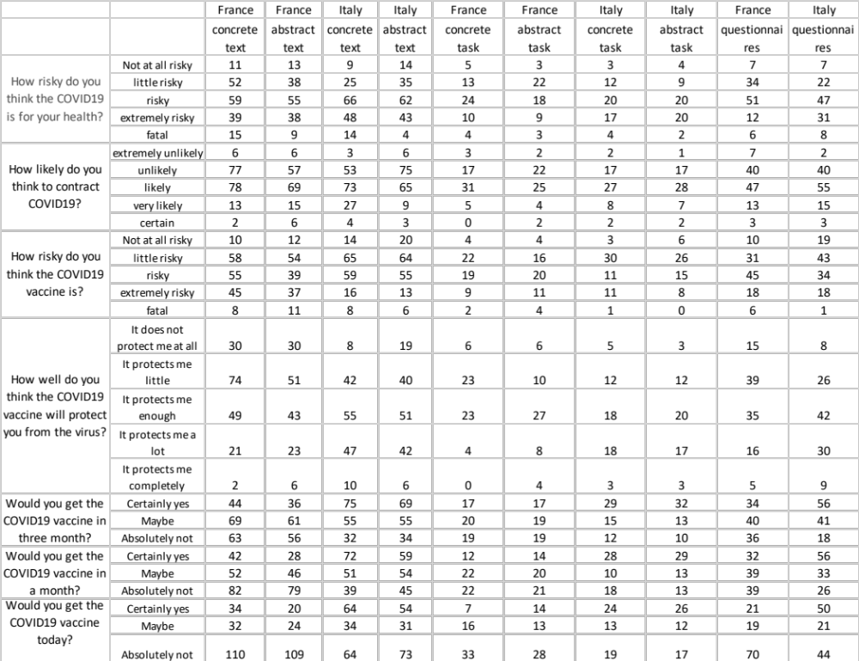

Table 3 - Stable preferences for the pro-vaxer type
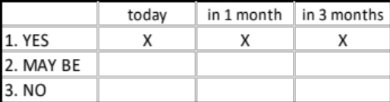

Table 4 - Stable preferences procrastinator type
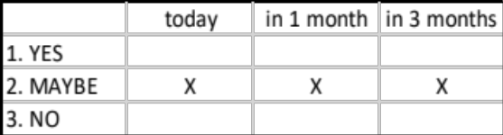

Table 5 - Stable preferences anti-vaxer type
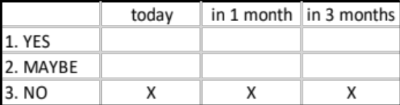

Table 6– example of unstable preferences
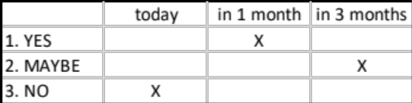

Table 7 – example of unstable preferences
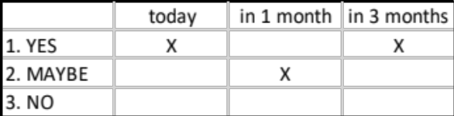

Table 8 – example of unstable preferences
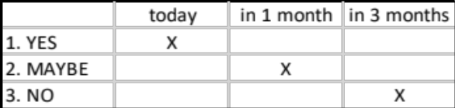

Table 9 Composition of categories
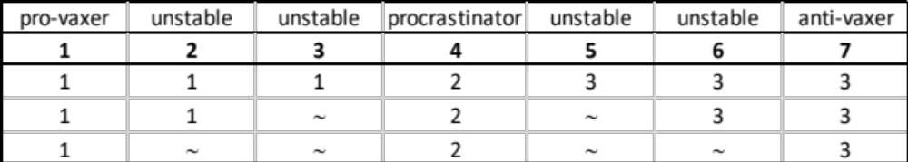
1: yes; 2: maybe; 3: no.

Table 10 Distribution of human behavior categories per group - France
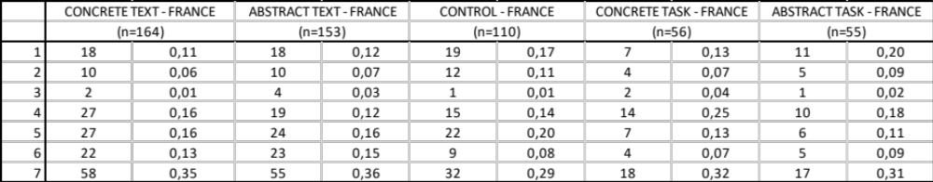

Table 11 Distribution of human behavior categories per group - Italy
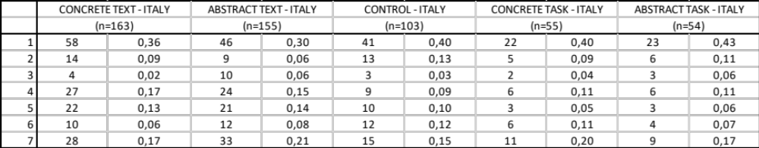

Table 12 OLS multivariate analysis – France
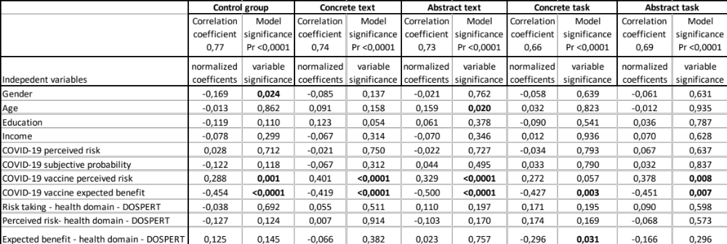
Dependent variable: HBC

Table 13 OLS multivariate analysis - Italy
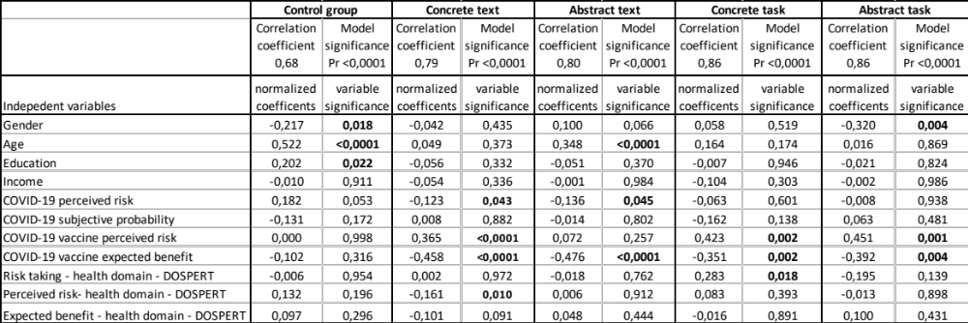
Dependent variable: HBC

Table 14. Per gender distribution of pro-vaxers and anti-vaxers in France
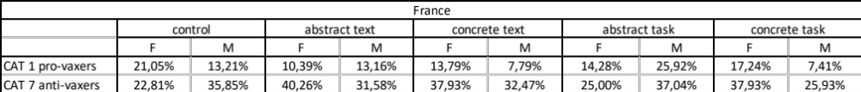

Table 15. Per gender distribution of pro-vaxers and anti-vaxers in Italy
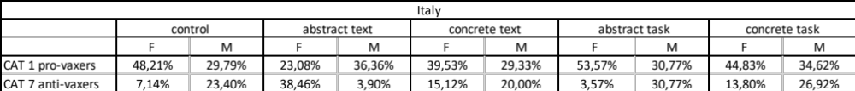

Table 16 DOSPERT psychometric test results, health domain
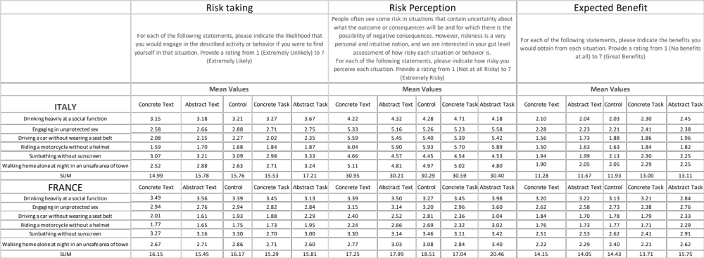

Table 17 t-test Italy vs France.
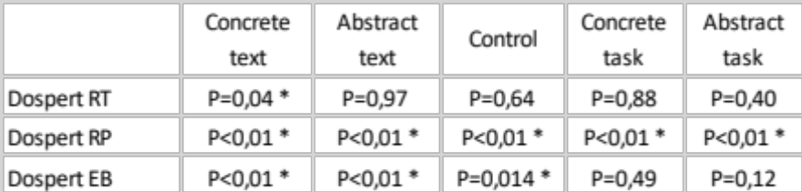
* significant difference at α=0.05

Table 18 Results of the neural network analysis of the abstract task in Italy
Observations | Original Human behavious categories | Predicted human behaviouor categories | residuals | Observations | Original Human behavious categories | Predicted human behaviouor categories | residuals
Oss1 | 1,000 | 1,157 | -0,157 | Oss28 | 2,000 | 1,996 | 0,004
Oss2 | 1,000 | 1,033 | -0,033 | Oss29 | 2,000 | 1,236 | 0,764
Oss3 | 1,000 | 0,938 | 0,062 | Oss30 | 3,000 | 2,533 | 0,467
Oss4 | 1,000 | 1,198 | -0,198 | Oss31 | 3,000 | 2,985 | 0,015
Oss5 | 1,000 | 1,139 | -0,139 | Oss32 | 3,000 | 2,593 | 0,407
Oss6 | 1,000 | 1,144 | -0,144 | Oss33 | 4,000 | 4,130 | -0,130
Oss7 | 1,000 | 1,123 | -0,123 | Oss34 | 4,000 | 4,011 | -0,011
Oss8 | 1,000 | 1,132 | -0,132 | Oss35 | 4,000 | 4,012 | -0,012
Oss9 | 1,000 | 0,690 | 0,310 | Oss36 | 4,000 | 3,962 | 0,038
Oss10 | 1,000 | 1,269 | -0,269 | Oss37 | 4,000 | 3,944 | 0,056
Oss11 | 1,000 | 1,162 | -0,162 | Oss38 | 4,000 | 3,506 | 0,494
Oss12 | 1,000 | 1,152 | -0,152 | Oss39 | 5,000 | 5,003 | -0,003
Oss13 | 1,000 | 1,243 | -0,243 | Oss40 | 5,000 | 5,007 | -0,007
Oss14 | 1,000 | 1,132 | -0,132 | Oss41 | 5,000 | 4,995 | 0,005
Oss15 | 1,000 | 1,313 | -0,313 | Oss42 | 6,000 | 5,965 | 0,035
Oss16 | 1,000 | 1,390 | -0,390 | Oss43 | 6,000 | 5,994 | 0,006
Oss17 | 1,000 | 0,938 | 0,062 | Oss44 | 6,000 | 6,039 | -0,039
Oss18 | 1,000 | 1,084 | -0,084 | Oss45 | 6,000 | 6,055 | -0,055
Oss19 | 1,000 | 0,983 | 0,017 | Oss46 | 7,000 | 7,077 | -0,077
Oss20 | 1,000 | 1,129 | -0,129 | Oss47 | 7,000 | 6,888 | 0,112
Oss21 | 1,000 | 0,984 | 0,016 | Oss48 | 7,000 | 7,076 | -0,076
Oss22 | 1,000 | 1,031 | -0,031 | Oss49 | 7,000 | 7,080 | -0,080
Oss23 | 1,000 | 1,173 | -0,173 | Oss50 | 7,000 | 7,077 | -0,077
Oss24 | 2,000 | 1,969 | 0,031 | Oss51 | 7,000 | 7,079 | -0,079
Oss25 | 2,000 | 1,156 | 0,844 | Oss52 | 7,000 | 6,910 | 0,090
Oss26 | 2,000 | 1,998 | 0,002 | Oss53 | 7,000 | 7,079 | -0,079
Oss27 | 2,000 | 1,987 | 0,013 | Oss54 | 7,000 | 7,070 | -0,070

