Table 1 Some active compounds from Ephedra and Asarum
Molecular number | Components | DL | HL | Degree | Source | Structure
MOL000098 | quercetin | 0.28 | 14.4 | 154 | Ephedra | 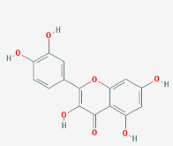
MOL000422 | kaempferol | 0.24 | 14.74 | 65 | Ephedra Asarum | 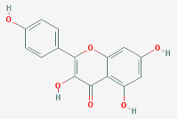
MOL000006 | luteolin | 0.25 | 15.94 | 58 | Ephedra | 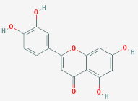
MOL004328 | naringenin | 0.21 | 16.98 | 38 | Ephedra | 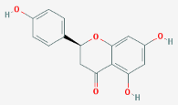
MOL000358 | beta-sitosterol | 0.75 | 5.36 | 38 | Ephedra | 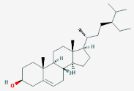
MOL000449 | stigmasterol | 0.76 | 5.57 | 31 | Ephedra | 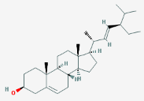
MOL001460 | cryptopin | 0.72 | 21.25 | 31 | Asarum | 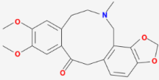
MOL002962 | (3S)-7-hydroxy-3-(2,3,4-trimethoxyphenyl)chroman-4-one | 0.33 | 16.64 | 29 | Asarum | 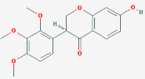
MOL001558 | sesamin | 0.83 | 13.44 | 23 | Asarum | 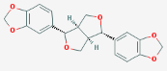
MOL005573 | genkwanin | 0.24 | 16.1 | 17 | Ephedra | 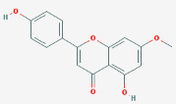
MOL002823 | herbacetin | 0.27 | 14.8 | 15 | Ephedra | 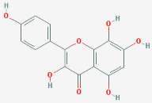
MOL005842 | pectolinarigenin | 0.3 | 16.56 | 14 | Ephedra | 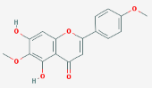
MOL002881 | diosmetin | 0.27 | 16.34 | 13 | Ephedra | 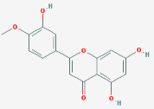
MOL004576 | taxifolin | 0.27 | 14.41 | 12 | Ephedra | 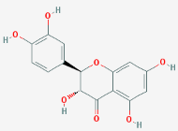
MOL005190 | eriodictyol | 0.24 | 15.81 | 10 | Ephedra | 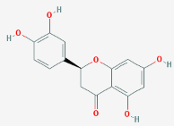
MOL012140 | 4,9-dimethoxy-1-vinyl-1b-carboline | 0.19 | 9.85 | 10 | Ephedra | 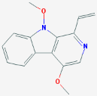
MOL012141 | caribine | 0.83 | 10.44 | 8 | Ephedra | 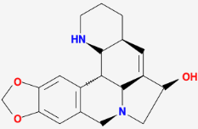
MOL011319 | truflex OBP | 0.24 | 4.9 | 7 | Ephedra | 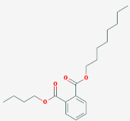
MOL009849 | ZINC05223929 | 0.83 | 14.12 | 6 | Asarum | 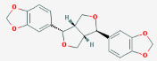
MOL001494 | mandenol | 0.19 | 5.39 | 3 | Ephedra | 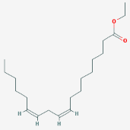
MOL001755 | 24-ethylcholest-4-en-3-one | 0.76 | 5.49 | 2 | Ephedra | 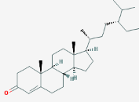
MOL001771 | poriferast-5-en-3beta-ol | 0.75 | 5.07 | 2 | Ephedra | 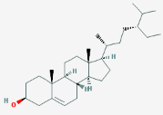
MOL005043 | campest-5-en-3beta-ol | 0.71 | 4.43 | 1 | Ephedra | 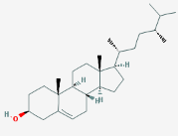

Table 2 Clusters of the key targets
Number | Module | Node | edge | Score
1 | 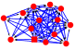 | 14 | 74 | 11.385
2 | 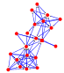 | 21 | 67 | 6.7

Table 3 Clusters of key targets
Ligand | Protein | Autodock docking score (kcal/mol)
Quercetin | IL6(4zs7) | -7.6
Quercetin | STAT1(4u2x) | -7.3
Quercetin | TNF(1du3) | -7.8
kaempferol | IL6(4zs7) | -6.9
kaempferol | STAT1(4u2x) | -7.2
kaempferol | TNF(1du3) | -7.8

