Supplementary Material

Effects of different treatment regimens on primary spontaneous pneumothorax: a systematic review and network meta-analysis

Table of contents

Table 1: PRISMA checklist (Page 3-5)
Table 2: Search strategy (Page 6-7)
Table 3: Risk of bias assessments (Page 8-83)
Table 4: GEADE (Page 84-106)
Table 5: League table of Recurrence rate (Page 107)
Table 6: SUCRA of Recurrence rate (Page 108)
Table 7: League table of Postoperative chest tube duration (days) (Page 109)
Table 8: SUCRA of Postoperative chest tube duration (days) (Page 110)
Table 9: League table of Postoperative air leakage duration (days) (Page 111)
Table 10: League table of Length of hospital stay (days) (Page 112)
Table 11: SUCRA of Length of hospital stay (days) (Page 113)
Table 12: League table of Rate of the complications (Page 114)
Table 13: SUCRA of Rate of the complications (Page 115)
Table 14: Sensitivity analysis (Page 116-119)
Table 15: Subgroup analysis (Page 120-123)

Figure 1: Risk of bias (Page 124)
Figure 2: Funnel plots (Page 125-129)
Figure 3: Rank probability- Recurrence rate (Page 130-131)
Figure 4: Rank probability- Postoperative chest tube duration (days) (Page 132-133)
Figure 5: Rank probability- Postoperative air leakage duration (days) (Page 134-135)
Figure 6: Rank probability- Length of hospital stay (days) (Page 136-137)
Figure 7: Rank probability- Rate of the complications (Page 138-139)
Figure 8: Heterogeneity (Page 140-143)
Figure 9: Inconsistency (Page 144-146)

Table 1: PRISMA checklist

PRISMA NMA Checklist of Items to Include When Reporting A Systematic Review Involving a Network Meta-analysis

Section/Topic | Item # | Checklist Item | Reported on Page #
TITLE
Title | 1 | Identify the report as a systematic review incorporating a network meta-analysis (or related form of meta-analysis). | Manuscript title page
ABSTRACT
Structured summary | 2 | Provide a structured summary including, as applicable:  Background: main objectives  Methods: data sources; study eligibility criteria, participants, and interventions; study appraisal; and synthesis methods, such as network meta-analysis.  Results: number of studies and participants identified; summary estimates with corresponding confidence/credible intervals; treatment rankings may also be discussed. Authors may choose to summarize pairwise comparisons against a chosen treatment included in their analyses for brevity.  Discussion/Conclusions: limitations; conclusions and implications of findings.  Other: primary source of funding; systematic review registration number with registry name. | Abstract
INTRODUCTION
Rationale | 3 | Describe the rationale for the review in the context of what is already known, including mention of why a network meta-analysis has been conducted. | 3st , 4st paragraph of the Introduction
Objectives | 4 | Provide an explicit statement of questions being addressed, with reference to participants, interventions, comparisons, outcomes, and study design (PICOS). | 1st , 3st , 4st paragraph of the Introduction, 1st paragraph of the Data synthesis and statistical analysis in Methods
METHODS
Protocol and registration | 5 | Indicate whether a review protocol exists and if and where it can be accessed (e.g., Web address); and, if available, provide registration information, including registration number. | 1st part of the Methods (Protocol and Registration)
Eligibility criteria | 6 | Specify study characteristics (e.g., PICOS, length of follow-up) and report characteristics (e.g., years considered, language, publication status) used as criteria for eligibility, giving rationale. Clearly describe eligible treatments included in the treatment network, and note whether any have been clustered or merged into the same node (with justification). | 2nd part of the Methods (Search strategy and selection criteria)
Information sources | 7 | Describe all information sources (e.g., databases with dates of coverage, contact with study authors to identify additional studies) in the search and date last searched. | 2nd part of the Methods (Search strategy and selection criteria)
Search | 8 | Present full electronic search strategy for at least one database, including any limits used, such that it could be repeated. | Supplementary material: Appendix B: Search strategy
Study selection | 9 | State the process for selecting studies (i.e., screening, eligibility, included in systematic review, and, if applicable, included in the meta-analysis). | Figure 1, 1st paragraph of the Results  (Study selection)
Data collection process | 10 | Describe method of data extraction from reports (e.g., piloted forms, independently, in duplicate) and any processes for obtaining and confirming data from investigators. | 3nd part of the Methods
Data items | 11 | List and define all variables for which data were sought (e.g., PICOS, funding sources) and any assumptions and simplifications made. | 3nd part of the Methods (Data extraction and quality assessment)
Geometry of the network | S1 | Describe methods used to explore the geometry of the treatment network under study and potential biases related to it. This should include how the evidence base has been graphically summarized for presentation, and what characteristics were compiled and used to describe the evidence base to readers. | Figure 2, 3nd part of the Results
Risk of bias within individual studies | 12 | Describe methods used for assessing risk of bias of individual studies (including specification of whether this was done at the study or outcome level), and how this information is to be used in any data synthesis. | 3nd part of the Methods (Data extraction and quality assessment)
Summary measures | 13 | State the principal summary measures (e.g., risk ratio, difference in means). Also describe the use of additional summary measures assessed, such as treatment rankings and surface under the cumulative ranking curve (SUCRA) values, as well as modified approaches used to present summary findings from meta-analyses. | 4nd part of the Methods (Data synthesis and statistical analysis)
Planned methods of analysis | 14 | Describe the methods of handling data and combining results of studies for each network meta-analysis. This should include, but not be limited to:  - Handling of multi-arm trials;  - Selection of variance structure;  - Selection of prior distributions in Bayesian analyses; and  - Assessment of model fit. | 4nd part of the Methods  (Data synthesis and statistical analysis)
Assessment of Inconsistency | S2 | Describe the statistical methods used to evaluate the agreement of direct and indirect evidence in the treatment network(s) studied. Describe efforts taken to address its presence when found. | 4nd part of the Methods (Data synthesis and statistical analysis)
Risk of bias across studies | 15 | Specify any assessment of risk of bias that may affect the cumulative evidence (e.g., publication bias, selective reporting within studies). | 4nd part of the Methods (Data synthesis and statistical analysis)
Additional analyses | 16 | Describe methods of additional analyses if done, indicating which were pre-specified. This may include, but not be limited to, the following:  - Sensitivity or subgroup analyses;  - Meta-regression analyses;  - Alternative formulations of the treatment network; and  - Use of alternative prior distributions for Bayesian analyses (if applicable). | 4nd part of the Methods (Data synthesis and statistical analysis)
RESULTS†
Study selection | 17 | Give numbers of studies screened, assessed for eligibility, and included in the review, with reasons for exclusions at each stage, ideally with a flow diagram. | Figure 1, 1st part of the Results
Presentation of network structure | S3 | Provide a network graph of the included studies to enable visualization of the geometry of the treatment network. | Figure 2
Summary of network geometry | S4 | Provide a brief overview of characteristics of the treatment network. This may include commentary on the abundance of trials and randomized patients for the different interventions and pairwise comparisons in the network, gaps of evidence in the treatment network, and potential biases reflected by the network structure. | 3nd part of the Results
Study characteristics | 18 | For each study, present characteristics for which data were extracted (e.g., study size, PICOS, follow-up period) and provide the citations. | Table 1
Risk of bias within studies | 19 | Present data on risk of bias of each study and, if available, any outcome level assessment. | 2st part of the Results
Results of individual studies | 20 | For all outcomes considered (benefits or harms), present, for each study: 1) simple summary data for each intervention group, and 2) effect estimates and confidence intervals. Modified approaches may be needed to deal with information from larger networks. | Figure 3, Figure 4, Supplementary material: Appendix E: Complete network meta-analysis results
Synthesis of results | 21 | Present results of each meta-analysis done, including confidence/credible intervals. In larger networks, authors may focus on comparisons versus a particular comparator (e.g. placebo or standard care), with full findings presented in an appendix. League tables and forest plots may be considered to summarize pairwise comparisons. If additional summary measures were explored (such as treatment rankings), these should also be presented. | Supplementary material: Appendix E: Complete network meta-analysis results
Exploration for inconsistency | S5 | Describe results from investigations of inconsistency. This may include such information as measures of model fit to compare consistency and inconsistency models, P values from statistical tests, or summary of inconsistency estimates from different parts of the treatment network. | Supplementary material: Appendix E: Complete network meta-analysis results
Risk of bias across studies | 22 | Present results of any assessment of risk of bias across studies for the evidence base being studied. | Supplementary material: Appendix C: Risk of bias assessments
Results of additional analyses | 23 | Give results of additional analyses, if done (e.g., sensitivity or subgroup analyses, meta-regression analyses, alternative network geometries studied, alternative choice of prior distributions for Bayesian analyses, and so forth). | Supplementary material: Appendix F: Subgroup analysis  Appendix G: Sensitivity analysis
DISCUSSION
Summary of evidence | 24 | Summarize the main findings, including the strength of evidence for each main outcome; consider their relevance to key groups (e.g., healthcare providers, users, and policy-makers). | Supplementary material: Appendix H: GRADE
Limitations | 25 | Discuss limitations at study and outcome level (e.g., risk of bias), and at review level (e.g., incomplete retrieval of identified research, reporting bias). Comment on the validity of the assumptions, such as transitivity and consistency. Comment on any concerns regarding network geometry (e.g., avoidance of certain comparisons). | 2st part of the Discussion
Conclusions | 26 | Provide a general interpretation of the results in the context of other evidence, and implications for future research. | CONCLUSION
FUNDING
Funding | 27 | Describe sources of funding for the systematic review and other support (e.g., supply of data); role of funders for the systematic review. This should also include information regarding whether funding has been received from manufacturers of treatments in the network and/or whether some of the authors are content experts with professional conflicts of interest that could affect use of treatments in the network. | Funding

PICOS = population, intervention, comparators, outcomes, study design.
* Text in italics indicate S wording specific to reporting of network meta-analyses that has been added to guidance from the PRISMA statement.
† Authors may wish to plan for use of appendices to present all relevant information in full detail for items in this section.

Table 2: Search strategy

PubMed
#15

Search: ((((((("Pneumothorax"[Mesh]) OR (primary spontaneous pneumothorax[Title/Abstract])) OR (spontaneous pneumothorax, primary[Title/Abstract])) OR (spontaneous pneumothorax[Title/Abstract])) OR (pneumothorax, spontaneous[Title/Abstract])) OR (idiopathic pneumothorax[Title/Abstract])) OR (pneumothorax, idiopathic[Title/Abstract])) AND (((((randomized controlled trial[Publication Type]) OR (controlled clinical trial[Publication Type])) OR (randomized[Title/Abstract])) OR (controlled[Title/Abstract])) OR (random[Title/Abstract])) | 616 | 04:13:15
#14

Search: ((((randomized controlled trial[Publication Type]) OR (controlled clinical trial[Publication Type])) OR (randomized[Title/Abstract])) OR (controlled[Title/Abstract])) OR (random[Title/Abstract]) | 1,575,694 | 04:11:40
#13

Search: random[Title/Abstract] | 276,195 | 04:11:12
#12

Search: controlled[Title/Abstract] | 784,132 | 04:10:45
#11

Search: randomized[Title/Abstract] | 530,414 | 04:10:25
#10

Search: controlled clinical trial[Publication Type] | 601,559 | 04:10:04
#9

Search: randomized controlled trial[Publication Type] | 512,605 | 04:09:31
#8

Search: (((((("Pneumothorax"[Mesh]) OR (primary spontaneous pneumothorax[Title/Abstract])) OR (spontaneous pneumothorax, primary[Title/Abstract])) OR (spontaneous pneumothorax[Title/Abstract])) OR (pneumothorax, spontaneous[Title/Abstract])) OR (idiopathic pneumothorax[Title/Abstract])) OR (pneumothorax, idiopathic[Title/Abstract]) | 17,930 | 04:08:07
#7

Search: pneumothorax, idiopathic[Title/Abstract] | 379 | 04:07:36
#6

Search: idiopathic pneumothorax[Title/Abstract] | 53 | 04:07:11
#5

Search: pneumothorax, spontaneous[Title/Abstract] | 34 | 04:06:30
#4

Search: spontaneous pneumothorax[Title/Abstract] | 4,642 | 04:05:56
#3

Search: spontaneous pneumothorax, primary[Title/Abstract] | 4 | 04:05:21
#2

Search: primary spontaneous pneumothorax[Title/Abstract] | 730 | 04:04:38
#1

Search: "Pneumothorax"[Mesh] Sort by: Most Recent | 16,880 | 04:01:10

Table 3: Risk of bias assessments

Risk of bias was assessed using the Risk of Bias 2 (RoB2) tool for randomized studies and the Risk of Bias In Nonrandomized Studies (ROBINS-I) tool for nonrandomized studies.

RoB2-RCT (20)

Unique ID | 1 | Study ID | Harvey, 1994 | Assessor | Muredili
Ref or Label | BMJ 1994;309:1338-9 | Aim | assignment to intervention (the 'intention-to-treat' effect)
Experimental | manual aspiration | Comparator | chest tube drainage | Source | Journal article(s) with results of the trial
Outcome | Recurrent rate | Results | odds ratio | Weight | 1
Domain | Signalling question |  | Response | Comments
Bias arising from the randomization process | 1.1 Was the allocation sequence random? |  | PY | We conducted a randomised comparison of simple aspiration with intercostal drainage to assess acceptability and outcome at one year.
Bias arising from the randomization process | 1.2 Was the allocation sequence concealed until participants were enrolled and assigned to interventions? |  | NI
Bias arising from the randomization process | 1.3 Did baseline differences between intervention groups suggest a problem with the randomization process? |  | N | Both groups were similar with respect to age, sex, height, weight, smoking history, lung function, and history of pneumothorax (table). There were no significant differences between the two groups in either the size or side of pneumothorax.
Bias arising from the randomization process | Risk of bias judgement |  | Some concerns
Bias due to deviations from intended interventions | 2.1.Were participants aware of their assigned intervention during the trial? |  | Y | participants underwent different procedures that cannot be blinded.
Bias due to deviations from intended interventions | 2.2.Were carers and people delivering the interventions aware of participants' assigned intervention during the trial? |  | Y
Bias due to deviations from intended interventions | 2.3. If Y/PY/NI to 2.1 or 2.2: Were there deviations from the intended intervention that arose because of the experimental context? |  | Y | In all 28 out of 35 aspirations were successful, although five patients required two aspirations. The remaining seven patients were subsequently treated by intercostal drainage.
Bias due to deviations from intended interventions | 2.4 If Y/PY to 2.3: Were these deviations likely to have affected the outcome? |  | PY | In all 28 out of 35 aspirations were successful, although five patients required two aspirations. The remaining seven patients were subsequently treated by intercostal drainage. So that there was an imbalance between the intervention and control groups
Bias due to deviations from intended interventions | 2.5. If Y/PY/NI to 2.4: Were these deviations from intended intervention balanced between groups? |  | N | Initially, there were 35 people in the intervention group and 38 in the control group, and 7 people in the intervention group were reassigned to the control group, so the two groups were unbalanced
Bias due to deviations from intended interventions | 2.6 Was an appropriate analysis used to estimate the effect of assignment to intervention? |  | Y | A logistic regression model found no significant associations with failed aspiration. In particular, there was no association with a history of pneumothorax or initial radiographic appearances. No significant differences were found in the recurrence rate at one year, but more patients who had intercostal drainage required pleurectomy than those patients who had had aspiration (P-0-02).
Bias due to deviations from intended interventions | 2.7 If N/PN/NI to 2.6: Was there potential for a substantial impact (on the result) of the failure to analyse participants in the group to which they were randomized? |  | NA
Bias due to deviations from intended interventions | Risk of bias judgement |  | High
Bias due to missing outcome data | 3.1 Were data for this outcome available for all, or nearly all, participants randomized? |  | Y | In the intervention group, 5 people were lost to follow-up and 30 people completed follow-up, while in the control group, 3 people were lost to follow-up and 35 people completed follow-up.
Bias due to missing outcome data | 3.2 If N/PN/NI to 3.1: Is there evidence that result was not biased by missing outcome data? |  | NA
Bias due to missing outcome data | 3.3 If N/PN to 3.2: Could missingness in the outcome depend on its true value? |  | NA
Bias due to missing outcome data | 3.4 If Y/PY/NI to 3.3: Is it likely that missingness in the outcome depended on its true value? |  | NA
Bias due to missing outcome data | Risk of bias judgement |  | Low
Bias in measurement of the outcome | 4.1 Was the method of measuring the outcome inappropriate? |  | N | Patients completed symptom score charts indicating the degree of pain experienced during drainage and throughout their hospital admission. Patients were reviewed at one and 12 months, and recurrence of pneumothorax or referral for thoracic surgery was recorded. The size of pneumothorax in presenting radiographs was graded (see table).
Bias in measurement of the outcome | 4.2 Could measurement or ascertainment of the outcome have differed between intervention groups? |  | N | Patients were reviewed at one and 12 months, and recurrence of pneumothorax or referral for thoracic surgery was recorded. Most likely, the diagnosis was made by chest radiograph
Bias in measurement of the outcome | 4.3 Were outcome assessors aware of the intervention received by study participants? |  | NI | not reported
Bias in measurement of the outcome | 4.4 If Y/PY/NI to 4.3: Could assessment of the outcome have been influenced by knowledge of intervention received? |  | PN | Most likely, the assessment of the outcome was made by chest radiograph, so it cannot be influenced by knowledge of intervention received.
Bias in measurement of the outcome | 4.5 If Y/PY/NI to 4.4: Is it likely that assessment of the outcome was influenced by knowledge of intervention received? |  | NA
Bias in measurement of the outcome | Risk of bias judgement |  | Low
Bias in selection of the reported result | 5.1 Were the data that produced this result analysed in accordance with a pre-specified analysis plan that was finalized before unblinded outcome data were available for analysis? |  | PY | not reported
Bias in selection of the reported result | 5.2 ... multiple eligible outcome measurements (e.g. scales, definitions, time points) within the outcome domain? |  | PN | recurrent rate‘s definition is clear
Bias in selection of the reported result | 5.3 ... multiple eligible analyses of the data? |  | PN | one eligible analyses of the data
Bias in selection of the reported result | Risk of bias judgement |  | Low
Overall bias | Risk of bias judgement |  | Some concerns | participants underwent different procedures that cannot be blinded.
Unique ID | 2 | Study ID | Noppen, 2002 | Assessor | Muredili
Ref or Label | Am J Respir Crit Care Med Vol 165. pp 1240–1244, 2002 | Aim | assignment to intervention (the 'intention-to-treat' effect)
Experimental | manual aspiration | Comparator | chest tube drainage | Source | Journal article(s) with results of the trial
Outcome | Recurrent rate | Results | odds ratio | Weight | 1
Domain | Signalling question |  | Response | Comments
Bias arising from the randomization process | 1.1 Was the allocation sequence random? |  | Y | atients were randomized at each center with separate random number lists into one of the two treatment groups using a computer-generated table numerically corresponding with the treatment group.
Bias arising from the randomization process | 1.2 Was the allocation sequence concealed until participants were enrolled and assigned to interventions? |  | PY
Bias arising from the randomization process | 1.3 Did baseline differences between intervention groups suggest a problem with the randomization process? |  | N | There were no differences in gender, age, percent total pneumothorax (defined as a pneumothorax with air completely surrounding the lung, i.e., without contact between parietal and visceral pleura on an upright posterio-anterior chest X-ray), pneumothorax size (Light index), affected side, body mass index calculated as weight (in kilograms) divided by height (in meters) squared, and smoking status
Bias arising from the randomization process | Risk of bias judgement |  | Low
Bias due to deviations from intended interventions | 2.1.Were participants aware of their assigned intervention during the trial? |  | Y | participants underwent different procedures that cannot be blinded
Bias due to deviations from intended interventions | 2.2.Were carers and people delivering the interventions aware of participants' assigned intervention during the trial? |  | Y
Bias due to deviations from intended interventions | 2.3. If Y/PY/NI to 2.1 or 2.2: Were there deviations from the intended intervention that arose because of the experimental context? |  | Y | Of the 11 patients in whom manual aspiration was unsuccessful at first attempt, a second attempt was made in six, but was also without success. In nine patients, chest tube drainage was eventually performed, which was successful within 1 week in every case.
Bias due to deviations from intended interventions | 2.4 If Y/PY to 2.3: Were these deviations likely to have affected the outcome? |  | PY | deviations likely to have affected the outcome
Bias due to deviations from intended interventions | 2.5. If Y/PY/NI to 2.4: Were these deviations from intended intervention balanced between groups? |  | Y | these deviations from intended intervention balanced between groups
Bias due to deviations from intended interventions | 2.6 Was an appropriate analysis used to estimate the effect of assignment to intervention? |  | Y | appropriate analysis used to estimate the effect of assignment to intervention
Bias due to deviations from intended interventions | 2.7 If N/PN/NI to 2.6: Was there potential for a substantial impact (on the result) of the failure to analyse participants in the group to which they were randomized? |  | NA
Bias due to deviations from intended interventions | Risk of bias judgement |  | Some concerns
Bias due to missing outcome data | 3.1 Were data for this outcome available for all, or nearly all, participants randomized? |  | Y | Recurrence rates at 1-year follow-up were 7 out of 27 (26%) in the manual aspiration group and 9 out of 33 (27.3%) in the chest tube drainage group
Bias due to missing outcome data | 3.2 If N/PN/NI to 3.1: Is there evidence that result was not biased by missing outcome data? |  | NA
Bias due to missing outcome data | 3.3 If N/PN to 3.2: Could missingness in the outcome depend on its true value? |  | NA
Bias due to missing outcome data | 3.4 If Y/PY/NI to 3.3: Is it likely that missingness in the outcome depended on its true value? |  | NA
Bias due to missing outcome data | Risk of bias judgement |  | Low
Bias in measurement of the outcome | 4.1 Was the method of measuring the outcome inappropriate? |  | N | One-year success in both groups was defined as the absence of recurrent pneumothorax during a 1-year follow-up period.
Bias in measurement of the outcome | 4.2 Could measurement or ascertainment of the outcome have differed between intervention groups? |  | N | measurement of outcome is chest x-ray
Bias in measurement of the outcome | 4.3 Were outcome assessors aware of the intervention received by study participants? |  | PY | outcome assessors is likely to aware of the intervention received by study participants
Bias in measurement of the outcome | 4.4 If Y/PY/NI to 4.3: Could assessment of the outcome have been influenced by knowledge of intervention received? |  | N | Recurrence of spontaneous pneumothorax was diagnosed by chest radiograph. So assessment of the outcome cannot be influenced by knowledge of intervention received.
Bias in measurement of the outcome | 4.5 If Y/PY/NI to 4.4: Is it likely that assessment of the outcome was influenced by knowledge of intervention received? |  | NA
Bias in measurement of the outcome | Risk of bias judgement |  | Low
Bias in selection of the reported result | 5.1 Were the data that produced this result analysed in accordance with a pre-specified analysis plan that was finalized before unblinded outcome data were available for analysis? |  | PY | not reported
Bias in selection of the reported result | 5.2 ... multiple eligible outcome measurements (e.g. scales, definitions, time points) within the outcome domain? |  | N | definition of recurrence is clear
Bias in selection of the reported result | 5.3 ... multiple eligible analyses of the data? |  | N | There is one analyses of the data
Bias in selection of the reported result | Risk of bias judgement |  | Low
Overall bias | Risk of bias judgement |  | Some concerns
Unique ID | 3 | Study ID | Ayed, 2006 | Assessor | Muredili
Ref or Label | Eur Respir J 2006; 27: 477–482 | Aim | assignment to intervention (the 'intention-to-treat' effect)
Experimental | manual aspiration | Comparator | chest tube drainage | Source | Journal article(s) with results of the trial
Outcome | Recurrent rate | Results | odds ratio | Weight | 5
Domain | Signalling question |  | Response | Comments
Bias arising from the randomization process | 1.1 Was the allocation sequence random? |  | Y | Randomisation was performed by self-selecting a sealed envelop
Bias arising from the randomization process | 1.2 Was the allocation sequence concealed until participants were enrolled and assigned to interventions? |  | Y
Bias arising from the randomization process | 1.3 Did baseline differences between intervention groups suggest a problem with the randomization process? |  | N | The baseline patient clinical characteristics for each group are shown in table 1. There were no differences in age, sex, weight, body mass index, smoking status or radio graphical appearances
Bias arising from the randomization process | Risk of bias judgement |  | Low
Bias due to deviations from intended interventions | 2.1.Were participants aware of their assigned intervention during the trial? |  | Y | participants underwent different procedures that cannot be blinded
Bias due to deviations from intended interventions | 2.2.Were carers and people delivering the interventions aware of participants' assigned intervention during the trial? |  | Y
Bias due to deviations from intended interventions | 2.3. If Y/PY/NI to 2.1 or 2.2: Were there deviations from the intended intervention that arose because of the experimental context? |  | PY | deviations from the intended intervention that arose because of the experimental context
Bias due to deviations from intended interventions | 2.4 If Y/PY to 2.3: Were these deviations likely to have affected the outcome? |  | PY | these deviations likely to have affected the outcome
Bias due to deviations from intended interventions | 2.5. If Y/PY/NI to 2.4: Were these deviations from intended intervention balanced between groups? |  | Y | deviations from intended intervention balanced between groups
Bias due to deviations from intended interventions | 2.6 Was an appropriate analysis used to estimate the effect of assignment to intervention? |  | Y | appropriate analysis used to estimate the effect of assignment to intervention
Bias due to deviations from intended interventions | 2.7 If N/PN/NI to 2.6: Was there potential for a substantial impact (on the result) of the failure to analyse participants in the group to which they were randomized? |  | NA
Bias due to deviations from intended interventions | Risk of bias judgement |  | Some concerns
Bias due to missing outcome data | 3.1 Were data for this outcome available for all, or nearly all, participants randomized? |  | Y | No loss of follow-up was found
Bias due to missing outcome data | 3.2 If N/PN/NI to 3.1: Is there evidence that result was not biased by missing outcome data? |  | NA
Bias due to missing outcome data | 3.3 If N/PN to 3.2: Could missingness in the outcome depend on its true value? |  | NA
Bias due to missing outcome data | 3.4 If Y/PY/NI to 3.3: Is it likely that missingness in the outcome depended on its true value? |  | NA
Bias due to missing outcome data | Risk of bias judgement |  | Low
Bias in measurement of the outcome | 4.1 Was the method of measuring the outcome inappropriate? |  | N | After discharge, patients were seen at 1 week, 3, 6, 12 and 24 months, or when indicated.
Bias in measurement of the outcome | 4.2 Could measurement or ascertainment of the outcome have differed between intervention groups? |  | N | Recurrence of spontaneous pneumothorax was diagnosed by chest radiograph。
Bias in measurement of the outcome | 4.3 Were outcome assessors aware of the intervention received by study participants? |  | PY | outcome assessors aware of the intervention received by study participants
Bias in measurement of the outcome | 4.4 If Y/PY/NI to 4.3: Could assessment of the outcome have been influenced by knowledge of intervention received? |  | N | Recurrence of spontaneous pneumothorax was diagnosed by chest radiograph. So assessment of the outcome cannot be influenced by knowledge of intervention received.
Bias in measurement of the outcome | 4.5 If Y/PY/NI to 4.4: Is it likely that assessment of the outcome was influenced by knowledge of intervention received? |  | NA
Bias in measurement of the outcome | Risk of bias judgement |  | Low
Bias in selection of the reported result | 5.1 Were the data that produced this result analysed in accordance with a pre-specified analysis plan that was finalized before unblinded outcome data were available for analysis? |  | PY | not reported
Bias in selection of the reported result | 5.2 ... multiple eligible outcome measurements (e.g. scales, definitions, time points) within the outcome domain? |  | PN | definition of recurrent is clear
Bias in selection of the reported result | 5.3 ... multiple eligible analyses of the data? |  | PN | There is one analyses of the data
Bias in selection of the reported result | Risk of bias judgement |  | Low
Overall bias | Risk of bias judgement |  | Some concerns
Unique ID | 4 | Study ID | Ramouz, 2018 | Assessor | Muredili
Ref or Label | Pak J Med Sci. 2018;34(6):1369-1374. | Aim | assignment to intervention (the 'intention-to-treat' effect)
Experimental | manual aspiration | Comparator | chest tube drainage | Source | Journal article(s) with results of the trial
Outcome | Recurrent rate | Results | odds ratio | Weight | 1
Domain | Signalling question |  | Response | Comments
Bias arising from the randomization process | 1.1 Was the allocation sequence random? |  | Y | Randomization performed using Randlist software.
Bias arising from the randomization process | 1.2 Was the allocation sequence concealed until participants were enrolled and assigned to interventions? |  | PY
Bias arising from the randomization process | 1.3 Did baseline differences between intervention groups suggest a problem with the randomization process? |  | N | Patients demographic data are listed in Table-I. According to pneumothorax treatment approach, Considering patients’ age, gender and cigarette smoking history and smoking amount, no significant differences between CTD and NA groups (Table-I).
Bias arising from the randomization process | Risk of bias judgement |  | Low
Bias due to deviations from intended interventions | 2.1.Were participants aware of their assigned intervention during the trial? |  | PN | A single-blinded, two-central randomized controlled trial carried out between September 2017 and June 2018
Bias due to deviations from intended interventions | 2.2.Were carers and people delivering the interventions aware of participants' assigned intervention during the trial? |  | N
Bias due to deviations from intended interventions | 2.3. If Y/PY/NI to 2.1 or 2.2: Were there deviations from the intended intervention that arose because of the experimental context? |  | NA
Bias due to deviations from intended interventions | 2.4 If Y/PY to 2.3: Were these deviations likely to have affected the outcome? |  | NA
Bias due to deviations from intended interventions | 2.5. If Y/PY/NI to 2.4: Were these deviations from intended intervention balanced between groups? |  | NA
Bias due to deviations from intended interventions | 2.6 Was an appropriate analysis used to estimate the effect of assignment to intervention? |  | Y | appropriate analysis used to estimate the effect of assignment to intervention
Bias due to deviations from intended interventions | 2.7 If N/PN/NI to 2.6: Was there potential for a substantial impact (on the result) of the failure to analyse participants in the group to which they were randomized? |  | NA
Bias due to deviations from intended interventions | Risk of bias judgement |  | Low
Bias due to missing outcome data | 3.1 Were data for this outcome available for all, or nearly all, participants randomized? |  | Y | There is no lost to follow-up
Bias due to missing outcome data | 3.2 If N/PN/NI to 3.1: Is there evidence that result was not biased by missing outcome data? |  | NA
Bias due to missing outcome data | 3.3 If N/PN to 3.2: Could missingness in the outcome depend on its true value? |  | NA
Bias due to missing outcome data | 3.4 If Y/PY/NI to 3.3: Is it likely that missingness in the outcome depended on its true value? |  | NA
Bias due to missing outcome data | Risk of bias judgement |  | Low
Bias in measurement of the outcome | 4.1 Was the method of measuring the outcome inappropriate? |  | N | Recurrence of spontaneous pneumothorax was diagnosed by chest radiograph.
Bias in measurement of the outcome | 4.2 Could measurement or ascertainment of the outcome have differed between intervention groups? |  | N | Recurrence of spontaneous pneumothorax was diagnosed by chest radiograph.
Bias in measurement of the outcome | 4.3 Were outcome assessors aware of the intervention received by study participants? |  | PY | Were outcome assessors are likely to be aware of the intervention received by study participants
Bias in measurement of the outcome | 4.4 If Y/PY/NI to 4.3: Could assessment of the outcome have been influenced by knowledge of intervention received? |  | N | Recurrence of spontaneous pneumothorax was diagnosed by chest radiograph. So assessment of the outcome cannot be influenced by knowledge of intervention received.
Bias in measurement of the outcome | 4.5 If Y/PY/NI to 4.4: Is it likely that assessment of the outcome was influenced by knowledge of intervention received? |  | NA
Bias in measurement of the outcome | Risk of bias judgement |  | Low
Bias in selection of the reported result | 5.1 Were the data that produced this result analysed in accordance with a pre-specified analysis plan that was finalized before unblinded outcome data were available for analysis? |  | PY | not reported
Bias in selection of the reported result | 5.2 ... multiple eligible outcome measurements (e.g. scales, definitions, time points) within the outcome domain? |  | PN | definition of recurrent is clear
Bias in selection of the reported result | 5.3 ... multiple eligible analyses of the data? |  | PN | There is one analyses of the data
Bias in selection of the reported result | Risk of bias judgement |  | Low
Overall bias | Risk of bias judgement |  | Low
Unique ID | 5 | Study ID | Kim, 2019 | Assessor | Muredili
Ref or Label | Korean J Thorac Cardiovasc Surg 2019;52:85-90 | Aim | assignment to intervention (the 'intention-to-treat' effect)
Experimental | manual aspiration | Comparator | chest tube drainage | Source | Journal article(s) with results of the trial
Outcome | Recurrent rate | Results | odds ratio | Weight | 3
Domain | Signalling question |  | Response | Comments
Bias arising from the randomization process | 1.1 Was the allocation sequence random? |  | Y | Patients were randomly assigned to the NA or CT group using a random number table
Bias arising from the randomization process | 1.2 Was the allocation sequence concealed until participants were enrolled and assigned to interventions? |  | PY
Bias arising from the randomization process | 1.3 Did baseline differences between intervention groups suggest a problem with the randomization process? |  | N | The characteristics of the patients in each group are shown in Table 1. There were no statistically significant differences in age, sex, body mass index, size of pneumothorax, the affected side, or smoking status.
Bias arising from the randomization process | Risk of bias judgement |  | Low
Bias due to deviations from intended interventions | 2.1.Were participants aware of their assigned intervention during the trial? |  | Y | participants underwent different procedures that cannot be blinded
Bias due to deviations from intended interventions | 2.2.Were carers and people delivering the interventions aware of participants' assigned intervention during the trial? |  | Y
Bias due to deviations from intended interventions | 2.3. If Y/PY/NI to 2.1 or 2.2: Were there deviations from the intended intervention that arose because of the experimental context? |  | Y | There were 21 people in the intervention group, 4 of whom received the treatment of the control group
Bias due to deviations from intended interventions | 2.4 If Y/PY to 2.3: Were these deviations likely to have affected the outcome? |  | PN | these deviations likely to have not affected the outcome
Bias due to deviations from intended interventions | 2.5. If Y/PY/NI to 2.4: Were these deviations from intended intervention balanced between groups? |  | NA
Bias due to deviations from intended interventions | 2.6 Was an appropriate analysis used to estimate the effect of assignment to intervention? |  | Y | the categorical variables were assessed with the chi-square test or the Fisher exact test. All p-values ＜0.05 were considered to indicate statistical significance.
Bias due to deviations from intended interventions | 2.7 If N/PN/NI to 2.6: Was there potential for a substantial impact (on the result) of the failure to analyse participants in the group to which they were randomized? |  | NA
Bias due to deviations from intended interventions | Risk of bias judgement |  | Some concerns
Bias due to missing outcome data | 3.1 Were data for this outcome available for all, or nearly all, participants randomized? |  | PY | No loss of follow-up was found
Bias due to missing outcome data | 3.2 If N/PN/NI to 3.1: Is there evidence that result was not biased by missing outcome data? |  | NA
Bias due to missing outcome data | 3.3 If N/PN to 3.2: Could missingness in the outcome depend on its true value? |  | NA
Bias due to missing outcome data | 3.4 If Y/PY/NI to 3.3: Is it likely that missingness in the outcome depended on its true value? |  | NA
Bias due to missing outcome data | Risk of bias judgement |  | Low
Bias in measurement of the outcome | 4.1 Was the method of measuring the outcome inappropriate? |  | N | Recurrence of spontaneous pneumothorax was diagnosed by chest radiograph
Bias in measurement of the outcome | 4.2 Could measurement or ascertainment of the outcome have differed between intervention groups? |  | PN | measurement or ascertainment of the outcome have not differed between intervention groups
Bias in measurement of the outcome | 4.3 Were outcome assessors aware of the intervention received by study participants? |  | PY | outcome assessors aware of the intervention received by study participants?
Bias in measurement of the outcome | 4.4 If Y/PY/NI to 4.3: Could assessment of the outcome have been influenced by knowledge of intervention received? |  | N | Recurrence of spontaneous pneumothorax was diagnosed by chest radiograph. So assessment of the outcome cannot be influenced by knowledge of intervention received.
Bias in measurement of the outcome | 4.5 If Y/PY/NI to 4.4: Is it likely that assessment of the outcome was influenced by knowledge of intervention received? |  | NA
Bias in measurement of the outcome | Risk of bias judgement |  | Low
Bias in selection of the reported result | 5.1 Were the data that produced this result analysed in accordance with a pre-specified analysis plan that was finalized before unblinded outcome data were available for analysis? |  | PY | not reported
Bias in selection of the reported result | 5.2 ... multiple eligible outcome measurements (e.g. scales, definitions, time points) within the outcome domain? |  | PN | definition of recurrent is clear
Bias in selection of the reported result | 5.3 ... multiple eligible analyses of the data? |  | PN | There is one analyses of the data
Bias in selection of the reported result | Risk of bias judgement |  | Low
Overall bias | Risk of bias judgement
Unique ID | 6 | Study ID | Shi,Ke, 2014 | Assessor | Muredili
Ref or Label | Chin J Lung Dis,August 2014,Vol,No.4 | Aim | assignment to intervention (the 'intention-to-treat' effect)
Experimental | Bullectomy | Comparator | Bullectomy＋Pleural abrasion | Source | Journal article(s) with results of the trial
Outcome | Recurrent rate | Results | odds ratio | Weight | 1
Domain | Signalling question |  | Response | Comments
Bias arising from the randomization process | 1.1 Was the allocation sequence random? |  | PY | Randomized double-blind controlled trial
Bias arising from the randomization process | 1.2 Was the allocation sequence concealed until participants were enrolled and assigned to interventions? |  | PY
Bias arising from the randomization process | 1.3 Did baseline differences between intervention groups suggest a problem with the randomization process? |  | PY | There was no significant difference in general condition between the two groups
Bias arising from the randomization process | Risk of bias judgement |  | Some concerns
Bias due to deviations from intended interventions | 2.1.Were participants aware of their assigned intervention during the trial? |  | PN | Randomized double-blind controlled trial
Bias due to deviations from intended interventions | 2.2.Were carers and people delivering the interventions aware of participants' assigned intervention during the trial? |  | PN
Bias due to deviations from intended interventions | 2.3. If Y/PY/NI to 2.1 or 2.2: Were there deviations from the intended intervention that arose because of the experimental context? |  | NA
Bias due to deviations from intended interventions | 2.4 If Y/PY to 2.3: Were these deviations likely to have affected the outcome? |  | NA
Bias due to deviations from intended interventions | 2.5. If Y/PY/NI to 2.4: Were these deviations from intended intervention balanced between groups? |  | NA
Bias due to deviations from intended interventions | 2.6 Was an appropriate analysis used to estimate the effect of assignment to intervention? |  | PY | appropriate analysis used to estimate the effect of assignment to intervention
Bias due to deviations from intended interventions | 2.7 If N/PN/NI to 2.6: Was there potential for a substantial impact (on the result) of the failure to analyse participants in the group to which they were randomized? |  | NA
Bias due to deviations from intended interventions | Risk of bias judgement |  | Low
Bias due to missing outcome data | 3.1 Were data for this outcome available for all, or nearly all, participants randomized? |  | Y | There is no lost to follow-up
Bias due to missing outcome data | 3.2 If N/PN/NI to 3.1: Is there evidence that result was not biased by missing outcome data? |  | NA
Bias due to missing outcome data | 3.3 If N/PN to 3.2: Could missingness in the outcome depend on its true value? |  | NA
Bias due to missing outcome data | 3.4 If Y/PY/NI to 3.3: Is it likely that missingness in the outcome depended on its true value? |  | NA
Bias due to missing outcome data | Risk of bias judgement |  | Low
Bias in measurement of the outcome | 4.1 Was the method of measuring the outcome inappropriate? |  | N | Recurrence of spontaneous pneumothorax was diagnosed by chest radiograph.
Bias in measurement of the outcome | 4.2 Could measurement or ascertainment of the outcome have differed between intervention groups? |  | N | measurement or ascertainment of the outcome have not differed between intervention groups
Bias in measurement of the outcome | 4.3 Were outcome assessors aware of the intervention received by study participants? |  | PY | outcome assessors aware of the intervention received by study participants
Bias in measurement of the outcome | 4.4 If Y/PY/NI to 4.3: Could assessment of the outcome have been influenced by knowledge of intervention received? |  | N | Recurrence of spontaneous pneumothorax was diagnosed by chest radiograph. So assessment of the outcome cannot be influenced by knowledge of intervention received.
Bias in measurement of the outcome | 4.5 If Y/PY/NI to 4.4: Is it likely that assessment of the outcome was influenced by knowledge of intervention received? |  | NA
Bias in measurement of the outcome | Risk of bias judgement |  | Low
Bias in selection of the reported result | 5.1 Were the data that produced this result analysed in accordance with a pre-specified analysis plan that was finalized before unblinded outcome data were available for analysis? |  | PY | not reported
Bias in selection of the reported result | 5.2 ... multiple eligible outcome measurements (e.g. scales, definitions, time points) within the outcome domain? |  | PN | definition of recurrent is clear
Bias in selection of the reported result | 5.3 ... multiple eligible analyses of the data? |  | PN | There is one analyses of the data
Bias in selection of the reported result | Risk of bias judgement |  | Low
Overall bias | Risk of bias judgement |  | Some concerns
Unique ID | 7 | Study ID | Min, 2014 | Assessor | Muredili
Ref or Label | Ann Thorac Surg 2014;98:1790–6 | Aim | assignment to intervention (the 'intention-to-treat' effect)
Experimental | Bullectomy | Comparator | Bullectomy＋Pleural abrasion | Source | Journal article(s) with results of the trial
Outcome | Recurrent rate | Results | odds ratio | Weight | 1
Domain | Signalling question |  | Response | Comments
Bias arising from the randomization process | 1.1 Was the allocation sequence random? |  | Y | computer-generated randomization concealed in a sealed envelope until the day of operation. Patients were randomly assigned (1:1) by a study nurse (who was masked to patients characteristics)
Bias arising from the randomization process | 1.2 Was the allocation sequence concealed until participants were enrolled and assigned to interventions? |  | Y
Bias arising from the randomization process | 1.3 Did baseline differences between intervention groups suggest a problem with the randomization process? |  | N | There were no statistically significant differences in age, sex, site of pneumothorax, smoking history, bullae location, type of bullae, number of incisions, or body mass index (BMI).
Bias arising from the randomization process | Risk of bias judgement |  | Low
Bias due to deviations from intended interventions | 2.1.Were participants aware of their assigned intervention during the trial? |  | PY | participants underwent different procedures that cannot be blinded
Bias due to deviations from intended interventions | 2.2.Were carers and people delivering the interventions aware of participants' assigned intervention during the trial? |  | PY
Bias due to deviations from intended interventions | 2.3. If Y/PY/NI to 2.1 or 2.2: Were there deviations from the intended intervention that arose because of the experimental context? |  | N | there are not deviations from the intended intervention that arose because of the experimental context
Bias due to deviations from intended interventions | 2.4 If Y/PY to 2.3: Were these deviations likely to have affected the outcome? |  | NA
Bias due to deviations from intended interventions | 2.5. If Y/PY/NI to 2.4: Were these deviations from intended intervention balanced between groups? |  | NA
Bias due to deviations from intended interventions | 2.6 Was an appropriate analysis used to estimate the effect of assignment to intervention? |  | Y | Continuous variables are presented as means with SDs and categorized variables as frequencies with associated percentages.
Bias due to deviations from intended interventions | 2.7 If N/PN/NI to 2.6: Was there potential for a substantial impact (on the result) of the failure to analyse participants in the group to which they were randomized? |  | NA
Bias due to deviations from intended interventions | Risk of bias judgement |  | Low
Bias due to missing outcome data | 3.1 Were data for this outcome available for all, or nearly all, participants randomized? |  | PY | Between January 2010 and January 2013, 305 patients were randomly assigned to the treatment (n ¼ 152) and control (n ¼ 153) groups. Of the 305 patients, 289 patients completed the study. Six patients in the treatment group and 7 in the control group dropped out of the trial owing to loss of follow-up
Bias due to missing outcome data | 3.2 If N/PN/NI to 3.1: Is there evidence that result was not biased by missing outcome data? |  | NA
Bias due to missing outcome data | 3.3 If N/PN to 3.2: Could missingness in the outcome depend on its true value? |  | NA
Bias due to missing outcome data | 3.4 If Y/PY/NI to 3.3: Is it likely that missingness in the outcome depended on its true value? |  | NA
Bias due to missing outcome data | Risk of bias judgement |  | Low
Bias in measurement of the outcome | 4.1 Was the method of measuring the outcome inappropriate? |  | PN | Recurrence of spontaneous pneumothorax was diagnosed by chest radiograph.
Bias in measurement of the outcome | 4.2 Could measurement or ascertainment of the outcome have differed between intervention groups? |  | PN | measurement or ascertainment of the outcome have not differed between intervention groups
Bias in measurement of the outcome | 4.3 Were outcome assessors aware of the intervention received by study participants? |  | PY | outcome assessors are likely to be aware of the intervention received by study participants
Bias in measurement of the outcome | 4.4 If Y/PY/NI to 4.3: Could assessment of the outcome have been influenced by knowledge of intervention received? |  | N | Recurrence of spontaneous pneumothorax was diagnosed by chest radiograph. So assessment of the outcome cannot be influenced by knowledge of intervention received.
Bias in measurement of the outcome | 4.5 If Y/PY/NI to 4.4: Is it likely that assessment of the outcome was influenced by knowledge of intervention received? |  | NA
Bias in measurement of the outcome | Risk of bias judgement |  | Low
Bias in selection of the reported result | 5.1 Were the data that produced this result analysed in accordance with a pre-specified analysis plan that was finalized before unblinded outcome data were available for analysis? |  | PY | not reported
Bias in selection of the reported result | 5.2 ... multiple eligible outcome measurements (e.g. scales, definitions, time points) within the outcome domain? |  | PN | definition of recurrent is clear
Bias in selection of the reported result | 5.3 ... multiple eligible analyses of the data? |  | PN | There is one analyses of the data
Bias in selection of the reported result | Risk of bias judgement |  | Low
Overall bias | Risk of bias judgement |  | Low
Unique ID | 8 | Study ID | Huo,YK, 2017 | Assessor | Muredili
Ref or Label | China Clin Pract Med,June 2017,Vol.8,No.3 | Aim | assignment to intervention (the 'intention-to-treat' effect)
Experimental | Bullectomy | Comparator | Bullectomy＋Pleural abrasion | Source | Journal article(s) with results of the trial
Outcome | Recurrent rate | Results | odds ratio | Weight | 1
Domain | Signalling question |  | Response | Comments
Bias arising from the randomization process | 1.1 Was the allocation sequence random? |  | Y | Table of random numbers
Bias arising from the randomization process | 1.2 Was the allocation sequence concealed until participants were enrolled and assigned to interventions? |  | PY
Bias arising from the randomization process | 1.3 Did baseline differences between intervention groups suggest a problem with the randomization process? |  | N | There was no statistical significance in the comparison of general information between the two groups, which was comparable
Bias arising from the randomization process | Risk of bias judgement |  | Low
Bias due to deviations from intended interventions | 2.1.Were participants aware of their assigned intervention during the trial? |  | Y | participants underwent different procedures that cannot be blinded
Bias due to deviations from intended interventions | 2.2.Were carers and people delivering the interventions aware of participants' assigned intervention during the trial? |  | Y
Bias due to deviations from intended interventions | 2.3. If Y/PY/NI to 2.1 or 2.2: Were there deviations from the intended intervention that arose because of the experimental context? |  | PN | didnt find deviations from the intended intervention that arose because of the experimental context
Bias due to deviations from intended interventions | 2.4 If Y/PY to 2.3: Were these deviations likely to have affected the outcome? |  | NA
Bias due to deviations from intended interventions | 2.5. If Y/PY/NI to 2.4: Were these deviations from intended intervention balanced between groups? |  | NA
Bias due to deviations from intended interventions | 2.6 Was an appropriate analysis used to estimate the effect of assignment to intervention? |  | PY | appropriate analysis used to estimate the effect of assignment to intervention
Bias due to deviations from intended interventions | 2.7 If N/PN/NI to 2.6: Was there potential for a substantial impact (on the result) of the failure to analyse participants in the group to which they were randomized? |  | NA
Bias due to deviations from intended interventions | Risk of bias judgement |  | Low
Bias due to missing outcome data | 3.1 Were data for this outcome available for all, or nearly all, participants randomized? |  | Y | No loss of follow-up occurred
Bias due to missing outcome data | 3.2 If N/PN/NI to 3.1: Is there evidence that result was not biased by missing outcome data? |  | NA
Bias due to missing outcome data | 3.3 If N/PN to 3.2: Could missingness in the outcome depend on its true value? |  | NA
Bias due to missing outcome data | 3.4 If Y/PY/NI to 3.3: Is it likely that missingness in the outcome depended on its true value? |  | NA
Bias due to missing outcome data | Risk of bias judgement |  | Low
Bias in measurement of the outcome | 4.1 Was the method of measuring the outcome inappropriate? |  | N | Recurrence of spontaneous pneumothorax was diagnosed by chest radiograph.
Bias in measurement of the outcome | 4.2 Could measurement or ascertainment of the outcome have differed between intervention groups? |  | PN | measurement or ascertainment of the outcome have not differed between intervention groups
Bias in measurement of the outcome | 4.3 Were outcome assessors aware of the intervention received by study participants? |  | PY | outcome assessors aware of the intervention received by study participants
Bias in measurement of the outcome | 4.4 If Y/PY/NI to 4.3: Could assessment of the outcome have been influenced by knowledge of intervention received? |  | N | Recurrence of spontaneous pneumothorax was diagnosed by chest radiograph. So assessment of the outcome cannot be influenced by knowledge of intervention received.
Bias in measurement of the outcome | 4.5 If Y/PY/NI to 4.4: Is it likely that assessment of the outcome was influenced by knowledge of intervention received? |  | NA
Bias in measurement of the outcome | Risk of bias judgement |  | Low
Bias in selection of the reported result | 5.1 Were the data that produced this result analysed in accordance with a pre-specified analysis plan that was finalized before unblinded outcome data were available for analysis? |  | PY | not reported
Bias in selection of the reported result | 5.2 ... multiple eligible outcome measurements (e.g. scales, definitions, time points) within the outcome domain? |  | PN | definition of recurrent is clear
Bias in selection of the reported result | 5.3 ... multiple eligible analyses of the data? |  | PN | one eligible analyses of the data
Bias in selection of the reported result | Risk of bias judgement |  | Low
Overall bias | Risk of bias judgement |  | Low
Unique ID | 9 | Study ID | Rena, 2008 | Assessor | Muredili
Ref or Label | Eur Respir J 2008; 31: 837–841 | Aim | assignment to intervention (the 'intention-to-treat' effect)
Experimental | Bullectomy＋Pleural abrasion | Comparator | Bullectomy＋Apical Pleurectomy | Source | Journal article(s) with results of the trial
Outcome | recurrent rate | Results | odds ratio | Weight | 3
Domain | Signalling question |  | Response | Comments
Bias arising from the randomization process | 1.1 Was the allocation sequence random? |  | PY | Patients were assigned at random to undergo one of the two procedures after the initial endoscopic evaluation
Bias arising from the randomization process | 1.2 Was the allocation sequence concealed until participants were enrolled and assigned to interventions? |  | PY
Bias arising from the randomization process | 1.3 Did baseline differences between intervention groups suggest a problem with the randomization process? |  | N | The patients’ characteristics are illustrated in table 2. There were no differences in age, sex, weight, height or smoking status, and clinical appearance was similar
Bias arising from the randomization process | Risk of bias judgement |  | Low
Bias due to deviations from intended interventions | 2.1.Were participants aware of their assigned intervention during the trial? |  | Y | participants underwent different procedures that cannot be blinded
Bias due to deviations from intended interventions | 2.2.Were carers and people delivering the interventions aware of participants' assigned intervention during the trial? |  | Y
Bias due to deviations from intended interventions | 2.3. If Y/PY/NI to 2.1 or 2.2: Were there deviations from the intended intervention that arose because of the experimental context? |  | PN | there are not deviations from the intended intervention that arose because of the experimental context
Bias due to deviations from intended interventions | 2.4 If Y/PY to 2.3: Were these deviations likely to have affected the outcome? |  | NA
Bias due to deviations from intended interventions | 2.5. If Y/PY/NI to 2.4: Were these deviations from intended intervention balanced between groups? |  | NA
Bias due to deviations from intended interventions | 2.6 Was an appropriate analysis used to estimate the effect of assignment to intervention? |  | PY | An unpaired t-test was used for the statistical analysis. Pearson’s Chi-squared test was used to ascertain significance between categorical variables. A p-value of ,0.05 was taken as significant.
Bias due to deviations from intended interventions | 2.7 If N/PN/NI to 2.6: Was there potential for a substantial impact (on the result) of the failure to analyse participants in the group to which they were randomized? |  | NA
Bias due to deviations from intended interventions | Risk of bias judgement |  | Low
Bias due to missing outcome data | 3.1 Were data for this outcome available for all, or nearly all, participants randomized? |  | N | After the first 24 months of the follow-up period, 25 (18.8%) patients from group A and 18 (16.7%) from group B could not be tracked down
Bias due to missing outcome data | 3.2 If N/PN/NI to 3.1: Is there evidence that result was not biased by missing outcome data? |  | PN | not reported
Bias due to missing outcome data | 3.3 If N/PN to 3.2: Could missingness in the outcome depend on its true value? |  | NI | not reported
Bias due to missing outcome data | 3.4 If Y/PY/NI to 3.3: Is it likely that missingness in the outcome depended on its true value? |  | PN
Bias due to missing outcome data | Risk of bias judgement |  | Some concerns
Bias in measurement of the outcome | 4.1 Was the method of measuring the outcome inappropriate? |  | N | Recurrence of spontaneous pneumothorax was diagnosed by chest radiograph.
Bias in measurement of the outcome | 4.2 Could measurement or ascertainment of the outcome have differed between intervention groups? |  | PN | measurement or ascertainment of the outcome have not differed between intervention groups
Bias in measurement of the outcome | 4.3 Were outcome assessors aware of the intervention received by study participants? |  | PY | outcome assessors aware of the intervention received by study participants
Bias in measurement of the outcome | 4.4 If Y/PY/NI to 4.3: Could assessment of the outcome have been influenced by knowledge of intervention received? |  | PN | Recurrence of spontaneous pneumothorax was diagnosed by chest radiograph. So assessment of the outcome cannot be influenced by knowledge of intervention received.
Bias in measurement of the outcome | 4.5 If Y/PY/NI to 4.4: Is it likely that assessment of the outcome was influenced by knowledge of intervention received? |  | NA
Bias in measurement of the outcome | Risk of bias judgement |  | Low
Bias in selection of the reported result | 5.1 Were the data that produced this result analysed in accordance with a pre-specified analysis plan that was finalized before unblinded outcome data were available for analysis? |  | PY | not reported
Bias in selection of the reported result | 5.2 ... multiple eligible outcome measurements (e.g. scales, definitions, time points) within the outcome domain? |  | PN | definition of recurrent is clear
Bias in selection of the reported result | 5.3 ... multiple eligible analyses of the data? |  | PN | There is one eligible analyses of the data
Bias in selection of the reported result | Risk of bias judgement |  | Low
Overall bias | Risk of bias judgement |  | Some concerns
Unique ID | 10 | Study ID | Chen, 2012 | Assessor | Muredili
Ref or Label | Ann Surg 2012;255:440–445 | Aim | assignment to intervention (the 'intention-to-treat' effect)
Experimental | Bullectomy＋Pleural abrasion | Comparator | Bullectomy＋Apical Pleurectomy | Source | Journal article(s) with results of the trial; Trial protocol
Outcome | recurrent rate | Results | odds ratio | Weight | 1
Domain | Signalling question |  | Response | Comments
Bias arising from the randomization process | 1.1 Was the allocation sequence random? |  | Y | Randomization was accomplished according to random numbers in sealed envelopes, which were opened before each thoracoscopic pleurodesis. There was no crossover between the 2 groups.
Bias arising from the randomization process | 1.2 Was the allocation sequence concealed until participants were enrolled and assigned to interventions? |  | PY
Bias arising from the randomization process | 1.3 Did baseline differences between intervention groups suggest a problem with the randomization process? |  | N | Their average age was 23.6 years (range, 15– 49), and 28 patients (17.5%) were smokers. The 2 groups were evenly distributed with respect to age, sex, weight, height, smoking status, side involvement, surgical indications, bleb number, and the number of used endoscopic stapler cartridges (Table 1).
Bias arising from the randomization process | Risk of bias judgement |  | Low
Bias due to deviations from intended interventions | 2.1.Were participants aware of their assigned intervention during the trial? |  | Y | participants underwent different procedures that cannot be blinded
Bias due to deviations from intended interventions | 2.2.Were carers and people delivering the interventions aware of participants' assigned intervention during the trial? |  | Y
Bias due to deviations from intended interventions | 2.3. If Y/PY/NI to 2.1 or 2.2: Were there deviations from the intended intervention that arose because of the experimental context? |  | N | there were not deviations from the intended intervention that arose because of the experimental context
Bias due to deviations from intended interventions | 2.4 If Y/PY to 2.3: Were these deviations likely to have affected the outcome? |  | NA
Bias due to deviations from intended interventions | 2.5. If Y/PY/NI to 2.4: Were these deviations from intended intervention balanced between groups? |  | NA
Bias due to deviations from intended interventions | 2.6 Was an appropriate analysis used to estimate the effect of assignment to intervention? |  | Y | Continuous variables such as age or weight were expressed as means ± standard deviations and were analyzed using the 2-sample t test. Categorical variables such as gender or smoking status were presented as frequencies (%) and analyzed by the Fisher exact test
Bias due to deviations from intended interventions | 2.7 If N/PN/NI to 2.6: Was there potential for a substantial impact (on the result) of the failure to analyse participants in the group to which they were randomized? |  | NA
Bias due to deviations from intended interventions | Risk of bias judgement |  | Low
Bias due to missing outcome data | 3.1 Were data for this outcome available for all, or nearly all, participants randomized? |  | Y | Outcome data were available for all participants.
Bias due to missing outcome data | 3.2 If N/PN/NI to 3.1: Is there evidence that result was not biased by missing outcome data? |  | NA
Bias due to missing outcome data | 3.3 If N/PN to 3.2: Could missingness in the outcome depend on its true value? |  | NA
Bias due to missing outcome data | 3.4 If Y/PY/NI to 3.3: Is it likely that missingness in the outcome depended on its true value? |  | NA
Bias due to missing outcome data | Risk of bias judgement |  | Low
Bias in measurement of the outcome | 4.1 Was the method of measuring the outcome inappropriate? |  | PN | Recurrence of spontaneous pneumothorax was diagnosed by chest radiograph.
Bias in measurement of the outcome | 4.2 Could measurement or ascertainment of the outcome have differed between intervention groups? |  | PN | measurement or ascertainment of the outcome have not differed between intervention groups
Bias in measurement of the outcome | 4.3 Were outcome assessors aware of the intervention received by study participants? |  | N | Telephone follow-ups were then conducted every 6 months by a registered nurse who was blinded to the group allocation, according to a standardized questionnaire that included whether a recurrence occurred, when it happened, and how it was treated.
Bias in measurement of the outcome | 4.4 If Y/PY/NI to 4.3: Could assessment of the outcome have been influenced by knowledge of intervention received? |  | NA
Bias in measurement of the outcome | 4.5 If Y/PY/NI to 4.4: Is it likely that assessment of the outcome was influenced by knowledge of intervention received? |  | NA
Bias in measurement of the outcome | Risk of bias judgement |  | Low
Bias in selection of the reported result | 5.1 Were the data that produced this result analysed in accordance with a pre-specified analysis plan that was finalized before unblinded outcome data were available for analysis? |  | Y | the data that produced this result analysed in accordance with a pre-specified analysis plan
Bias in selection of the reported result | 5.2 ... multiple eligible outcome measurements (e.g. scales, definitions, time points) within the outcome domain? |  | N | definition of recurrent is clear
Bias in selection of the reported result | 5.3 ... multiple eligible analyses of the data? |  | N | there is one eligible analyses of the data
Bias in selection of the reported result | Risk of bias judgement |  | Low
Overall bias | Risk of bias judgement |  | Low
Unique ID | 11 | Study ID | Chen,2006 | Assessor | Muredili
Ref or Label |  | Aim | assignment to intervention (the 'intention-to-treat' effect)
Experimental | Bullectomy＋Pleural abrasion | Comparator | Bullectomy＋Pleural abrasion＋Chemical Pleurodesis（minocycline） | Source | Journal article(s) with results of the trial
Outcome | recurrent rate | Results | odds ratio | Weight | 1
Domain | Signalling question |  | Response | Comments
Bias arising from the randomization process | 1.1 Was the allocation sequence random? |  | Y | Patients were randomized to additional minocycline pleurodesis (minocycline group) or observation (observation group) when the lung was expanded. Randomization was accomplished according to the chart number, which was randomly assigned before any kind of workup and management
Bias arising from the randomization process | 1.2 Was the allocation sequence concealed until participants were enrolled and assigned to interventions? |  | Y
Bias arising from the randomization process | 1.3 Did baseline differences between intervention groups suggest a problem with the randomization process? |  | N | The two groups were evenly distributed with respect to age, sex, weight, height, smoking status, side involvement, surgical indications, surgical approaches, operative findings, number of endoscopic stapler cartridges used, and duration of operation (Table 1
Bias arising from the randomization process | Risk of bias judgement |  | Low
Bias due to deviations from intended interventions | 2.1.Were participants aware of their assigned intervention during the trial? |  | Y | participants underwent different procedures that cannot be blinded
Bias due to deviations from intended interventions | 2.2.Were carers and people delivering the interventions aware of participants' assigned intervention during the trial? |  | Y
Bias due to deviations from intended interventions | 2.3. If Y/PY/NI to 2.1 or 2.2: Were there deviations from the intended intervention that arose because of the experimental context? |  | N | there are not deviations from the intended intervention that arose because of the experimental context
Bias due to deviations from intended interventions | 2.4 If Y/PY to 2.3: Were these deviations likely to have affected the outcome? |  | NA
Bias due to deviations from intended interventions | 2.5. If Y/PY/NI to 2.4: Were these deviations from intended intervention balanced between groups? |  | NA
Bias due to deviations from intended interventions | 2.6 Was an appropriate analysis used to estimate the effect of assignment to intervention? |  | Y | Freedom from recurrence was analyzed by the Kaplan-Meier method, and comparisons were made by log-rank test. To identify other factors associated with recurrence of pneumothorax, we performed secondary analyses, using the Cox regression model for age, sex (male vs. female), smoking status (yes vs. no), operation indication (ipsilateral recurrence vs. others), operation method (needlescopic vs. conventional VATS), number of blebs (1 or 2 vs. 0 or 3 or more), number of endoscopic stapler cartridge, meperidine use (yes vs. no), dose of requested meperidine
Bias due to deviations from intended interventions | 2.7 If N/PN/NI to 2.6: Was there potential for a substantial impact (on the result) of the failure to analyse participants in the group to which they were randomized? |  | NA
Bias due to deviations from intended interventions | Risk of bias judgement |  | Low
Bias due to missing outcome data | 3.1 Were data for this outcome available for all, or nearly all, participants randomized? |  | Y | No lost to follow-up
Bias due to missing outcome data | 3.2 If N/PN/NI to 3.1: Is there evidence that result was not biased by missing outcome data? |  | NA
Bias due to missing outcome data | 3.3 If N/PN to 3.2: Could missingness in the outcome depend on its true value? |  | NA
Bias due to missing outcome data | 3.4 If Y/PY/NI to 3.3: Is it likely that missingness in the outcome depended on its true value? |  | NA
Bias due to missing outcome data | Risk of bias judgement |  | Low
Bias in measurement of the outcome | 4.1 Was the method of measuring the outcome inappropriate? |  | N | Recurrence of spontaneous pneumothorax was diagnosed by chest radiograph.
Bias in measurement of the outcome | 4.2 Could measurement or ascertainment of the outcome have differed between intervention groups? |  | N | measurement or ascertainment of the outcome have not differed between intervention groups
Bias in measurement of the outcome | 4.3 Were outcome assessors aware of the intervention received by study participants? |  | N | Follow-ups were then conducted by telephone conversation every 6 mo by a registered nurse who was blinded to the group allocation, according to a standard questionnaire that included when the patient returned to work or school, whether a recurrence occurred, when it happened, and how it was treated
Bias in measurement of the outcome | 4.4 If Y/PY/NI to 4.3: Could assessment of the outcome have been influenced by knowledge of intervention received? |  | NA
Bias in measurement of the outcome | 4.5 If Y/PY/NI to 4.4: Is it likely that assessment of the outcome was influenced by knowledge of intervention received? |  | NA
Bias in measurement of the outcome | Risk of bias judgement |  | Low
Bias in selection of the reported result | 5.1 Were the data that produced this result analysed in accordance with a pre-specified analysis plan that was finalized before unblinded outcome data were available for analysis? |  | PY | not reported
Bias in selection of the reported result | 5.2 ... multiple eligible outcome measurements (e.g. scales, definitions, time points) within the outcome domain? |  | PN | definition of recurrent is clear
Bias in selection of the reported result | 5.3 ... multiple eligible analyses of the data? |  | PN | There is one eligible analyses of the data
Bias in selection of the reported result | Risk of bias judgement |  | Low
Overall bias | Risk of bias judgement |  | Low
Unique ID | 12 | Study ID | Wu,YB, 2017 | Assessor | Muredili
Ref or Label | ／Medical Innovation of China。2017，14(08)：005-009／Medical Innovation of China。2017，14(08)：005-009 | Aim | assignment to intervention (the 'intention-to-treat' effect)
Experimental | Bullectomy（tubular Neoveil） | Comparator | Bullectomy＋Pleural abrasion | Source | Journal article(s) with results of the trial
Outcome | recurrent rate | Results | odds ratio | Weight | 1
Domain | Signalling question |  | Response | Comments
Bias arising from the randomization process | 1.1 Was the allocation sequence random? |  | Y | Table of random numbers
Bias arising from the randomization process | 1.2 Was the allocation sequence concealed until participants were enrolled and assigned to interventions? |  | PY
Bias arising from the randomization process | 1.3 Did baseline differences between intervention groups suggest a problem with the randomization process? |  | N | There was no significant difference in general characteristics between the two groups and they were comparable
Bias arising from the randomization process | Risk of bias judgement |  | Low
Bias due to deviations from intended interventions | 2.1.Were participants aware of their assigned intervention during the trial? |  | Y | participants underwent different procedures that cannot be blinded
Bias due to deviations from intended interventions | 2.2.Were carers and people delivering the interventions aware of participants' assigned intervention during the trial? |  | Y
Bias due to deviations from intended interventions | 2.3. If Y/PY/NI to 2.1 or 2.2: Were there deviations from the intended intervention that arose because of the experimental context? |  | PN | didn't find deviations from the intended intervention that arose because of the experimental context
Bias due to deviations from intended interventions | 2.4 If Y/PY to 2.3: Were these deviations likely to have affected the outcome? |  | NA
Bias due to deviations from intended interventions | 2.5. If Y/PY/NI to 2.4: Were these deviations from intended intervention balanced between groups? |  | NA
Bias due to deviations from intended interventions | 2.6 Was an appropriate analysis used to estimate the effect of assignment to intervention? |  | PY | appropriate analysis used to estimate the effect of assignment to intervention
Bias due to deviations from intended interventions | 2.7 If N/PN/NI to 2.6: Was there potential for a substantial impact (on the result) of the failure to analyse participants in the group to which they were randomized? |  | NA
Bias due to deviations from intended interventions | Risk of bias judgement |  | Low
Bias due to missing outcome data | 3.1 Were data for this outcome available for all, or nearly all, participants randomized? |  | PY | No loss of follow-up was found
Bias due to missing outcome data | 3.2 If N/PN/NI to 3.1: Is there evidence that result was not biased by missing outcome data? |  | NA
Bias due to missing outcome data | 3.3 If N/PN to 3.2: Could missingness in the outcome depend on its true value? |  | NA
Bias due to missing outcome data | 3.4 If Y/PY/NI to 3.3: Is it likely that missingness in the outcome depended on its true value? |  | NA
Bias due to missing outcome data | Risk of bias judgement |  | Low
Bias in measurement of the outcome | 4.1 Was the method of measuring the outcome inappropriate? |  | PN | Recurrence of spontaneous pneumothorax was diagnosed by chest radiograph
Bias in measurement of the outcome | 4.2 Could measurement or ascertainment of the outcome have differed between intervention groups? |  | PN | measurement or ascertainment of the outcome have not differed between intervention groups
Bias in measurement of the outcome | 4.3 Were outcome assessors aware of the intervention received by study participants? |  | PY | outcome assessors aware of the intervention received by study participants?
Bias in measurement of the outcome | 4.4 If Y/PY/NI to 4.3: Could assessment of the outcome have been influenced by knowledge of intervention received? |  | PN | Recurrence of spontaneous pneumothorax was diagnosed by chest radiograph. So assessment of the outcome cannot be influenced by knowledge of intervention received.
Bias in measurement of the outcome | 4.5 If Y/PY/NI to 4.4: Is it likely that assessment of the outcome was influenced by knowledge of intervention received? |  | NA
Bias in measurement of the outcome | Risk of bias judgement |  | Low
Bias in selection of the reported result | 5.1 Were the data that produced this result analysed in accordance with a pre-specified analysis plan that was finalized before unblinded outcome data were available for analysis? |  | PY | not reported
Bias in selection of the reported result | 5.2 ... multiple eligible outcome measurements (e.g. scales, definitions, time points) within the outcome domain? |  | PN | definition of recurrent is clear
Bias in selection of the reported result | 5.3 ... multiple eligible analyses of the data? |  | PN | one eligible analyses of the data
Bias in selection of the reported result | Risk of bias judgement |  | Low
Overall bias | Risk of bias judgement |  | Low
Unique ID | 13 | Study ID | Zhang, 2017 | Assessor | Muredili
Ref or Label | J Thorac Dis 2017;9(4):1093-1099 | Aim | assignment to intervention (the 'intention-to-treat' effect)
Experimental | Bullectomy(PGA sleeve)＋Pleural abrasion＋Staple line coverage | Comparator | Bullectomy＋Pleural abrasion＋Staple line coverage | Source | Journal article(s) with results of the trial
Outcome | recurrent rate | Results | odds ratio | Weight | 1
Domain | Signalling question |  | Response | Comments
Bias arising from the randomization process | 1.1 Was the allocation sequence random? |  | PY | The patients were randomly assigned to either the  experimental group or the control group by a computer.
Bias arising from the randomization process | 1.2 Was the allocation sequence concealed until participants were enrolled and assigned to interventions? |  | PY
Bias arising from the randomization process | 1.3 Did baseline differences between intervention groups suggest a problem with the randomization process? |  | N | No statistically significant differences were observed between the two groups in terms of age, gender, BMI, smoking habits, and the side of the pneumothorax.
Bias arising from the randomization process | Risk of bias judgement |  | Low
Bias due to deviations from intended interventions | 2.1.Were participants aware of their assigned intervention during the trial? |  | Y | participants underwent different procedures that cannot be blinded
Bias due to deviations from intended interventions | 2.2.Were carers and people delivering the interventions aware of participants' assigned intervention during the trial? |  | Y
Bias due to deviations from intended interventions | 2.3. If Y/PY/NI to 2.1 or 2.2: Were there deviations from the intended intervention that arose because of the experimental context? |  | PN | there were not deviations from the intended intervention that arose because of the experimental context
Bias due to deviations from intended interventions | 2.4 If Y/PY to 2.3: Were these deviations likely to have affected the outcome? |  | NA
Bias due to deviations from intended interventions | 2.5. If Y/PY/NI to 2.4: Were these deviations from intended intervention balanced between groups? |  | NA
Bias due to deviations from intended interventions | 2.6 Was an appropriate analysis used to estimate the effect of assignment to intervention? |  | Y | The continuous variables are presented as the mean ± standard deviation and were analysed by an independent sample t-test. The categorical variables are expressed as frequencies (%) and were analysed by a χ2  test. The differences were considered statistically significant when the P value was less than 0.05.
Bias due to deviations from intended interventions | 2.7 If N/PN/NI to 2.6: Was there potential for a substantial impact (on the result) of the failure to analyse participants in the group to which they were randomized? |  | NA
Bias due to deviations from intended interventions | Risk of bias judgement |  | Low
Bias due to missing outcome data | 3.1 Were data for this outcome available for all, or nearly all, participants randomized? |  | PY | No loss of follow-up was found
Bias due to missing outcome data | 3.2 If N/PN/NI to 3.1: Is there evidence that result was not biased by missing outcome data? |  | NA
Bias due to missing outcome data | 3.3 If N/PN to 3.2: Could missingness in the outcome depend on its true value? |  | NA
Bias due to missing outcome data | 3.4 If Y/PY/NI to 3.3: Is it likely that missingness in the outcome depended on its true value? |  | NA
Bias due to missing outcome data | Risk of bias judgement |  | Low
Bias in measurement of the outcome | 4.1 Was the method of measuring the outcome inappropriate? |  | PN | Recurrence of spontaneous pneumothorax was diagnosed by chest radiograph
Bias in measurement of the outcome | 4.2 Could measurement or ascertainment of the outcome have differed between intervention groups? |  | PN | measurement or ascertainment of the outcome have not differed between intervention groups?
Bias in measurement of the outcome | 4.3 Were outcome assessors aware of the intervention received by study participants? |  | PN | The follow-up was carried out by a clinical reexamination in our outpatient facility or by telephone
Bias in measurement of the outcome | 4.4 If Y/PY/NI to 4.3: Could assessment of the outcome have been influenced by knowledge of intervention received? |  | NA
Bias in measurement of the outcome | 4.5 If Y/PY/NI to 4.4: Is it likely that assessment of the outcome was influenced by knowledge of intervention received? |  | NA
Bias in measurement of the outcome | Risk of bias judgement |  | Low
Bias in selection of the reported result | 5.1 Were the data that produced this result analysed in accordance with a pre-specified analysis plan that was finalized before unblinded outcome data were available for analysis? |  | PY | not reported
Bias in selection of the reported result | 5.2 ... multiple eligible outcome measurements (e.g. scales, definitions, time points) within the outcome domain? |  | PN | definition of recurrent is clear
Bias in selection of the reported result | 5.3 ... multiple eligible analyses of the data? |  | PN | There is one eligible analyses of the data
Bias in selection of the reported result | Risk of bias judgement |  | Low
Overall bias | Risk of bias judgement |  | Low
Unique ID | 14 | Study ID | Lee, 2014 | Assessor | Muredili
Ref or Label | Ann Thorac Surg 2014;98:2005–11 | Aim | assignment to intervention (the 'intention-to-treat' effect)
Experimental | Bullectomy＋Staple line coverage（absorbable mesh） | Comparator | Bullectomy＋Pleural abrasion | Source | Journal article(s) with results of the trial; Trial protocol
Outcome | recurrent rate | Results | odds ratio | Weight | 1
Domain | Signalling question |  | Response | Comments
Bias arising from the randomization process | 1.1 Was the allocation sequence random? |  | Y | an envelope containing a random n  umber was opened for each patient.
Bias arising from the randomization process | 1.2 Was the allocation sequence concealed until participants were enrolled and assigned to interventions? |  | PY
Bias arising from the randomization process | 1.3 Did baseline differences between intervention groups suggest a problem with the randomization process? |  | N | The median age of the 1,414 patients (1,295 male; 91.6%) was 18 years (range, 15 to 35 years), and 990 patients were never-smokers. Operations were performed for right pneumothorax in 652 patients (46.1%) and left pneumothorax in 761 patients (53.8%), with no clinical differences between the two groups (Table 1).
Bias arising from the randomization process | Risk of bias judgement |  | Low
Bias due to deviations from intended interventions | 2.1.Were participants aware of their assigned intervention during the trial? |  | Y | participants underwent different procedures that cannot be blinded
Bias due to deviations from intended interventions | 2.2.Were carers and people delivering the interventions aware of participants' assigned intervention during the trial? |  | Y
Bias due to deviations from intended interventions | 2.3. If Y/PY/NI to 2.1 or 2.2: Were there deviations from the intended intervention that arose because of the experimental context? |  | PN | there were not deviations from the intended intervention that arose because of the experimental context
Bias due to deviations from intended interventions | 2.4 If Y/PY to 2.3: Were these deviations likely to have affected the outcome? |  | NA
Bias due to deviations from intended interventions | 2.5. If Y/PY/NI to 2.4: Were these deviations from intended intervention balanced between groups? |  | NA
Bias due to deviations from intended interventions | 2.6 Was an appropriate analysis used to estimate the effect of assignment to intervention? |  | Y | . Freedom from recurrence was analyzed by the Kaplan-Meier method, and comparisons were made by the log-rank test. Risk factors of 1 year and overall recurrence or RRI were analyzed by a logistic model. Risk factors of freedom from recurrence or RRI (1-, 2-, and 3-year) were analyzed by the Cox proportional hazard model.
Bias due to deviations from intended interventions | 2.7 If N/PN/NI to 2.6: Was there potential for a substantial impact (on the result) of the failure to analyse participants in the group to which they were randomized? |  | NA
Bias due to deviations from intended interventions | Risk of bias judgement |  | Low
Bias due to missing outcome data | 3.1 Were data for this outcome available for all, or nearly all, participants randomized? |  | N | Sixteen patients dropped out as they failed to meet the minimum requirement of at least 1-year follow-up
Bias due to missing outcome data | 3.2 If N/PN/NI to 3.1: Is there evidence that result was not biased by missing outcome data? |  | PY | The number of people lost to follow-up is relatively small
Bias due to missing outcome data | 3.3 If N/PN to 3.2: Could missingness in the outcome depend on its true value? |  | NA
Bias due to missing outcome data | 3.4 If Y/PY/NI to 3.3: Is it likely that missingness in the outcome depended on its true value? |  | NA
Bias due to missing outcome data | Risk of bias judgement |  | Low
Bias in measurement of the outcome | 4.1 Was the method of measuring the outcome inappropriate? |  | PN | Recurrence of spontaneous pneumothorax was diagnosed by chest radiograph. So assessment of the outcome cannot be influenced by knowledge of intervention received.
Bias in measurement of the outcome | 4.2 Could measurement or ascertainment of the outcome have differed between intervention groups? |  | PN | measurement or ascertainment of the outcome have not differed between intervention groups
Bias in measurement of the outcome | 4.3 Were outcome assessors aware of the intervention received by study participants? |  | Y | After discharge from the hospital, patients received outpatient follow-up care, including chest radiography at 1 week and at 6 and 12 months. Subsequently, patients received follow-up care annually at clinics or by telephone. Patients were instructed to visit a clinic or emergency room for any signs related to recurrent pneumothorax.
Bias in measurement of the outcome | 4.4 If Y/PY/NI to 4.3: Could assessment of the outcome have been influenced by knowledge of intervention received? |  | N | Recurrence of spontaneous pneumothorax was diagnosed by chest radiograph. So assessment of the outcome cannot be influenced by knowledge of intervention received.
Bias in measurement of the outcome | 4.5 If Y/PY/NI to 4.4: Is it likely that assessment of the outcome was influenced by knowledge of intervention received? |  | NA
Bias in measurement of the outcome | Risk of bias judgement |  | Low
Bias in selection of the reported result | 5.1 Were the data that produced this result analysed in accordance with a pre-specified analysis plan that was finalized before unblinded outcome data were available for analysis? |  | Y | After review the protocol，they matches
Bias in selection of the reported result | 5.2 ... multiple eligible outcome measurements (e.g. scales, definitions, time points) within the outcome domain? |  | PN | one eligible outcome measurements within the outcome domain
Bias in selection of the reported result | 5.3 ... multiple eligible analyses of the data? |  | PN | There is one eligible analyses of the data
Bias in selection of the reported result | Risk of bias judgement |  | Low
Overall bias | Risk of bias judgement |  | Low
Unique ID | 15 | Study ID | Chung,2008 | Assessor | Muredili
Ref or Label | J Korean Med Sci 2008; 23: 284-7 | Aim | assignment to intervention (the 'intention-to-treat' effect)
Experimental | Bullectomy | Comparator | Bullectomy＋Chemical Pleurodesis (dextrose solution) | Source | Journal article(s) with results of the trial
Outcome | recurrent rate | Results | odds ratio | Weight | 1
Domain | Signalling question |  | Response | Comments
Bias arising from the randomization process | 1.1 Was the allocation sequence random? |  | NI | We designed the multicenter, prospective, randomized trial under the approval of our center’s Institutional Review Board.
Bias arising from the randomization process | 1.2 Was the allocation sequence concealed until participants were enrolled and assigned to interventions? |  | NI
Bias arising from the randomization process | 1.3 Did baseline differences between intervention groups suggest a problem with the randomization process? |  | N | The three groups did not differ significantly in age, sex, or surgical approach. There were no operative deaths, and all procedures were uneventful.
Bias arising from the randomization process | Risk of bias judgement |  | Some concerns
Bias due to deviations from intended interventions | 2.1.Were participants aware of their assigned intervention during the trial? |  | Y | participants underwent different procedures that cannot be blinded
Bias due to deviations from intended interventions | 2.2.Were carers and people delivering the interventions aware of participants' assigned intervention during the trial? |  | Y
Bias due to deviations from intended interventions | 2.3. If Y/PY/NI to 2.1 or 2.2: Were there deviations from the intended intervention that arose because of the experimental context? |  | PN | Were there not deviations from the intended intervention that arose because of the experimental context
Bias due to deviations from intended interventions | 2.4 If Y/PY to 2.3: Were these deviations likely to have affected the outcome? |  | NA
Bias due to deviations from intended interventions | 2.5. If Y/PY/NI to 2.4: Were these deviations from intended intervention balanced between groups? |  | NA
Bias due to deviations from intended interventions | 2.6 Was an appropriate analysis used to estimate the effect of assignment to intervention? |  | Y | Analysis of variance (ANOVA) was used to compare patient characteristics, postoperative hospital stay, days until chest tube removal, and chest tube drainage amount. Chi-square test was used to compare categorical variables.
Bias due to deviations from intended interventions | 2.7 If N/PN/NI to 2.6: Was there potential for a substantial impact (on the result) of the failure to analyse participants in the group to which they were randomized? |  | NA
Bias due to deviations from intended interventions | Risk of bias judgement |  | Low
Bias due to missing outcome data | 3.1 Were data for this outcome available for all, or nearly all, participants randomized? |  | Y | No loss of follow-up was found
Bias due to missing outcome data | 3.2 If N/PN/NI to 3.1: Is there evidence that result was not biased by missing outcome data? |  | NA
Bias due to missing outcome data | 3.3 If N/PN to 3.2: Could missingness in the outcome depend on its true value? |  | NA
Bias due to missing outcome data | 3.4 If Y/PY/NI to 3.3: Is it likely that missingness in the outcome depended on its true value? |  | NA
Bias due to missing outcome data | Risk of bias judgement |  | Low
Bias in measurement of the outcome | 4.1 Was the method of measuring the outcome inappropriate? |  | PN | Recurrence of spontaneous pneumothorax was diagnosed by chest radiograph
Bias in measurement of the outcome | 4.2 Could measurement or ascertainment of the outcome have differed between intervention groups? |  | PN | measurement or ascertainment of the outcome have not differed between intervention groups
Bias in measurement of the outcome | 4.3 Were outcome assessors aware of the intervention received by study participants? |  | PY | Patients follow-up was conducted by outpatient clinic visits and telephone interviews
Bias in measurement of the outcome | 4.4 If Y/PY/NI to 4.3: Could assessment of the outcome have been influenced by knowledge of intervention received? |  | N | Recurrence of spontaneous pneumothorax was diagnosed by chest radiograph. So assessment of the outcome cannot be influenced by knowledge of intervention received.
Bias in measurement of the outcome | 4.5 If Y/PY/NI to 4.4: Is it likely that assessment of the outcome was influenced by knowledge of intervention received? |  | NA
Bias in measurement of the outcome | Risk of bias judgement |  | Low
Bias in selection of the reported result | 5.1 Were the data that produced this result analysed in accordance with a pre-specified analysis plan that was finalized before unblinded outcome data were available for analysis? |  | PY | not reported
Bias in selection of the reported result | 5.2 ... multiple eligible outcome measurements (e.g. scales, definitions, time points) within the outcome domain? |  | PN | definition of recurrent is clear
Bias in selection of the reported result | 5.3 ... multiple eligible analyses of the data? |  | PN | There is one eligible analyses of the data
Bias in selection of the reported result | Risk of bias judgement |  | Low
Overall bias | Risk of bias judgement |  | Some concerns
Unique ID | 16 | Study ID | Olesen, 2018 | Assessor | Muredili
Ref or Label | European Journal of Cardio-Thoracic Surgery 0 (2018) 1–9 | Aim | assignment to intervention (the 'intention-to-treat' effect)
Experimental | Bullectomy＋Pleural abrasion | Comparator | Chest tube drainage | Source | Journal article(s) with results of the trial; Trial protocol
Outcome | recurrent rate | Results | odds ratio | Weight | 1
Domain | Signalling question |  | Response | Comments
Bias arising from the randomization process | 1.1 Was the allocation sequence random? |  | Y | Allocation concealment was achieved with a web-based computer-generated randomization module.(www.randomize.dkrandomization was done by either the principal investigator or 1 of the 2 assistant investigators
Bias arising from the randomization process | 1.2 Was the allocation sequence concealed until participants were enrolled and assigned to interventions? |  | PY
Bias arising from the randomization process | 1.3 Did baseline differences between intervention groups suggest a problem with the randomization process? |  | N | Baseline characteristics of the 181 enrolled patients revealed more daily smokers in patients with large bullae >_1 cm versus those with small blebs (P < 0.001, Table 2). No other demographic differences were observed between the 2 cohorts (Table 2)
Bias arising from the randomization process | Risk of bias judgement |  | Low
Bias due to deviations from intended interventions | 2.1.Were participants aware of their assigned intervention during the trial? |  | Y | participants underwent different procedures that cannot be blinded
Bias due to deviations from intended interventions | 2.2.Were carers and people delivering the interventions aware of participants' assigned intervention during the trial? |  | Y
Bias due to deviations from intended interventions | 2.3. If Y/PY/NI to 2.1 or 2.2: Were there deviations from the intended intervention that arose because of the experimental context? |  | PN | there were not deviations from the intended intervention that arose because of the experimental context
Bias due to deviations from intended interventions | 2.4 If Y/PY to 2.3: Were these deviations likely to have affected the outcome? |  | NA
Bias due to deviations from intended interventions | 2.5. If Y/PY/NI to 2.4: Were these deviations from intended intervention balanced between groups? |  | NA
Bias due to deviations from intended interventions | 2.6 Was an appropriate analysis used to estimate the effect of assignment to intervention? |  | Y | We used the Mann–Whitney test to compare categorical data  and the v2 test to compare numerical proportions. Patients were included in the analysis with the available data, and we did not attempt to estimate missing data
Bias due to deviations from intended interventions | 2.7 If N/PN/NI to 2.6: Was there potential for a substantial impact (on the result) of the failure to analyse participants in the group to which they were randomized? |  | NA
Bias due to deviations from intended interventions | Risk of bias judgement |  | Low
Bias due to missing outcome data | 3.1 Were data for this outcome available for all, or nearly all, participants randomized? |  | Y | None were lost to follow up
Bias due to missing outcome data | 3.2 If N/PN/NI to 3.1: Is there evidence that result was not biased by missing outcome data? |  | NA
Bias due to missing outcome data | 3.3 If N/PN to 3.2: Could missingness in the outcome depend on its true value? |  | NA
Bias due to missing outcome data | 3.4 If Y/PY/NI to 3.3: Is it likely that missingness in the outcome depended on its true value? |  | NA
Bias due to missing outcome data | Risk of bias judgement |  | Low
Bias in measurement of the outcome | 4.1 Was the method of measuring the outcome inappropriate? |  | PN | Recurrence of spontaneous pneumothorax was diagnosed by chest radiograph
Bias in measurement of the outcome | 4.2 Could measurement or ascertainment of the outcome have differed between intervention groups? |  | PN | measurement or ascertainment of the outcome have not differed between intervention groups
Bias in measurement of the outcome | 4.3 Were outcome assessors aware of the intervention received by study participants? |  | PY | We asked all patients to complete a follow-up questionnaire  (self-constructed) at 4 weeks and 1 year after discharge, focusing on any episodes of recurrent pneumothorax.
Bias in measurement of the outcome | 4.4 If Y/PY/NI to 4.3: Could assessment of the outcome have been influenced by knowledge of intervention received? |  | N | Recurrence of spontaneous pneumothorax was diagnosed by chest radiograph. So assessment of the outcome cannot be influenced by knowledge of intervention received.
Bias in measurement of the outcome | 4.5 If Y/PY/NI to 4.4: Is it likely that assessment of the outcome was influenced by knowledge of intervention received? |  | NA
Bias in measurement of the outcome | Risk of bias judgement |  | Low
Bias in selection of the reported result | 5.1 Were the data that produced this result analysed in accordance with a pre-specified analysis plan that was finalized before unblinded outcome data were available for analysis? |  | PY | review of the protocol, they matches
Bias in selection of the reported result | 5.2 ... multiple eligible outcome measurements (e.g. scales, definitions, time points) within the outcome domain? |  | N | definition of recurrence is clear
Bias in selection of the reported result | 5.3 ... multiple eligible analyses of the data? |  | N | There is one eligible analyses of the data
Bias in selection of the reported result | Risk of bias judgement |  | Low
Overall bias | Risk of bias judgement |  | Low
Unique ID | 17 | Study ID | Al-Mourgi, 2015 | Assessor | Muredili
Ref or Label | International Journal of Health Sciences, Qassim University,Vol.9,No.4 (Oct-Dec 2015) | Aim | assignment to intervention (the 'intention-to-treat' effect)
Experimental | Bullectomy＋Apical Pleurectomy | Comparator | Chest tube drainage | Source | Journal article(s) with results of the trial
Outcome | recurrent rate | Results | odds ratio | Weight | 1
Domain | Signalling question |  | Response | Comments
Bias arising from the randomization process | 1.1 Was the allocation sequence random? |  | NI | This was a prospective double-blind, randomized clinical trial conducted at our hospital, Forty one patients, presented to the hospital with first attack PSP from January 2010 to January 2013, were randomized to be treated by chest tube drainage (conservative group, group 1) or by primary video-assisted thoracoscopy (VATS group, group 2). Outcomes were; duration of intercostal tube drainage, mean hospital stay, and recurrence rates of pneumothorax during the period of follow up
Bias arising from the randomization process | 1.2 Was the allocation sequence concealed until participants were enrolled and assigned to interventions? |  | NI
Bias arising from the randomization process | 1.3 Did baseline differences between intervention groups suggest a problem with the randomization process? |  | N | Table 1 shows that, there was no significant difference between both groups in their demographic findings
Bias arising from the randomization process | Risk of bias judgement |  | Some concerns
Bias due to deviations from intended interventions | 2.1.Were participants aware of their assigned intervention during the trial? |  | PN | This was a prospective double-blind, randomized clinical trial conducted at our hospital, Forty one patients, presented to the hospital with first attack PSP from January 2010 to January 2013, were randomized to be treated by chest tube drainage (conservative group, group 1) or by primary video-assisted thoracoscopy (VATS group, group 2). Outcomes were; duration of intercostal tube drainage, mean hospital stay, and recurrence rates of pneumothorax during the period of follow up.
Bias due to deviations from intended interventions | 2.2.Were carers and people delivering the interventions aware of participants' assigned intervention during the trial? |  | PN
Bias due to deviations from intended interventions | 2.3. If Y/PY/NI to 2.1 or 2.2: Were there deviations from the intended intervention that arose because of the experimental context? |  | NA
Bias due to deviations from intended interventions | 2.4 If Y/PY to 2.3: Were these deviations likely to have affected the outcome? |  | NA
Bias due to deviations from intended interventions | 2.5. If Y/PY/NI to 2.4: Were these deviations from intended intervention balanced between groups? |  | NA
Bias due to deviations from intended interventions | 2.6 Was an appropriate analysis used to estimate the effect of assignment to intervention? |  | PY | Statistical analysis was done using SPSS program version 18.0. Qualitative data were expressed as number, percentage and mean ± standard deviation. Mc Nemar test was used to compare paired categorical data. The degree of significance was taken at P value which is considered significant if < 0.05 and non significant if higher
Bias due to deviations from intended interventions | 2.7 If N/PN/NI to 2.6: Was there potential for a substantial impact (on the result) of the failure to analyse participants in the group to which they were randomized? |  | NA
Bias due to deviations from intended interventions | Risk of bias judgement |  | Low
Bias due to missing outcome data | 3.1 Were data for this outcome available for all, or nearly all, participants randomized?
Bias due to missing outcome data | 3.2 If N/PN/NI to 3.1: Is there evidence that result was not biased by missing outcome data?
Bias due to missing outcome data | 3.3 If N/PN to 3.2: Could missingness in the outcome depend on its true value?
Bias due to missing outcome data | 3.4 If Y/PY/NI to 3.3: Is it likely that missingness in the outcome depended on its true value?
Bias due to missing outcome data | Risk of bias judgement
Bias in measurement of the outcome | 4.1 Was the method of measuring the outcome inappropriate?
Bias in measurement of the outcome | 4.2 Could measurement or ascertainment of the outcome have differed between intervention groups?
Bias in measurement of the outcome | 4.3 Were outcome assessors aware of the intervention received by study participants?
Bias in measurement of the outcome | 4.4 If Y/PY/NI to 4.3: Could assessment of the outcome have been influenced by knowledge of intervention received?
Bias in measurement of the outcome | 4.5 If Y/PY/NI to 4.4: Is it likely that assessment of the outcome was influenced by knowledge of intervention received?
Bias in measurement of the outcome | Risk of bias judgement
Bias in selection of the reported result | 5.1 Were the data that produced this result analysed in accordance with a pre-specified analysis plan that was finalized before unblinded outcome data were available for analysis?
Bias in selection of the reported result | 5.2 ... multiple eligible outcome measurements (e.g. scales, definitions, time points) within the outcome domain?
Bias in selection of the reported result | 5.3 ... multiple eligible analyses of the data?
Bias in selection of the reported result | Risk of bias judgement
Overall bias | Risk of bias judgement
Unique ID | 18 | Study ID | Tschopp, 2002 | Assessor | Muredili
Ref or Label | Eur Respir J 2002; 20: 1003–1009 | Aim | assignment to intervention (the 'intention-to-treat' effect)
Experimental | VATS: Simple Thoracoscopic Chemical Pleurodesis (Talcage) | Comparator | Chest tube drainage | Source | Journal article(s) with results of the trial
Outcome | recurrent rate | Results | odds ratio | Weight | 1
Domain | Signalling question |  | Response | Comments
Bias arising from the randomization process | 1.1 Was the allocation sequence random? |  | PY | In this prospective randomised comparison of two well-established procedures of  treating PSP requiring at least a chest tube.  All data were collected prospectively by computerised questionnaire and then pooled in one centre  sealed envelopes
Bias arising from the randomization process | 1.2 Was the allocation sequence concealed until participants were enrolled and assigned to interventions? |  | PY
Bias arising from the randomization process | 1.3 Did baseline differences between intervention groups suggest a problem with the randomization process? |  | N | There were no differences between the two groups in characteristics of the patients, duration of drainage or hospital stay (table 2).
Bias arising from the randomization process | Risk of bias judgement |  | Low
Bias due to deviations from intended interventions | 2.1.Were participants aware of their assigned intervention during the trial? |  | Y | There were no differences between the two groups in characteristics of the patients, duration of drainage or hospital stay (table 2).
Bias due to deviations from intended interventions | 2.2.Were carers and people delivering the interventions aware of participants' assigned intervention during the trial? |  | Y
Bias due to deviations from intended interventions | 2.3. If Y/PY/NI to 2.1 or 2.2: Were there deviations from the intended intervention that arose because of the experimental context? |  | PN | there were not deviations from the intended intervention that arose because of the experimental context
Bias due to deviations from intended interventions | 2.4 If Y/PY to 2.3: Were these deviations likely to have affected the outcome? |  | NA
Bias due to deviations from intended interventions | 2.5. If Y/PY/NI to 2.4: Were these deviations from intended intervention balanced between groups? |  | NA
Bias due to deviations from intended interventions | 2.6 Was an appropriate analysis used to estimate the effect of assignment to intervention? |  | Y | Characteristics were compared using the unpaired two-tailed t-test and Chi-squared or Mann-Whitney test for nonparametric data
Bias due to deviations from intended interventions | 2.7 If N/PN/NI to 2.6: Was there potential for a substantial impact (on the result) of the failure to analyse participants in the group to which they were randomized? |  | NA
Bias due to deviations from intended interventions | Risk of bias judgement |  | Low
Bias due to missing outcome data | 3.1 Were data for this outcome available for all, or nearly all, participants randomized? |  | PY | two cases in the TT group were lost at follow-up.
Bias due to missing outcome data | 3.2 If N/PN/NI to 3.1: Is there evidence that result was not biased by missing outcome data? |  | NA
Bias due to missing outcome data | 3.3 If N/PN to 3.2: Could missingness in the outcome depend on its true value? |  | NA
Bias due to missing outcome data | 3.4 If Y/PY/NI to 3.3: Is it likely that missingness in the outcome depended on its true value? |  | NA
Bias due to missing outcome data | Risk of bias judgement |  | Low
Bias in measurement of the outcome | 4.1 Was the method of measuring the outcome inappropriate? |  | N | Recurrence of spontaneous pneumothorax was diagnosed by chest radiograph
Bias in measurement of the outcome | 4.2 Could measurement or ascertainment of the outcome have differed between intervention groups? |  | PN | measurement or ascertainment of the outcome have not differed between intervention groups
Bias in measurement of the outcome | 4.3 Were outcome assessors aware of the intervention received by study participants? |  | Y | outcome assessors aware of the intervention received by study participants
Bias in measurement of the outcome | 4.4 If Y/PY/NI to 4.3: Could assessment of the outcome have been influenced by knowledge of intervention received? |  | N | Recurrence of spontaneous pneumothorax was diagnosed by chest radiograph. So assessment of the outcome cannot be influenced by knowledge of intervention received.
Bias in measurement of the outcome | 4.5 If Y/PY/NI to 4.4: Is it likely that assessment of the outcome was influenced by knowledge of intervention received? |  | NA
Bias in measurement of the outcome | Risk of bias judgement |  | Low
Bias in selection of the reported result | 5.1 Were the data that produced this result analysed in accordance with a pre-specified analysis plan that was finalized before unblinded outcome data were available for analysis? |  | PY | not reported
Bias in selection of the reported result | 5.2 ... multiple eligible outcome measurements (e.g. scales, definitions, time points) within the outcome domain? |  | PN | definition of recurrent is clear
Bias in selection of the reported result | 5.3 ... multiple eligible analyses of the data? |  | PN | There is one eligible analyses of the data
Bias in selection of the reported result | Risk of bias judgement |  | Low
Overall bias | Risk of bias judgement |  | Low
Unique ID | 19 | Study ID | Chen, 2013 | Assessor | Muredili
Ref or Label | Lancet 2013; 381: 1277–82 | Aim | assignment to intervention (the 'intention-to-treat' effect)
Experimental | Manual Aspiration＋Chemical Pleurodesis (minocycline) | Comparator | Manual Aspiration | Source | Journal article(s) with results of the trial; Trial protocol
Outcome | recurrent rate | Results | odds ratio | Weight | 1
Domain | Signalling question |  | Response | Comments
Bias arising from the randomization process | 1.1 Was the allocation sequence random? |  | Y | Randomisation was done at each centre according to computer-generated random numbers with a block size of four in sequentially numbered, sealed envelopes (appendix). The nurse opened the randomisation envelopes and did the randomisation after successful treatment of the pneumothorax by simple aspiration and drainage.
Bias arising from the randomization process | 1.2 Was the allocation sequence concealed until participants were enrolled and assigned to interventions? |  | Y
Bias arising from the randomization process | 1.3 Did baseline differences between intervention groups suggest a problem with the randomization process? |  | N | Patients’ characteristics were similar in both groups (table 1).
Bias arising from the randomization process | Risk of bias judgement |  | Low
Bias due to deviations from intended interventions | 2.1.Were participants aware of their assigned intervention during the trial? |  | Y | participants underwent different procedures that cannot be blinded
Bias due to deviations from intended interventions | 2.2.Were carers and people delivering the interventions aware of participants' assigned intervention during the trial? |  | Y
Bias due to deviations from intended interventions | 2.3. If Y/PY/NI to 2.1 or 2.2: Were there deviations from the intended intervention that arose because of the experimental context? |  | N | there were not deviations from the intended intervention that arose because of the experimental context
Bias due to deviations from intended interventions | 2.4 If Y/PY to 2.3: Were these deviations likely to have affected the outcome? |  | NA
Bias due to deviations from intended interventions | 2.5. If Y/PY/NI to 2.4: Were these deviations from intended intervention balanced between groups? |  | NA
Bias due to deviations from intended interventions | 2.6 Was an appropriate analysis used to estimate the effect of assignment to intervention? |  | Y | Details about estimation of sample size are in the appendix. We did intention-to-treat (all randomly assigned patients) analyses for the primary endpoint. Continuous variables are presented as means with SDs and categorical variables as frequencies with associated percentages. For two-group comparisons, we used the two-sample t test for continuous variables and Fisher’s exact test for cate gorical variables. We did the Wilcoxon rank-sum test to compare chest pain scores between groups.
Bias due to deviations from intended interventions | 2.7 If N/PN/NI to 2.6: Was there potential for a substantial impact (on the result) of the failure to analyse participants in the group to which they were randomized? |  | NA
Bias due to deviations from intended interventions | Risk of bias judgement |  | Low
Bias due to missing outcome data | 3.1 Were data for this outcome available for all, or nearly all, participants randomized? |  | Y | No loss of follow-up was found
Bias due to missing outcome data | 3.2 If N/PN/NI to 3.1: Is there evidence that result was not biased by missing outcome data? |  | NA
Bias due to missing outcome data | 3.3 If N/PN to 3.2: Could missingness in the outcome depend on its true value? |  | NA
Bias due to missing outcome data | 3.4 If Y/PY/NI to 3.3: Is it likely that missingness in the outcome depended on its true value? |  | NA
Bias due to missing outcome data | Risk of bias judgement |  | Low
Bias in measurement of the outcome | 4.1 Was the method of measuring the outcome inappropriate? |  | PN | Recurrence of spontaneous pneumothorax was diagnosed by chest radiograph.
Bias in measurement of the outcome | 4.2 Could measurement or ascertainment of the outcome have differed between intervention groups? |  | PN | measurement or ascertainment of the outcome have not differed between intervention groups
Bias in measurement of the outcome | 4.3 Were outcome assessors aware of the intervention received by study participants? |  | Y | Patients unable to attend the clinic were followed up via telephone by registered nurses who were masked to group allocation; the nurses administered a standard questionnaire, which included questions about pneumothorax recurrence (in cases of recurrence, questions about timing and treatment were asked).
Bias in measurement of the outcome | 4.4 If Y/PY/NI to 4.3: Could assessment of the outcome have been influenced by knowledge of intervention received? |  | N | Recurrence of spontaneous pneumothorax was diagnosed by chest radiograph. So assessment of the outcome cannot be influenced by knowledge of intervention received
Bias in measurement of the outcome | 4.5 If Y/PY/NI to 4.4: Is it likely that assessment of the outcome was influenced by knowledge of intervention received? |  | NA
Bias in measurement of the outcome | Risk of bias judgement |  | Low
Bias in selection of the reported result | 5.1 Were the data that produced this result analysed in accordance with a pre-specified analysis plan that was finalized before unblinded outcome data were available for analysis? |  | Y | By comparison, the two matched
Bias in selection of the reported result | 5.2 ... multiple eligible outcome measurements (e.g. scales, definitions, time points) within the outcome domain? |  | N | definition of recurrent is clear
Bias in selection of the reported result | 5.3 ... multiple eligible analyses of the data? |  | N | There is one eligible analyses of the data
Bias in selection of the reported result | Risk of bias judgement |  | Low
Overall bias | Risk of bias judgement |  | Low
Unique ID | 20 | Study ID | Brown, 2020 | Assessor | Muredili
Ref or Label | N Engl J Med 2020;382:405-15. | Aim | assignment to intervention (the 'intention-to-treat' effect)
Experimental | Conservative Treatment | Comparator | Interventional Treatment | Source | Journal article(s) with results of the trial; Trial protocol
Outcome | recurrent rate | Results | odds ratio | Weight | 1
Domain | Signalling question |  | Response | Comments
Bias arising from the randomization process | 1.1 Was the allocation sequence random? |  | Y | Randomization was performed with the use of  an adaptive biased-coin (urn) technique
Bias arising from the randomization process | 1.2 Was the allocation sequence concealed until participants were enrolled and assigned to interventions? |  | PY
Bias arising from the randomization process | 1.3 Did baseline differences between intervention groups suggest a problem with the randomization process? |  | N | There was no significant difference in general characteristics between the two groups and they were comparable
Bias arising from the randomization process | Risk of bias judgement |  | Low
Bias due to deviations from intended interventions | 2.1.Were participants aware of their assigned intervention during the trial? |  | Y | The nature of the randomized treatment approaches meant that the trial-group assignments were not masked to all the patients and the clinicians involved in their care.
Bias due to deviations from intended interventions | 2.2.Were carers and people delivering the interventions aware of participants' assigned intervention during the trial? |  | Y
Bias due to deviations from intended interventions | 2.3. If Y/PY/NI to 2.1 or 2.2: Were there deviations from the intended intervention that arose because of the experimental context? |  | Y | In the conservative management group, 137 of 162 patients (84.6%) did not undergo any intervention, but 25 patients (15.4%) did, with reasons shown in Table S2. In the intervention group, 10 patients (6.5%) declined any intervention, and their care was managed conservatively.
Bias due to deviations from intended interventions | 2.4 If Y/PY to 2.3: Were these deviations likely to have affected the outcome? |  | PN | 25 of 149 patients (16.8%) as compared with 14 of 159 (8.8%) (absolute risk difference, 8.0 percentage points; 95% CI, 0.5 to 15.4) (Table 2).
Bias due to deviations from intended interventions | 2.5. If Y/PY/NI to 2.4: Were these deviations from intended intervention balanced between groups? |  | NA
Bias due to deviations from intended interventions | 2.6 Was an appropriate analysis used to estimate the effect of assignment to intervention? |  | Y | Other categorical variables were analyzed by  estimation of absolute risk differences and relative risks and a two-sided test. Count variables were analyzed by estimation of relative rates. Kaplan–Meier curves and a Cox proportional hazards estimate of the hazard ratio were used for the time until radiographic resolution, the time until symptom resolution, and the time until ipsilateral pneumothorax recurrence
Bias due to deviations from intended interventions | 2.7 If N/PN/NI to 2.6: Was there potential for a substantial impact (on the result) of the failure to analyse participants in the group to which they were randomized? |  | NA
Bias due to deviations from intended interventions | Risk of bias judgement |  | Some concerns
Bias due to missing outcome data | 3.1 Were data for this outcome available for all, or nearly all, participants randomized? |  | PY | 154 Were assigned to interventional management of pneumothorax，149 Had data on recurrence within 12 month，162 Were assigned to conservative management of pneumothorax，159 Had data on recurrence within 12 month
Bias due to missing outcome data | 3.2 If N/PN/NI to 3.1: Is there evidence that result was not biased by missing outcome data? |  | NA
Bias due to missing outcome data | 3.3 If N/PN to 3.2: Could missingness in the outcome depend on its true value? |  | NA
Bias due to missing outcome data | 3.4 If Y/PY/NI to 3.3: Is it likely that missingness in the outcome depended on its true value? |  | NA
Bias due to missing outcome data | Risk of bias judgement |  | Low
Bias in measurement of the outcome | 4.1 Was the method of measuring the outcome inappropriate? |  | N | Recurrence of spontaneous pneumothorax was diagnosed by chest radiograph
Bias in measurement of the outcome | 4.2 Could measurement or ascertainment of the outcome have differed between intervention groups? |  | PN | measurement or ascertainment of the outcome have not differed between intervention groups
Bias in measurement of the outcome | 4.3 Were outcome assessors aware of the intervention received by study participants? |  | Y | ll the patients had an in-person, unmasked clinical assessment between 24 and 72 hours after randomization and were assessed again at 2-week, 4-week, and 8-week follow-up visits. These visits included a chest radiograph (if the pneumothorax had not resolved on the previous radiograph) and a structured questionnaire regarding symptoms, analgesia use, and patient satisfaction. Pneumothorax recurrence was assessed 6 and 12 months after randomization by telephone calls to the patients and by clinical record searches.
Bias in measurement of the outcome | 4.4 If Y/PY/NI to 4.3: Could assessment of the outcome have been influenced by knowledge of intervention received? |  | N | Recurrence of spontaneous pneumothorax was diagnosed by chest radiograph. So assessment of the outcome cannot be influenced by knowledge of intervention received.
Bias in measurement of the outcome | 4.5 If Y/PY/NI to 4.4: Is it likely that assessment of the outcome was influenced by knowledge of intervention received? |  | NA
Bias in measurement of the outcome | Risk of bias judgement |  | Low
Bias in selection of the reported result | 5.1 Were the data that produced this result analysed in accordance with a pre-specified analysis plan that was finalized before unblinded outcome data were available for analysis? |  | Y | reviewed the protocol, they matches
Bias in selection of the reported result | 5.2 ... multiple eligible outcome measurements (e.g. scales, definitions, time points) within the outcome domain? |  | N | definition of recurrent is clear
Bias in selection of the reported result | 5.3 ... multiple eligible analyses of the data? |  | N | There is one eligible analyses of the data
Bias in selection of the reported result | Risk of bias judgement |  | Low
Overall bias | Risk of bias judgement |  | Some concerns

ROBINS-I: observational studies (17)

Ayed et al. “The results of thoracoscopic surgery for primary spontaneous pneumothorax”.
ROBINS-I (risk of bias assessment for nonrandomized studies)
Bias | Author’s judgment | Support for judgment
Pre-intervention domains
Bias due to confounding  (Confounding) | Low risk | There was no significant difference in confounding factor distribution between the two groups
Bias in selection of participants into the study  (Selection bias) | Low risk | From January 1994 to June 1996, 72 patients with persistent or recurrent primary SP were treated by VATS; these patients compromise this study. Preoperative investigations included a chest radiograph, CBC count, serum electrolytes, and renal function tests
At-intervention domain
Bias in classification of interventions  (Information bias) | Low risk | Intervention status is well-defined and defined solely on information collected at time of intervention.
Post-intervention domains
Bias due to deviations from intended interventions  (Confounding) | Low risk | Deviations from intended interventions likely reflect usual clinical practice.
Bias due to missing data  (Selection bias) | Low risk | All patients in this study were followed regularly(mean follow-up time, 42 months; range, 36 to 54 months).
Bias in measurement of the outcome  (Information bias) | Low risk | Data recorded for all patients included the number of episodes of pneumothorax, the operative time, and the presence of blebs or bullae. Data are expressed as mean.
Bias in selection of reported result (Reporting bias) | Low risk | Recurrence rate is the most important outcome for patients with primary spontaneous pneumothorax; risk of selective reporting bias is deemed low.

Chang et al. “Modified needlescopic video-assisted thoracic surgery for primary spontaneous pneumothorax : the long term effects of apical pleurectomy versus pleural abrasion”
ROBINS-I (risk of bias assessment for nonrandomized studies)
Bias | Author’s judgment | Support for judgment
Pre-intervention domains
Bias due to confounding  (Confounding) | Low risk | There was no significant difference in confounding factor distribution between the two groups
Bias in selection of participants into the study  (Selection bias) | Moderate risk | The indications for operation included ipsilateral recurrence, continuous air leaks for more than 72 h, and contralateral recurrence. Patients older than 55 years of age or with preexisting pulmonary diseases were excluded from this study to avoid patients with secondary pneumothorax. In addition, patients who underwent a conventional VATS technique or had previous VATS procedures on the involved side were also excluded from the analyses.
At-intervention domain
Bias in classification of interventions  (Information bias) | Low risk | Apical pleurectomy or pleural abrasion was performed under the vision of needlescope. Between June 2001 and September 2002, pleurodesis was performed by apical pleurectomy. Between October 2002 and October 2003, pleural abrasion was performed because of its shorter operation time and easier operative technique. Informed consent was obtained from each patient after thorough explanation of the procedures.
Post-intervention domains
Bias due to deviations from intended interventions  (Confounding) | Low risk | Interventions consist of surgical methods, data for which was collected retrospectively. Deviations should be insignificant.
Bias due to missing data  (Selection bias) | Low risk | Missing data is unlikely to have a significant effect on the study.
Bias in measurement of the outcome  (Information bias) | Low risk | The clinical data, operative findings, operation time, duration of postoperative chest drainage, length of hospital stay, and complications were collected from the medical records. The requested doses of meperidine were collected from the nursing records. Patients were followed up by clinical visits for at least 12 months and by telephone conversation thereafter. Risk of measurement bias is inherently low, and assessment of outcome is unlikely to have been affected by knowledge of intervention received.
Bias in selection of the reported result  (Reporting bias) | Low risk | Mean operation time was 103 min in the pleurectomy group and 78 min in the abrasion group (p = 0.001). Complications developed in four patients (6.2%): prolonged air leaks in three patients and wound infection in one patient. The mean postoperative hospital stay was 3.8 ± 1.8 days. The two groups had comparable doses of requested analgesics, complication rates, postoperative chest tube and hospital stays, and postoperative pulmonary function test. Ipsilateral recurrence did not occur in any of the pleurectomy group patients after a mean follow-up of 31 months, but it occurred in three patients (8.6%) in the abrasion group after a mean follow up of 19 months.

Ocakcioglu et al. “Surgical Treatment of Spontaneous Pneumothorax: Pleural Abrasion or Pleurectomy?”.
ROBINS-I (risk of bias assessment for nonrandomized studies)
Bias | Author’s judgment | Support for judgment
Pre-intervention domains
Bias due to confounding  (Confounding) | Low risk | There was no significant difference in confounding factor distribution between the two groups
Bias in selection of participants into the study  (Selection bias) | Low risk | Indications for surgical treatment of PSP were as follows: (a) recurrent pneumothorax; (b) prolonged air leak over 7 days in the first episode of pneumothorax; (c) bilateral pneumothorax in the first episode; and (d) abnormal findings (bleb/bullae or residual space) on radiologic examinations. Exclusion criteria were as follows: (a) suspected secondary pneumothorax by interstitial lung disease, chronic obstructive pulmonary disease, asthma, pulmonary fibrosis, or treatment of preexisting malignancy; (b) chest traumas; (c) existence of documented infection such as pneumonia or tuberculosis; (d) history of previous thoracic surgery; (e) and connective tissue disease or other systemic disease.
At-intervention domain
Bias in classification of interventions  (Information bias) | Low risk | Intervention is well-defined and bullectomy was performed in all patients; even when the bleb or bullae were not found, a wedge resection of the apex of the upper lobe was performed. After resection, surgical pleurodesis was performed using one of the 2 methods: apical pleurectomy or pleural abrasion.
Post-intervention domains
Bias due to deviations from intended interventions  (Confounding) | Low risk | Deviations are unlikely, and any deviations will reflect usual clinical practice
Bias due to missing data  (Selection bias) | Low risk | The mean follow-up period was 19.3 (range, 6 to 36) months, and was significantly longer in the apical pleurectomy group (20.31± 7.88 vs. 21.13± 8.95 mo, respectively; No such missing data observed in both group
Bias in measurement of the outcome  (Information bias) | Moderate risk | Outcome assessors were not blinded to the treatment allocation of patients; this may have a slight impact on the results.
Bias in selection of reported result (Reporting bias) | No information | No information as to whether authors selected outcomes measure a priori.

Alayouty et al. “Mechanical versus chemical pleurodesis for management of primary spontaneous pneumothorax evaluated with thoracic echography”.
ROBINS-I (risk of bias assessment for nonrandomized studies)
Bias | Author’s judgment | Support for judgment
Pre-intervention domains
Bias due to confounding  (Confounding) | Low risk | The two groups were evenly distributed with respect to age, sex, smoking status, side of recurrence, surgical indications, surgical approaches, operative findings and duration of operation
Bias in selection of participants into the study  (Selection bias) | Low risk | Preoperatively, all patients had RPSP. Our patients required VATS because of ipsilateral recurrence with continuous air leaks for more than three days (76 patients) or contralateral recurrence with the presence of hemopneumothorax (six patients) and were eligible for this study. The exclusion criteria were as follows: age above 45 years, underlying pulmonary disease, previous ipsilateral thoracic operation, allergy to tetracycline or minocycline, and unwillingness to undergo randomization.
At-intervention domain
Bias in classification of interventions  (Information bias) | Low risk | VATS was performed under general anesthesia for this group of patients. When the blebs were identified, they were grasped with ring forceps and excised with a 45 mm endoscopic stapler. Apical stapling was done at the most suspicious area if no blebs could be identified. Patients were then randomized to minocycline pleurodesis or abrasion of the entire parietal pleura. If the number allocated to the patient entering the trial was odd, the patient was allocated to pleural abrasion (group A); if the number was even, the patient was allocated to minocycline-enduced pleurodesis (group B).
Post-intervention domains
Bias due to deviations from intended interventions  (Confounding) | Low risk | Deviations from intended intervention are likely to reflect usual practice.
Bias due to missing data  (Selection bias) | Moderate risk | Two patients were excluded because of  incomplete follow-up
Bias in measurement of the outcome  (Information bias) | Low risk | Main outcome measure of recurrence rate is unlikely to be affected by knowledge of intervention.
Bias in selection of reported result (Reporting bias) | Low risk | Recurrence rate is the most important outcome for patients with primary spontaneous pneumothorax; risk of selective reporting bias is deemed low.

S .Moreno-Merino et al “Comparative study of talc poudrage versus pleural abrasion for the treatment of primary spontaneous pneumothorax”.
ROBINS-I (risk of bias assessment for nonrandomized studies)
Bias | Author’s judgment | Support for judgment
Pre-intervention domains
Bias due to confounding  (Confounding) | Low risk | There was no significant difference in confounding factor distribution between the two groups
Bias in selection of participants into the study  (Selection bias) | Moderate risk | From July 1992 to December 2010, 787 patients were treated in our department for primary spontaneous pneumothorax.
At-intervention domain
Bias in classification of interventions  (Information bias) | Low risk | A retrospective comparative study was performed, including 787 patients with primary spontaneous pneumothorax. The 787 patients were classified into two groups: Group A (pleural abrasion) n = 399 and Group B (talc pleurodesis) n = 388. Classification is clear.
Post-intervention domains
Bias due to deviations from intended interventions  (Confounding) | Low risk | Deviations from intended intervention are likely to reflect usual practice.
Bias due to missing data  (Selection bias) | Low risk | There is not missing data
Bias in measurement of the outcome  (Information bias) | Low risk | Main outcome measure of recurrence rate is unlikely to be affected by knowledge of intervention.
Bias in selection of reported result (Reporting bias) | Low risk | Recurrence rate is the most important outcome for patients with primary spontaneous pneumothorax; risk of selective reporting bias is deemed low.

Chen et al. “Effects of additional minocycline pleurodesis after thoracoscopic procedures for primary spontaneous pneumothorax”.
ROBINS-I (risk of bias assessment for nonrandomized studies)
Bias | Author’s judgment | Support for judgment
Pre-intervention domains
Bias due to confounding  (Confounding) | Low risk | There was no significant difference in confounding factor distribution between the two groups
Bias in selection of participants into the study  (Selection bias) | Low risk | The indications for operation included ipsilateral recurrence, continuous air leaks for ⬎ 3 days, contralateral recurrence, presence of hemothorax, or uncomplicated first episode. Informed consents were obtained from the patients after thorough explanations. Patients ⬎ 60 years of age or with preexisting pulmonary diseases were excluded from this study to avoid patients with secondary pneumothorax. In addition, patients who had a history of thoracotomy or thoracoscopic procedures on the involved side were also excluded from the analyses.
At-intervention domain
Bias in classification of interventions  (Information bias) | Low risk | Between January 1992 and April 2001, 398 consecutive patients with spontaneous pneumothorax were referred to our thoracic surgical division for VATS. Before April 1994, nothing was administered to the pleural cavity after operation (control group). Since April 1994, additional minocycline pleurodesis was performed for the purpose of decreasing the incidence of prolonged air leaks and ipsilateral recurrence of pneumothorax after operation (minocycline group).
Post-intervention domains
Bias due to deviations from intended interventions  (Confounding) | Low risk | Deviations from intended intervention are likely to reflect usual practice.
Bias due to missing data  (Selection bias) | Low risk | There is not missing data
Bias in measurement of the outcome  (Information bias) | Moderate risk | The clinical data, operative findings, operation time, durations of postoperative chest drainage, length of hospital stay, and complications were collected from the medical records. The requested doses of meperidine were collected from the nursing records.
Bias in selection of reported result (Reporting bias) | Low risk | Recurrence rate is the most important outcome for patients with primary spontaneous pneumothorax; risk of selective reporting bias is deemed low.

Sakamoto et al. “Staple line coverage with absorbable mesh after thoracoscopic bullectomy for spontaneous pneumothorax”.
ROBINS-I (risk of bias assessment for nonrandomized studies)
Bias | Author’s judgment | Support for judgment
Pre-intervention domains
Bias due to confounding  (Confounding) | Low risk | There was no significant difference in confounding factor distribution between the two groups
Bias in selection of participants into the study  (Selection bias) | Moderate risk | Patients with PSP were included, but were not specified described.
At-intervention domain
Bias in classification of interventions  (Information bias) | Low risk | From June 1999 to August 2002, wide coverage of the staple line with absorbable mesh was performed on 114 patients with PSP at Yokohama Rosai Hospital and Yokohama City University Hospital. These patients were compared retrospectively with 126 patients who underwent thoracoscopic bullectomy alone from June 1993 to September 1999.
Post-intervention domains
Bias due to deviations from intended interventions  (Confounding) | Low risk | Deviations from intended intervention are likely to reflect usual practice.
Bias due to missing data  (Selection bias) | Low risk | There is not missing data
Bias in measurement of the outcome  (Information bias) | Moderate risk | The freedom from recurrence was analyzed by the Kaplan-Meier method, and the log-rank test was used to assess the statistical differences between the two groups.
Bias in selection of reported result (Reporting bias) | Low risk | Recurrence rate is the most important outcome for patients with primary spontaneous pneumothorax; risk of selective reporting bias is deemed low.

Nakanishi et al. “An apical symphysial technique using a wide absorbable mesh placed on the apex for primary spontaneous pneumothorax”.
ROBINS-I (risk of bias assessment for nonrandomized studies)
Bias | Author’s judgment | Support for judgment
Pre-intervention domains
Bias due to confounding  (Confounding) | Low risk | There was no significant difference in confounding factor distribution between the two groups
Bias in selection of participants into the study  (Selection bias) | Low risk | The study included all patients who wanted surgical therapy for primary spontaneous pneumothorax, after giving informed consent, regardless of air leakage or frequency of pneumothorax, and who had undergone bullectomy.
At-intervention domain
Bias in classification of interventions  (Information bias) | Low risk | All operative procedures were performed under thoracoscopy. Bullectomy was performed with stapling instruments to resect bullae or blebs from all patients. Patients in whom the apical pleura was covered with an absorbable mesh sheet and fibrin glue after bullectomy formed the apical covering group (group A). This procedure had been started since October 1998. Patients who underwent bullectomy alone formed group B.
Post-intervention domains
Bias due to deviations from intended interventions  (Confounding) | Low risk | Deviations from intended intervention are likely to reflect usual practice.
Bias due to missing data  (Selection bias) | Low risk | There is not missing data
Bias in measurement of the outcome  (Information bias) | Moderate risk | The cumulative recurrence rate of each group was calculated to evaluate the effectiveness of each procedure according to the Kaplan-Meier method, with postoperative pneumothorax recurrence as the primary end point.
Bias in selection of reported result (Reporting bias) | Low risk | Recurrence rate is the most important outcome for patients with primary spontaneous pneumothorax; risk of selective reporting bias is deemed low.

Sun et al. “Treatment of primary spontaneous pneumothorax with polypropylene mesh under thoracoscopy”.
ROBINS-I (risk of bias assessment for nonrandomized studies)
Bias | Author’s judgment | Support for judgment
Pre-intervention domains
Bias due to confounding  (Confounding) | Low risk | There was no significant difference in confounding factor distribution between the two groups
Bias in selection of participants into the study  (Selection bias) | Moderate risk | The study included all patients who wanted surgical therapy for primary spontaneous pneumothorax, after giving informed consent.
At-intervention domain
Bias in classification of interventions  (Information bias) | Low risk | All operative procedures were performed under thoracoscopy. Bullectomy was performed with stapling instruments to resect bullae or blebs from all patients. Patients in whom the apical pleura was covered with an absorbable mesh sheet after bullectomy formed the apical covering group (group A). Patients who underwent bullectomy alone formed group B.
Post-intervention domains
Bias due to deviations from intended interventions  (Confounding) | Low risk | Deviations from intended intervention are likely to reflect usual practice.
Bias due to missing data  (Selection bias) | Low risk | There is not missing data
Bias in measurement of the outcome  (Information bias) | Moderate risk | postoperative pneumothorax recurrence as the primary end point.
Bias in selection of reported result (Reporting bias) | Low risk | Recurrence rate is the most important outcome for patients with primary spontaneous pneumothorax; risk of selective reporting bias is deemed low.

Hong, Ki Pyo et al. “Staple Line Coverage with a Polyglycolic Acid Patch and Fibrin Glue without Pleural Abrasion after Thoracoscopic Bullectomy for Primary Spontaneous Pneumothorax”.
ROBINS-I (risk of bias assessment for nonrandomized studies)
Bias | Author’s judgment | Support for judgment
Pre-intervention domains
Bias due to confounding  (Confounding) | Low risk | No significant differences were found in sex, age, body mass index, and pneumothorax site.
Bias in selection of participants into the study  (Selection bias) | Low risk | Surgical treatment of primary spontaneous pneumothoraxwas offered when patients exhibited: (1) ipsilateral or contralateral recurrent pneumothorax, (2) persistent air leakage (lasting for more than five days), (3) definite bullae that were detected on a chest X-ray or multiple bullae on a computed tomography scan, (4) simultaneous bilateral spontaneous pneumothorax, or (5) spontaneous hemopneumothorax
At-intervention domain
Bias in classification of interventions  (Information bias) | Low risk | A retrospective analysis was carried out of 116 operations performed between January 2011 and April 2013. During this period, staple lines were covered with a polyglycolic acid patch and fibrin glue in 58 cases (group A), while 58 cases underwent thoracoscopic bullectomy only (group B).
Post-intervention domains
Bias due to deviations from intended interventions  (Confounding) | Low risk | Deviations from intended intervention are likely to reflect usual practice.
Bias due to missing data  (Selection bias) | Low risk | There is not missing data
Bias in measurement of the outcome  (Information bias) | Moderate risk | postoperative pneumothorax recurrence as the primary end point.
Bias in selection of reported result (Reporting bias) | Low risk | Recurrence rate is the most important outcome for patients with primary spontaneous pneumothorax; risk of selective reporting bias is deemed low.

Hirai et al. “Covering the staple line with a polyglycolic acid sheet after bullectomy for primary spontaneous pneumothorax prevents postoperative recurrent pneumothorax.”
ROBINS-I (risk of bias assessment for nonrandomized studies)
Bias | Author’s judgment | Support for judgment
Pre-intervention domains
Bias due to confounding  (Confounding) | Low risk | No significant differences were observed between the groups in terms of gender, the affected side, height, body weight, height/weight ratio, smoking habits, or surgical procedure.
Bias in selection of participants into the study  (Selection bias) | Moderate risk | Among the 265 patients (279 cases) with primary spontaneous pneumothorax (PSP) who underwent surgery at Nippon Medical School Chiba Hokusoh Hospital between April 1994 and December 2007.
At-intervention domain
Bias in classification of interventions  (Information bias) | Low risk | The cases of 92 patients (98 cases) that underwent bullectomy alone before September 2002 (group A) and 173 patients (181 cases) who underwent bullectomy followed by covering of the visceral pleura with a PGA sheet in October 2002 or later (group B) were reviewed retrospectively.
Post-intervention domains
Bias due to deviations from intended interventions  (Confounding) | Low risk | Deviations from intended intervention are likely to reflect usual practice.
Bias due to missing data  (Selection bias) | Low risk | There is not missing data
Bias in measurement of the outcome  (Information bias) | Moderate risk | postoperative pneumothorax recurrence as the primary end point. All data in the text and tables are expressed as mean ± SD values.
Bias in selection of reported result (Reporting bias) | Low risk | Recurrence rate is the most important outcome for patients with primary spontaneous pneumothorax; risk of selective reporting bias is deemed low.

Lee et al. “Efficacy of polyglycolic acid sheet after thoracoscopic bullectomy for spontaneous pneumothorax”.
ROBINS-I (risk of bias assessment for nonrandomized studies)
Bias | Author’s judgment | Support for judgment
Pre-intervention domains
Bias due to confounding  (Confounding) | Low risk | No significant differences were observed between the groups in terms of confounding factor distribution.
Bias in selection of participants into the study  (Selection bias) | Low risk | Patients underwent thoracoscopic bullectomy if they had (1) a recurrent pneumothorax, (2) a persistent air leak (> 3 days), (3) a bulla that was detected on chest roentgenography, (4) an occupational hazard, (5) a hemopneumothorax, or (6) a simultaneous bilateral spontaneous pneumothorax Patients who had undergone a previous ipsilateral thoracic operation, those older than 40 years, or those with a catamenial pneumothorax were excluded.
At-intervention domain
Bias in classification of interventions  (Information bias) | Low risk | From January 2009 to August 2011, 128 patients (group A) underwent thoracoscopic bullectomy with pleural abrasion for PSP. Coverage of the staple line with absorbable PGA sheets and pleural abrasion after thoracoscopic bullectomy was performed in 129 patients (group B).
Post-intervention domains
Bias due to deviations from intended interventions  (Confounding) | Low risk | Deviations from intended intervention are likely to reflect usual practice.
Bias due to missing data  (Selection bias) | Low risk | After hospital discharge, all patients received clinical follow-up for at least 12 months. Follow-up was carried out by clinical visits in our outpatient department or by telephone. There is not missing data
Bias in measurement of the outcome  (Information bias) | Moderate risk | Recurrence-free rates after thoracoscopic bullectomy were calculated by the Kaplan-Meier method.
Bias in selection of reported result (Reporting bias) | Low risk | Recurrence rate is the most important outcome for patients with primary spontaneous pneumothorax; risk of selective reporting bias is deemed low.

Loubani et al. “Video assisted thoracoscopic bullectomy and acromycin pleurodesis: an effective treatment for spontaneous pneumothorax”.
ROBINS-I (risk of bias assessment for nonrandomized studies)
Bias | Author’s judgment | Support for judgment
Pre-intervention domains
Bias due to confounding  (Confounding) | Low risk | No significant differences were observed between the groups in terms of confounding factor distribution.
Bias in selection of participants into the study  (Selection bias) | Moderate risk | The indications for operation included persistent spontaneous pneumothorax in 21 (40%) and recurrent spontaneous pneumothorax in 31 (60%). All these were consecutive patients and the only exclusion criterion was the presence of history of lung disease.
At-intervention domain
Bias in classification of interventions  (Information bias) | Low risk | The two therapeutic options werebullectomy alone in 26 procedures carried out over the period 1 January 1993 to 30 September 1994 and the next 26 procedures included bullectomy and chemical pleurodesis with 2 g of Acromycin (tetracycline hydrocholor produced by Lederle).
Post-intervention domains
Bias due to deviations from intended interventions  (Confounding) | Low risk | Deviations from intended intervention are likely to reflect usual practice.
Bias due to missing data  (Selection bias) | Low risk | Missing data is unlikely to have a significant effect on the study.
Bias in measurement of the outcome  (Information bias) | Moderate risk | test depending on the type of variable distribution. FisheAll the data is presented as the mean±SE of the mean. The data were analysed with the Mann±Whitney U-test and X²-test was used to test for significance in the analysis of the incidence of the recurrence. A P-value of less than 0c05 was taken to be statistically significant.
Bias in selection of reported result (Reporting bias) | Low risk | Recurrence rate is the most important outcome for patients with primary spontaneous pneumothorax; risk of selective reporting bias is deemed low.

Dżeljilji et al. “Efficacy and safety of pleurectomy and wedge resection versus simple pleurectomy in patients with primary spontaneous pneumothorax”.
ROBINS-I (risk of bias assessment for nonrandomized studies)
Bias | Author’s judgment | Support for judgment
Pre-intervention domains
Bias due to confounding  (Confounding) | Low risk | No significant differences were observed between the groups in terms of confounding factor distribution.
Bias in selection of participants into the study  (Selection bias) | Moderate risk | The surgical indications included were as follows:(I) Recurrent spontaneous pneumothorax on the same side;(II) Lack of full lung expansion; (III) PAL—persistent air leak >5 days; (IV) Considering patient preference (profession, access to professional medical care).Exclusion criteria(I) Pathological changes within the pulmonary parenchyma, which may indicate SSP (secondary spontaneous pneumothorax);(II) Fluid in the pleural cavity; (III) Infection; (IV) Family occurrence of PSP.
At-intervention domain
Bias in classification of interventions  (Information bias) | Low risk | We performed a prospective consecutive study involving all patients with PSP, who underwent VATS pleurectomy from top to the diaphragm. Seventy-three patients were operated on in The Department of Thoracic Surgery in Zabrze, in the period from January 2008 to December 2014, with the implementation of thoracoscopic chest wall pleurectomy, 33 (45.21%) of which had wedge lung resection performed additionally.
Post-intervention domains
Bias due to deviations from intended interventions  (Confounding) | Low risk | Deviations from intended intervention are likely to reflect usual practice.
Bias due to missing data  (Selection bias) | Low risk | Follow-up was complete in all patients. Follow-up information was obtained from the hospital case records and from questionnaire completed. Mean follow-up was 22 months. Missing data is unlikely to have a significant effect on the study.
Bias in measurement of the outcome  (Information bias) | Moderate risk | The results of the laboratory tests and clinical studies were prepared using the elements of descriptive statistics (arithmetic mean, standard deviation, median, minimum, maximum) and presented in the form of tables.
Bias in selection of reported result (Reporting bias) | Low risk | Recurrence rate is the most important outcome for patients with primary spontaneous pneumothorax; risk of selective reporting bias is deemed low.

Divisi et al. “Video-assisted thoracic surgery versus pleural drainage in the management of the first episode of primary spontaneous pneumothorax”.
ROBINS-I (risk of bias assessment for nonrandomized studies)
Bias | Author’s judgment | Support for judgment
Pre-intervention domains
Bias due to confounding  (Confounding) | Low risk | No significant differences were observed between the groups in terms of confounding factor distribution.
Bias in selection of participants into the study  (Selection bias) | Moderate risk | From July 2006 to October 2012, we observed 122 patients with a first episode of PSP.
At-intervention domain
Bias in classification of interventions  (Information bias) | Low risk | Between July 2006 and October 2012, we treated 122 patients with a first episode of PSP by VATS (61 patients) or pleural drainage (61 patients).
Post-intervention domains
Bias due to deviations from intended interventions  (Confounding) | Low risk | Deviations from intended intervention are likely to reflect usual practice.
Bias due to missing data  (Selection bias) | Low risk | Missing data is unlikely to have a significant effect on the study.
Bias in measurement of the outcome  (Information bias) | Moderate risk | We evaluated using analysis of variance test the average age, side involved, time of intervention, total time of employment of operating room, duration of drainage, length of hospitalization, and the number of relapses for each method. The Student t test for independent data was used for comparison between VATS and PD, while the significance value (P) was evaluated by the log-rank test. All P values less than .05 were considered to indicate significance and confidence interval at 95%.
Bias in selection of reported result (Reporting bias) | Low risk | Recurrence rate is the most important outcome for patients with primary spontaneous pneumothorax; risk of selective reporting bias is deemed low.
Chen et al. “Intrapleural minocycline following simple aspiration for initial treatment of primary spontaneous pneumothorax”.
ROBINS-I (risk of bias assessment for nonrandomized studies)
Bias | Author’s judgment | Support for judgment
Pre-intervention domains
Bias due to confounding  (Confounding) | Low risk | No significant differences were observed between the groups in terms of confounding factor distribution.
Bias in selection of participants into the study  (Selection bias) | Moderate risk | From January 2004 to November 2006, all patients with the diagnosis of spontaneous pneumothorax admitted to the emergency department (ED) or general wards of a 2600-bed university teaching hospital with an ED annual census of around 100,000 patient-visits were identified. After careful review of the medical records, only patients who underwent manual aspiration as their initial treatment were selected. To avoid cases of recurrent or secondary spontaneous pneumothorax, patients with a previous history of spontaneous pneumothorax, aged over 50 years, or with preexisting pulmonary diseases were excluded. Unsuccessful aspiration requiring further chest tube insertion and thoracoscopic surgery were additional exclusion criteria. The selection criteria for patients with or without minocycline pleurodesis were the same. This study was approved by the Institutional Review Board of National Taiwan University Hospital.
At-intervention domain
Bias in classification of interventions  (Information bias) | Low risk | Between January 2004 and November 2006, 64 patients with a first episode of PSP were successfully treated by simple aspiration using pigtail or intravenous needle catheter. From December 2005, 31 of the patients also received 300mg of minocycline hydrochloride post lung expansion, instilled through the catheter into the pleural space (minocycline group). The control group consisted of the first 33 patients of the series who had successfully undergone simple aspiration alone between January 2004 and December 2005.
Post-intervention domains
Bias due to deviations from intended interventions  (Confounding) | Low risk | Deviations from intended intervention are likely to reflect usual practice.
Bias due to missing data  (Selection bias) | Low risk | Missing data is unlikely to have a significant effect on the study.
Bias in measurement of the outcome  (Information bias) | Moderate risk | The Kaplan–Meier method was used to evaluate freedom from recurrence, and the log-rank test was applied for comparisons. A p-value of less than 0.05 was considered significant for all tests. The data, including patient demographics, radiographic size of pneumothorax, volume of air aspirated, hospitalization rates, duration of observation, complications, and operative findings and results, were collected through retrospective chart review and documentation of database information.
Bias in selection of reported result (Reporting bias) | Low risk | Recurrence rate is the most important outcome for patients with primary spontaneous pneumothorax; risk of selective reporting bias is deemed low.

Chew et al. “Conservative versus invasive treatment of primary spontaneous pneumothorax: a retrospective cohort study”.
ROBINS-I (risk of bias assessment for nonrandomized studies)
Bias | Author’s judgment | Support for judgment
Pre-intervention domains
Bias due to confounding  (Confounding) | Low risk | No significant differences were observed between the groups in terms of confounding factor distribution.
Bias in selection of participants into the study  (Selection bias) | Low risk | Study subjects were clinically stable (i.e., in no risk of haemodynamic compromise) patients with primary spontaneous pneumothorax presenting to the Cairns Base Hospital Emergency Department in the years 2006–2011. Only adult patients (minimum age 15 years) were included. Patients found on case-note review to have secondary spontaneous pneumothoraces, that is, those who developed pneumothoraces on the background of existing lung disease, were excluded. If no information was found to suggest a secondary cause, the pneumothorax was assumed to be primary spontaneous.
At-intervention domain
Bias in classification of interventions  (Information bias) | Moderate risk | Conservative versus invasive treatment of primary spontaneous pneumothorax.
Post-intervention domains
Bias due to deviations from intended interventions  (Confounding) | Low risk | Deviations from intended intervention are likely to reflect usual practice.
Bias due to missing data  (Selection bias) | Low risk | Missing data is unlikely to have a significant effect on the study.
Bias in measurement of the outcome  (Information bias) | Moderate risk | Outcome data collected included length of hospital stay, symptom-directed acute re-presentations, recurrences (defined as a new pneumothorax on the same side) within 24 months, and development of complications post-treatment.
Bias in selection of reported result (Reporting bias) | Low risk | Recurrence rate is the most important outcome for patients with primary spontaneous pneumothorax; risk of selective reporting bias is deemed low.

Table 4: GRADE

Manual aspiration compared to Chest tube drainage for Primary spontaneous pneumothorax
Bibliography: Different treatment regimens for Primary spontaneous pneumothorax. Cochrane Database of Systematic Reviews [Year], Issue [Issue].
Outcomes | No of Participants  (studies)  Follow up | Quality of the evidence  (GRADE) | Relative effect  (95% CI) | Anticipated absolute effects
 |  |  |  | Risk with Chest tube drainage | Risk difference with Manual aspiration (95% CI)
Recurrence rate | 367  (5 studies)  12-24 months | ⊕⊕⊕⊝  MODERATE¹  due to risk of bias | OR 1.14  (0.7 to 1.86) | Study population
 |  |  |  | 230 per 1000 | 24 more per 1000  (from 57 fewer to 127 more)
 |  |  |  | Moderate
 |  |  |  | 250 per 1000 | 25 more per 1000  (from 61 fewer to 133 more)
Rate of the complications | 207  (2 studies)  12-24 months | ⊕⊕⊕⊕  HIGH^{1,2}  due to risk of bias, large effect | OR 0.17  (0.04 to 0.8) | Study population
 |  |  |  | 103 per 1000 | 84 fewer per 1000  (from 19 fewer to 98 fewer)
 |  |  |  | Moderate
 |  |  |  | 120 per 1000 | 97 fewer per 1000  (from 22 fewer to 115 fewer)
Length of hospital stay (days) | 380  (5 studies)  12-24 months | ⊕⊕⊕⊝  MODERATE¹  due to risk of bias |  |  | The mean length of hospital stay (days) in the intervention groups was  2.56 lower  (2.88 to 2.23 lower)
*The basis for the assumed risk (e.g. the median control group risk across studies) is provided in footnotes. The corresponding risk (and its 95% confidence interval) is based on the assumed risk in the comparison group and the relative effect of the intervention (and its 95% CI).
CI: Confidence interval; OR: Odds ratio;
GRADE Working Group grades of evidence
High quality: Further research is very unlikely to change our confidence in the estimate of effect.
Moderate quality: Further research is likely to have an important impact on our confidence in the estimate of effect and may change the estimate.
Low quality: Further research is very likely to have an important impact on our confidence in the estimate of effect and is likely to change the estimate.
Very low quality: We are very uncertain about the estimate.
¹ 1 RCT no allocation concealment
² OR 0.17(0.04-0.8)

Bullectomy compared to Bullectomy+Pleural abrasion for Primary spontaneous pneumothorax
Bibliography: . Different treatment regimens for Primary spontaneous pneumothorax. Cochrane Database of Systematic Reviews [Year], Issue [Issue].
Outcomes | No of Participants  (studies)  Follow up | Quality of the evidence  (GRADE) | Relative effect  (95% CI) | Anticipated absolute effects
 |  |  |  | Risk with Bullectomy+Pleural abrasion | Risk difference with Bullectomy (95% CI)
Recurrence rate | 550  (3 studies)  6-24 months | ⊕⊕⊕⊝  MODERATE¹  due to risk of bias | OR 0.95  (0.45 to 2.01) | Study population
 |  |  |  | 54 per 1000 | 3 fewer per 1000  (from 29 fewer to 49 more)
 |  |  |  | Moderate
 |  |  |  | 55 per 1000 | 3 fewer per 1000  (from 29 fewer to 50 more)
Rate of the complications | 261  (2 studies)  6-24 months | ⊕⊕⊕⊝  MODERATE¹  due to risk of bias | OR 0.82  (0.21 to 3.16) | Study population
 |  |  |  | 38 per 1000 | 7 fewer per 1000  (from 30 fewer to 73 more)
 |  |  |  | Moderate
 |  |  |  | 28 per 1000 | 5 fewer per 1000  (from 22 fewer to 55 more)
Postoperative chest tube duration (days) | 538  (3 studies)  6-24 months | ⊕⊕⊕⊝  MODERATE¹  due to risk of bias |  |  | The mean postoperative chest tube duration (days) in the intervention groups was  0.88 lower  (1.16 to 0.59 lower)
Postoperative air leakage duration (days) | 289  (1 study)  6-24 months | ⊕⊕⊕⊝  MODERATE¹  due to risk of bias |  |  | The mean postoperative air leakage duration (days) in the intervention groups was  0 higher  (0.06 lower to 0.06 higher)
Length of hospital stay (days) | 538  (3 studies)  6-24 months | ⊕⊕⊕⊝  MODERATE¹  due to risk of bias |  |  | The mean length of hospital stay (days) in the intervention groups was  0.49 lower  (0.8 to 0.18 lower)
*The basis for the assumed risk (e.g. the median control group risk across studies) is provided in footnotes. The corresponding risk (and its 95% confidence interval) is based on the assumed risk in the comparison group and the relative effect of the intervention (and its 95% CI).
CI: Confidence interval; OR: Odds ratio;
GRADE Working Group grades of evidence
High quality: Further research is very unlikely to change our confidence in the estimate of effect.
Moderate quality: Further research is likely to have an important impact on our confidence in the estimate of effect and may change the estimate.
Low quality: Further research is very likely to have an important impact on our confidence in the estimate of effect and is likely to change the estimate.
Very low quality: We are very uncertain about the estimate.
¹ 1 RCT no allocation concealment

Bullectomy+Pleural abrasion compared to Bullectomy+Apical pleurectomy for Primary spontaneous pneumothorax
Bibliography: . Different treatment regimens for Primary spontaneous pneumothorax. Cochrane Database of Systematic Reviews [Year], Issue [Issue].
Outcomes | No of Participants  (studies)  Follow up | Quality of the evidence  (GRADE) | Relative effect  (95% CI) | Anticipated absolute effects
 |  |  |  | Risk with Bullectomy+Apical pleurectomy | Risk difference with Bullectomy+Pleural abrasion (95% CI)
Recurrence rate | 445  (4 studies)  24-42 months | ⊕⊕⊝⊝  LOW | OR 2.16  (0.87 to 5.36) | Study population
 |  |  |  | 28 per 1000 | 31 more per 1000  (from 4 fewer to 107 more)
 |  |  |  | Moderate
 |  |  |  | 13 per 1000 | 15 more per 1000  (from 2 fewer to 53 more)
Rate of the complications | 373  (3 studies)  24-42 months | ⊕⊕⊝⊝  LOW | OR 0.55  (0.26 to 1.18) | Study population
 |  |  |  | 107 per 1000 | 45 fewer per 1000  (from 77 fewer to 17 more)
 |  |  |  | Moderate
 |  |  |  | 75 per 1000 | 32 fewer per 1000  (from 54 fewer to 12 more)
Postoperative chest tube duration (days) | 373  (3 studies)  24-42 months | ⊕⊕⊕⊝  MODERATE  due to plausible counfounding would change the effect |  |  | The mean postoperative chest tube duration (days) in the intervention groups was  0.43 lower  (0.72 to 0.14 lower)
Length of hospital stay (days) | 373  (3 studies)  24-42 months | ⊕⊕⊝⊝  LOW |  |  | The mean length of hospital stay (days) in the intervention groups was  0.45 lower  (0.76 to 0.14 lower)
*The basis for the assumed risk (e.g. the median control group risk across studies) is provided in footnotes. The corresponding risk (and its 95% confidence interval) is based on the assumed risk in the comparison group and the relative effect of the intervention (and its 95% CI).
CI: Confidence interval; OR: Odds ratio;
GRADE Working Group grades of evidence
High quality: Further research is very unlikely to change our confidence in the estimate of effect.
Moderate quality: Further research is likely to have an important impact on our confidence in the estimate of effect and may change the estimate.
Low quality: Further research is very likely to have an important impact on our confidence in the estimate of effect and is likely to change the estimate.
Very low quality: We are very uncertain about the estimate.

Bullectomy+Pleural abrasion+Chemical pleurodesis with minocycline compared to Bullectomy+Apical pleurectomy for Primary spontaneous pneumothorax
Bibliography: . Different treatment regimens for Primary spontaneous pneumothorax. Cochrane Database of Systematic Reviews [Year], Issue [Issue].
Outcomes | No of Participants  (studies)  Follow up | Quality of the evidence  (GRADE) | Relative effect  (95% CI) | Anticipated absolute effects
 |  |  |  | Risk with Bullectomy+Apical pleurectomy | Risk difference with Bullectomy+Pleural abrasion+Chemical pleurodesis with minocycline (95% CI)
Recurrence rate | 160  (1 study)  12 months | ⊕⊕⊕⊝  MODERATE¹  due to imprecision | OR 1  (0.2 to 5.11) | Study population
 |  |  |  | 38 per 1000 | 0 fewer per 1000  (from 30 fewer to 129 more)
 |  |  |  | Moderate
 |  |  |  | 38 per 1000 | 0 fewer per 1000  (from 30 fewer to 130 more)
Rate of the complications | 160  (1 study)  12 months | ⊕⊕⊕⊕  HIGH^{1,2}  due to imprecision, plausible counfounding would change the effect | OR 0.65  (0.18 to 2.39) | Study population
 |  |  |  | 75 per 1000 | 25 fewer per 1000  (from 61 fewer to 87 more)
 |  |  |  | Moderate
 |  |  |  | 75 per 1000 | 25 fewer per 1000  (from 61 fewer to 87 more)
Postoperative chest tube duration (days) | 160  (1 study)  12 months | ⊕⊕⊕⊝  MODERATE¹  due to indirectness |  |  | The mean postoperative chest tube duration (days) in the intervention groups was  0.1 higher  (0.26 lower to 0.46 higher)
Length of hospital stay (days) | 160  (1 study)  12 months | ⊕⊕⊕⊝  MODERATE¹  due to imprecision |  |  | The mean length of hospital stay (days) in the intervention groups was  0 higher  (0.39 lower to 0.39 higher)
*The basis for the assumed risk (e.g. the median control group risk across studies) is provided in footnotes. The corresponding risk (and its 95% confidence interval) is based on the assumed risk in the comparison group and the relative effect of the intervention (and its 95% CI).
CI: Confidence interval; OR: Odds ratio;
GRADE Working Group grades of evidence
High quality: Further research is very unlikely to change our confidence in the estimate of effect.
Moderate quality: Further research is likely to have an important impact on our confidence in the estimate of effect and may change the estimate.
Low quality: Further research is very likely to have an important impact on our confidence in the estimate of effect and is likely to change the estimate.
Very low quality: We are very uncertain about the estimate.
¹ only included 1 article
² OR 2.95 (1.35,6.46)

Bullectomy+Pleural abrasion compared to Bullectomy+Chemical pleurodesis with minocycline for Primary spontaneous pneumothorax
Bibliography: . Different treatment regimens for Primary spontaneous pneumothorax. Cochrane Database of Systematic Reviews [Year], Issue [Issue].
Outcomes | No of Participants  (studies)  Follow up | Quality of the evidence  (GRADE) | Relative effect  (95% CI) | Anticipated absolute effects
 |  |  |  | Risk with Bullectomy+Chemical pleurodesis with minocycline | Risk difference with Bullectomy+Pleural abrasion (95% CI)
Recurrence rate | 82  (1 study)  24 months | ⊕⊝⊝⊝  VERY LOW¹  due to imprecision | OR 5.52  (0.26 to 118.61) | Study population
 |  |  |  | 0 per 1000 | -
 |  |  |  | Moderate
 |  |  |  | 0 per 1000 | -
Rate of the complications | 80  (1 study)  24 months | ⊕⊝⊝⊝  VERY LOW¹  due to imprecision | OR 1.24  (0.34 to 4.43) | Study population
 |  |  |  | 125 per 1000 | 25 more per 1000  (from 79 fewer to 263 more)
 |  |  |  | Moderate
 |  |  |  | 125 per 1000 | 25 more per 1000  (from 79 fewer to 263 more)
Postoperative air leakage duration (days) | 84  (1 study)  24 months | ⊕⊝⊝⊝  VERY LOW¹  due to imprecision |  |  | The mean postoperative air leakage duration (days) in the intervention groups was  1 lower  (2.7 lower to 0.7 higher)
Length of hospital stay (days) | 84  (1 study)  24 months | ⊕⊝⊝⊝  VERY LOW¹  due to imprecision |  |  | The mean length of hospital stay (days) in the intervention groups was  1 higher  (0.53 lower to 2.53 higher)
*The basis for the assumed risk (e.g. the median control group risk across studies) is provided in footnotes. The corresponding risk (and its 95% confidence interval) is based on the assumed risk in the comparison group and the relative effect of the intervention (and its 95% CI).
CI: Confidence interval; OR: Odds ratio;
GRADE Working Group grades of evidence
High quality: Further research is very unlikely to change our confidence in the estimate of effect.
Moderate quality: Further research is likely to have an important impact on our confidence in the estimate of effect and may change the estimate.
Low quality: Further research is very likely to have an important impact on our confidence in the estimate of effect and is likely to change the estimate.
Very low quality: We are very uncertain about the estimate.
¹ Only 1article inclued

Bullectomy+Pleural abrasion compared to Bullectomy+Chemical pleurodesis with talc for Primary spontaneous pneumothorax
Bibliography: . Different treatment regimens for Primary spontaneous pneumothorax. Cochrane Database of Systematic Reviews [Year], Issue [Issue].
Outcomes | No of Participants  (studies)  Follow up | Quality of the evidence  (GRADE) | Relative effect  (95% CI) | Anticipated absolute effects
 |  |  |  | Risk with Bullectomy+Chemical pleurodesis with talc | Risk difference with Bullectomy+Pleural abrasion (95% CI)
Recurrence rate | 787  (1 study)  96 months | ⊕⊝⊝⊝  VERY LOW¹  due to imprecision | OR 2.72  (0.86 to 8.62) | Study population
 |  |  |  | 10 per 1000 | 17 more per 1000  (from 1 fewer to 72 more)
 |  |  |  | Moderate
 |  |  |  | 10 per 1000 | 17 more per 1000  (from 1 fewer to 70 more)
Rate of the complications | 787  (1 study)  96 months | ⊕⊝⊝⊝  VERY LOW¹  due to imprecision | OR 3.48  (1.88 to 6.44) | Study population
 |  |  |  | 36 per 1000 | 79 more per 1000  (from 30 more to 158 more)
 |  |  |  | Moderate
 |  |  |  | 36 per 1000 | 79 more per 1000  (from 30 more to 158 more)
Length of hospital stay (days) | 787  (1 study)  96 months | ⊕⊝⊝⊝  VERY LOW¹  due to imprecision |  |  | The mean length of hospital stay (days) in the intervention groups was  0.4 higher  (0.1 to 0.7 higher)
*The basis for the assumed risk (e.g. the median control group risk across studies) is provided in footnotes. The corresponding risk (and its 95% confidence interval) is based on the assumed risk in the comparison group and the relative effect of the intervention (and its 95% CI).
CI: Confidence interval; OR: Odds ratio;
GRADE Working Group grades of evidence
High quality: Further research is very unlikely to change our confidence in the estimate of effect.
Moderate quality: Further research is likely to have an important impact on our confidence in the estimate of effect and may change the estimate.
Low quality: Further research is very likely to have an important impact on our confidence in the estimate of effect and is likely to change the estimate.
Very low quality: We are very uncertain about the estimate.
¹ Only 1 article was included

Bullectomy+Pleural abrasion compared to Bullectomy+Pleural abrasion+Chemical pleurodesis with minocycline for Primary spontaneous pneumothorax
Bibliography: . Different treatment regimens for Primary spontaneous pneumothorax. Cochrane Database of Systematic Reviews [Year], Issue [Issue].
Outcomes | No of Participants  (studies)  Follow up | Quality of the evidence  (GRADE) | Relative effect  (95% CI) | Anticipated absolute effects
 |  |  |  | Risk with Bullectomy+Pleural abrasion+Chemical pleurodesis with minocycline | Risk difference with Bullectomy+Pleural abrasion (95% CI)
Recurrence rate | 566  (2 studies)  12-96 months |  | OR 4.01  (1.56 to 10.29) | Study population
 |  |  |  | 26 per 1000 | 72 more per 1000  (from 14 more to 192 more)
 |  |  |  | Moderate
 |  |  |  | 24 per 1000 | 66 more per 1000  (from 13 more to 178 more)
Rate of the complications | 566  (2 studies)  12-96 months | ⊕⊕⊝⊝  LOW¹  due to inconsistency, large effect | OR 2.34  (1.25 to 4.37) | Study population
 |  |  |  | 87 per 1000 | 95 more per 1000  (from 19 more to 206 more)
 |  |  |  | Moderate
 |  |  |  | 77 per 1000 | 86 more per 1000  (from 17 more to 190 more)
Postoperative chest tube duration (days) | 566  (2 studies)  12-96 months | ⊕⊕⊝⊝  LOW |  |  | The mean postoperative chest tube duration (days) in the intervention groups was  0.34 higher  (0.12 lower to 0.8 higher)
Length of hospital stay (days) | 566  (2 studies)  12-96 months | ⊕⊕⊝⊝  LOW |  |  | The mean length of hospital stay (days) in the intervention groups was  0.78 higher  (0.25 to 1.31 higher)
*The basis for the assumed risk (e.g. the median control group risk across studies) is provided in footnotes. The corresponding risk (and its 95% confidence interval) is based on the assumed risk in the comparison group and the relative effect of the intervention (and its 95% CI).
CI: Confidence interval; OR: Odds ratio;
GRADE Working Group grades of evidence
High quality: Further research is very unlikely to change our confidence in the estimate of effect.
Moderate quality: Further research is likely to have an important impact on our confidence in the estimate of effect and may change the estimate.
Low quality: Further research is very likely to have an important impact on our confidence in the estimate of effect and is likely to change the estimate.
Very low quality: We are very uncertain about the estimate.
¹ OR 2.05 (1.16,3.63)

Bullectomy with tubular Neoveil compared to Bullectomy+Pleural abrasion for Primary spontaneous pneumothorax
Bibliography: . Different treatment regimens for Primary spontaneous pneumothorax. Cochrane Database of Systematic Reviews [Year], Issue [Issue].
Outcomes | No of Participants  (studies)  Follow up | Quality of the evidence  (GRADE) | Relative effect  (95% CI) | Anticipated absolute effects
 |  |  |  | Risk with Bullectomy+Pleural abrasion | Risk difference with Bullectomy with tubular Neoveil (95% CI)
Recurrence rate | 120  (1 study)  6 months | ⊕⊕⊕⊝  MODERATE¹  due to imprecision | OR 0.31  (0.06 to 1.6) | Study population
 |  |  |  | 100 per 1000 | 67 fewer per 1000  (from 93 fewer to 51 more)
 |  |  |  | Moderate
 |  |  |  | 100 per 1000 | 67 fewer per 1000  (from 93 fewer to 51 more)
Rate of the complications | 120  (1 study)  6 months | ⊕⊕⊕⊝  MODERATE¹  due to imprecision | OR 1  (0.06 to 16.37) | Study population
 |  |  |  | 17 per 1000 | 0 fewer per 1000  (from 16 fewer to 201 more)
 |  |  |  | Moderate
 |  |  |  | 17 per 1000 | 0 fewer per 1000  (from 16 fewer to 204 more)
Postoperative chest tube duration (days) | 120  (1 study)  6 months | ⊕⊕⊕⊝  MODERATE¹  due to imprecision |  |  | The mean postoperative chest tube duration (days) in the intervention groups was  2.5 lower  (2.8 to 2.2 lower)
Postoperative air leakage duration (days) | 120  (1 study)  6 months | ⊕⊕⊕⊝  MODERATE¹  due to imprecision |  |  | The mean postoperative air leakage duration (days) in the intervention groups was  1 lower  (1.25 to 0.75 lower)
Length of hospital stay (days) | 120  (1 study)  6 months | ⊕⊕⊕⊝  MODERATE¹  due to imprecision |  |  | The mean length of hospital stay (days) in the intervention groups was  0.4 lower  (1.03 lower to 0.23 higher)
*The basis for the assumed risk (e.g. the median control group risk across studies) is provided in footnotes. The corresponding risk (and its 95% confidence interval) is based on the assumed risk in the comparison group and the relative effect of the intervention (and its 95% CI).
CI: Confidence interval; OR: Odds ratio;
GRADE Working Group grades of evidence
High quality: Further research is very unlikely to change our confidence in the estimate of effect.
Moderate quality: Further research is likely to have an important impact on our confidence in the estimate of effect and may change the estimate.
Low quality: Further research is very likely to have an important impact on our confidence in the estimate of effect and is likely to change the estimate.
Very low quality: We are very uncertain about the estimate.
¹ Only 1 article was included

Bullectomy with PGA sleeve+Pleural abrasion+Staple line coverage compared to Bullectomy+Pleural abrasion+Staple line coverage for Primary spontaneous pneumothorax
Bibliography: . Different treatment regimens for Primary spontaneous pneumothorax. Cochrane Database of Systematic Reviews [Year], Issue [Issue].
Outcomes | No of Participants  (studies)  Follow up | Quality of the evidence  (GRADE) | Relative effect  (95% CI) | Anticipated absolute effects
 |  |  |  | Risk with Bullectomy+Pleural abrasion+Staple line coverage | Risk difference with Bullectomy with PGA sleeve+Pleural abrasion+Staple line coverage (95% CI)
Recurrence rate | 134  (1 study)  12 months | ⊕⊕⊕⊝  MODERATE¹  due to imprecision | Not estimable | See comment | See comment
Rate of the complications | 134  (1 study)  12 months | ⊕⊕⊕⊝  MODERATE¹  due to imprecision | OR 0.18  (0.04 to 0.83) | Study population
 |  |  |  | 162 per 1000 | 128 fewer per 1000  (from 24 fewer to 154 fewer)
 |  |  |  | Moderate
 |  |  |  | 162 per 1000 | 128 fewer per 1000  (from 24 fewer to 154 fewer)
Postoperative chest tube duration (days) | 134  (1 study)  12 months | ⊕⊕⊕⊝  MODERATE¹  due to imprecision |  |  | The mean postoperative chest tube duration (days) in the intervention groups was  0.48 lower  (0.85 to 0.11 lower)
Postoperative air leakage duration (days) | 134  (1 study)  12 months | ⊕⊕⊕⊝  MODERATE¹  due to imprecision |  |  | The mean postoperative air leakage duration (days) in the intervention groups was  0.46 lower  (0.9 to 0.02 lower)
Length of hospital stay (days) | 134  (1 study)  12 months | ⊕⊕⊕⊝  MODERATE¹  due to imprecision |  |  | The mean length of hospital stay (days) in the intervention groups was  0.49 lower  (0.86 to 0.12 lower)
*The basis for the assumed risk (e.g. the median control group risk across studies) is provided in footnotes. The corresponding risk (and its 95% confidence interval) is based on the assumed risk in the comparison group and the relative effect of the intervention (and its 95% CI).
CI: Confidence interval; OR: Odds ratio;
GRADE Working Group grades of evidence
High quality: Further research is very unlikely to change our confidence in the estimate of effect.
Moderate quality: Further research is likely to have an important impact on our confidence in the estimate of effect and may change the estimate.
Low quality: Further research is very likely to have an important impact on our confidence in the estimate of effect and is likely to change the estimate.
Very low quality: We are very uncertain about the estimate.
¹ Only 1 study was included

Bullectomy+Staple line coverage with absorbable mesh compared to Bullectomy for Primary spontaneous pneumothorax
Bibliography: . Different treatment regimens for Primary spontaneous pneumothorax. Cochrane Database of Systematic Reviews [Year], Issue [Issue].
Outcomes | No of Participants  (studies)  Follow up | Quality of the evidence  (GRADE) | Relative effect  (95% CI) | Anticipated absolute effects
 |  |  |  | Risk with Bullectomy | Risk difference with Bullectomy+Staple line coverage with absorbable mesh (95% CI)
Recurrence rate | 931  (5 studies)  24-33 months | ⊕⊕⊝⊝  LOW | OR 0.19  (0.11 to 0.32) | Study population
 |  |  |  | 167 per 1000 | 130 fewer per 1000  (from 107 fewer to 146 fewer)
 |  |  |  | Moderate
 |  |  |  | 209 per 1000 | 161 fewer per 1000  (from 131 fewer to 181 fewer)
Rate of the complications | 240  (1 study)  24-33 months | ⊕⊕⊝⊝  LOW | Not estimable | See comment | See comment
Postoperative chest tube duration (days) | 495  (3 studies)  24-33 months | ⊕⊕⊝⊝  LOW |  |  | The mean postoperative chest tube duration (days) in the intervention groups was  0.21 lower  (0.44 lower to 0.03 higher)
Length of hospital stay (days) | 240  (1 study)  24 months | ⊕⊝⊝⊝  VERY LOW¹  due to imprecision |  |  | The mean length of hospital stay (days) in the intervention groups was  3 lower  (4.08 to 1.92 lower)
*The basis for the assumed risk (e.g. the median control group risk across studies) is provided in footnotes. The corresponding risk (and its 95% confidence interval) is based on the assumed risk in the comparison group and the relative effect of the intervention (and its 95% CI).
CI: Confidence interval; OR: Odds ratio;
GRADE Working Group grades of evidence
High quality: Further research is very unlikely to change our confidence in the estimate of effect.
Moderate quality: Further research is likely to have an important impact on our confidence in the estimate of effect and may change the estimate.
Low quality: Further research is very likely to have an important impact on our confidence in the estimate of effect and is likely to change the estimate.
Very low quality: We are very uncertain about the estimate.
¹ Only 1 study was included

Bullectomy+Staple line coverage with absorbable mesh compared to Bullectomy+Pleura abrasion for Primary spontaneous pneumothorax
Bibliography: . Different treatment regimens for Primary spontaneous pneumothorax. Cochrane Database of Systematic Reviews [Year], Issue [Issue].
Outcomes | No of Participants  (studies)  Follow up | Quality of the evidence  (GRADE) | Relative effect  (95% CI) | Anticipated absolute effects
 |  |  |  | Risk with Bullectomy+Pleura abrasion | Risk difference with Bullectomy+Staple line coverage with absorbable mesh (95% CI)
Recurrence rate | 1414  (1 study)  12 months | ⊕⊕⊕⊝  MODERATE¹  due to imprecision | OR 0.91  (0.67 to 1.24) | Study population
 |  |  |  | 142 per 1000 | 11 fewer per 1000  (from 42 fewer to 28 more)
 |  |  |  | Moderate
 |  |  |  | 142 per 1000 | 11 fewer per 1000  (from 42 fewer to 28 more)
Rate of the complications | 1414  (1 study)  12 months | ⊕⊕⊕⊝  MODERATE¹  due to imprecision | OR 0.89  (0.56 to 1.41) | Study population
 |  |  |  | 56 per 1000 | 6 fewer per 1000  (from 24 fewer to 21 more)
 |  |  |  | Moderate
 |  |  |  | 56 per 1000 | 6 fewer per 1000  (from 24 fewer to 21 more)
Postoperative chest tube duration (days) | 1414  (1 study)  12 months | ⊕⊕⊕⊝  MODERATE¹  due to imprecision |  |  | The mean postoperative chest tube duration (days) in the intervention groups was  0 higher  (0.17 lower to 0.17 higher)
*The basis for the assumed risk (e.g. the median control group risk across studies) is provided in footnotes. The corresponding risk (and its 95% confidence interval) is based on the assumed risk in the comparison group and the relative effect of the intervention (and its 95% CI).
CI: Confidence interval; OR: Odds ratio;
GRADE Working Group grades of evidence
High quality: Further research is very unlikely to change our confidence in the estimate of effect.
Moderate quality: Further research is likely to have an important impact on our confidence in the estimate of effect and may change the estimate.
Low quality: Further research is very likely to have an important impact on our confidence in the estimate of effect and is likely to change the estimate.
Very low quality: We are very uncertain about the estimate.
¹ Only 1 study was included

Bullectomy+Pleural abrasion+Staple line coverage with absorbable mesh compared to Bullectomy+Pleural abrasion for Primary spontaneous pneumothorax
Bibliography: . Different treatment regimens for Primary spontaneous pneumothorax. Cochrane Database of Systematic Reviews [Year], Issue [Issue].
Outcomes | No of Participants  (studies)  Follow up | Quality of the evidence  (GRADE) | Relative effect  (95% CI) | Anticipated absolute effects
 |  |  |  | Risk with Bullectomy+Pleural abrasion | Risk difference with Bullectomy+Pleural abrasion+Staple line coverage with absorbable mesh (95% CI)
Recurrence rate | 257  (1 study)  12 months | ⊕⊕⊝⊝  LOW^{1,2}  due to imprecision, large effect | OR 0.3  (0.11 to 0.86) | Study population
 |  |  |  | 117 per 1000 | 79 fewer per 1000  (from 15 fewer to 103 fewer)
 |  |  |  | Moderate
 |  |  |  | 117 per 1000 | 79 fewer per 1000  (from 15 fewer to 103 fewer)
Rate of the complications | 257  (1 study)  12 months | ⊕⊕⊝⊝  LOW^{1,2}  due to imprecision, large effect | Not estimable | See comment | See comment
Postoperative chest tube duration (days) | 257  (1 study)  12 months | ⊕⊕⊝⊝  LOW^{1,2}  due to imprecision, large effect |  |  | The mean postoperative chest tube duration (days) in the intervention groups was  0.13 lower  (0.55 lower to 0.29 higher)
Postoperative air leakage duration (days) | 257  (1 study)  12 months | ⊕⊕⊝⊝  LOW^{1,2}  due to imprecision, large effect |  |  | The mean postoperative air leakage duration (days) in the intervention groups was  0.04 lower  (0.49 lower to 0.41 higher)
Length of hospital stay (days) | 257  (1 study)  12 months | ⊕⊕⊝⊝  LOW^{1,2}  due to imprecision, large effect |  |  | The mean length of hospital stay (days) in the intervention groups was  0.17 higher  (0.4 lower to 0.74 higher)
*The basis for the assumed risk (e.g. the median control group risk across studies) is provided in footnotes. The corresponding risk (and its 95% confidence interval) is based on the assumed risk in the comparison group and the relative effect of the intervention (and its 95% CI).
CI: Confidence interval; OR: Odds ratio;
GRADE Working Group grades of evidence
High quality: Further research is very unlikely to change our confidence in the estimate of effect.
Moderate quality: Further research is likely to have an important impact on our confidence in the estimate of effect and may change the estimate.
Low quality: Further research is very likely to have an important impact on our confidence in the estimate of effect and is likely to change the estimate.
Very low quality: We are very uncertain about the estimate.
¹ Only 1 study was included
² OR 3.51 (1.09, 12.34)

Bullectomy compared to Bullectomy+Chemical Pleurodesis with achromycin for Primary spontaneous pneumothorax
Bibliography: . Different treatment regimens for Primary spontaneous pneumothorax. Cochrane Database of Systematic Reviews [Year], Issue [Issue].
Outcomes | No of Participants  (studies)  Follow up | Quality of the evidence  (GRADE) | Relative effect  (95% CI) | Anticipated absolute effects
 |  |  |  | Risk with Bullectomy+Chemical Pleurodesis with achromycin | Risk difference with Bullectomy (95% CI)
Recurrence rate | 52  (1 study)  38 months | ⊕⊝⊝⊝  VERY LOW¹  due to imprecision | OR 5.95  (0.64 to 55.03) | Study population
 |  |  |  | 38 per 1000 | 154 more per 1000  (from 14 fewer to 649 more)
 |  |  |  | Moderate
 |  |  |  | 39 per 1000 | 156 more per 1000  (from 14 fewer to 652 more)
Postoperative chest tube duration (days) | 52  (1 study)  38 months | ⊕⊝⊝⊝  VERY LOW¹  due to imprecision |  |  | The mean postoperative chest tube duration (days) in the intervention groups was  1.6 higher  (1.03 to 2.17 higher)
Length of hospital stay (days) | 52  (1 study)  38 months | ⊕⊝⊝⊝  VERY LOW¹  due to imprecision |  |  | The mean length of hospital stay (days) in the intervention groups was  1.96 higher  (1.37 to 2.55 higher)
*The basis for the assumed risk (e.g. the median control group risk across studies) is provided in footnotes. The corresponding risk (and its 95% confidence interval) is based on the assumed risk in the comparison group and the relative effect of the intervention (and its 95% CI).
CI: Confidence interval; OR: Odds ratio;
GRADE Working Group grades of evidence
High quality: Further research is very unlikely to change our confidence in the estimate of effect.
Moderate quality: Further research is likely to have an important impact on our confidence in the estimate of effect and may change the estimate.
Low quality: Further research is very likely to have an important impact on our confidence in the estimate of effect and is likely to change the estimate.
Very low quality: We are very uncertain about the estimate.
¹ Only 1 study included

Bullectomy compared to Bullectomy+Chemical Pleurodesis with dextrose solution for Primary spontaneous pneumothorax
Bibliography: . Different treatment regimens for Primary spontaneous pneumothorax. Cochrane Database of Systematic Reviews [Year], Issue [Issue].
Outcomes | No of Participants  (studies)  Follow up | Quality of the evidence  (GRADE) | Relative effect  (95% CI) | Anticipated absolute effects
 |  |  |  | Risk with Bullectomy+Chemical Pleurodesis with dextrose solution | Risk difference with Bullectomy (95% CI)
Recurrence rate | 99  (1 study)  12 months | ⊕⊕⊕⊝  MODERATE¹  due to imprecision | OR 3.06  (0.31 to 30.52) | Study population
 |  |  |  | 20 per 1000 | 40 more per 1000  (from 14 fewer to 368 more)
 |  |  |  | Moderate
 |  |  |  | 20 per 1000 | 39 more per 1000  (from 14 fewer to 364 more)
Postoperative chest tube duration (days) | 99  (1 study)  12 months | ⊕⊕⊕⊝  MODERATE¹  due to imprecision |  |  | The mean postoperative chest tube duration (days) in the intervention groups was  0.01 higher  (0.77 lower to 0.79 higher)
Length of hospital stay (days) | 99  (1 study)  12 months | ⊕⊕⊕⊝  MODERATE¹  due to imprecision |  |  | The mean length of hospital stay (days) in the intervention groups was  0.01 higher  (0.77 lower to 0.79 higher)
*The basis for the assumed risk (e.g. the median control group risk across studies) is provided in footnotes. The corresponding risk (and its 95% confidence interval) is based on the assumed risk in the comparison group and the relative effect of the intervention (and its 95% CI).
CI: Confidence interval; OR: Odds ratio;
GRADE Working Group grades of evidence
High quality: Further research is very unlikely to change our confidence in the estimate of effect.
Moderate quality: Further research is likely to have an important impact on our confidence in the estimate of effect and may change the estimate.
Low quality: Further research is very likely to have an important impact on our confidence in the estimate of effect and is likely to change the estimate.
Very low quality: We are very uncertain about the estimate.
¹ Only 1 study was included

Bullectomy+Pleurectomy compared to Pleurectomy for Primary spontaneous pneumothorax
Bibliography: . Different treatment regimens for Primary spontaneous pneumothorax. Cochrane Database of Systematic Reviews [Year], Issue [Issue].
Outcomes | No of Participants  (studies)  Follow up | Quality of the evidence  (GRADE) | Relative effect  (95% CI) | Anticipated absolute effects
 |  |  |  | Risk with Pleurectomy | Risk difference with Bullectomy+Pleurectomy (95% CI)
Recurrence rate | 73  (1 study)  22 months | See comment | OR 12.36  (0.64 to 238.45) | Study population
 |  |  |  | 0 per 1000 | -
 |  |  |  | Moderate
 |  |  |  | 0 per 1000 | -
Rate of the complications | 73  (1 study)  22 months | ⊕⊝⊝⊝  VERY LOW¹  due to imprecision | OR 0.3  (0.06 to 1.58) | Study population
 |  |  |  | 175 per 1000 | 115 fewer per 1000  (from 162 fewer to 76 more)
 |  |  |  | Moderate
 |  |  |  | 175 per 1000 | 115 fewer per 1000  (from 162 fewer to 76 more)
Postoperative chest tube duration (days) | 73  (1 study)  22 months | ⊕⊝⊝⊝  VERY LOW¹  due to imprecision |  |  | The mean postoperative chest tube duration (days) in the intervention groups was  0.07 lower  (1.58 lower to 1.44 higher)
*The basis for the assumed risk (e.g. the median control group risk across studies) is provided in footnotes. The corresponding risk (and its 95% confidence interval) is based on the assumed risk in the comparison group and the relative effect of the intervention (and its 95% CI).
CI: Confidence interval; OR: Odds ratio;
GRADE Working Group grades of evidence
High quality: Further research is very unlikely to change our confidence in the estimate of effect.
Moderate quality: Further research is likely to have an important impact on our confidence in the estimate of effect and may change the estimate.
Low quality: Further research is very likely to have an important impact on our confidence in the estimate of effect and is likely to change the estimate.
Very low quality: We are very uncertain about the estimate.
¹ Only 1 study was included

Bullectomy+Pleural abrasion compared to Chest tube drainage for Primary spontaneous pneumothorax
Bibliography: . Different treatment regimens for Primary spontaneous pneumothorax. Cochrane Database of Systematic Reviews [Year], Issue [Issue].
Outcomes | No of Participants  (studies)  Follow up | Quality of the evidence  (GRADE) | Relative effect  (95% CI) | Anticipated absolute effects
 |  |  |  | Risk with Chest tube drainage | Risk difference with Bullectomy+Pleural abrasion (95% CI)
Recurrence rate | 303  (2 studies)  12-60 months | ⊕⊕⊕⊝  MODERATE¹  due to large effect | OR 0.23  (0.12 to 0.46) | Study population
 |  |  |  | 286 per 1000 | 201 fewer per 1000  (from 130 fewer to 240 fewer)
 |  |  |  | Moderate
 |  |  |  | 270 per 1000 | 192 fewer per 1000  (from 125 fewer to 228 fewer)
Rate of the complications | 303  (2 studies)  12-60 months | ⊕⊕⊝⊝  LOW | OR 7.65  (0.39 to 150.36) | Study population
 |  |  |  | 0 per 1000 | -
 |  |  |  | Moderate
 |  |  |  | 0 per 1000 | -
Postoperative chest tube duration (days) | 122  (1 study)  12-60 months | ⊕⊕⊝⊝  LOW |  |  | The mean postoperative chest tube duration (days) in the intervention groups was  8 lower  (8.56 to 7.44 lower)
Length of hospital stay (days) | 122  (1 study)  12-60 months | ⊕⊕⊝⊝  LOW |  |  | The mean length of hospital stay (days) in the intervention groups was  9 lower  (9.79 to 8.21 lower)
*The basis for the assumed risk (e.g. the median control group risk across studies) is provided in footnotes. The corresponding risk (and its 95% confidence interval) is based on the assumed risk in the comparison group and the relative effect of the intervention (and its 95% CI).
CI: Confidence interval; OR: Odds ratio;
GRADE Working Group grades of evidence
High quality: Further research is very unlikely to change our confidence in the estimate of effect.
Moderate quality: Further research is likely to have an important impact on our confidence in the estimate of effect and may change the estimate.
Low quality: Further research is very likely to have an important impact on our confidence in the estimate of effect and is likely to change the estimate.
Very low quality: We are very uncertain about the estimate.
¹ OR 0.2 (0.1, 0.35)

Bullectomy + Apical pleurectomy compared to Chest tube drainage for Primary spontaneous pneumothorax
Bibliography: . Different treatment regimens for Primary spontaneous pneumothorax. Cochrane Database of Systematic Reviews [Year], Issue [Issue].
Outcomes | No of Participants  (studies)  Follow up | Quality of the evidence  (GRADE) | Relative effect  (95% CI) | Anticipated absolute effects
 |  |  |  | Risk with Chest tube drainage | Risk difference with Bullectomy + Apical pleurectomy (95% CI)
Recurrence rate | 41  (1 study)  24 months | ⊕⊕⊕⊝  MODERATE¹  due to imprecision | OR 0.03  (0 to 0.57) | Study population
 |  |  |  | 455 per 1000 | 430 fewer per 1000  (from 133 fewer to 455 fewer)
 |  |  |  | Moderate
 |  |  |  | 455 per 1000 | 431 fewer per 1000  (from 133 fewer to 455 fewer)
Length of hospital stay (days) | 41  (1 study)  24 months | ⊕⊕⊕⊝  MODERATE¹  due to imprecision |  |  | The mean length of hospital stay (days) in the intervention groups was  2.7 lower  (3.48 to 1.92 lower)
*The basis for the assumed risk (e.g. the median control group risk across studies) is provided in footnotes. The corresponding risk (and its 95% confidence interval) is based on the assumed risk in the comparison group and the relative effect of the intervention (and its 95% CI).
CI: Confidence interval; OR: Odds ratio;
GRADE Working Group grades of evidence
High quality: Further research is very unlikely to change our confidence in the estimate of effect.
Moderate quality: Further research is likely to have an important impact on our confidence in the estimate of effect and may change the estimate.
Low quality: Further research is very likely to have an important impact on our confidence in the estimate of effect and is likely to change the estimate.
Very low quality: We are very uncertain about the estimate.
¹ Only 1 study included

Simple thoracoscopic chemical pleurodesis with talc compared to Chest tube drainage for Primary spontaneous pneumothorax
Bibliography: . Different treatment regimens for Primary spontaneous pneumothorax. Cochrane Database of Systematic Reviews [Year], Issue [Issue].
Outcomes | No of Participants  (studies)  Follow up | Quality of the evidence  (GRADE) | Relative effect  (95% CI) | Anticipated absolute effects
 |  |  |  | Risk with Chest tube drainage | Risk difference with Simple thoracoscopic chemical pleurodesis with talc (95% CI)
Recurrence rate | 106  (1 study)  18 months | ⊕⊕⊕⊕  HIGH^{1,2}  due to imprecision, large effect | OR 0.1  (0.03 to 0.38) | Study population
 |  |  |  | 340 per 1000 | 291 fewer per 1000  (from 176 fewer to 325 fewer)
 |  |  |  | Moderate
 |  |  |  | 340 per 1000 | 291 fewer per 1000  (from 176 fewer to 325 fewer)
Postoperative chest tube duration (days) | 108  (1 study)  18 months | ⊕⊕⊕⊝  MODERATE¹  due to imprecision |  |  | The mean postoperative chest tube duration (days) in the intervention groups was  0.1 higher  (1.24 lower to 1.44 higher)
Length of hospital stay (days) | 108  (1 study)  18 months | ⊕⊕⊕⊝  MODERATE¹  due to imprecision |  |  | The mean length of hospital stay (days) in the intervention groups was  0.6 higher  (0.84 lower to 2.04 higher)
*The basis for the assumed risk (e.g. the median control group risk across studies) is provided in footnotes. The corresponding risk (and its 95% confidence interval) is based on the assumed risk in the comparison group and the relative effect of the intervention (and its 95% CI).
CI: Confidence interval; OR: Odds ratio;
GRADE Working Group grades of evidence
High quality: Further research is very unlikely to change our confidence in the estimate of effect.
Moderate quality: Further research is likely to have an important impact on our confidence in the estimate of effect and may change the estimate.
Low quality: Further research is very likely to have an important impact on our confidence in the estimate of effect and is likely to change the estimate.
Very low quality: We are very uncertain about the estimate.
¹ Only 1 study included
² OR 0.09 (0.02, 0.35)

Manual aspiration+Chemical pleurodesis with minocycline compared to Manual aspiration for Primary spontaneous pneumothorax
Bibliography: . Different treatment regimens for Primary spontaneous pneumothorax. Cochrane Database of Systematic Reviews [Year], Issue [Issue].
Outcomes | No of Participants  (studies)  Follow up | Quality of the evidence  (GRADE) | Relative effect  (95% CI) | Anticipated absolute effects
 |  |  |  | Risk with Manual aspiration | Risk difference with Manual aspiration+Chemical pleurodesis with minocycline (95% CI)
Recurrence rate | 278  (2 studies)  12 months |  | OR 0.4  (0.24 to 0.67) | Study population
 |  |  |  | 454 per 1000 | 204 fewer per 1000  (from 96 fewer to 288 fewer)
 |  |  |  | Moderate
 |  |  |  | 412 per 1000 | 193 fewer per 1000  (from 93 fewer to 268 fewer)
Rate of the complications | 64  (1 study)  12 months | ⊕⊝⊝⊝  VERY LOW¹  due to imprecision | Not estimable | See comment | See comment
Length of hospital stay (days) | 278  (2 studies)  12 months | ⊕⊕⊝⊝  LOW |  |  | The mean length of hospital stay (days) in the intervention groups was  0.2 higher  (0.1 lower to 0.5 higher)
*The basis for the assumed risk (e.g. the median control group risk across studies) is provided in footnotes. The corresponding risk (and its 95% confidence interval) is based on the assumed risk in the comparison group and the relative effect of the intervention (and its 95% CI).
CI: Confidence interval; OR: Odds ratio;
GRADE Working Group grades of evidence
High quality: Further research is very unlikely to change our confidence in the estimate of effect.
Moderate quality: Further research is likely to have an important impact on our confidence in the estimate of effect and may change the estimate.
Low quality: Further research is very likely to have an important impact on our confidence in the estimate of effect and is likely to change the estimate.
Very low quality: We are very uncertain about the estimate.
¹ Only 1 study was included

Conservative treatment compared to Chest tube drainage for Primary spontaneous pneumothorax
Bibliography: . Different treatment regimens for Primary spontaneous pneumothorax. Cochrane Database of Systematic Reviews [Year], Issue [Issue].
Outcomes | No of Participants  (studies)  Follow up | Quality of the evidence  (GRADE) | Relative effect  (95% CI) | Anticipated absolute effects
 |  |  |  | Risk with Chest tube drainage | Risk difference with Conservative treatment (95% CI)
Recurrence rate | 110  (1 study)  24 months | ⊕⊝⊝⊝  VERY LOW¹  due to imprecision | OR 1.13  (0.34 to 3.75) | Study population
 |  |  |  | 103 per 1000 | 12 more per 1000  (from 66 fewer to 199 more)
 |  |  |  | Moderate
 |  |  |  | 103 per 1000 | 12 more per 1000  (from 65 fewer to 198 more)
Rate of the complications | 110  (1 study)  24 months | ⊕⊝⊝⊝  VERY LOW¹  due to imprecision | OR 0.02  (0 to 0.33) | Study population
 |  |  |  | 328 per 1000 | 318 fewer per 1000  (from 189 fewer to 328 fewer)
 |  |  |  | Moderate
 |  |  |  | 328 per 1000 | 318 fewer per 1000  (from 189 fewer to 328 fewer)
Length of hospital stay (days) | 110  (1 study)  24 months | ⊕⊝⊝⊝  VERY LOW¹  due to imprecision |  |  | The mean length of hospital stay (days) in the intervention groups was  5.7 lower  (7.05 to 4.35 lower)
*The basis for the assumed risk (e.g. the median control group risk across studies) is provided in footnotes. The corresponding risk (and its 95% confidence interval) is based on the assumed risk in the comparison group and the relative effect of the intervention (and its 95% CI).
CI: Confidence interval; OR: Odds ratio;
GRADE Working Group grades of evidence
High quality: Further research is very unlikely to change our confidence in the estimate of effect.
Moderate quality: Further research is likely to have an important impact on our confidence in the estimate of effect and may change the estimate.
Low quality: Further research is very likely to have an important impact on our confidence in the estimate of effect and is likely to change the estimate.
Very low quality: We are very uncertain about the estimate.
¹ Only 1 study was included

Conservative treatment compared to Interventional treatment for Primary spontaneous pneumothorax
Bibliography: . Different treatment regimens for Primary spontaneous pneumothorax. Cochrane Database of Systematic Reviews [Year], Issue [Issue].
Outcomes | No of Participants  (studies)  Follow up | Quality of the evidence  (GRADE) | Relative effect  (95% CI) | Anticipated absolute effects
 |  |  |  | Risk with Interventional treatment | Risk difference with Conservative treatment (95% CI)
Recurrence rate | 308  (1 study)  12 months | ⊕⊕⊕⊝  MODERATE¹  due to imprecision | OR 0.48  (0.24 to 0.96) | Study population
 |  |  |  | 168 per 1000 | 80 fewer per 1000  (from 6 fewer to 122 fewer)
 |  |  |  | Moderate
 |  |  |  | 168 per 1000 | 80 fewer per 1000  (from 6 fewer to 122 fewer)
Rate of the complications | 316  (1 study)  12 months | ⊕⊕⊕⊝  MODERATE¹  due to imprecision | OR 0.24  (0.12 to 0.47) | Study population
 |  |  |  | 266 per 1000 | 186 fewer per 1000  (from 121 fewer to 225 fewer)
 |  |  |  | Moderate
 |  |  |  | 266 per 1000 | 186 fewer per 1000  (from 120 fewer to 224 fewer)
Length of hospital stay (days) | 316  (1 study)  12 months | ⊕⊕⊕⊝  MODERATE¹  due to imprecision |  |  | The mean length of hospital stay (days) in the intervention groups was  4.5 lower  (5.82 to 3.18 lower)
*The basis for the assumed risk (e.g. the median control group risk across studies) is provided in footnotes. The corresponding risk (and its 95% confidence interval) is based on the assumed risk in the comparison group and the relative effect of the intervention (and its 95% CI).
CI: Confidence interval; OR: Odds ratio;
GRADE Working Group grades of evidence
High quality: Further research is very unlikely to change our confidence in the estimate of effect.
Moderate quality: Further research is likely to have an important impact on our confidence in the estimate of effect and may change the estimate.
Low quality: Further research is very likely to have an important impact on our confidence in the estimate of effect and is likely to change the estimate.
Very low quality: We are very uncertain about the estimate.
¹ Only 1 study was included

Table 5: League table of recurrence rate

Table 6: SUCRA of Recurrence rate
Treatment | SUCRA | PrBest | MeanRank
CT | 11.7 | 0.0 | 17.8
BT | 37.5 | 0.0 | 12.9
MA | 9.2 | 0.0 | 18.3
BT+PA | 38.6 | 0.0 | 12.7
IT | 2.0 | 0.0 | 19.6
BT+CP(talc) | 68.2 | 1.3 | 7.0
BT(TN) | 70.9 | 5.2 | 6.5
BT(PGA)+PA+SLC | 62.8 | 12.2 | 8.1
BT+PA+SLC | 73.2 | 1.3 | 6.1
BT+SLC | 43.0 | 0.0 | 11.8
BT+CP(dt) | 66.4 | 8.6 | 7.4
BT+CP(talc-dt) | 63.1 | 6.4 | 8.0
TSCP(Talc) | 61.6 | 1.5 | 8.3
MA+CP(mc) | 24.0 | 0.0 | 15.4
CTD | 12.3 | 0.0 | 17.7
BT+AP | 53.5 | 0.0 | 9.8
BT+CP(mc) | 59.9 | 5.9 | 8.6
BT+PA+CP(mc) | 77.5 | 2.5 | 5.3
BT+CP(ac) | 79.3 | 19.9 | 4.9
PT | 85.5 | 35.2 | 3.8

Table 7: League table of Postoperative chest tube duration (days)

Table 8: SUCRA of Postoperative chest tube duration (days)

Treatment | SUCRA | PrBest | MeanRank
BT | 50.0 | 0.0 | 7.0
BT+PA | 44.2 | 0.0 | 7.7
BT+AP | 37.6 | 0.0 | 8.5
BT+PA+CP(mc) | 52.2 | 0.2 | 6.7
BT(TN) | 94.8 | 62.2 | 1.6
BT(PGA)+PA+SLC | 62.1 | 7.1 | 5.5
BT+PA+SLC | 49.7 | 0.3 | 7.0
BT+SLC | 71.4 | 1.0 | 4.4
BT+CP(ac) | 85.8 | 25.9 | 2.7
BT+CP(dt) | 51.6 | 1.7 | 6.8
PT | 42.2 | 1.7 | 7.9
CTD | 4.5 | 0.0 | 12.5
TSCP(Talc) | 3.9 | 0.0 | 12.5

Table 9: League table of Postoperative air leakage duration (days)

Table 10: League table of Length of hospital stay (days)

Table 11: SUCRA of Length of hospital stay (days)

Treatment | SUCRA | PrBest | MeanRank
MA | 19.6 | 0.0 | 14.7
CTD | 5.7 | 0.0 | 17.0
BT | 60.6 | 0.0 | 7.7
BT+PA | 58.0 | 0.0 | 8.1
BT+AP | 42.5 | 0.0 | 10.8
BT+PA+CP(mc) | 65.8 | 0.5 | 6.8
BT+CP(mc) | 72.7 | 8.0 | 5.6
BT+CP(talc) | 64.3 | 2.9 | 7.1
BT(TN) | 64.1 | 2.9 | 7.1
BT(PGA)+PA+SLC | 62.9 | 5.8 | 7.3
BT+PA+SLC | 55.4 | 0.4 | 8.6
BT+SLC | 93.7 | 54.5 | 2.1
BT+CP(ac) | 85.7 | 21.1 | 3.4
BT+CP(dt) | 60.6 | 1.8 | 7.7
TSCP(talc) | 4.2 | 0.0 | 17.3
MA+CP(mc) | 18.3 | 0.0 | 14.9
CT | 51.8 | 1.9 | 9.2
IT | 14.2 | 0.0 | 15.6

Table 12: League table of Rate of the complications

Table 13: SUCRA of Rate of the complications

Treatment | SUCRA | PrBest | MeanRank
MA | 80.7 | 3.1 | 3.9
CTD | 56.6 | 0.0 | 7.5
BT | 36.0 | 0.0 | 10.6
BT+PA | 29.3 | 0.0 | 11.6
BT+AP | 19.1 | 0.0 | 13.1
BT+PA+CP(mc) | 52.5 | 0.0 | 8.1
BT+CP(mc) | 36.3 | 0.0 | 10.6
BT+CP(talc) | 64.4 | 0.3 | 6.3
BT(TN) | 33.9 | 0.4 | 10.9
BT(PGA)+PA+SLC | 62.9 | 9.0 | 6.6
BT+PA+SLC | 34.2 | 0.0 | 10.9
BT+SLC | 34.1 | 0.0 | 10.9
PT | 5.6 | 0.0 | 15.2
MA+CP(mc) | 73.8 | 16.7 | 4.9
CT | 96.7 | 70.4 | 1.5
IT | 83.8 | 0.0 | 3.4

Table 14: Sensitivity analysis

A. Forest plot
Sensitivity analysis – RCTs only
Recurrence rate for PSP-RCTs only | Recurrence rate for PSP-all included studies
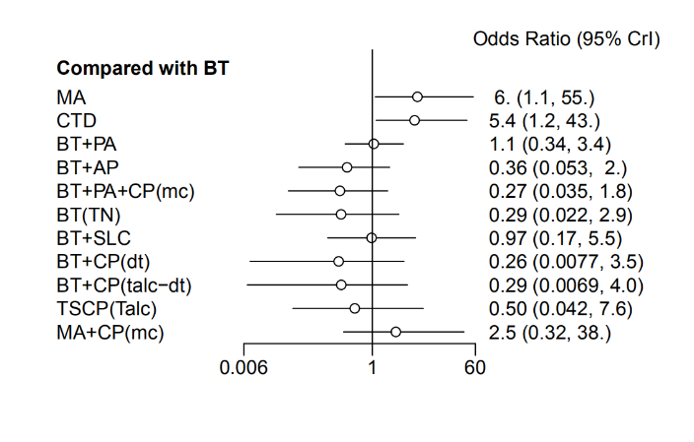 | 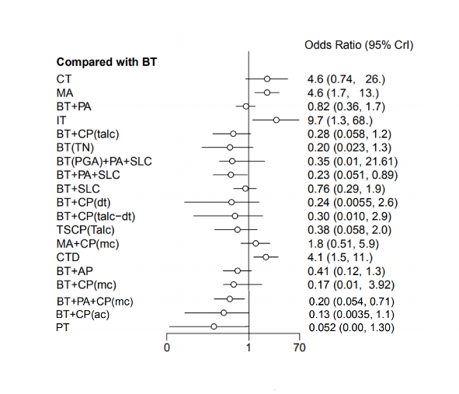
Sensitivity analysis –Random model versus fixed model in NMA
Recurrence rate-random model | Recurrence rate-fixed model
Dbar pD DIC  69.78856 54.29679 124.08535  75 data points, ratio 0.9305, I^2 = 0% | Dbar pD DIC  70.35085 52.42608 122.77693  75 data points, ratio 0.938, I^2 = 0%
Postoperative chest tube duration (days)-random model | Postoperative chest tube duration (days)-fixed model
Dbar pD DIC  42.13483 41.43593 83.57076  42 data points, ratio 1.003, I^2 = 3% | Dbar pD DIC  148.47951 33.03066 181.51016  42 data points, ratio 3.535, I^2 = 72%
Postoperative air leakage duration (days)-random model | Postoperative air leakage duration (days)-fixed model
Dbar pD DIC  10 10 20  10 data points, ratio 1.002, I^2 = 10% | Dbar pD DIC  10 10 20  10 data points, ratio 0.9998, I^2 = 10%
Length of hospital stay (days)-random model | Length of hospital stay (days)-fixed model
Dbar pD DIC  57.97532 57.03234 115.00766  58 data points, ratio 0.9996, I^2 = 2% | Dbar pD DIC  194.03392 46.10506 240.13898  58 data points, ratio 3.345, I^2 = 71%
Rate of the complications-random model | Rate of the complications-fixed model
Dbar pD DIC  32.93011 31.72183 64.65194  46 data points, ratio 0.7159, I^2 = 0% | Dbar pD DIC  32.51087 30.14614 62.65701  46 data points, ratio 0.7068, I^2 = 0%

B. League table of PSP-RCTs (Recurrence rate)

C. SUCRA of PSP-RCTs (Recurrence rate)

Treatment | SUCRA | PrBest | MeanRank
MA | 3.3 | 0.0 | 11.6
CTD | 7.1 | 0.0 | 11.2
BT | 42.9 | 0.0 | 7.3
BT+PA | 39.2 | 0.0 | 7.7
BT+AP | 68.4 | 3.0 | 4.5
BT+PA+CP(mc) | 78.9 | 15.6 | 3.3
BT(TN) | 77.3 | 21.8 | 3.5
BT+SLC | 45.6 | 0.0 | 7.0
BT+CP(dt) | 73.2 | 25.4 | 3.9
BT+CP(talc-dt) | 70.4 | 22.6 | 4.3
TSCP(Talc) | 70.2 | 11.6 | 4.3
MA+CP(mc) | 23.5 | 0.0 | 9.4

Table 15: Subgroup analysis for first episode of PSP versus recurrent PSP

A. Forest plot
First episode of primary spontaneous pneumothorax | Recurrent primary spontaneous pneumothorax
Recurrence rate | Recurrence rate
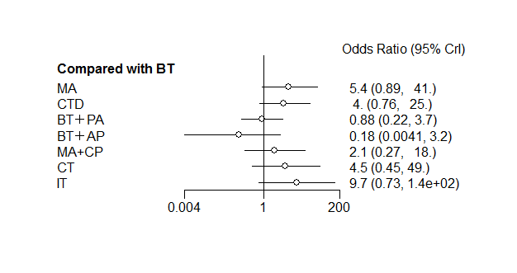 | 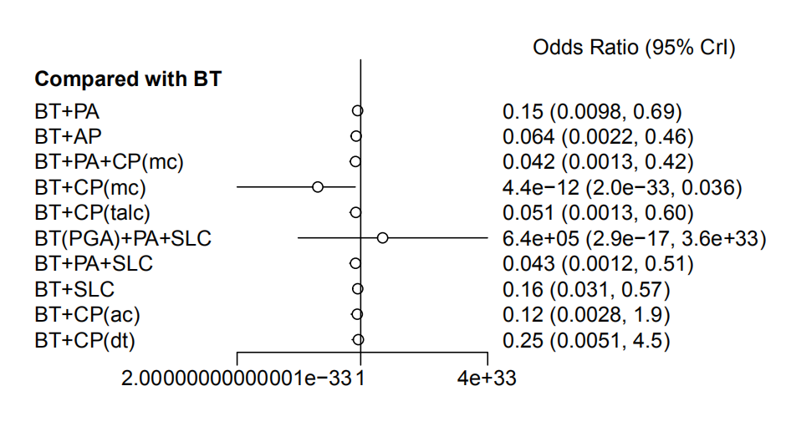

B. League table of first episode of PSP- Recurrence rate

C. League table of recurrent PSP- Recurrence rate

D. SUCRA

First episode of PSP
Treatment | SUCRA | PrBest | MeanRank
MA | 18.9 | 0.0 | 6.7
CTD | 34.4 | 0.0 | 5.6
BT | 75.0 | 5.3 | 2.8
BT+PA | 80.2 | 5.1 | 2.4
BT+AP | 96.7 | 89.2 | 1.2
MA+CP(mc) | 57.3 | 0.3 | 4.0
CT | 31.6 | 0.0 | 5.8
IT | 5.9 | 0.0 | 7.6

Recurrent PSP
Treatment | SUCRA | PrBest | MeanRank
BT | 3.6 | 0.0 | 10.6
BT+PA | 30.0 | 0.0 | 8.0
BT+AP | 55.5 | 1.0 | 5.5
BT+PA+CP(mc) | 70.8 | 8.3 | 3.9
BT+CP(mc) | 76.1 | 39.8 | 3.4
BT+CP(talc) | 69.0 | 7.1 | 4.1
BT(PGA)+PA+SLC | 59.7 | 27.4 | 5.0
BT+PA+SLC | 75.0 | 8.6 | 3.5
BT+SLC | 36.0 | 0.0 | 7.4
BT+CP(ac) | 45.1 | 5.9 | 6.5
BT+CP(dt) | 29.4 | 2.0 | 8.1

Figure 1: Risk of bias
Risk of bias was assessed using the Risk of Bias 2 (RoB2) tool for randomized studies and the Risk of Bias In Nonrandomized Studies (ROBINS-I) tool for nonrandomized studies.

RoB2-RCT (20)

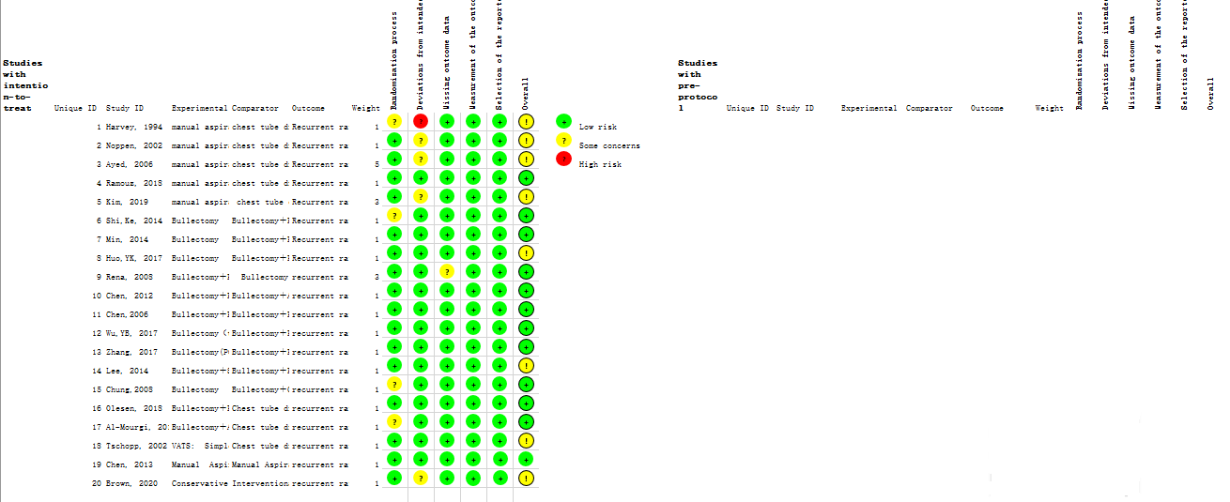

Figure 2: Funnel plots

A. Recurrent rate
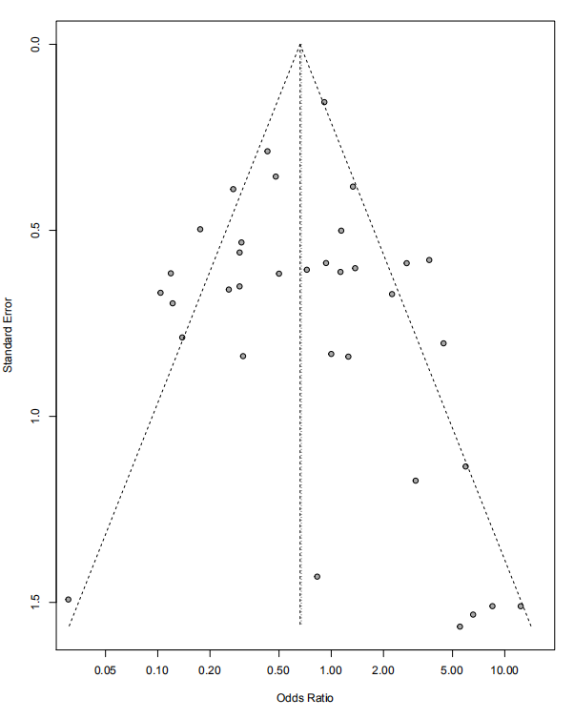
B. Postoperative chest tube duration (days)
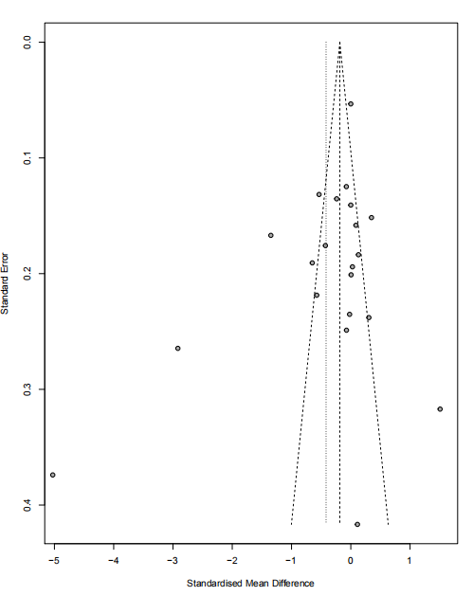

C. Postoperative air leakage duration (days)

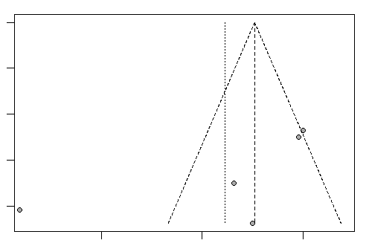

D. Length of hospital stay (days)

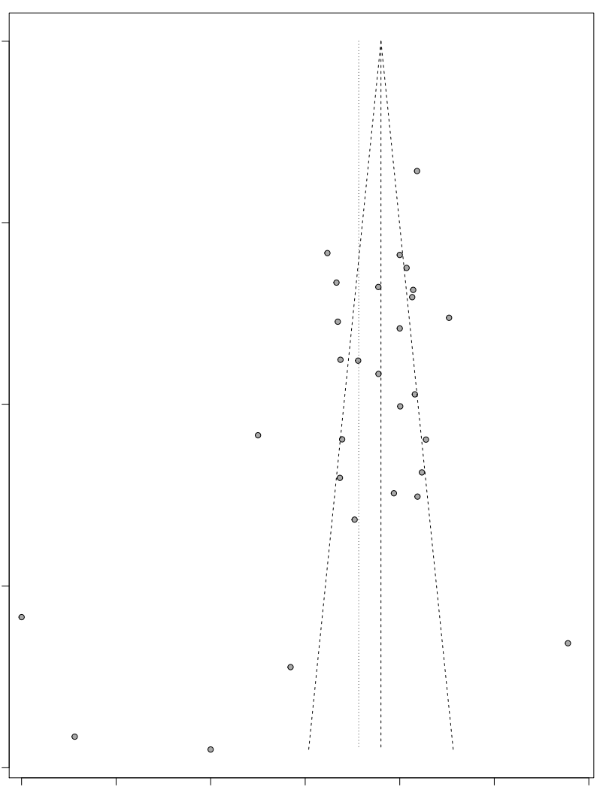
E. Rate of the complications

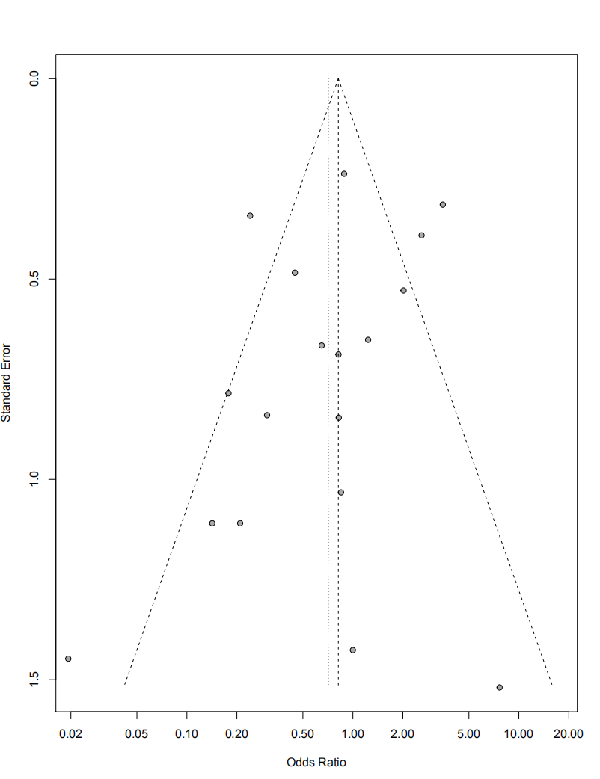

Figure 3: Rank probability- Recurrence rate

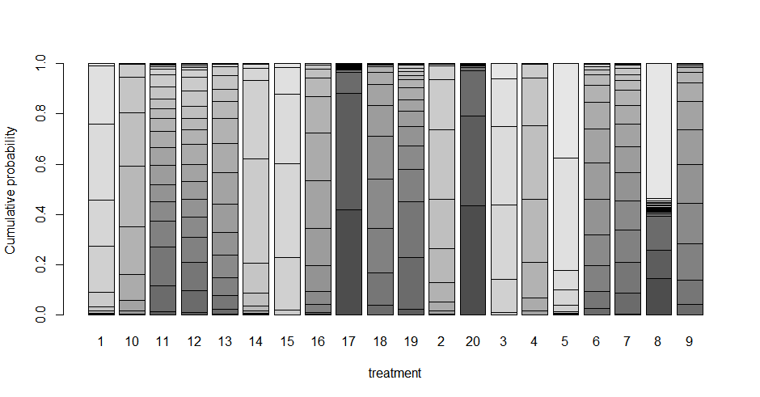
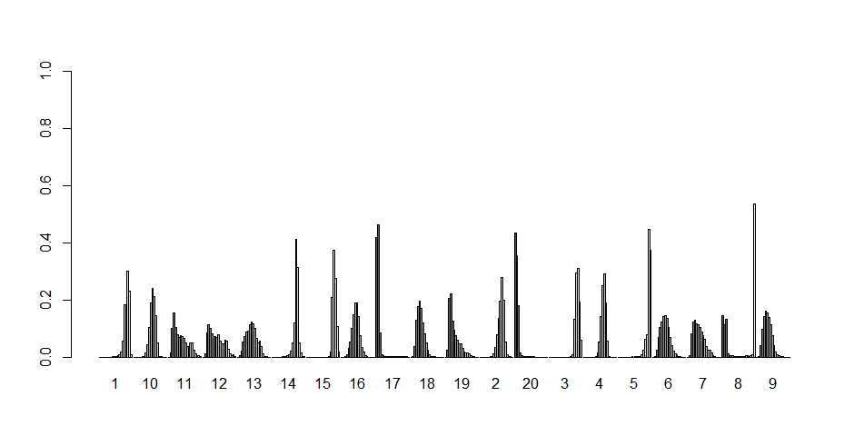
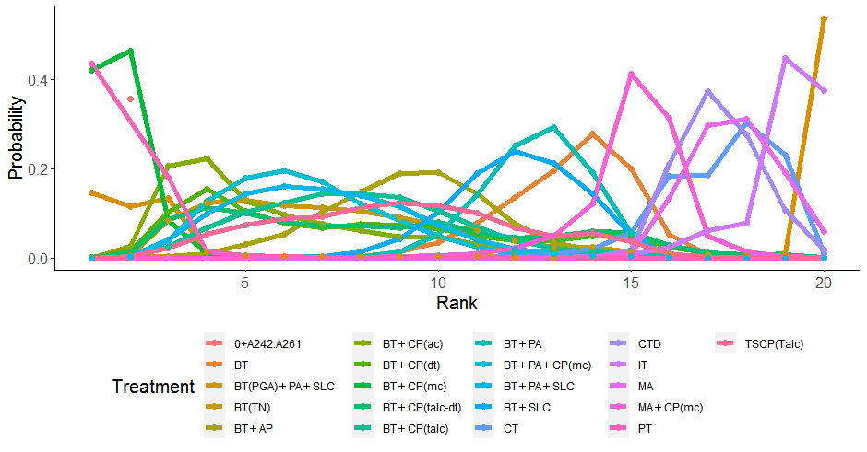
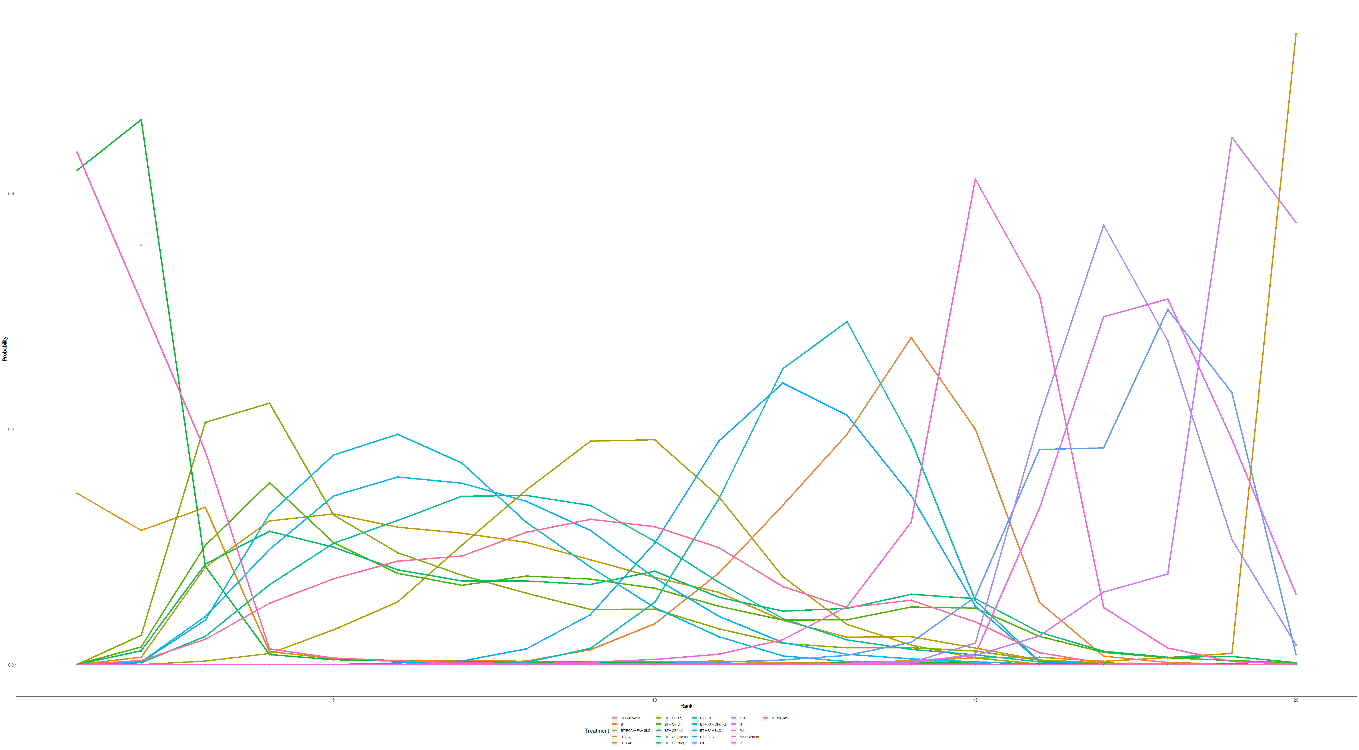
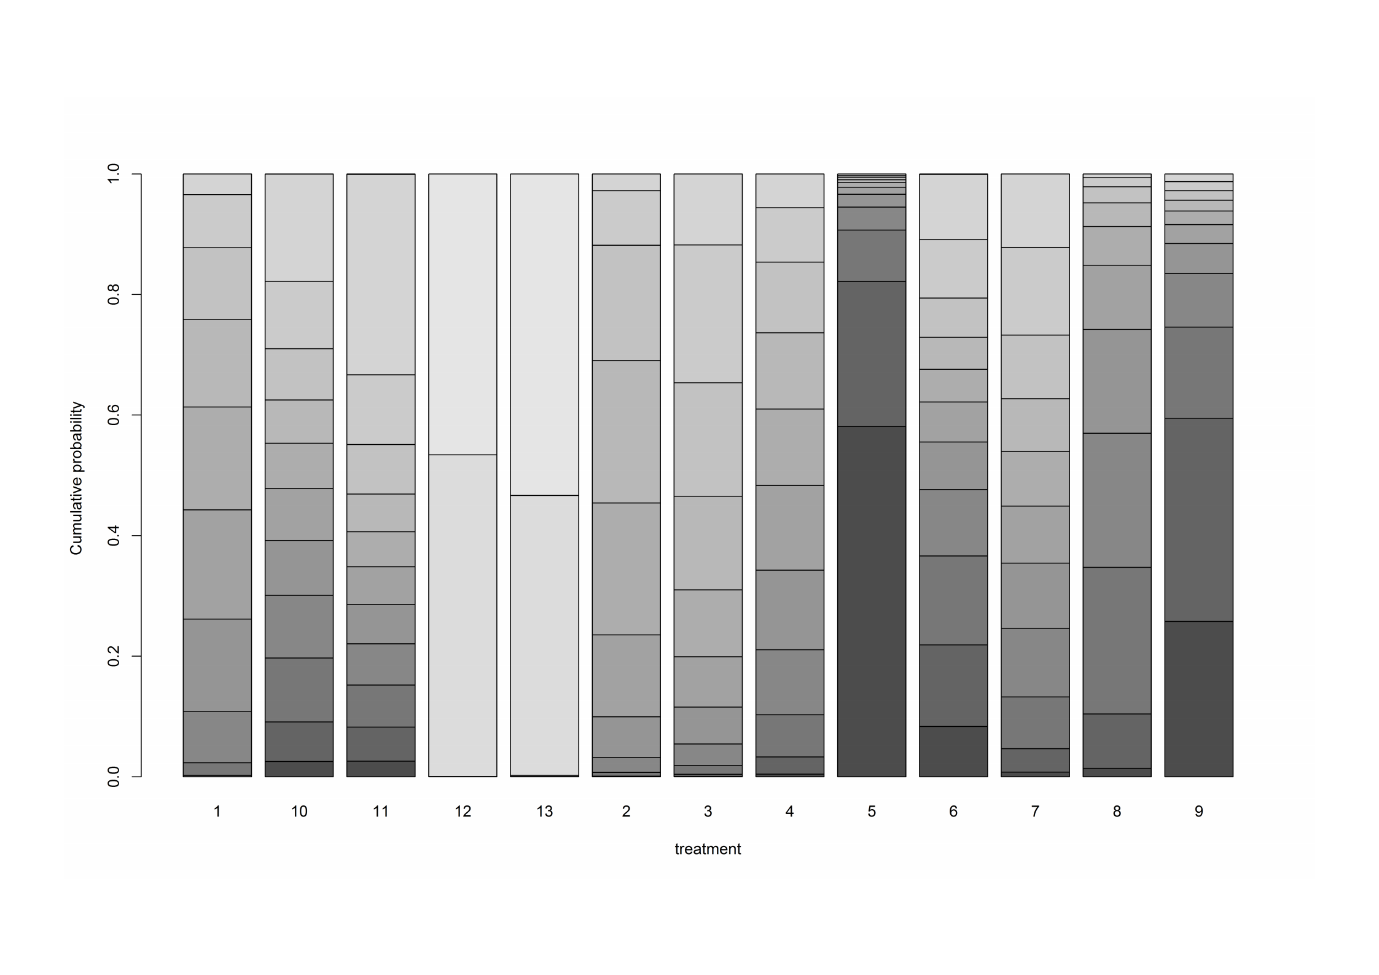
Figure 4: Rank probability- Postoperative chest tube duration (days)
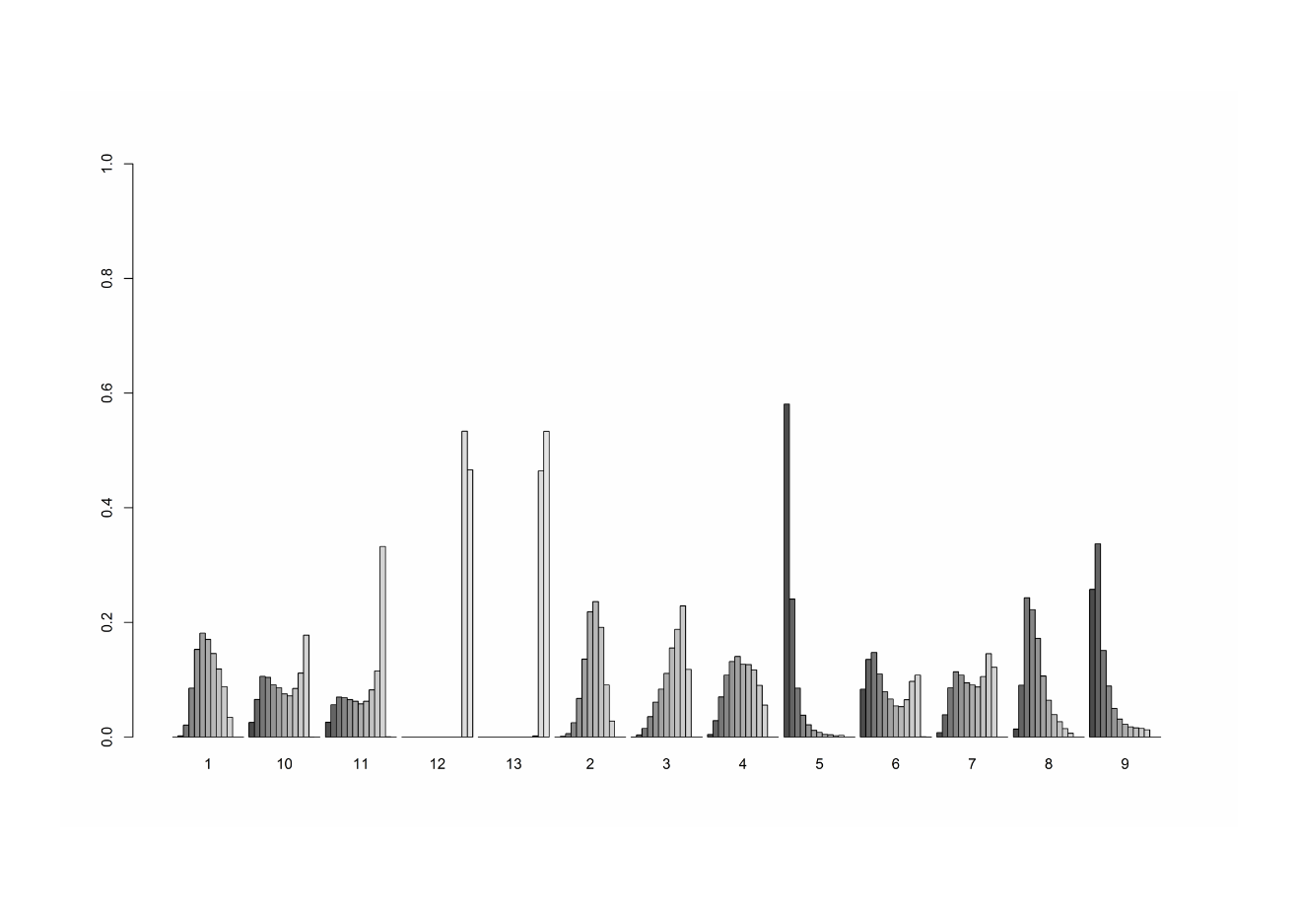
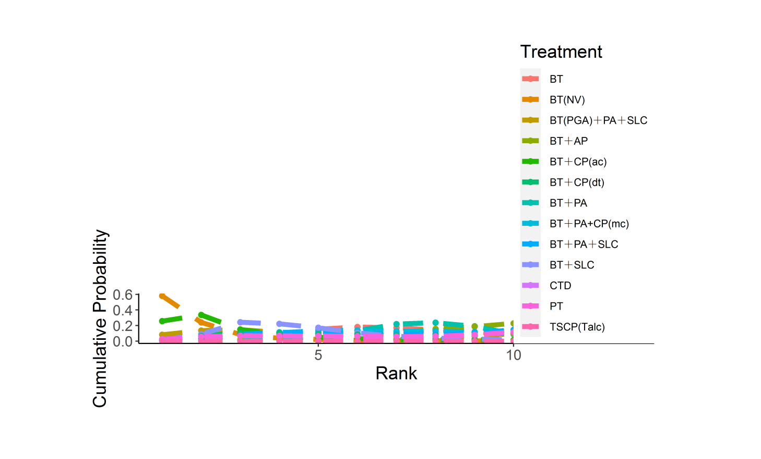
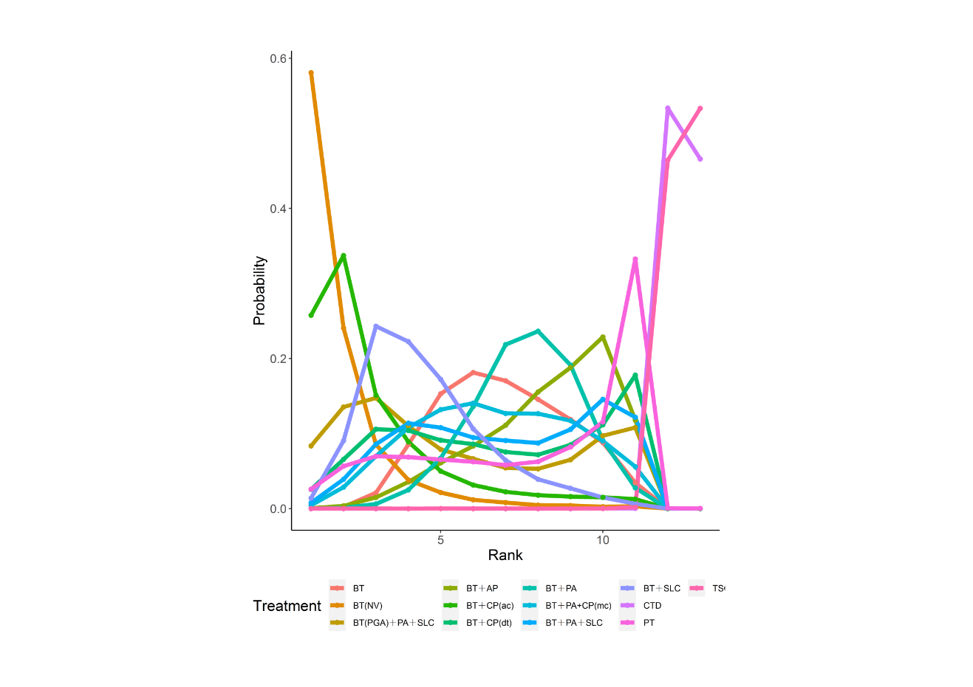
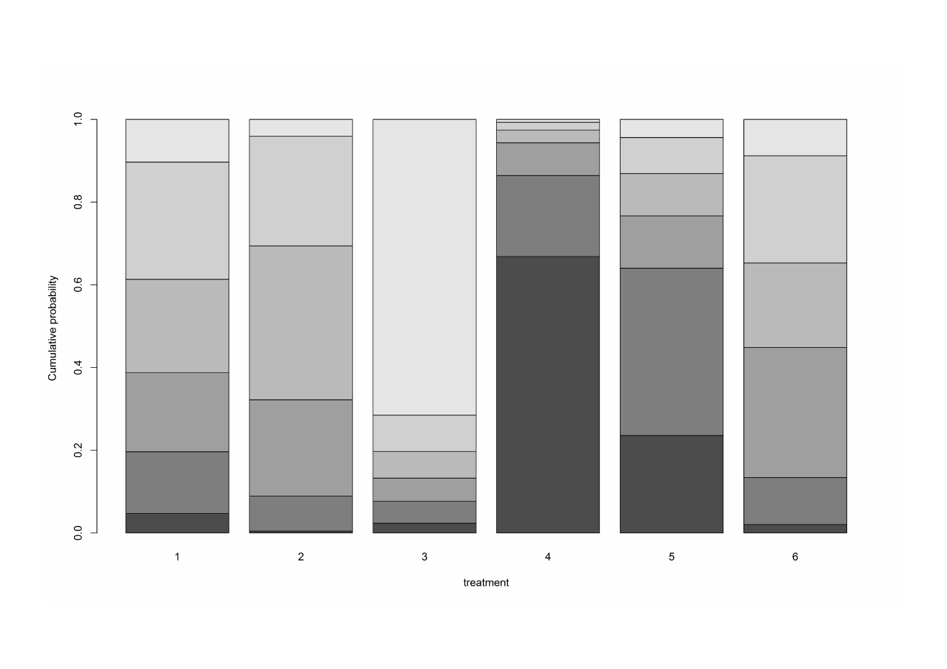
Figure 5: Rank probability- Postoperative air leakage duration (days)
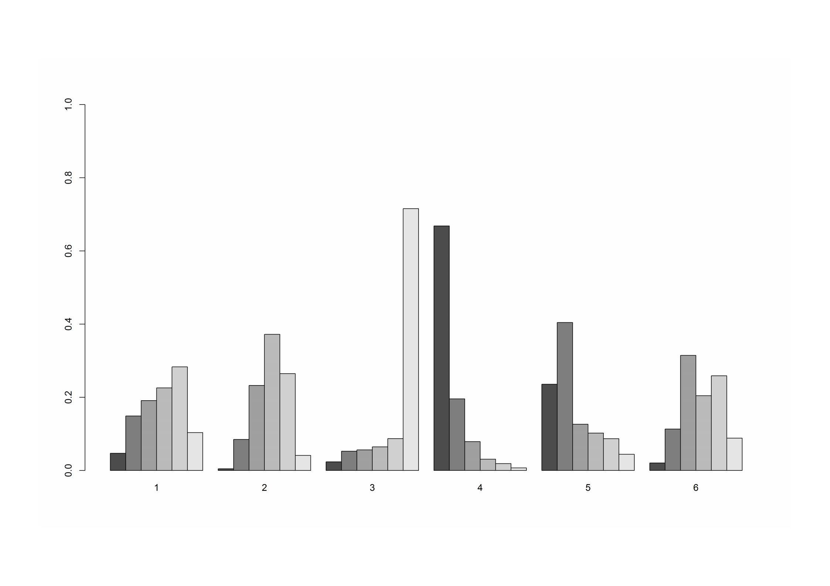
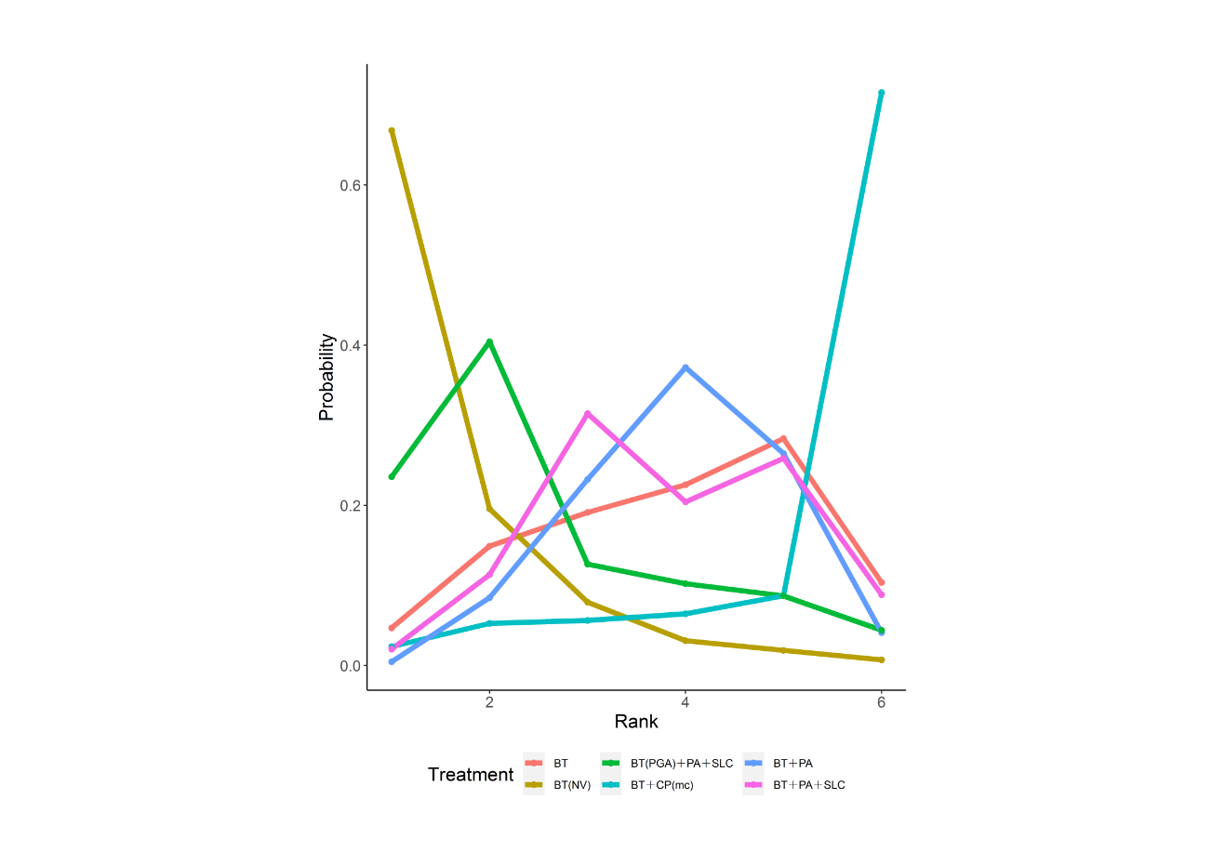
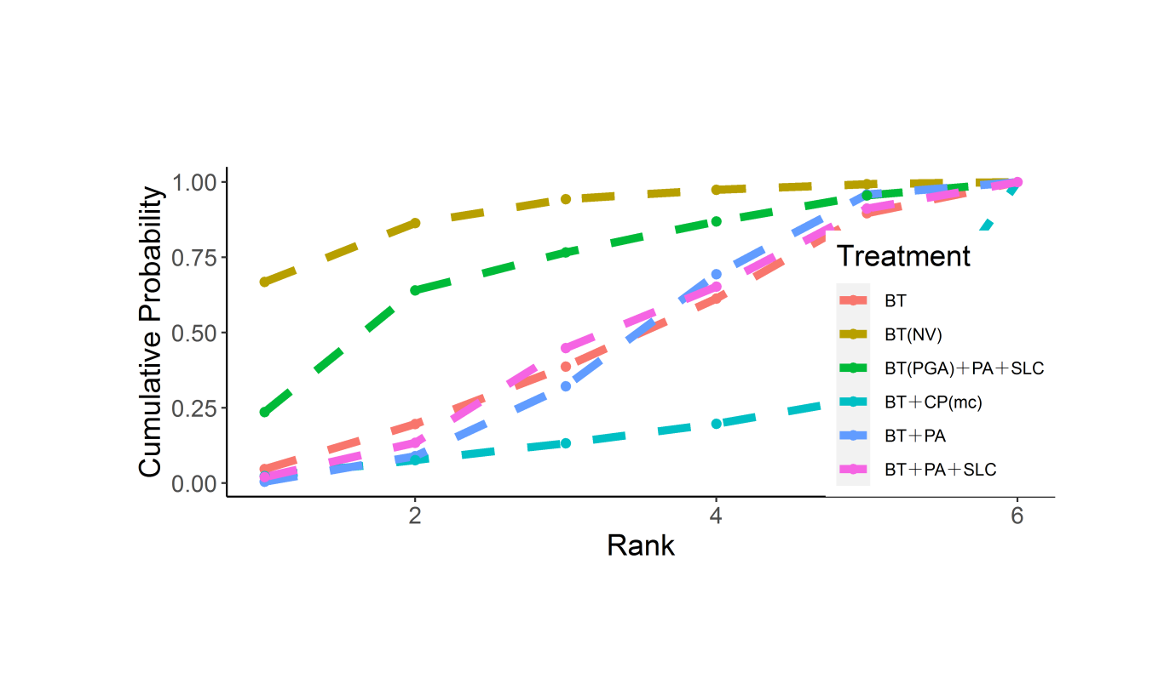
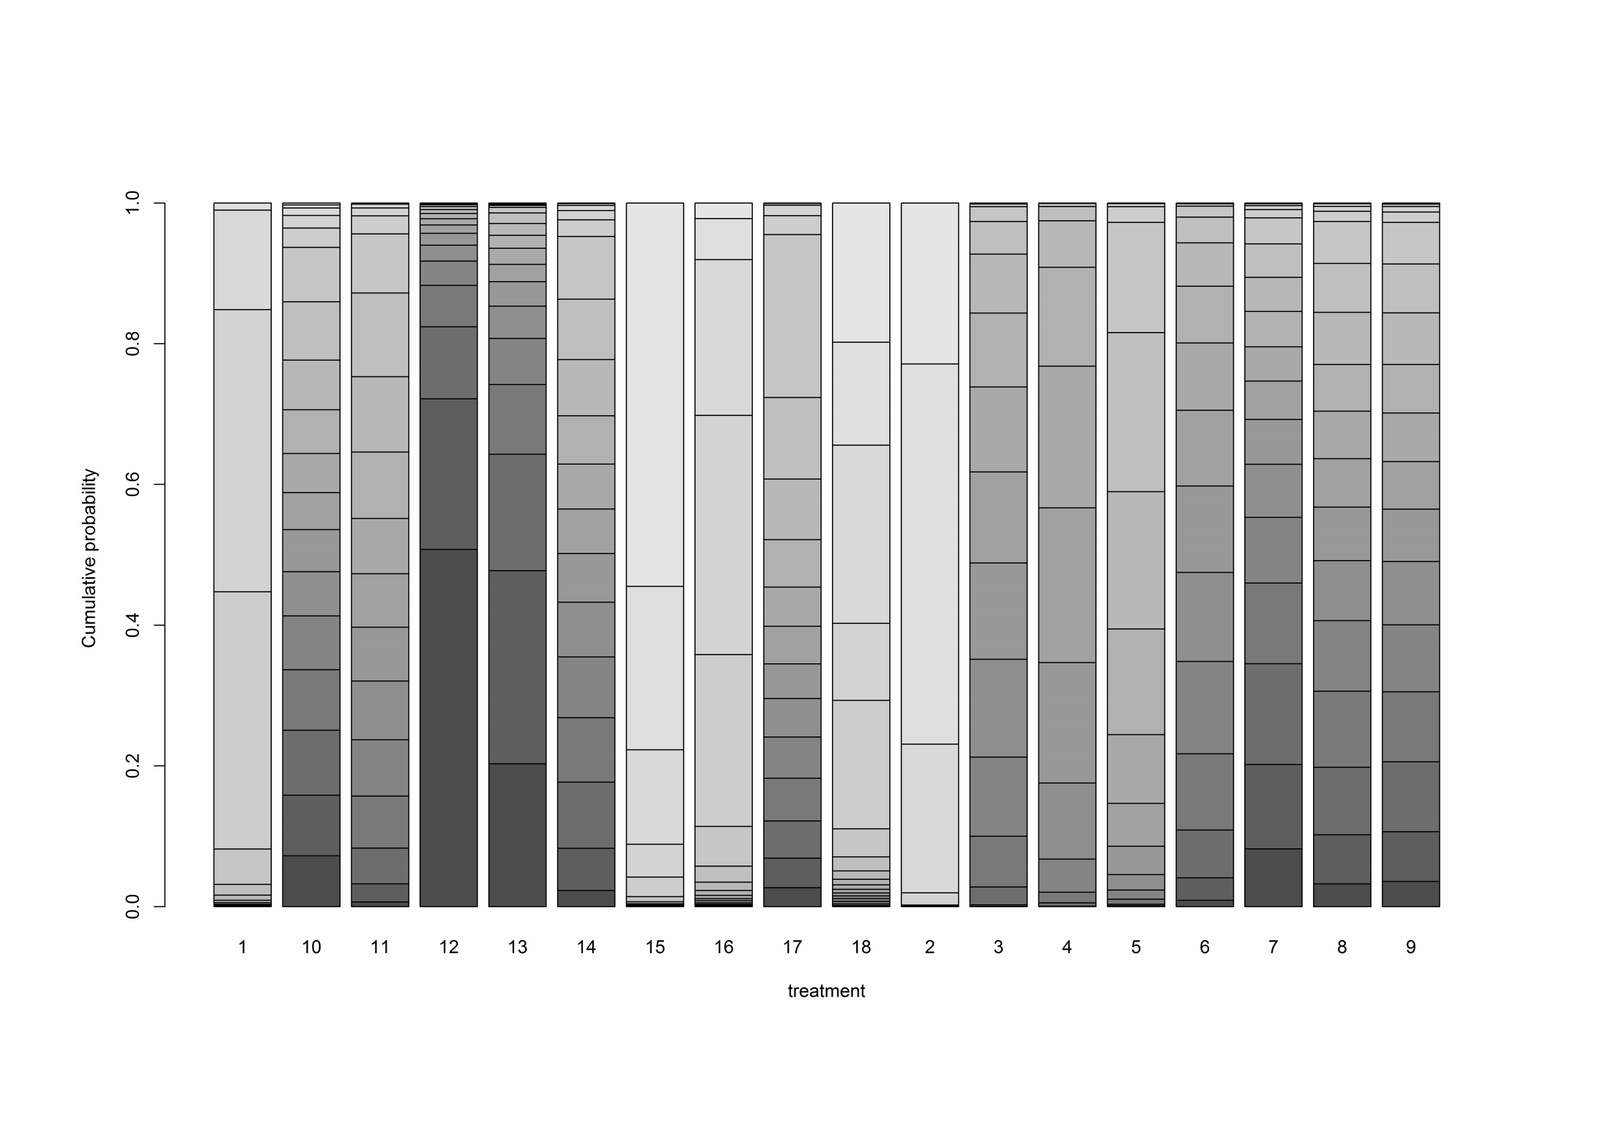
Figure 6: Rank probability- Length of hospital stay (days)
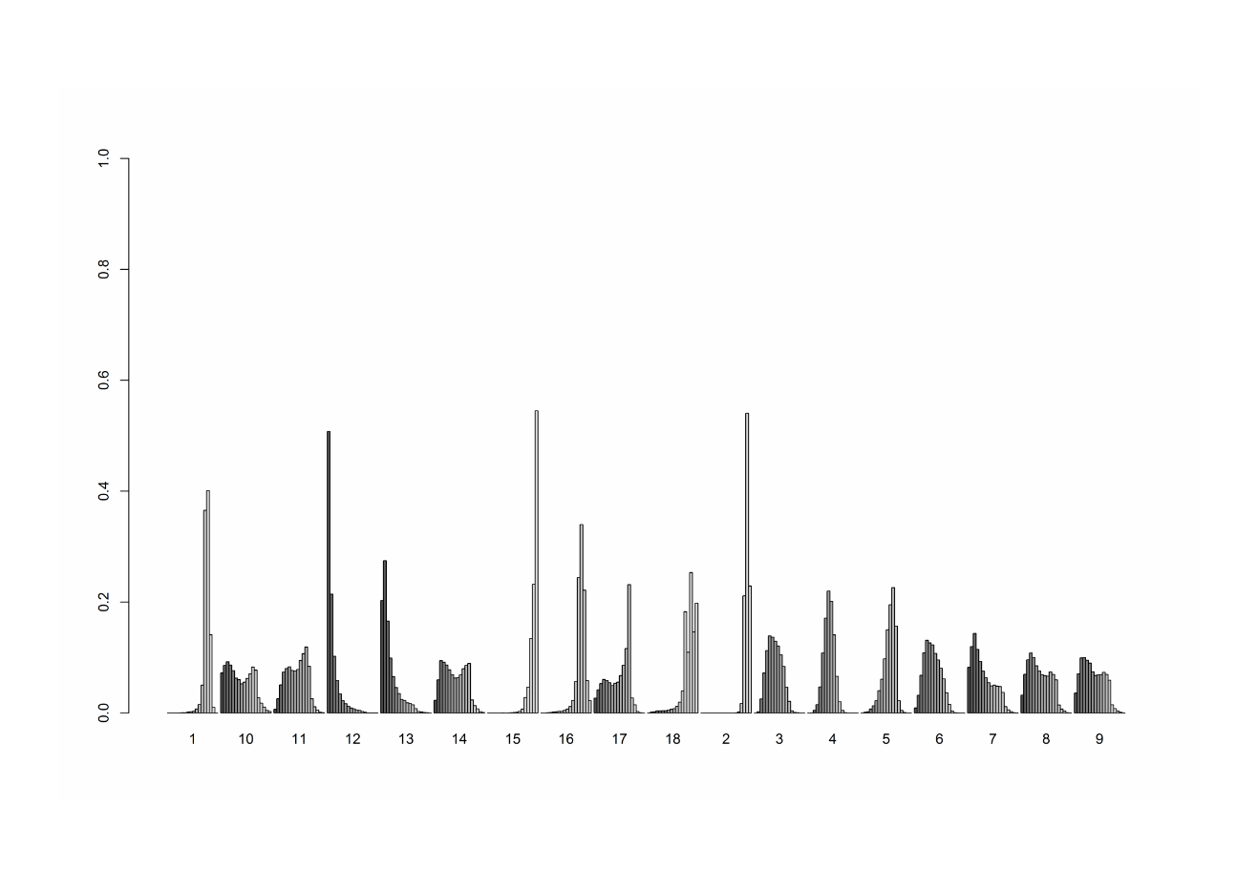

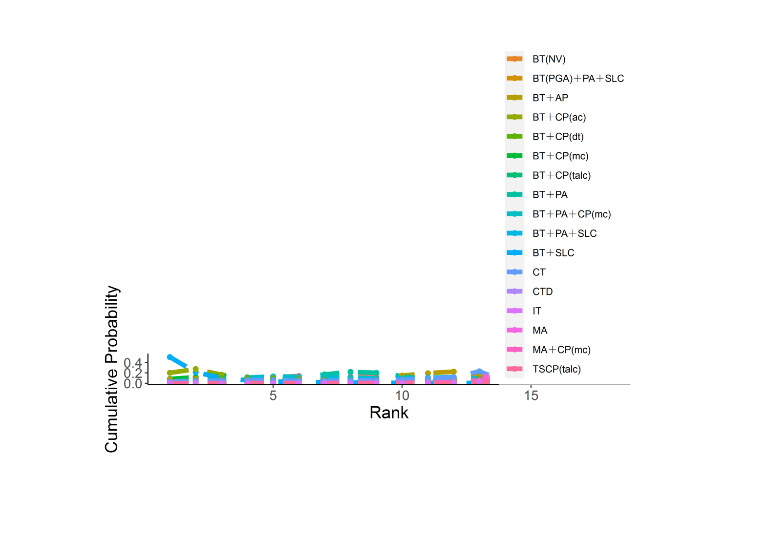
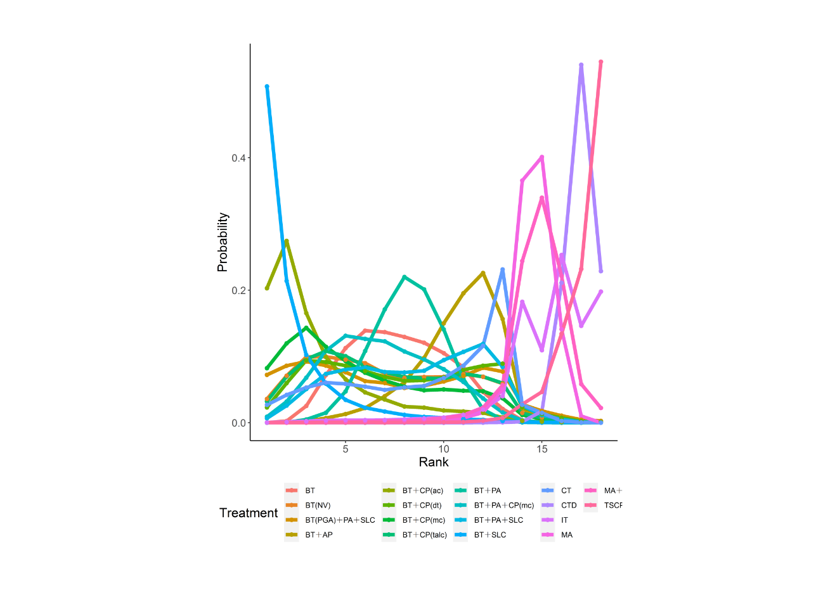
Figure 7: Rank probability- Rate of the complications
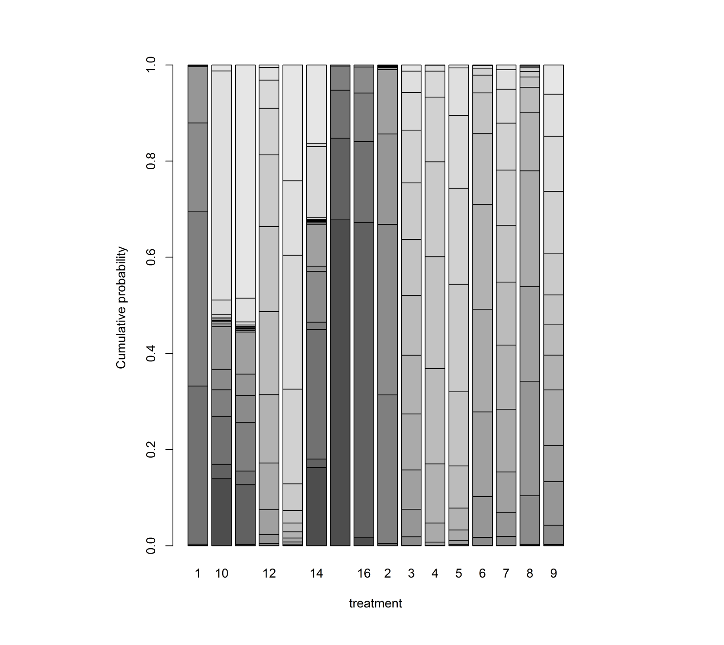
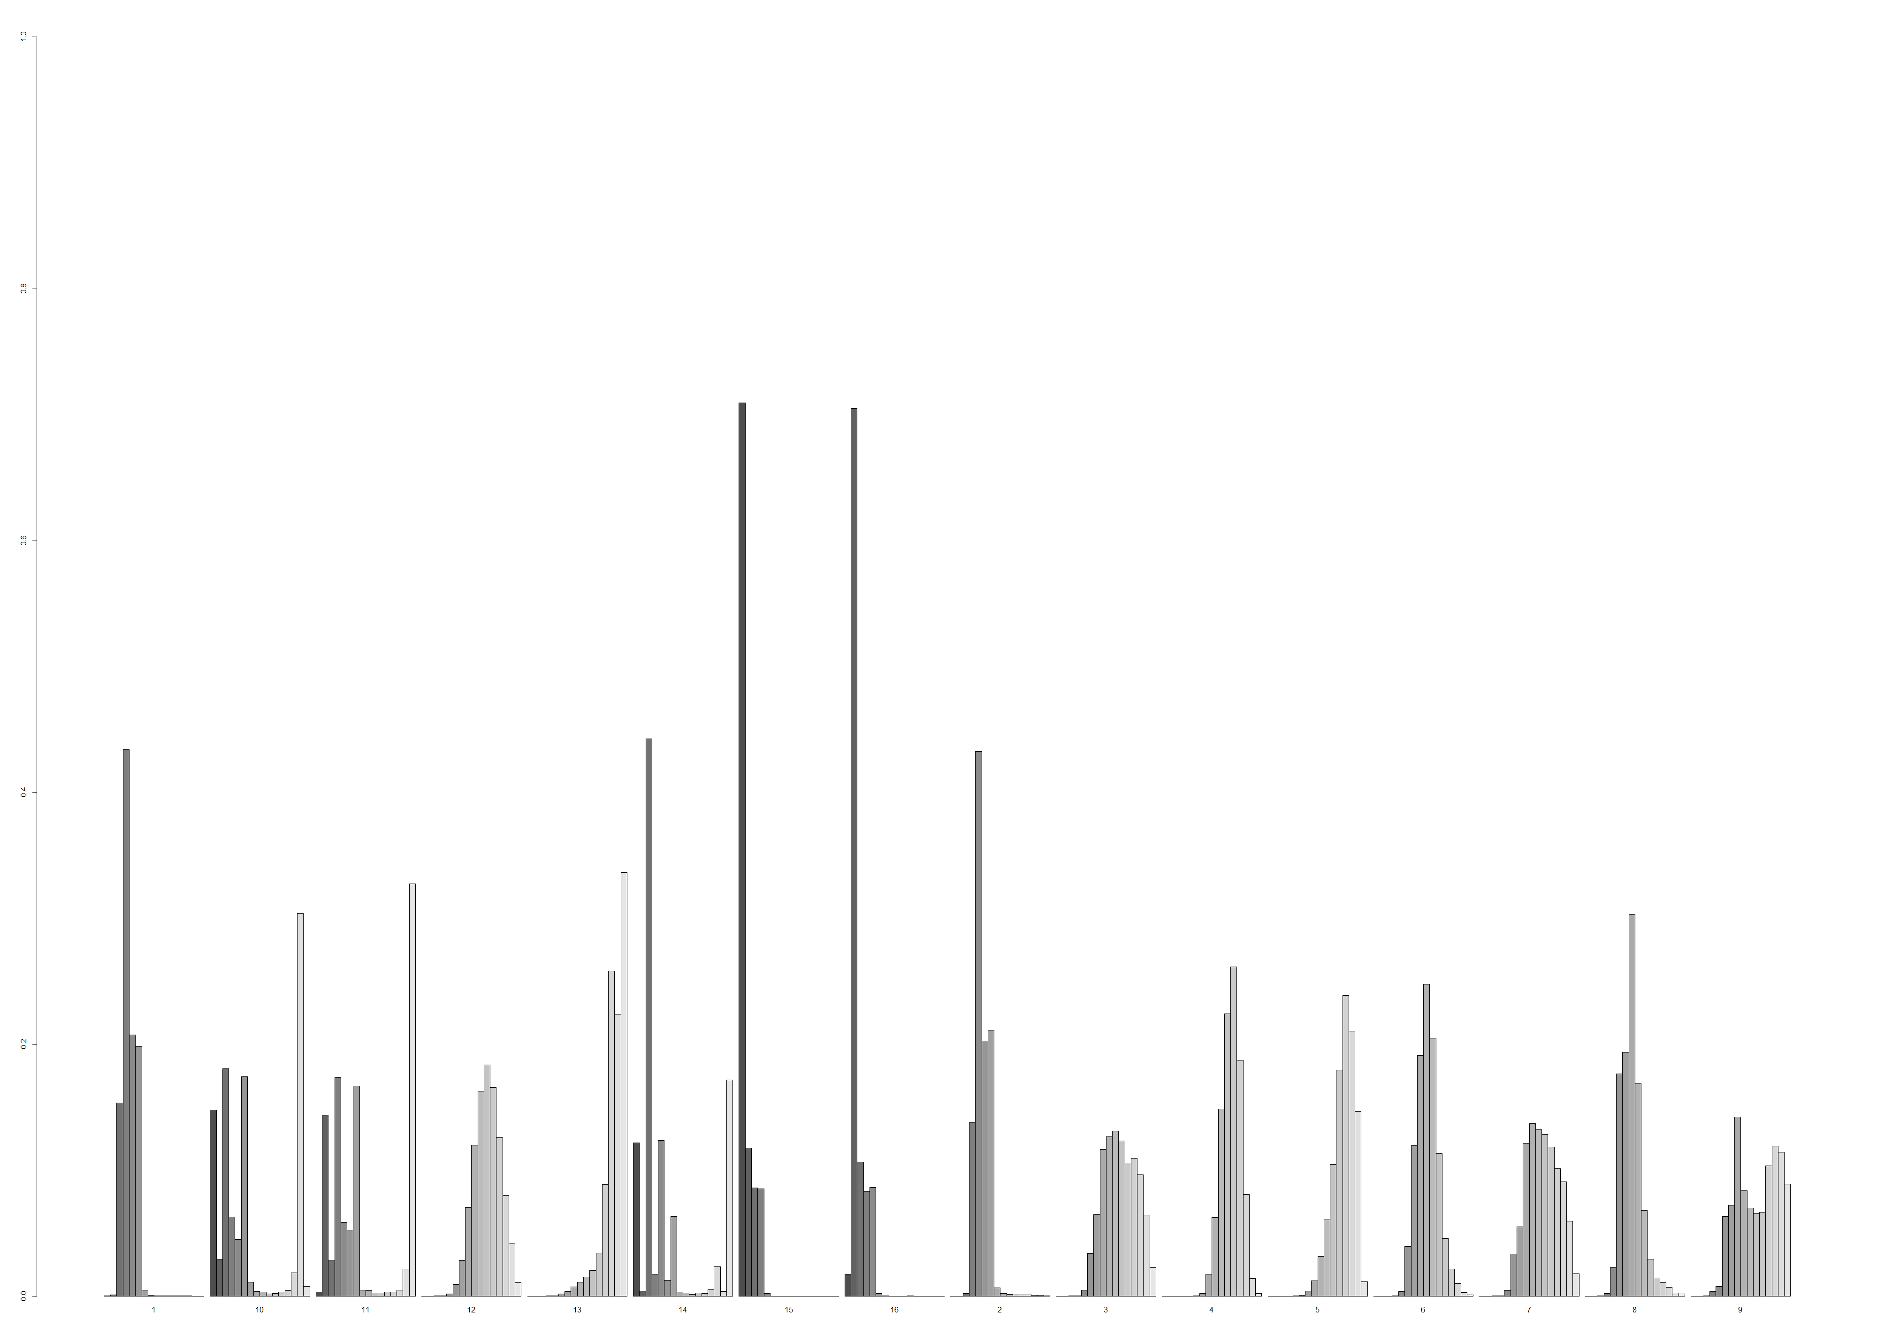

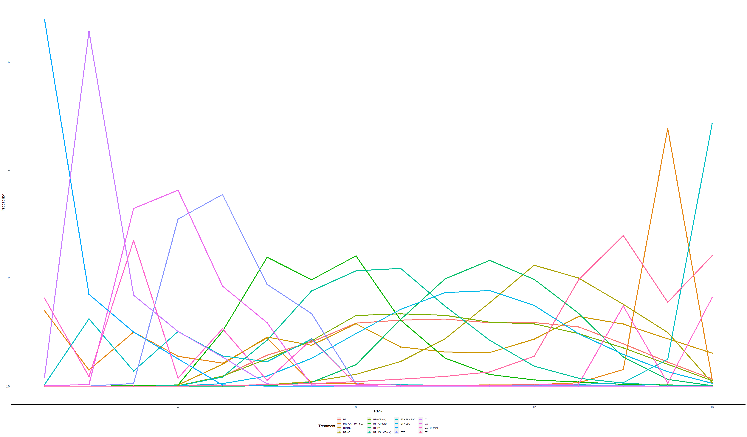
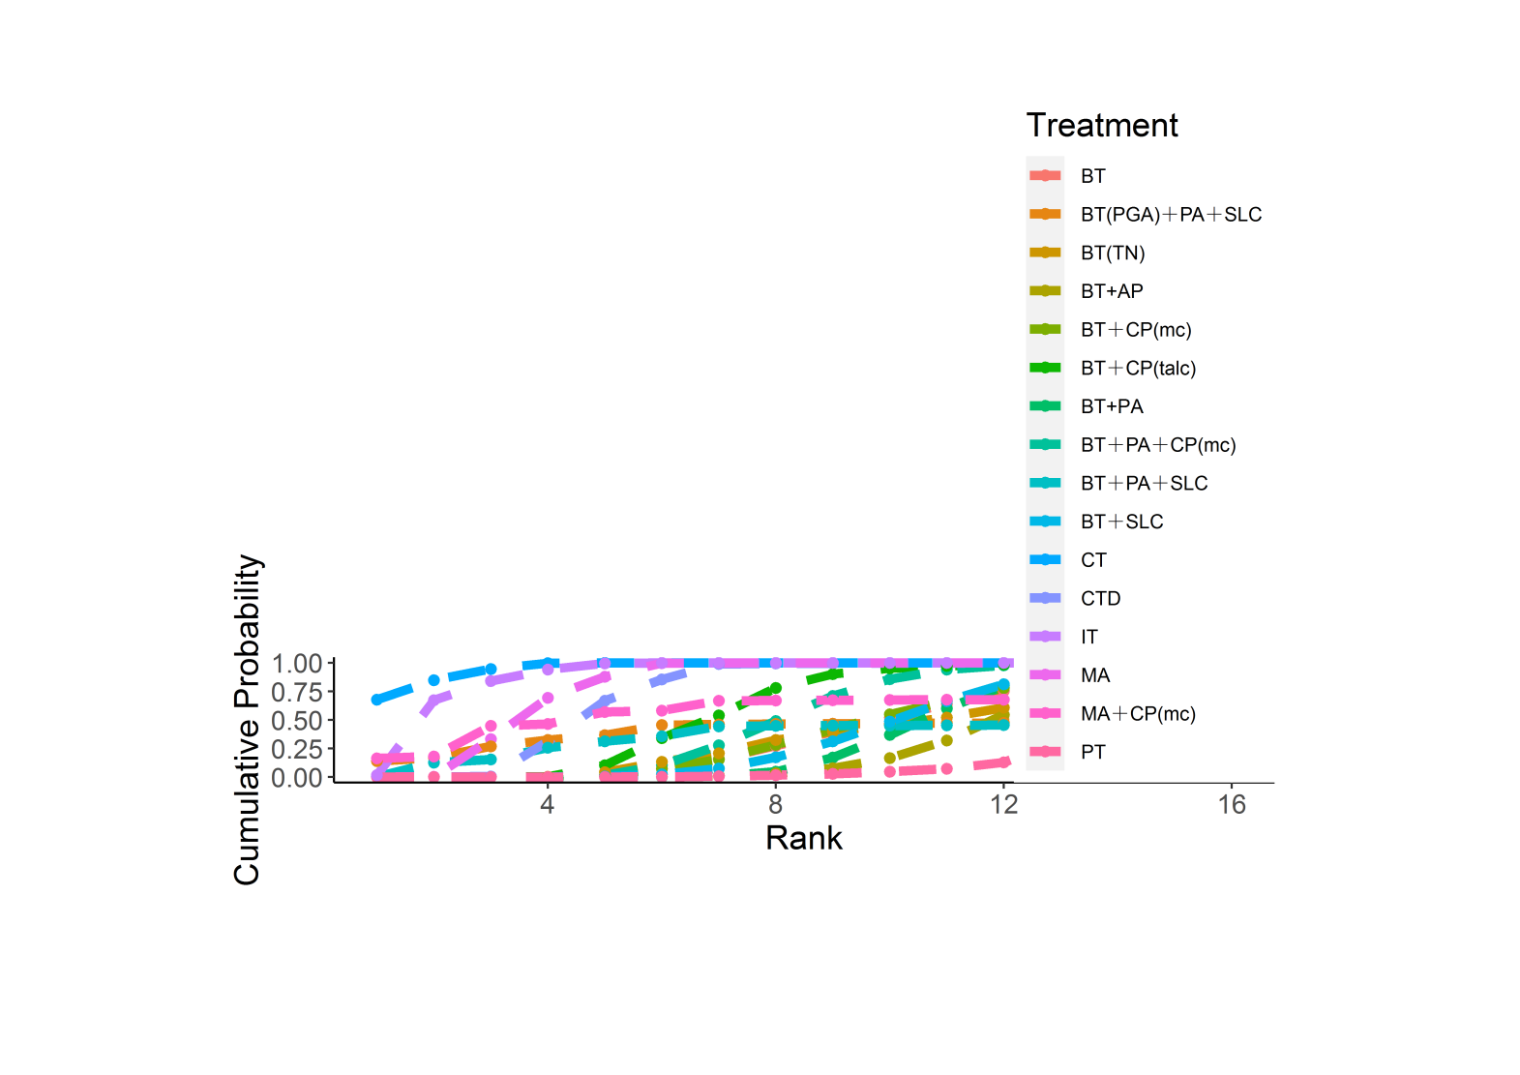

Figure 8: Heterogeneity
A. Recurrence rate

B. Postoperative chest tube duration (days)

C. Length of hospital stay (days)

D. Rate of the complications

Figure 9: Inconsistency

A. Recurrence rate

B. Postoperative chest tube duration (days)

C. Length of hospital stay (days)

D. Rate of the complications
