Supplementary Information

Identification of fungal dihydrouracil-oxidase genes by expression in Saccharomyces cerevisiae

Jonna Bouwknegt¹, Aurin M. Vos¹, Raúl A. Ortiz Merino, Daphne C. van Cuylenburg-Oude Vrielink, Marijke A. H. Luttik and Jack T. Pronk*

Department of Biotechnology, Delft University of Technology, van der Maasweg 9, 2629 HZ Delft, the Netherlands

Manuscript for publication in Antonie van Leeuwenhoek
Category: Fungal and Yeast Microbiology

*Correspondence: Jack T. Pronk, e-mail j.t.pronk@tudelft.nl, tel +31 15 2782416

This PDF file contains:
Figure S1
Table S1-S2

Separate datasets:
Dataset S01: fasta file multiple sequence alignment
Dataset S02: raw phylogenetic tree data
Dataset S03: fasta file blast search
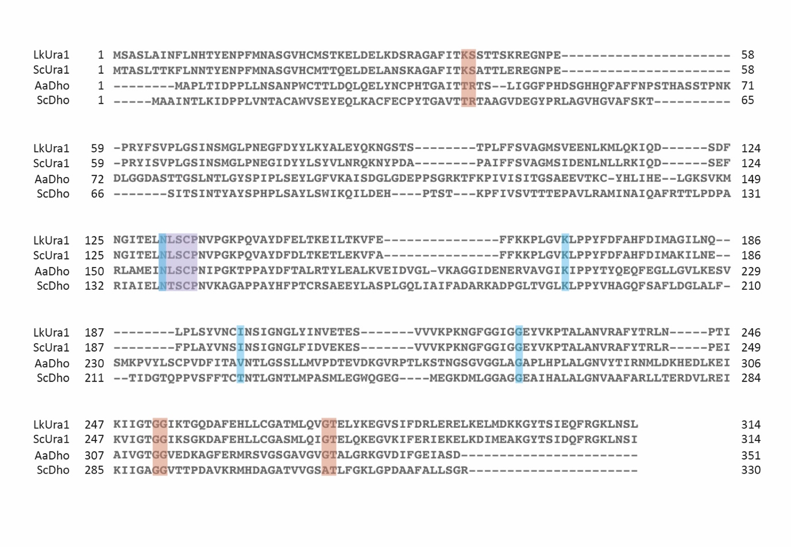Figure S1. Multiple sequence alignment of Ura1 enzymes and DHUO enzymes. Class-I-A protein sequences of S. cerevisiae (ScUra1) and L. kluyveri (LkUra1) and DHUO proteins of A. alternata (AaDho) and Sch. commune (ScDho) were subjected to a multiple sequence alignment in Clustal Omega using default settings. Based on protein sequence similarity, predicted functional sites (The UniProt Consortium 2019) were shown. Purple; active site (NxSCP), Blue; binding sites FMN, Red; nucleotide binding of FMN.
Table S1. 10 highest scoring bacterial homologs for a blastp search with Ura1-orthologs from mucormycota a. A blastp (NCBI; (Camacho et al. 2009)) search in available proteomes of bacteria (taxid:2) was performed using Ura1-orthologs of Mucoromycota fungi (Figure 1), S. cerevisiae (ScUra1) or L. kluyveri (LkUra1) as query. The ten proteins with highest similarity and their respective host, were presented in this table. Results are presented with the host organism (top), GenBank accession number of the protein (middle), and E-value (bottom).

Query  Organism  Protein | Rhizopus azygosporus  A0A367JNI9 | Rhizopus azygosporus  A0A367JHE7 | Rhizopus microsporus  A0A2G4SIK6 | Rhizopus delamar  I1BT22 | Parasitella parasiticas  A0A0B7NIC1 | Mucor ambiguus  A0A0C9MDX3 | Absidia glauca  A0A168QAJ3 | Phycomyces blakeleeanus  A0A167N250 | Saccharomyces cerevisiae  P28272 | Lachancea kluyveri  Q7Z892
1 | Laribacter honkongensis  WP_027824372.1  4·10⁻¹³⁷ | Laribacter honkongensis  WP_027824372.1  4·10⁻¹³⁷ | Crenobacter cavernae  WP_129210658.1  4·10⁻¹³⁶ | Crenobacter cavernae  WP_129210658.1  5·10⁻¹³⁷ | Crenobacter cavernae  WP_115431880.1  5·10⁻¹³⁷ | Crenobacter cavernae  WP_129210658.1  5·10⁻¹³⁸ | Jeongeupia naejangsanensis  WP_203537192.1  5·10⁻¹³⁸ | Laribacter sp.  MBP8813637.1  2·10⁻¹³⁵ | Enterococcus sp. CU12B  KAF1305604.1  6·10⁻¹⁷³ | Enterococcus mediterraneensis  WP_122646993.1  2·10⁻¹⁷⁸
2 | Laribacter honkongensis  WP_012696339.1  7·10⁻¹³⁷ | Laribacter honkongensis  WP_012696339.1  7·10⁻¹³⁷ | Laribacter honkongensis  WP_027824372.1  5·10⁻¹³⁶ | Crenobacter cavernae  WP_115431880.1  2·10⁻¹³⁶ | Crenobacter cavernae  WP_129210658.1  2·10⁻¹³⁶ | Crenobacter cavernae  WP_115431880.1  2·10⁻¹³⁷ | Laribacter sp.  MBP8813637.1  2·10⁻¹³⁷ | Laribacter honkongensis  WP_027824372.1  7·10⁻¹³⁵ | Enterococcus sp. CU12B  WP_202622260.1  7·10⁻¹⁷³ | Enterococcus massiliensis  WP_048602930.1  3·10⁻¹⁷⁶
3 | Crenobacter cavernae  WP_129210658.1  1·10⁻¹³⁶ | Crenobacter cavernae  WP_129210658.1  4·10⁻¹³⁶ | Laribacter honkongensis  WP_012696339.1  1·10⁻¹³⁵ | Jeongeupia sp. USM3  WP_070525525.1  5·10⁻¹³⁶ | Jeongeupia naejangsanensis  WP_203537192.1  6·10⁻¹³⁶ | Laribacter honkongensis  WP_027824372.1  3·10⁻¹³⁶ | Chitiniphilus shinanonensis  WP_040430830.1  3·10⁻¹³⁷ | Laribacter honkongensis  WP_012696339.1  2·10⁻¹³⁴ | Enterococcus faecalis  WP_034862897.1  2·10⁻¹⁷² | Enterococcus Sp. DIV2402  WP_207940501.1  1·10⁻¹⁷⁴
4 | Crenobacter cavernae  WP_115431880.1  2·10⁻¹³⁵ | Crenobacter cavernae  WP_115431880.1  1·10⁻¹³⁵ | Crenobacter cavernae  WP_115431880.1  2·10⁻¹³⁵ | Jeongeupia naejangsanensis  WP_203537192.1  5·10⁻¹³⁶ | Laribacter honkongensis  WP_027824372.1  6·10⁻¹³⁵ | Laribacter honkongensis  WP_012696339.1  5·10⁻¹³⁶ | Jeongeupia sp. USM3  WP_070525525.1  3·10⁻¹³⁶ | Jeongeupia naejangsanensis  WP_203537192.1  4·10⁻¹³⁰ | Enterococcus gallinarum  WP_117474532.1  3·10⁻¹⁷² | Unclassified Enterococcus  WP_165005935.1  2·10⁻¹⁷⁴
5 | Laribacter sp.  MBP8813637.1  3·10⁻¹³⁵ | Laribacter sp.  MBP8813637.1  2·10⁻¹³⁵ | Jeongeupia naejangsanensis  WP_203537192.1  2·10⁻¹³⁴ | Jeongeupia chitinilytica  WP_189458989.1  2·10⁻¹³⁴ | Jeongeupia sp. USM3  WP_070525525.1  6·10⁻¹³⁵ | Crenobacter luteus  WP_082824196.1  8·10⁻¹³⁶ | Laribacter honkongensis  WP_012696339.1  4·10⁻¹³⁶ | Jeongeupia sp. USM3  WP_070525525.1  1·10⁻¹²⁹ | Enterococcus  WP_029486858.1  3·10⁻¹⁷² | Enterococcus sp. DIV1271a  WP_207699663.1  2·10⁻¹⁷³
6 | Jeongeupia chitinilytica  WP_189458989.1  1·10⁻¹³⁴ | Jeongeupia naejangsanensis  WP_203537192.1  1·10⁻¹³⁴ | Laribacter sp.  MBP8813637.1  3·10⁻¹³⁴ | Laribacter honkongensis  WP_027824372.1  5·10⁻¹³⁴ | Crenobacter luteus  WP_082824196.1  9·10⁻¹³⁵ | Crenobacter luteus  WP_131862996.1  1·10⁻¹³⁵ | Crenobacter cavernae  WP_115431880.1  5·10⁻¹³⁶ | Crenobacter cavernae  WP_115431880.1  7·10⁻¹²⁹ | Enterococcus sp. DIV2402  WP_207940501.1  1·10⁻¹⁷¹ | Enterococcus sp. DIV1298c  WP_207115710.1  3·10⁻¹⁷³
7 | Crenobacter luteus  WP_082824196.1  9·10⁻¹³⁴ | Jeongeupia chitinilytica  WP_189458989.1  4·10⁻¹³⁴ | Jeongeupia sp. USM3  WP_070525525.1  1·10⁻¹³³ | Laribacter honkongensis  WP_012696339.1  9·10⁻¹³⁴ | Laribacter honkongensis  WP_012696339.1  1·10⁻¹³⁴ | Laribacter sp.  MBP8813637.1  2·10⁻¹³⁵ | Crenobacter cavernae  WP_129210658.1  1·10⁻¹³⁵ | Crenobacter cavernae  WP_129210658.1  2·10⁻¹²⁸ | Enterococcus  WP_003127297.1  2·10⁻¹⁷¹ | Enterococcus  WP_071867076.1  3·10⁻¹⁷³
8 | Crenobacter luteus  WP_131862996.1  6·10⁻¹³² | Crenobacter luteus  WP_082824196.1  1·10⁻¹³² | Crenobacter luteus  WP_082824196.1  4·10⁻¹³² | Laribacter sp.  MBP8813637.1  4·10⁻¹³³ | Crenobacter luteus  WP_131862996.1  1·10⁻¹³⁴ | Jeongeupia naejangsanensis  WP_203537192.1  3·10⁻¹³⁴ | Laribacter honkongensis  WP_027824372.1  2·10⁻¹³⁵ | Chitinibacter tainanensis  WP_034619876.1  3·10⁻¹²⁸ | Enterococcus  WP_138371833.1  3·10⁻¹⁷¹ | Enterococcus DIV1094  WP_206854181.1  4·10⁻¹⁷³
9 | Jeongeupia sp. HS-3  WP_200917361.1  1·10⁻¹³¹ | Crenobacter luteus  WP_131862996.1  7·10⁻¹³² | Crenobacter luteus  WP_131862996.1  1·10⁻¹³¹ | Crenobacter luteus  WP_082824196.1  1·10⁻¹³¹ | Jeongeupia chitinilytica  WP_189458989.1  2·10⁻¹³⁴ | Jeongeupia sp. USM3  WP_070525525.1  4·10⁻¹³⁴ | Chitiniphilus eburneus  WP_136774475.1  2·10⁻¹³⁵ | Chitinibacter sp. 2T18  WP_179358028.1  4·10⁻¹²⁸ | Enterococcus mundtii  WP_195339280.1  3·10⁻¹⁷¹ | Enterococcus mundtii  WP_115357638.1  4·10⁻¹⁷³
10 | Uliginosibacterium sp.  MBK9218298.1  3·10⁻¹³¹ | Uliginosibacterium sp.  MBK9218298.1  9·10⁻¹³² | Uliginosibacterium sp.  MBK9218298.1  1·10⁻¹³¹ | Crenobacter luteus  WP_131862996.1  1·10⁻¹³¹ | Chitinibacter sp. 2T18  WP_179358028.1  3·10⁻¹³³ | Crenobacter luteus  KZE30316.1  4·10⁻¹³³ | Jeongeupia chitinilytica  WP_189458989.1  4·10⁻¹³⁵ | Uliginosibacterium sp.  MBK9218298.1  4·10⁻¹²⁸ | Enterococcus gallinarum  WP_156247377.1  4·10⁻¹⁷¹ | Enterococcus mundtii  WP_074799017.1  4·10⁻¹⁷³

Table S2. Oligonucleotides used in this study.
Number | 5' sequence
6005 | GATCATTTATCTTTCACTGCGGAGAAG
7823 | ATCCGTCGAAACTAAGTTCTGG
7998 | AAGCTTATCGATACCGTCGACC
11334 | TGCGCATGTTTCGGCGTTCGAAACTTCTCCGCAGTGAAAGATAAATGATCGGTACAGAATTACAAAAAGAGTTTTAGAGCTAGAAATAGCAAGTTAAAATAAGGCTAGTCCGTTATCAAC
11335 | GTTGATAACGGACTAGCCTTATTTTAACTTGCTATTTCTAGCTCTAAAACTCTTTTTGTAATTCTGTACCGATCATTTATCTTTCACTGCGGAGAAGTTTCGAACGCCGAAACATGCGCA
11336 | TAGACGTTTCAAATAGATATACACAATTACTCAAAAAAAAATTGAACTTCCGTACCAAACTTATCGGAATTTGAAGAACTATGATGGGACAAGTTATGGAAGAGTGTTAAGATTCGTATG
11337 | CATACGAATCTTAACACTCTTCCATAACTTGTCCCATCATAGTTCTTCAAATTCCGATAAGTTTGGTACGGAAGTTCAATTTTTTTTTGAGTAATTGTGTATATCTATTTGAAACGTCTA
12363 | AGAACTTAGTTTCGACGGATGCCACGTGTCTTGTCCAGAG
12364 | TCGACGGTATCGATAAGCTTGTGCTCCAGGTACCTTATCTAC
12365 | AGAACTTAGTTTCGACGGATCAGAGCTCATGGCTCCATTGAC
12366 | TCGACGGTATCGATAAGCTTTCTTGTGCTCCAGGTACCTTAG
12479 | TAGACGTTTCAAATAGATATACACAATTACTCAAAAAAAAATTGAACTTCCGTACCAAACTACCCGATACCGGTGATGGC
12480 | CATACGAATCTTAACACTCTTCCATAACTTGTCCCATCATAGTTCTTCAAATTCCGATAAACCCTCACTAAAGGGAACAAAAGC

