Supporting Information

Photogenerated Reactive Oxygen Species and Hyperthermia by Cu₃SnS₄ Nanoflakes for Advanced Photocatalytic and Photothermal Antibacterial Therapy

Yangzi Yang^{1,2}, Chengwei Wang^{1,2}, Ning Wang^{1,2}, Jiaxin Li^{2,3}, Yingchun Zhu⁵, Jiantao Zai^{4*}, Jingke Fu^{1,2*}, and Yongqiang Hao^{1,2*}

Figure S1. HRTEM image of the Cu₃SnS₄ NFs.

Figure S2. The selected area electron diffraction (SAED) pattern of the Cu₃SnS₄ NFs.

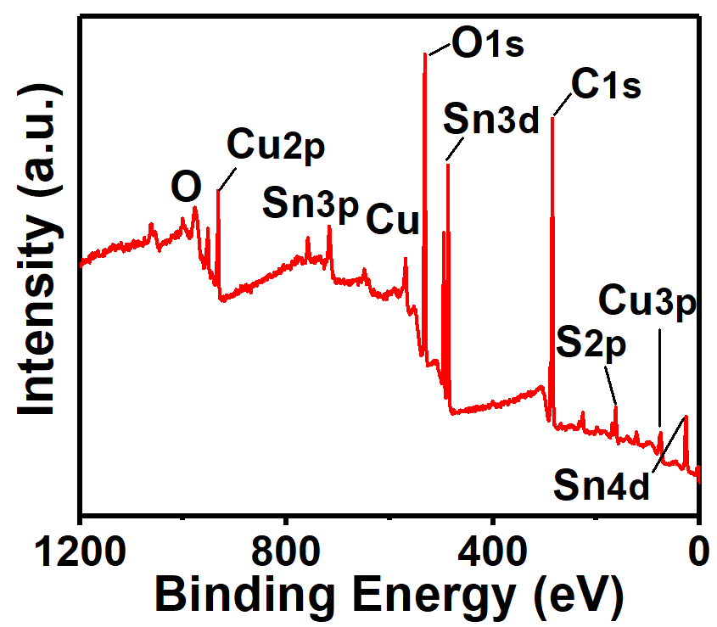
Figure S3. The XPS survey spectrum of the Cu₃SnS₄ NFs.

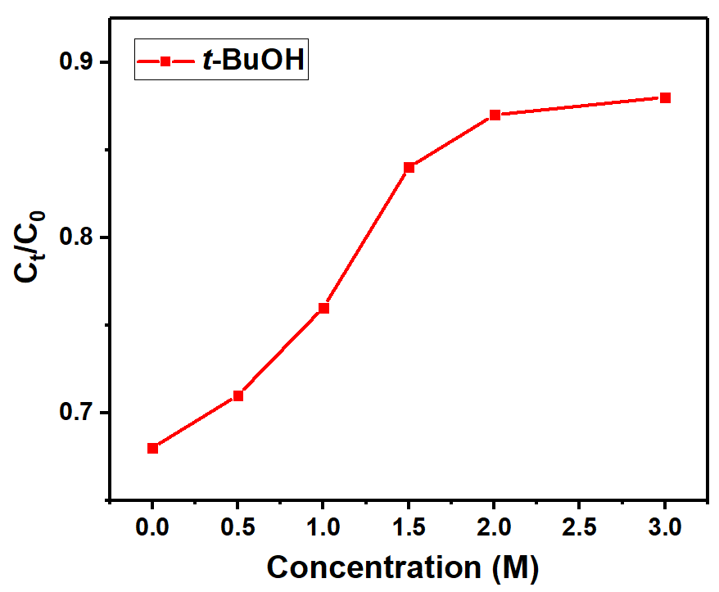
Figure S4. Influence of t-BuOH to the Cu₃SnS₄ NFs mediated methylene blue degradation. Conditions: 10 μg mL⁻¹ methylene blue, 100 μg mL⁻¹ Cu₃SnS₄ NFs, t = 120 min, 25 °C.
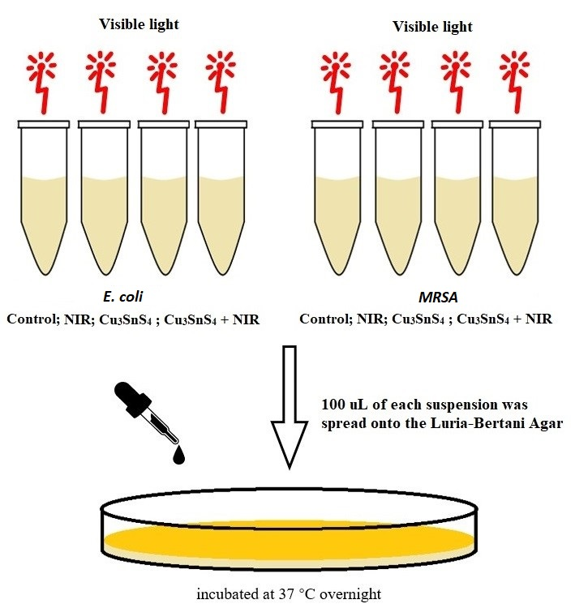
Figure S5. Illustration of the process of antibacterial experiment in vitro.

Figure S6. Photographs of E. coli and MRSA bacterial colonies formed on lysogeny broth (LB)-agar plates under visible light irradiation for different times. (B) Corresponding CFU amount of E. coli and MRSA bacteria after visible light irradiation for different times.

Figure S7. (A) Photographs of E. coli and MRSA bacterial colonies formed on lysogeny broth (LB)-agar plates under NIR irradiation (808 nm, 10 min) with different power density. (B) Corresponding CFU amount of E. coli and MRSA bacteria after NIR irradiation (808 nm, 10 min) with different power density.

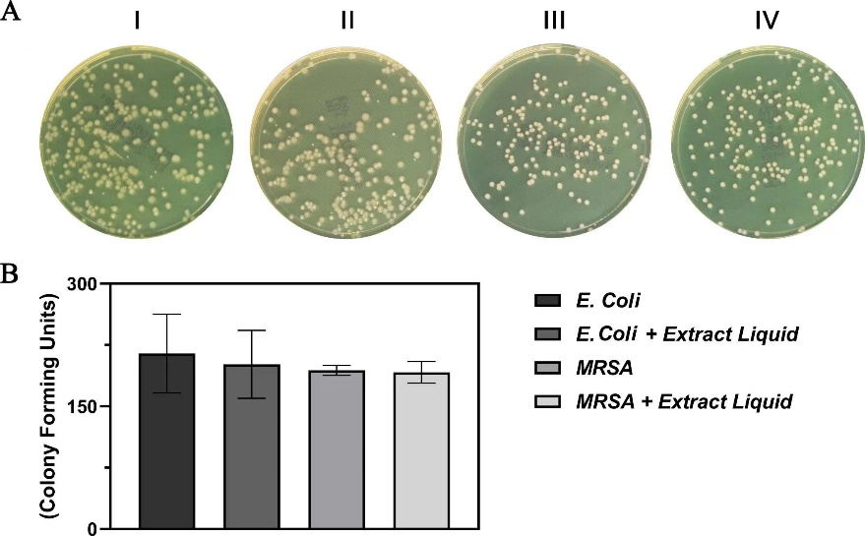
Figure S8. (A) Photographs of E. coli and MRSA bacterial colonies formed on lysogeny broth (LB)-agar plates. I: E. coli, II: E. coli after the treatment with Cu ions extract liquid, III: MRSA IV: MRSA after the treatment with Cu ions extract liquid. (B) Corresponding CFU amount of E. coli and MRSA bacteria after different treatments.

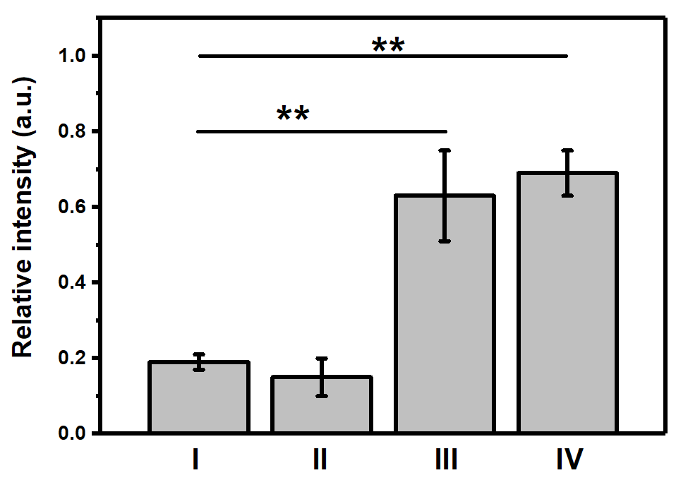
Figure S9. Relative fluorescence intensity of DCF after different treatements. Data are presented as means ± SDs (n = 4). **p < 0.01. Group I: control group in the absence of NFs; Group II: NIR group with the irradiation of NIR laser (808 nm, 1.5 W cm⁻², 10 min) in the absence of NFs; Group III: Cu₃SnS₄ group with the treatment with Cu₃SnS₄ NFs under no laser irradiation; Group IV: Cu₃SnS₄ + NIR group with the treatment with Cu₃SnS₄ NFs plus NIR irradiation (808 nm, 1.5 W cm⁻², 10 min). All groups were exposed to visible light for 20 min.

Figure S10. Relative cell viability of HUVEC and L929 cells after treatement with Cu₃SnS₄ NFs (0-100 μg mL⁻¹) for 24 h and 48 h under dark conditions. Data are presented as means ± SDs (n = 6).

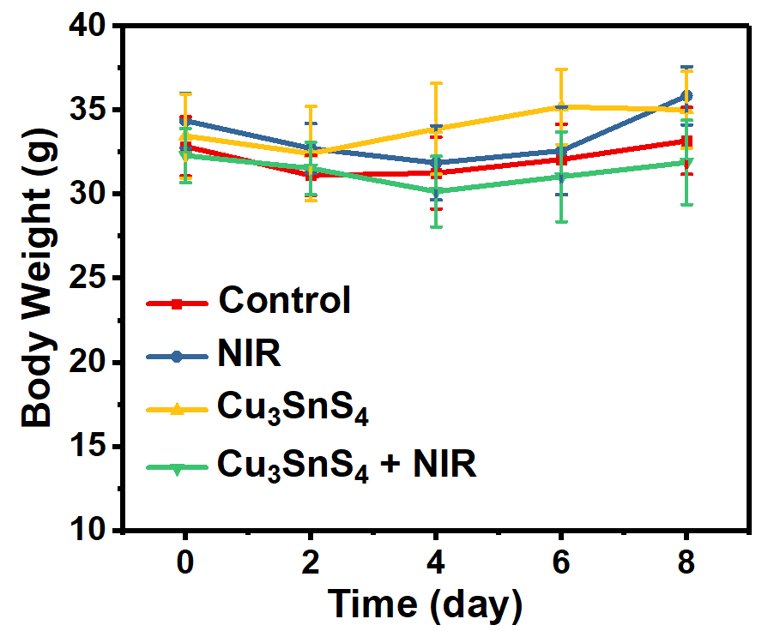
Figure S11. Time dependent change of body weight of mice after different treatments. Data are presented as means ± SDs (n = 6).

Figure S12. In vivo hematological index (AST, ALT, BUN, and CREA) of male ICR mice on day 8 after different treatments. Data are presented as means ± SDs (n = 6). Group I: control group in the absence of NFs; Group II: NIR group with the irradiation of NIR laser (808 nm, 1.0 W cm⁻², 10 min) in the absence of NFs; Group III: Cu₃SnS₄ group with the treatment with Cu₃SnS₄ NFs under no laser irradiation; Group IV: Cu₃SnS₄ + NIR group with the treatment with Cu₃SnS₄ NFs plus NIR irradiation (808 nm, 1.0 W cm⁻², 10 min). All groups were exposed to visible light during the treatment.

Figure S13. The major hematological indicators of healthy male ICR mice on day 8 after different treatments. Data are presented as means ± SDs (n = 6). Group I: control group in the absence of NFs; Group II: NIR group with the irradiation of NIR laser (808 nm, 1.0 W cm⁻², 10 min) in the absence of NFs; Group III: Cu₃SnS₄ group with the treatment with Cu₃SnS₄ NFs under no laser irradiation; Group IV: Cu₃SnS₄ + NIR group with the treatment with Cu₃SnS₄ NFs plus NIR irradiation (808 nm, 1.0 W cm⁻², 10 min). All groups were exposed to visible light during the treatment.

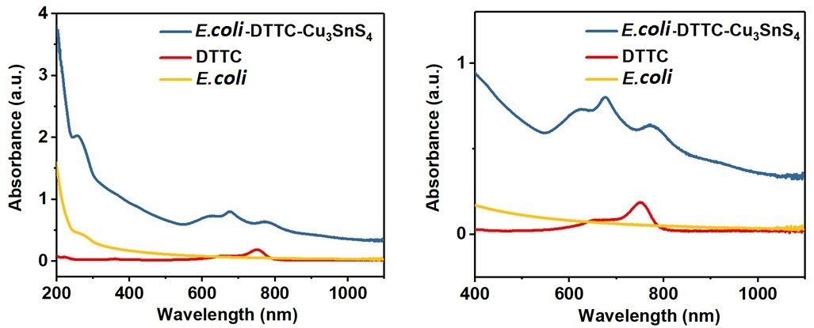
Figure S14. The UV/Vis/NIR absorption spectra of the E. coli, DTTC and E. coli-DTTC-Cu₃SnS₄.
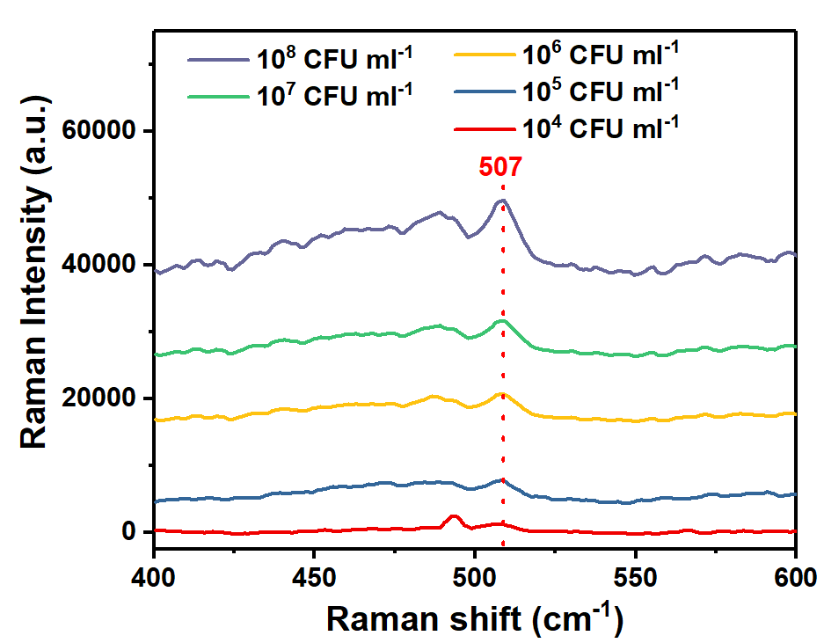
Figure S15. In vitro SERS spectra of E. coli-DTTC-Cu₃SnS₄ under the excitation of a 785 nm laser.

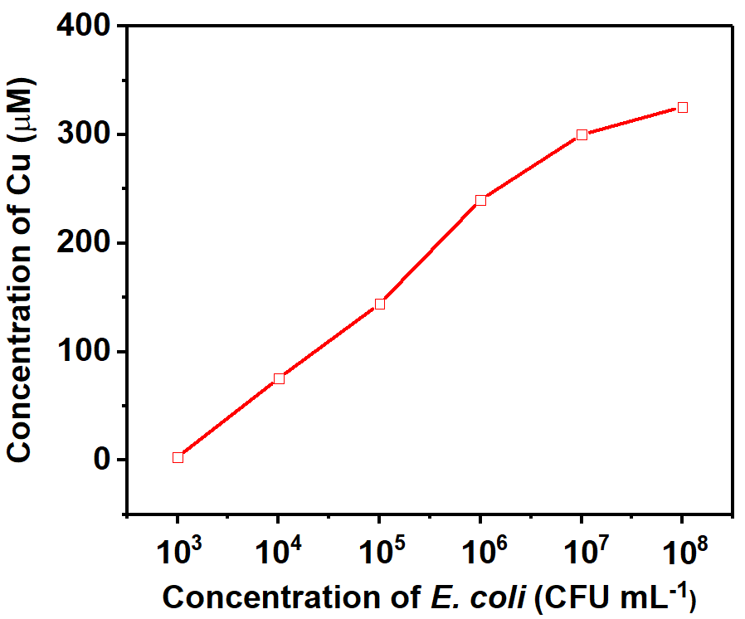
Figure S16. The concentration of Cu in the E. coli-DTTC-Cu₃SnS₄, which is positively related to the concentration of the E. coli.

