Research on the drought tolerance mechanism of Pennisetum glaucum (L.) in the root during seedling

Ailing Zhang¹*, Yang Ji²*, Min Sun¹*, Chuang Lin¹*, Puding Zhou¹, Juncai Ren³, Dan Luo¹, Xiaoshan Wang¹, Encong Ma¹, Linkai Huang¹**

¹Department of Grassland Science, Faculty of Animal Science and Technology, Sichuan Agricultural University, Chengdu 611130, China
²Sichuan Animal Science Academy, Chengdu 610066, China
³College of Animal Science and Technology, Rongchang Campus, Southwest University, Chongqing, 402460, China
*Ailing Zhang, Yang Ji, Min Sun and Chuang Lin contributed equally to this work
**Corresponding Author: huanglinkai@sicau.edu.cn

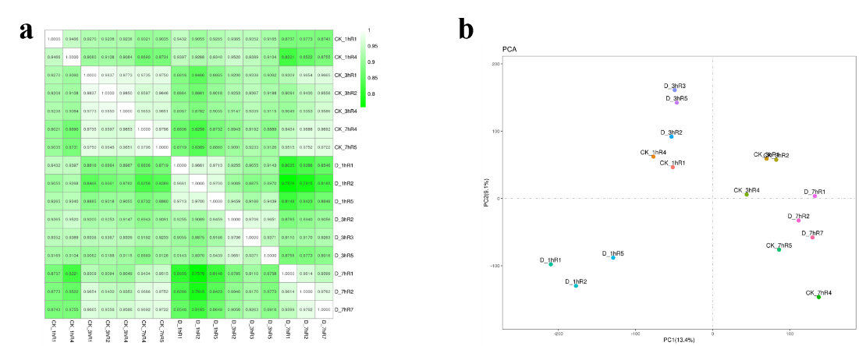
Supplemental Figure 1. a. the Pearson correlation based on all expressed genes. b. principal component analysis (PCA) based on all expressed genes.

