Holobiont nitrogen control and its potential for eutrophication resistance in an obligate photosymbiotic jellyfish
Till Röthig^{1,2,#,*}, Giulia Puntin^{1,3,#}, Jane CY Wong¹, Alfred Burian⁴, Wendy McLeod¹, David M Baker^{1,*}

¹ The Swire Institute of Marine Science and School of Biological Sciences, The University of Hong Kong, Hong Kong, SAR
²Department of Biology, University of Konstanz, Konstanz, Germany
³ Department of Animal Ecology & Systematics, Justus Liebig University, Giessen, Germany
⁴ Aquatic Research Facility, Environmental Sustainability Research Centre, University of Derby, Derby, United Kingdom

# contributed equally
* Corresponding author

Additional Information File 1 – Supplementary Figures

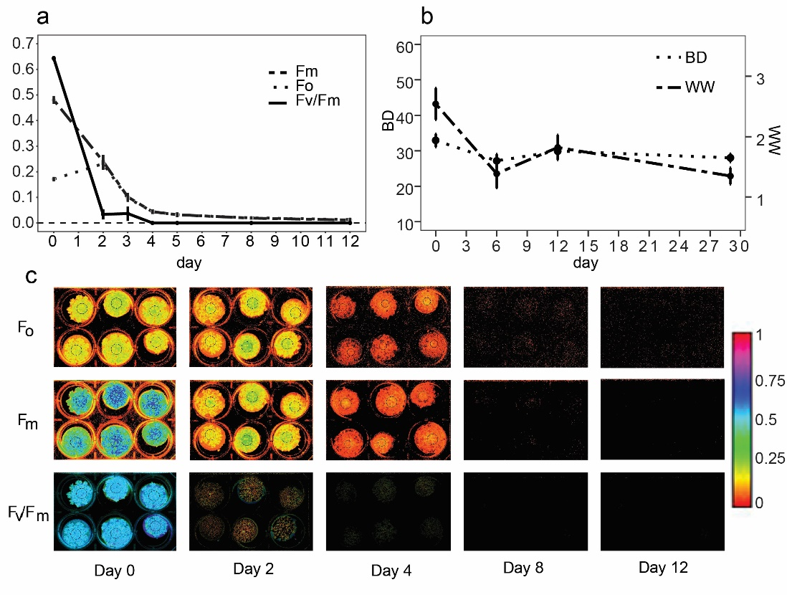

Fig.S1. Effects of menthol bleaching on C. xamachana. (a) Photosynthetic efficiency throughout menthol exposure (day 1-4) and bleaching process. n = 12; Imaging-PAM, Walz, Germany; F_{o}: dark-adapted minimal fluorescence yields; F_{m}: dark-adapted maximal fluorescence yield; F_{v}/F_{m}: maximum quantum yield. (b) Response of bell diameter (BD) and wet weight (WW) towards bleaching (mean, n = 12). c: Visualization of photosynthetic efficiency (i.e., F_{o}, F_{m}, and F_{v}/F_{m}).

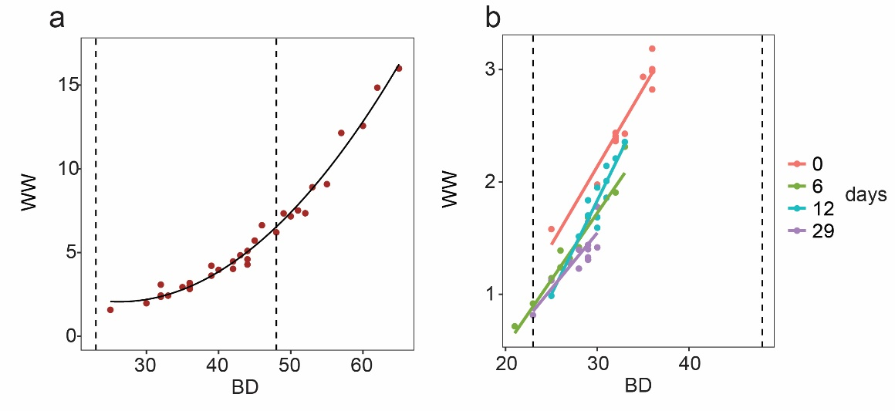
Fig.S2. Relationship between wet weight (WW) and bell diameter (BD) in (a) symbiotic (n = 35) [WW_{symbiotic} = 8.538 + (-0.494*BD) + (0.009*BD2)] and (b) aposymbiotic C. xamachana (n = 12) [WW_{aposymbiotic} = -1.440 + (0.100*BD)]. Different colors indicate the number of days after the start of the four day menthol bleaching. Dashed vertical lines indicate minimum and maximum BD of medusae employed in the pulse-chase experiment.

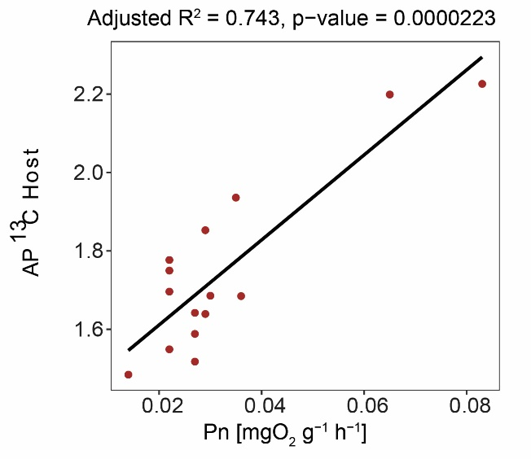
Fig.S3. Net primary production (P_{n}) and host carbon enrichment. Host fraction enrichment expressed as AP¹³C light-incubated medusae (SymL) from all incubations (pulse, chase 3 h and chase 6 h; n = 15; y = 1.394 + 10.845x).

