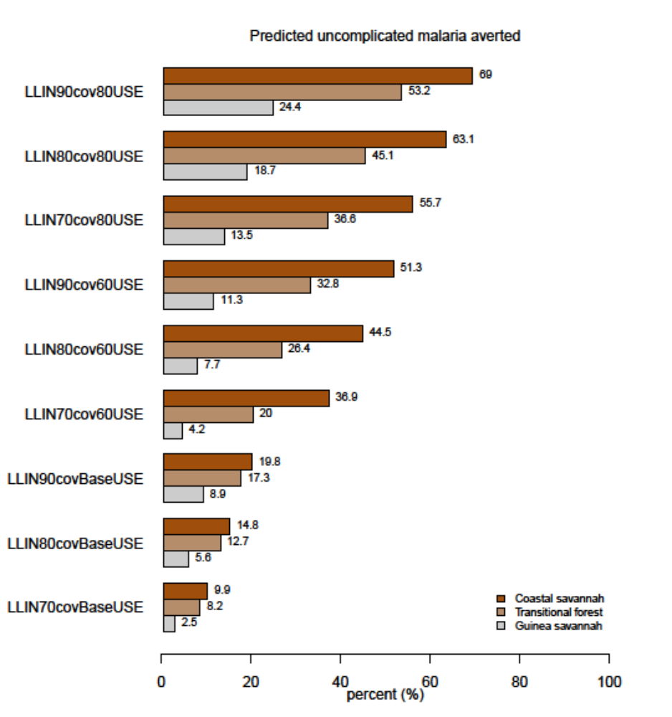
S4 Fig 1a: Impact of attaining various levels of LLINs coverage and usage while maintaining IRS coverage and PE at prevailing baseline levels on predicted reported uncomplicated malaria cases across zones. BaseUSE is LLIN usage at baseline (56%, 45% and 35% in the Guinea savannah, Transitional forest and Coastal savannah respectively)
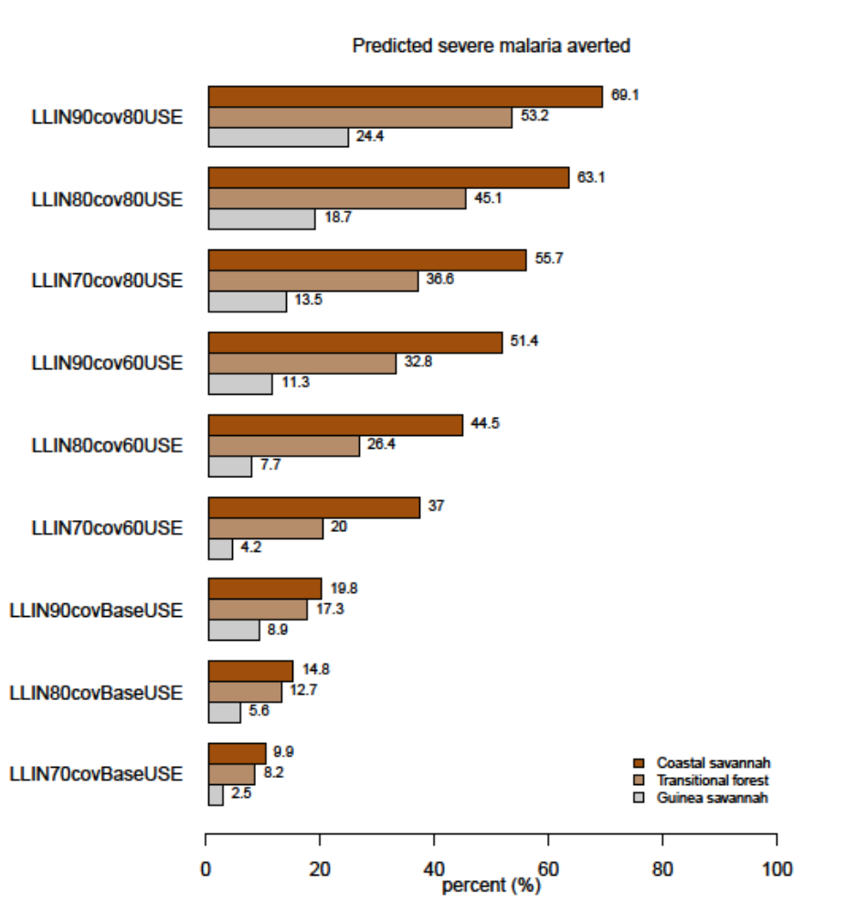
S4 Fig 1b: Impact of attaining various levels of LLINs coverage and usage while maintaining IRS coverage and PE at prevailing baseline levels on predicted reported severe malaria cases across zones. BaseUSE is LLIN usage at baseline (56%, 45% and 35% in the Guinea savannah, Transitional forest and Coastal savannah respectively)

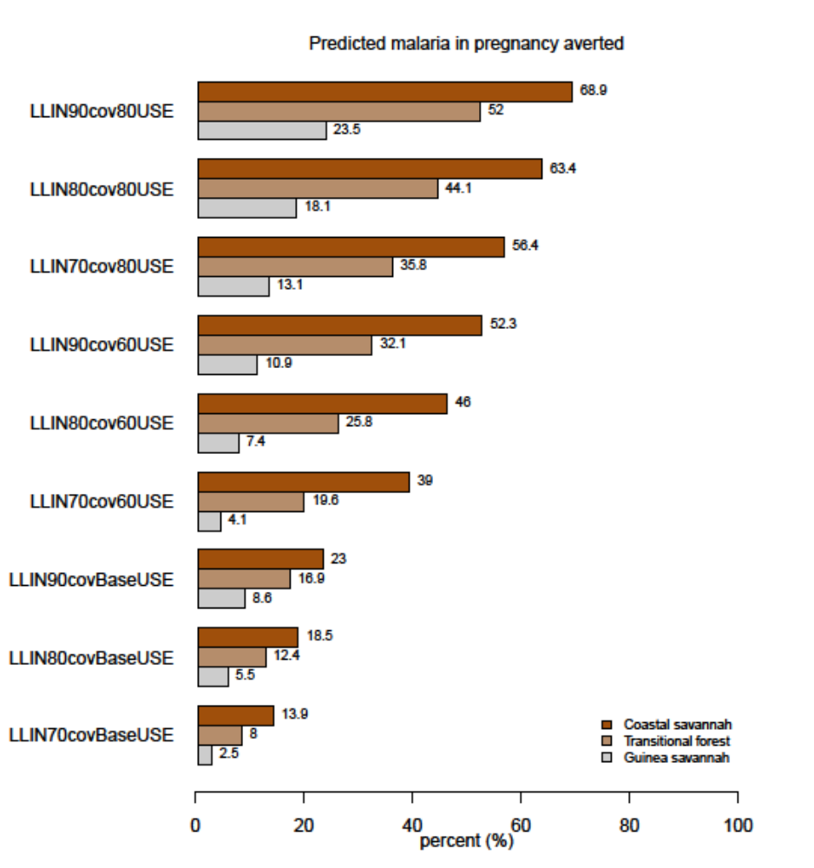
S4 Fig 1c: Impact of attaining various levels of LLINs coverage and usage while maintaining IRS coverage and PE at prevailing baseline levels on predicted reported malaria in pregnancy cases across zones. BaseUSE is LLIN usage at baseline (56%, 45% and 35% in the Guinea savannah, Transitional forest and Coastal savannah respectively)

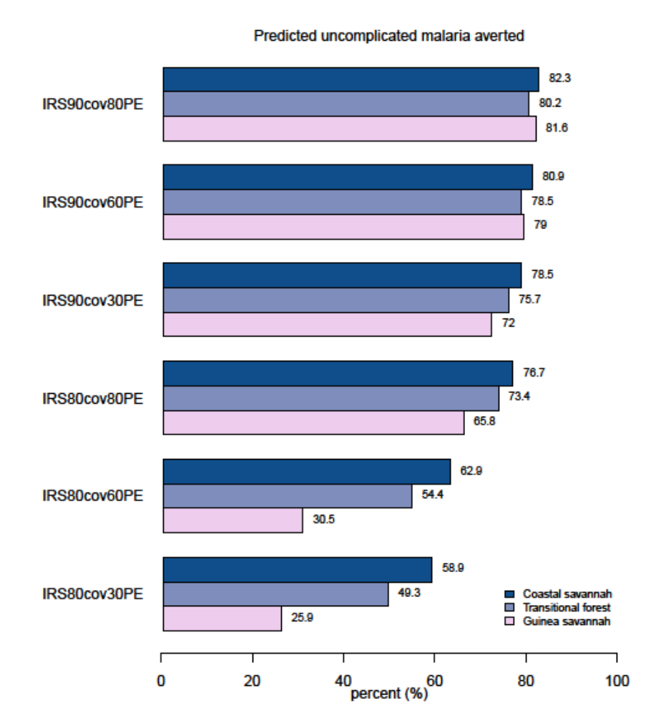
S4 Fig 2a: Impact of attaining various levels of IRS coverage and Protective Efficacy (PE) while maintaining LLIN coverage and PE at prevailing baseline levels on predicted reported uncomplicated malaria cases across zones.
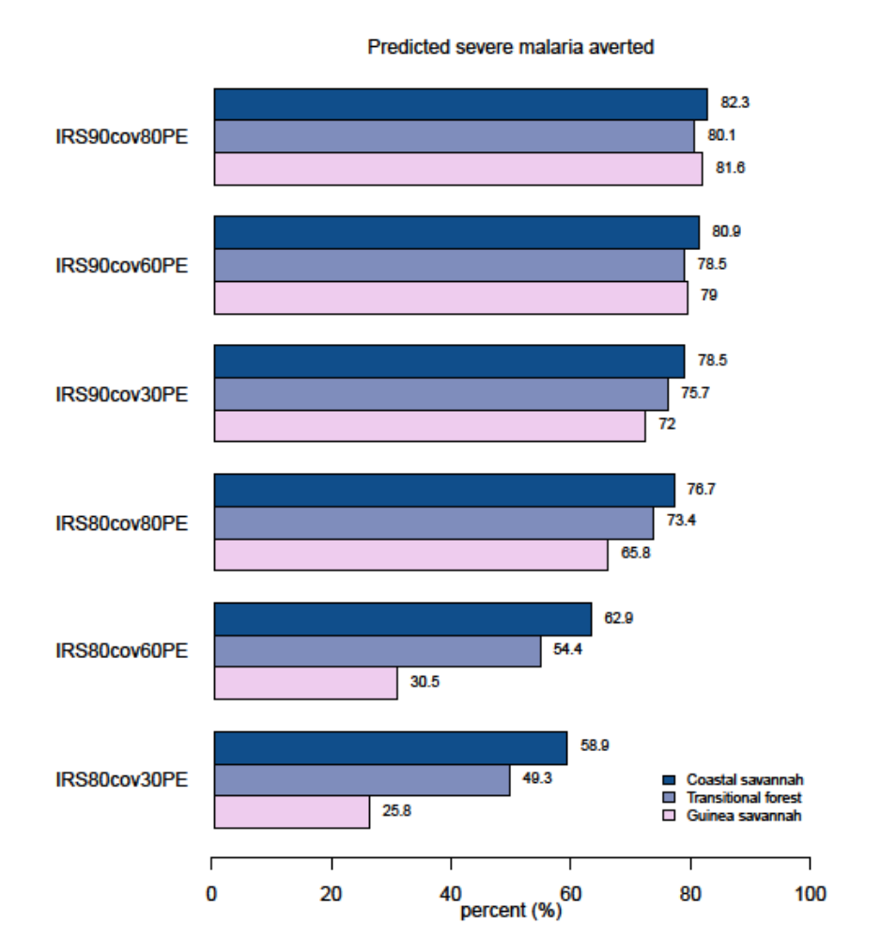
S4 Fig 2b: Impact of attaining various levels of IRS coverage and Protective Efficacy (PE) while maintaining LLIN coverage and PE at prevailing baseline levels on predicted reported severe malaria cases across zones.
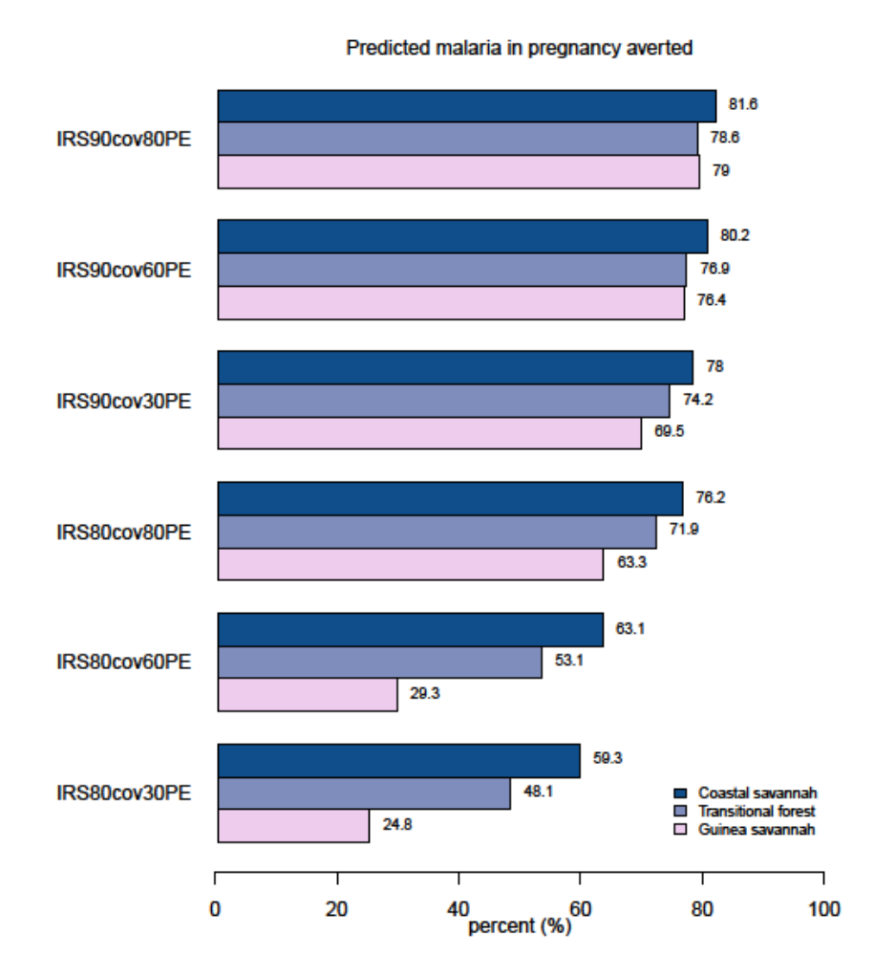
S4 Fig 2c: Impact of attaining various levels of IRS coverage and Protective Efficacy (PE) while maintaining LLIN coverage and PE at prevailing baseline levels on predicted reported malaria in pregnancy cases across zones.
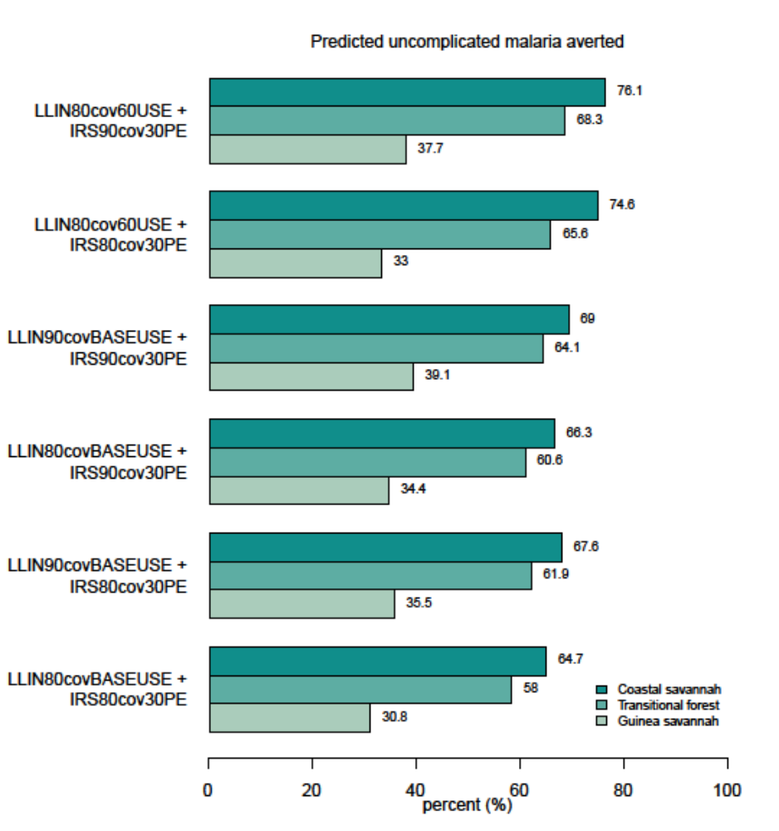
S4 Fig 3a: Impact of attaining various levels of LLINs and IRS coverages, LLIN usage and IRS Protective Efficacies (PE) on predicted reported uncomplicated malaria cases across zones. BaseUSE is LLIN usage at baseline (56%, 45% and 35% in the Guinea savannah, Transitional forest and Coastal savannah respectively)

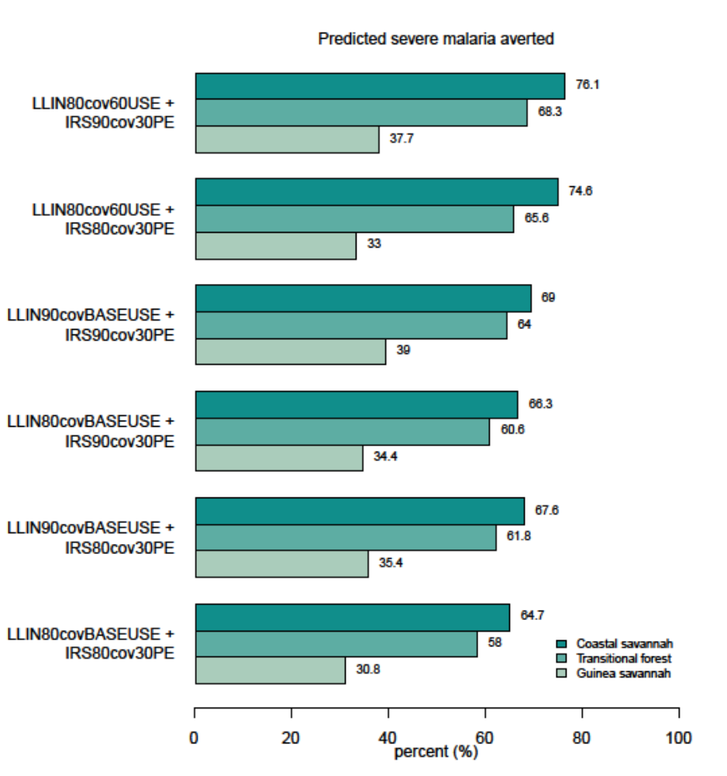
S4 Fig 3b: Impact of attaining various levels of LLINs and IRS coverages, LLIN usage and IRS Protective Efficacies (PE) on predicted reported severe malaria cases across zones. BaseUSE is LLIN usage at baseline (56%, 45% and 35% in the Guinea savannah, Transitional forest and Coastal savannah respectively)

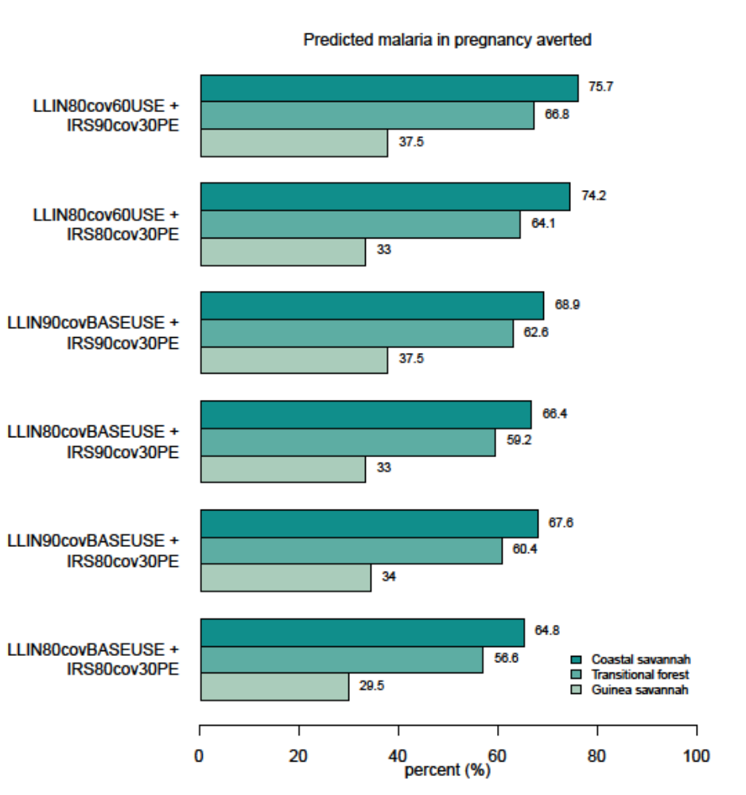
S4 Fig 3c: Impact of attaining various levels of LLINs and IRS coverages, LLIN usage and IRS Protective Efficacies (PE) on predicted reported malaria in pregnancy cases across zones. BaseUSE is LLIN usage at baseline (56%, 45% and 35% in the Guinea savannah, Transitional forest and Coastal savannah respectively)

