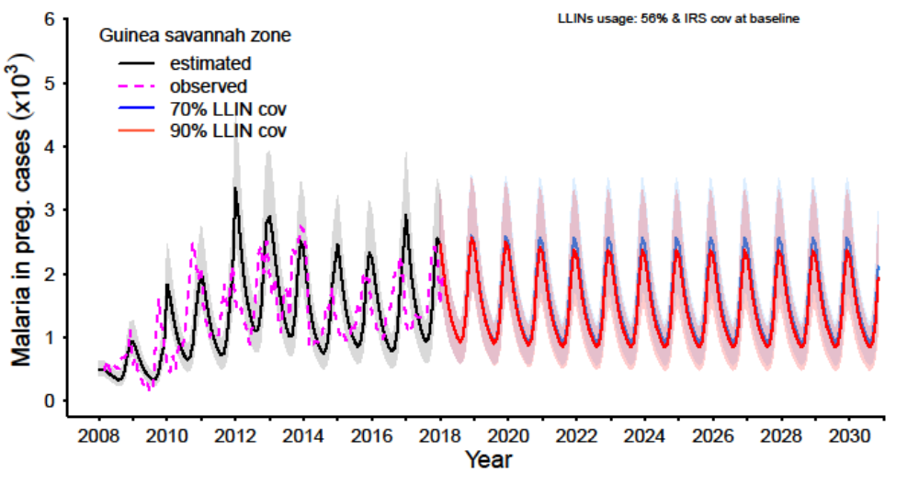S3 Fig 1a: Impact of attaining LLINs coverage levels of 70% and 90% within 3 years at a usage level of 56% and Protective Efficacy (PE) of 30% for LLIN and IRS respectively with IRS coverage at prevailing baseline levels on malaria in pregnancy cases in the Guinea savannah zone.
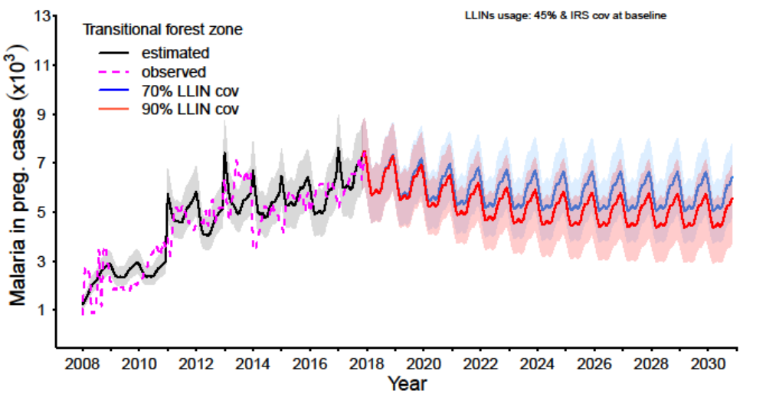S3 Fig 1b: Impact of attaining LLINs coverage levels of 70% and 90% within 3 years at a usage level of 45% and Protective Efficacy (PE) of 30% for LLIN and IRS respectively with IRS coverage at prevailing baseline levels on malaria in pregnancy cases in the Transitional forest zone.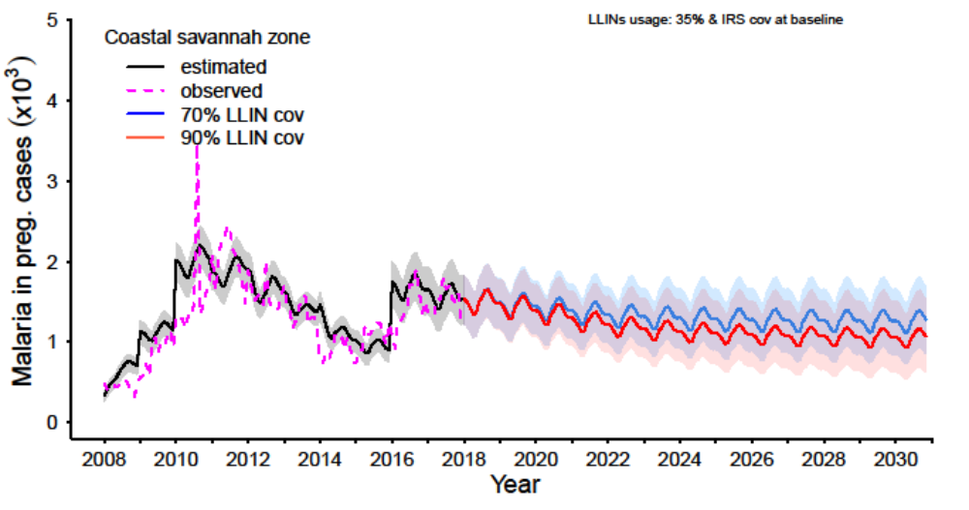S3 Fig 1c: Impact of attaining LLINs coverage levels of 70% and 90% within 3 years at a usage level of 35% and Protective Efficacy (PE) of 30% for LLIN and IRS respectively with IRS coverage at prevailing baseline levels on malaria in pregnancy cases in the Coastal savannah zone.
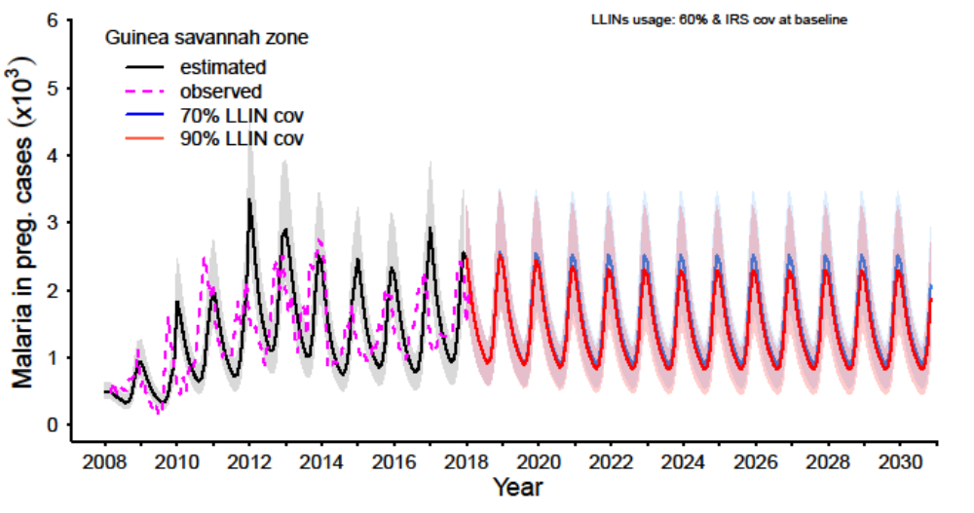S3 Fig 2a: Impact of attaining LLINs coverage levels of 70% and 90% within 3 years at a usage level of 60% and Protective Efficacy (PE) of 30% for LLIN and IRS respectively with IRS coverage at prevailing baseline levels on malaria in pregnancy cases in the Guinea savannah zone.
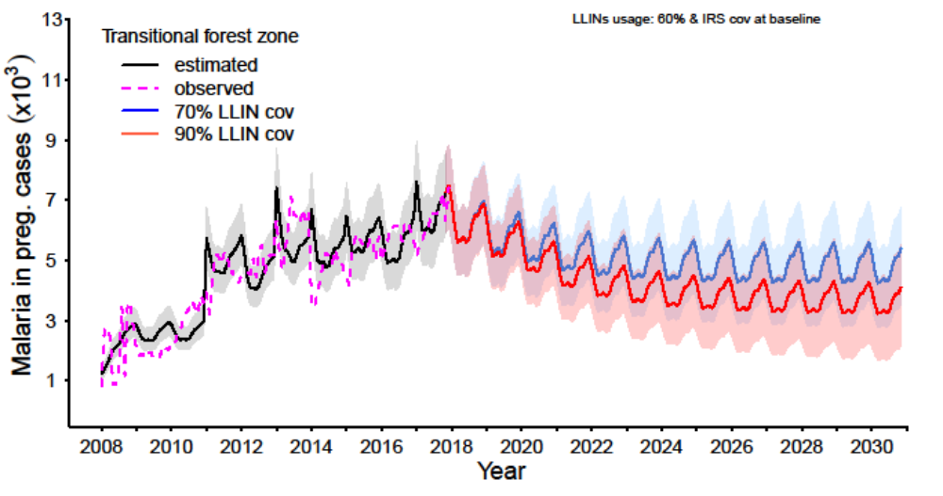S3 Fig 2b: Impact of attaining LLINs coverage levels of 70% and 90% within 3 years at a usage level of 60% and Protective Efficacy (PE) of 30% for LLIN and IRS respectively with IRS coverage at prevailing baseline levels on malaria in pregnancy cases in the Transitional forest zone.

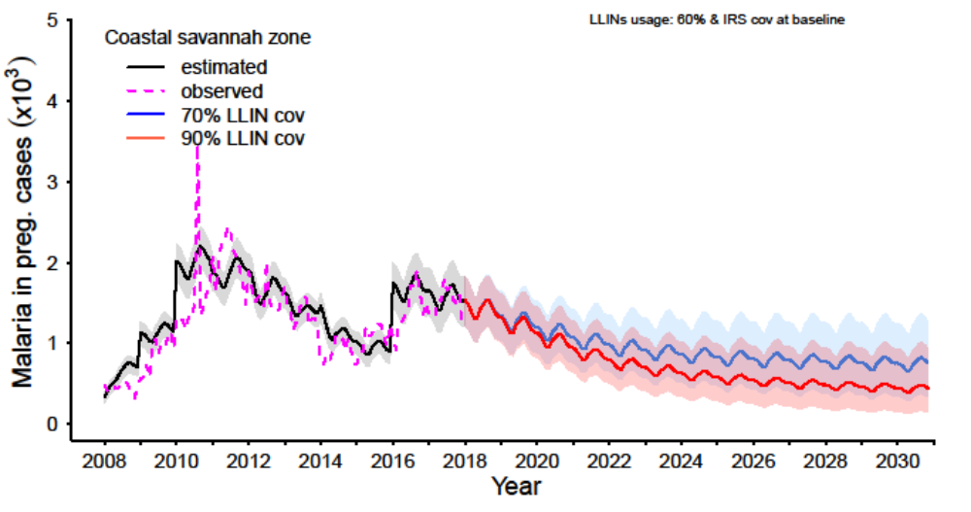S3 Fig 2c: Impact of attaining LLINs coverage levels of 70% and 90% within 3 years at a usage level of 60% and Protective Efficacy (PE) of 30% for LLIN and IRS respectively with IRS coverage at prevailing baseline levels on malaria in pregnancy cases in the Coastal savannah zone.
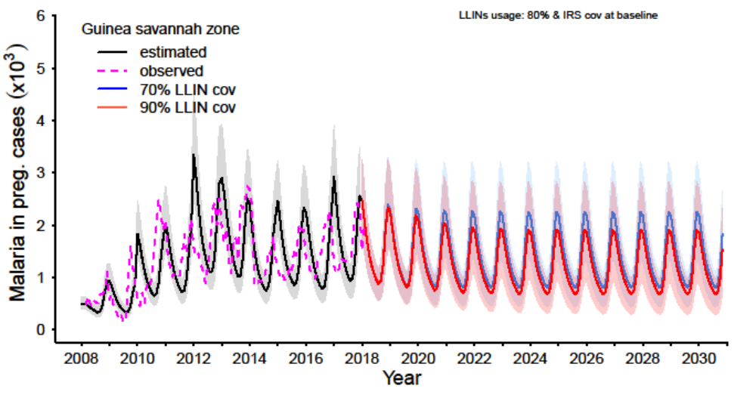S3 Fig 3a: Impact of attaining LLINs coverage levels of 70% and 90% within 3 years at a usage level of 80% and Protective Efficacy (PE) of 30% for LLIN and IRS respectively with IRS coverage at prevailing baseline levels on malaria in pregnancy cases in the Guinea savannah zone.

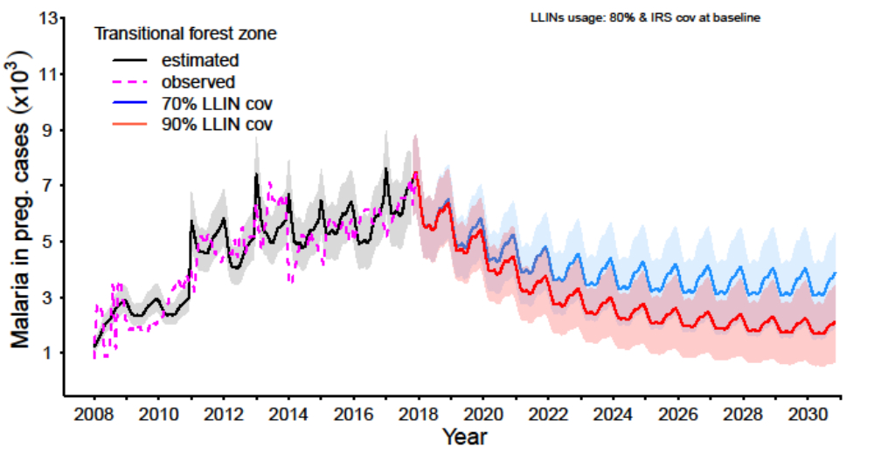S3 Fig 3b: Impact of attaining LLINs coverage levels of 70% and 90% within 3 years at at a usage level of 80% and Protective Efficacy (PE) of 30% for LLIN and IRS respectively with IRS coverage at prevailing baseline levels on malaria in pregnancy cases in the Transitional forest zone.
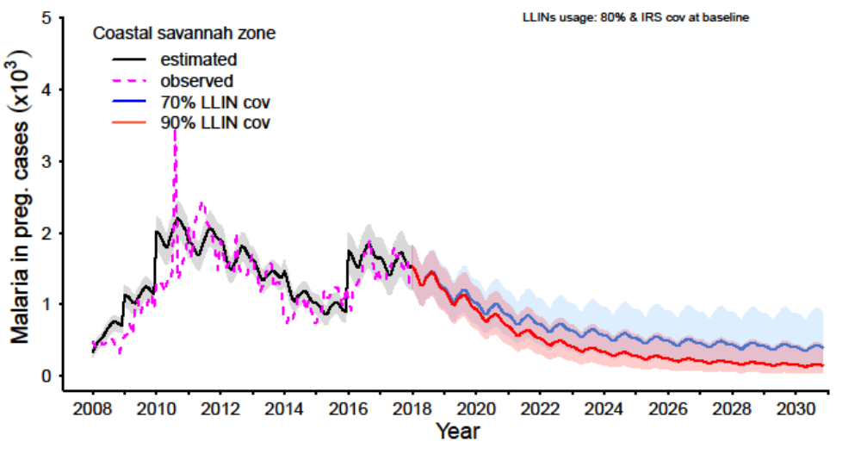S3 Fig 3c: Impact of attaining LLINs coverage levels of 70% and 90% within 3 years at at a usage level of 80% and Protective Efficacy (PE) of 30% for LLIN and IRS respectively with IRS coverage at prevailing baseline levels on malaria in pregnancy cases in the Coastal savannah zone.

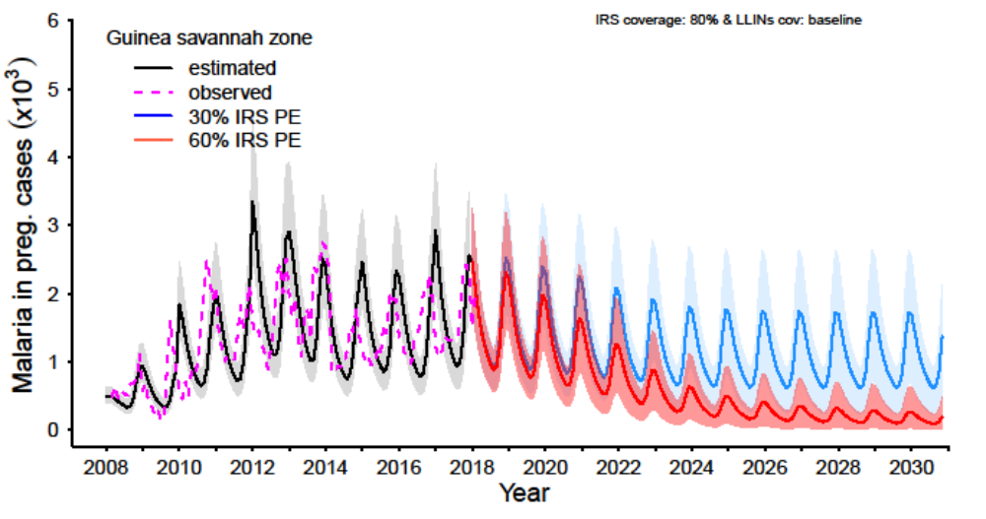S3 Fig 4a: Impact of attaining various levels of IRS coverage within 5 years at 30% and 60% Protective Efficacy (PE) while maintaining IRS coverage at 80% and PE and coverage level of LLINs at prevailing baseline levels on malaria in pregnancy cases in the Guinea savannah zone.

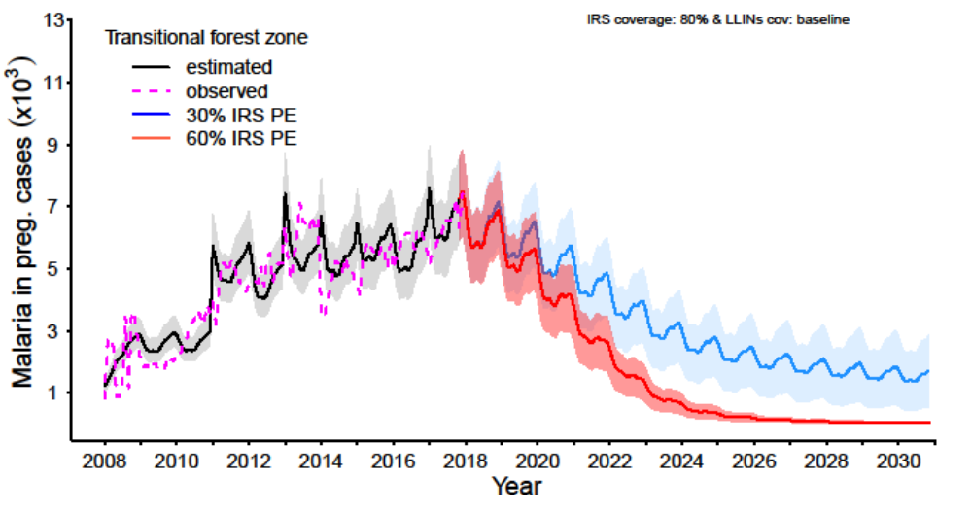S3 Fig 4b: Impact of attaining various levels of IRS coverage within 5 years at 30% and 60% Protective Efficacy (PE) while maintaining IRS coverage at 80% and PE and coverage level of LLINs at prevailing baseline levels on malaria in pregnancy cases in the Transitional forest zone.

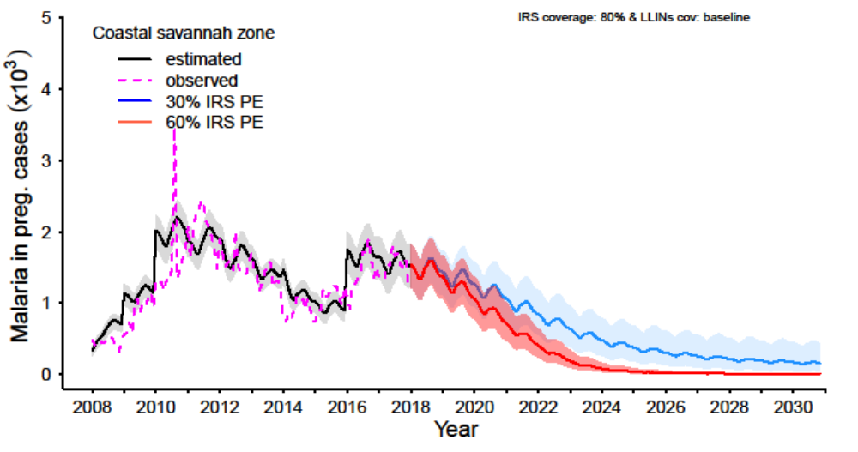S3 Fig 4c: Impact of attaining various levels of IRS within 5 years at 30% and 60% Protective Efficacy (PE) while maintaining IRS coverage at 80% and PE and coverage level of LLINs at prevailing baseline levels on malaria in pregnancy cases in the Coastal savannah zone.

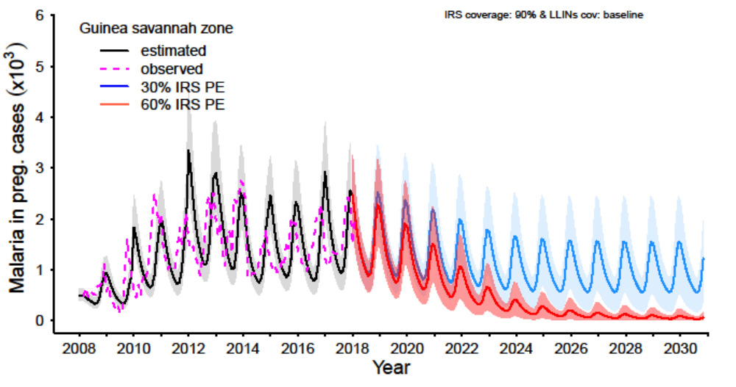S3 Fig 5a: Impact of attaining various levels of IRS coverage within 5 years at 30% and 60% Protective Efficacy (PE) while maintaining IRS coverage at 90% and PE and coverage level of LLINs at prevailing baseline levels on malaria in pregnancy cases in the Guinea savannah zone.

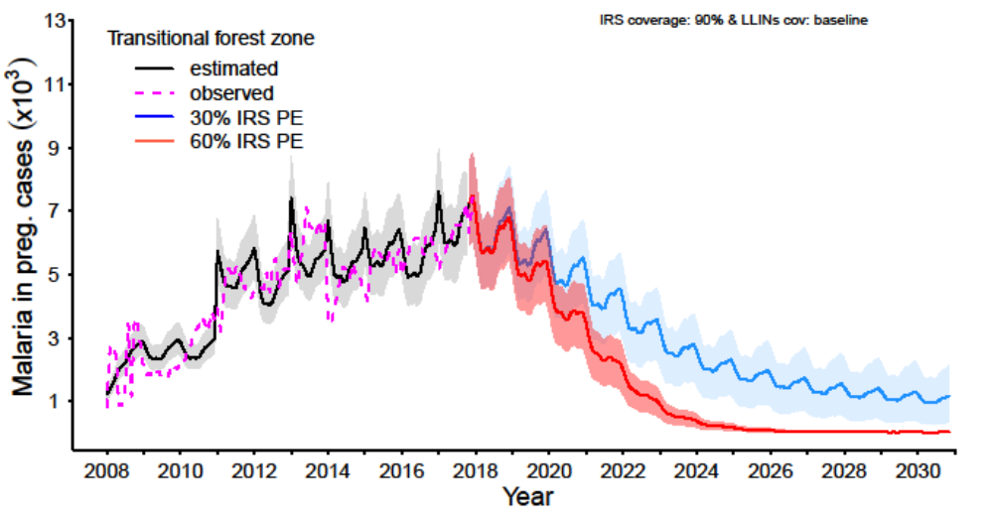S3 Fig 5b: Impact of attaining various levels of IRS coverage within 5 years at 30% and 60% Protective Efficacy (PE) while maintaining IRS coverage at 90% and PE and coverage level of LLINs at prevailing baseline levels on malaria in pregnancy cases in the Transitional forest zone.

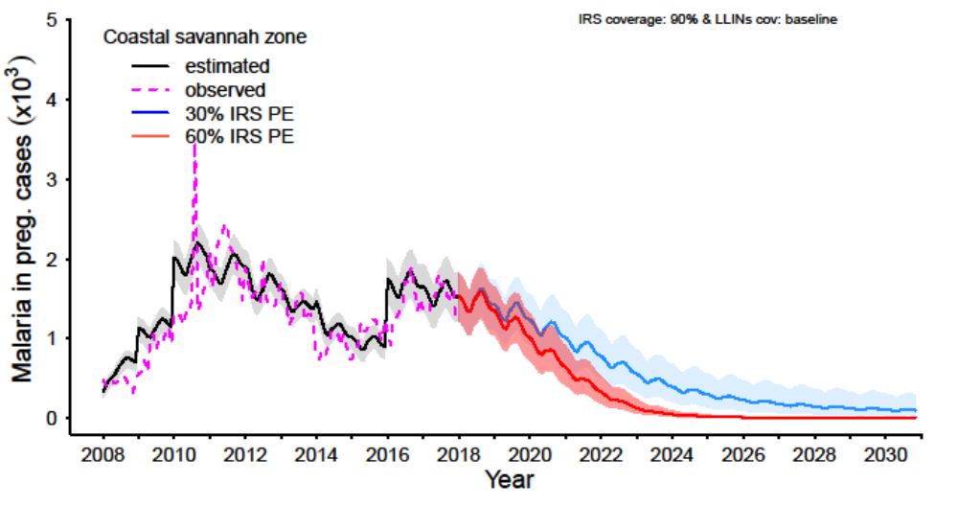S3 Fig 5c: Impact of attaining various levels of IRS coverage within 5 years at 30% and 60% Protective Efficacy (PE) while maintaining IRS coverage at 90% and PE and coverage level of LLINs at prevailing baseline levels on malaria in pregnancy cases in the Coastal savannah zone.

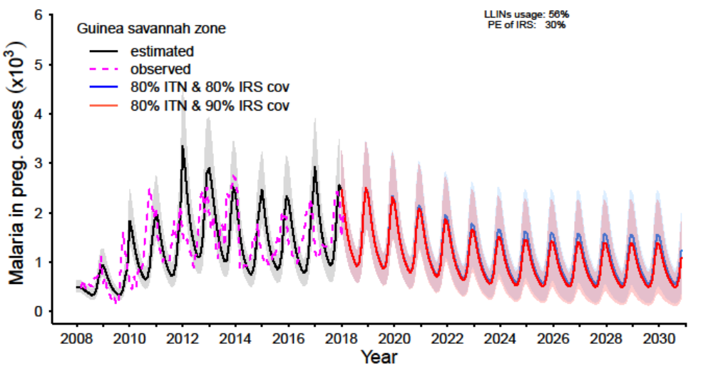S3 Fig 6a: Impact of attaining a combination of various levels of LLINs and IRS coverage within 3 and 5 years respectively at baseline LLINs usage (56%) and Protective Efficacy (PE) of IRS (30%) and LLINs (40%) on malaria in pregnancy cases in the Guinea savannah zone.
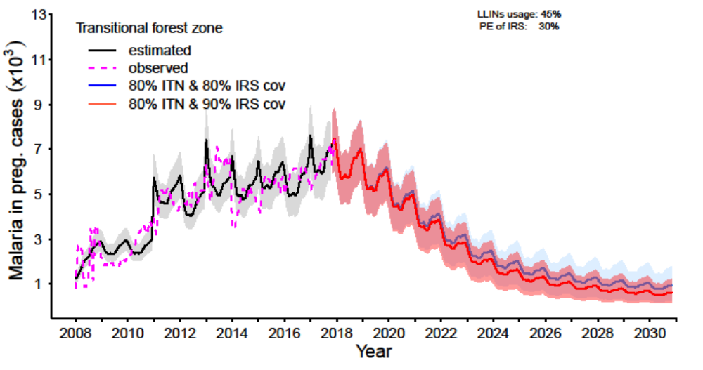S3 Fig 6b: Impact of attaining a combination of various levels of LLINs and IRS coverage within 3 and 5 years respectively at baseline baseline LLINs usage (45%) and Protective Efficacy (PE) of IRS (30%) and LLINs (40%) on malaria in pregnancy cases in the Transitional forest zone.
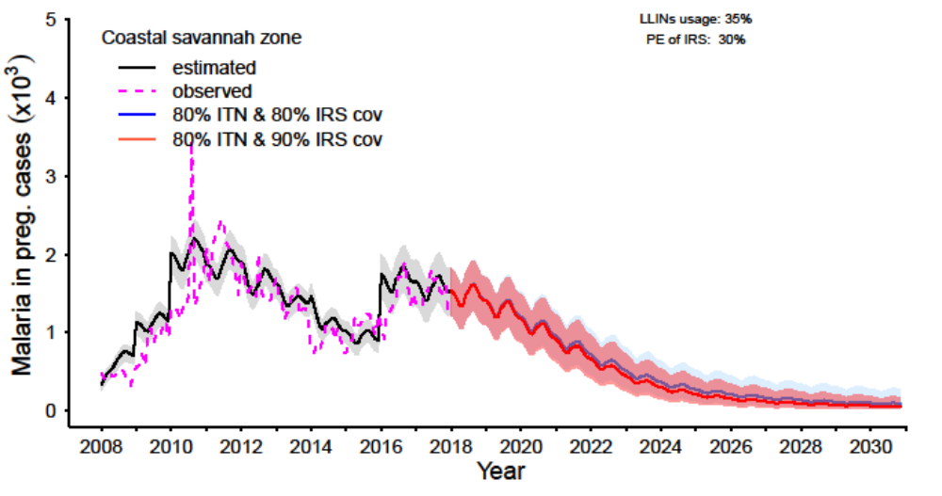S3 Fig 6c: Impact of attaining a combination of various levels of LLINs and IRS coverage within 3 and 5 years respectively at baseline LLINs usage (35%) and Protective Efficacy (PE) of IRS (30%) and LLINs (40%) on malaria in pregnancy cases in the Coastal savannah zone.

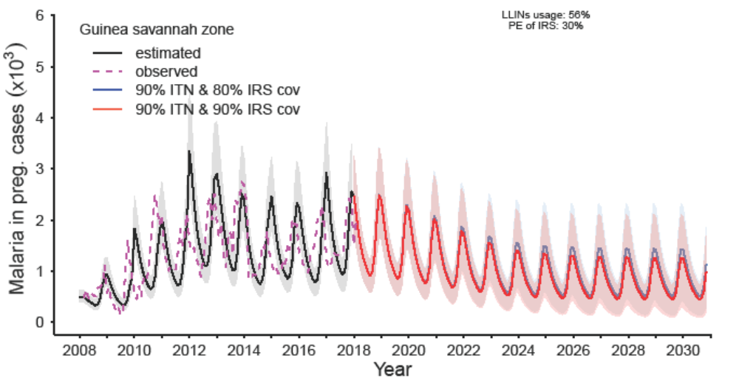S3 Fig 7a: Impact of attaining a combination of various levels of LLINs and IRS coverage within 3 and 5 years respectively at baseline LLINs usage (56%) and Protective Efficacy (PE) of IRS (30%) and LLINs (40%) on malaria in pregnancy cases in the Guinea savannah zone.

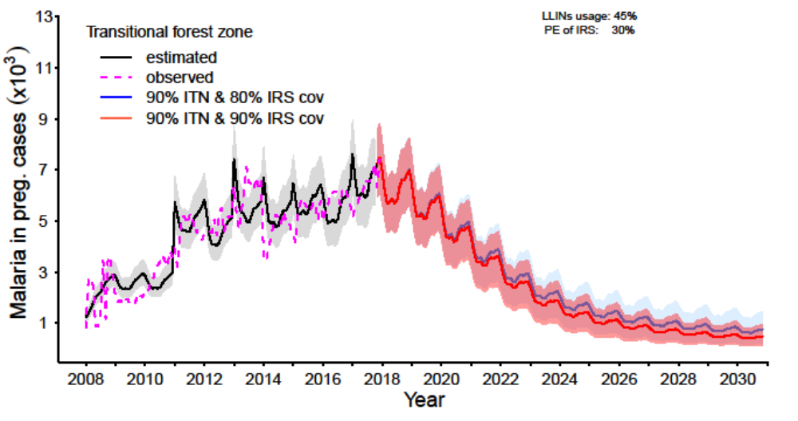
S3 Fig 7b: Impact of attaining a combination of various levels of LLINs and IRS coverage within 3 and 5 years respectively at baseline LLINs usage (45%) and Protective Efficacy (PE) of IRS (30%) and LLINs (40%) on malaria in pregnancy cases in the Transitional forest zone.

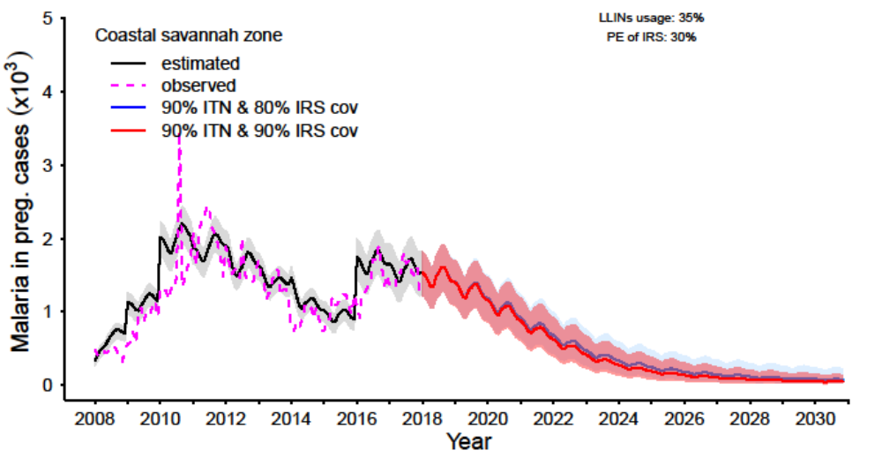S3 Fig 7c: Impact of attaining a combination of various levels of LLINs and IRS coverage within 3 and 5 years respectively at baseline LLINs usage (35%) and Protective Efficacy (PE) of IRS (30%) and LLINs (40%) on malaria in pregnancy cases in the Coastal savannah zone.

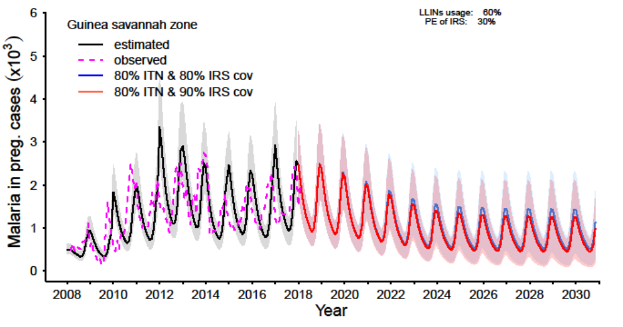S3 Fig 8a: Impact of attaining a combination of various levels of LLINs and IRS coverage within 3 and 5 years respectively at baseline Protective Efficacy (PE) of IRS (30%) and elevated level of LLINs usage (60%) on malaria in pregnancy cases in the Guinea savannah zone.

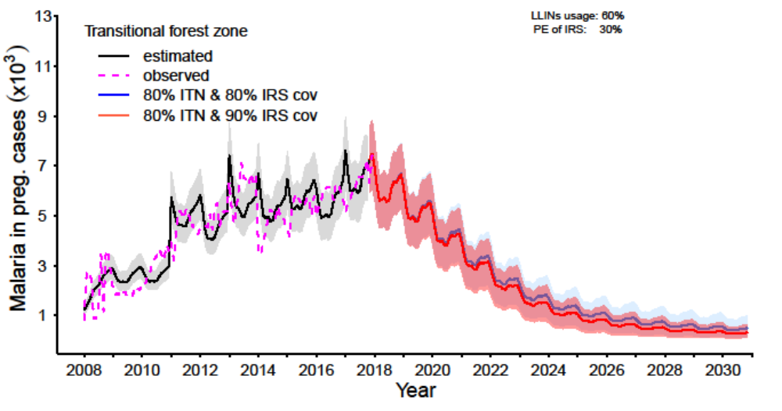S3 Fig 8b: Impact of attaining a combination of various levels of LLINs and IRS coverage within 3 and 5 years respectively at baseline Protective Efficacy (PE) of IRS (30%) and elevated level of LLINs usage (60%) on malaria in pregnancy cases in the Transitional forest zone.

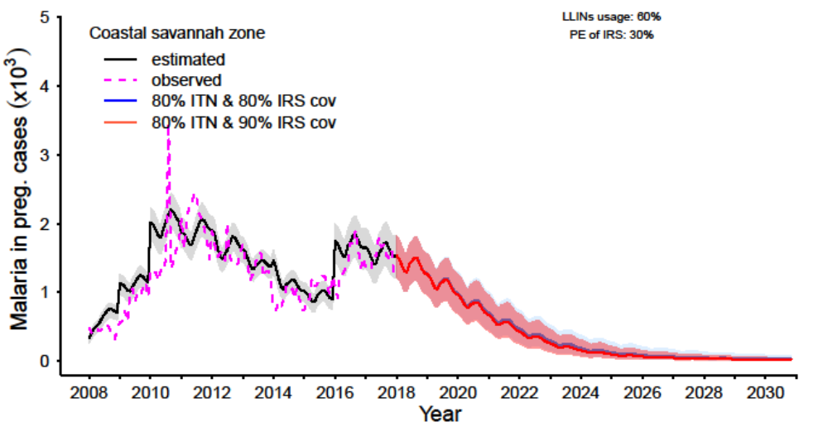S3 Fig 8c: Impact of attaining a combination of various levels of LLINs and IRS coverage within 3 and 5 years respectively at baseline Protective Efficacy (PE) of IRS (30%) and elevated level of LLINs usage (60%) on malaria in pregnancy cases in the Coastal savannah.

