Supplemental table 1. Fixed effects of semen production and semen quality traits in Test bulls
Levels | No. recs | CONC  (10⁹/ml) | VOL  (ml) | TS  (10⁹/ejaculate) | IM  (%) | PTM  (%) | TNSDP  (Semen doses)
Ejaculate no |  | ** | ** | ** | NS | NS | **
1 | 1926-3036 | 0* | 0* | 0* | 0* | 0* | 0*
2 | 104-257 | -0.35±0.61 | -0.52±1.77 | -2.16±3.73 | 2.49±22.47 | 1.32±14.15 | -88.48±8.18
Collection interval |  | NS | NS | NS | NS | NS | NS
6 to 7 days | 1884-2984 | 0* | 0* | 0* | 0* | 0* | 0*
8 to 10 days | 66-122 | 0.03±0.040 | -0.058±0.14 | -0.08±0.29 | -1.51±1.74 | 1.36±1.65 | 17.66±21.34
11 to 14 days | 80-187 | -0.73±0.037 | -0.02±0.11 | -0.33±0.24 | -0.32±1.44 | -1.13±1.53 | -14.37±19.86
Time of collection |  | NS | * | NS | NS | NS | *
6 to ≤ 7 | 323-445 | -0.02±0.04 | -0.13±0.11 | -0.14±0.23 | 1.19±1.39 | -2.42±1.20 | -14.88±15.56
7 to ≤ 8 | 351-614 | 0.00±0.04 | -0.17±0.11 | -0.28±0.23 | 0.54±1.37 | -1.73±1.15 | -24.33±14.96
8 to ≤ 9 | 630-966 | 0* | 0* | 0* | 0* | 0* | 0*
9 to ≤ 10 | 492-817 | -0.04±0.04 | 0.13±0.11 | 0.02±0.23 | 0.28±1.14 | 0.30±1.20 | 7.42±15.57
> 10 am | 234-451 | -0.03±0.04 | 0.01±0.12 | -0.19±0.25 | 0.63±1.51 | 0.39±1.33 | 6.52±17.33
Significance level: **: P < 0.01, *: P <0.05 and NS: Non-significant. 0*: Reference value for class variable;
CONC: Sperm concentration (10⁹/ml); VOL: Ejaculate volume (ml); IM: Initial motility (%); PTM: Post thaw motility (%); TNSDP: Theoretical number of semen doses per ejaculate.

Supplemental table 2. Repeatability of bull effect and phenotypic correlations in Jersey and Jersey crossbred bulls
Traits | CONC  (10⁹/ml) | VOL  (ml) | IM  (%) | PTM  (%) | TNSDP  (Semen doses)
CONC | 0.43±0.03 | -0.42±0.08 | 0.20±0.09 | 0.22±0.09 | 0.64±0.06
VOL | -0.20±0.04 | 0.32±0.03 | 0.09±0.10 | 0.05±0.10 | 0.36±0.09
IM | 0.11±0.04 | 0.04±0.03 | 0.33±0.03 | 0.75±0.05 | 0.50±0.07
PTM | 0.08±0.04 | 0.01±0.04 | 0.27±0.03 | 0.37±0.03 | 0.55±0.07
TNSDP | 0.30±0.03 | 0.18±0.03 | 0.17±0.03 | 0.36±0.03 | 0.32±0.03
Bull effects: Above diagonal, Phenotypic correlation: Below diagonal, Repeatability: Diagonal elements; CONC: Sperm concentration (10⁹/ml); VOL: Ejaculate volume (ml); IM: Initial motility (%); PTM: Post thaw motility (%); TNSDP: Theoretical number of semen doses per ejaculate.

Supplemental table 3. Repeatability of Bull effect and phenotypic correlations in Gir and Sahiwal bulls
Traits | CONC  (10⁹/ml) | VOL  (ml) | IM  (%) | PTM  (%) | TNSDP  (Semen doses)
CONC | 0.33±0.05 | -0.23±0.16 | 0.27±0.16 | -0.002±0.18 | 0.70±0.09
VOL | -0.09±0.06 | 0.45±0.06 | 0.02±0.18 | 0.27±0.17 | 0.53±0.12
IM | 0.16±0.04 | 0.04±0.05 | 0.14±0.03 | 0.58±0.13 | 0.24±0.17
PTM | -0.01±0.03 | 0.06±0.04 | 0.07±0.02 | 0.07±0.02 | 0.23±0.17
TNSDP | 0.38±0.05 | 0.28±0.06 | 0.08±0.04 | 0.10±0.03 | 0.35±0.06
Bull effects: Above diagonal, Phenotypic correlation: Below diagonal, Repeatability: Diagonal elements; CONC: Sperm concentration (10⁹/ml); VOL: Ejaculate volume (ml); IM: Initial motility (%); PTM: Post thaw motility (%); TNSDP: Theoretical number of semen doses per ejaculate.

Supplemental table 4. Bull effects correlations between test bulls and adult bulls in Jersey and Jersey crossbred bulls
TRAITS | Jersey and Jersey crossbreds
TRAITS | CONC | VOL | TS | IM | PTM | TNSDP
Test bulls – Adult 1 | 0.80±0.17 | 0.67±0.13 | 0.45±0.18 | 0.91±0.09 | 0.74±0.12 | 0.60±0.16
Test bulls – Adult 2 | 0.83±0.16 | 0.60±0.13 | 0.55±0.15 | 0.88±0.09 | 0.73±0.12 | 0.71±0.13
Test bulls – Adult 3 | 0.61±0.19 | 0.48±0.16 | 0.37±0.18 | 0.96±0.08 | 0.75±0.12 | 0.52±0.15
Adult 1 – Adult 2 | 0.95±0.01 | 0.82±0.05 | 0.90±0.04 | 0.92±0.03 | 0.99±0.01 | 0.90±0.04
Adult 1 – Adult 3 | 0.77±0.05 | 0.53±0.10 | 0.76±0.07 | 0.92±0.03 | 0.98±0.02 | 0.75±0.07
Adult 2 – Adult 3 | 0.88±0.03 | 0.86±0.03 | 0.89±0.03 | 0.95±0.02 | 0.96±0.01 | 0.89±0.03
Test bulls: first 6 ejaculates Adult 1: 1 to 3 years of age; Adult 2: 3 to 4 years of age; Adult 3: 4 to 5 years of age
CONC: Sperm concentration (10⁹/ml); VOL: Ejaculate volume (ml); IM: Initial motility (%); PTM: Post thaw motility (%); TNSDP: Theoretical number of semen doses per ejaculate.

Supplemental Fig. 1. Effect of age at semen collection on theoretical number semen doses
(Subtitle: 0 = reference solution as HF 75% × age (> 4 to 5 years))
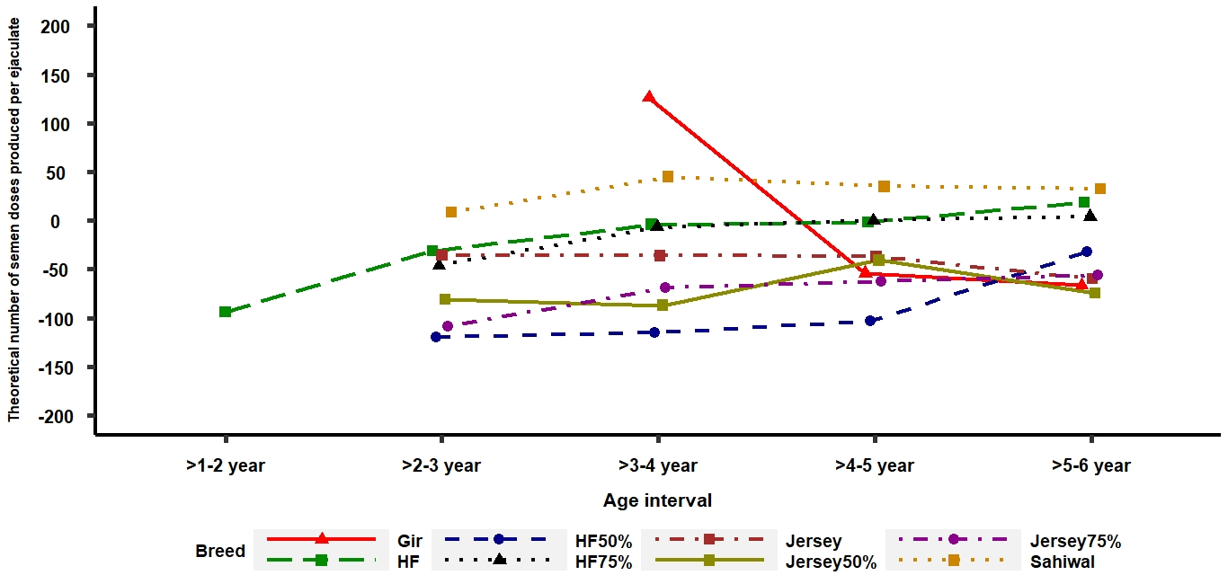

Supplemental Fig. 2. Effect of the collector on theoretical number semen doses over the years
(subtitle: 0 = reference solution as collector 1 × 2016 year; for clarity, only 6 major collectors are reported)

