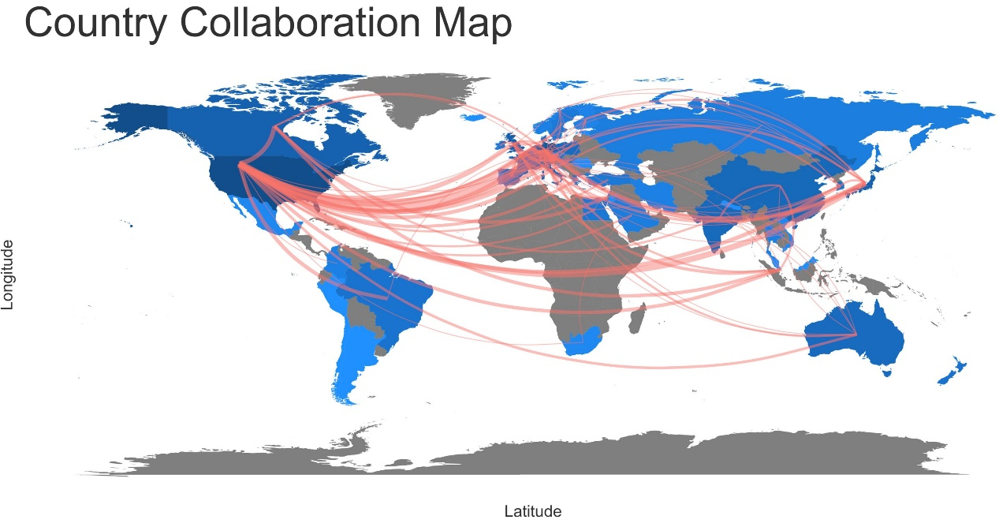Supplementary Figure 3. Country collaboration map
Two countries connected by a red line mean they cooperate with each other. The color shade of countries is related to the number of collaborations. Darker color means greater number of collaborations.

