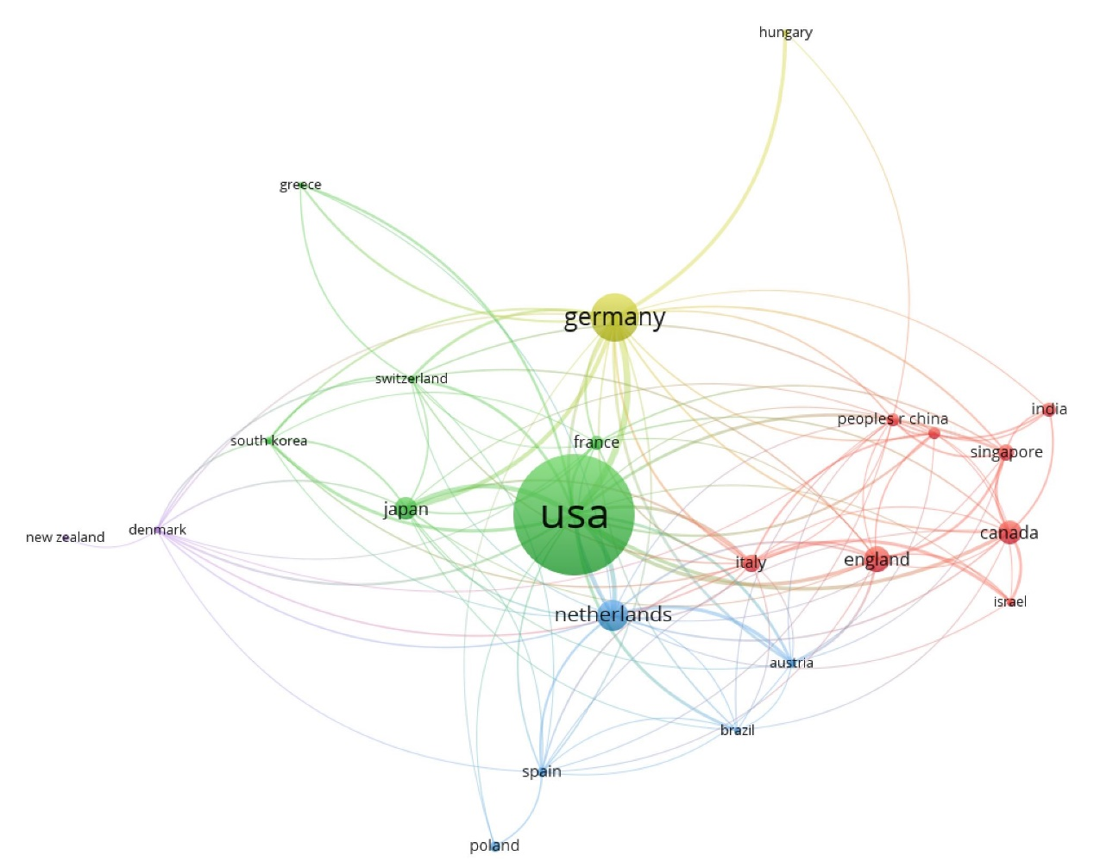Supplementary Figure 2. The co-authorship analysis of countries. The size of a node is proportional to the number of collaborations.

