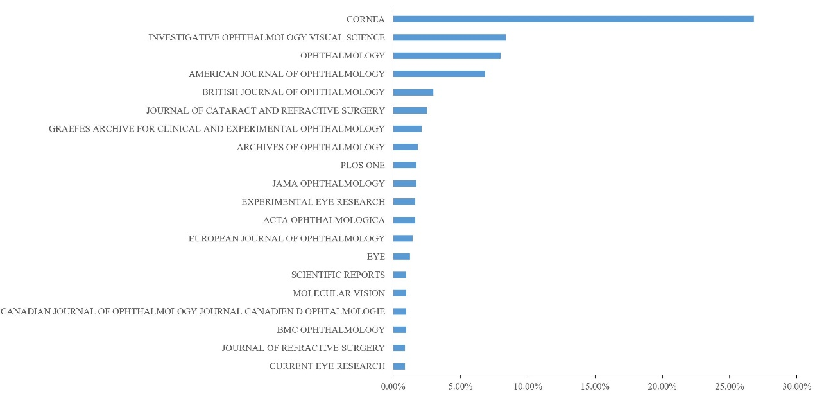Supplementary Figure 6. Top 20 Journals with the most publications in the FECD research field
The x-axis represents its proportion of the total 1041 publications.

