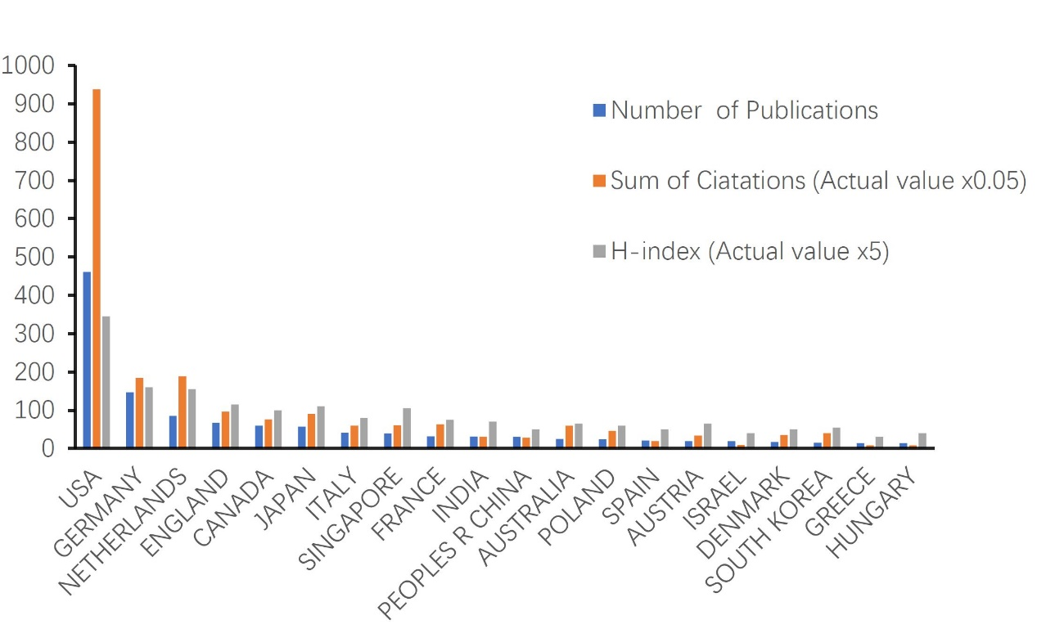Supplementary Figure 1. Contributions of different countries to the FECD research field. FECD: Fuchs endothelial corneal dystrophy.

