Supplementary Data
Figure S1 shows the UV spectra of L1 & C1 and L2 & C2.
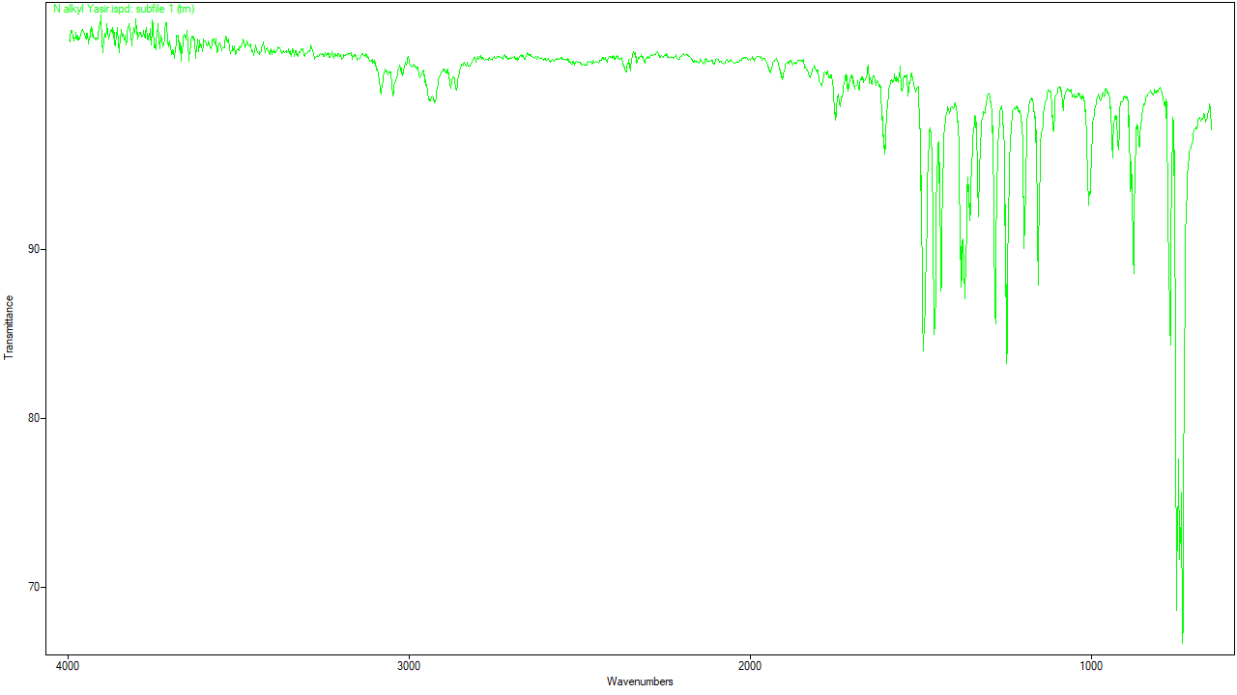
FT-IR of N-alkylated benzimidazole
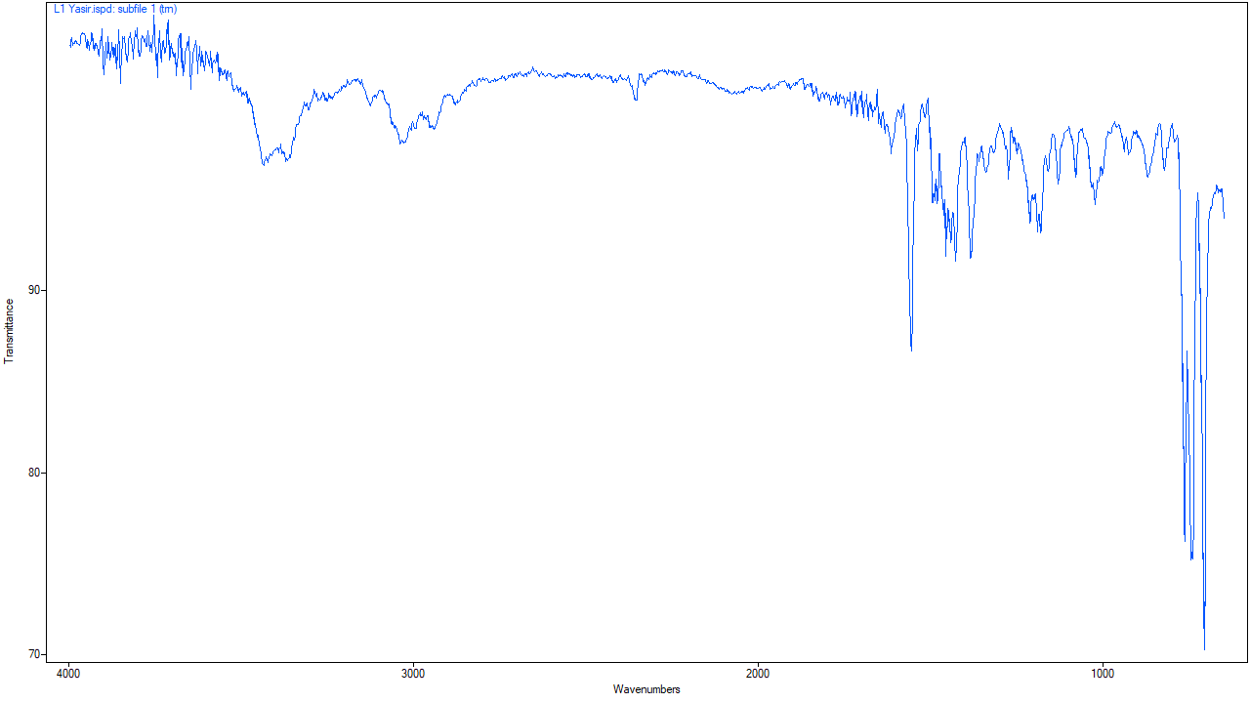
FT-IR of L1
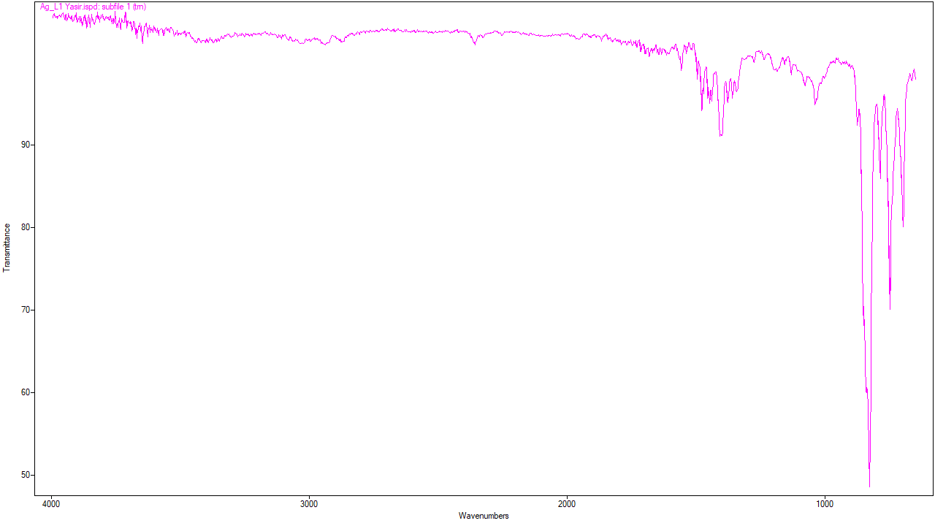FT-IR of C1
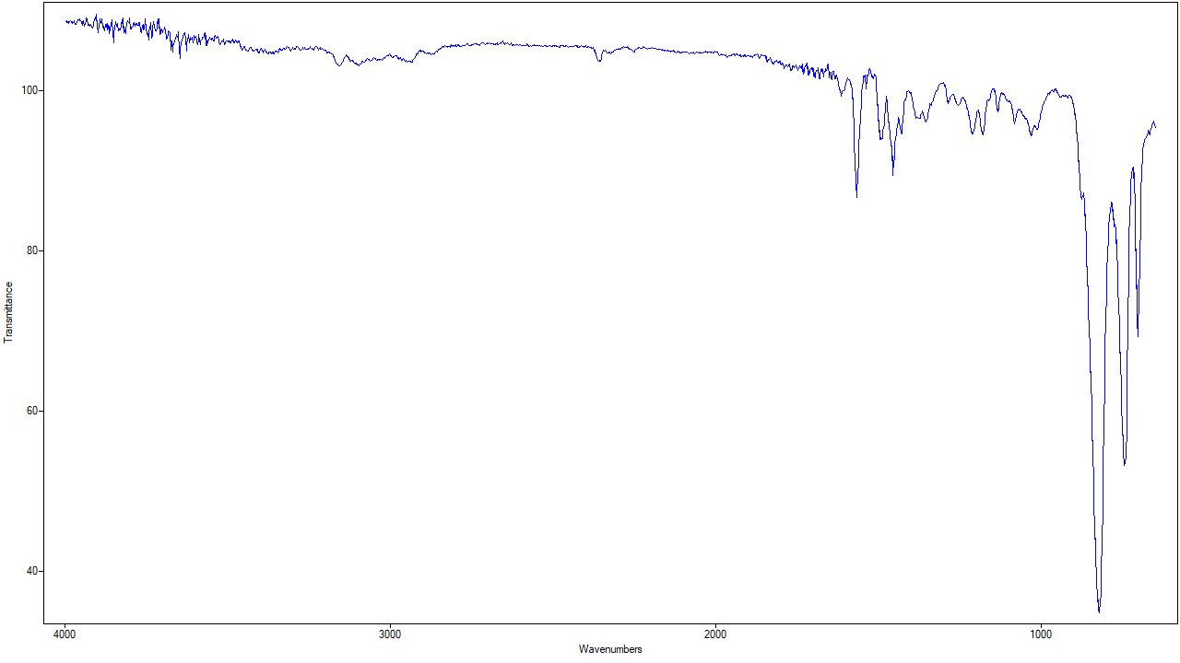
FT-IR of L2
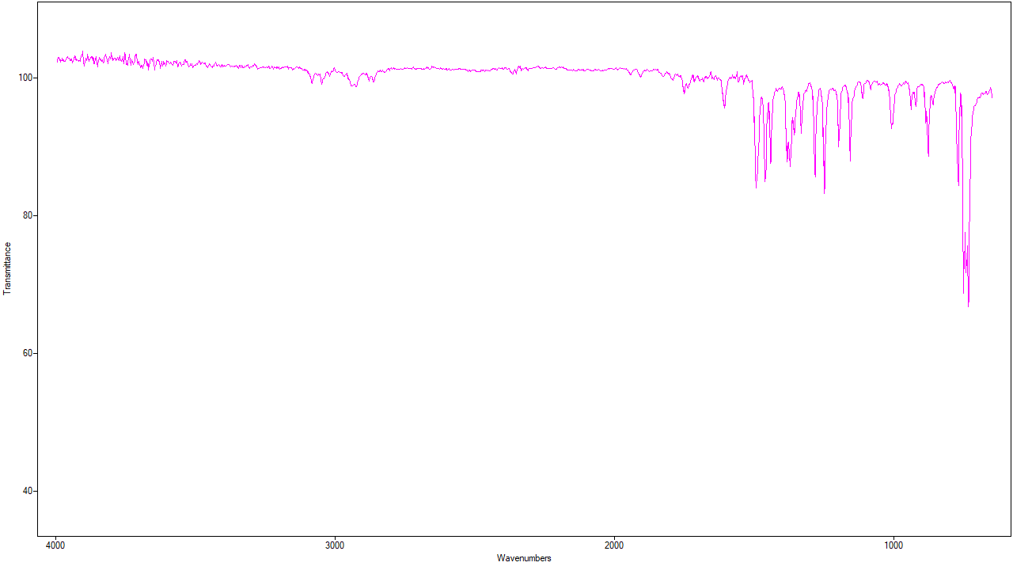
FT-IR of C2
Figure S2 shows the FT-IR spectra of L1 & C1 and L2 & C2.
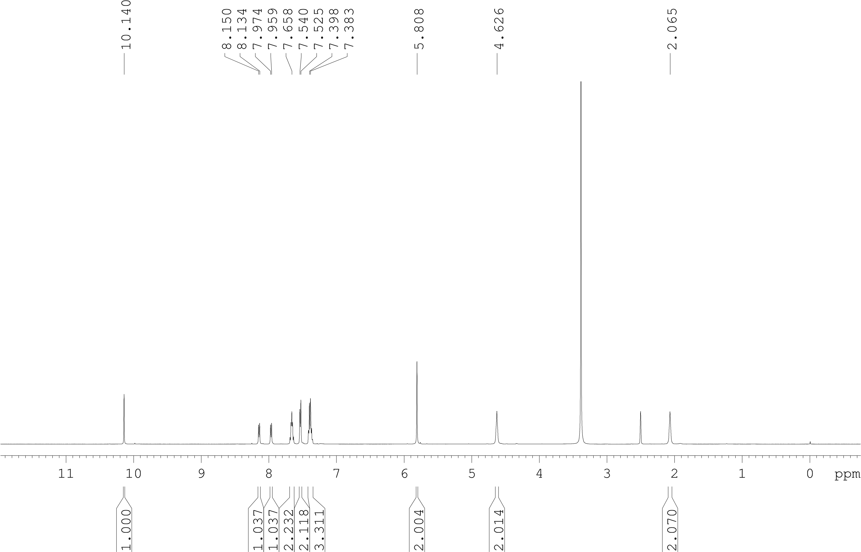
L1_1H

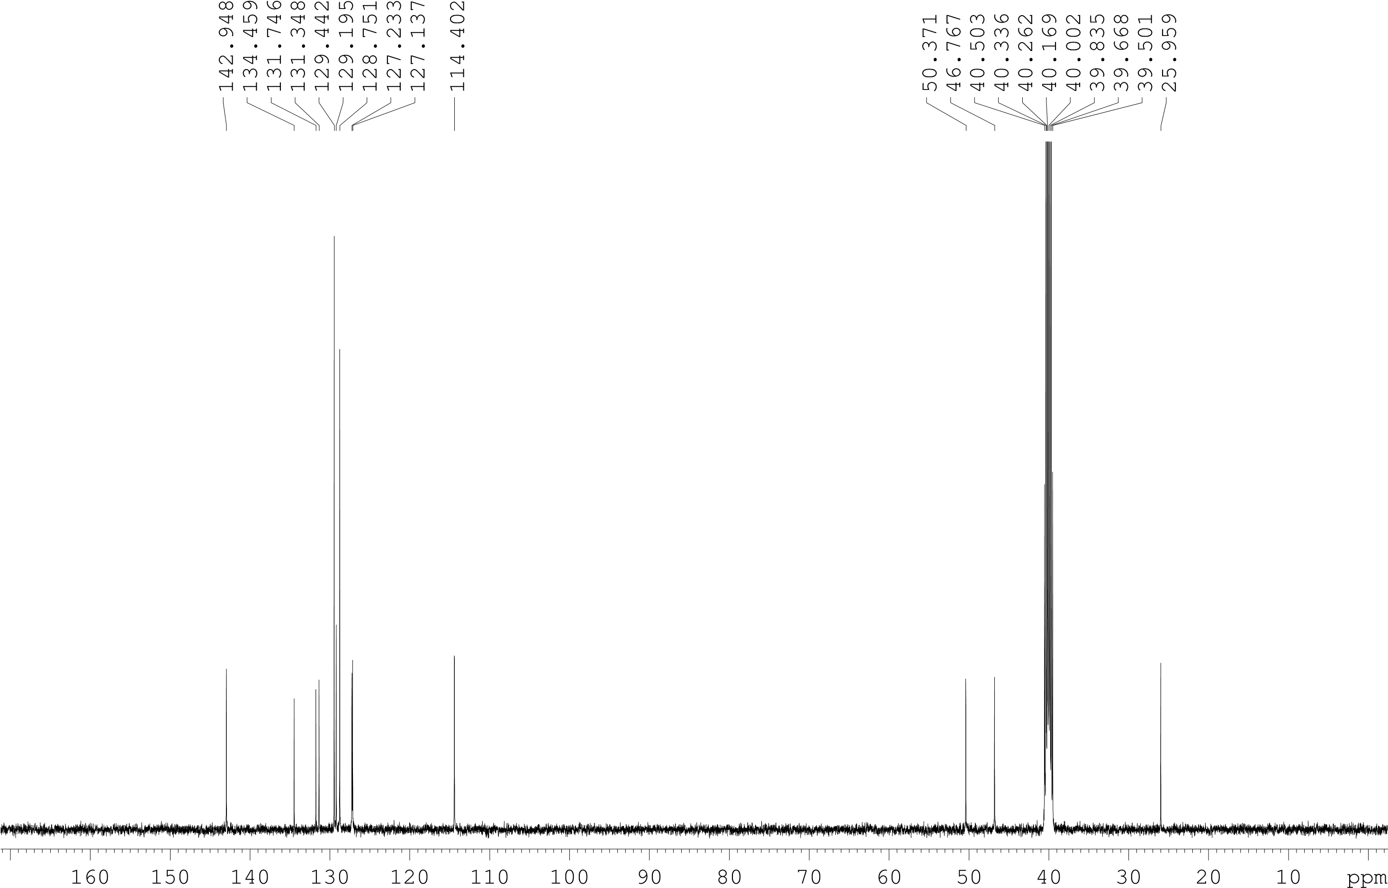
L1_13C

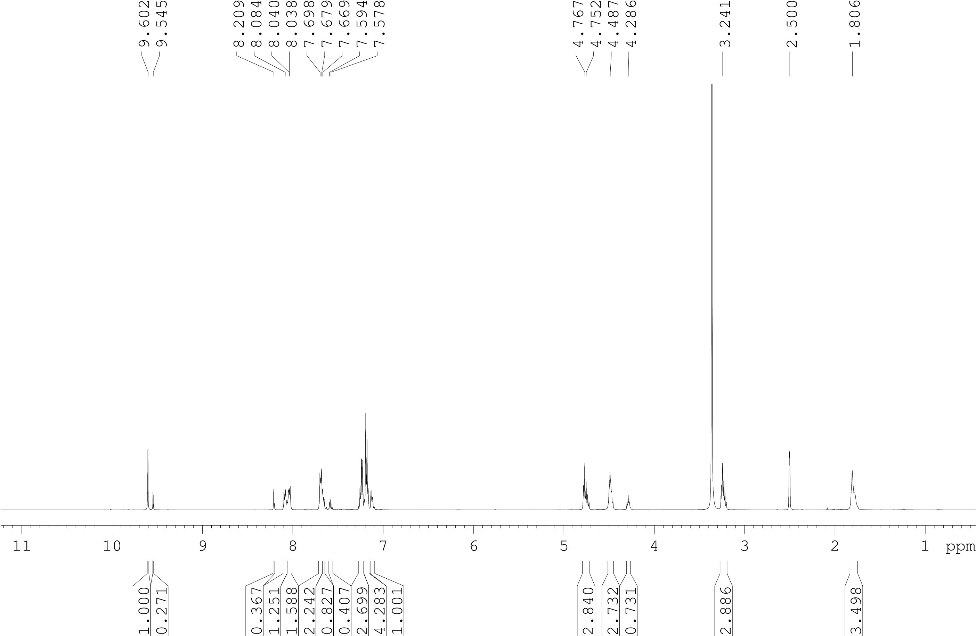
L2_1H
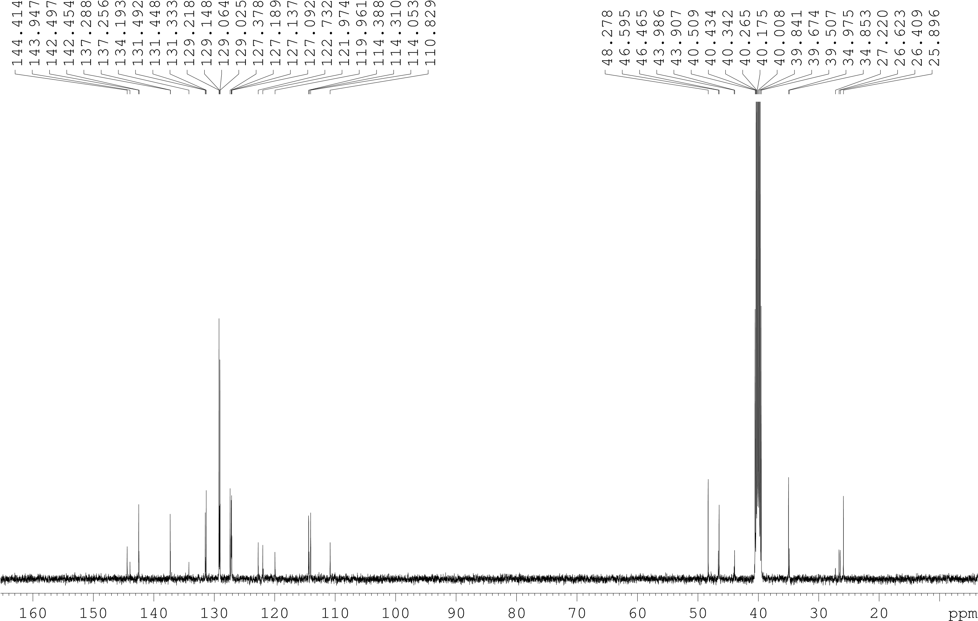
L2_13C
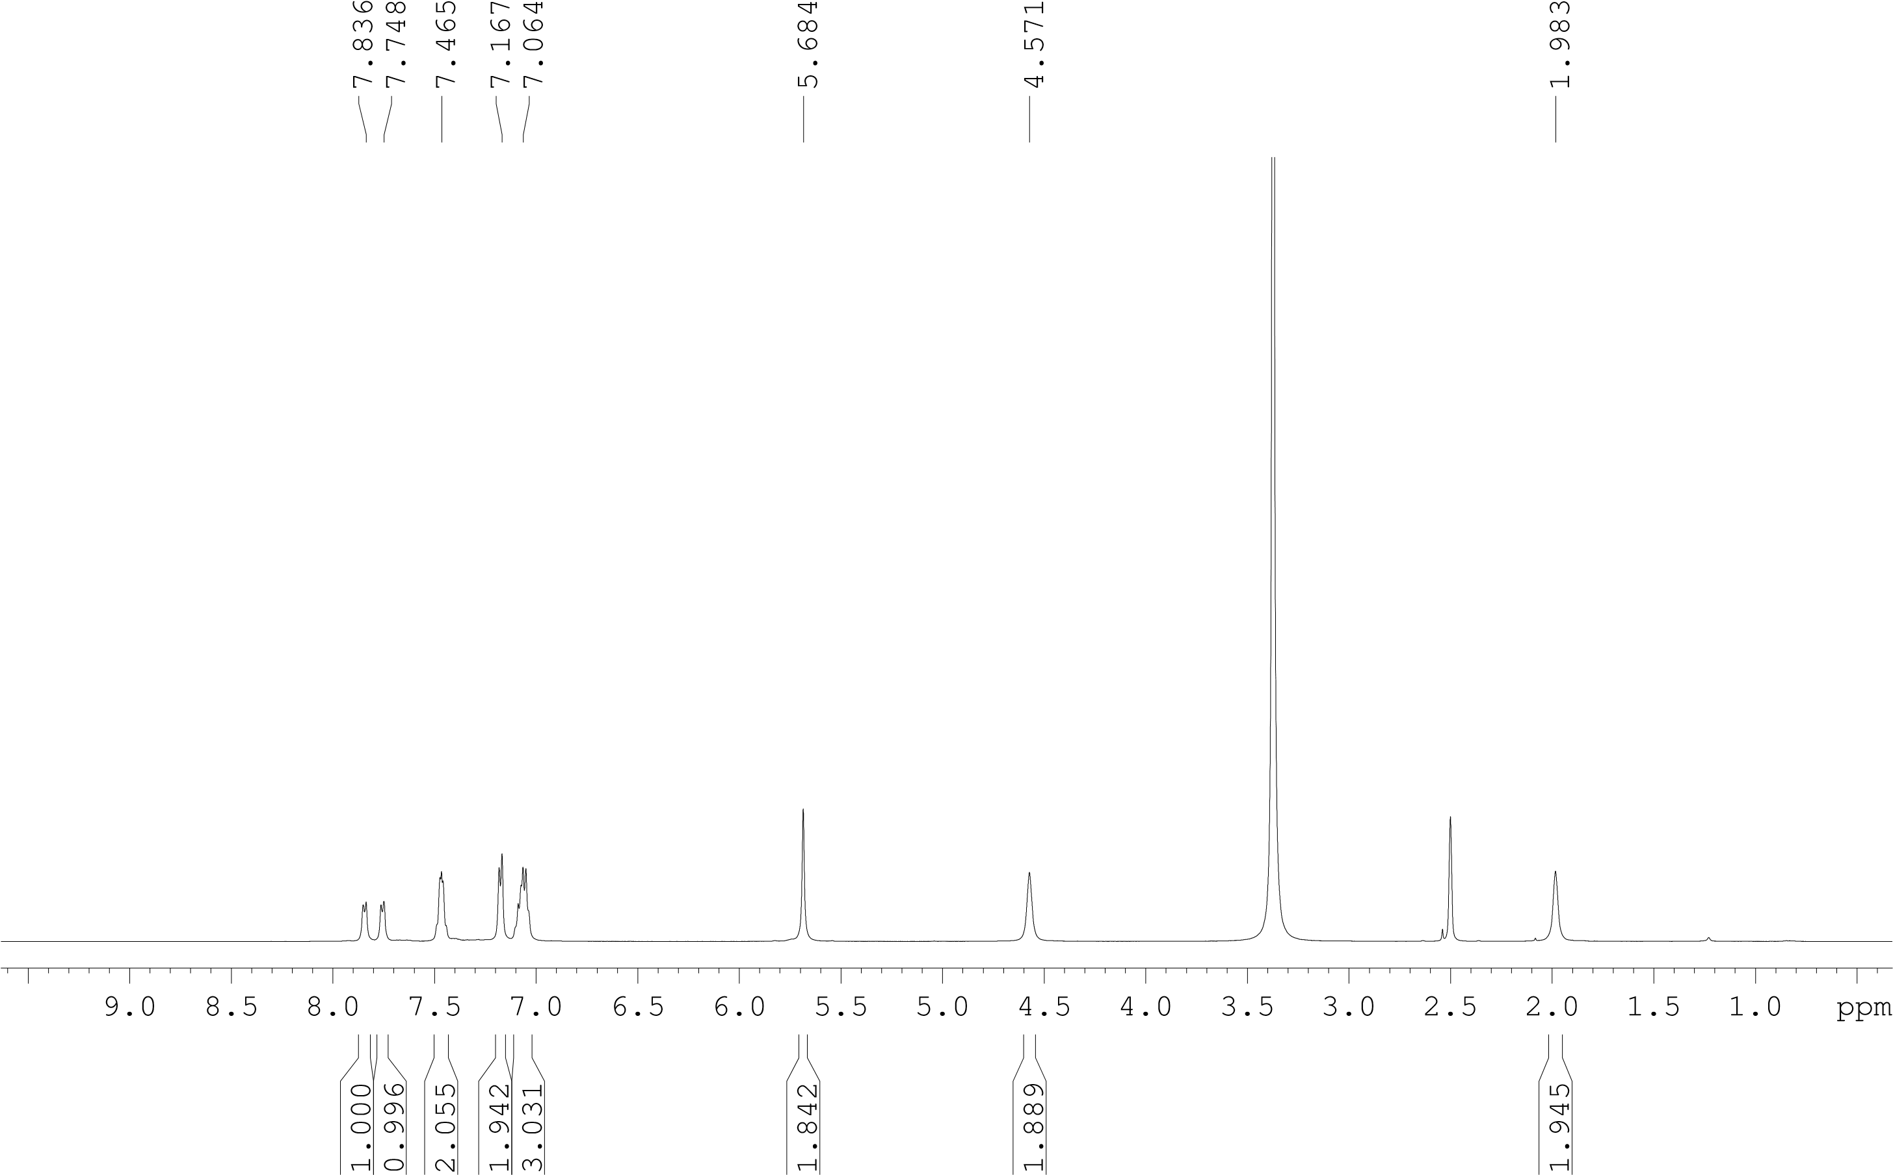
C1_1H
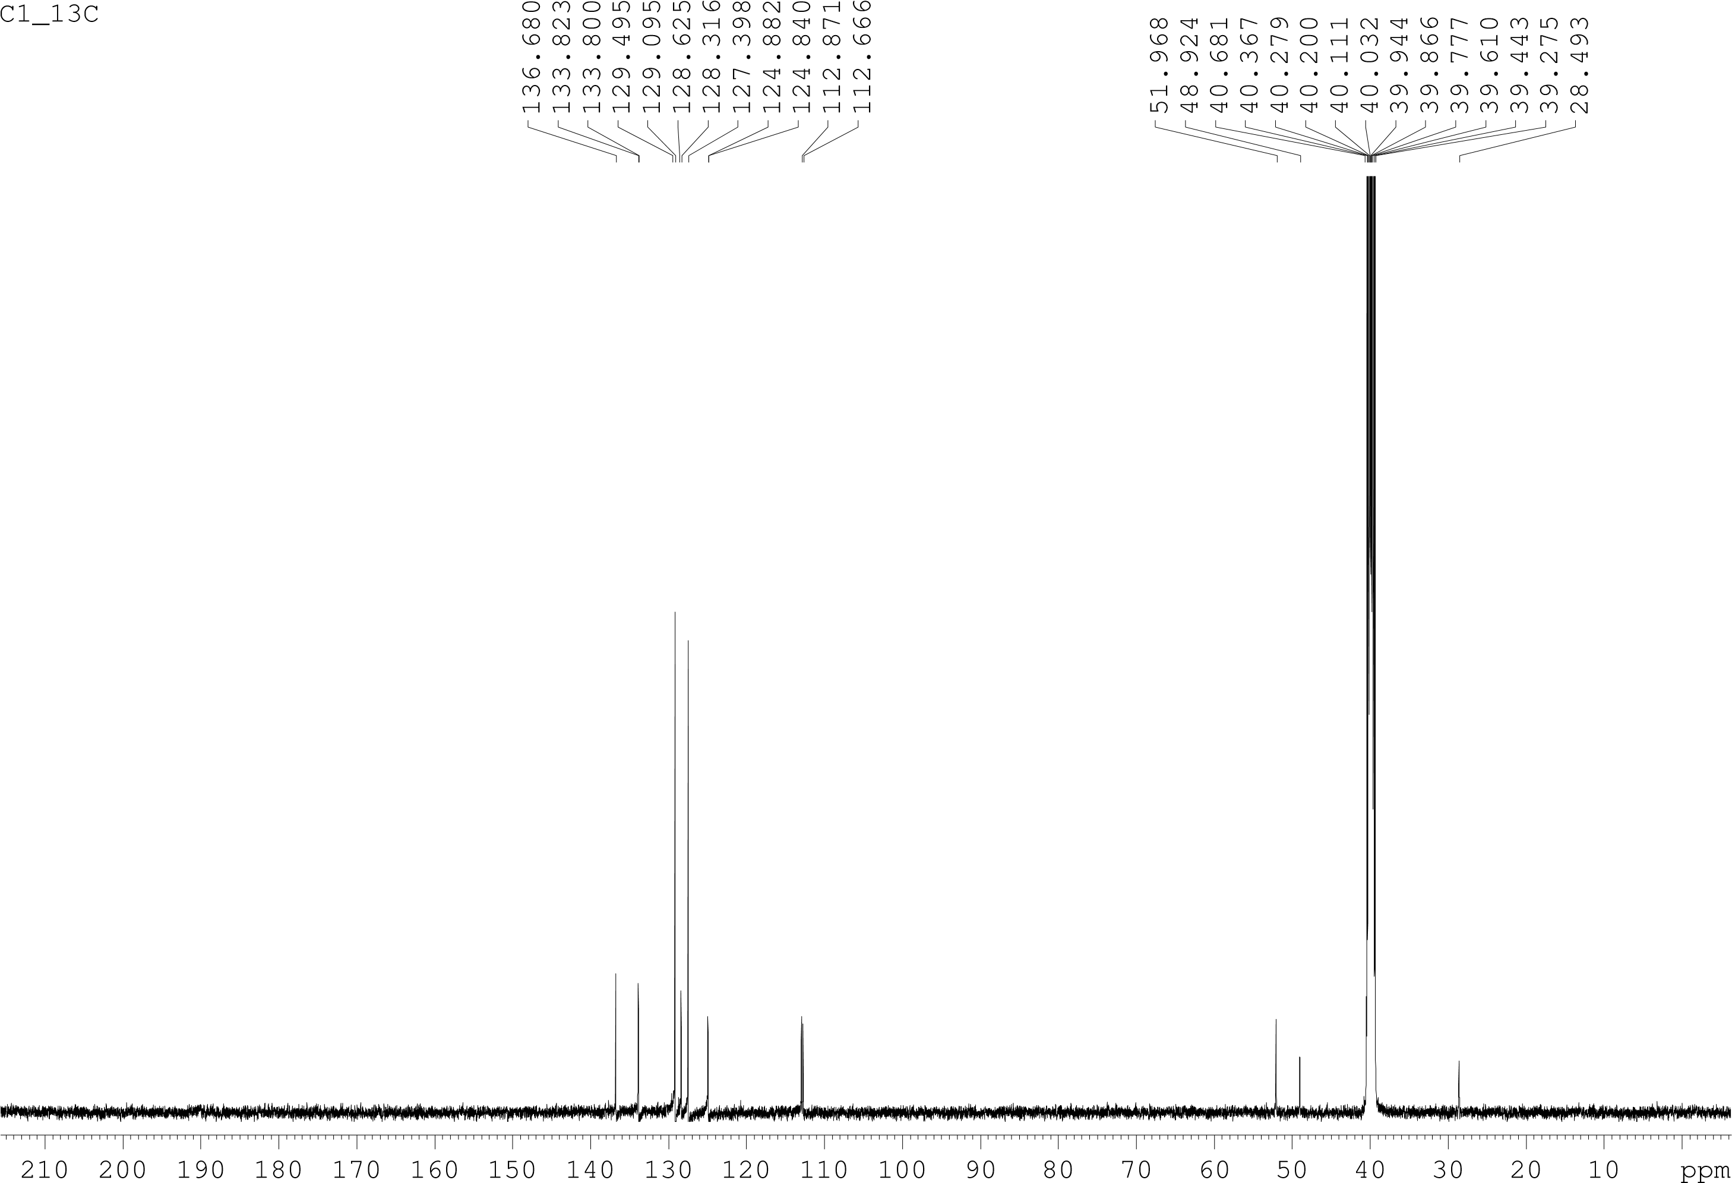
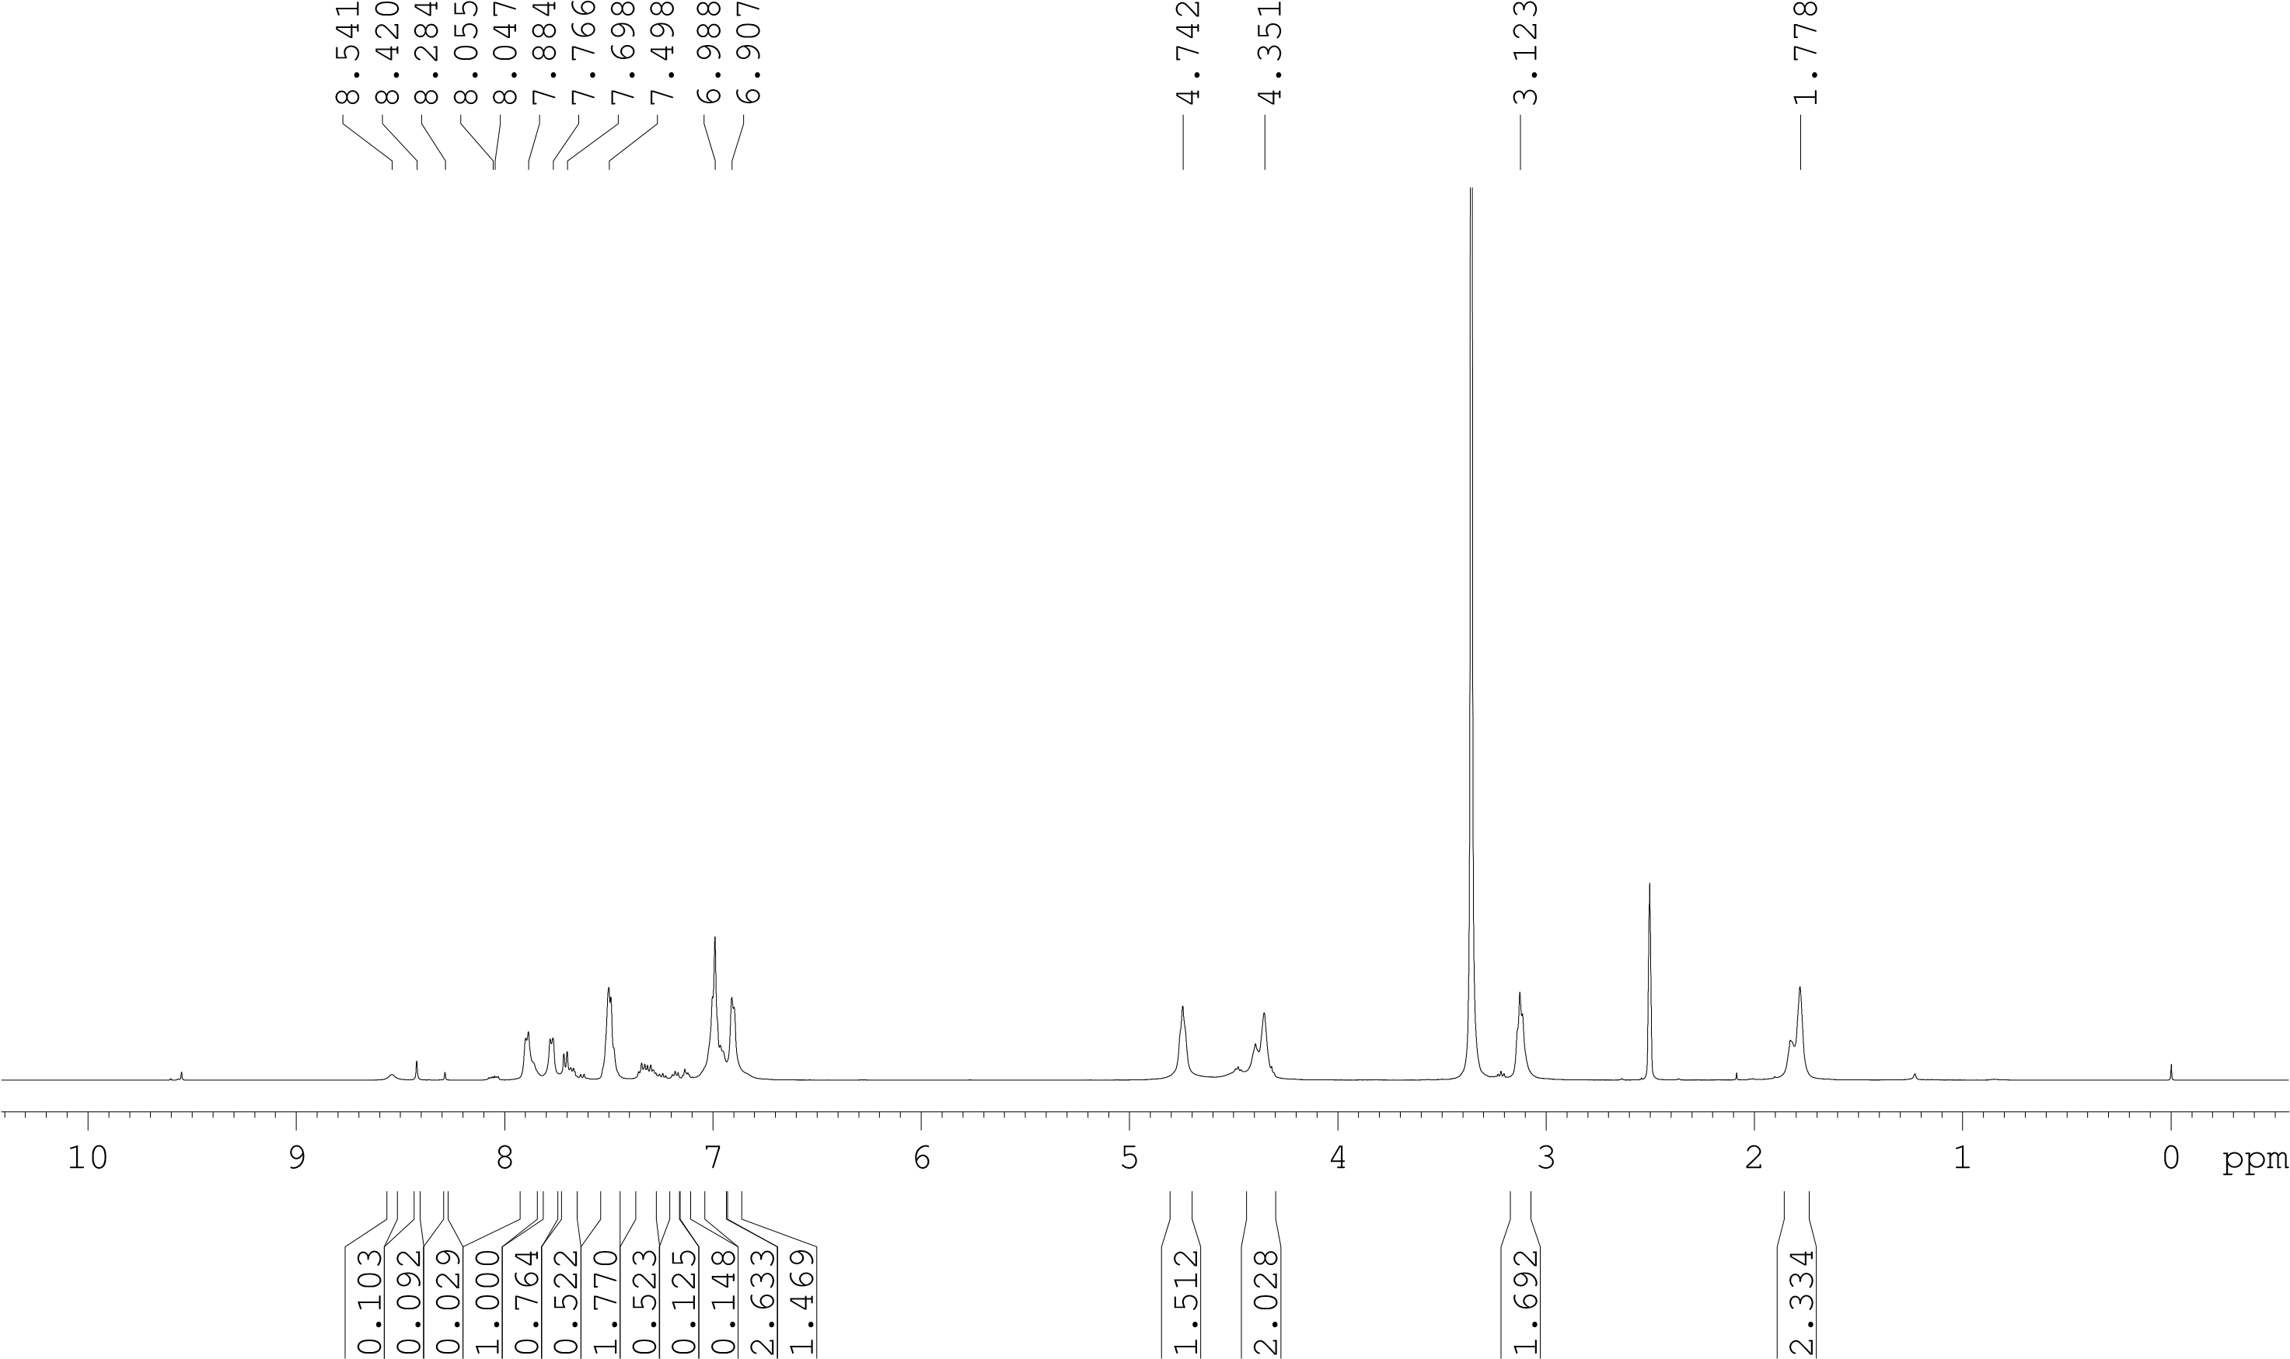
C2_1H

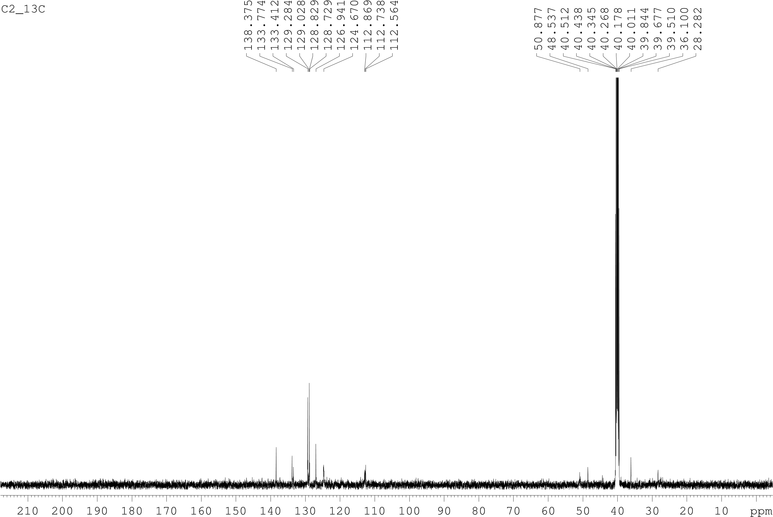

Figure S3 shows the FT-NMR spectra of L1 & C1 and L2 & C2.

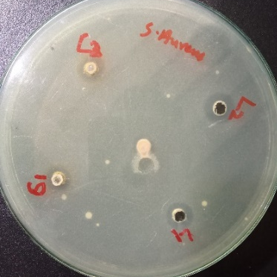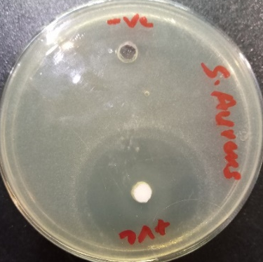
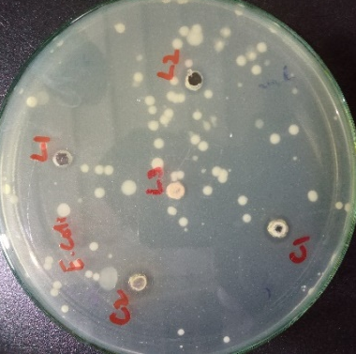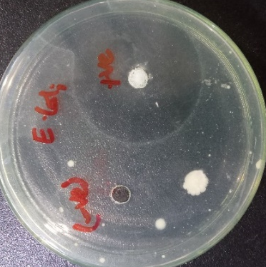
Antimicrobial Estimation of synthesized salts and complexes against S. aureus and E. Coli. All the test sample are applied in the concentration of 10 mg/mL. Ciprofloxacine has been used as positive control
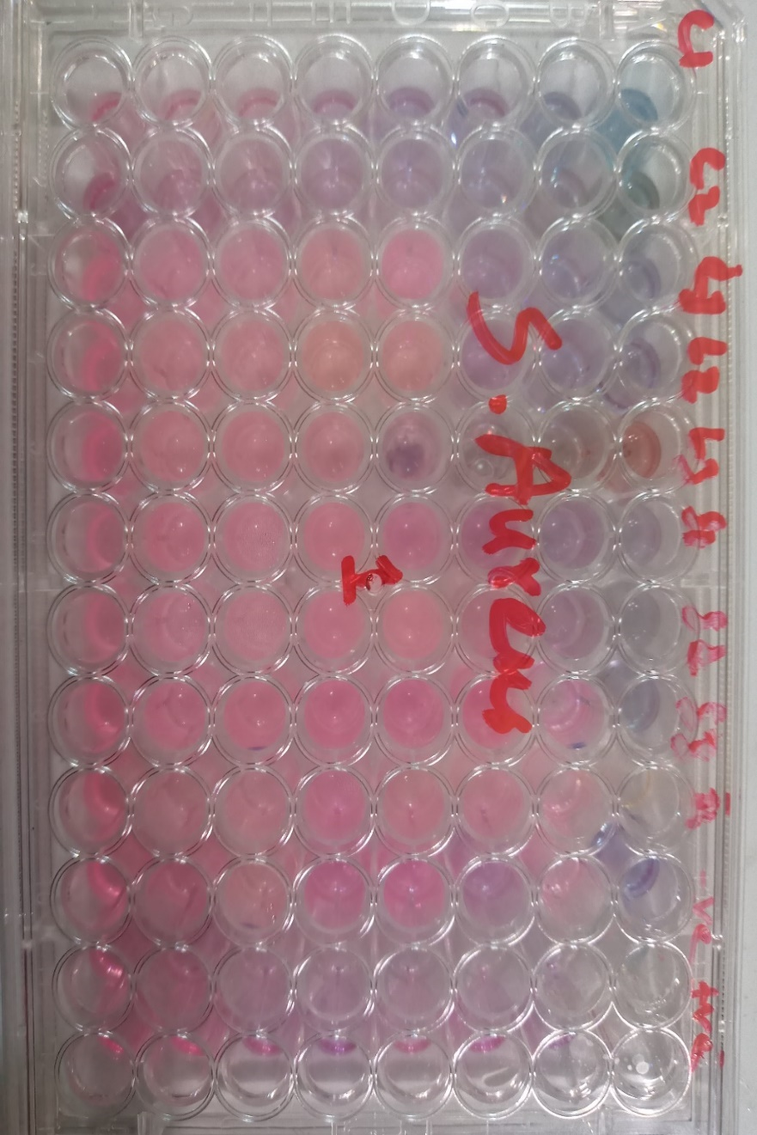
MIC estimation of synthesized salts and silver complexes against S. Aureus.

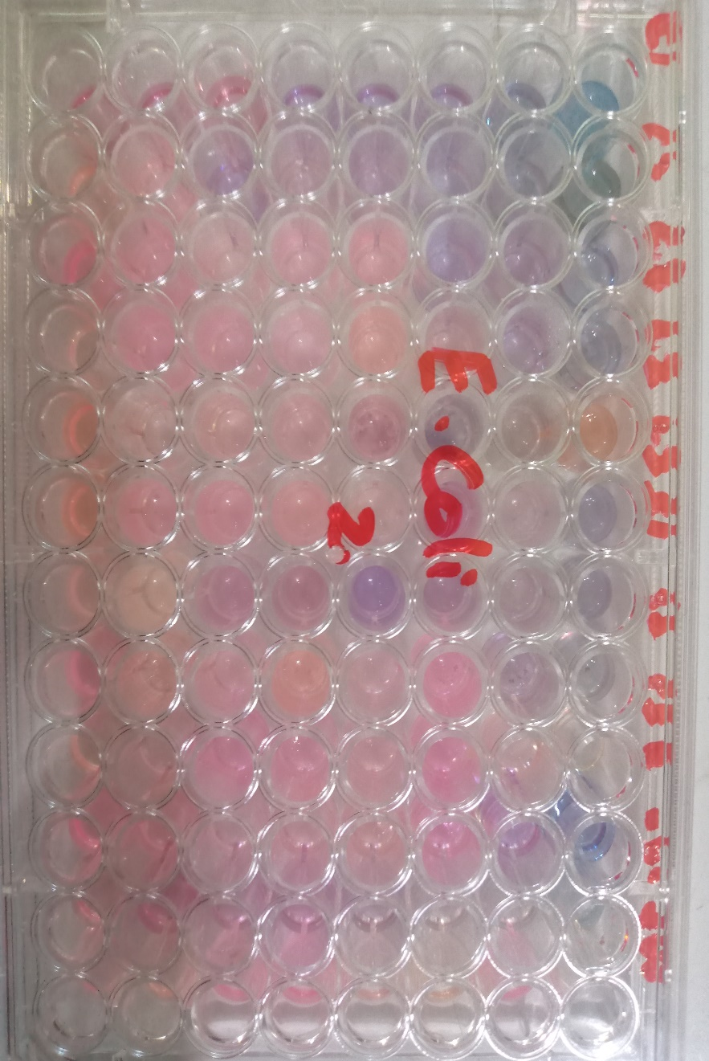
MIC estimation of synthesized salts and silver complexes against E. Coli.
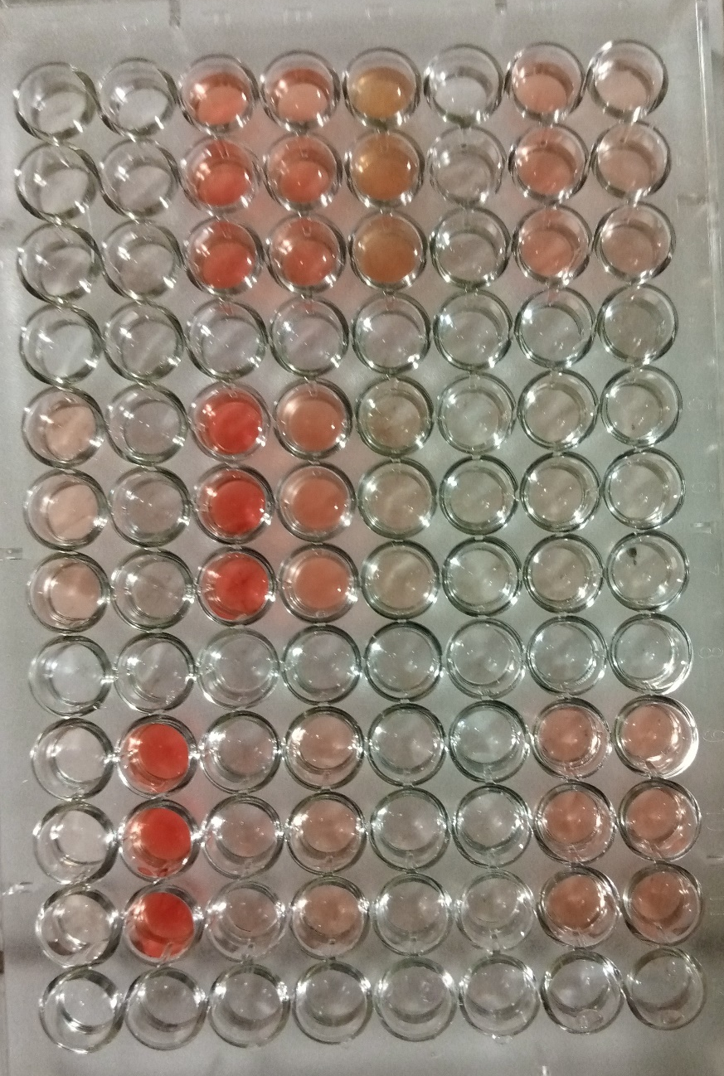
Figure S4 shows the hemolytic assay for the determination of cytotoxicity of benzimidazolium salts and silver complexes

Figure S5 shows the Results of antioxidant potentials using DPPH scavenging assay

