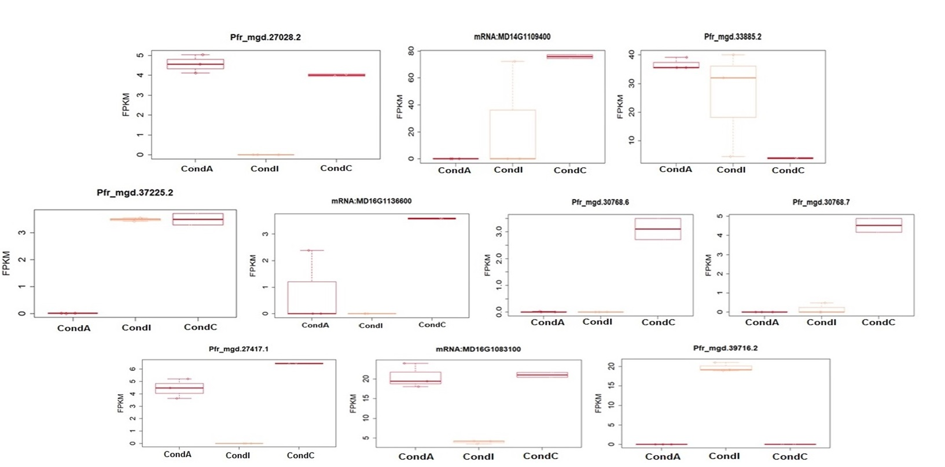
Sup. Figure 1. Gene expression level differences among PGB_invit inoculated (active-A and inactive-I) and control (C) groups according to HiSat2 analysis.

